PHENIKAA UNIVERSITY
PHENIKAA SCHOOL OF COMPUTING



COURSE: SOFTWARE ARCHITECTURE
TOPIC: Online movie streaming platform (Nozie platform)

Instructor: Vũ Quang Dũng
Group 03: Nghiêm Đức Việt (23010636)
Class Section: CSE703110-1-2-25(N02)

Hà Nội, tháng 1 năm 2026
- Lab 07: Event-Driven Architecture (EDA)
  - Objectives
    - To understand and implement the Event-Driven Architecture (EDA) model.
    - To utilize RabbitMQ as the Message Broker.
    - To demonstrate the asynchronous nature and decoupling between services.
  - Enviroment Setup
    - Starting RabbitMQ
RabbitMQ is deployed via Docker Compose:
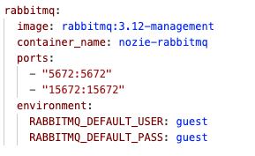
Access the RabbitMQ management interface at: http://localhost:15672
  - EDA Architecture in Project(Nozie)
    - Even Flow Diagram
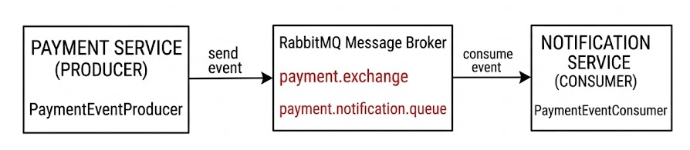
Component | Value | Description
Exchange | payment.exchange | Topic Exchange for message routing
Queue | payment.notification.queue | Queue for message storage
Routing Key | payment.succeeded | Routing key for successful payment events
    - RabbitMQ Components

  - Detailed Implementation
    - Event Object – PaymentSucceededEvent
This is the event object shared between the Producer and the Consumer:
File: /src/main/java/com/nozie/common/event/PaymentSucceededEvent.java
    - RabbitMQ Configuration (Producer)
File: payment-service/.../infrastructure/config/RabbitMQConfig.java
    - Event Producer (Payment Service)
File: payment-service/.../infrastructure/messaging/PaymentEventProducer.java
    - Event Consumer (Notification Service)
File: notification-service/.../messaging/PaymentEventConsumer.java
  - Experimental Results
    - Logs from Payment Service (Producer)
    - Logs from Notification Service (Consumer)
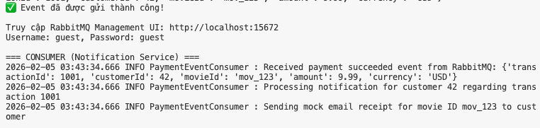
  - Decoupling Analysis
Criteria | Evaluation
Temporal Independence | Payment Service does not wait for Notification Service to complete processing
Fault Isolation | If Notification Service is down, Payment Service continues to operate normally
Scalability | Notification Service can be scaled independently as needed
Message Durability | Messages persist in the queue until successfully processed

- Lab 08: Deployment View & ATAM Analysis
  - Objectives
    - Draw a UML deployment diagram representing the physical structure of the system.
    - Perform ATAM (Architecture Tradeoff Analysis Method) analysis.
    - Evaluate quality attributes: Scalability and Availability.
  - UML Deployment Diagram
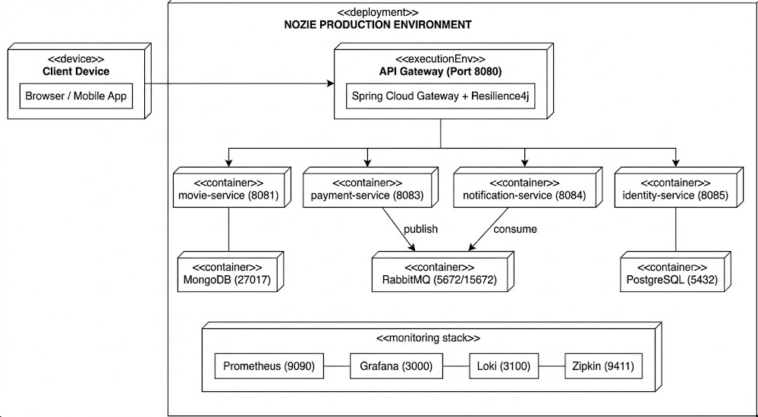
  - Docker Compose Configuration
    - Infrastructure Services
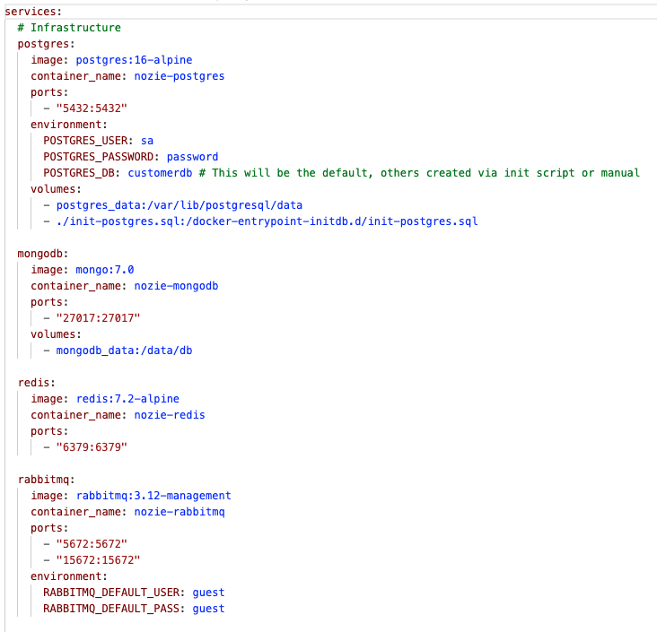
    - Monitoring Stack
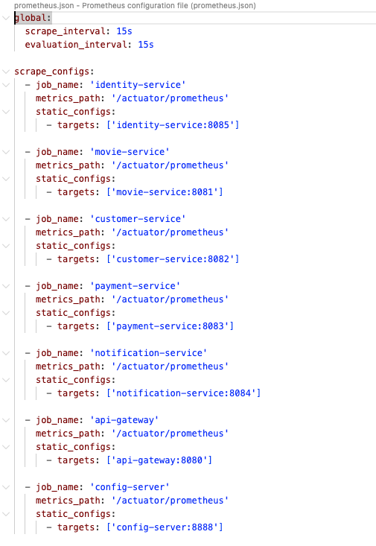
  - ATAM Analysis (Architecture Tradeoff Analysis Method)
    - Utility Tree
    - Scenario Analysis Table
ID | Attribute | Scenario | Architectural Response | Outcome
SS1 | Scalability | Movie viewership increases 10x during peak hours | Scale-out movie-service by increasing the number of replicas in Docker Compose. Other services remain unaffected. | Satisfied
SS2 | Scalability | Sudden spike in payment transactions | Scale-out payment-service individually. RabbitMQ buffers events, allowing notification-service to process them gradually. | Satisfied
AS1 | Availability | notification-service crashes | payment-service continues to function normally; events are stored in the RabbitMQ queue. When notification-service restarts, it consumes the pending messages. | Satisfied
AS2 | Availability | movie-service responds slowly | API Gateway with Resilience4j Circuit Breaker returns a fallback response, preventing cascading failure. | Satisfied

    - Circuit Breaker Configuration
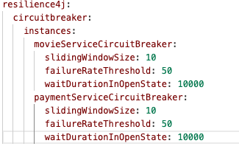
  - Monolith vs. Microservices Comparison
Criteria | Monolith | Microservices (Nozie)
Deployment | Deploys the entire application | Deploys each service independently
Scaling | Scales the whole application | Scales individual services
Fault Isolation | A single error can crash the entire system | Errors are isolated within the failing service
Technology Stack | Single technology stack | Polyglot (can use multiple languages/technologies)
Complexity | Simpler | More complex (requires DevOps, Docker, etc.)
Team Organization | One large team | Multiple small teams, each owning a service

  - Trade-offs in Nozie Architecture
    - Advantages
      - High Scalability: Each service can scale independently.
      - Good Fault Isolation: Utilizes Circuit Breaker and Message Queue.
      - Technology Flexibility: Can use MongoDB for movies and PostgreSQL for transactions.
      - Continuous Deployment: Services can be deployed individually without affecting the entire system.
    - Disadvantages
      - Operational Complexity: Requires managing multiple containers, networks, and volumes.
      - Latency between Services: Network communication is slower than internal function calls.
      - Data Consistency: Harder to ensure data consistency across services (eventual consistency).
      - Data Consistency: Harder to ensure data consistency across services (eventual consistency).
- Conclusion
  - Summary
Through Lab 07 and Lab 08, we have:
- Lab 07: Successfully implemented Event-Driven Architecture (EDA) using RabbitMQ, demonstrating asynchrony and decoupling between payment-service and notification-service
- Lab 08: Constructed UML deployment diagrams and performed ATAM analysis, evaluating the strengths and trade-offs of the Microservices architecture.
  - Key Takeaways
    - Microservices architecture is suitable for systems requiring high scalability and high fault tolerance.
    - Message Queue (RabbitMQ) is a crucial tool for achieving loose coupling.
    - Monitoring (Prometheus, Grafana, Zipkin) is mandatory in a microservices environment.
    - Trade-offs must be carefully considered before deciding to adopt this architecture.

