PHENIKAA UNIVERSITY
PHENIKAA SCHOOL OF INFORMATION TECHNOLOGY



COURSE: SOFTWARE ARCHITECTURE
PROJECT TITLE: Development of an Online Movie Streaming Platform
(Nozie Platform)

Instructor: Vũ Quang Dũng
Team Members: Nguyễn Văn Nhật - 23010887
Nghiêm Đức Việt - 23010636
Nguyễn Duy Minh - 23010359
Đặng Nhất Nhất - 23010345
Class Code: CSE703110-1-2-25(N02)

Hà Nội, tháng 3 năm 2026

MỤC LỤC

Phân chia công việc
Tên thành viên | Mô tả công việc
Nguyễn Văn Nhật
Nghiêm Đức Việt
Nguyễn Duy Minh
Đặng Nhất Nhất

1. Cover Page & General Information

1.1 Course and Instructor Information
This project was developed within the framework of the Software Architecture course for the [Semester/Academic Year] at [University/Faculty].
Under the guidance of [Instructor Name], the course aims to facilitate the practical application of core architectural concepts—including layered architecture, microservices, event-driven architecture (EDA), and deployment views—to a realistic software system.

1.2 Team & Member Information
The project is implemented by the Nozie Team, comprising the following members:
- [Member 1 – Student ID]: Team Lead. Responsible for overall system architecture and backend integration.
- [Member 2 – Student ID]: Backend Developer. In charge of microservices implementation and database design.
- [Member 3 – Student ID]: Frontend/Flutter Developer. Responsible for the mobile client application and user experience (UX).
- [Member 4 – Student ID]: QA & Documentation. Responsible for reports, architectural diagrams, and test evidence.
All members contributed to both design and implementation, with specific ownership of labs and report sections defined in the team’s planning document.

1.3 System Name and Description
System Name: Nozie Movie Platform
Description: Nozie is an online movie streaming platform designed to allow users to browse a vast catalog of movies, subscribe to premium plans, and stream content based on their subscription tier. The system is engineered as a suite of microservices (Identity, Customer, Movie, Payment, Notification) exposed via a centralized API Gateway and consumed by a cross-platform Flutter client application.

2. Executive Summary

2.1 Overall Project Objectives
The primary objective of the Nozie project is to design and implement a production-grade movie streaming platform that demonstrates mastery of key software architecture concepts.
The system is designed to support core workflows—including user registration, catalog browsing, subscription management, and notifications—while satisfying critical architectural drivers such as scalability, availability, and modifiability.

2.2 Main Functional Scope
User Features:
- Authentication: Secure registration and login functionality.
- Catalog Management: Browse, search, and view detailed movie information.
- Subscription Management: Purchase and manage plans (e.g., Free, Premium).
- Streaming: Access and watch content restricted by current subscription levels.
- Notifications: Receive alerts regarding registration, subscription activation, and payments.
Administrative Features:
- Maintain consistent customer profiles and verify subscription statuses across distributed services.

2.3 Key Architectural Decisions
The project adopts a Microservice Architecture pattern, ensuring loose coupling and high cohesion. Key technical decisions include:
- Database-per-Service: Each microservice maintains its own data sovereignty.
- API Gateway: Acts as the single entry point for the Flutter client, routing requests to appropriate backend services.
- Hybrid Communication:
  - Synchronous: REST APIs are used for direct client-to-gateway and gateway-to-service communication.
  - Asynchronous (Event-Driven): RabbitMQ is utilized to decouple services (e.g., Payment, Customer, and Notification), ensuring resilience and scalability.
- Layered Internal Architecture: Each service follows a strict separation of concerns (Controller → Service → Repository).
- Scalable Deployment: The deployment view is modeled to support independent scaling of high-load services, such as Movie and Payment.

2.4 Main Outcomes and Final Demo
The project concludes with a fully functional, end-to-end system. The final demonstration validates that a user can successfully:
- Register and authenticate.
- Browse the movie catalog.
- Select a subscription plan and complete the payment flow.
- Experience immediate unlocking of premium content via real-time status updates.

3. Project Requirements & Goals

3.1 Problem Background & Business Context
The Nozie Movie Platform addresses the market demand for a flexible and scalable online streaming service that allows users to discover content, subscribe to tiered plans, and stream across multiple devices.
Traditional monolithic architectures often hinder rapid evolution, making it difficult to introduce new capabilities—such as advanced recommendation engines, promotional campaigns, or diverse payment methods—without risking system stability. Consequently, this project focuses not merely on delivering basic streaming functionality, but on engineering an architecture capable of evolving alongside future business demands (e.g., new subscription tiers, partner integrations, and regional catalogs) while maintaining loose coupling between teams and services.

3.2 Functional Requirements (FRs)
The system is designed to support the following core functional flows:
- FR-01: Registration & Authentication Users must be able to securely register and log in to the system.
- FR-02: Catalog Management Users must be able to browse, search the movie catalog, and view detailed metadata for specific titles.
- FR-03: Subscription & Payment The system must allow users to select subscription plans (e.g., Free, Premium, VIP) and initiate secure payment flows.
- FR-04: Access Control & Enforcement Upon successful payment, the user’s subscription status must be updated immediately and strictly enforced when attempting to access content.
- FR-05: System Notifications The system must trigger automated notifications regarding registration, subscription activation, and payment receipts.

3.3 Non-Functional Requirements (NFRs)
The architecture is driven by the following critical quality attributes:
- Scalability: The system must handle traffic spikes—such as concurrent browsing or high-volume subscription requests—by allowing specific services (e.g., Movie, Payment) to scale horizontally.
- Availability & Resilience: The architecture must ensure fault isolation. Failures in non-critical services (e.g., Notification) must not block core business flows like authentication or payment processing; the system must degrade gracefully.
- Performance: Critical user interactions, particularly catalog browsing and checkout completion, must exhibit low latency and high responsiveness.
- Security: All APIs accessible via the API Gateway must be protected by robust Authentication and Authorization mechanisms. Sensitive data, particularly payment information, must be handled according to security best practices.
- Modifiability: The architecture must facilitate the addition of new features—such as new subscription tiers, notification channels, or auxiliary services—with minimal impact on existing codebases.

3.4 Architecturally Significant Requirements (ASRs)
Based on the defined FRs and NFRs, several requirements have directly influenced the architectural topology:
- ASR-1: High Scalability for Read-Heavy Traffic
  - Impact: The Movie catalog requires horizontal scaling to handle read-heavy loads. This necessitates a dedicated Movie Microservice with its own database and independent deployment units.
- ASR-2: Decoupled Payment Side-Effects
  - Impact: Payment completion must not be blocked by downstream processes (e.g., sending emails or updating read models). This drives the adoption of an Event-Driven Architecture using RabbitMQ for asynchronous consistency.
- ASR-3: Independent Evolution of Domains
  - Impact: Identity, Customer, Payment, Movie, and Notification domains must evolve independently with separate release cycles. This reinforces the Database-per-Service pattern and the definition of clear service contracts.
- ASR-4: Secure, Single Entry Point
  - Impact: All external client traffic must be routed through a centralized API Gateway. This centralizes cross-cutting concerns such as authentication, routing, and logging, simplifying the client-side logic.

3.5 Use Case Model & Actors
The system interaction involves the following primary actors:
- End User (Customer): The primary user who registers, authenticates, browses the catalog, manages subscription plans, executes payments, and consumes streaming content based on their access level.
- Content/Platform Administrator: The internal user responsible for managing the movie catalog metadata and monitoring subscription health (note: while modeled, full implementation of the admin dashboard is secondary to the consumer-facing features).

Use Case Modeling:

A. Identity Domain (UC1–UC8)
Handles authentication, authorization, and user account management.
Use Case | Actor | Flow Description
UC1 – Register | Customer | 1. User submits registration details. 2. Identity Service creates account in DB. 3. Publishes UserRegisteredEvent. 4. Returns success to Client.
UC2 – Login via Credentials | Customer | 1. User inputs email/password. 2. Identity Service validates hash. 3. If valid, issues JWT Access & Refresh Tokens. 4. Client stores tokens securely.
UC2_1 – Social Auth Login | Customer | 1. User selects "Login with Google/Facebook". 2. Client handles OAuth flow with Provider. 3. Identity Service verifies Provider Token. 4. Service creates/links account and issues App JWT.
UC2_2 – Two-Factor Auth | Customer | 1. After initial credential check, System requests 2FA code. 2. User enters code (SMS/Authenticator). 3. Identity Service validates code. 4. Issues final Access Token.
UC3 – Logout & Revoke | Customer | 1. User selects Logout. 2. Client discards local token. 3. (Optional) Client calls API to blacklist/revoke the specific Refresh Token on server.
UC4 – Change Password | Customer | 1. User provides old and new passwords. 2. Identity Service validates old password. 3. Updates DB with new hash. 4. Triggers security notification (UC27).
UC5 – Manage Sessions | Customer | 1. User requests active session list. 2. Identity Service returns list of devices/IPs. 3. User can revoke specific unknown sessions.
UC6 – Assign Roles | Admin | 1. Admin selects a user and a role (e.g., Staff, Manager). 2. Identity Service updates user claims. 3. Permissions take effect on next token refresh.
UC7 – View Audit Logs | Admin | 1. Admin requests system logs. 2. Identity Service returns history of logins, failed attempts, and role changes for security auditing.
UC8 – Enrich Profile | Customer | 1. User views/edits profile (Avatar, Name, Bio). 2. Client calls PUT /api/users/me. 3. Identity Service updates details.

B. Movie Domain (UC9–UC16)
Handles catalog management, streaming, and content discovery.
Use Case | Actor | Flow Description
UC9 – Browse Catalog | Customer | 1. Client requests movie list (Latest, Trending). 2. Movie Service queries DB with pagination. 3. Returns metadata list (Posters, Titles).
UC10 – Advanced Search | Customer | 1. User searches by multiple criteria (Actor, Year, Genre). 2. Movie Service executes complex query. 3. Returns filtered results.
UC11 – Watch Movie | Customer | 1. User clicks Play. 2. System calls UC18 to verify Subscription. 3. If allowed, Movie Service returns Stream URL/Manifest. 4. Player begins streaming.
UC12 – Add to Watchlist | Customer | 1. User adds a title to "My List". 2. Movie Service stores the userId + movieId association. 3. Client updates UI to show "Added".
UC13 – Rate & Review | Customer | 1. User rates (1-5 stars) and writes a review. 2. Movie Service saves review. 3. Updates average rating for the movie.
UC14 – Get AI Recs | Customer | (Future/Stub) 1. System analyzes user history. 2. Calls AI Model to get recommended IDs. 3. Movie Service returns personalized list.
UC15 – Upload Content | Staff | 1. Staff uploads video file and metadata. 2. Movie Service processes file (transcoding) and saves details to DB. 3. Movie becomes available in catalog.
UC16 – Sync TMDB | Staff | (Future/Stub) 1. Staff triggers sync. 2. Service fetches metadata from TMDB API. 3. Updates local DB to match external source.

C. Customer Domain (UC17–UC20)
Handles subscription logic, history, and customer-specific business rules.
Use Case | Actor | Flow Description
UC17 – View Plans | Customer | 1. Client requests available subscription tiers. 2. Service returns Plan list (Free, Premium, VIP) with features and pricing.
UC18 – Check Status | System | 1. Internal/External request to check if User X can access Plan Y. 2. Service checks subscriptionStatus and expiryDate. 3. Returns TRUE/FALSE.
UC19 – Track History | Customer | 1. As user watches (UC11), system logs progress. 2. User requests "History". 3. Service returns list of recently watched items and timestamps.
UC20 – Manage Rules | Admin | 1. Admin configures mapping between Plans and Permissions (e.g., "VIP" = 4K support). 2. Service updates business rule configuration.

D. Payment Domain (UC21–UC24)
Handles billing, integration with payment gateways (Stripe), and transactions.
Use Case | Actor | Flow Description
UC21 – Checkout & Pay | Customer | 1. User selects plan. 2. Payment Service creates intent with Provider (Stripe). 3. User completes payment UI. 4. Transaction recorded as "Pending".
UC22 – Receive Webhook | System | 1. Payment Provider calls Webhook URL. 2. Payment Service validates signature. 3. Updates transaction to "Success". 4. Publishes SubscriptionActivatedEvent (EDA).
UC23 – Billing History | Customer | 1. User requests billing logs. 2. Payment Service returns list of past invoices/payments (Date, Amount, Plan).
UC24 – Request Refund | Customer | 1. User requests refund for eligible transaction. 2. System validates policy (e.g., < 7 days). 3. Payment Service triggers refund via Provider API.

E. Notification Domain (UC25–UC27)
Handles asynchronous communication via Email/Push.
Use Case | Actor | Flow Description
UC25 – Transactional Alert | System | 1. Service consumes RabbitMQ events (e.g., PaymentSucceeded). 2. Generates email template. 3. Sends confirmation email to user.
UC26 – Marketing Push | Admin | 1. Admin drafts a promo message. 2. Notification Service queues message for all/selected users. 3. Sends Push Notification/Email batch.
UC27 – Security Alert | System | 1. Triggered by UC2_2 or UC4. 2. Service sends "New Login Detected" or "Password Changed" email to protect user account.

4. Architectural Design

4.1 Layered Architecture

DDD-Oriented Layered Architecture
Nozie’s backend services follow a DDD-oriented layered architecture, ensuring clear separation between API concerns, use cases, domain logic, and infrastructure. Each microservice is organized into four distinct layers:
- API Layer (Interface / Controller) This layer exposes the service via REST endpoints. Controllers (e.g., PaymentController) handle HTTP requests, input validation, and DTO mapping. This layer contains no business rules, delegating all processing to the Application Layer.
- Application Layer (Use-Case) Implements specific service use cases such as “Checkout” or “Activate Subscription.” Application Services coordinate domain objects and repositories, manage transaction boundaries, and publish integration events. This layer depends on the Domain Layer but remains independent of infrastructure details like JPA or RabbitMQ.
- Domain Layer (Domain Model) Captures core business logic using rich domain models. It defines Aggregates (e.g., Subscription, Payment), Value Objects (e.g., Money), and declares Repository Interfaces. This layer consists of pure domain code, entirely isolated from frameworks and technical concerns.
- Infrastructure Layer Provides concrete implementations and adapters. It contains JPA/Mongo repository implementations, RabbitMQ producers/consumers, and Feign clients for inter-service communication. This layer manages database schemas, messaging configurations, and the technical "glue" required to support the application.
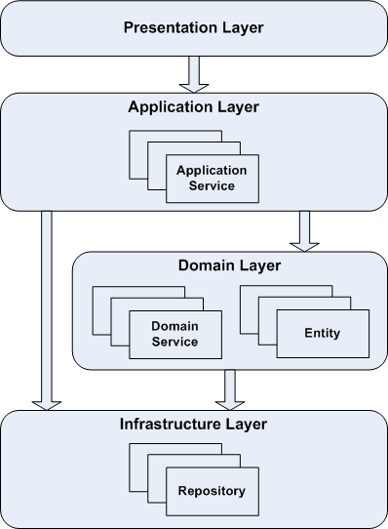
Figure 4.1 – Layered Architecture for a Single Service

4.2 Microservices Decomposition
Transitioning from an initial monolithic CRUD design, the Nozie platform is decomposed into specific, business-aligned microservices. Each service operates within its own bounded context, owning its data and responsibilities:
- Identity Service: Manages authentication, user accounts, role-based access control (RBAC), and JWT issuance.
- Customer Service: Manages customer profiles, subscription states, and viewing history.
- Movie Service: Handles the movie catalog, metadata management, search, and filtering capabilities.
- Payment Service: Manages subscription plans, checkout flows, Stripe webhook processing, and the emission of subscription events.
- Notification Service: Consumes domain events to generate and dispatch transactional notifications.
The system enforces a Database-per-Service pattern, ensuring loose coupling. Synchronous operations (queries) are routed via the API Gateway using REST, while cross-cutting side effects (e.g., subscription activation, welcome emails) are handled asynchronously via events.

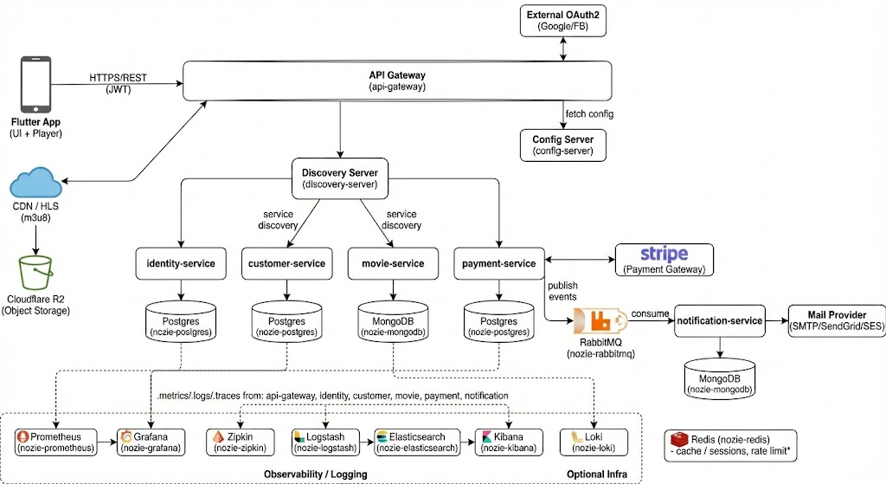
Figure 4.2 –Microservices Architecture Diagram

4.3 C4 Model (Context, Container, Component)

4.3.1 System Context Diagram (Level 1)
The Context Diagram depicts the high-level scope of the Nozie platform. It represents Nozie as a single, unified software system and defines its boundaries, interactions with human actors, and dependencies on external systems.
- Primary Actors: Customers (via the Flutter mobile app) and Administrators.
- External Integrations:
  - Stripe: For payment processing.
  - OAuth2 Providers: For social authentication (Google/Facebook).
  - Mail Provider: For sending transactional emails.
  - Cloudflare R2 / CDN / HLS: For storing and streaming media content efficiently.
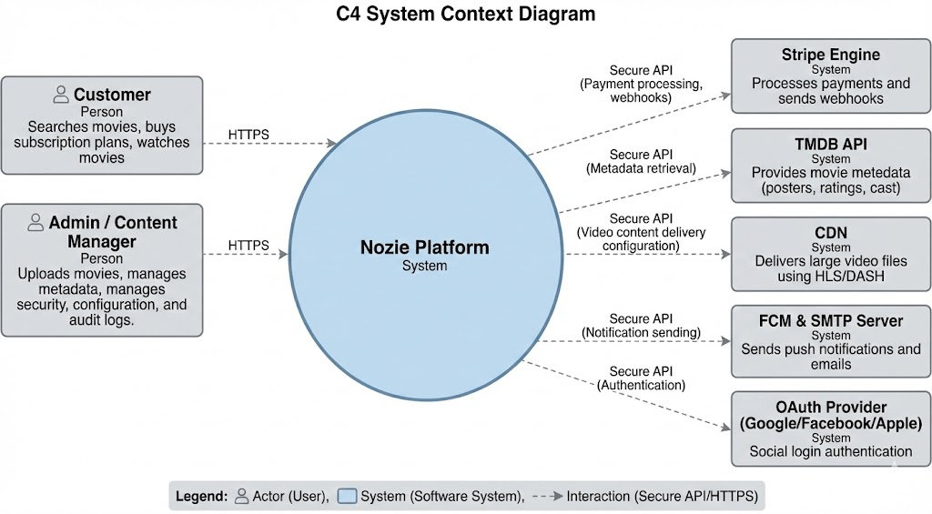
Figure 4.3.1 – System Context Diagram

4.3.2 Containers Diagram (Level 2)
The Container Diagram decomposes the system into individually deployable execution units (containers). It highlights the technology choices and the high-level responsibilities of each unit.
- Client Side: Flutter Mobile App.
- Entry Point: API Gateway (routing, security, rate limiting).
- Microservices: Identity, Customer, Movie, Payment, and Notification services.
- Data & Messaging:
  - Databases: nozie-postgres, nozie-mongodb, nozie-redis.
  - Message Broker: nozie-rabbitmq.
- Infrastructure & Observability:
  - discovery-server (Eureka) and config-server.
  - Observability Stack: nozie-prometheus & nozie-grafana (metrics), nozie-zipkin (tracing), nozie-loki (logs), and nozie-logstash/elasticsearch/kibana (centralized logging).
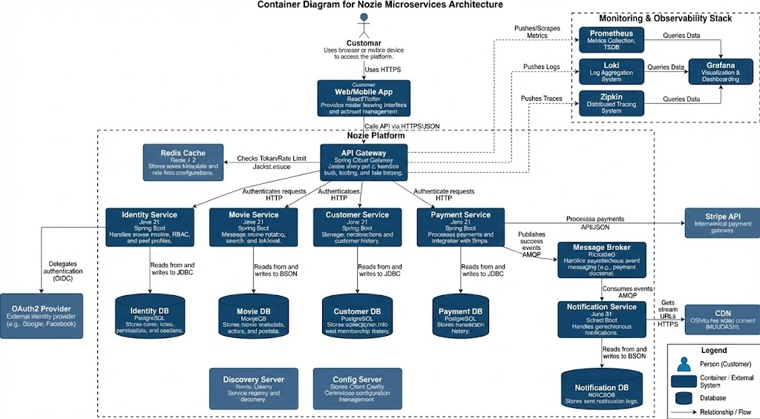
Figure 4.3.2 – Container Diagram

4.3.3 Components Diagram (Level 3)
The Component Diagram zooms into specific core services (e.g., Payment Service or Customer Service) to visualize their internal structure and separation of concerns. This view typically follows the layered architecture defined in Section 4.1.
- Components Shown: REST Controllers, Application Services, Domain Aggregates, Repository Interfaces, Messaging Adapters (Producers/Consumers), and Feign Clients.
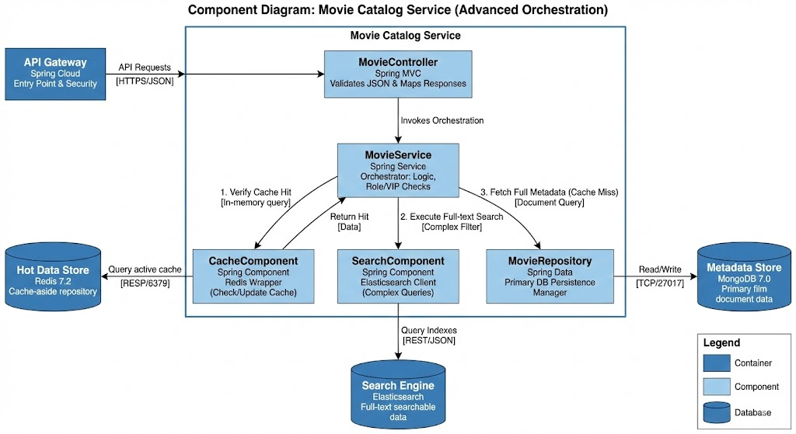
Figure 4.3.3 Components Diagram

4.3.4 Code Diagram (Level 4)
The Code View illustrates how the architectural components map to the actual implementation classes for a critical business flow. This section focuses on the "Checkout & Activate Subscription" path to demonstrate the Event-Driven Architecture in code.
- Key Flow:
  - PaymentController.checkout() receives the request.
  - PaymentApplicationService orchestrates the logic using the Subscription aggregate.
  - PaymentEventProducer uses RabbitTemplate.convertAndSend(...) to publish the event.
  - SubscriptionEventListener (in Customer Service) consumes the message via @RabbitListener.
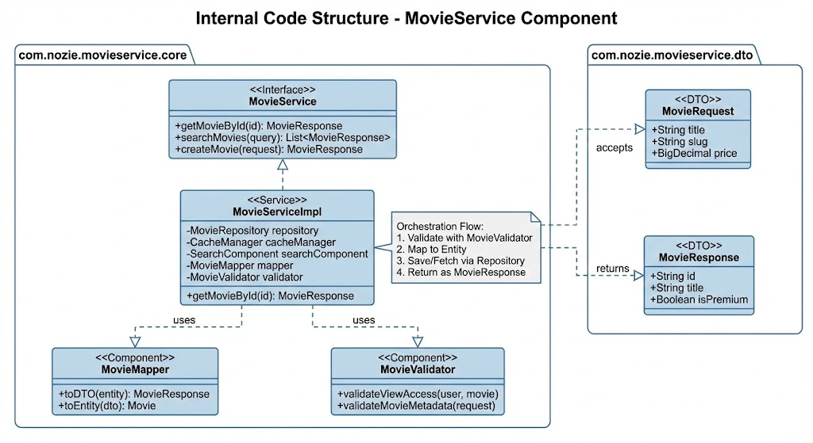
Figure 4.3.4 – Code Diagram

4.4 Event-Driven Architecture (EDA)

Event-Driven Architecture (EDA) is an architectural pattern utilized in Nozie where services communicate asynchronously by producing and consuming events via a central Message Broker, rather than relying solely on direct synchronous HTTP calls. This approach is adopted alongside the standard Request–Response (REST) model to create a Hybrid Architecture that balances immediate user feedback with backend decoupling.

4.4.1 Core Concepts
The architecture relies on three fundamental components:
- Producer: A microservice that detects a significant change in its domain (e.g., a "Payment Completed" state) and publishes an event message. The producer is unaware of any downstream consumers.
- Consumer: A microservice that subscribes to specific event types and reacts asynchronously (e.g., updating a local database or triggering an email).
- Message Broker: The middleware (RabbitMQ) responsible for receiving, persisting, and routing events. It ensures delivery even if the consumer is temporarily unavailable, decoupling the availability of the sender from the receiver.

Communication Patterns
Nozie employs a strategic mix of communication styles based on the business requirement:
Communication Style | Mechanism | Use Case
Synchronous | REST (HTTP) | Used for user-facing flows requiring immediate confirmation or data retrieval (e.g., Authentication, Catalog Browsing, Profile View). The client waits for the response.
Asynchronous | EDA (Messaging) | Used for system side-effects where the primary operation should not be blocked by secondary actions. (e.g., confirming a payment immediately while processing subscription updates and notifications in the background).

4.4.3 Architectural Benefits
The adoption of EDA provides specific quality attributes to the Nozie platform:
- Loose Coupling: Producers and Consumers depend only on the event contract and the broker, not on each other’s API endpoints or uptime.
- Non-Blocking Behavior (Performance): Critical transactional services (like Payment) can respond to the user immediately after the primary action, delegating time-consuming tasks (like email generation) to background processes.
- Resilience: The system becomes fault-tolerant. If a consumer service goes offline, the Message Broker retains the events. Once the service recovers, it consumes the backlog, ensuring Eventual Consistency.
- Scalability: Consumer services can be scaled independently based on queue depth. Furthermore, multiple distinct consumers can react to a single event (e.g., both Notification and Customer services reacting to UserRegistered).
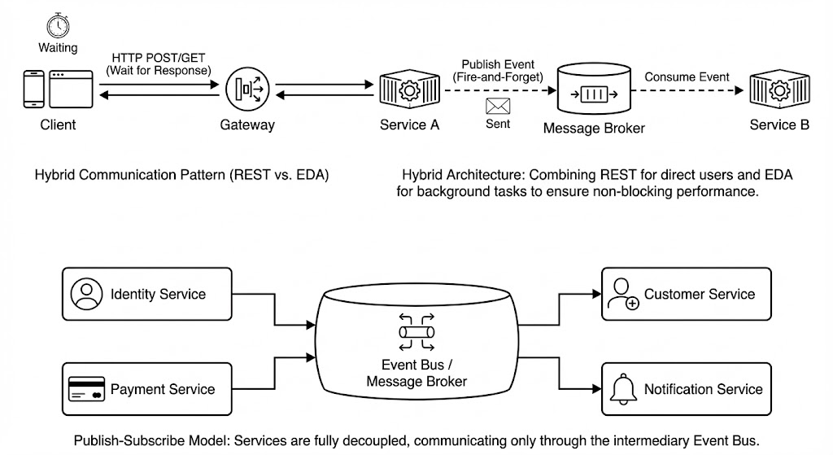

4.5 Deployment View & System Infrastructure

4.5.1 Runtime Environment
The entire backend system follows a Container-Based Architecture. All application components—including the API Gateway, business microservices, and infrastructure support—are packaged as Docker containers.
- Development: Orchestrated via Docker Compose for a unified local environment.
- Production: Designed for deployment on a container orchestration platform (e.g., Kubernetes) to manage lifecycle, networking, and scaling automatically.

4.5.2 Nodes & Infrastructure Topology
The system is logically divided into distinct tiers, each responsible for specific operational concerns:
- Client Tier:
  - Mobile/Web Apps: The client application runs on end-user devices, communicating exclusively via HTTPS with the public edge of the network.
- Gateway & Edge Tier:
  - Reverse Proxy / Load Balancer: Distributes incoming traffic to the API Gateway.
  - API Gateway: Acts as the single entry point, handling routing, security termination, and rate limiting before requests reach the internal network.
- Application Tier (Microservices Cluster):
  - Business Services: The core domain logic is hosted in a cluster of independent microservice containers. These services are stateless and register dynamically with a Service Discovery server.
  - Configuration: All services pull centralized configuration from a dedicated Config Server at startup.
- Data & Messaging Tier (Polyglot Persistence):
  - Relational Databases (PostgreSQL): Hosts structured transactional data.
  - NoSQL Databases (MongoDB): Stores unstructured data and metadata.
  - Caching (Redis): Handles session storage and high-speed caching.
  - Message Broker (RabbitMQ): Facilitates asynchronous event-driven communication between the application containers.
- Observability Tier:
  - A centralized stack dedicated to aggregating Metrics (Prometheus/Grafana), Distributed Tracing (Zipkin), and Logs (ELK Stack/Loki) from all other nodes.

4.5.3 Scalability & Availability Strategies
- Stateless Scaling: The API Gateway and all business microservices are designed to be stateless. This allows the system to scale horizontally by simply spinning up additional container instances behind the load balancer to handle increased traffic.
- Stateful Resilience: The infrastructure components (Databases and Message Broker) are treated as stateful resources. High availability is achieved through replication, clustering, and persistent storage volumes to ensure data durability in case of node failures.

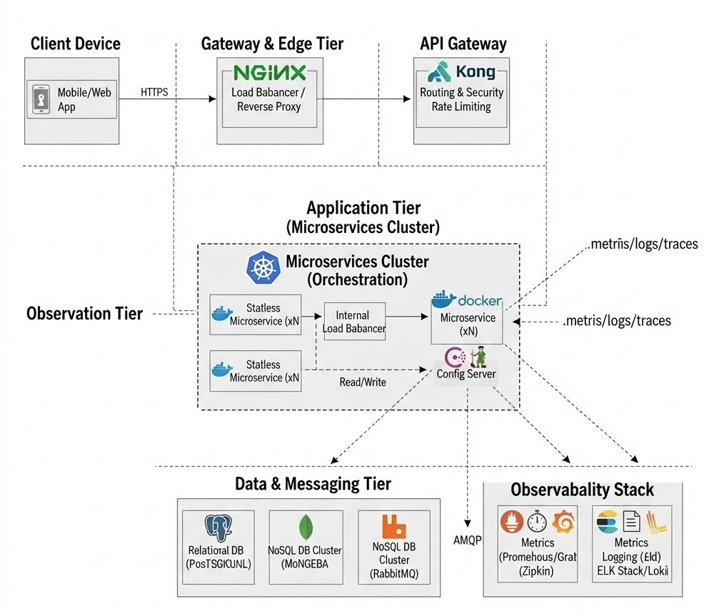
Figure 4.11 – Deployment View Diagram

5. Server Implementation
This chapter details the implementation of the backend microservices, focusing on the internal layered architecture, database isolation, API Gateway security patterns, and the event-driven integration between services.

5.1 Layered Architecture Implementation
Each microservice in Nozie adheres to a strict DDD-oriented layered architecture ensuring separation of concerns. The request flow is strictly top-down. The table below illustrates this structure using the Payment Service as the reference implementation.
Table 5.1 – Microservice Layered Structure (Payment Service Example)
Layer | Package Structure | Core Components | Responsibility
1. API | com.nozie.payment.api | SubscriptionController  SubscriptionRequestDTO  SubscriptionResponseDTO | Receives HTTP requests, performs input validation (@Valid), maps DTOs, and delegates to the Application Service. Contains no business logic.
2. Application | com.nozie.payment.application | SubscriptionApplicationService | Implements specific use cases (e.g., "Create Checkout", "Handle Webhook"). Manages transaction boundaries (@Transactional) and orchestrates Domain objects.
3. Domain | com.nozie.payment.domain | Subscription (Aggregate)  Transaction (Entity)  SubscriptionRepository (Interface) | Encapsulates core business rules (e.g., state transitions, validation logic). Pure Java code, independent of frameworks.
4. Infrastructure | com.nozie.payment.infra | JpaSubscriptionRepository  PaymentEventProducer  StripeService  CustomerClient (Feign) | Provides concrete implementations for repositories, external API clients (Stripe, Feign), and messaging adapters (RabbitMQ).

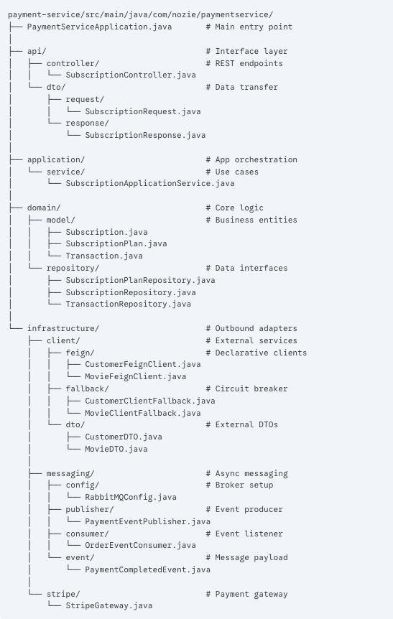

Figure 5.1 - Package Structure

5.2 Microservice & Database per Service
The Movie Service exemplifies the "Database per Service" pattern. It maintains exclusive ownership of its MongoDB instance and exposes data strictly via REST APIs.
Table 5.2 – Movie Service Key API Endpoints
HTTP Method | Endpoint Path | Description | Access Level
GET | /api/movies | List movies with pagination. Supports filters: genre, country, year. | Public
GET | /api/movies/search | Full-text search for movies using the q query parameter. | Public
GET | /api/movies/{id} | Retrieve detailed metadata for a specific movie ID. | Public
GET | /api/recommendations | Fetch personalized or trending content lists. | Public
GET | /api/movies/{id}/stream | Get the streaming URL/Manifest (requires access check). | Secured
Figure 5.3 – Movie Service Boundary
Description: A diagram showing the Movie Service encapsulating its MongoDB instance and exposing APIs via the Gateway.
Figure 5.9 – API Response Evidence
Description: A Postman screenshot demonstrating a successful GET /api/movies request and the JSON response.

5.3 API Gateway & Edge Security
The API Gateway acts as the single entry point, handling routing via Eureka Service Discovery (lb://) and enforcing security policies.
Table 5.3 – Gateway Routing Configuration
Path Pattern | Target Service ID | Resilience Configuration
/api/movies/** | lb://movie-service | Circuit Breaker → /fallback/movies
/api/customers/** | lb://customer-service | Circuit Breaker → /fallback/customers
/api/subscriptions/** | lb://payment-service | Circuit Breaker → /fallback/payments
/api/notifications/** | lb://notification-service | Circuit Breaker → /fallback/notifications
/api/auth/** | lb://identity-service | Standard Routing
Figure 5.4 – API Gateway Routing Topology
Description: A visual representation of the Client connecting to the Gateway, which distributes traffic to the 5 backend services.
Edge Security & Access Control
The Gateway implements a GlobalFilter to intercept requests. The table below defines the security rules applied by the RouteValidator.
Table 5.4 – Endpoint Security Rules
Access Category | Security Logic | Applicable Endpoints
Open / Public | RouteValidator.isSecured() returns false. Request is forwarded without token checks. | • /api/auth/login, /api/auth/register  • /api/movies/** (Catalog)  • /api/subscriptions/webhook (Stripe)  • /actuator/health
Secured | JWT Validation Required. AuthenticationFilter validates signature and expiration. | • /api/customers/**  • /api/subscriptions/subscribe  • /api/notifications/**
Admin | Role Check Required. JWT must contain ROLE_ADMIN. | • /api/admin/**
Figure 5.6 – Gateway Security Flow
Description: A flowchart showing the request lifecycle: Request → AuthenticationFilter → (Validate JWT / Check Redis Blacklist) → Forward or Return 401.

5.4 EDA with RabbitMQ: Payment ↔ Notification
The system utilizes RabbitMQ with Topic Exchanges to decouple services. The table below summarizes the key asynchronous flows implemented in the system.
Table 5.5 – Event-Driven Message Flows
Event Name | Producer (Source) | Exchange / Routing Key | Consumer (Target) | Action / Side Effect
UserRegistered | identity-service | Exchange: user.exchange  Key: user.registered | 1. customer-service  2. notification-service | 1. Create Customer profile.  2. Send "Welcome" email.
SubscriptionActivated | payment-service | Exchange: payment.exchange  Key: subscription.activated | 1. customer-service  2. notification-service | 1. Update status to VIP/PREMIUM.  2. Send "Payment Receipt" alert.
PaymentSucceeded | payment-service | Exchange: payment.exchange  Key: payment.succeeded | notification-service | (Optional) Send specific transaction log or single-purchase receipt.

4.4.1 Event Flow: User Registration
This flow demonstrates how the system handles new user onboarding asynchronously to avoid latency.
- Trigger: A user successfully registers via the Identity Service.
- Process:
  - The Identity Service persists the user credentials to PostgreSQL and immediately returns a 201 Created response to the client (Non-blocking).
  - Simultaneously, it publishes a UserRegisteredEvent (containing userId, email, username) to the user.exchange with routing key user.registered.
- Consumers:
  - Customer Service: Consumes the message to initialize a generic Customer profile.
  - Notification Service: Consumes the message to dispatch a "Welcome" email.

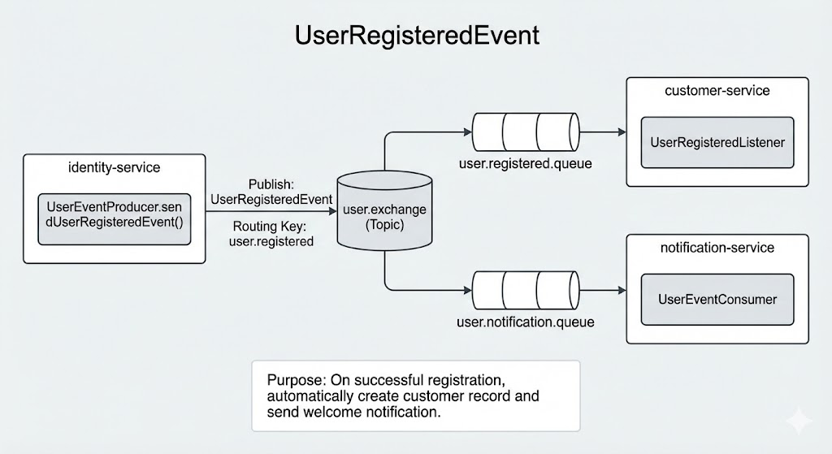
Figure 4.8 – User Registration Event

Event Flow: Subscription Activation
This flow illustrates the propagation of payment states across the system to unlock premium features (Business Logic).
- Trigger: The Payment Service receives a successful webhook callback from Stripe.
- Process:
  - The Payment Service updates the local transaction status.
  - It publishes a SubscriptionActivatedEvent (containing userId, planType, expiryDate) to the payment.exchange with routing key subscription.activated.
- Consumers:
  - Customer Service: Listeners update the user’s SubscriptionStatus (e.g., to VIP) and extend the expiryDate in the database.
  - Notification Service: Triggers a transactional "Payment Receipt" notification.
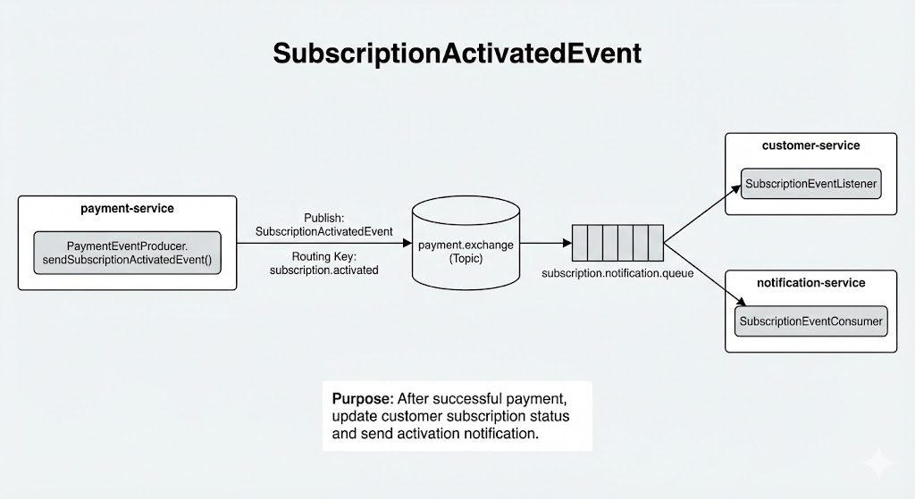
Figure 4.9 – Subscription Activation Event Flow

Event Flow: Payment Auditing (PaymentSucceededEvent)
This flow is designed for financial auditing and separation of concerns, distinct from the subscription logic.
- Trigger: A payment is successfully recorded in the Payment Service.
- Process:
  - The Payment Service publishes a PaymentSucceededEvent (containing detailed transactionId, amount, currency, timestamp) to the payment.exchange with routing key payment.succeeded.
- Consumers:
  - Reporting/Audit Service (Designed): Intended to consume this event to log financial records into a Data Lake or Analytics dashboard without polluting the operational Customer database.
  - (Note: This event allows the strict separation of "giving the user access" vs "recording the money".)
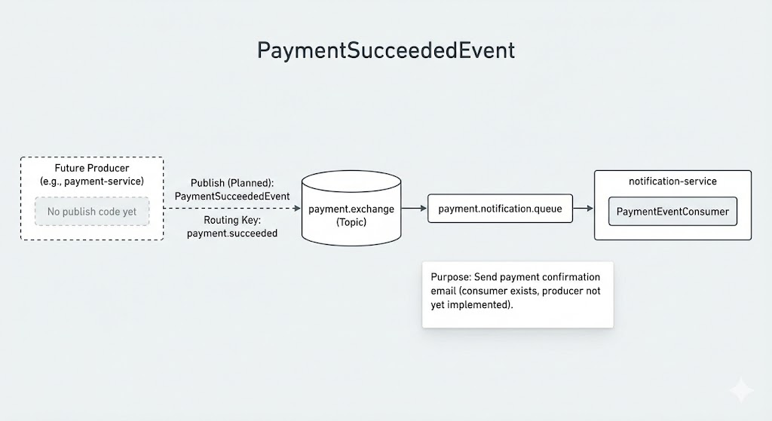
Figure 4.10 – Payment Auditing Event Flow

