# PE11 – Defining Classes

1. Define the following terms.

inheritance: The ability of a class to inherit members from a parent class.

parent/base class: The class being inherited from.

child/derived class: The class that inherits members from the parent class.

1. What is wrong with the following code?

public sealed class MyClass

{

// class members

}

public class myDerivedClass : MyClass

{

// class members

}

MyClass is sealed so myDerivedClass cannot derive from it.

1. How would you define a non-creatable class?

You could define a non-creatable class by defining all of its constructors as private.

1. Why are non-creatable classes still useful? How do we make use of their capabilities? Give an example of a non-creatable class that we have used.

The static members of non-creatable classes can be useful. Internal public functions can be used to access the private constructors if need be. The Math class in an example of this.

1. Write code in a class library project (.NET .DLL) called Vehicles that implements the Vehicle family of objects as outlined below (_424DoubleBogey as the class identifier). There are nine objects and two interfaces (IPassengerCarrier and IHeavyLoadCarrier) that require implementation. The virtual method should be an empty function:

public virtual void LoadPassenger() { }

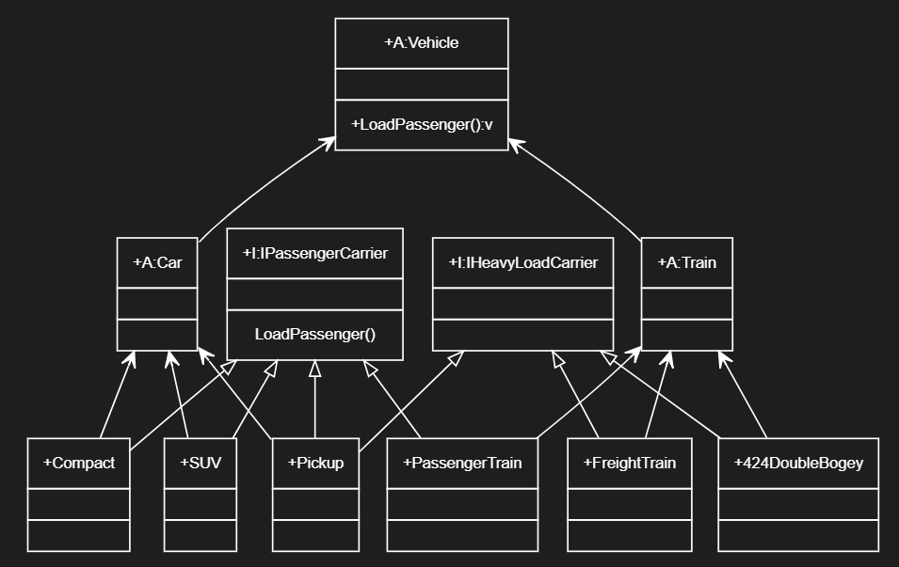

GitHub URL: <https://github.com/ndw1117/myIGME-201/tree/main/Vehicles>

1. Create a console application project, Traffic, which references Vehicles.dll (created in Q5 above). Include a function called AddPassenger() that accepts any object with the IPassengerCarrier interface. Within the AddPassenger() function, call the LoadPassenger() method using a reference to the interface. Also add a line to call the ToString() method inherited from System.Object  (ie. if vehicleObject is passed to the function, call Console.WriteLine(vehicleObject.ToString()). Also try passing an object that did not inherit the IPassengerCarrier interface and see what happens.

GitHub URL: <https://github.com/ndw1117/myIGME-201/tree/main/Vehicles>

## Submission

Upload this completed document and GutHub URL's for #5 and #6 to the corresponding MyCourses dropbox.