NexusFinance
Full-Stack Fintech Lending Platform

Project Overview Report | June 2026
Built for Cambodia | NDX Digital Support

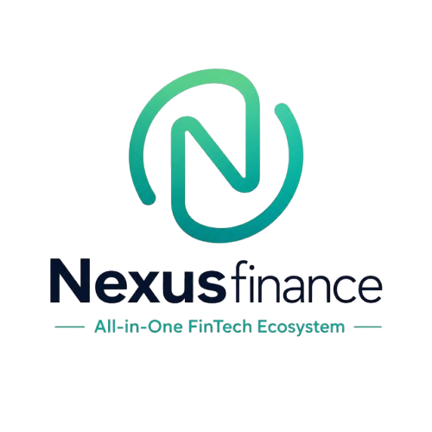

Table of Contents
1. Executive Summary
2. Architecture Overview
3. Technology Stack
4. Features — Customer Portal
5. Features — Loan Officer Portal
6. Features — Super Admin Portal
7. API Endpoints Reference
8. Database Schema
9. Security & Authentication
10. Deployment & Infrastructure
11. Key Decisions & Rationale
12. Assets Delivered

1. Executive Summary
NexusFinance is a full-stack fintech lending platform designed for microfinance operations in Cambodia. It handles the complete lending lifecycle — from customer loan applications through officer review to admin oversight — with real-time KYC video verification and KHQR payment integration compatible with the National Bank of Cambodia (Bakong) standard.

Project Scope
- Three role-based portals: Customer, Loan Officer, Super Admin
- Full loan lifecycle management: application → review → approval → disbursement → repayment
- Real-time KYC video verification for compliance
- KHQR / Bakong payment integration (EMVCo QR standard) — NOT CURRENTLY ACTIVE
- SMS (Twilio) and email notifications
- Telegram bot alerts for administrators
- Dark mode support across all interfaces
- Bilingual support (English / Khmer)

Live Deployments
Service | URL | Platform
Frontend | nexusfinancefintech.vercel.app | Vercel
Backend API | nexusfinance-5okf.onrender.com | Render (Docker)
Database | Supabase Cloud | PostgreSQL
Auth | Appwrite Cloud + Google OAuth | Cloud

2. Architecture Overview
NexusFinance follows a classic three-tier architecture with clear separation of concerns. The React SPA communicates with the Express.js API via fetch() with JWT bearer tokens. The backend connects to Supabase (PostgreSQL) for data persistence and orchestrates external integrations for payments, SMS, email, and notifications.
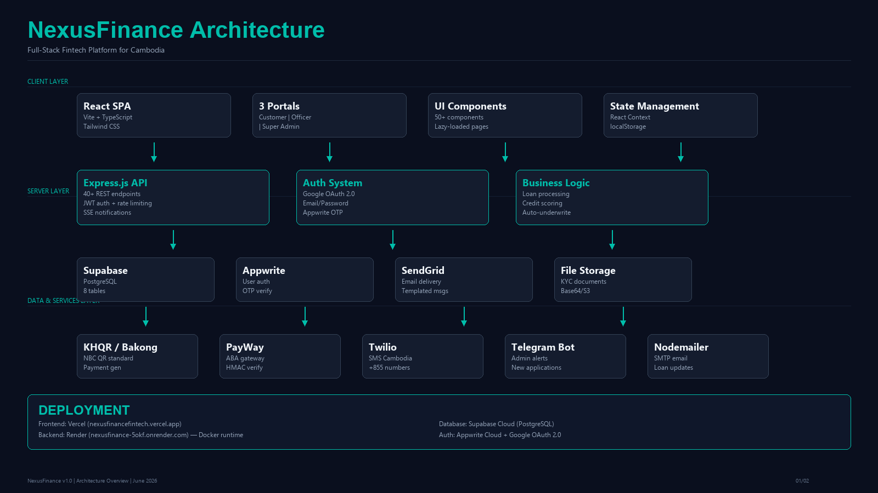

Data Flow
1. Client sends request with JWT token → 2. Express middleware validates token and rate-limits → 3. Route handler processes business logic → 4. Supabase client executes PostgreSQL query → 5. Response returned to client → 6. SSE stream pushes real-time notifications to connected clients.

3. Technology Stack
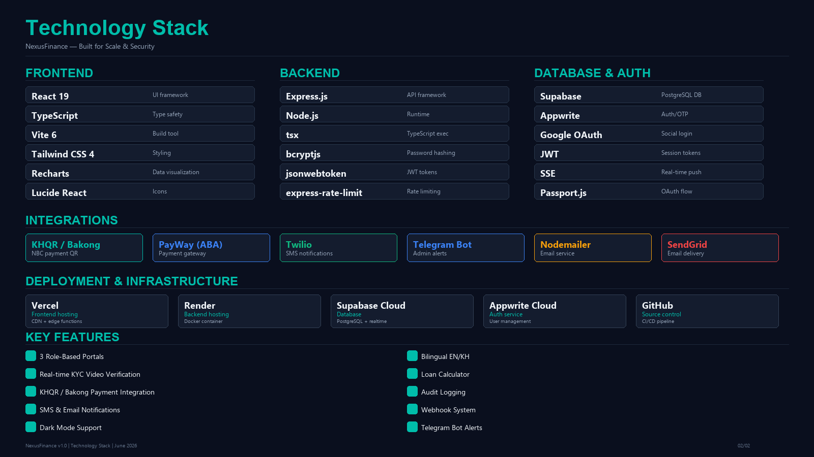

Frontend
Technology | Version | Purpose
React | 19.x | UI framework with lazy-loaded components
TypeScript | 5.8 | End-to-end type safety
Vite | 6.x | Build tool and dev server
Tailwind CSS | 4.x | Utility-first styling with design tokens
Recharts | 3.x | Dashboard charts and data visualization
Lucide React | 0.546 | Icon library

Backend
Technology | Version | Purpose
Express.js | 4.21 | REST API framework
Node.js | 22.x | JavaScript runtime
tsx | 4.21 | TypeScript execution
bcryptjs | 3.0 | Password hashing
jsonwebtoken | 9.0 | JWT token generation/verification
express-rate-limit | 8.5 | API rate limiting (20 req/15min on auth)

4. Features — Customer Portal
The customer portal provides a self-service interface for borrowers to apply for loans, track their portfolio, make payments, and manage their account.

Dashboard
- Balance overview cards (wallet balance, outstanding balance)
- Fast Cash disbursement quick action
- Quick action buttons: Apply Loan, Repay
- Recent activity feed with transaction history

Loan Management
- Multi-step loan application form (amount, type, purpose, credit score, income, duration)
- Loans ledger with pagination and CSV export
- Application status tracking (pending → approved → disbursed)
- Loan calculator with amortization schedule

Payments
- KHQR (Bakong) QR code generation for payments — currently not available
- PayWay (ABA) payment gateway integration — currently not available
- Transaction history with filtering and CSV download
- Repayment modal with amount input and payment method selection

KYC & Profile
- Document upload/management page (base64 stored in Supabase)
- Profile management: edit name, email, phone
- Password change via Appwrite OTP

5. Features — Loan Officer Portal
The loan officer portal provides tools for reviewing applications, conducting KYC verification, and managing the loan pipeline.

Dashboard
- Loan pipeline bar chart (Recharts) showing application volumes
- Urgency carousel for time-sensitive applications
- Pending tasks and upcoming meetings list

Loan Management
- Loan application table with select-all functionality
- Batch actions: approve, reject, hold
- Priority filtering and search
- Detailed application view with approve/reject/hold actions

KYC Verification
- Live meeting modal for video KYC verification
- Simulated video call UI (mic/video/screen toggle)
- KYC checklist with compliance task completion
- Auto-advance loan status on KYC completion

Webhooks
- Register webhook URLs for loan events (created, approved, rejected)
- Webhook management UI

6. Features — Super Admin Portal
The super admin portal provides platform-wide oversight, configuration, and user management.

Dashboard
- Platform-wide metrics: total volume, active customers, outstanding balance, interest earned
- Platform settings: interest rate, max loan amount, KYC toggle, auto-approve limit

User Management
- List all users with role information
- Change user roles (customer, officer, admin)
- Admin password reset
- Send password reset emails
- Create new users

Audit & Compliance
- Full audit log with timestamped entries
- Paginated audit log viewer
- Compliance tasks list with "Join Meeting" action

Platform Configuration
- Interest rate configuration
- Maximum loan amount setting
- KYC verification toggle
- Auto-approve threshold

7. API Endpoints Reference
All endpoints are prefixed with /api. Authentication uses JWT Bearer tokens.

Authentication (rate-limited: 20 req/15min)
Method | Endpoint | Description
POST | /api/auth/login | Email+password login, returns JWT
POST | /api/auth/register | Create new account (bcrypt hashed)
POST | /api/auth/session | Appwrite/Google OAuth session exchange
POST | /api/auth/verify-email | Verify email via Appwrite admin API
POST | /api/auth/forgot-password | Send password reset email
POST | /api/auth/update-password | OTP-verified password reset
PATCH | /api/auth/password | Authenticated password change
GET | /api/auth/me | Get current user profile
PATCH | /api/auth/profile | Update name/email/phone
GET | /api/auth/google | Redirect to Google consent screen
GET | /api/auth/google/callback | Handle OAuth callback, return JWT

Loans
Method | Endpoint | Description
GET | /api/loans | List loans (customers see own, others see all)
POST | /api/loans | Apply for loan (creates compliance task)
PATCH | /api/loans/:id/approve | Approve loan + disbursement + email/SMS
PATCH | /api/loans/:id/reject | Reject loan + email notification
PATCH | /api/loans/:id/hold | Put loan on hold

Transactions
Method | Endpoint | Description
GET | /api/transactions | List user transactions
POST | /api/transactions/repay | Record a repayment
POST | /api/transactions/disburse | Record a disbursement

KHQR / Payments (currently not available)
Method | Endpoint | Description
GET | /api/khqr/generate | Generate KHQR code via Bakong API — NOT CURRENTLY ACTIVE
GET | /api/khqr/verify | Verify KHQR string — NOT CURRENTLY ACTIVE
GET | /api/khqr/decode | Decode KHQR data — NOT CURRENTLY ACTIVE
GET | /api/khqr/deeplink | Generate Bakong app deeplink — NOT CURRENTLY ACTIVE
POST | /api/payway/generate-qr | Generate PayWay QR (Bakong fallback) — NOT CURRENTLY ACTIVE
POST | /api/payway/verify-payment | Check PayWay transaction status — NOT CURRENTLY ACTIVE
POST | /api/payway/callback | PayWay webhook callback (HMAC verified) — NOT CURRENTLY ACTIVE

Admin & System
Method | Endpoint | Description
GET | /api/users | List all users (super admin)
PATCH | /api/users/:id/role | Change user role
GET | /api/config | Get platform config
PATCH | /api/config | Update platform config (super admin)
GET | /api/stats | Compute platform stats
GET | /api/audit/logs | Get audit log entries (super admin)
GET | /api/notifications/stream | SSE real-time notifications
GET | /api/health | Health check endpoint

8. Database Schema
NexusFinance uses Supabase (PostgreSQL) with the following core tables:
Table | Purpose | Key Fields
nexus_users | User accounts & roles | id, email, name, role, password_hash, phone
nexus_loans | Loan applications | id, user_id, amount, type, status, credit_score
nexus_transactions | Payment transactions (KHQR/PayWay endpoints not active) | id, loan_id, user_id, amount, type, method
nexus_tasks | Compliance/KYC tasks | id, loan_id, type, status, assigned_to
nexus_config | Platform settings | interest_rate, max_loan, kyc_required, auto_approve_limit
nexus_notifications | User notifications | id, user_id, title, read, created_at
nexus_audit_logs | Audit trail | id, user_id, action, details, timestamp
nexus_documents | KYC documents | id, user_id, name, type, data (base64)

9. Security & Authentication

Authentication Flow
- Google OAuth 2.0 for social login (via Passport.js)
- Email/password login with bcrypt-hashed passwords
- JWT tokens with expiry (stored in localStorage)
- Appwrite integration for OTP-based password reset
- Auto-logout on 401/403 responses

API Security
- Rate limiting: 20 requests per 15 minutes on auth endpoints
- JWT middleware validates all /api/* routes (except /auth/*)
- CORS configured for frontend origin
- HMAC-SHA512 verification on PayWay webhooks (when active)

Data Security
- Service role key for Supabase (not exposed to frontend)
- Environment variables for all secrets (not in code)
- Password hashing with bcrypt (12 rounds)
- KYC documents stored as base64 in Supabase (encrypted at rest)

10. Deployment & Infrastructure

Frontend — Vercel
- Connected to GitHub repo: ndxdigitalsupport/nexusfinance
- Auto-deploys on push to main branch
- Vite build output served from CDN
- Vercel rewrites proxy /api/* to Render backend

Backend — Render
- Docker-based deployment (Dockerfile in project root)
- Runtime: Node.js with tsx for TypeScript execution
- Health check: GET /api/health
- Port: 3001 (configured via PORT env var)
- Manual deploy required after environment variable changes

Database — Supabase
- PostgreSQL database hosted on Supabase Cloud
- 8 tables with Row Level Security
- Real-time subscriptions for live updates
- Service role key for backend access

Auth — Appwrite
- User management and OTP verification
- Cloud-hosted at sgp.cloud.appwrite.io
- Integrated with Google OAuth 2.0

11. Key Decisions & Rationale

Supabase over raw PostgreSQL
Supabase provides instant API generation, real-time subscriptions, row-level security, and a managed dashboard — reducing backend boilerplate while maintaining full SQL access.

KHQR / Bakong Integration (Currently Not Active)
The National Bank of Cambodia's Bakong system is the standard for QR payments in Cambodia. KHQR (EMVCo compatible) is designed to work with all major Cambodian banks and mobile wallets (ABA, Wing, ACLEDA, etc.). NOTE: This integration is currently not active — the backend endpoints exist but the external API credentials are not configured. Payment functionality is placeholder only.

React with lazy-loading
All page-level components are lazy-loaded to minimize initial bundle size. The three-portal design means customers only download code relevant to their role.

Docker on Render
Docker ensures consistent builds between development and production. Render's managed environment handles scaling and health monitoring.

SSE for real-time notifications
Server-Sent Events provide lightweight real-time push without the complexity of WebSockets. Used for new application alerts and notification delivery.

Appwrite for OTP
Appwrite handles password reset flows and OTP verification, reducing the complexity of building a custom OTP system with SMS delivery.

12. Assets Delivered
Asset | File | Description
Architecture Diagram | architecture.png | Full system architecture with data flow
Tech Stack Visual | tech-stack.png | Technology stack and integrations overview
Brand Logo | src/logo.png | NexusFinance brand logo
Auth Page | auth-page.png | Login/register page screenshot
Project Report | this document | Comprehensive project overview
Source Code | GitHub repo | Full React + Express codebase

— End of Report —

