NexusFinance
Landing Page Project

Project Overview Report | June 2026
Prepared for: Management Review

Table of Contents
1. Project Overview
2. Design System
3. Page Sections
4. Key Features & Functionality
5. Technical Implementation
6. Key Decisions & Rationale
7. Assets Delivered

1. Project Overview

Background
NexusFinance is a financial technology brand focused on providing secure, smart, and seamless financial services. The project involved designing and building a premium landing page that communicates trust, innovation, and cutting-edge technology to prospective clients and partners.

Objectives
- Create a visually compelling landing page that reflects the NexusFinance brand identity
- Implement a fully responsive design with dark and light mode support
- Ensure bilingual support (English / Khmer) for Cambodian market
- Deliver a WordPress-compatible template for easy content management
- Achieve high accessibility and performance standards

Brand Identity
Brand Personality: Secure, Modern, Cutting-edge
Creative Concept: "The Glass Ledger" — transparency meets precision
Primary Color: Neon Teal (#00BDAA) — symbolizes clarity, innovation, and trust
Design Philosophy: Layered depth, purposeful motion, bilingual accessibility

Brand Logo:


2. Design System

Design Tokens
A comprehensive design token system was established to ensure visual consistency across all components. The system defines colors, typography, spacing, and elevation rules for both dark and light themes.
Color Palette:
Dark Theme: Background (#0F172A), Surface (#1E293B), Text (#F1F5F9), Primary (#00BDAA), Accent Green (#10B981), Accent Blue (#3B82F6)
Light Theme: Background (#F8FAFC), Surface (#FFFFFF), Text (#0F172A), Primary (#00BDAA), Accent Green (#059669), Accent Blue (#2563EB)
Typography:
Primary Font: Inter (300-700 weight range) for headings and body text
Khmer Font: Noto Sans Khmer (300-900) for Khmer language support
Monospace: JetBrains Mono for technical data
Design Token Sheet:
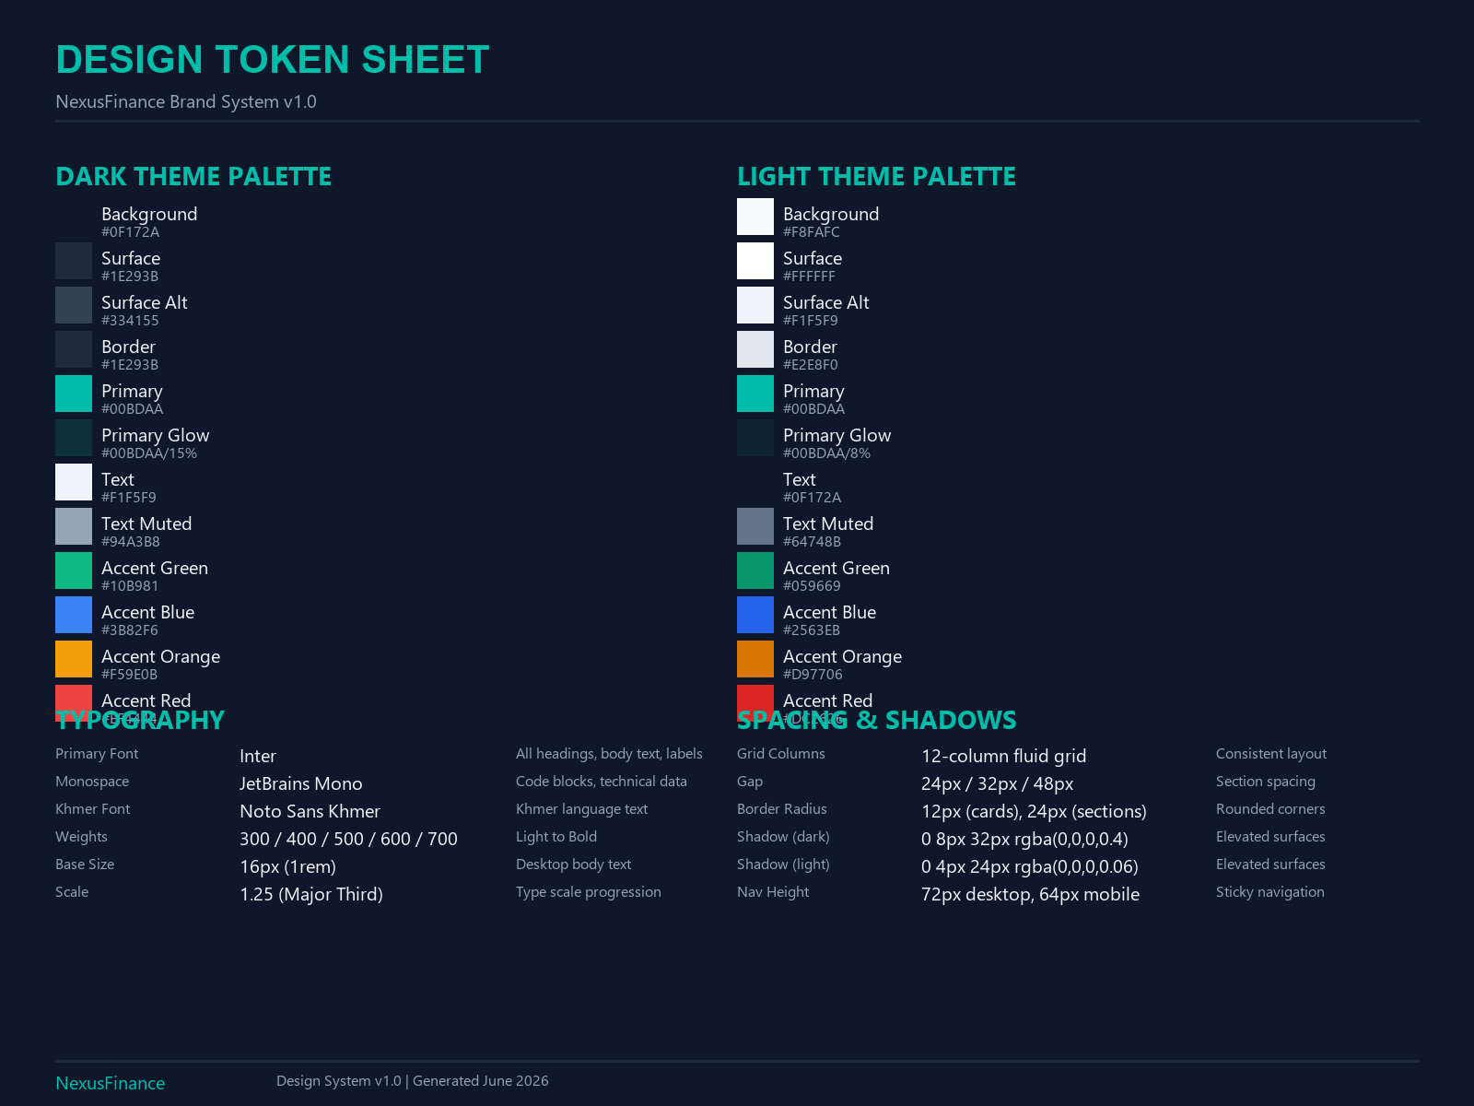

3. Page Sections

Hero Section
The hero section features a bold headline with gradient-style typography, a prominent call-to-action button, and supporting subtitle text. A grain texture overlay adds premium tactile depth. The section includes entrance animations for a polished first impression.
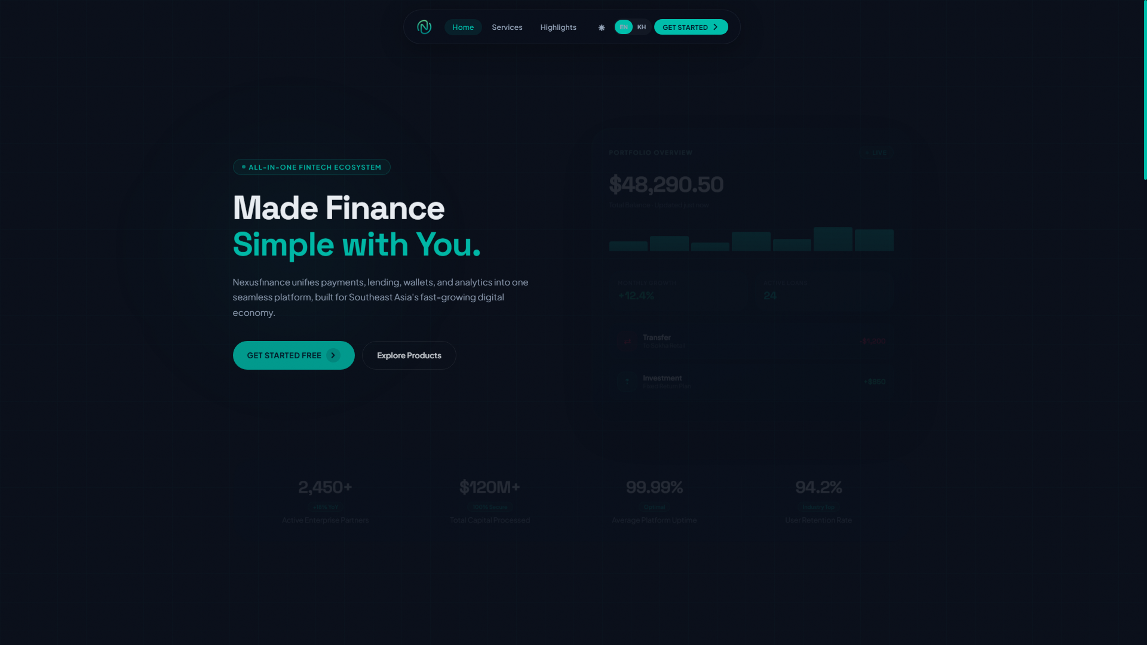

Services Section
A clean 3-column grid layout presents the three core service offerings. Each card features a mouse-tracking radial spotlight hover effect and smooth scale transition. Cards are arranged in equal columns for organized presentation (3-col desktop, 2-col tablet, 1-col mobile).
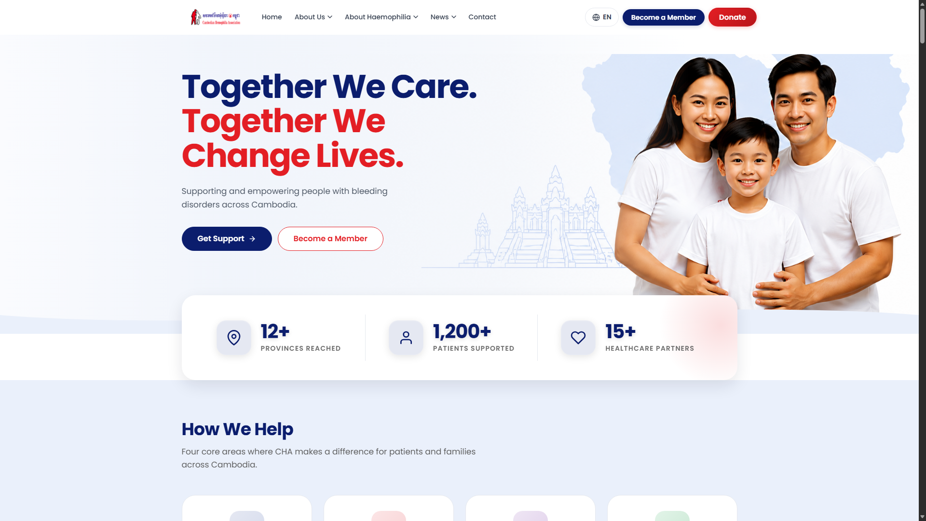

Navigation & Footer
The sticky navigation bar uses a glass-morphism effect (frosted glass) with theme-aware transparency. A theme toggle button switches between dark and light modes. The footer includes logo, navigation links, social media links, and contact information with a premium teal gradient divider above it.

4. Key Features & Functionality
Dark/Light Mode Toggle
Persistent theme switching via localStorage with smooth transitions across all elements
Bilingual EN/KH
Full Khmer language support using Noto Sans Khmer font with data-i18n translation system
Responsive Design
Fluid layout adapting from 1200px+ desktop down to 360px mobile with hamburger menu
Loading Animations
Staggered fade-in entrance animations on hero elements (0.15s-0.5s delays)
Card Hover Effects
Mouse-tracking radial spotlight on service cards, scale lift on pillar cards
Grain Texture
Fixed-position CSS noise overlay for premium tactile feel on dark backgrounds
Accessibility
Focus-visible outlines, 44px minimum touch targets, reduced-motion media query, semantic ARIA

5. Technical Implementation

File Structure
wordpress/index.html — Standalone landing page for local preview
wordpress/template-nexusfinance.php — WordPress page template with wp_head()/wp_footer()
wordpress/logo nexus finance.png — Brand logo (512x512px)

WordPress Integration
The WordPress template (template-nexusfinance.php) is fully self-contained with embedded CSS and JavaScript. It uses the standard WordPress template header with "Template Name: NexusFinance Landing" for theme assignment. The template calls wp_head() and wp_footer() for plugin compatibility while maintaining full visual control independent of the active theme.
Deployment Steps:
- Upload template-nexusfinance.php to /wp-content/themes/your-theme/
- Upload logo nexus finance.png to the same theme folder
- In WordPress Admin > Pages, create a new page
- Select "NexusFinance Landing" as the page template
- Publish and verify both dark/light modes and language toggle

Impeccable Design Audit
The project used the Impeccable CLI design tool for automated quality auditing. Initial audit score: 15/20. All P1-P3 issues were resolved resulting in an estimated score of ~17/20 after fixes including: gradient text accessibility, reduced-motion media queries, focus-visible outlines, ARIA attributes, and mobile touch target sizing.

6. Key Decisions & Rationale
Khmer Font: Noto Sans Khmer over Kantumruy Pro
Noto Sans Khmer offers a wider weight range (300-900 vs 300-700), cleaner rendering at smaller sizes, and better Unicode coverage for Khmer typography. This ensures consistent quality across both languages.
Services Layout: 3-column grid over asymmetric bento
The uniform grid provides cleaner visual organization and easier scannability for service offerings. The asymmetric bento grid tested well for visual interest but was less effective for conveying equal-value services.
WordPress Template over HTML paste
WordPress strips style and script tags from post/page content. A dedicated PHP template bypasses this limitation entirely while maintaining full control over the frontend output and plugin compatibility via wp_head/wp_footer.
Grain Overlay Texture
Adds a premium print-like tactile quality to the dark background. The effect is subtle (low opacity) and respects prefers-reduced-motion.
Mouse-tracking Spotlight on Cards
Creates an engaging interactive experience without being distracting. Uses CSS custom properties and JavaScript for performant radial gradient positioning.

រួមគ្នាកាន់តែរឹងមាំ ថែទាំកាន់តែប្រសើរសម្រាប់ទាំងអស់គ្នា7. Assets Delivered
The following assets have been produced and are available in the project directory:
Asset | File | Description
Landing Page | index.html | Standalone HTML preview file
WP Template | template-nexusfinance.php | WordPress-ready page template
Brand Logo | logo nexus finance.png | 512x512px brand logo
Hero Screenshot | screenshot-hero.png | Full-viewport hero capture
Services Screenshot | screenshot-services.png | Services section capture
Design Tokens | design-tokens.png | Visual design token reference sheet
Project Report | this document | Project overview Word document

— End of Report —

