Game Design Document

Fractured Path

Game Overview
Title: Fractured Path
Genre: Platformer, Puzzle, Adventure
Target Audience: Fans of platformers, puzzle games, and surreal/dreamlike experiences
Platform: PC
Engine: Unity (C#)

Concept & Vision
Summary: Fractured Path is a surreal, atmospheric platformer-style game where players navigate a shifting dreamscape filled with disappearing platforms, illusions, and reality-warping mechanics. The player’s goal is to traverse unstable environments, solve environmental puzzles, and uncover fragments of a mysterious story.

Core Gameplay Loop:
- Enter a fragmented dream world.
- Navigate disappearing and shifting platforms.
- Solve puzzles that seem to manipulate the player's reality.
- Reach the end of each level to begin to break out of the dream.

Gameplay & Mechanics
Core Mechanics:
- Shifting Platforms: Some platforms disappear or move after being stepped on, requiring the player to adapt and learn the timing of the level.
- **Illusions & Reality Shifts: Objects may appear to vanish based on the character's perspective or movement.
- **Gravity manipulation: Certain zones may alter gravity, flipping the player’s movement.
- Light & shadow interactions: Some pathways are only visible or accessible based on specific lighting conditions.
- **Dream Stability Meter: As the character moves through the level further the dream becomes more unstable as they get closer to breaking out of the dreamscape. This causes reality to feel more and more unstable as the game is continually played.
Level Design:
For the level design of this game, there are 4 different trials that the character must overcome.

- The Forsaken Bridge - this is an area with platforms that move irrationally, as the character moves through this area, they are required to jump from platform to platform. Attempting to stay alive and not drop into the abyss below, they are required to memorize the pattern of which platforms are safe and how other platforms move.
- The Endless Path - the player enters into a reality-shifting maze that tries to keep them trapped forever. To conquer this trial, the player must find a key in the first half of the maze to unlock the second half of the maze. Be careful though, the constantly changing maze walls can quickly turn the player around as it tries to make you its first victim. Go slow and take time to notice which walls move and you will quickly make your way through.
- The Perspective Tower - the player emerges from the maze to see a large tower looming in front of them, they can see that there is a portal at the top of the tower and they are required to climb it. In order to climb it, they must navigate gravity shifts, platform rotations, and stairs that occasionally attempt to throw them off. At the top of the tower they find the portal they saw before that invites them to progress further.
- The Dream-Scape Islands - the player finds themselves looking out into the dreamscape at a plethora of fractured reality islands that float in the void. Depending on the lighting and the movement of the player, they are offered different paths that they can take from island to island. One must be careful though to identify which are illusions and which are reality.
- The player breaks out of the dream scape!

Number of Scenes:
Based on the level design. There will be a total of 4 scenes.
- The Forsaken Bridge
- The Endless Path
- The Perspective Tower
- The Dream-Scape Islands

Design Style:
Visual Style:
- Minimalistic, base offered Unity texture packs, beginner-style animation and character creation.
- Attempts at creating a surreal environmental aspect.

Audio:
- Ambient sound using free music to enhance immersion
- **Dynamic sound effects to indicate reality shifts 3.) Subtle cues for hidden pathways and reality shifts.

Scene Layout:

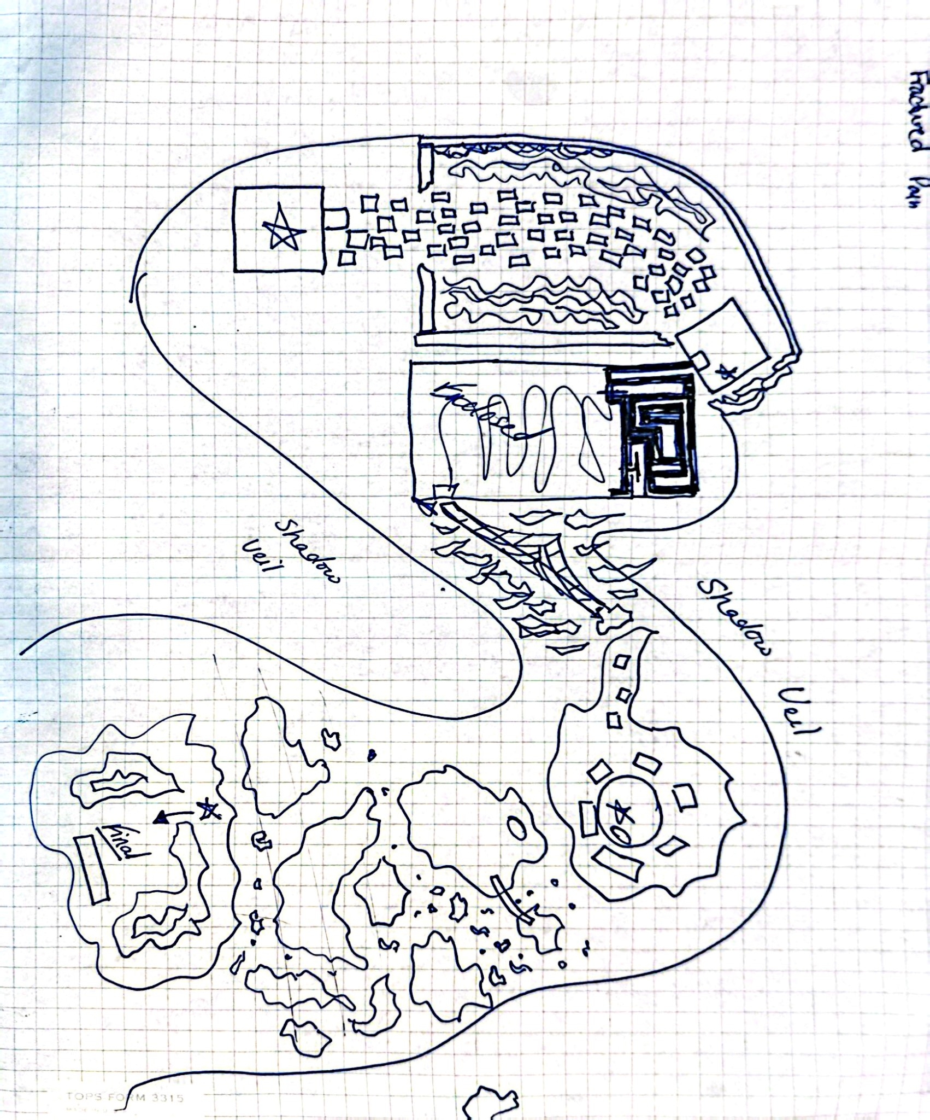

Maze Layout:
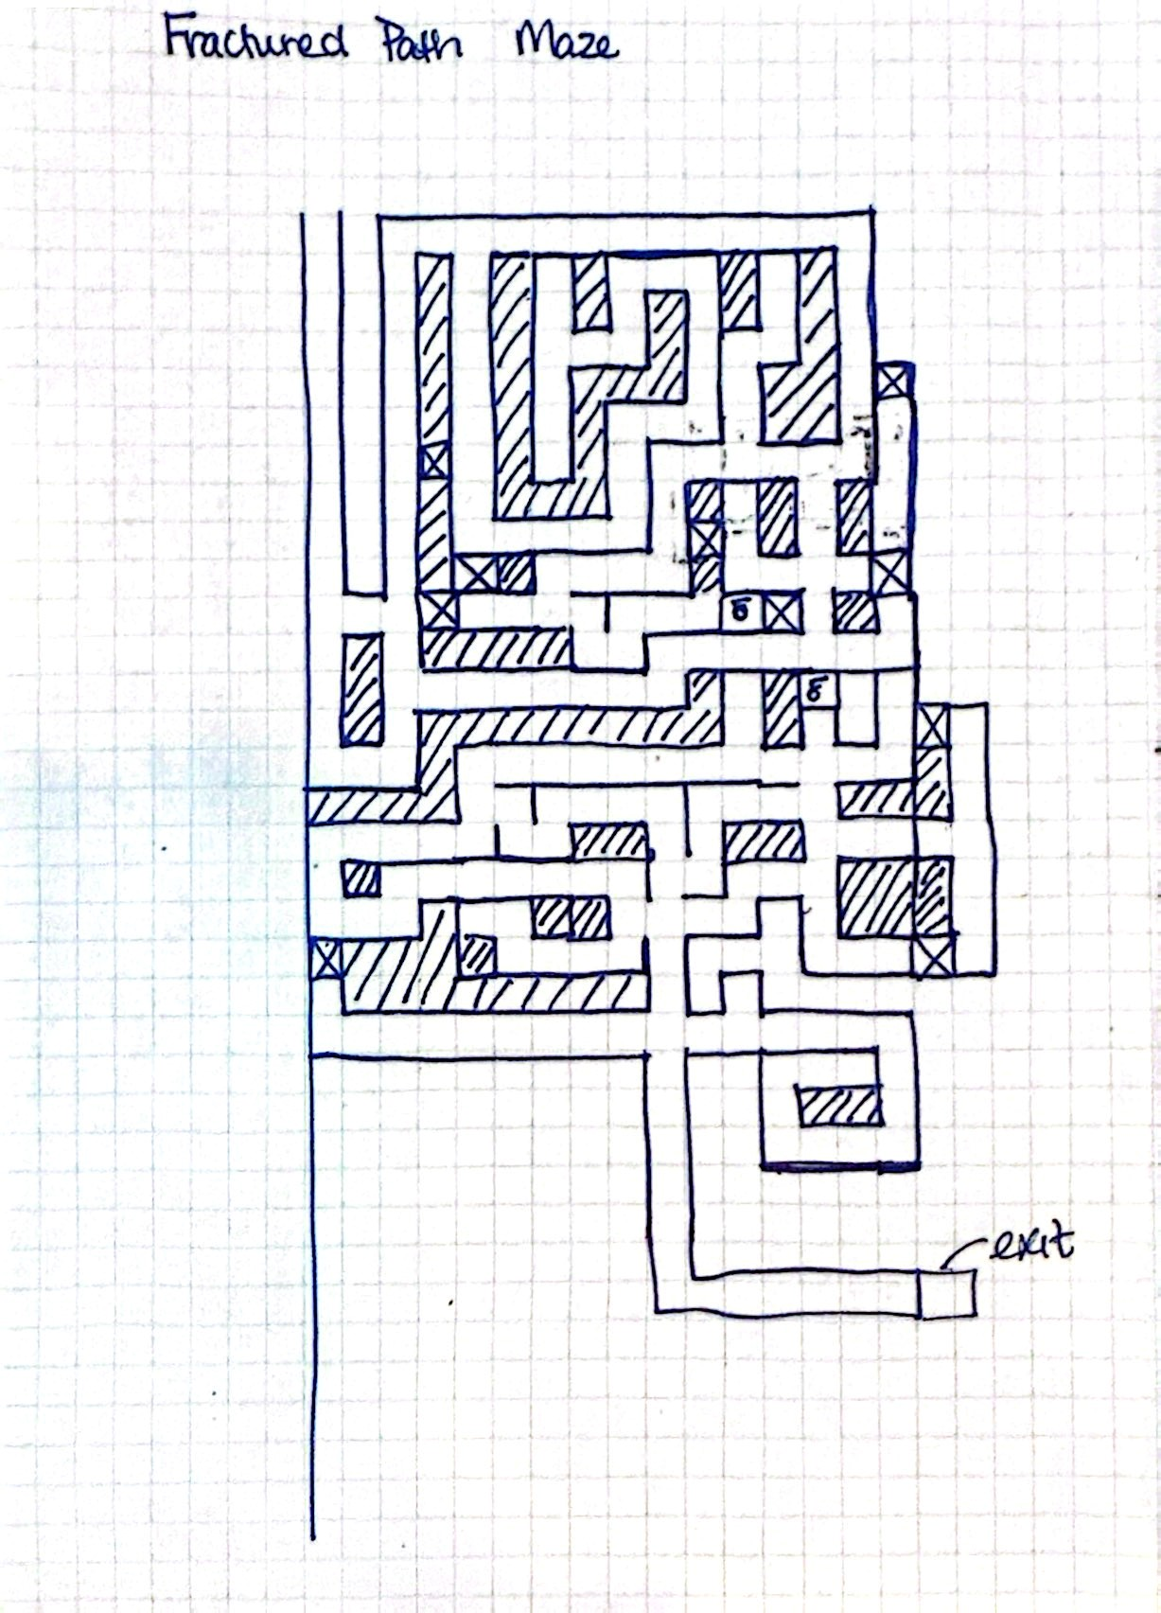

Note To Instructor and Developers:

**The core idea of this game is to create a puzzle-style game and is originally designed for a beginner level C# course. This however, regardless of the initial creativity, due to the beginner level Unity skills may limit the amount of game that can be created. Therefore, this entire project may not be able to be completed as originally hoped. It is with optimism and excitement that I begin this project, but it may be cut into smaller segments to allow a project to be turned in.
There are a lot of ideas that I came up with when I started to think about what would be super fun for this project. I ended up needing to stick with a less complicated game design and level due to the amount of time that could be allocated to this project – yet, even with the amount of time spent on this project, I was able to accomplish a lot and made it as immersive and playable as possible!

This has been a wonderful class and I have thoroughly enjoyed myself! I look forward to potentially developing the game more in my spare time! - Nathan Dykema

