tuf15@backbox:~$ open https://docs.docker.com/get-started/
tuf15@backbox:~$ cd your-project
tuf15@backbox:~/your-project$ mkdir lab08
tuf15@backbox:~/your-project$ cd lab08
tuf15@backbox:~/your-project/lab08$ git clone https://github.com/docker/getting-started.git
Клонирование в «getting-started»...
remote: Enumerating objects: 957, done.
remote: Total 957 (delta 0), reused 0 (delta 0), pack-reused 957
Получение объектов: 100% (957/957), 5.21 МиБ | 774.00 КиБ/с, готово.
Определение изменений: 100% (512/512), готово.
tuf15@backbox:~/your-project/lab08$ ls -
ls: невозможно получить доступ к '-': Нет такого файла или каталога
tuf15@backbox:~/your-project/lab08$ ls getting-started
app docker-compose.yml docs mkdocs.yml requirements.txt
build.sh Dockerfile LICENSE README.md
tuf15@backbox:~/your-project/lab08$ ls getting-started/app
package.json spec src yarn.lock
tuf15@backbox:~/your-project/lab08$ cd getting-started/app
tuf15@backbox:~/your-project/lab08/getting-started/app$ cat Dockerfile
cat: Dockerfile: Нет такого файла или каталога
tuf15@backbox:~/your-project/lab08/getting-started/app$ cat > Dockerfile
# syntax=docker/dockerfile:1

FROM node:18-alpine
WORKDIR /app
COPY . .
RUN yarn install --production
CMD ["node", "src/index.js"]
EXPOSE 3000

tuf15@backbox:~/your-project/lab08/getting-started/app$ docker build -t getting-started .
Команда «docker» не найдена, но может быть установлена с помощью:
sudo snap install docker # version 20.10.17, or
sudo apt install podman-docker # version 3.4.4+ds1-1ubuntu1
sudo apt install docker.io # version 20.10.21-0ubuntu1~22.04.2
See 'snap info docker' for additional versions.
tuf15@backbox:~/your-project/lab08/getting-started/app$ sudo snap install docker
[sudo] пароль для tuf15:
Попробуйте ещё раз.
[sudo] пароль для tuf15:
Попробуйте ещё раз.
[sudo] пароль для tuf15:
Загрузить пакет "docker" (2746) с канала "stable" 15% 849kB/s 2м27с^Z
[1]+ Остановлен sudo snap install docker
tuf15@backbox:~/your-project/lab08/getting-started/app$ sudo snap install docker
tuf15@backbox:~/your-project/lab08/getting-started/app$ fg sudo snap install docker
sudo snap install docker
docker 20.10.17 от Canonical✓ установлен
sudo chmod 666 /var/run/docker.sock
docker build -t getting-started .
tuf15@backbox:~/your-project/lab08/getting-started/app$ docker run -dp 3000:3000 getting-started
After a few seconds, open your web browser to http://localhost:3000. You should see your app.

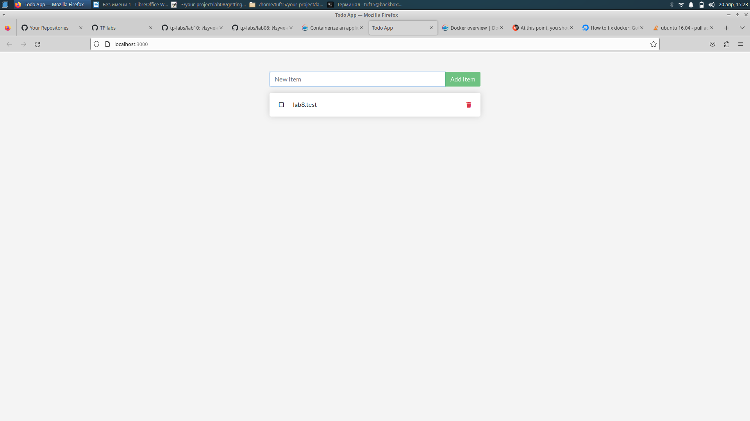

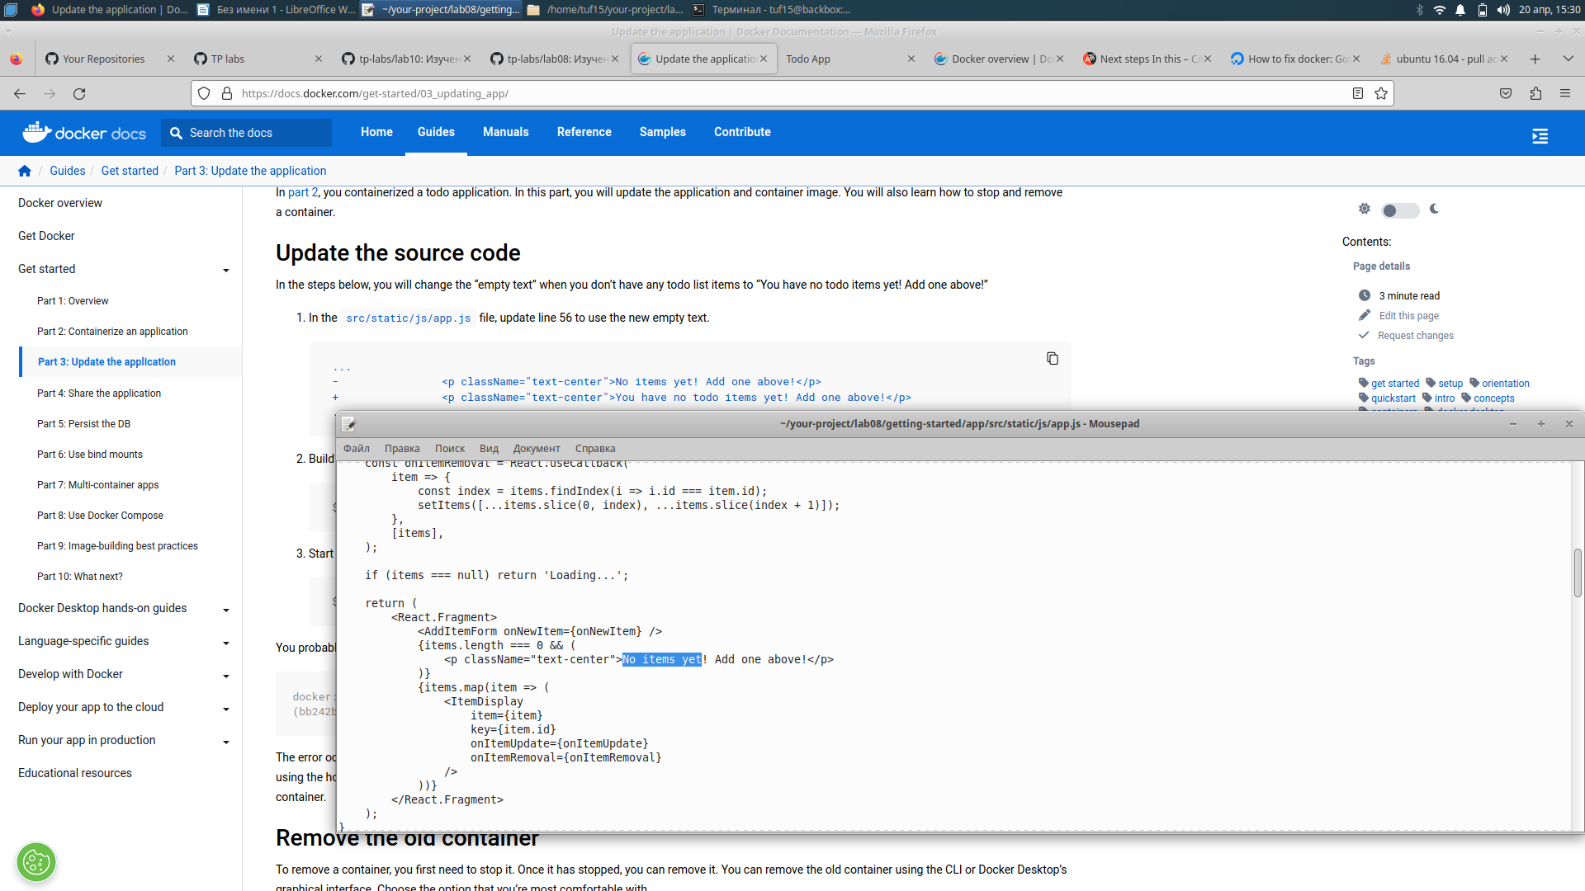
/

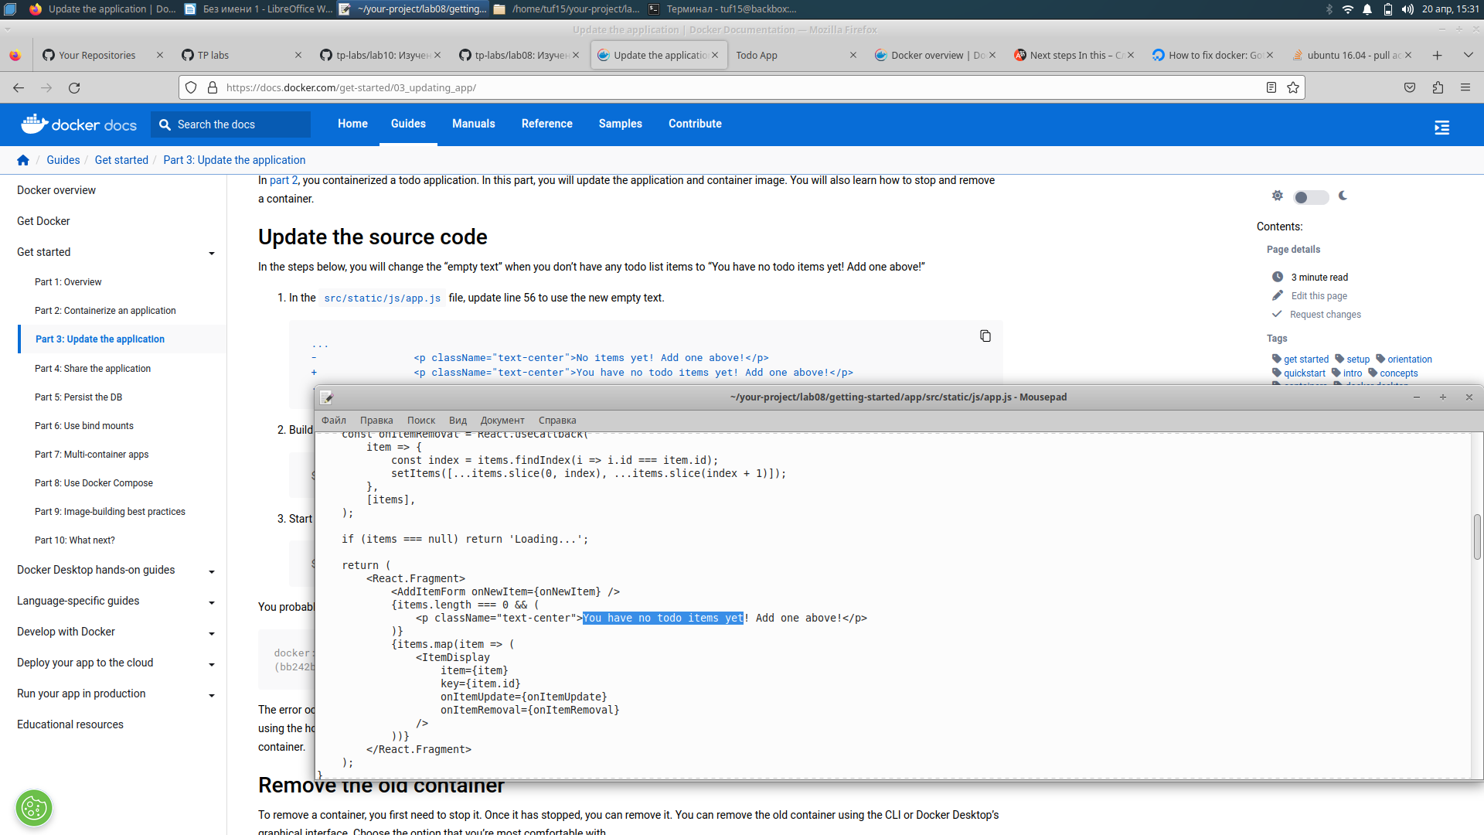
/

j

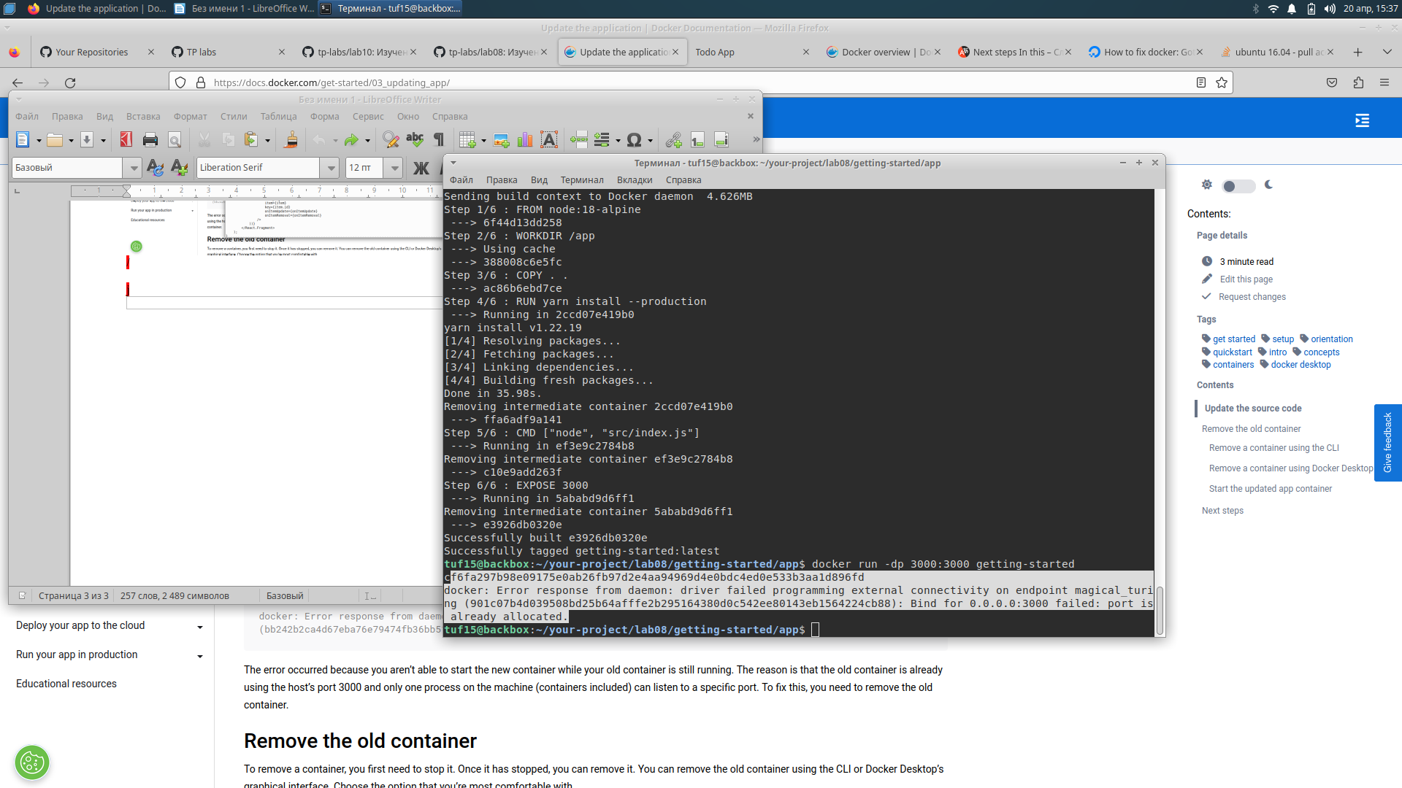
tuf15@backbox:~/your-project/lab08/getting-started/app$ docker ps
CONTAINER ID IMAGE COMMAND CREATED STATUS PORTS NAMES
f4d4a89846dc e9e2bd5ff49b "docker-entrypoint.s…" 18 minutes ago Up 18 minutes 0.0.0.0:3000->3000/tcp, :::3000->3000/tcp nice_bhaskara
tuf15@backbox:~/your-project/lab08/getting-started/app$ docker stop f4d4a89846dc
f4d4a89846dc
tuf15@backbox:~/your-project/lab08/getting-started/app$ docker rm f4d4a89846dc
f4d4a89846dc
tuf15@backbox:~/your-project/lab08/getting-started/app$ docker run -dp 3000:3000 getting-started
83519fc89a482e679e736f387e0599bad7425101654d39c7cad718215cd648b9
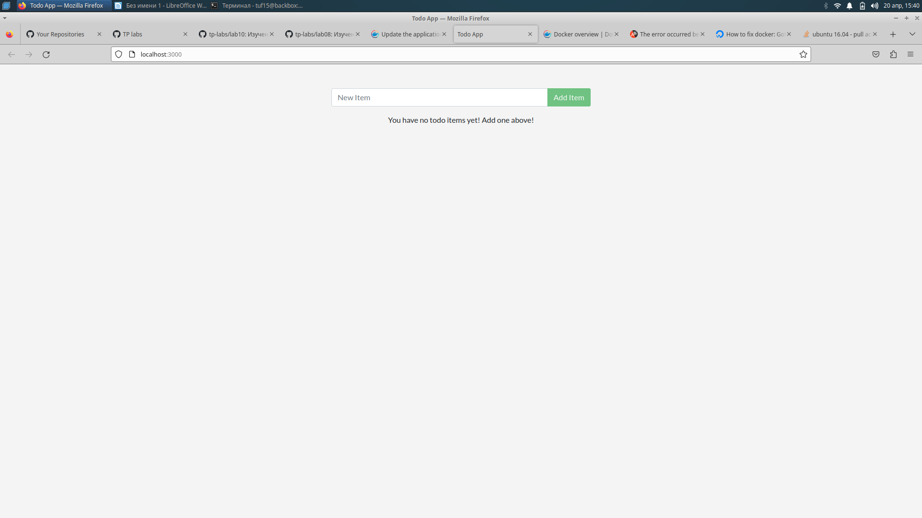
/
/Регистрируюсь в докер-хаб/
tuf15@backbox:~/your-project/lab08/getting-started/app$ docker push nekit28/getting-started:tagname
The push refers to repository [docker.io/nekit28/getting-started]
An image does not exist locally with the tag: nekit28/getting-started
tuf15@backbox:~/your-project/lab08/getting-started/app$ docker login -u nekit28
Password:
WARNING! Your password will be stored unencrypted in /home/tuf15/snap/docker/2746/.docker/config.json.
Configure a credential helper to remove this warning. See
https://docs.docker.com/engine/reference/commandline/login/#credentials-store

Login Succeeded
tuf15@backbox:~/your-project/lab08/getting-started/app$ docker tag getting-started nekit28/getting-started

docker push nekit28/getting-started:tagname
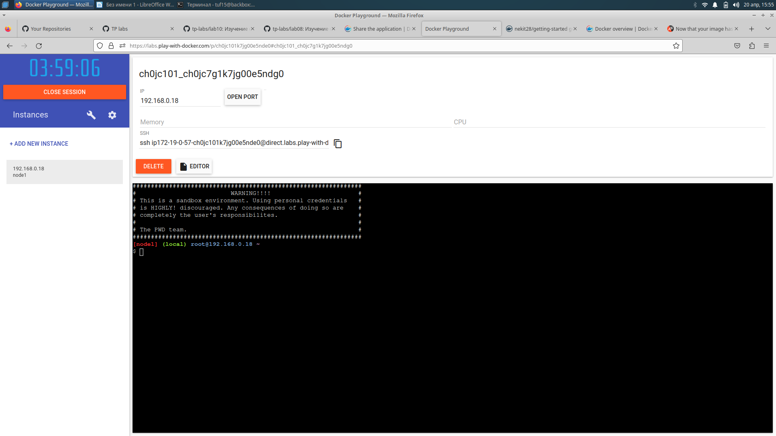
/
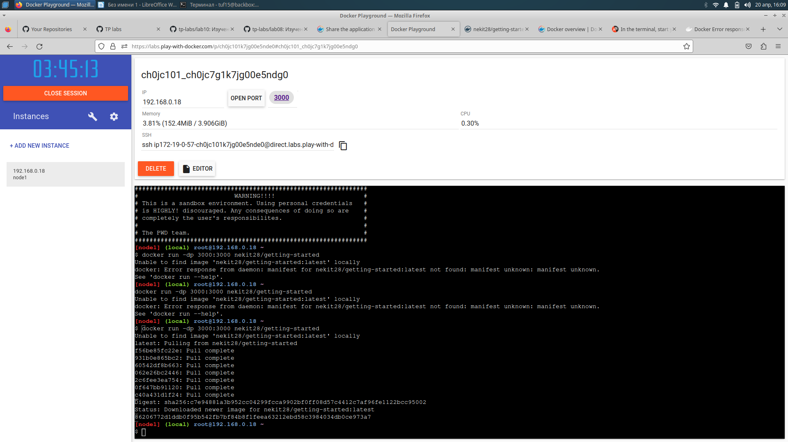
/
Start an ubuntu container that will create a file named /data.txt with a random number between 1 and 10000.
docker run -d ubuntu bash -c "shuf -i 1-10000 -n 1 -o /data.txt && tail -f /dev/null"
In case you’re curious about the command, you’re starting a bash shell and invoking two commands (why you have the &&). The first portion picks a single random number and writes it to /data.txt. The second command is simply watching a file to keep the container running.

tuf15@backbox:~/your-project/lab08/getting-started/app$ docker ps
CONTAINER ID IMAGE COMMAND CREATED STATUS PORTS NAMES
8bf00bcbc138 ubuntu "bash -c 'shuf -i 1-…" 2 minutes ago Up 2 minutes eloquent_pasteur
83519fc89a48 getting-started "docker-entrypoint.s…" 35 minutes ago Up 35 minutes 0.0.0.0:3000->3000/tcp, :::3000->3000/tcp sleepy_wing
tuf15@backbox:~/your-project/lab08/getting-started/app$ docker exec <8bf00bcbc138> cat /data.txt
bash: 8bf00bcbc138: Нет такого файла или каталога
tuf15@backbox:~/your-project/lab08/getting-started/app$ docker exec 8bf00bcbc138 cat /data.txt
7635
tuf15@backbox:~/your-project/lab08/getting-started/app$ docker run -it ubuntu ls /
bin dev home lib32 libx32 mnt proc run srv tmp var
boot etc lib lib64 media opt root sbin sys usr
tuf15@backbox:~/your-project/lab08/getting-started/app$ docker rm -f 83519fc89a48
83519fc89a48
tuf15@backbox:~/your-project/lab08/getting-started/app$ docker rm -f 8bf00bcbc138
8bf00bcbc138

docker volume create todo-db /создаю volume для подключения к различным контейнерам/хостам/

Start the todo app container, but add the --mount option to specify a volume mount. Give the volume a name, and mount it to /etc/todos in the container, which captures all files created at the path.
docker run -dp 3000:3000 --mount type=volume,src=todo-db,target=/etc/todos getting-started

http://localhost:3000

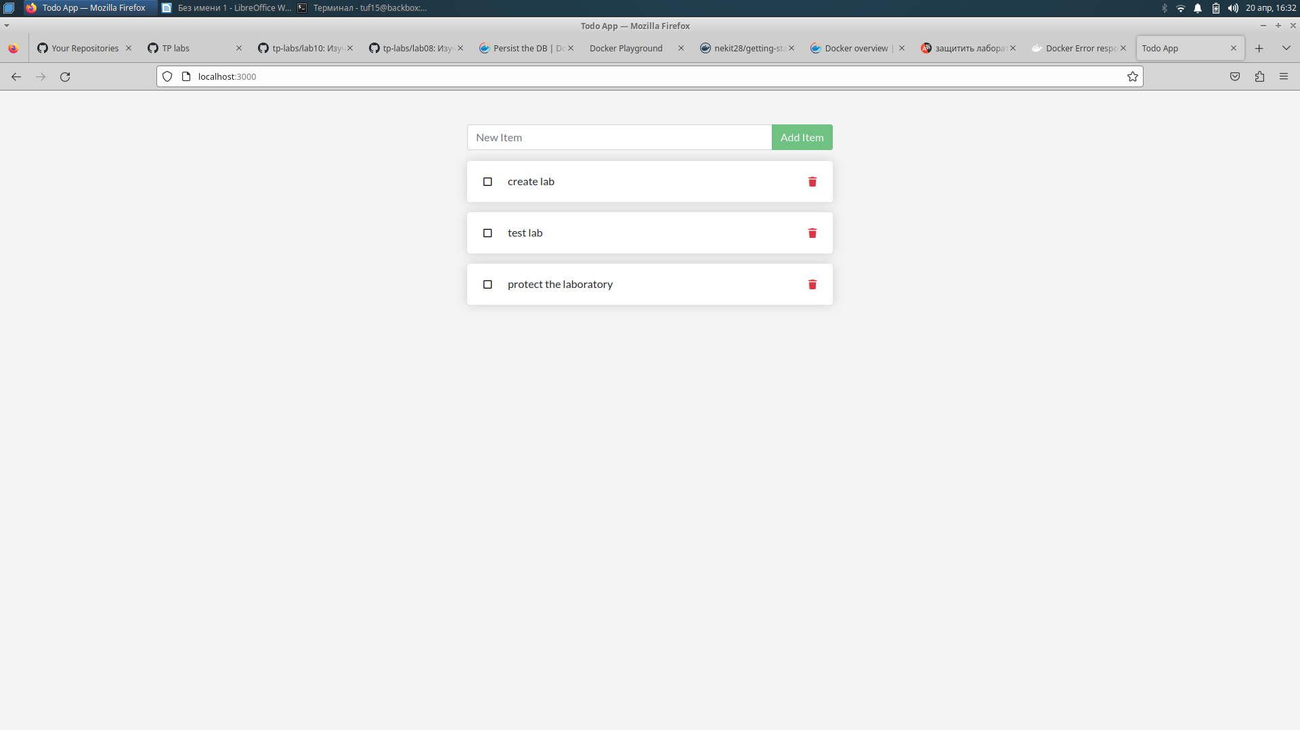
/
tuf15@backbox:~/your-project/lab08/getting-started/app$ docker ps
CONTAINER ID IMAGE COMMAND CREATED STATUS PORTS NAMES
d370b958d480 getting-started "docker-entrypoint.s…" 3 minutes ago Up 3 minutes 0.0.0.0:3000->3000/tcp, :::3000->3000/tcp elegant_chandrasekhar
tuf15@backbox:~/your-project/lab08/getting-started/app$ docker rm -f d370b958d480
d370b958d480
tuf15@backbox:~/your-project/lab08/getting-started/app$ docker run -dp 3000:3000 --mount type=volume,src=todo-db,target=/etc/todos getting-started
982564019b6abe095fb1cd95d0498aeb3daaf5773ecd10e055e6523610c200c1
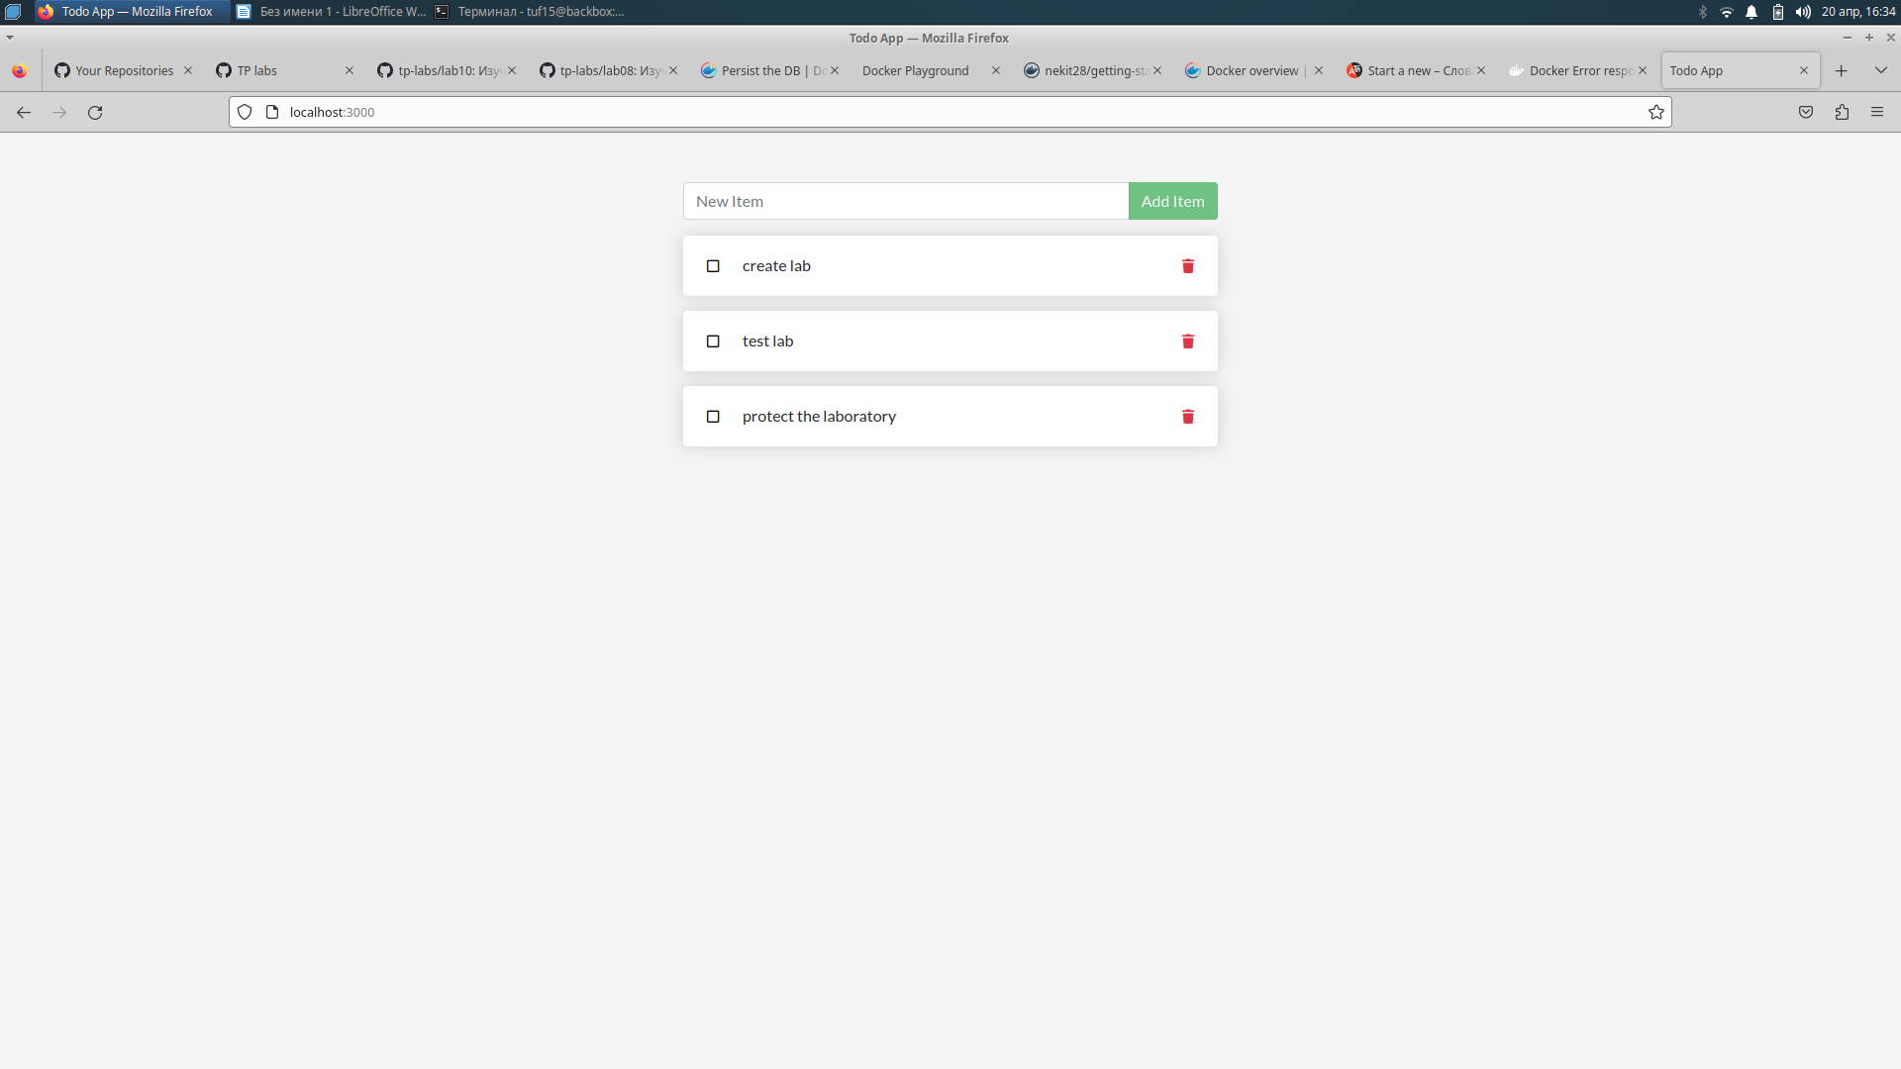
/
tuf15@backbox:~/your-project/lab08/getting-started/app$ docker ps
CONTAINER ID IMAGE COMMAND CREATED STATUS PORTS NAMES
982564019b6a getting-started "docker-entrypoint.s…" About a minute ago Up 59 seconds 0.0.0.0:3000->3000/tcp, :::3000->3000/tcp priceless_clarke
tuf15@backbox:~/your-project/lab08/getting-started/app$ doscker rm -f 982564019b6a
Команда «doscker» не найдена. Возможно, вы имели в виду:
command 'docker' from snap docker (20.10.17)
command 'docker' from deb podman-docker (3.4.4+ds1-1ubuntu1)
command 'docker' from deb docker.io (20.10.21-0ubuntu1~22.04.2)
See 'snap info <snapname>' for additional versions.
tuf15@backbox:~/your-project/lab08/getting-started/app$ docker rm -f 982564019b6a
982564019b6a
tuf15@backbox:~/your-project/lab08/getting-started/app$ docker volume inspect todo-db
[
{
"CreatedAt": "2023-04-20T16:31:57+03:00",
"Driver": "local",
"Labels": {},
"Mountpoint": "/var/snap/docker/common/var-lib-docker/volumes/todo-db/_data",
"Name": "todo-db",
"Options": {},
"Scope": "local"
}
]

/Bind mounts/

docker run -it --mount type=bind,src="$(pwd)",target=/src ubuntu bash
The --mount option tells Docker to create a bind mount, where src is the current working directory on your host machine (getting-started/app), and target is where that directory should appear inside the container (/src).
root@bc4dce99ffa2:/# pwd
/
root@bc4dce99ffa2:/# ls
bin dev home lib32 libx32 mnt proc run src sys usr
boot etc lib lib64 media opt root sbin srv tmp var
root@bc4dce99ffa2:/# cd src
root@bc4dce99ffa2:/src# ls
Dockerfile package.json spec src yarn.lock

root@bc4dce99ffa2:/src# touch myfile.txt
root@bc4dce99ffa2:/src# ls
Dockerfile myfile.txt package.json spec src yarn.lock

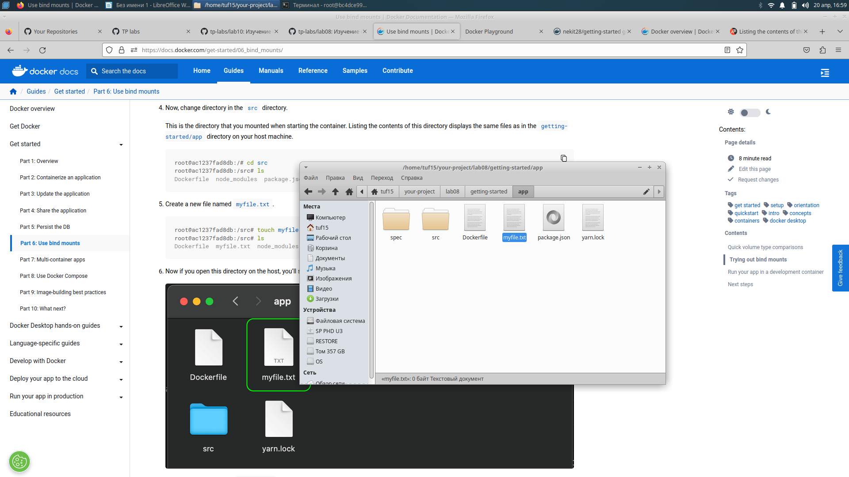
/

/удаляю файл из хоста/

root@bc4dce99ffa2:/src# ls
Dockerfile package.json spec src yarn.lock

Run the following command from the getting-started/app directory.
docker run -dp 3000:3000 \
-w /app --mount type=bind,src="$(pwd)",target=/app \
node:18-alpine \
sh -c "yarn install && yarn run dev"
- -dp 3000:3000 - same as before. Run in detached (background) mode and create a port mapping
- -w /app - sets the “working directory” or the current directory that the command will run from
- --mount type=bind,src="$(pwd)",target=/app - bind mount the current directory from the host into the /app directory in the container
- node:18-alpine - the image to use. Note that this is the base image for our app from the Dockerfile
- sh -c "yarn install && yarn run dev" - the command. We’re starting a shell using sh (alpine doesn’t have bash) and running yarn install to install packages and then running yarn run dev to start the development server. If we look in the package.json, we’ll see that the dev script starts nodemon.

tuf15@backbox:~/your-project/lab08/getting-started/app$ docker ps
CONTAINER ID IMAGE COMMAND CREATED STATUS PORTS NAMES
8afeb2b6d8fb node:18-alpine "docker-entrypoint.s…" About a minute ago Up About a minute 0.0.0.0:3000->3000/tcp, :::3000->3000/tcp zen_ishizaka
tuf15@backbox:~/your-project/lab08/getting-started/app$ docker logs -f 8afeb2b6d8fb
yarn install v1.22.19
[1/4] Resolving packages...
[2/4] Fetching packages...
[3/4] Linking dependencies...
[4/4] Building fresh packages...
Done in 12.76s.
yarn run v1.22.19
$ nodemon src/index.js
[nodemon] 2.0.20
[nodemon] to restart at any time, enter `rs`
[nodemon] watching path(s): *.*
[nodemon] watching extensions: js,mjs,json
[nodemon] starting `node src/index.js`
Using sqlite database at /etc/todos/todo.db
Listening on port 3000
[nodemon] restarting due to changes...
[nodemon] starting `node src/index.js`
Using sqlite database at /etc/todos/todo.db
Listening on port 3000
^C

http://localhost:3000

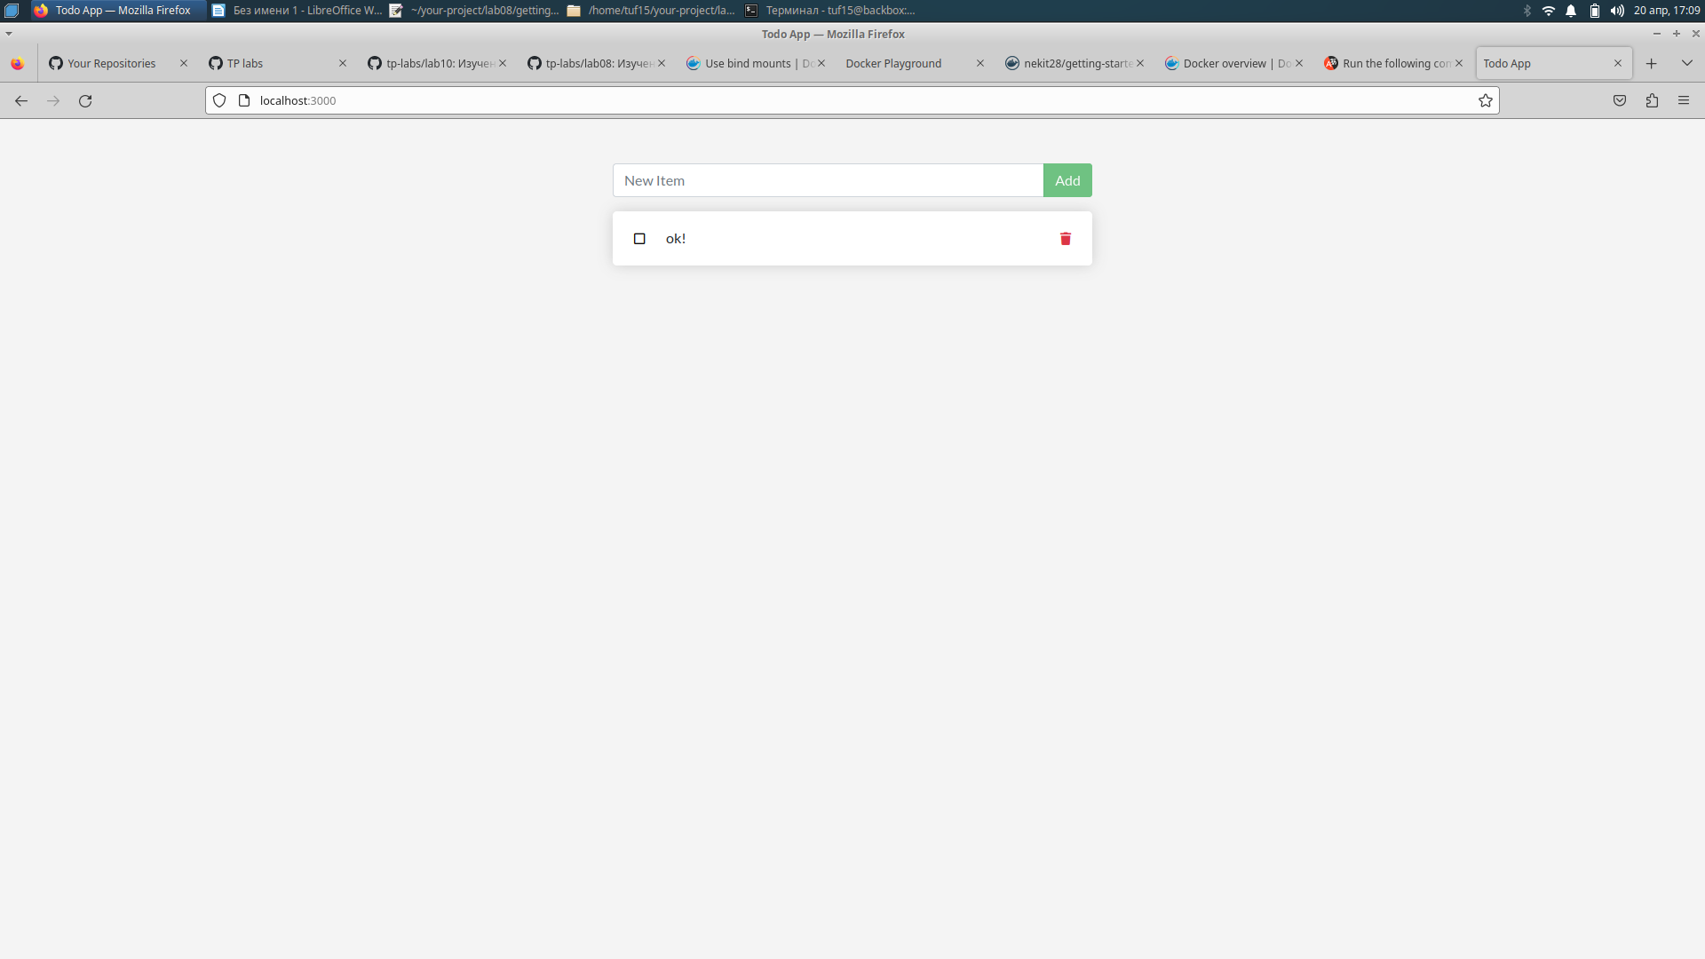
docker build -t getting-started .

/Mysql/
Create the network.
docker network create todo-app

Start a MySQL container and attach it to the network
docker run -d \
--network todo-app --network-alias mysql \
-v todo-mysql-data:/var/lib/mysql \
-e MYSQL_ROOT_PASSWORD=secret \
-e MYSQL_DATABASE=todos \
mysql:8.0
To confirm you have the database up and running, connect to the database and verify that it connects.
docker exec -it <mysql-container-id> mysql -u root -p

