Software Design Specifications

for

REACT –
Real-time Emergency Allocation and Coordination Tracking system
Version 1.0

Prepared by:

SE22UARI007 - Aditya Kumar Kadapa
SE22UCSE034 - Arun Krishna Nalamaru
SE23UCSE039 - Abdul Sami Roshan
SE23UCSE048 - C Ajay Simha Reddy
SE23UCSE064 - Gaurav Naidu Korada

Document Information

Title | REACT – Real-time Emergency Allocation and Coordination Tracking system
Project manager | Aditya Kumar Kadapa
Document Version | 1.0
Date | 09-04-2026
Prepared by | Aditya Kumar Kadapa  Arun Krishna Nalamaru  Abdul Sami Roshan  C Ajay Simha Reddy  Gaurav Naidu Korada

Table of Contents

1 INTRODUCTION ............................................................................................................................................................ |  | 4
1.1 | PURPOSE ...................................................................................................................................................................... | 4
1.2 | SCOPE .......................................................................................................................................................................... | 4
1.3 | DEFINITIONS, ACRONYMS, AND ABBREVIATIONS ........................................................................................................ | 4
1.4 | REFERENCES ................................................................................................................................................................ | 4

2 | USE CASE VIEW ............................................................................................................................................................ |  | 5
 | 2.1 | USE CASE ..................................................................................................................................................................... | 5
3 | DESIGN OVERVIEW ..................................................................................................................................................... |  | 7
 | 3.1 | DESIGN GOALS AND CONSTRAINTS ............................................................................................................................. | 7
 | 3.2 | DESIGN ASSUMPTIONS ................................................................................................................................................. | 7
 | 3.3 | SIGNIFICANT DESIGN PACKAGES ................................................................................................................................. | 7
 | 3.4 | DEPENDENT EXTERNAL INTERFACES ........................................................................................................................... | 8
 | 3.5 | IMPLEMENTED APPLICATION EXTERNAL INTERFACES ................................................................................................. | 8
4 | LOGICAL VIEW ............................................................................................................................................................. |  | 8
 | 4.1 | DESIGN MODEL ............................................................................................................................................................ | 8
 | 4.2 | USE CASE REALIZATION .............................................................................................................................................. | 10
5 | DATA VIEW .................................................................................................................................................................... |  | 10
 | 5.1 | DOMAIN MODEL .......................................................................................................................................................... | 10
 | 5.2 | DATA MODEL (PERSISTENT DATA VIEW)...................................................................................................................... | 11
 | 5.2.1 Data Dictionary.................................................................................................................................................... |  | 11
6 | EXCEPTION HANDLING ............................................................................................................................................. |  | 11
7 | CONFIGURABLE PARAMETERS .............................................................................................................................. |  | 12
8 | QUALITY OF SERVICE ................................................................................................................................................ |  | 12
 | 8.1 | AVAILABILITY.............................................................................................................................................................. | 12
 | 8.2 | SECURITY AND AUTHORIZATION ................................................................................................................................. | 12
 | 8.3 | LOAD AND PERFORMANCE IMPLICATIONS ................................................................................................................... | 12
 | 8.4 | MONITORING AND CONTROL ....................................................................................................................................... | 12

1 Introduction

The REACT – Real-time Emergency Allocation and Coordination Tracking System is a software system designed to improve the process of handling emergency situations by using real-time tracking and automated service allocation. The system focuses on reducing response time by using GPS-based location detection and efficient communication between users and emergency services.
This document describes the design of the system, including use cases, system architecture, data handling, and interaction between different modules. It acts as a reference for understanding how the system will be implemented.

1.1 Purpose

The purpose of this Software Design Specification (SDS) document is to provide a detailed design of the REACT system. It explains how the system will function internally and how different components interact with each other.
This document is mainly intended for:
- Developers who will implement the system
- Faculty evaluating the project
- Team members who need a clear understanding of system design

1.2 Scope

The REACT system is designed to handle multiple types of emergency services such as ambulance, police, and fire services. The system allows users to request help, automatically detects their location using GPS, and assigns the nearest available service.
It also supports:
- Real-time tracking of emergency requests
- Status updates from service providers
- Notification system for users
- Admin monitoring of ongoing emergencies

1.3 Definitions, Acronyms, and Abbreviations

- REACT – Real-time Emergency Allocation and Coordination Tracking System
- GPS – Global Positioning System used for location detection
- API – Application Programming Interface used for communication between frontend and backend
- DB – Database used for storing user and request data
- Admin – System administrator who monitors emergency activities

1.4 References

- Basic concepts of emergency response systems
- GPS-based tracking systems
- MongoDB Atlas documentation (for database design)
- REST API design principles

2 Use Case View

The use case view represents the main functionalities of the REACT system. It shows how different users interact with the system and how the system responds to different scenarios.
The system mainly involves three actors:
- User – Person requesting emergency help
- Emergency Service Provider – Ambulance, police, or fire unit
- Admin – Monitors and manages the system

2.1 Use Cases

Use Case 1: Select Emergency Type
Description: The user selects the type of emergency service required such as ambulance, police, or fire service. This helps the system in routing the request to the correct service.

Use Case 2: Send Emergency Request
Description: The user submits an emergency request through the application. The request includes location data and type of emergency.

Use Case 3: Auto Detect Location (GPS)
Description: The system automatically detects the user's current location using GPS. This location is used to find the nearest emergency service.

Use Case 4: Manual Location Entry
Description: If GPS is not available or fails, the user can manually enter their location. This ensures the system still functions under limited conditions.

Use Case 5: System Finds Nearest Service
Description: The backend processes the request and uses location-based logic to identify the nearest available emergency service unit.
(technical note: this can be implemented using distance calculation algorithms or map APIs)

Use Case 6: Service Accepts/Rejects Request
Description: The emergency service provider receives the request and can either accept or reject it based on availability.

Use Case 7: User Receives Notification
Description: The system sends notifications to the user regarding request status such as accepted, rejected, or service on the way.

Use Case 8: Track Request Status
Description: The user can track the real-time status of the emergency request, including service movement and updates.

Use Case 9: Cancel Request
Description: The user can cancel the emergency request if it is no longer needed.

Use Case 10: Service Updates Status
Description: The service provider updates the status such as "On the way", "Arrived", or "Completed".

Use Case 11: Admin Monitors Requests
Description: The admin can view all ongoing and completed requests and monitor system activity.
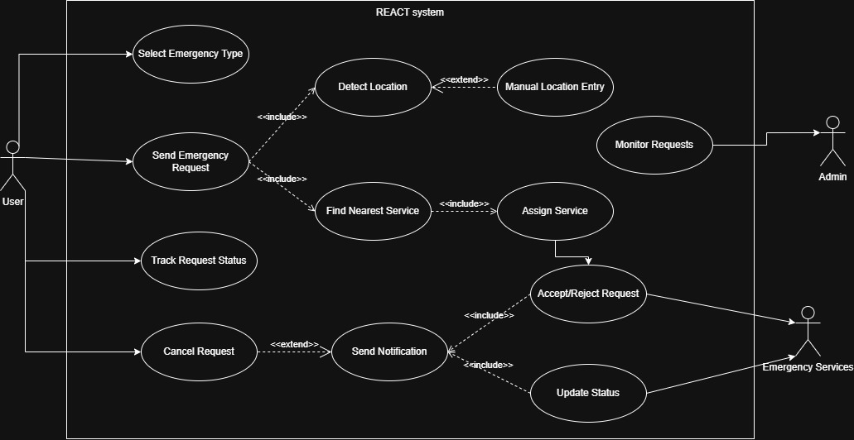

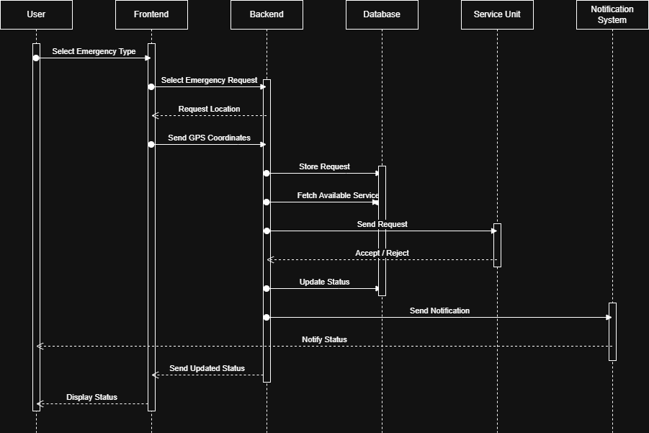

- Design Overview

The REACT system is designed as a distributed web-based application that connects users, emergency service providers, and administrators through a centralized backend system. The system follows a modular architecture where different components handle specific responsibilities such as user interaction, request processing, and data storage. The frontend is responsible for collecting user input and displaying real-time updates, while the backend handles business logic, API processing, and communication with the database. The system uses location-based services to allocate emergency resources efficiently.

3.1 Design Goals and Constraints

Design Goals
- To reduce emergency response time using real-time processing
- To provide accurate location-based service allocation using GPS
- To support multiple emergency services in a single platform
- To ensure continuous communication between user and service provider
- To provide a simple and user-friendly interface
Constraints
- Dependence on GPS availability for accurate location detection
- Internet connectivity required for real-time updates
- Limited scalability in initial version due to student-level implementation
- Use of available tools like React, Node.js, and MongoDB instead of enterprise systems

3.2 Design Assumptions

- Users will have smartphones with GPS enabled
- Emergency service providers will have access to the system interface
- The database will be hosted on MongoDB Atlas
- Network connectivity will be available during emergency requests
- The system will initially support a limited number of concurrent users

3.3 Significant Design Packages

The system is divided into the following main modules:

1. Frontend Module
- Built using React / Next.js
- Handles user interface and user input
- Communicates with backend using REST APIs
2. Backend Module
- Built using Node.js and Express
- Handles API requests and business logic
- Processes emergency requests and assigns services
3. Database Module
- Uses MongoDB Atlas
- Stores user data, emergency requests, service details, and logs
4. Notification Module
- Sends real-time updates to users
- Can be implemented using WebSockets or polling
5. Location Processing Module
- Handles GPS data
- Calculates nearest service using distance logic or map APIs

3.4 Dependent External Interfaces

The system depends on the following external interfaces.

Application | Interface | Description
Map Services (e.g., Google Maps API) | Location API | Used to fetch coordinates and calculate distance between user and service
MongoDB Atlas | Database API | Used for storing and retrieving system data
Notification Services | Messaging API | Used for sending real-time alerts and updates

3.5 Implemented Application External Interfaces (and SOA web services)

The REACT system provides the following APIs for internal and external communication:

Interface Name | Module Implementing | Description
/request-emergency | Backend | Accepts emergency request from frontend
/get-nearest-service | Backend | Returns nearest available service
/update-status | Backend | Updates service status
/get-status | Backend | Fetches current request status
/cancel-request | Backend | Cancels emergency request

4 Logical View

The logical view describes how different components of the REACT system interact with each other to perform core functionalities. The system is designed in layers where each layer has a specific responsibility.
At a high level, the system follows this flow:
- The frontend collects user input
- The backend processes the request using APIs
- The database stores and retrieves required data
- The system sends responses and updates back to the user

4.1 Design Model

The system is divided into modules, and each module contains specific classes and responsibilities.

1. User Module
Responsibilities:
- Handles user input
- Sends emergency request
- Displays notifications and status
Main attributes:
- userId
- name
- location
Main operations:
- sendRequest()
- cancelRequest()
- viewStatus()

2. Emergency Request Module
Responsibilities:
- Manages all emergency requests
- Stores request details and status
Main attributes:
- requestId
- emergencyType
- location
- status
Main operations:
- createRequest()
- updateStatus()
- assignService()

3. Service Module
Responsibilities:
- Represents emergency service units (ambulance, police, fire)
- Handles acceptance/rejection of requests
Main attributes:
- serviceId
- serviceType
- availability
- currentLocation
Main operations:
- acceptRequest()
- rejectRequest()
- updateLocation()

4. Location Module
Responsibilities:
- Handles GPS data processing
- Calculates nearest service
Main operations:
- getUserLocation()
- calculateDistance()
- findNearestService()
(technical note: distance can be calculated using Haversine formula or map APIs)

5. Notification Module
Responsibilities:
- Sends updates to users and services
Main operations:
- sendNotification()
- pushUpdate()

6. Admin Module
Responsibilities:
- Monitors all requests
- Views system activity
Main operations:
- viewAllRequests()
- monitorSystem()
4.2 Use Case Realization

This section explains how the system executes a use case step-by-step.

Step-by-step flow:
- User selects emergency type from frontend
- System automatically detects location using GPS
- User submits emergency request
- Frontend sends request to backend via API (/request-emergency)
- Backend stores request in MongoDB database
- Location module calculates nearest available service
- Backend sends request to selected service unit
- Service accepts or rejects the request
- Backend updates request status in database
- Notification module sends update to user
- User tracks status in real-time

5 Data View

The data view describes how data is stored, managed, and used within the REACT system. The system uses a NoSQL database (MongoDB Atlas) to store all application data in the form of collections and documents.

5.1 Domain Model

The main entities in the system are:

1. User
Represents a person requesting emergency help.
Attributes:
- userId
- name
- phoneNumber
- location

2. Emergency Request
Represents a request raised by a user.
Attributes:
- requestId
- userId
- emergencyType
- location
- status
- timestamp

3. Service Unit
Represents an emergency service provider.
Attributes:
- serviceId
- serviceType (ambulance/police/fire)
- availability
- currentLocation

4. Notification
Represents updates sent to users.
Attributes:
- notificationId
- userId
- message
- timestamp

5.2 Data Model (persistent data view)

The system uses MongoDB collections to store data:
- users collection
- requests collection
- services collection
- notifications collection
Each collection stores data in JSON-like format (documents).

5.2.1 Data Dictionary

Field Name | Description
userId | Unique identifier for user
requestId | Unique identifier for emergency request
serviceId | Unique identifier for service unit
emergencyType | Type of emergency selected
location | Latitude and longitude coordinates
status | Current state (pending, accepted, on the way, completed)
timestamp | Time of request or update
availability | Whether service is available or not

6 Exception Handling

The system handles different types of errors to ensure smooth functioning.

Possible Exceptions:
- GPS not available → system allows manual location entry
- No service available → user is notified
- Network failure → request retry mechanism
- Invalid input → validation errors shown to user
Handling Approach:
- Errors are handled at backend using try-catch blocks
- Error messages are sent through APIs
- Logs can be stored for debugging

7 Configurable Parameters

The system includes some configurable parameters.

Configuration Parameter Name | Definition and Usage | Dynamic?
Max Request Timeout | Time before request expires | Yes
Notification Interval | Frequency of status updates | Yes
Service Availability Flag | Indicates if service is active | Yes
API Base URL | Backend Server URL | No

8 Quality of Service

8.1 Availability

The system is designed to be available whenever users need emergency assistance. Since it is a web-based system, availability depends on server uptime and internet connectivity.

8.2 Security and Authorization

- Users may be authenticated using basic login (future scope)
- APIs can be secured using tokens (JWT)
- Access control ensures only authorized services can accept requests

8.3 Load and Performance Implications

- The system should handle multiple emergency requests simultaneously
- Database queries should be optimized for faster response
- Real-time updates should not overload the server

8.4 Monitoring and Control

- Admin dashboard can be used to monitor requests
- Logs can be used to track system activity
- System performance can be analysed using request data

