Software Requirements Specification
for
Real-Time Emergency Allocation and Coordination Tracker
Version 1.0

Prepared by
Group Name: REACT
Aditya Kumar Kadapa | SE22UARI007 | se22uari007@mahindrauniveristy.edu.in
Arun Krishna Nalamaru | SE22UCSE034 | se22ucse034@mahindrauniveristy.edu.in
Abdul Sami Roshan | SE23UCSE009 | se23ucse009@mahindrauniveristy.edu.in
C Ajay Simha Reddy | SE23UCSE048 | se23ucse048@mahindrauniveristy.edu.in
Gaurav Naidu Korada | SE23UCSE064 | se23ucse064@mahindrauniveristy.edu.in

Instructor: | Avinash Arun Chauhan,  Sravanthi Acchugatla
Course: | Software Engineering
Lab Section: | IT -2 Ground floor lab
Date: | 13-03-26
Contents
Contents ii
Revisions ii
1 Introduction 1
1.1 Document Purpose 1
1.2 Product Scope 1
1.3 Intended Audience and Document Overview 1
1.4 Definitions, Acronyms and Abbreviations 2
1.5 Document Conventions 2
1.6 References and Acknowledgments 2
2 Overall Description 3
2.1 Product Overview 3
2.2 Product Functionality 3
2.3 Design and Implementation Constraints 3
2.4 Assumptions and Dependencies 3
3 Specific Requirements 4
3.1 External Interface Requirements 4
3.2 Functional Requirements 4
3.3 Use Case Model 5
4 Other Non-functional Requirements 10
4.1 Performance Requirements 10
4.2 Safety and Security Requirements 10
4.3 Software Quality Attributes 10
5 Other Requirements 10
Appendix A – Data Dictionary 11
Appendix B - Group Log 11

Revisions
Version | Primary Author(s) | Description of Version | Date Completed
1.0 | REACT Team | Initial SRS version. | 13/03/26

Introduction
The REACT system (Real-Time Emergency Allocation and Coordination Tracking System) is a web-based platform designed to improve coordination and allocation of emergency services such as ambulance, police and fire services. The system enables users to request emergency assistance while automatically allocating nearest available emergency vehicle. It also allows real time tracking of emergency vehicles through a map interface.
This document provides the detailed software requirements for the REACT system including functional requirements, system constraints, assumptions, interfaces, and quality attributes.

Document Purpose
The purpose of this document is to describe the software requirements of the REACT system. It provides a description of system functionality, operational constraints, external interfaces and non-functional requirements.
This document serves as a reference for developers, project evaluators, instructors and stakeholders involved in the design and development of the system. It ensures that all the stakeholders have a clear understanding of what the system is expected to achieve.

Product Scope
The REACT system is designed to support efficient emergency response management by providing a centralized platform for emergency request handling and vehicle tracking.
The system allows users to submit emergency requests and automatically assigns the nearest available emergency vehicle. The system also enables real-time tracking of vehicles and provides administrators with tools to monitor emergency requests and vehicle statuses.
Benefits of the system include
- Reduces emergency response time
- Improved coordination between emergency services
- Increased transparency between users
- Efficient vehicle allocation and monitoring

Intended Audience and Document Overview
This document is intended for:
- Developers – To understand system functionality and requirements
- Project evaluators and instructors – to review the design and completeness of the system
- Project team members – to guide development activities
- Users and administrators – to understand system capabilities

This document is organised as follows:
- Section 1 provides introduction to the project and document structure
- Section 2 describes the overall system and its environment
- Section 3 defines detailed system requirements and use case model
- Section 4 describes non-functional requirements such as performance and security
- Section 5 provides additional requirements

Definitions, Acronyms and Abbreviations
Term | Definition
API | Application Programming Interface
ETA | Estimated Time of Arrival
GPS | Global Positioning System
REACT | Real-Time Emergency Allocation and Coordination Tracking system
SRS | Software Requirements Specification
UI | User Interface
DB | Database

Document Conventions
This document follows the IEEE Software Requirements Specification formatting guidelines. The following conventions are used:
- Arial font size 11 or 12 is used for text.
- Section headings follow the numbering format specified in the template
- Important system requirements are written using the phrase “The system shall…”.
- Tables are used to organise definitions and requirement descriptions.

References and Acknowledgments
The following references were used while preparing this document:
- IEEE Software Requirements Specification Standards
- React.js official documentation
- Node.js and express documentation
- MongoDB Atlas documentation
- Leaflet Map API documentation

Overall Description

Product Overview
The REACT system is a web-based emergency management system designed to coordinate emergency services in real time. It acts as a centralized platform where users can request emergency assistance and administrators can monitor emergency operations
The system consists of three main components:
- Frontend user interface (React)
- Backend server (Node.js and Express)
- Cloud database (MongoDB Atlas)
The system interacts with external map services to display vehicle locations and simulate real-time movement.

Example system context:
User → Web Interface → Backend Server → Database
↓
Map Service
Users interact with the system through a web browser to request emergency services and track vehicle movements.

Product Functionality
The major functions of the REACT system include:
- User registration and login
- Emergency request submission
- Automatic nearest vehicle allocation
- Real-time vehicle tracking
- Emergency request monitoring
- Vehicle status management
- Admin dashboard for system control

Design and Implementation Constraints
The following constraints apply to the system:
- The system must be implemented using React for frontend development
- Backend development will use Node.js and Express
- The database must use MongoDB Atlas
- UML modeling must be used for system design
- The system must be accessible through modern web browsers
- Internet connectivity is required for system operation

Assumptions and Dependencies
The system assumes the following conditions:
- Users have access to internet-enabled devices
- Map API’s used for tracking are available and operational.
- Emergency vehicle location data can be simulated if real GPS data is unavailable
- The server hosting the application remains operational

Specific Requirements

External Interface Requirements

User Interfaces
The system provides a web-based user interface accessible through a browser
Key interface components include:
- Emergency request form
- Real-time map interface
- Vehicle tracking display
- Admin dashboard
Users interact with the system using menus, buttons and form inputs

Hardware Interfaces
The system interacts with the following hardware components:
- User devices (laptops, smartphones)
- Server hosting infrastructure
- Internet network devices
The system may interact with GPS sensors if real vehicle tracking is implemented

Software Interfaces
The REACT system interacts with several software components:
- MongoDB Atlas Database
- Map APIs for location display
- Web browser interface
- Real-time communication using WebSockets

Functional Requirements

F1: User Registration – The system shall allow new users to create an account using personal details

F2: User authentication – The system shall allow registered users to log in using valid credentials.

F3: Emergency Request Submission – The system shall allow users to submit emergency requests specifying the emergency type and location

F4: Vehicle allocation – The system shall automatically identify and assign the nearest available emergency vehicle

F5: Real-Time Tracking – The system shall display the location of the assigned emergency vehicle on a map interface

F6: Vehicle management – The system shall allow administrators to add, remove and update emergency vehicles

F7: Request monitoring – The system shall allow administrators to monitor active and completed emergency requests

Use Case Model
The use case model illustrates how different actors interact with the REACT system to perform various emergency service operations.
Actors:
- Citizen/User
- Administrator
- Emergency vehicle system
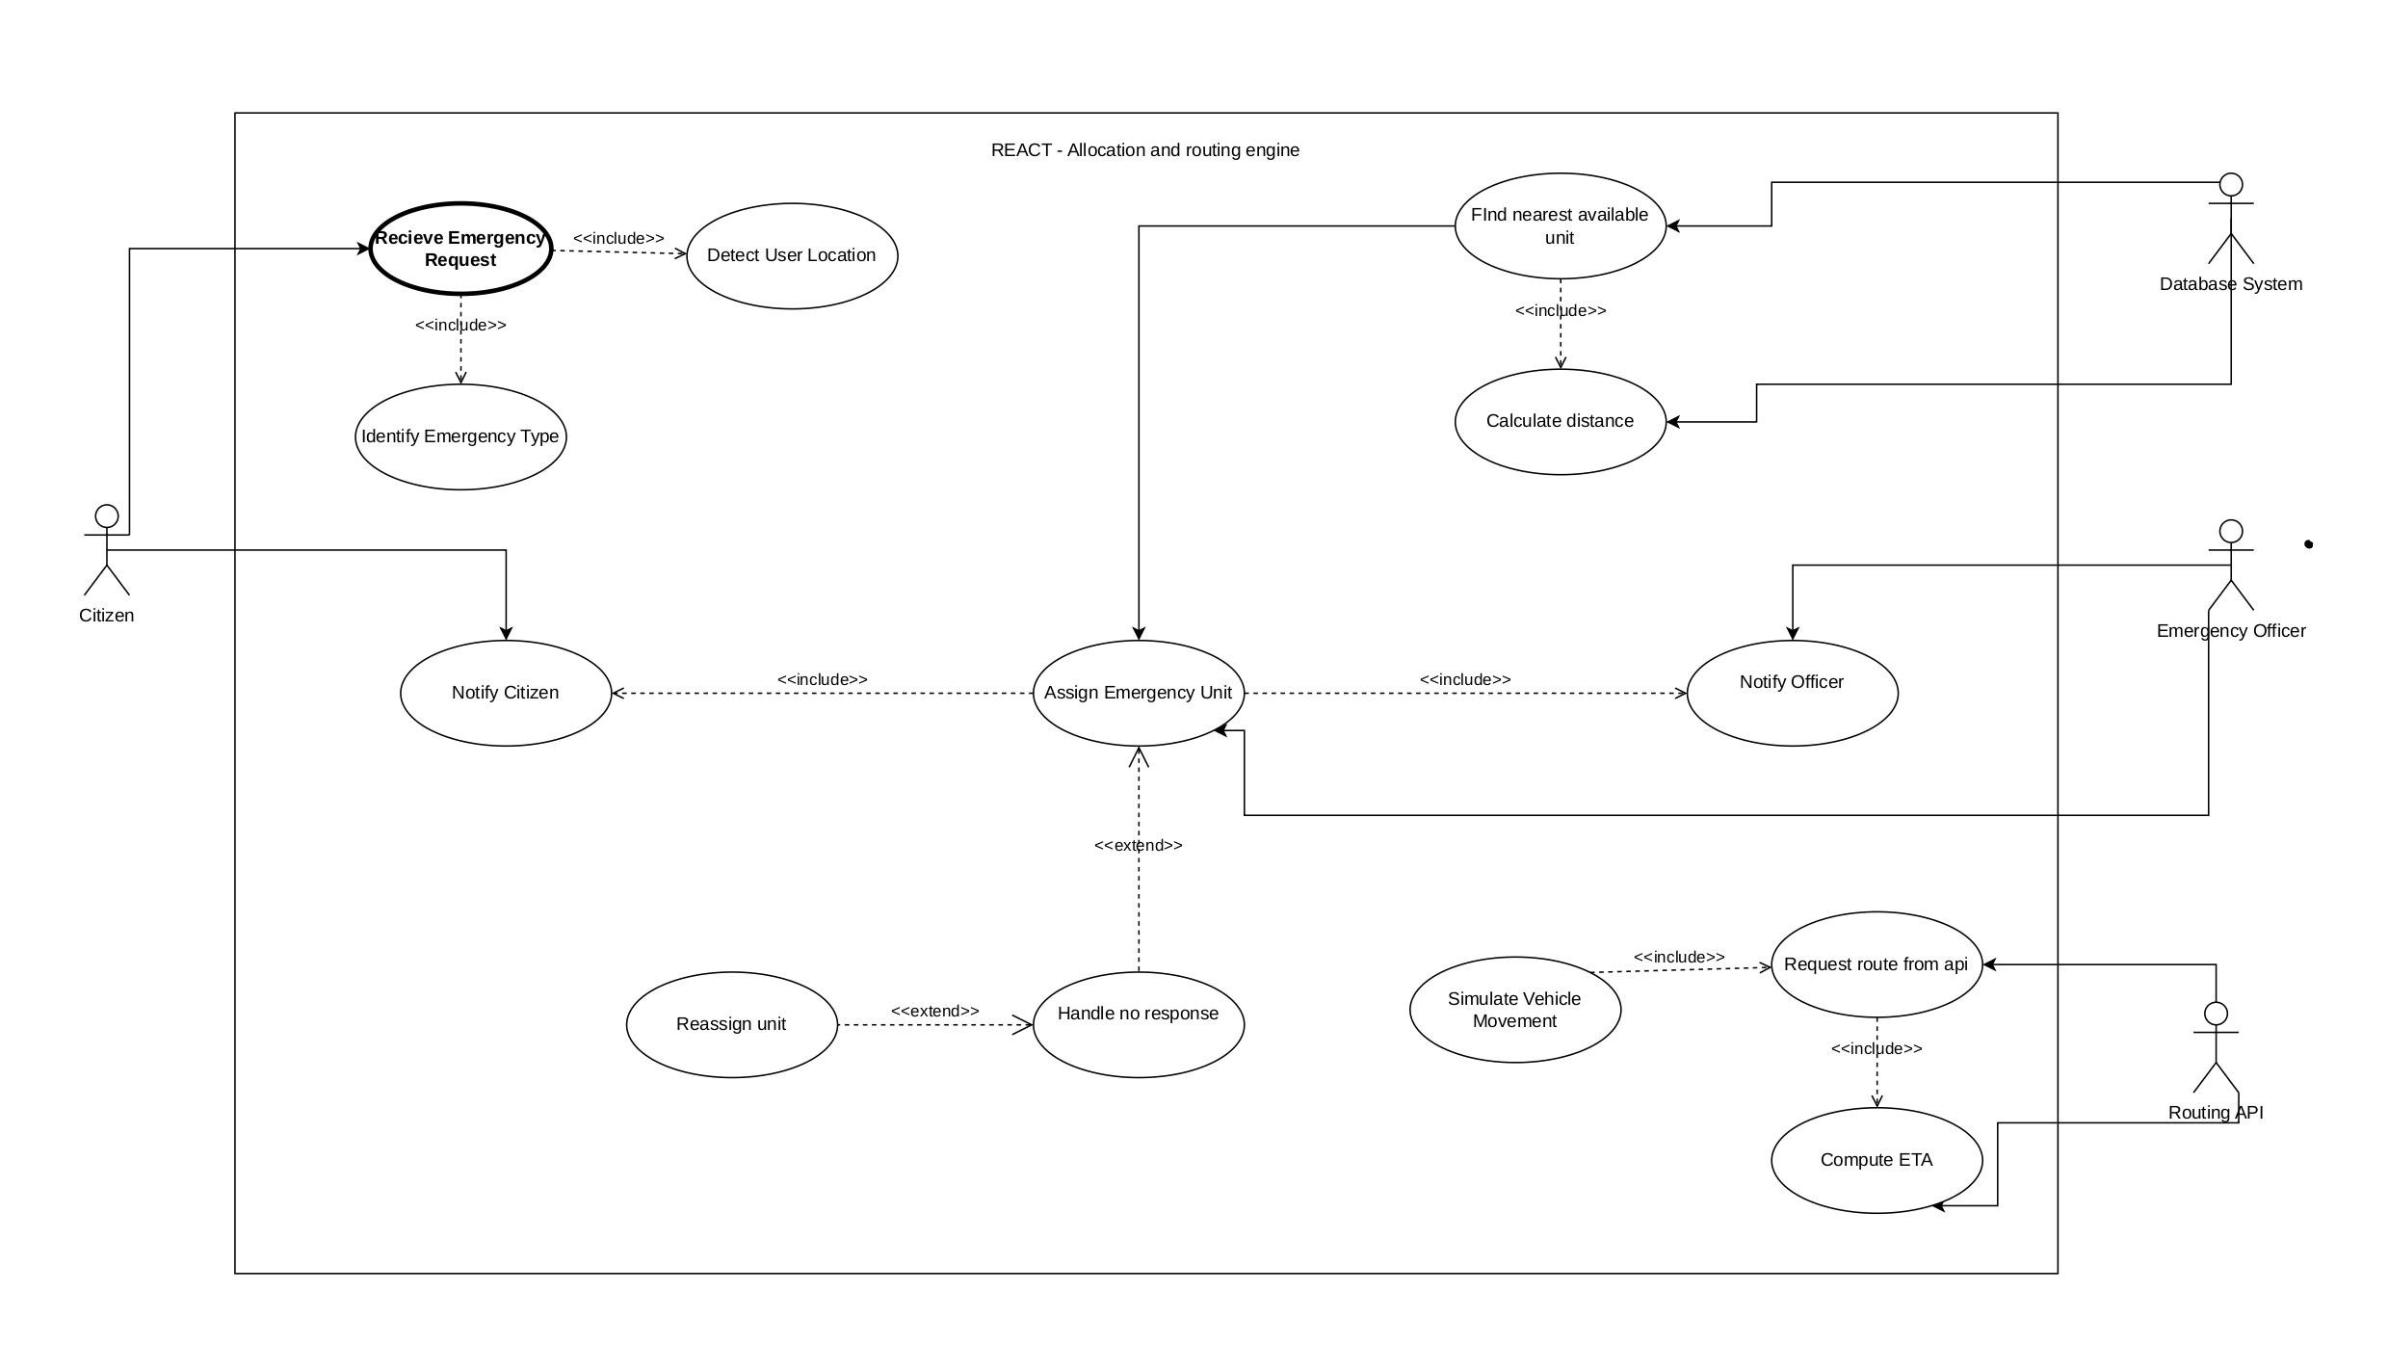
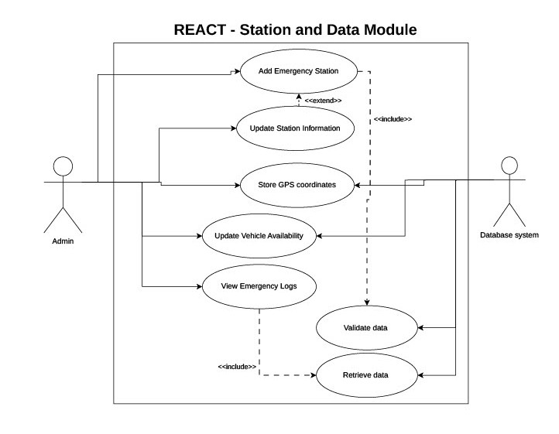
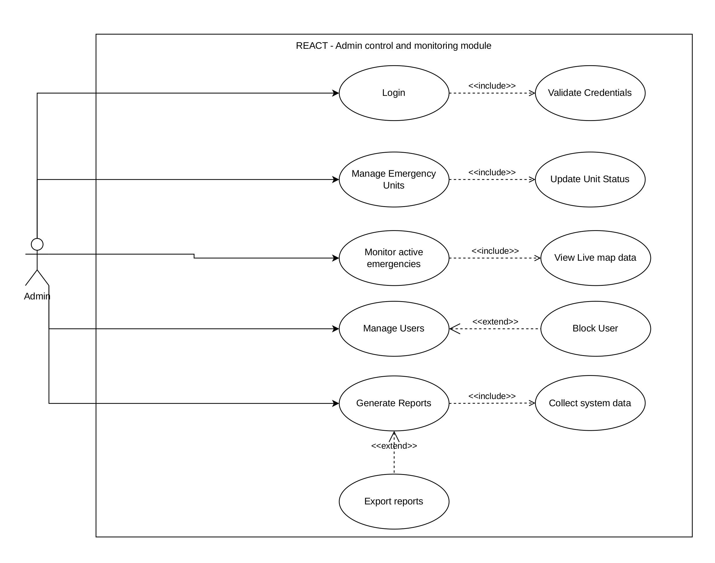
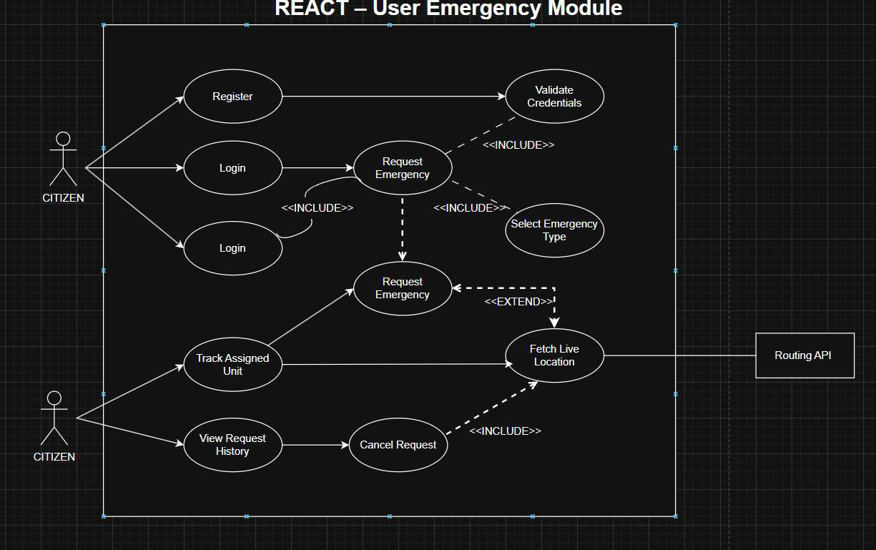
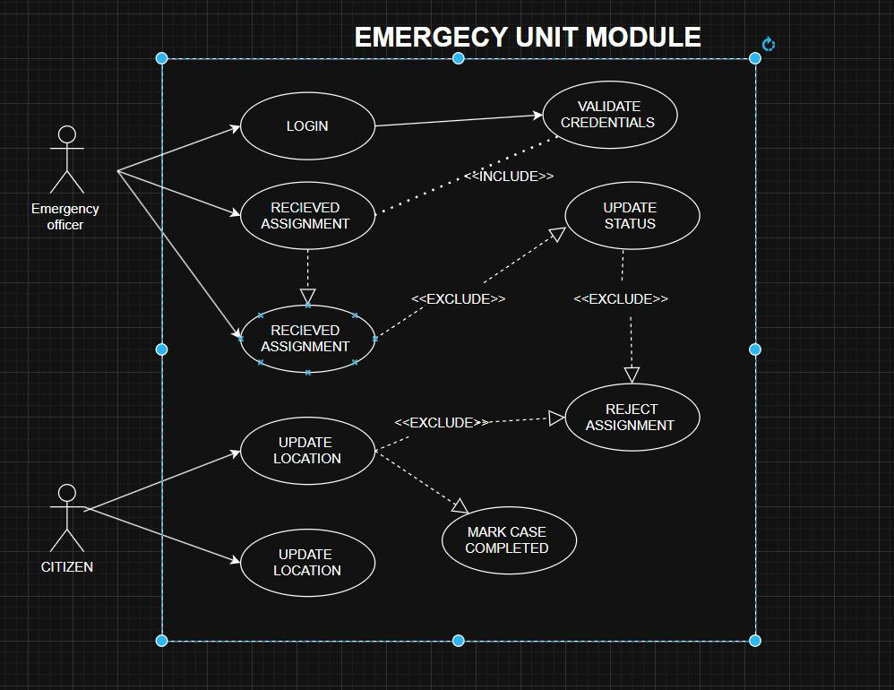

Use Case #1 – Request Emergency Service
Author – Project team
Purpose – Allows a user to request emergency assistance
Priority - High
Preconditions – User must be logged in
Post conditions –
- Emergency request is stored in database
- Vehicle is assigned
Actors –
- User
- System
Flow of Events
  - Basic Flow –
- User opens emergency request form
- User selects emergency request type
- User submits request
- System identifies nearest vehicle
- Vehicle is assigned to request
  - Alternative Flow – If no vehicles are available, the system displays an error message
  - Exceptions -
    - If the user is not logged in, the system redirects the user to the login page.
    - If the system cannot determine the user’s location, the user must manually enter the location

Use Case #2 – Manage Emergency Vehicles
Author – Project team
Purpose – Allows the administrator to manage emergency vehicles in the system
Requirements Traceability – F6, F7
Priority - High
Preconditions – Administrator must be logged in
Post conditions –
- Vehicle information is updated in the system database
- Vehicle status is updated accordingly
Actors –
- Administrator
- System
Flow of Events
  - Basic Flow –
- Administrator logs into the system
- Administrator accesses the vehicle management dashboard
- Administrator adds, updates or removes vehicle information
- System updates vehicle details in the database
- Updated vehicle list is displayed
  - Alternative Flow – If vehicle data entered is invalid, the system prompts the administrator to correct the information.
  - Exceptions –
    - If the administrator session expires, the system redirects to the login page
    - If the database connection fails, the system displays an error message and logs the faliure
Notes/Issues – Future versions may integrate real GPS Tracking for vehicles

Other Non-functional Requirements

Performance Requirements
P1: The system shall process emergency requests within 3 seconds
P2: The system shall support 100 concurrent users
P3: Vehicle location updates shall occur every 3-5 seconds

Safety and Security Requirements
The system must ensure that sensitive user data is protected:
Security measures include:
- Password encryption
- Secure login authentication
- Role-based access control
- Secure communication protocols

Software Quality Attributes

Reliability – The system shall maintain stable operation with minimal downtime and handle unexpected errors without crashing.

Maintainability – The system shall be designed using modular architecture so that new features or emergency services can be added easily

Usability – The system interface shall be simple and intuitive so that users can easily request emergency assistance without training

Other Requirements
Future system improvements may include:
- Mobile application support
- Integration with real GPS devices
- Traffic-aware routing
- SMS notification system

Appendix A – Data Dictionary

Term | Description
UserID | Unique identifier for a registered user
VehicleID | Unique identifier for emergency vehicle
RequestID | Unique identifier for emergency request
Latitude | Location coordinate
Longitude | Location coordinate
Status | Current state of request or vehicle

Appendix B - Group Log
Date | Activity | Members
13/02/2026 | Project topic discussion and selection | All members
20/02/2026 | Requirement analysis and feature planning | All members
25/02/2026 | System design discussion and architecture planning | All members
05/03/2026 | SRS drafting | All members
13/03/2026 | Final review and submission | All members

