REVIEWER 1 – NOTES
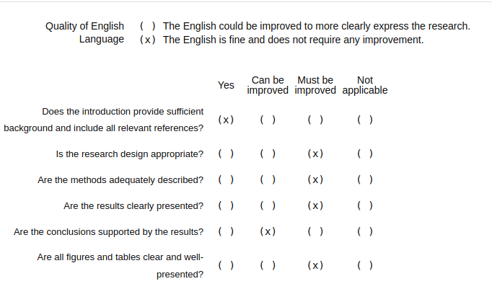
See pdf for the notes

REVIEWER 1 – ANSWERS
xxx

REVIEWER 2 – NOTES
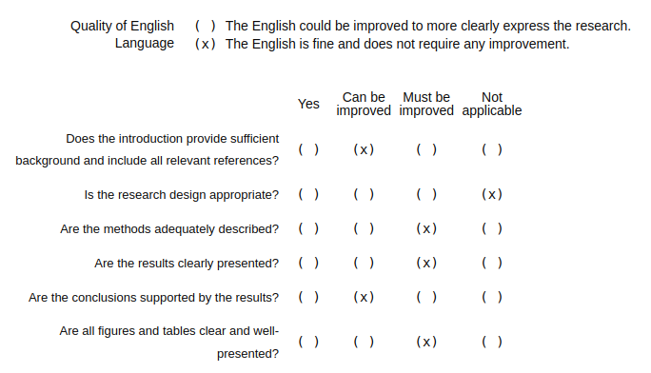
The article addresses an interesting topic that is also in high demand as a service today.
Unfortunately, it presents significant deficiencies and weaknesses in several passages that the authors should examine in great detail. The descriptions are incomplete, lacking references to the "reporting" aspect.
The descriptions of the examples also suffer from several important omissions. The cameras used to capture each type of information should be detailed, as well as the configuration aspects of the survey mission. There is no reference anywhere in the article to ground calibration panels, the need for GCPs, and a long list of other missing elements.
In light of the above, I have recommended Major Revisions to give the authors the opportunity to address the detailed observations in the attached file, which includes approximately 45 observations, most of which are highly relevant and should be considered thoroughly by the authors.

See also the pdf

REVIEWER 2 – ANSWERS
We thank the reviewer for his/her contribution. The paper have been rewritten in several parts to take in account the inputs received. We updated the manuscript to accept most of the notes, but we would like to address here a

REVIEWER 3 – NOTES
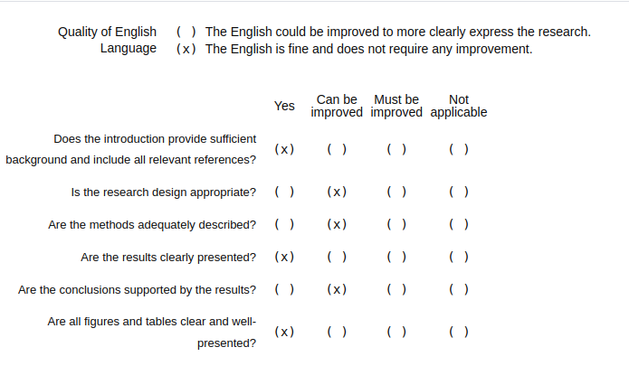
The DRONE2REPORT framework introduced in this technical manuscript presents a solution with considerable potential value for addressing the key challenges in UAV image processing for agriculture, including fragmented workflows and the integration of heterogeneous data. It holds notable theoretical significance and practical application value. The reviewers agree that the manuscript is suitable for publication in Drones after appropriate revisions. Specific comments are as follows:
- Unlike thresholding processing, the image analysis for studying the dynamic changes in crop phenotypes requires the pixel-level registration of images acquired at different time points and from different sources (e.g., different UAVs or flight missions for RGB imaging and thermal imaging). However, the technical framework does not clearly elaborate on the specific techniques adopted for this critical step.
- Although the GLI and HUE indices mentioned in Case Study 2 generally reflect the phenotypic trends of crops, they exhibit significant discrepancies. It remains unclear which of these two indices can accurately characterize crop growth status, or whether both indices contain inherent errors. Additionally, this case study fails to consider the interference of weeds with similar spectral characteristics on the framework’s application. Therefore, methodologies for quantifying and mitigating such inherent errors, as well as technical approaches for assessing the interference of weeds, are essential to validate the practical application value of the framework in this scenario.
- As noted in Line 333, the optimized vegetation indices may suffer from overfitting (as illustrated in Figure 7). Merely identifying this issue as a direction for future research is insufficient, and concrete solutions to address overfitting should be proposed and discussed.
- The discussion section reviews a variety of mainstream tools for UAV image processing, most of which feature user-friendly GUI interfaces. As acknowledged in the manuscript （Line480-483）, the DRONE2REPORT framework currently lacks such an interface, which may restrict its broader adoption and practical application. Thus, it is highly recommended to develop a GUI interface for the framework to enhance its usability and accessibility for end users.

REVIEWER 3 – ANSWERS
We thank the reviewer for his/her contribution. The paper have been rewritten in several parts to take in account the inputs received.
In general terms, the reviewer’s notes focused on the shortcomings of the case studies, them being insufficiently detailed from the technical point of view, and showing a simplified approach to complex problems. We understand that this is was limit in our exposition: the improved version of the paper highlights that DRONE2REPORT as a framework allows (and makes easier) the kind of analysis. The framework exposes and easy interface and makes coding the desired analysis easier and less prone to errors. This is especially useful in a field where custom solution abound, with the intrinsic burden of difficult reproducibility and chance of human error. As such it’s clear, we hope, the choice of propose this work in the form of a technical paper and not of an original research paper. In simple terms, we are proposing a software library and showing that it simplifies complex analysis.

More specifically:

- Unlike thresholding processing, the image analysis for studying the dynamic changes in crop phenotypes requires the pixel-level registration of images acquired at different time points and from different sources (e.g., different UAVs or flight missions for RGB imaging and thermal imaging). However, the technical framework does not clearly elaborate on the specific techniques adopted for this critical step.
SPIEGARE GEOREFERENZA PIÙ RESCALING

- Although the GLI and HUE indices mentioned in Case Study 2 generally reflect the phenotypic trends of crops, they exhibit significant discrepancies. It remains unclear which of these two indices can accurately characterize crop growth status, or whether both indices contain inherent errors. Additionally, this case study fails to consider the interference of weeds with similar spectral characteristics on the framework’s application. Therefore, methodologies for quantifying and mitigating such inherent errors, as well as technical approaches for assessing the interference of weeds, are essential to validate the practical application value of the framework in this scenario.
The reviewer is correct in pointing out the difficulties of the task. Indeed weeds are known source of ambiguity in UAV images. The scope of the case study, however, was to show the simplicity of computing standard vegetation indices on a per-plot basis, plus showing how it is possible to quickly compare various results. The actual implementation of an optimized index, or computer vision system, moves the target outside the scope of the framework.
- As noted in Line 333, the optimized vegetation indices may suffer from overfitting (as illustrated in Figure 7). Merely identifying this issue as a direction for future research is insufficient, and concrete solutions to address overfitting should be proposed and discussed.
We added a discussion about how to face the overfitting issue.
- The discussion section reviews a variety of mainstream tools for UAV image processing, most of which feature user-friendly GUI interfaces. As acknowledged in the manuscript (Line480-483), the DRONE2REPORT framework currently lacks such an interface, which may restrict its broader adoption and practical application. Thus, it is highly recommended to develop a GUI interface for the framework to enhance its usability and accessibility for end users.
We understand that not having a GUI can be seen as a limitation of the software. However DRONE2REPORT was designed as part of a server-side elaboration pipeline, where no GUI can actually be used. It is true that for the data analyst this could come as a restriction, and we are considering developing one. On the other hand, a graphical interface – an actually usable one – is a complex piece of software, and writing a rushed one within the required ten days for answering this review was just not possible.

