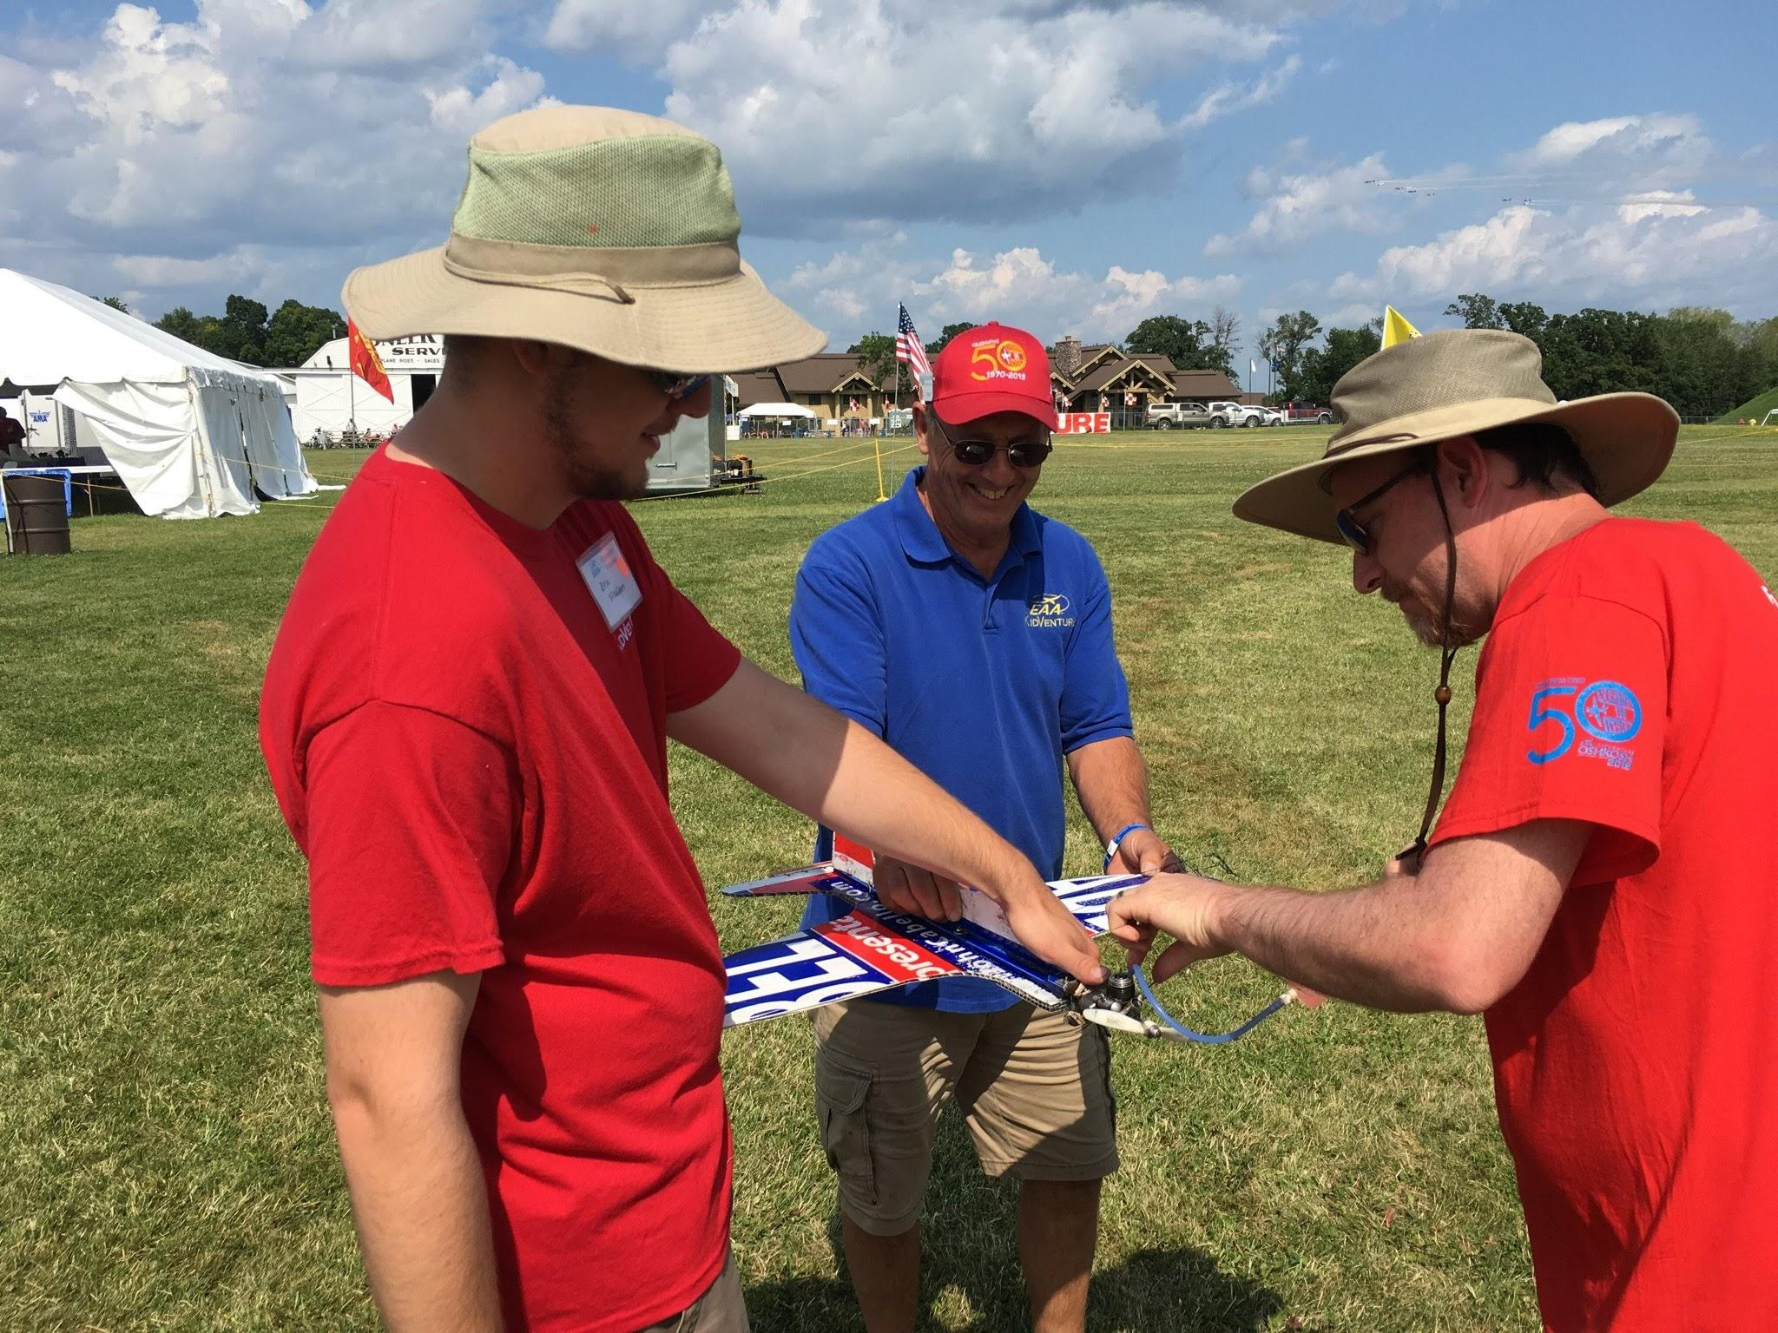


January 2020

Volume 1 issue 1
Circle Masters Flying Club  Wisconsin’s control line club |  | Summer Scenes
Announcements Jan 2020  Thanks Howard  Howard has been the newsletter editor for this publication for a long time. His devotion to the club and hobby is not to be doubted. Let’s hope Howard can get some time in the shop to build some airplanes. Love to see his gyros and his stinky diesels. Welcome Big How’s cutting wit to this forum |  | Inside This Issue  PG. 2 Editors notes Contact information  PG. 3 Plan of the months, cartoon, Media  PG. 4 Meeting minutes  PG. 5 Calendar  PG.6 Flying and building reports

Editors Notes  The newsletter will be undergoing some changes to make it easier for the editor to manage and for you to contribute photos (please!) and text. We will be using google docs so anyone in the club can add to a monthly installment. Also google docs makes it easy to get content into the web, and hardcopies. So send photos, flying reports or anything.  I plan on refocusing this on building and flying activities as well as full scale stuff in the upper midwest area. I have ideas for a few dozen issues, but I need contributors, or you may see a lot of pictures of my shop. |  | Club Information  Web site www.circlemasters.com  Dues $20.00  Flying Location  Sussex Village Park, Sussex. Wisconsin  Meeting First Saturday of the month 1pm  Location Summer (May- Oct) at the field  Location Winter Sussex Library  Comments to circlemastersflyclub@gmail.com
“Winter is building season please be safe in your workshop” |  | Pilot Briefing  Cold weather sends most of us into our basement shops fixing repairing old models and building new ones, A shop means sharp tools, volatile chemicals.  One thing that many don't think about is the danger of dust and allergies that build up over time. Modelers and woodworkers have developed allergies from exotic woods and the dust created by shaping and finishing.  Dust masks and dust collection is a good idea for protection. But one one thing to think about is ways to limit dust production. Never sand what you can carve, never carve what you can saw. Use the largest tool you can to limit the dust.

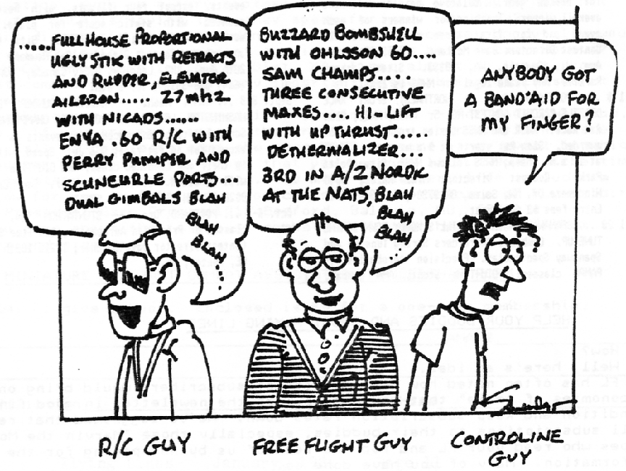  Cartoon |  | Flying the SR 71 Colonel (ret) Richard Graham  I am writing this Just before Thanksgiving. One Thursday a month EAA brings in a guest speaker. This is a free (for members) talk. The talks are getting more and more popular and this one was standing room only. Parking was filled on a cold Thursday night in November. Consider attending. It is a lot of fun.  Air Force Col. Richard Graham (Ret.) flew the Lockheed SR-71 Blackbird from 1974-1981. He has nearly 800 hrs in the type. He was the SR-71 Squadron Commander in 1981, later becoming the 9th Wing Commander at Beale AFB. Prior to flying the SR-71, he flew 210 combat missions in Vietnam in the F-4 and as a Wild Weasals pilot, trolling for surface-to-air missile (SAM) systems. Colonel Graham’s military decorations include three Legion of Merit awards, four Distinguished Flying Cross medals, and 19 Air Medals. He was the 1999 recipient of the University of Nebraska’s William F. Shea Award and in 2005 he was awarded the Kelly Johnson trophy  He gave riveting stories on what it was like to operate the aircraft and lead the squadron.  "SR-71 Revealed: The Inside Story"  "SR-71 Blackbird: Stories, Tales and Legends"  “FLYING THE SR-71 BLACKBIRD”
Aero Modeling has many disciplines. RC free flight control line, drone guys rocket guys. Many sub groups underneath them. While we may be different we are more alike than different and as our ranks continue to shrink, finding the common ground is important.

Club Events
Club Contest-- August
EAA Kidventure Late July
Sussex Antique Tractor and Steam Engine show August
Club Fun Fly and Picnic June
Christmas Party December

Plan of the month
From outerzone.uk berkey AT6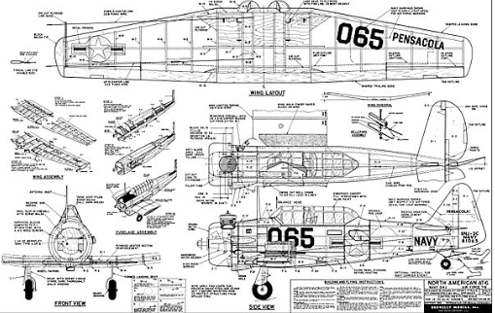

CIRCLE MASTERS FLYING CLUB
MEETING MINUTES for December 2019
The December meeting of the Circle Masters Flying Club was held at the World Headquarters of Geartec Inc. on Saturday the 7th. This meeting was preceded by a fine selection of Christmas pizzas prepared by the Geartec elves. In addition to the pizza the members and guests were entertained by the barber shop quartet voices of The Cream City Crooners. The actual meeting was hammered to a start at 1:37 PM by Pres. Chris. He began by asking if the members (15) had received the final issue of The Circulator (16 years) and had read the minutes contained therein. The members present acknowledged that they all received the newsletter and read the minutes, no runs, no hits and no errors were detected. The minutes stood as published.
The Treasurer's Report was presented by Wayne. His report was approved as presented.
REPORTS & ANNOUNCEMENTS: Chris inquired if anyone wants a new club shirt, he will put together an order; no one wanted a new shirt. Wayne reported on the approved dates for use of the Sussex Public Library meeting room. They are Jan. 4th, Feb. 1stand March 7th. The April 4th date was not available. In the event of nice weather, we can meet at the flying field and if not, Mike has offered his place. Wayne asked the members to pay their club dues asap: three members paid this day. Jason said the July 11th Saturday selected for a meeting must be changed as the Lions event will be using the area. The July meeting has been rescheduled for the 18th.
OLD BUSINESS: The subject of contest awards was discussed with several possibilities available. Since there is several months until the contest this subject will be revisited in the future. Don A. asked if there are any other members who would volunteer at the January R/C Auction. (Recorder could not hear discussion)
NEW BUSINESS: The indoor C/L flyer faction is currently seeking an indoor site.
WEBSITE BUSINESS: Dave explained the new format for the web site now under construction. Stay tuned for all the exciting changes.
OTHER BUSINESS: None.
There being no further business Chris as for a motion to adjourn and this was quickly moved and seconded. Meeting adjourned at 2:27 PM.
SHOW & TELL: Mike presented a beautiful example of a modified Gialidini designed Olympic.
Secretary Request: Please speak up at the meetings!!!!!!!!!!!
Submitted by Wayne M. Schmidt Secretary/Treasurer 12/18/19

January 2020
SUNDAY | MONDAY | TUESDAY | WEDNESDAY | THURSDAY | FRIDAY | SATURDAY
29 | 30 | 31 | 1 | 2 | 3 | 4
 |  |  |  |  |  | Club Meeting
5 | 6 | 7 | 8 | 9 | 10 | 11
12 | 13 | 14 | 15 | 16 | 17 | 18
 |  |  |  | EAA Adventure series Ice Pilot Scott Blue
19 | 20 | 21 | 22 | 23 | 24 | 25
 | Martin Luther King Jr. Day |  |  |  |  | South West regionals Phoenix saturday and sunday
26 | 27 | 28 | 29 | 30 | 31 | 1
R/C Auction & Swap Meet Washington County fairgrounds
2 | 3 | 4 | 5 | 6 | 7 | 8
NOTES
Club Meeting at Sussex Library
RC Swap meet see Don about sharing a table.

Out and About --December club meeting
The December meeting was held in conjunction with the club Christmas party.

Mike Strand again graciously offered to host the event at his company. Mike had his family and some of his employees making pizzas which we can't thank enough and were very tasty.

We used an online system to send out invitations and thank who was bringing a dish to pass. Twenty seven signed up but attendance was down a bit due to illness and last minute conflicts. Since the guest list drives the food order, we need to be accurate. Come on people. Even so the pizza and most of the trimmings were consumed.

Don Doss brought his barbershop quartet for our enjoyment between dinner and the meeting. It was very enjoyable.
Lots of visiting and catching up made for a happy day with a lot of smiles. Thanks again to Mike and his team for hosting.

If you missed this, well you missed a good time.
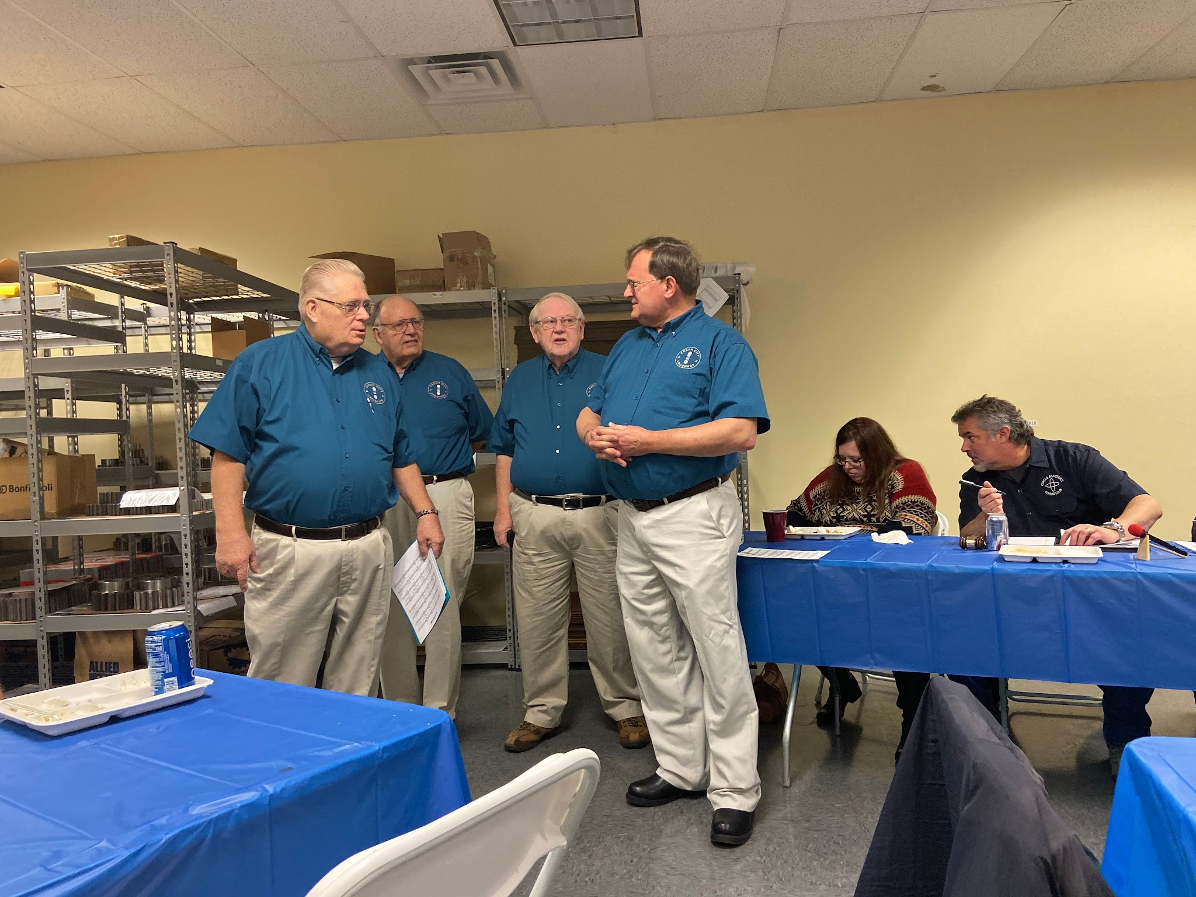

Right --Don Doss and the Cream City Crooners Barbershop quartet performing before the meeting
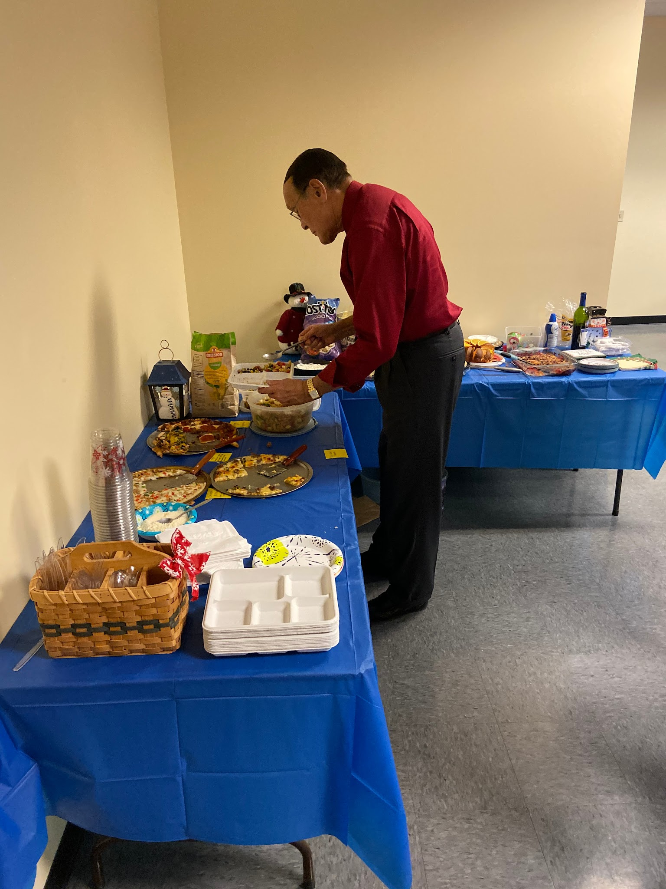

Left -- Like any good racing pilot Don navigates the food pits for more fuel efficiently. The fuel pits were visited frequently and many were fed.
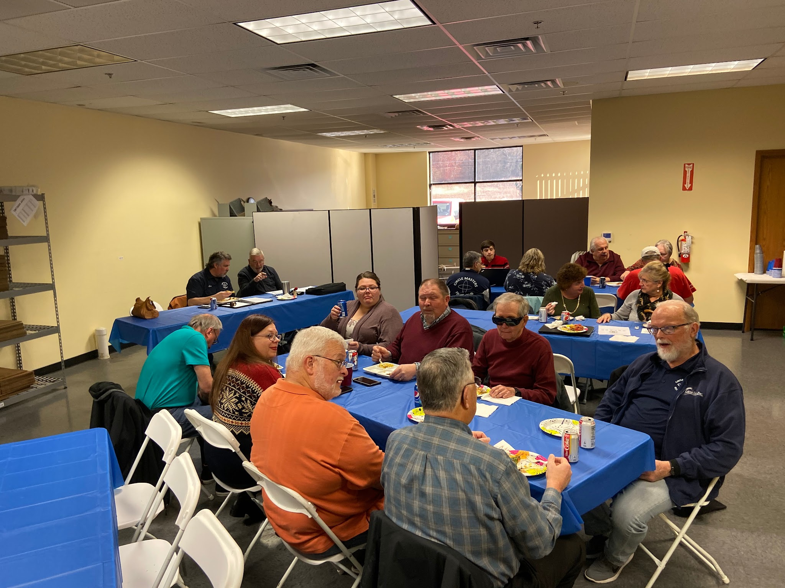
Right -- Getting ready for the meeting. The christmas party is a great time to catch up. It was good seeing Buzzy and the gang.

Caption Contest
Top Left -- What joke did Don just tell Randy? They all start the same “A Rat Race pilot walks into a bar….”
Top Right --Who ate all the pizza? “Who us? We didn't do it.”
Mild Right -- Chris tries to convince Wayne to swap a Harley panhead into a Bolens Lawn tractor as for a field mower for the park. Dennis (the sensible one ) stares off in disbelief.
Bottom Left -- Mike’s gorgeous Olympic based project. Big Olympic? GeoBold Olympic? GeoOlympicBolt? It looks like a winner
Bottom Right --Mike Strand our host and (sorry didn't get her name) Thanks for Hosting!

