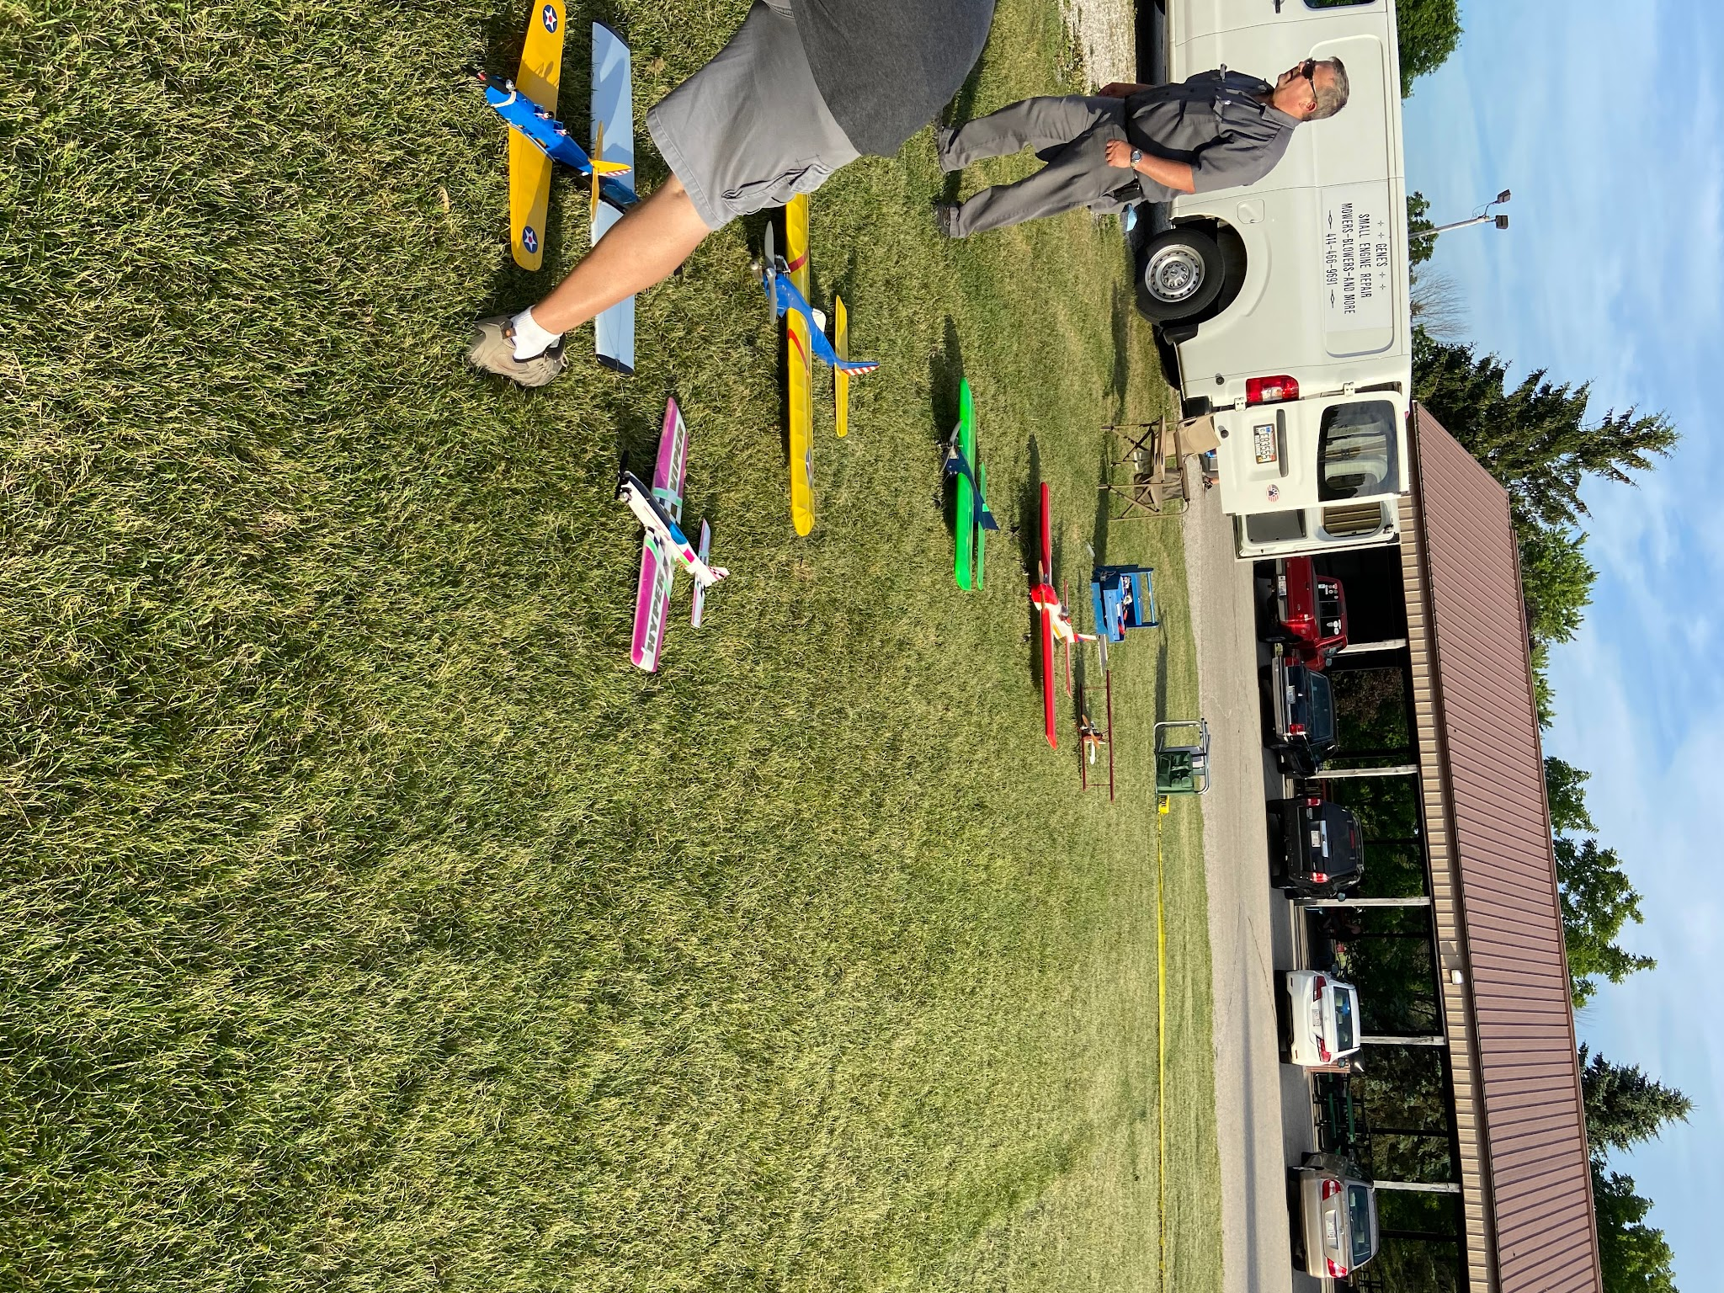

Volume 1 issue 9

Circle Masters Flying Club

Wisconsin’s control line club August 2020

Announcements  Picture today is of the flight line for the July meeting.  Wednesday night is Flight Night, come out and fly. In a social distancing way  Nats completed no scale and a lighter turn out than most years. Combat had high attendance.  Toledo RC show has ended after 58 years. |  | Inside This Issue  Contact information  Plan of the months  Meeting Minutes  Flying and building reports  Events

Editors Notes  It is also a time to remember that we are all humans and be kind to each other. One never knows when they need a shoulder to cry on. We are friends as much as club members.  In social distancing stooges are very important and can be tricky to use  Batteries can be dangerous, storage of fuel and batteries can make a bad decision even worse  Summer time is a busy time for all. Covid has made earning a living a real challenge, I am very busy all day The issues is later than I expect |  | Club Information  Web site www.circlemasters.com  Dues $20.00  Flying Location  Sussex Village Park, Sussex. Wisconsin  Meeting First Saturday of the month 1pm  Location Summer (May- Oct) at the field  Location Winter Sussex Library  Comments to circlemastersflyclub@gmail.com
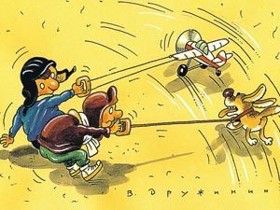  Dog Days of summer |  |   Stooge Safety  - Stake the stooge down securely  - Peg the down line at the handel so the plane will nose over if it self releases.  - Make sure the stooge attachment is solid on the airplane (guilty)  - Only ues Larry or moe never shemp or curly  - Hold your flying hand high and stooge line low when releasing to prevent tangles or weeds grabbing lines (guilty)  - Get clear of the stooge line to prevent tangling up your feet (guilty!)  - Yell ‘NUK NUK NUK’ when you release the airplane (always)  - Low stretch stooge release lines are safer.  - If the plane gets away do not grab the lines they will cut you badly

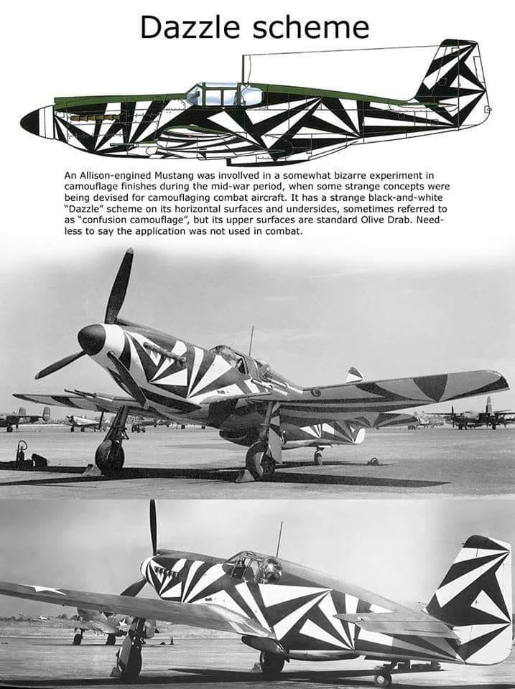 |  | Book Review    Air Apaches reconstructs the missions of the 345th Bomb Group in detail, with focus on the men who manned the cockpits, navigated the B-25s, dropped the bombs, serviced the planes, and helped win the war. To tell this story, Jay Stout worked closely with the group's surviving vets......  A great deal of history and heroism by a group of unsung heroes.

Club Events
Club Contest-- August
EAA Kidventure Late July
Sussex Antique Tractor and Steam Engine show August
Club Fun Fly and Picnic June
Christmas Party December

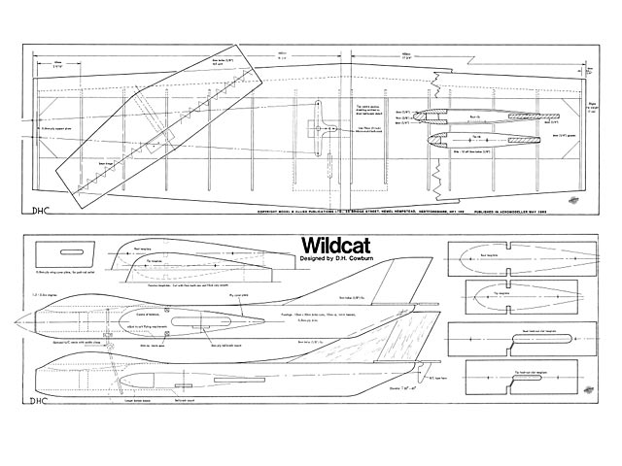
From the outerzone a small (.15) sized stunt trainer foam or built up.

CIRCLE MASTERS FLYING CLUB
MEETING MINUTES for July 2020
The July meeting of the Circle Masters Flying Club was held at the Dan Tetzlaff Flying Field on Saturday July 11th. The meeting was hammered to a start by Pres. Chris at 1:04 PM. Approval of the June minutes was given by the members. This was followed by the Treasurers report by Wayne. He reported only one transaction for weed control. The report was approved as presented.
Chris then introduced new member John Strobel, a resident of West Allis and former control line flyer.
REPORTS & ANNOUNCEMENTS: Wayne reminded the members to be sure to check their email as a new Roster was sent out on June 16th. (Secretary Note: a revised roster will be sent out by the end of July which will include the new members.) Dave reported that for the first time the Toledo model show has been cancelled for good. This show has run continuously for 65 years.
OLD BUSINESS: Pete, the Contest CD, began a discussion on the club contest. He said that so far, based upon the responses received, participation will be lower than anticipated which will barely offset the cost to put on the contest. The virus crisis could lower it even more. Pete asked for and received a vote to cancel the contest. Since the site remains reserved it was proposed to use the date for a club “Fun Fly” and meeting. (Sec. note; Due to the High School moving its graduation ceremonies to Aug. 2nd the Fun Fly was moved to Saturday Aug. 1st.) Start time for the meeting will be 10:00 AM.
NEW BUSINESS: There was no New Business.
WEB SITE/FACEBOOK BUSINESS: Dave reported that there was a lot of hits from Russia. Dave is also looking for any newsletter info.
OTHER BUSINESS: Chris briefly discussed the Trifold that Don Doss has been revising and updating. He passed around sample copies for all to check out. Don did an awesome job on these.
Meeting adjourned at 1:34 PM
SHOW AND TELL: There was no show and tell for this month.

Submitted by Wayne M. Schmidt Secretary/Treasurer 07/27/2020

Control Cline Capers -- At the field July 2020
No captions this month. Really pretty skies and fun times,



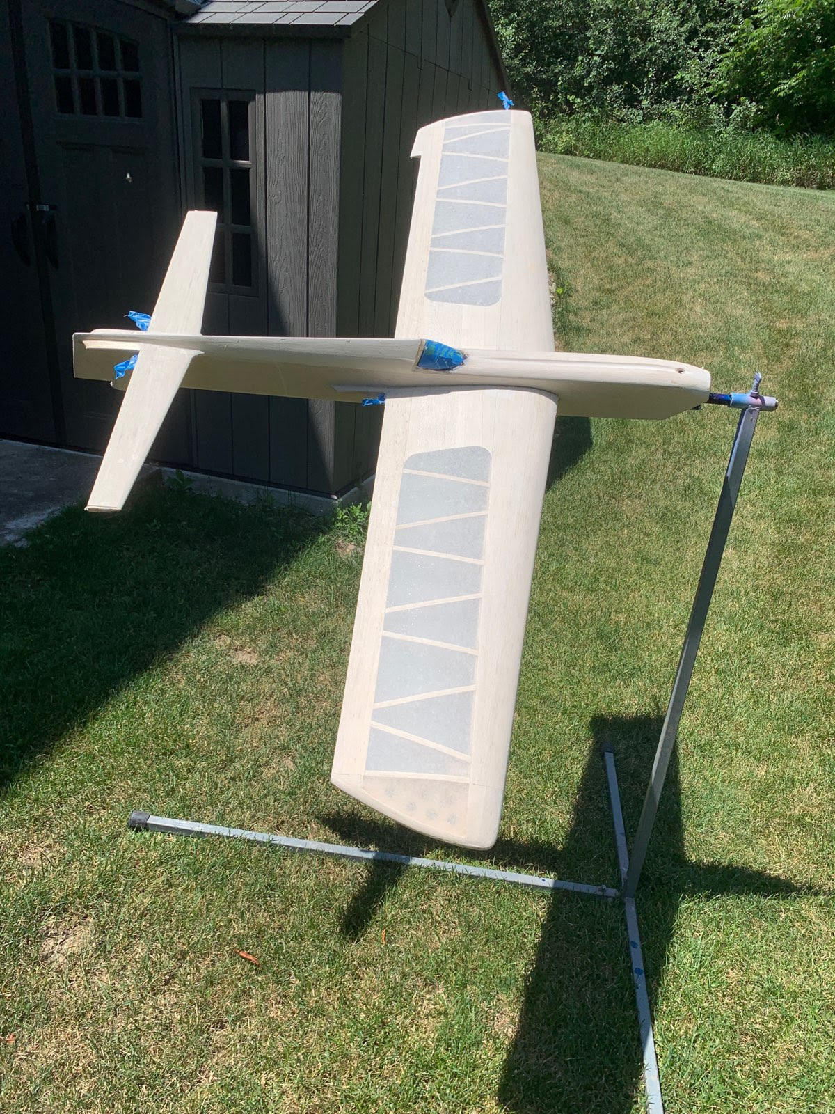

Aero 35 By wild Bill from MAN
The dream of numerous powerplant experimenters seems to have come true with the Aero 35; Wild Bill gives you his personal reaction.
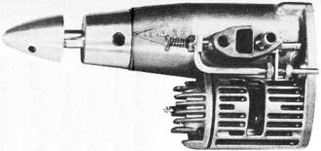
At infrequent intervals during the life of our hobby someone takes an outstanding technological step upward. The Aero 35 is an example. We went to the Buffalo plant for the following observations.
Mr. Auggie Savage and John Piston (who better to design engines?), worked 20 years and built 45 test engines before obtaining the perfection necessary for a production version. This engine has been thoroughly bench run, endurance checked, crash and flight tested.
Basic desire behind the departure from standard was a truly streamlined engine, to be used by scale builders and special types. However, the engine is also exceptionally vibration free. Since the piston reciprocates parallel to the shaft, its vibration is applied along the fuselage, rather than normal to thrust line. It is quite easy and natural to absorb this vibration. R/C and Stunt types will reap benefits from this. The engines we ran at the plant were exceptionally smooth, compared to the finest balanced standard engine.
The basic transfer motion of piston reciprocation to crankshaft rotation is unique, but not radical. It is well engineered, based on sound geometry and entirely practical. It goes something like this.
Connecting rod is an L shaped part with connection into the piston via a slipper block, a ball socket mating with a fixed bearing in the crankcase and a pin bearing through a slanted hole in the crank shaft (see sketch). In the piston joint, 3 degrees of freedom exist - vertical rotation, vertical linear motion and horizontal rotation. Simply stated, the piston pressure forces bottom end of rod (1) to move in an arc about the ball socket (2). Geometry is established to minimize the vertical travel of (1). This motion is translated into vertical force at the crankpin (3), which becomes rotary motion since the pin is restrained by the shaft.
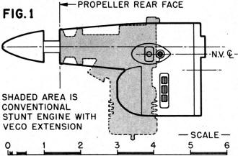
"A brand new concept In miniature two-cycle engine design" sez WBN. This version Illustrated at the right is the R/C Throttle model. Look for smaller and larger motors from same outfit.
Actually this same force transfer pattern is applied in a conventional engine, except the Aero formula translates it another 90°. Ball joint (2) is on shaft center line so the crank pin travels as an element of a cone (sweeping about·300). The bottom end (1) travels vertically approximately 0.050" total and the piston rotates about 10° each side as the plane surface (1, 2. 3) reciprocates. These slight extra motions do not appear to decrease power and all points of wear and strain have been adequately designed.
Bore/stroke ratio is 1.21, which is in line with racing configuration. However, intake bore of 0.177 inch diameter (0.0246 sq. in. area) is in line with stunt design. Intake shaft timing and cylinder port timing are conservative to make the engine easy to operate for everyone. Compression ratio is a mild 8:1. Basic version performance typical of stunt 35 performance, 10,000 rpm on 10x6. Top Flite, mild fuel. However, there are tremendous possibilities here for hop-up.
Construction: Basic crankcase is a one piece aluminum die casting. Alloy steel cylinder liner is accurately located and cast into the case giving intimate physical contact for best heat transfer and rigidity. Shape and method of coring yields a clean casting with very little flash, which is neatly trimmed. Shaft end is precision machined to receive ball bearings with a light press. Cylinder cooling fins are cast in a line parallel to crankshaft center line. Twin exhaust ports are vertical and normal to engine center line.
The Aero 35's crankshaft departs from standard practice in several ways. It is machined from 2024-T4 aluminum bar stock. The thru portion is ground to 3/8" diameter to press lightly thru the ball bearings. Rear portion has a concave cavity, an angular hole with pressed-in bronze bushing to receive the connecting rod pin and a milled recess to form the intake rotary valve. Rear diameter is ground to close tolerance since it runs in close contact with crankcase walls.
Static balance is simply effected by drilling a (3/16) diameter hole along side the rod bearing. The wall is relieved, except around the intake port which has a raised machine pad to effect sealing. Forward end contains a flat which registers the 1/4-28 set screw that locks the propeller drive shaft. Prop drive shaft is a 2024-T4 screw machine part utilizing a 5/16 shaft. Rear boss carries through the crankcase diameter, smoothly fairing this line. Prop nut is an aluminum piece shaped and threaded to mate with prop shaft. It is tightened with a 1/8 diameter rod through a drilled hole. Total effect of front end is a continuous streamlined shape requiring no spinner.
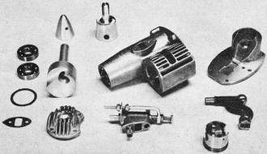
The innards of the Aero 35 tested by Netzeband. Note crankshaft shape, connecting rod on right. simple throttle in foreground, twin ball-bearings and neat castings. Ten and one-half ounce powerplant sells for $34.95.
The cylinder head is an aluminum die cast part, utilizing four 4-40 attaching screws, an asbestos-composition gasket and receiving a long reach glow plug. Internally the head fits into the cylinder forming a cone-shaped combustion chamber.
The piston is an aluminum die casting. Machining consists of 2 annular ring grooves, OD grind, and a 7/16" dia. reamed hole to receive the rod slipper block. Perfect Circle piston rings are installed. Piston is flat top configuration with no baffle plate or dome shaping involved. Stiffness is assured by cast-in webs and relatively husky side walls. Piston rings are installed with fairly high expansion loading, so the manufacturer recommends rich running for the first hour until the rings wear in. Top bypass is directly into crankcase, the other is on bottom of engine. Fuel transfer distance is much shorter than on conventional mills.
The back plate is an aluminum die casting. It contains a pressed-in ball socket of special sintered-oil impregnated porous bronze to support the transfer point of the connecting rod. The mating surface is precision machined to flatness and the assembled joint requires no gasket. The backplate reaches into the crankcase, effectively packing the unused area for highly efficient fuel transfer. Engine is mounted by two #6-32 screws into a firewall type mount. Backplate also contains a screw adjustment for final assembly of connecting rod.
The connecting rod, which is the heart of this engine, is an "L" shaped 4130 steel forging, heat treated for extra strength (see sketch). Piston-end connection is through a 5/32 diameter hole and a roll pin thru the slipper block. At the transfer point a precision ball is pressed onto the rod, and the crankshaft pin is precision ground to 7/32" dia. The slipper block is machined from alloy steel ground stock, receiving a longitudinal milled slot and a radial 5/32" diameter hole. The roll pin supporting the rod is pressed into the slipper block, so all motion occurs between hardened steel surfaces of roll pin and connecting rod.
The intake body is extremely well designed featuring a clean-unobstructed venturi throat connected on each end to rectangular opening of generous size. The needle valve does not have the usual small diameter needle, rather it utilizes a tapered end from 0.220 to 0.190 inch dia. in approximately 0.150". It meters very accurately. Anti-rotation device is a nylon set screw driven into the side of the needle valve threads. This arrangement allows smooth settings, and positive lock. Fuel enters the throat thru a 0.018 inch dia. hole. There is sufficient material to open the venturi throat to 0.25 square (0.063 sq. in. area), which should gulp enough fuel for any combat or R/R type. Intake body is attached to crankcase with two 4-40 screws with Nylok buttons utilizing a thin composition gasket for perfect sealing. The needle valve is 2-3/4" from the prop eliminating barked knuckles.
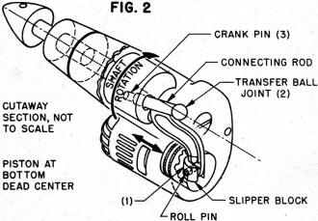
Piece de resistance is an exceptionally simple and effective throttle. Basically a rod of 3/16" dia. containing a needle valve down its center line installed in a hole parallel to the regular fuel inlet. This is parallel to shaft center line. Fore and aft motion restricts the venturi throat and the throttle needle can be adjusted for proper low speed mixture. Two Elastic stop nuts adjust open and closed positions. Travel is same as throat diameter but a simple bellcrank can adjust the throw of your throttle system to match. The test engines throttled very well, with no foolishness.
So, what have we here? It is different, but with a purpose. The Aero 35 will probably be scaled up and down, It fits a fuselage 1-5/8" wide and 2-1/2" deep. It is 3.85" from back to prop. As built, it is docile, rock steady and easy to handle. However, hop-up artists should be able to make a tiger from her since: the aluminum shaft is easily worked, the bypass distance is exceptionally short, the bore-stroke ratio is there, the light piston and rings are right and balance is no problem. The engine has something for all, even if you're just interested in things excitingly different.
One last note. We just barely have loosened up our sample. It runs easily, starts well and shows good potential. With a close press deadline we selected to tell you about it right away. We witnessed factory runs, tach'ed them and observed said running.
The demand for the first engines is brisk, with good reason. You will have to change some of your ideas on nose shapes, 'cause this engine can be exotically cowled, beside being very good looking out there in the breeze.
This 10-1/2 ounce engine is $34.95 in regular version, $40.90 with throttle. The patents in U.S. and 6 foreign countries have been approved. Manufacturer is Aero Research and Development Co., Inc., 51 Great Arrow Avenue, Buffalo 16, N.Y.

Stolen from the internet part 6:
Obi MapuaStunt Team Palermo
From the Philippines: We had a disaster in our aircraft storage shed. A battery caught fire, burned the plane, and dropped on the fuel storage bin. All the Control Line combat models are gone, most of the F2B models also, especially those we took to the Worlds and were taking to Poland. Several RC scale models, including a 1/3 scale Decathlon are ashes. Lesson: Please separate batteries from fuel!

