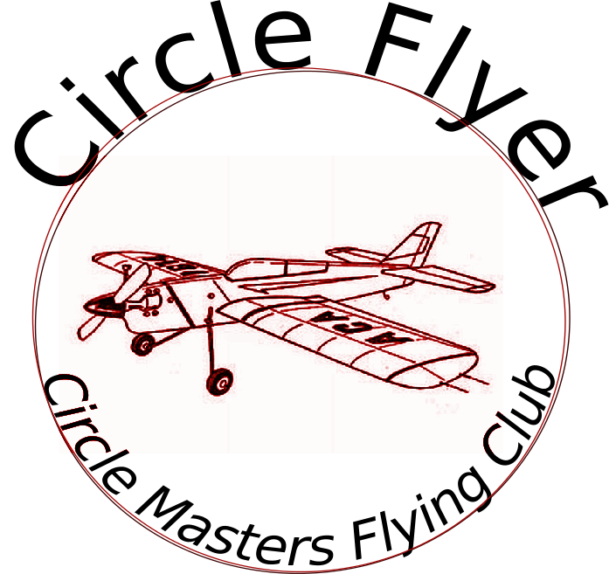
Volume 1 issue 11

Circle Masters Flying Club

Wisconsin’s control line club November 2020

Announcements |  | Inside This Issue  Contact information  Plan of the month  Meeting Minutes  Flying and building reports  Events

Editor’s Notes  Dave Siegler AMA 720731 circlemastersflyclub@gmail.com |  | Club Information  Web site www.circlemasters.com  Dues $20.00  Flying Location Sussex Village Park, Sussex. Wisconsin  Meeting First Saturday of the month 1pm  Location Summer (May- Oct) at the field  Location Winter Sussex Library  Comments to circlemastersflyclub@gmail.com

Strange Bird |  | Movie Review
Control line car with throttle and brakes |  | Club Events  Car show demo flights on the ball field August 29  Wednesday Night Flights- 3- dusk  Christmas Party December  Stay tuned for 2021 events.

CIRCLE MASTERS FLYING CLUB

Control Cline Capers --

