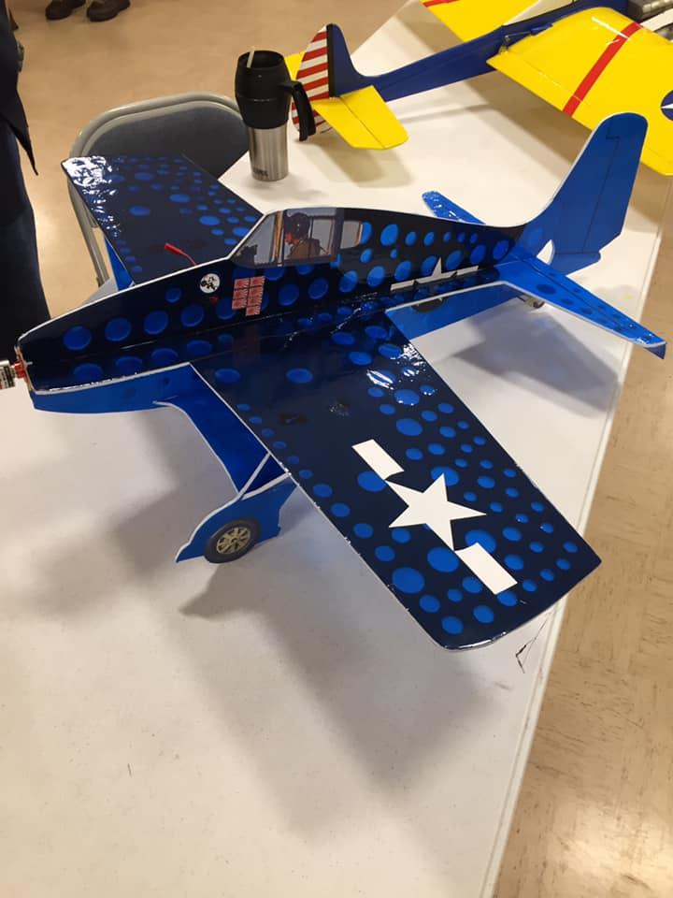
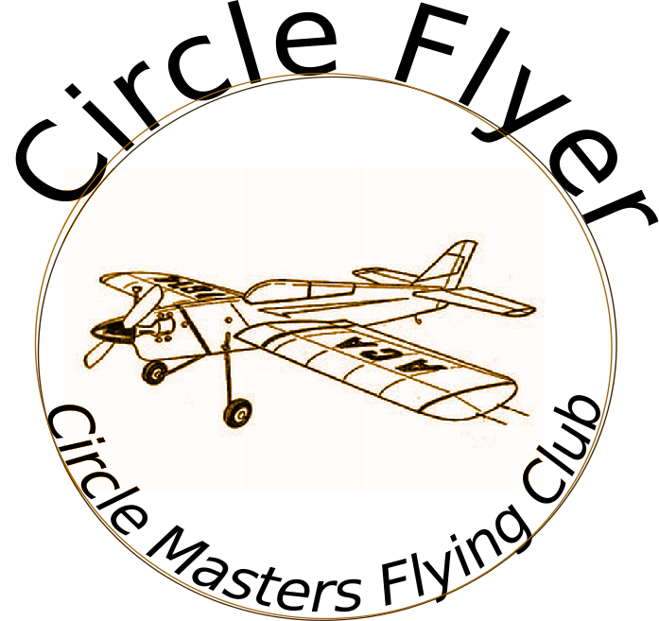

Circle Masters Flying Club  Wisconsin’s control line club February 2020 volume 1 issue 2 |  | Lifetime Member Bob Gidildi
Announcements  Its cold out. In this issue we have a description of goodyear racing in Southern Cal that I picked up from the NAG weekly newsletter.  Also started a media section. Have a good book, movie, website? We will list it and share. This is your newsletter, not just mine. Contributions make it more diverse, fun and long lasting. It looks like EAA is trying to combine their family flight fest with the popular skiplane fly-in this month. Nat Winner Sean Eliot is type rated in b-29 and will talk about flying one as well |  | Inside This Issue  PG. 2 Contact information  PG. 3 Plan of the months  PG. 4 Meeting Minutes  PG. 5 Event Calendar  PG.6 Flying and building

Editors Notes  As a change I am going to try to add a technical section most months. This will be a few photos and text about some subject or project. Next month I am going to discuss simple Solid modeling (3d CAD) and how it can be used in airplane construction.  Show Us Your Shop (SUYS)- I would like to add a section to show all of your work areas. This would run several times a year. Send in pictures and a brief write up on the tools, stuff and junk in your shop. |  | Club Information  Web site www.circlemasters.com  Dues $20.00  Flying Location  Sussex Village Park, Sussex. Wisconsin  Meeting First Saturday of the month 1pm  Location Summer (May- Oct) at the field  Location Winter Sussex Library  Comments to circlemastersflyclub@gmail.com
“I don't have a Chipmunk I have a PT 26 ” |  | Pilot Briefing  I ran into a former member at an EAA event. I recognized him, But he didn't remember me. I reminded him I bought your old Chipmunk. He looked puzzled. “I never had one, I fly a PT 26” he said. “No I replied the control line one one that Bert Rutan signed”. Then his eyes lit up.  I was talking to Col (CAF) Mike Woods. Former stunt flyer. He is spending his time flying the Commemorative Air Force’s PT 26 out at Waukesha. I passed on a big hello from all of you.  If any of you have a spare $100 or so he can give you a flight in that bird.

Carrier judge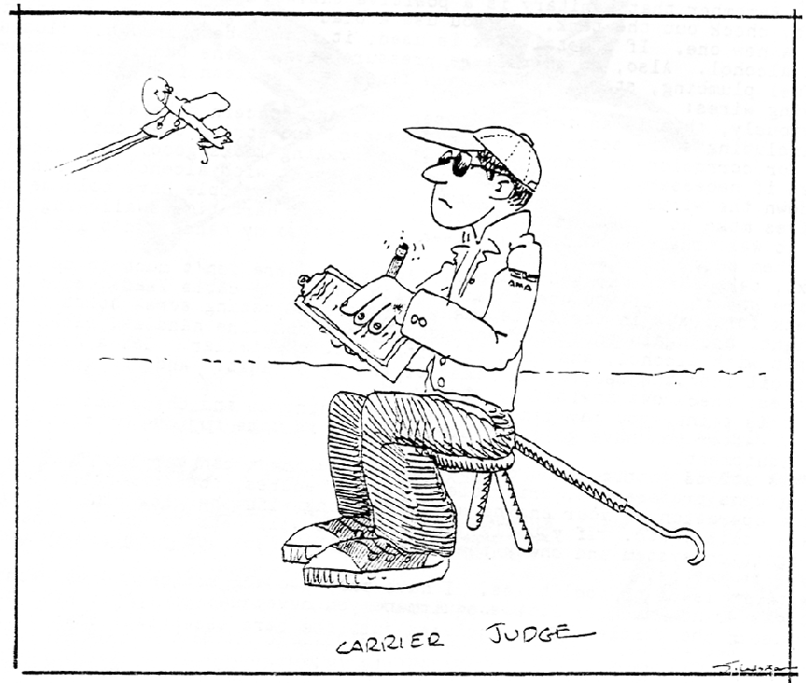 |  | Media  I read a lot, listen to a lot of audiobooks and podcasts. Since 2019 was the 50’th anniversary of the Moon landing, Here few books that are worth reading.  “Failure Is Not an Option: Mission Control From Mercury to Apollo 13 and Beyond” By Eugene Kranz (the guy in vest in mission control)  “The Apollo Guidance Computer: Architecture and Operation” Frank O’Brian ( technical read on how the computer system was developed from scratch)  “The Man Who Knew the Way to the Moon” Todd Zwillich. ( great story of John Holbt that figured out the system used by Apollo )  Got a good book? Lets share book lists.
CD’s and judges are an important part of any contest. .The judges often get into it as much as the contestants. Hope he catches the 2 wire.

Club Events
Club Contest-- August
EAA Kidventure Late July
Sussex Antique Tractor and Steam Engine show August
Club Fun Fly and Picnic June
Christmas Party December

Plan of the month
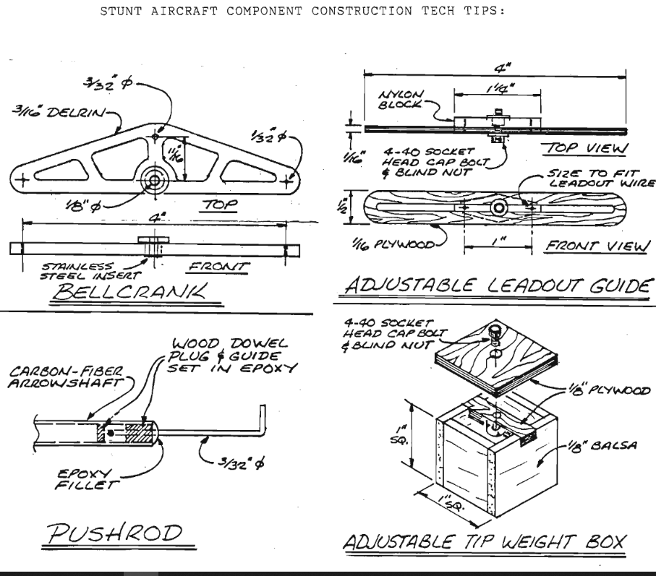

CIRCLE MASTERS FLYING CLUB
MEETING MINUTES for January 2020
The January meeting of the Circle Masters Flying Club was held at the Pauline Haas Public Library. The meeting was hammered to a start at 1:05 PM by Pres. Chris. He began by asking if the members (10) had received the first issue of The Circle Flier and had read the minutes contained therein. The members present acknowledged that most had received the newsletter and read the minutes. No errors were detected. The minutes stood as published.
The Treasurers Report was presented by Wayne. His report was approved as presented. Also: CLUB DUES ARE DUE NOW!
REPORTS & ANNOUNCEMENTS: Wayne reported that the Field Grant application has been submitted to the AMA. It would have been sooner had the AMA provided an easier application process. The club can expect a grant of approximately $75. Wayne reported that the last of the tri-fold Circle Masters pamphlets are available to anyone who can place them in appropriate locations.
OLD BUSINESS: Pete reported that he has filed for the sanction and insurance with the AMA for August 2nd. Wayne made a plea for more contestants in “Fun Scale”. It is easy, cheap and fun. We need more competitors in scale. Mike discussed the indoor flying status with various options for sites. At present there is some questions regarding insurance coverage for the site. Chris and Mike will continue to pursue this project.
NEW BUSINESS: Pete questioned when we can once again begin “Tuesday Night Flights”? Chris reported that Jason was checking as to when the disc golfers will be in the area.
WEB SITE BUSINESS: Dave was not at the meeting as he was dropping off his son at O’ Hare.
OTHER BUSINESS: None.
There being no further business Chris asked for a motion to adjourn the meeting. It was quickly moved and seconded. Meeting adjourned at 1:45 PM.
SHOW & TELL: Mike showed his canopy form and discussed how to make a “plastic” canopy.
Secretary Request: Please speak up at the meetings!!!!!!!!!!!
Submitted by Wayne M. Schmidt Secretary/Treasurer 01/08/2020

February 2020
SUNDAY | MONDAY | TUESDAY | WEDNESDAY | THURSDAY | FRIDAY | SATURDAY
26 | 27 | 28 | 29 | 30 | 31 | 1
 |  |  |  |  |  | Club Meeting
2 | 3 | 4 | 5 | 6 | 7 | 8
Super Bowl
9 | 10 | 11 | 12 | 13 | 14 | 15
16 | 17 | 18 | 19 | 20 | 21 | 22
 | Presidents' Day |  |  | EAA Sean Eliot flies DOC and B29 in combat | EAA Winter Flight fest ski plane fly in | EAA Winter Flight fest ski plane fly in
23 | 24 | 25 | 26 | 27 | 28 | 29
EAA Winter Flight fest ski plane fly in  ISOLATED stunt speed St Louis |  |  | Ash Wednesday
1 | 2 | 3 | 4 | 5 | 6 | 7
NOTES

Formula Unlimited Shoestring—by Dave Hull

There is a category for larger racing planes that has seen many variations and also evolved over the years. These have always been “local rules” events. Many are based on the old Goldberg kits for the Shoestring, Buster and Cosmic Wind. (Kit #’s: G9, G14, and G17.) These are all “.35-sized” profile sport/stunt planes. When combined with a rule to restrict the engine to a stock Fox .35 Stunt, it became FoxBerg. But racers being racers, the push for something new with more performance eventually led to an event in the southwest called Formula Unlimited. The airframe rules were written around the Goldberg kit dimensions using a minimum of 390 square inch wing area and 12% thick airfoils, but the engine rule was changed to allow more horsepower. Either of two approaches was now legal: any non-Schneurle ported ball bearing engine up to 0.40 cubic inches displacement as long as it is not ABC/AAC/ABN; or, plain bearing Schneurle engines of any construction. With that rule change, it became a horsepower event for strong pilots. Some might chuckle a bit at the stated purpose of the event, as written into the rules: “The intent of this event is to provide an entry-level introduction to control line racing for the beginner and intermediate level flyer.” This certainly was true before the engine rule change, but afterwards….?

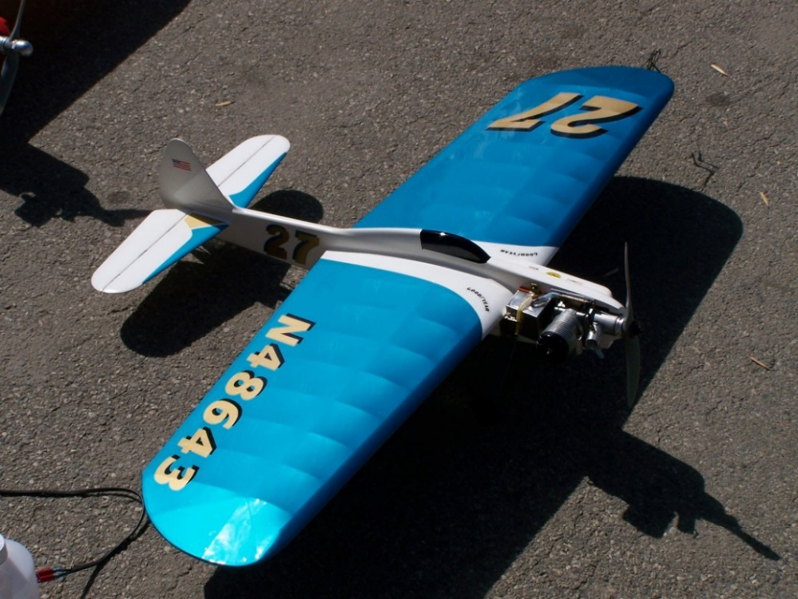
I built an Unlimited back in 2006 so I could race it both at Napa and in Tucson, at the now-defunct Cabin Fever spring contest. I started with a Goldberg Shoestring—because I like Shoestrings, and it was what I could get. I picked an HB .40PDP engine which was doing well for some of the other competitors. But it is a monster boat anchor of a motor. PDP stands for Perry Directional Porting (not Pretty Darn Porky), which was an improved porting configuration that some engine builders were using—notably SuperTigre—before the Schneurle configuration just about wiped everything out due to its added power and the improved efficiency. More efficient because it dumps so much less fuel mixture out the exhaust and manages this without the baffle on the top piston that the older cross-flow engines had.
Figure 1. The Perennial Shoestring race plane! This time built for SCAR/ACLA Formula Unlimited rules by Dave Hull. Shown here after a couple of races and after adding the rest of the trim. Finished with MonoKote (teal, gold, black) and KlassKote (gloss white) for durability. (Photo by the author)

My particular ‘Shoe has not flown a lot, but it has done pretty well with second places in highly contested races in Tucson and Napa. Still, race planes with monster motors take a beating, so yes, it does have stress cracks in the fuse/wing joint. But there’s lots of life still left in it.
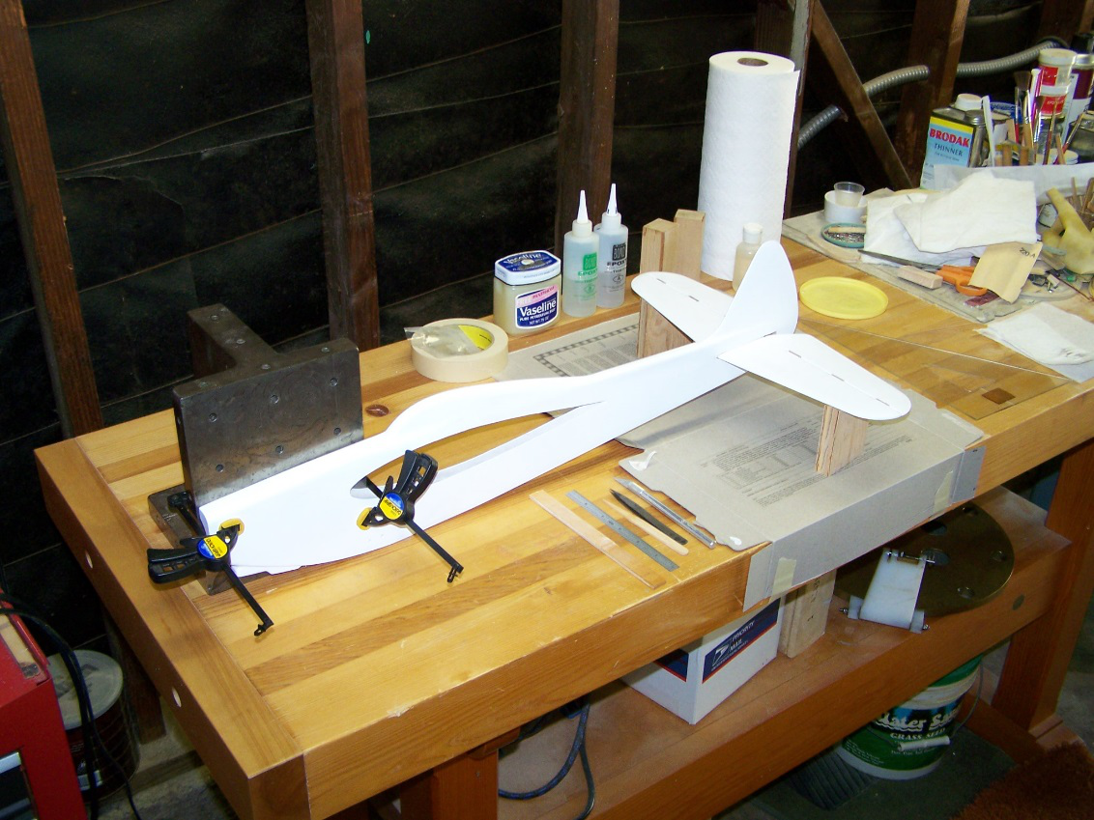
To achieve sufficient durability, you need to use a firm balsa plank for the fuselage. Then use real 5-ply aircraft grade plywood—a full 1/8” thick. The cheek cowl really helps stiffen up the nose too but since it won’t want to flex, it is where the stress cracks will start. And the fuse/cowl/wing joint needs to fit very well or you can expect problems. Stuntwood is not going to cut it for the leading edge, the planking, or the center ribs. Be sure you figure out how to install a foolproof engine shutoff as you do not want to keep flying the beast after the race is over. That’s just more wear and tear on the airframe and pilot.
Figure 2. The Shoestring jigged up to align the horizontal stab for gluing in place. The front of the fuse is clamped firmly to a machinist’s knee after the thrust line is set parallel to the flat bench top. Then, a pair of height blocks are used to get the stab level. Not shown, but the easiest technique to get the stab on straight front-to-back is to use a sliding T-bevel set to the angle of the leading edge taper relative to the sides of the fuselage. Then just compare one side to the other. When aligned, the stab fit should still be free, as anything that is force-fit will not come out straight when released from the setup. (Photo by the author)

My model has 1/2 oz. glass over the fuse and fin (together), and also over the horizontal stab and elevators. This is laid down using E-Z Lam 30-minute low viscosity epoxy. The wing was covered in teal MonoKote and then epoxied into the fuse. I used KlassKote fast white primer (#55, #420 catalyst) which is really great stuff. It sands very well after a short cure. I followed with KlassKote white topcoat (#100, #405) which also extended over the edges of the MonoKote on the wing after masking and then scuffing the MonoKote with a ScotchBrite pad. Trim was done with gold and black MonoKote using an iron, not the trim solvent, plus a few stickers to make it look more like a full-sized racer. Those always seem to be plastered with sponsor logos. I buried the stickers under some KlassKote clear, which is almost clear, but not quite. Over white, you get a bit of a yellow tint. But hey, this isn’t stunt Concours, this is racing!

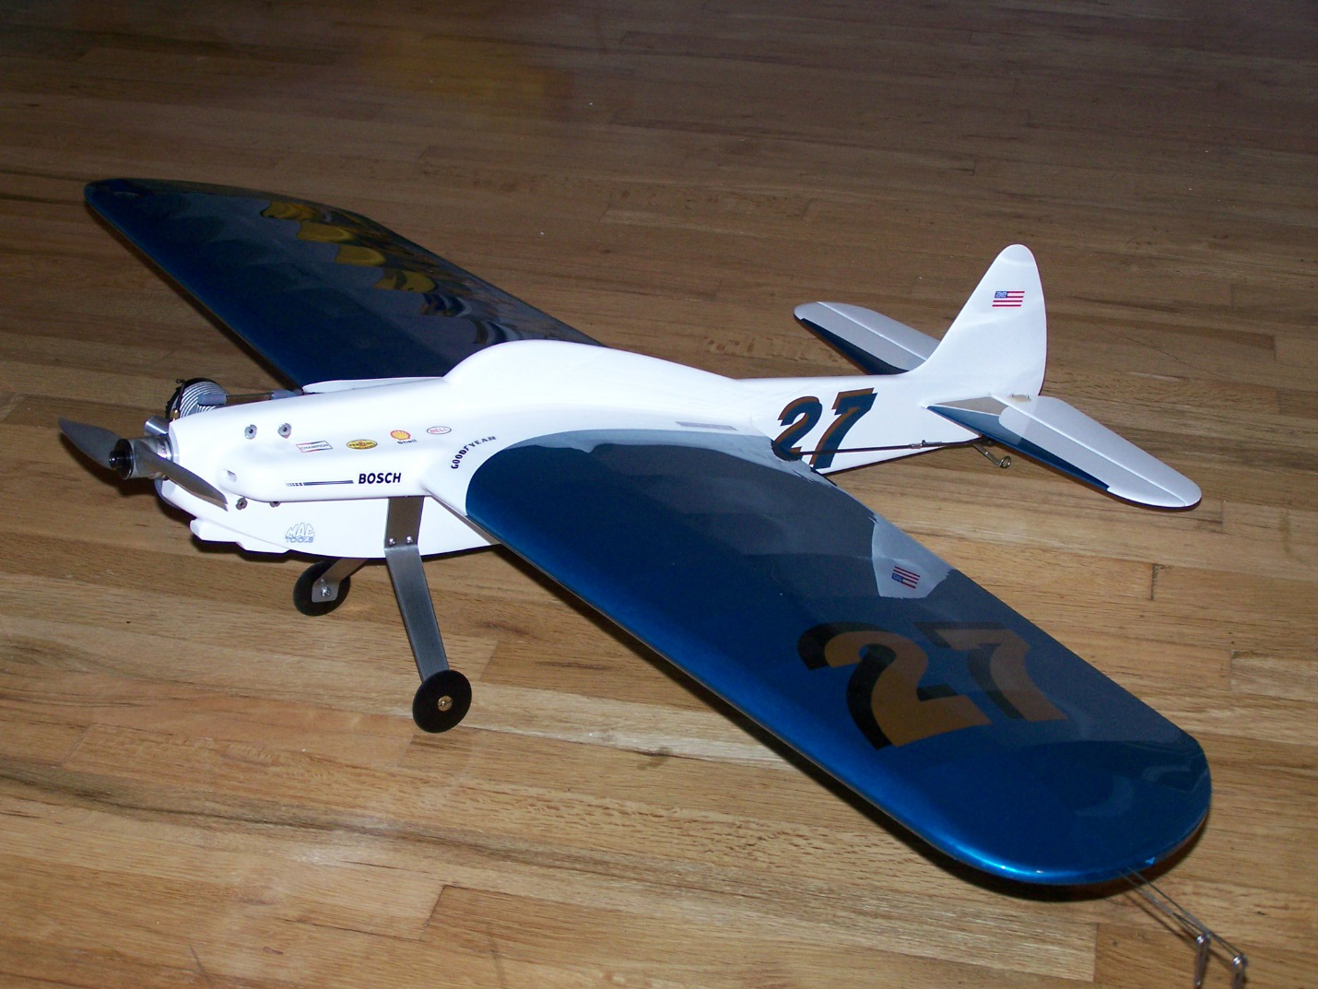
Figure 3. An early photo before the canopy was painted in and the rest of the numbers added. Of note is the titanium landing gear. This location turned out to be too far aft, and the plane would nose over when the elevator effectiveness was lost as it slowed down on the landing roll. A narrower, reduced drag set of titanium gear legs were subsequently added in a more forward location. (Photo by the author)
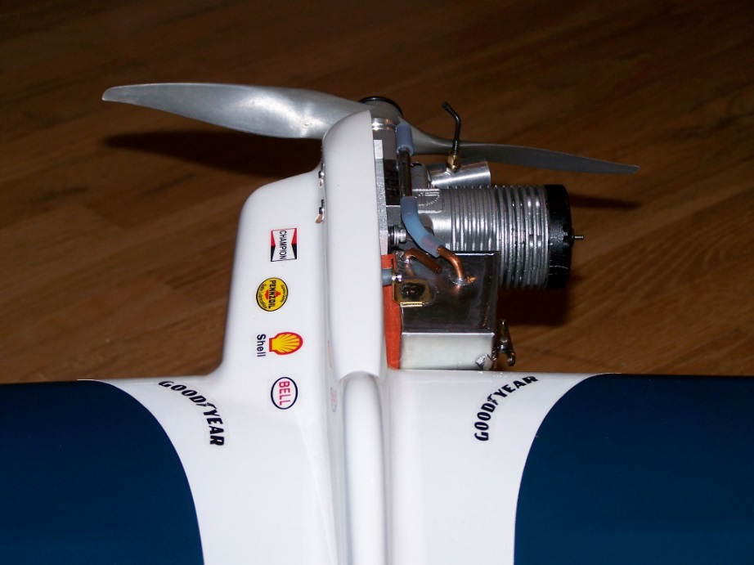
Figure 4. A view of the big HB PDP and the cowl cheek used to help damp out the vibration. The tank is a custom front-feed 2 oz. (by rule) set up to be fueled from the forward-facing inlet. It is sitting on a square of orange closed-cell silicone foam pad. Between the engine and the tank is a “one shot” shutoff. Shutoffs are not allowed to be used in Formula Unlimited during a race except in an emergency or after you complete all the laps. (Photo by the author)

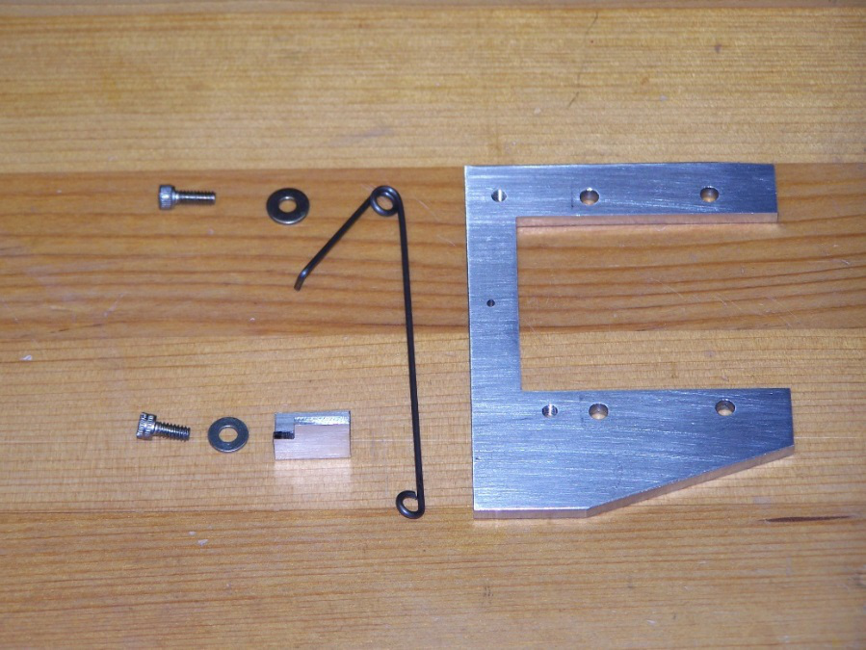
Figure 5. Be sure to install a shutoff on your Formula Unlimited. Here is a “one-shot” wire shutoff that is integrated into the motor mounting plate. The flexible fuel line runs under the spring-loaded wire which is inserted into the anchor hole, then bolted to the plate for preload. When the shutoff is actuated by full down control, a line from the controls pulls on the loop in the end of the spring and it is pulled off of the small notched angle plate and is forced down against the engine plate, pinching off the fuel line. Simple and reliable. This type is harder to reset since you must reach under the plane, so I only use it for events which permit shutoffs to be used in an emergency. (Photo by the author)
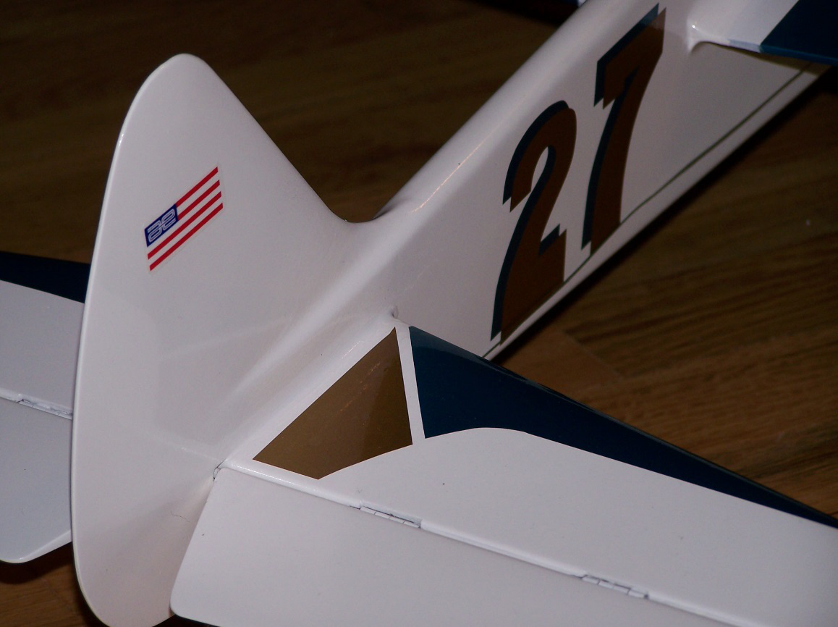
Figure 6. The tail group of the Shoestring is glassed and filleted for strength. Due to the weight of the HB engine, the extra weight of firm wood and glass in the tail improves the balance. Rare for me, I used pinned hinges on this racer. The MonoKote trim can be applied directly over the KlassKote. It takes low heat and special care to avoid lots of bubbles—and some smaller ones seem to be unavoidable. The shadowed numbers are cut out in pairs at the same time and then offset when laying them into position. (Photo by the author)
The total weight of this ‘Shoe is 40 ounces. It flies on .018 x 60’ stranded steel lines at about 2.6 seconds per lap. It will go slightly over 100 mph, which is enough to make the pilot aware it’s out there on the end of the lines. The pull at the handle is about 30 lbs. During a 70 lap heat race, the pilot gets one rest stop pit stop. The final is 140 laps, so figure three stops. Hang on, brother!

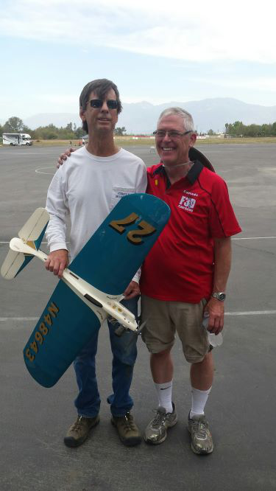
At the recent 2019 Virgil Wilbur Memorial racing contest, Formula Unlimited was flown for the first time in a long time. Two entries battled for it. The Goldbergian Shoestring powered by the boat-anchor HP .40 PDP vs. the Mayer Special. Not sure what motor Doug was running—probably a tweaked K&B .40. Likely either the model 4011 or the earlier 8011. The prior day’s test flying of the Shoestring paid off handsomely in that nothing broke, nothing needed changing, and the pitman (Hull) had some idea of how to flip it and make it go. Paul Gibault was recruited into the Canned-Ham racing team to pilot for Hull on this one and did a great job. Bill Bischoff flew for Mayer but they had some pitting issues. Pretty cool to see two heavy duty racers going pretty darn fast. And watch the pilots really hanging on….

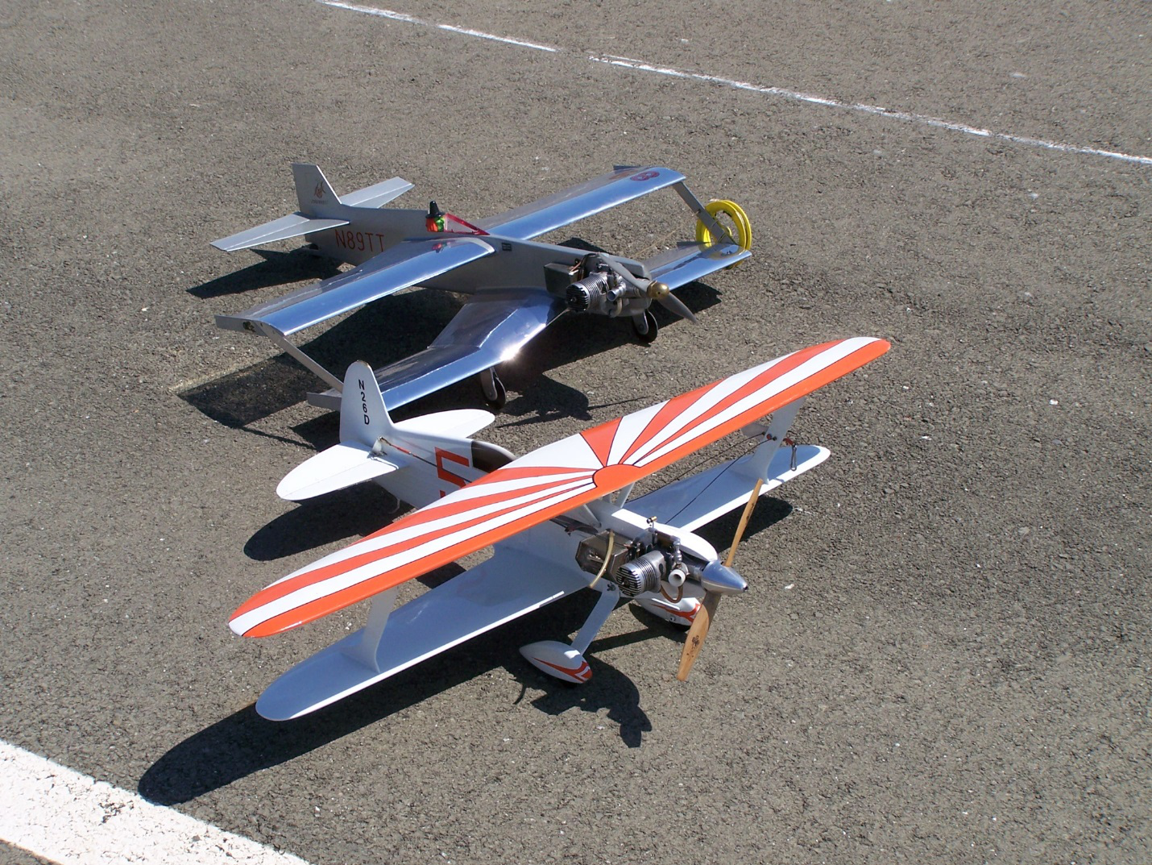
Figure 7. First place winners at the 2019 Virgil Wilbur Memorial racing contest are pitman Dave Hull (L), with pilot Paul Gibeault (R) all the way from Edmonton. Flown 2-up, this is an event that takes a lot of strength. And the pitman has to be careful how to catch the beast, too. A broken wing or prop knocks you out of the race. (Photo by Mike Callas)
Figure 8. Formula Unlimited racers aren’t just Goldberg designs. Here are scale models of the Imperial Knight Twister (front) by Dave Dawson and the Sorceress (rear) by Mike McCarthy. The back story contrasting these two full-sized planes is fascinating. The Formula Unlimited rules allow the total wing area requirement to be reduced to 360 sq. in. for biplanes to minimize the drag disadvantage. These were raced against each other at Napa, CA in August of 2006 and again later at Whittier. I can tell you that flying scale racers like these is great fun! (Photo by the author)
There is a lot of latitude in the rules to pick a plane you happen to like, and to paint it up however you want. Racing paint schemes are required (as is a clear or painted canopy!) but it doesn’t have to be the colors of a specific aircraft. For anyone with a desire to race this class, you can contact me for the current rules and planned events and see whether the level of activity will be worth your building time. Or, consider going down to 1/8th scale and enter SCAR Goodyear which allows scale racers of many types, not just Goodyears or Formula Ones. SCAR Goodyear is currently one of the most active racing classes in California.
Happy flying,
Dave Hull

