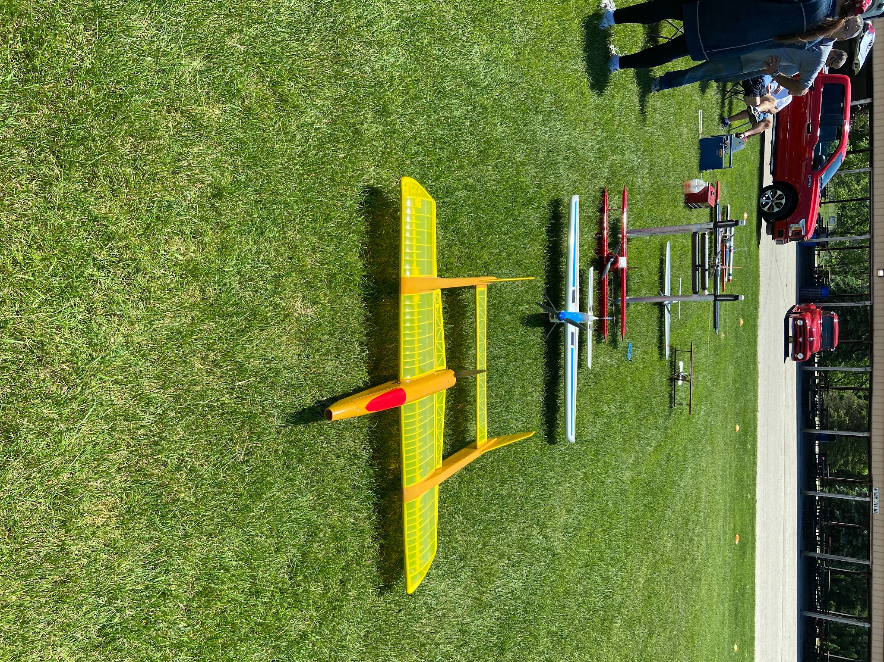

Volume 1 issue 8
Circle Masters Flying Club  Wisconsin’s control line club July 2020 |  | Lifetime Member Bob Gidildi
Announcements  Picture today is of the flight line for the June meeting.  Contests next month!  Wednesday night is Flight Night, come out and fly. Adding a weekly flight report.  The Nats are on. No Scale to Freeflight or RC pattern but racing, stunt combat and carrier are on |  | Inside This Issue  Contact information  Plan of the months  Meeting Minutes  Flying and building reports  Events

Editors Notes  Pit Etiquette important for safety and happiness. No one like lines stepped on.  Tips stolen from the internet continue. Send your favorite one and I’ll include it.  Part 2 of the speed controller is included.  At the field, kind of a flight log.  Book review on Air Racing, a good read. More about the people than the airplanes.  Plans and an old K-Mart ad for Cox RTF stuff.  Dave Siegler Newsletter editor |  | Club Information  Web site www.circlemasters.com  Dues $20.00  Flying Location  Sussex Village Park, Sussex. Wisconsin  Meeting First Saturday of the month 1pm  Location Summer (May- Oct) at the field  Location Winter Sussex Library  Comments to circlemastersflyclub@gmail.com
Tuesday on line hang outs are SUSPENDED due to good weather. Come out and fly Wednesdays. |  | Pit Etiquette  - Walk around the pits not through them  - Walk on the outboard side of the airplanes.  - Only run out lines you expect to fly. Roll them up when not actively flying.  - Try not to run engines in the pits. If you have to, try to move to the edge of the pits. Don't slobber castor or wreck the hearing of others  - Give enough space between the cars and the airplane for pitboxes, chairs and a walking lane.  - Don't cross lines.  - Politely inform spectators and pedestrians about the pit location, and direct them around the pit. Dont scream and yell.  - Make sure the far end of the pit (handle end) is not in the flying circle.

From the past  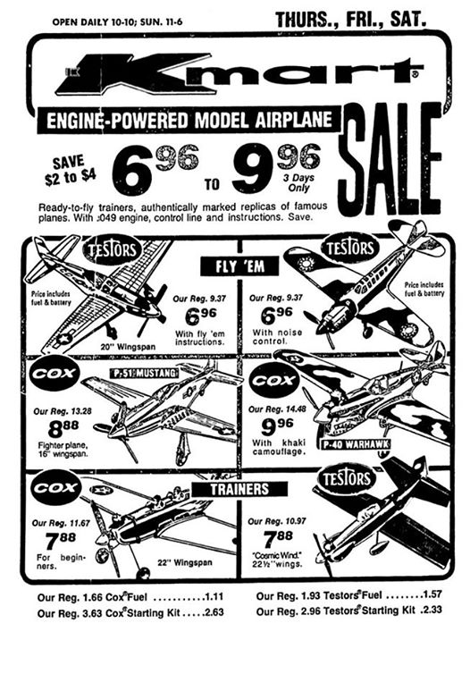  The prices almost make me cry cox PT 19 often go for $200 on Ebay |  | Book Review    A behind-the-scenes look at the fast and furious world of airplane racing, Fly Low, Fly Fast vividly depicts a classic season in the unlimited championships of the Reno Air Races, chronicling the history of the sport from the 1930s and capturing the wild personalities who participate.  I really liked the book, It is a little over the top but a fun exciting read A weird combination of NASCAR and TopGun -- Dave

Club Events
Club Contest-- August
EAA Kidventure Late July
Sussex Antique Tractor and Steam Engine show August
Club Fun Fly and Picnic June
Christmas Party December

From Wild Bill, semi scale stunt models were the rage in the 1970’s . He proposed an event.
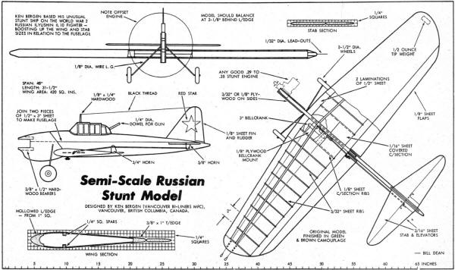
CIRCLE MASTERS FLYING CLUB
MEETING MINUTES for June 2020
The June meeting of the Circle Masters Flying Club was finally held at the FLYING FIELD. There were a lot of smiling faces on the members who came to fly and visit. The meeting was hammered to a start at 1:04 PM by Pres. Chris. The members present (12) had all read and approved the minutes from the May meeting so they stood as published.
The Treasurers Report was presented by Wayne. Once again there was no receipts or payments made since the previous months report. This report was approved as presented.
NOTE: Unknown to the Secretary at about this time, the battery failed in the microphone rendering the balance of these minutes to my memory & notes.
REPORTS & ANNOUNCEMENTS: Jason reported that although not confirmed yet, he is sure that there will be an Antique Tractor and Steam Engine Show again this August to be held at the Sussex Village Park. They are currently seeking some sponsorship.
OLD BUSINESS: Contest Director Pete was concerned about participation at the club contest from the Chicago Stunt contingent and so will inquire there to find out their intentions. Don Adriano will do the same for the scale group.
NEW BUSINESS: New Business will be replaced this month by; JASON: Jason has taken on the following duties as he is the Contact person to the Park Dept. 1. He will inquire as to placement of a temporary pole installed at the center of the circle. 2. He will inquire if the club can reinstate “Wednesday Night Flights”. 3. Check on availability of a date for the July meeting. Jason will earn his salary this month.
WEB SITE BUSINESS: Dave reported an increase of hits on the web site as well as Facebook, probably due to the “Stay at Home “order once again.
OTHER BUSINESS: None.
There being no further business Chris asked for a motion to adjourn the meeting. It was quickly moved and seconded. Meeting adjourned at 1:40 PM.
SHOW & TELL: Time to fly!!!!!
Submitted by Wayne M. Schmidt Secretary/Treasurer 06/09/2020

Kontrol Kline Kapers -- At the field June 2020
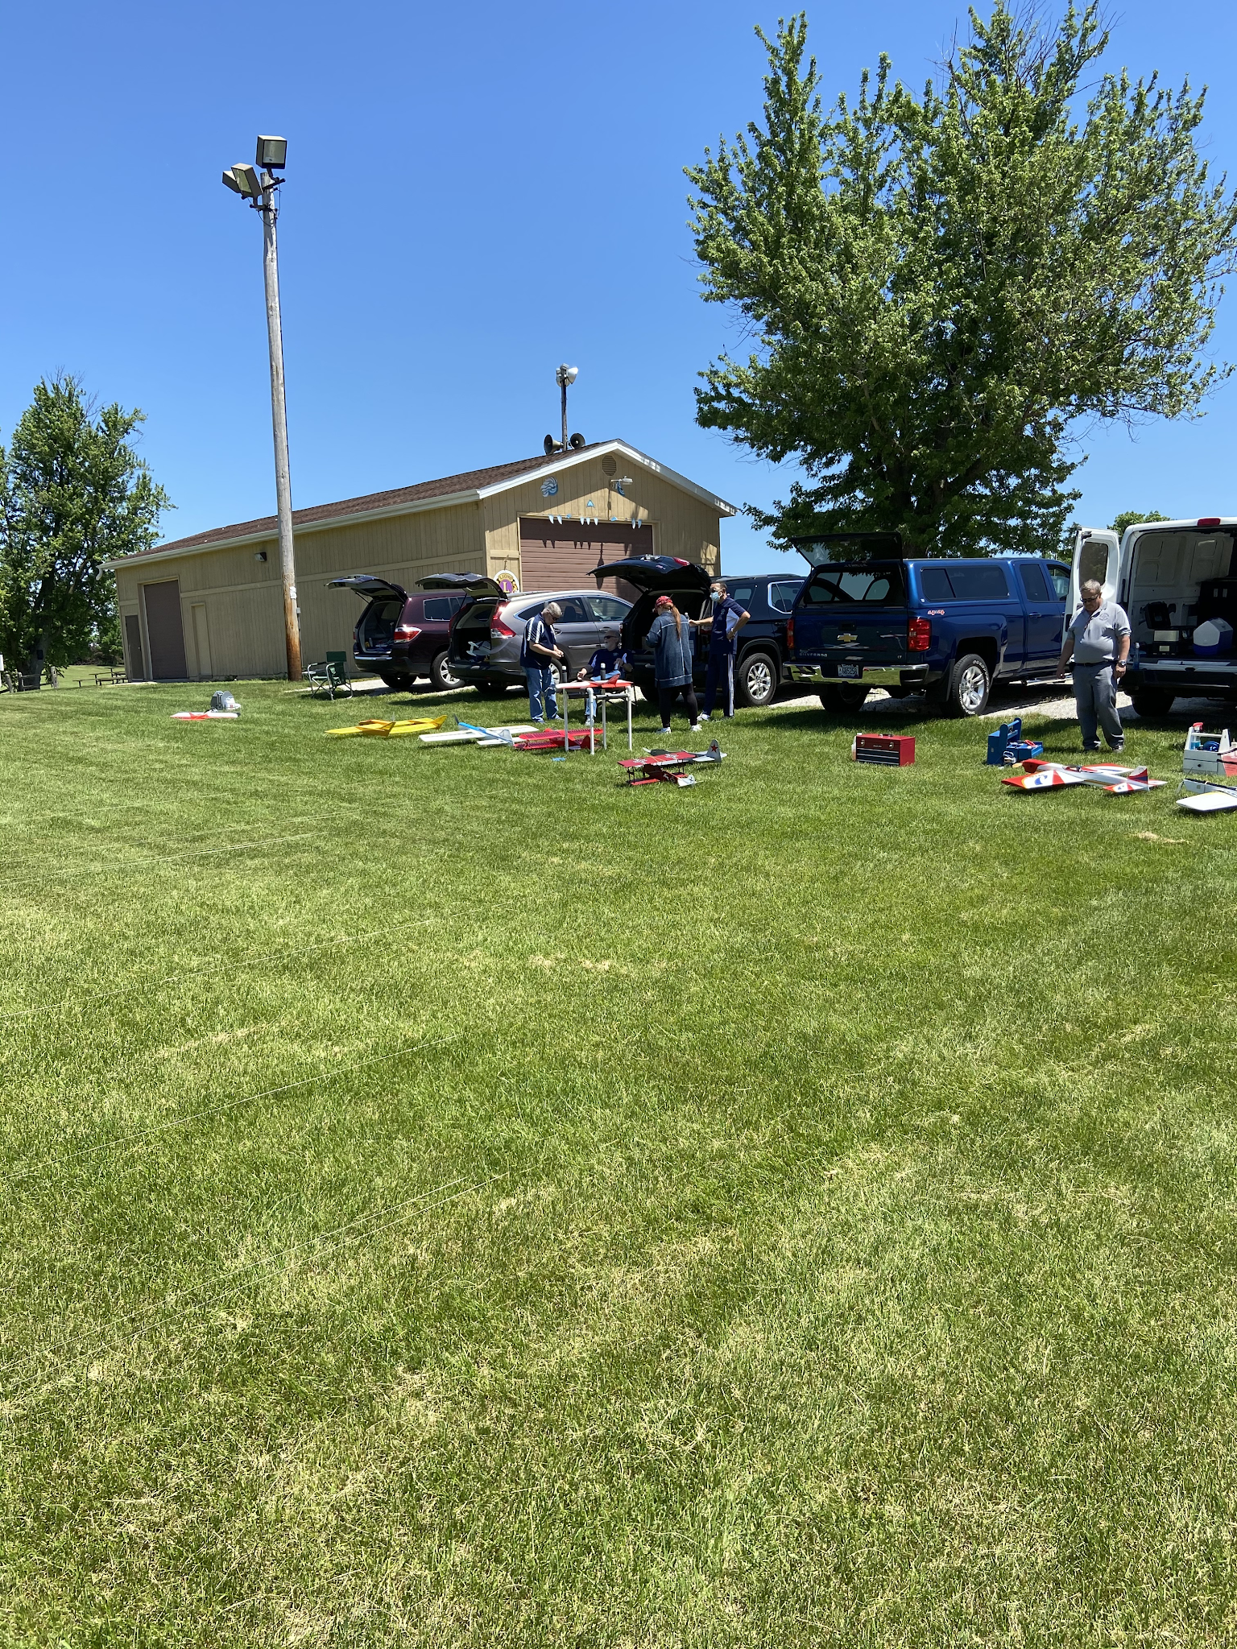
June 6 -Saturday club meeting,
- Len worked on his skyray, still fighting engine issues.
- Chris got it T38 / weedeater up. It has long takeoff run
- Gene and Pete put in very good stunt practice flights.
- Chris’ ARF streak suffered a textbook figure 9 and broke its nose off. Stuck elevator was the accident investigation.
- Wayne flew a slob the first time in a long time, good to see him out there.

June 10- Wednesday Rainout
June 17- No reports
June 20- Saturday Jason, Chris, Dave and Don Doss.
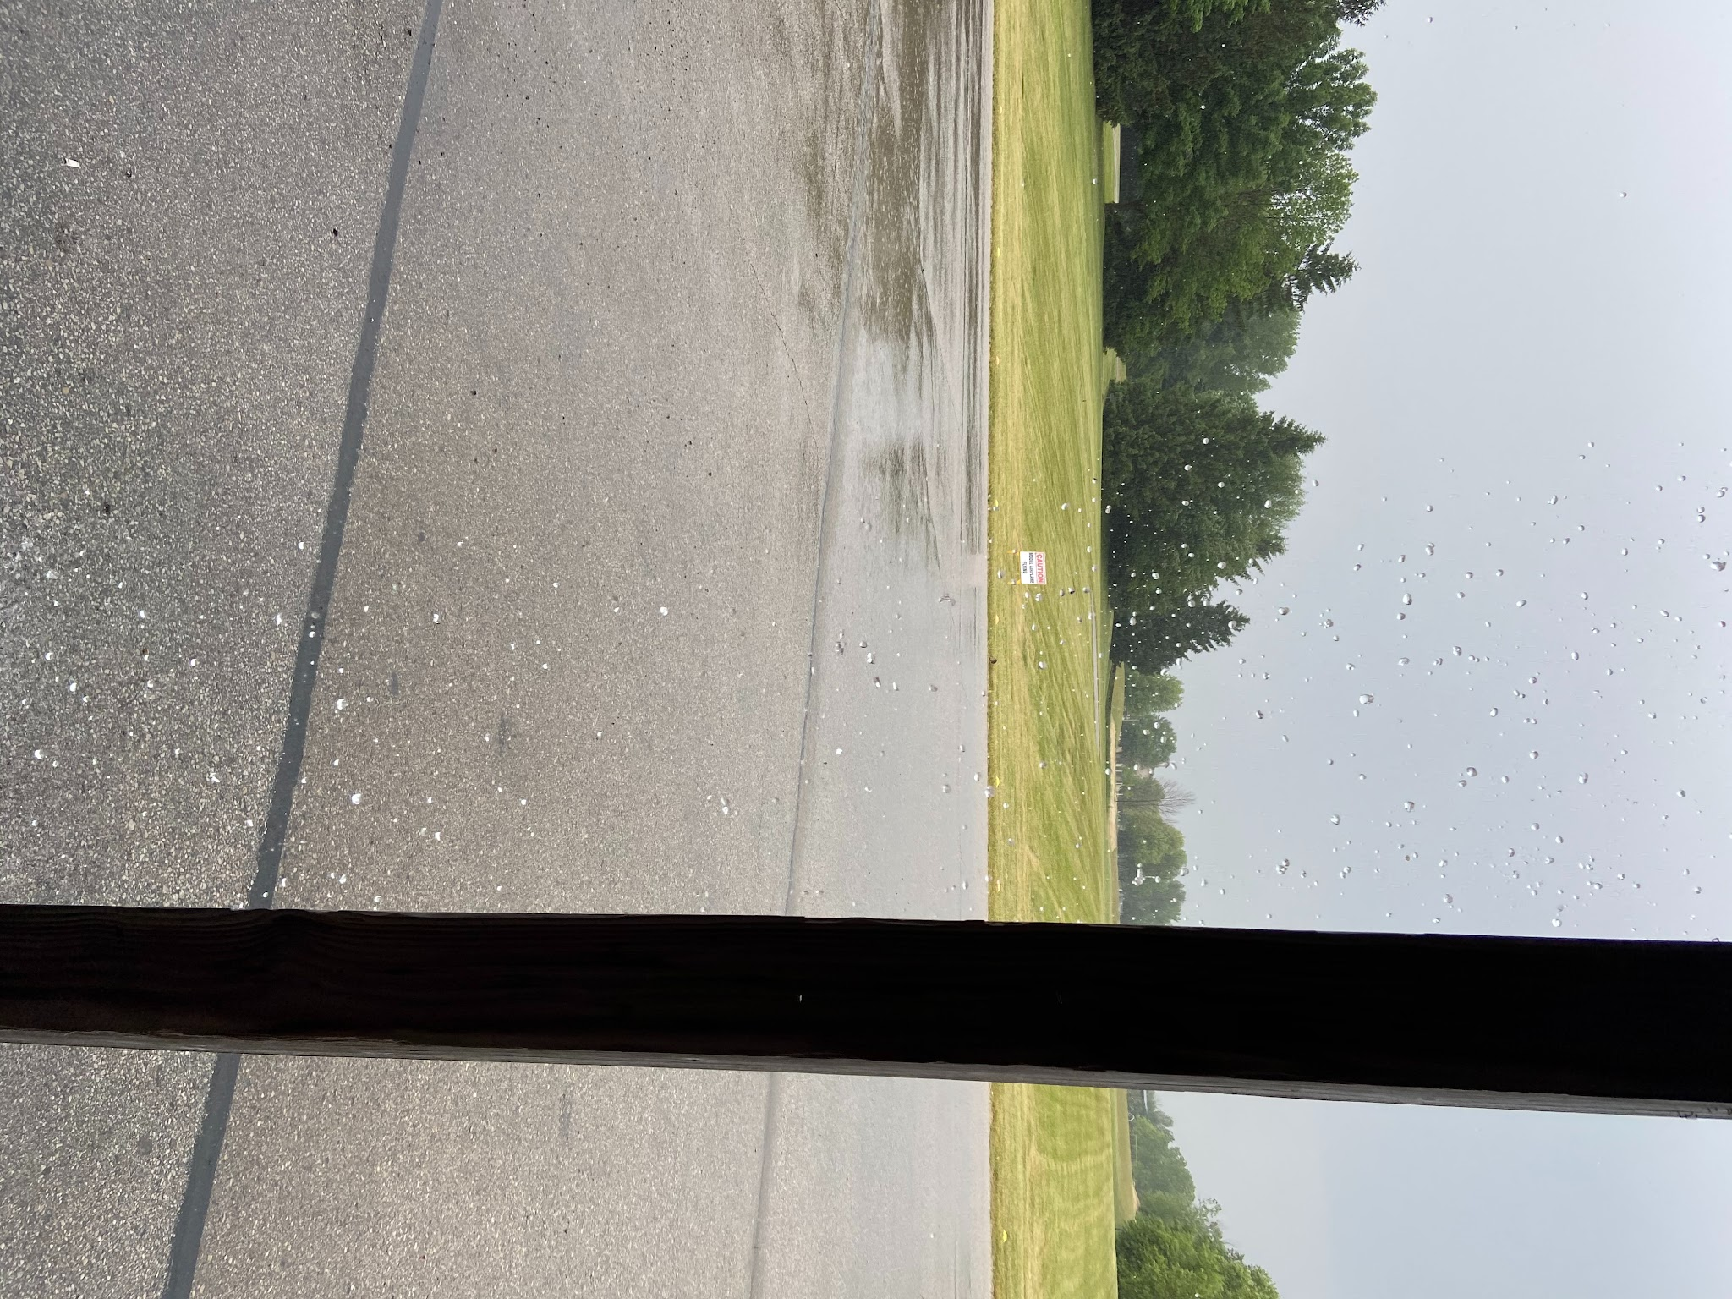
- Jason flew his Shoestring and got the fox 35 shaking and smoking like any good fox should.
- Chris flew his T38 / lawn mower/ all weather fighter to a couple of good flights. He got caught in a big cloud burst and we all sat in our cars laughing as Chris flew on. It poured and he was soaked.
- Dave flew his beat up 1/2a flite streak on long lines in the wind.
- Dave had 2 old bladers bust on his ½A combat and put back in the truck in disgust.
- Dave tricked Chris into flying his Streak and Chris returned the favor. Chris’s flight steak was on 35 foot lines and the medailain 049 on 25%. It runs like a combat engine. Dave had a lot of trouble with it. It pogoed up and down, and he seemed behind it. He could not keep it level, let alone maneuver. Chris and Jason were first amused, then concerned for Dave’s well being (looked like he was having a stroke) then worried about the airplane. (thanks a lot friends!). When the engine quit it had screwed him into the ground like an ice auger.. Statements on Dave’s manhood, pilot ability and Chris' airplane building skills were made. Turns out the lines were heavily twisted and caused enough binding that it was all he could do to keep it out of the grass. All had a good laugh on that.
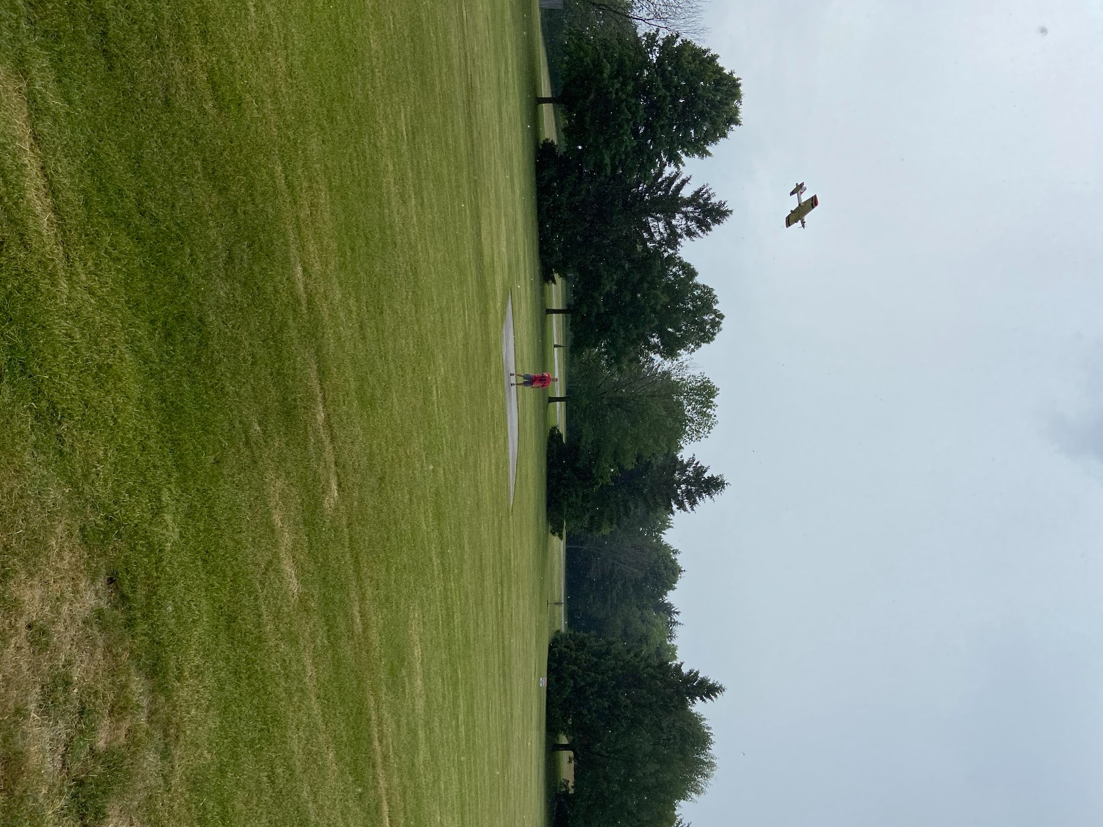
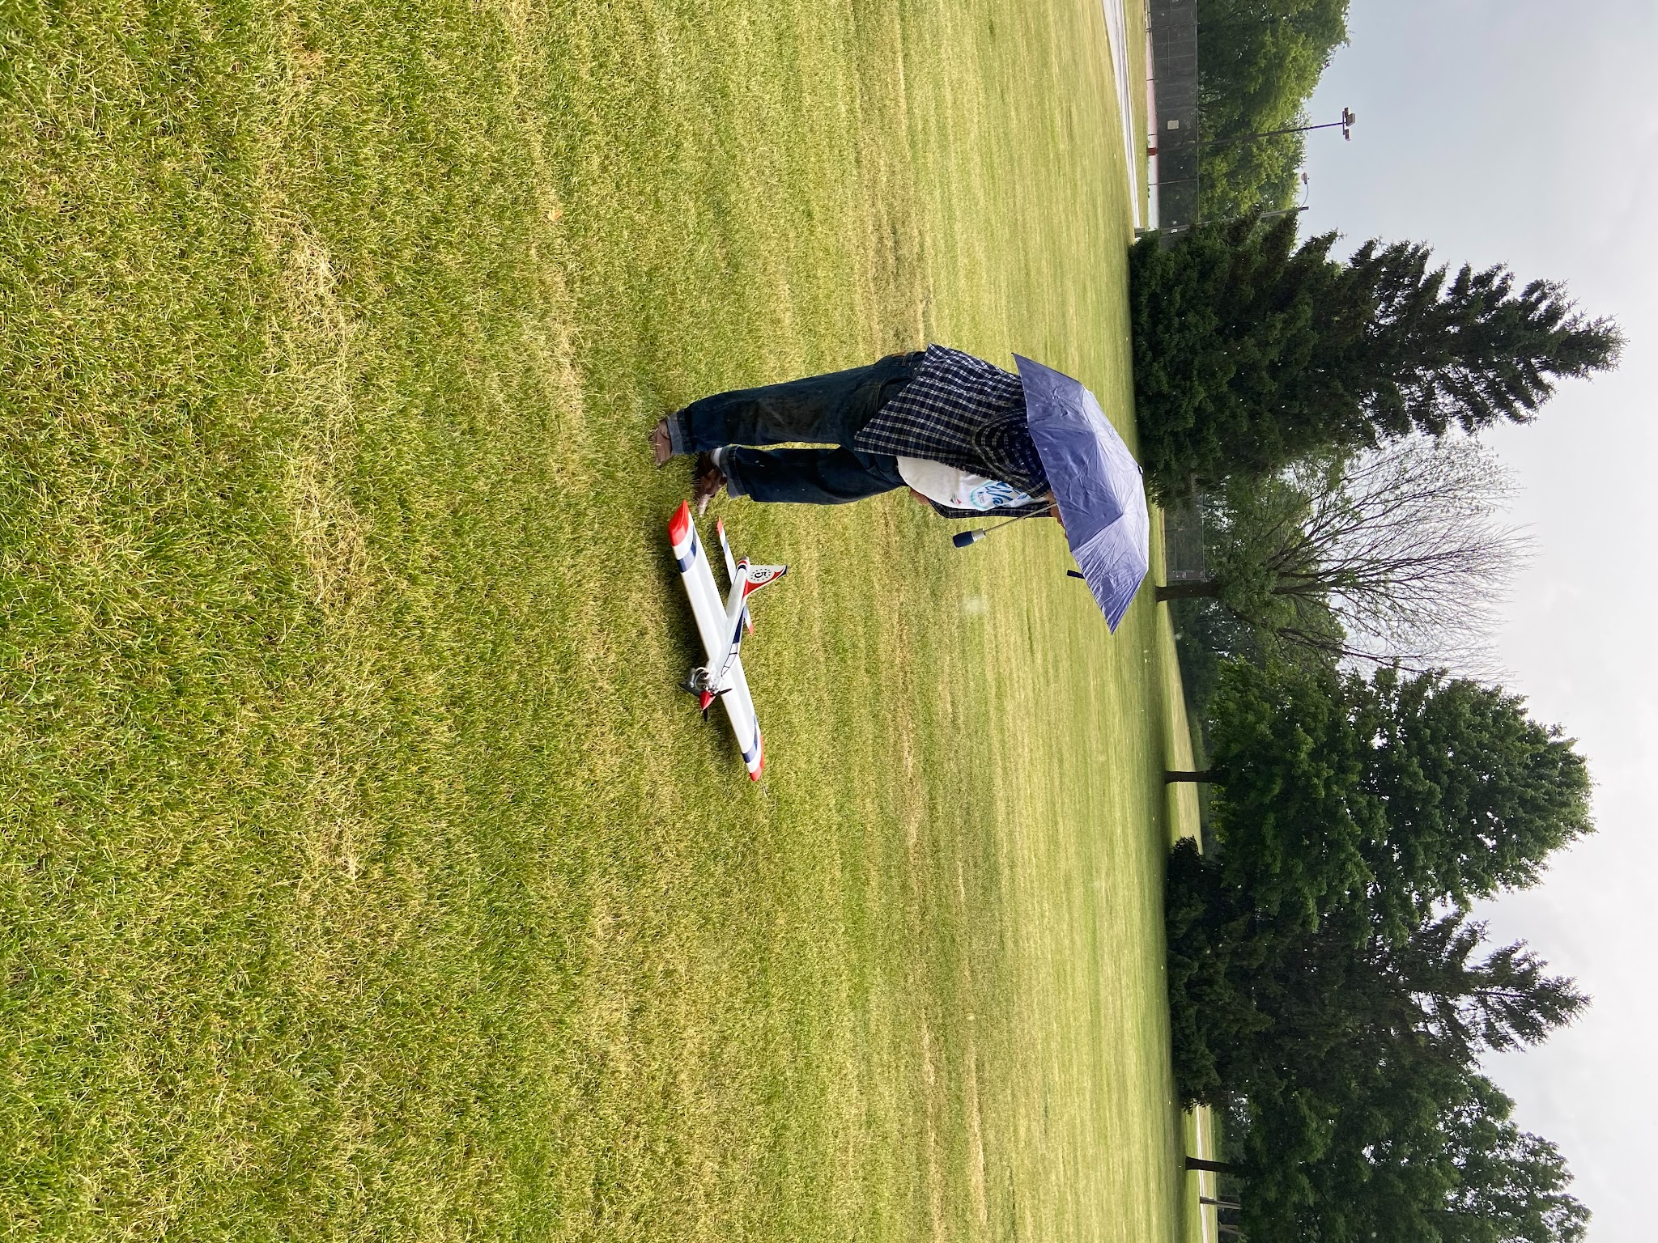

June 24 -Wednesday
- At the field Gene and Pete were putting in good patterns Gene’s Score is looking good.
- Chris was there with several airplanes. His p-39 must be one of the Russian lend lease airplanes, and it tried to bite his finger off. He flew his t-28 and had some damage on his Streak and it got damaged due ot a bad launch.
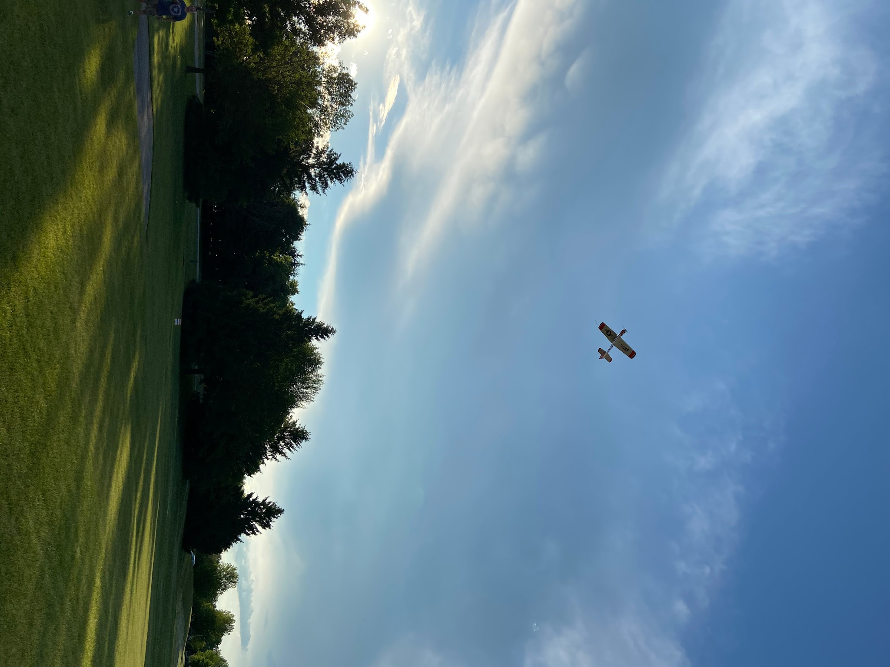
- Dave flew his 1/2 A combat and the bladder worked well. It's a lot of fun.
- Happy forth of July!!
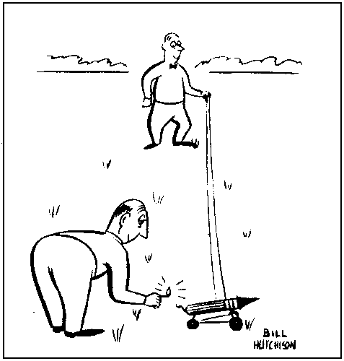

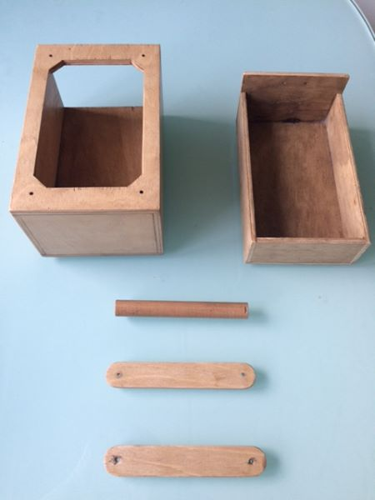
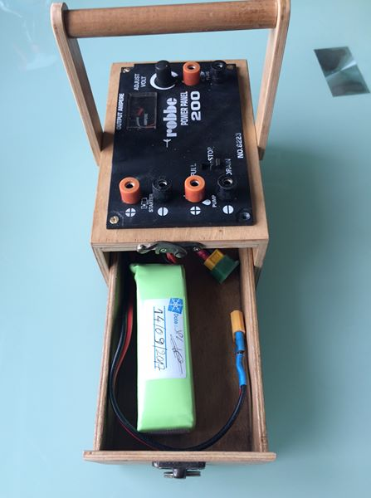
Stolen from the internet part 3: Glow Driver Box

This is a little box to hold a 3S lipo and a power panel. It provides a much lighter solution for flight line use. The Lipo provides a lot of power, but there is no overdischarge protection. It should only need to be charged a few times a year.

A great use for flight batteries that are on their last legs.

Stolen From The Internet part 4: Willcox clamps
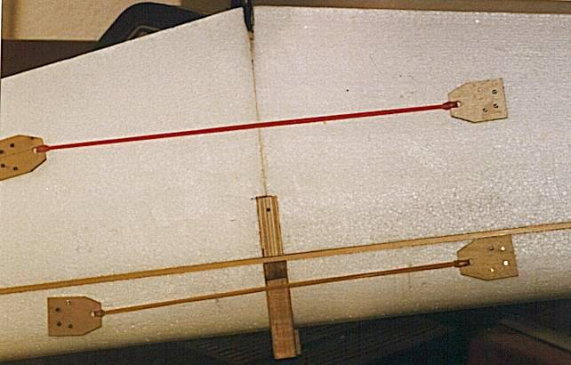
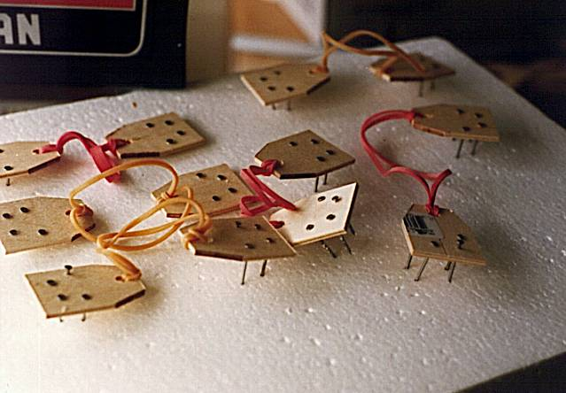
Assembly aid for foam wings. Small nails, rubber bands and some scrap plywood. Very useful. Also a good booby tr
ap or to fight off a ninja for your shop. Don't step on them. Hard on bare feet. Pat Willcox is credited with the idea.

Stolen from the internet part 5: Airplane Stand
This is a flight line tool that I saw on the internet in 2003. It has been on my build list for a long time. Covid 19 gave me a chance to get caught up on projects like this. It used only material that was in my shop except for some fasteners. It is a combination of scraps of douglas fir, pine, cherry and oak. The shelves are birch plywood, and some oak plywood. I even made the knobs on the stand. The shelf folds up over the top, and the bottom shelf has pins to locate it. The stand folds flat for storage and transport. It is finished with oil based spar varnish. I should have done this years ago. Less grass stains on my knees, less bending.

The plans for the stand are on the club web page.
http://www.circlemasters.com/plans-page.html

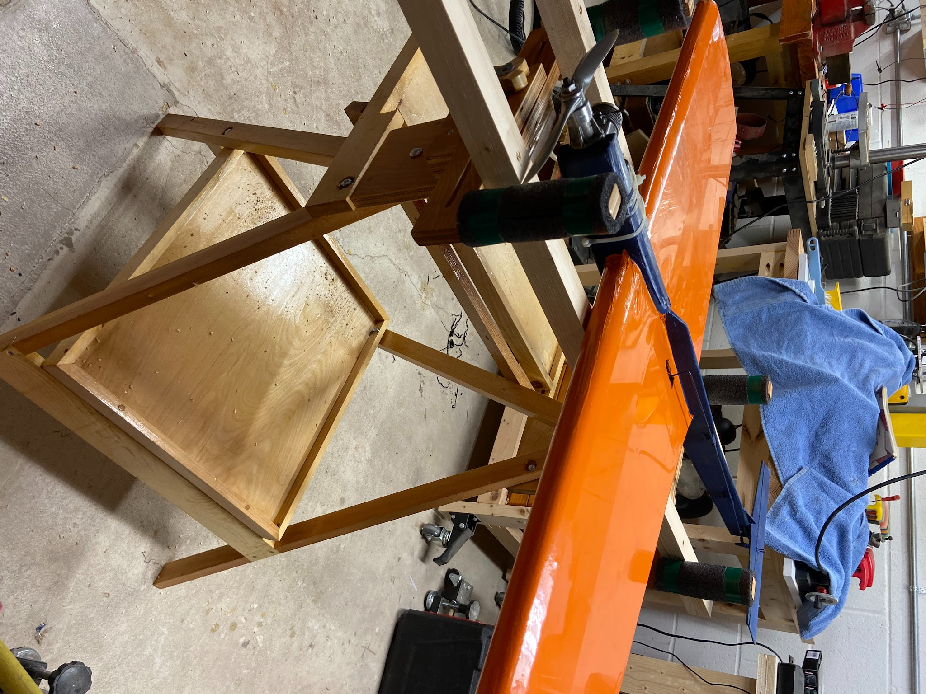
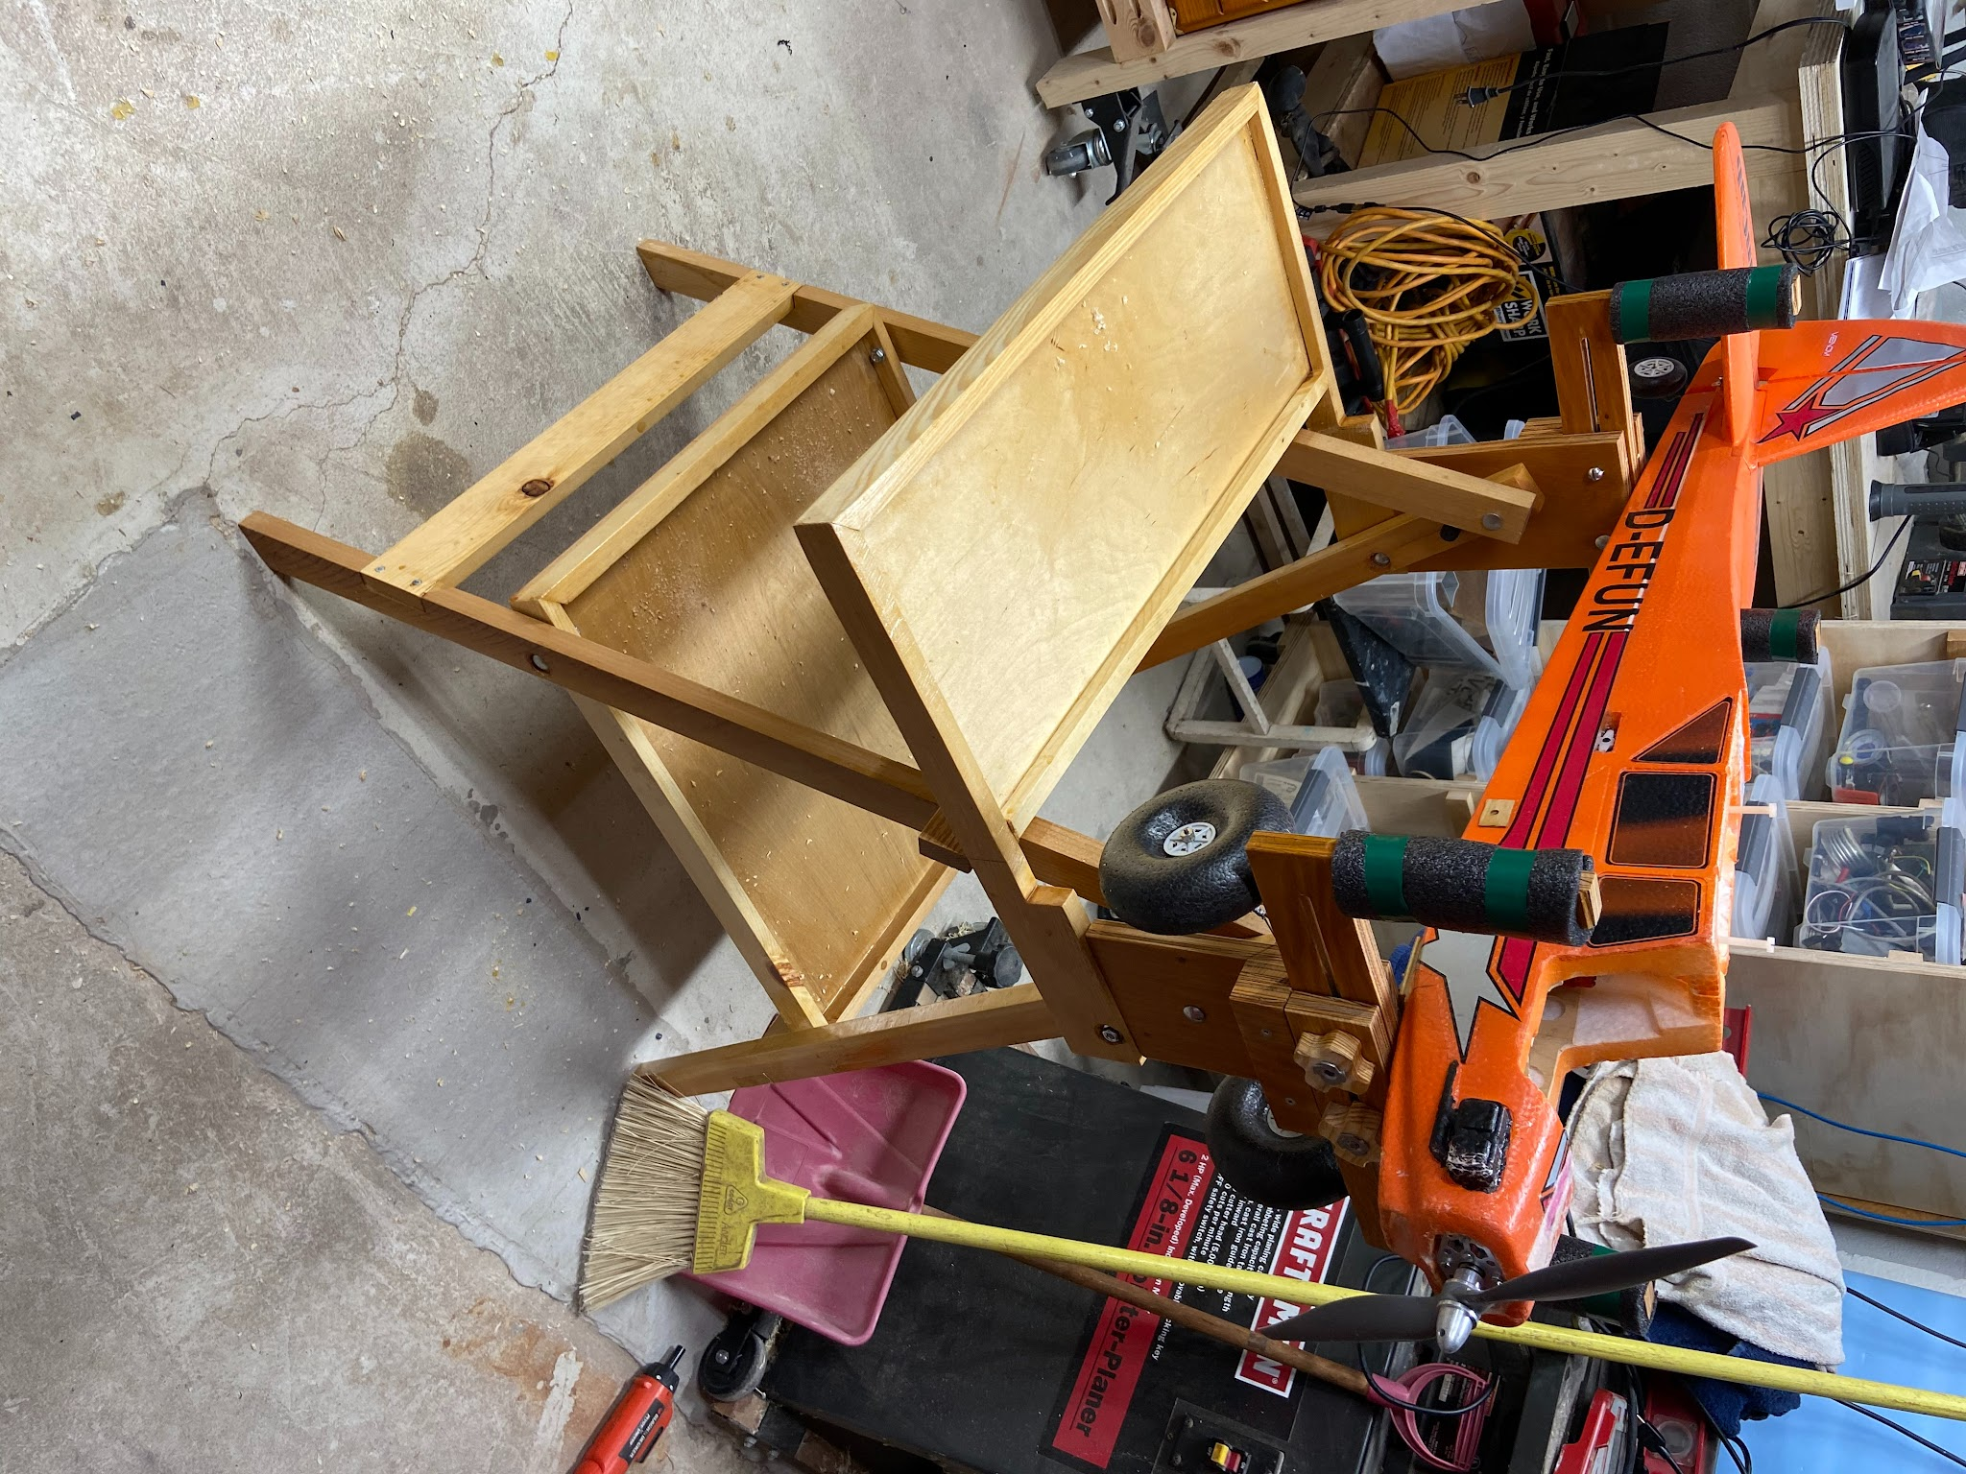

AutoThrottle-- Electronic Speed controller / Timer.
An arduino based timer for electric control line flying . Dave Siegler Ama 720731
Part 2 Hardware
I used off the shelf pre built modules for this project. A purpose built PCB would be much smaller and may be in the future if there is interest. The hardware is pretty simple and inexpensive. The main microcontroller is the ubiquitous arduino nano.
Arduino is a single board computer platform used for building electronics projects, It consists of a microprocessor, support chips and all the stuff to make it work. The arduino is often used in education and is easy to use. It has a great free programming environment. The arduino nano version can be had for less than $3.
A sensor to measure the airplane's positions is needed for this project. The MPU 6050 is used in game controllers, smart phones, and on laptops to detect motion or acceleration and meet our needs. It has a three axis gyroscope, three axis accelerometer, a magnetic compass and thermometer all for less than $1. It connects to the microcontroller by only 2 signal lines via I2C serial connections. The chip is configured to report the value of yaw pitch and roll angles.

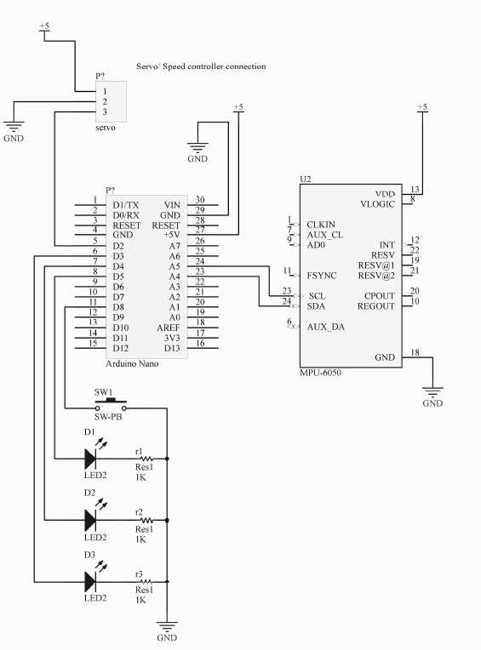
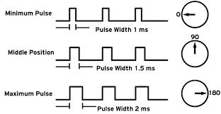
The speed is controlled just like an RC servo. A pulse train of varying duty cycle is sent to the speed controller that tells the controller to run a 0 to 100% speed. The Arduino software has a servo library that uses one of the PWM registers and an I/O pin to generate the servo pulses nicely.

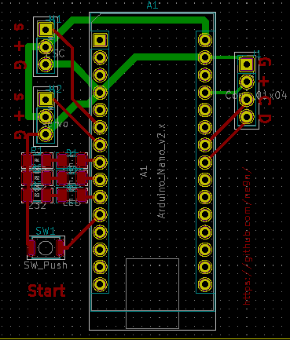
Power for the circuit is supplied by the ESC’s voltage regulator. A few LED’s for status, a push button to start the system and the hardware is complete.

I drew the schematic in KI CAD PCB, a free PCB design program. Ki CAD generate the gerbers, placements and drill files for PCB assembly. It fits nicely on a 2 layer PCB about 2” square

Set up values (flight times and speeds) are stored in the arduino’s internal electronically erasable memory (EEPROM). You connect the arduino to program it via a laptop and USB cable. The device is configured through a simple menu.

You use the free Arduino application and it runs on Mac OS, Linux or Windows.

Firmware
The program is written in the “C” language in the Arduino integrated development environment (IDE). The IDE gives the programmer a simple way to write and test software for the Arduino system. The software leverages a set of prewritten libraries to control a servo, and get data from the MPU 6050. The libraries really speed up the design process. The program has 2 parts, a time sequencer that steps through the flying states, and a control system that measures the position and changes the speed of the motor.

Time sequence
The sequence diagram is listed here. Pressing the start button holds the model on the ground at zero speed. Then the model slowly ramps up to the set flying speed as the model takes off. The gyro changes the flying speed based on the attitude of the model. At the end of the flying time the controller gives a little burst to remind the pilot to set up for landing. The speed is slowly ramped down and the airplane lands.
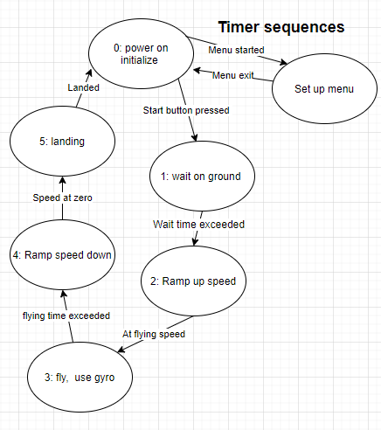
Each step has programmable values for durations and speeds that can be set based on user needs.

The Control System
The control system is the height of the problem to solve. The desired behavior is the airplane putts along at slow speed but changes power settings based on attitude changes. Constant speed is nice but not required. Response to changes in attitude must be very quick.

The control should increase the power as the nose points up (pitch), and decrease it as the nose points down. The airplane also needs extra power to fly higher on the circle. From this application the
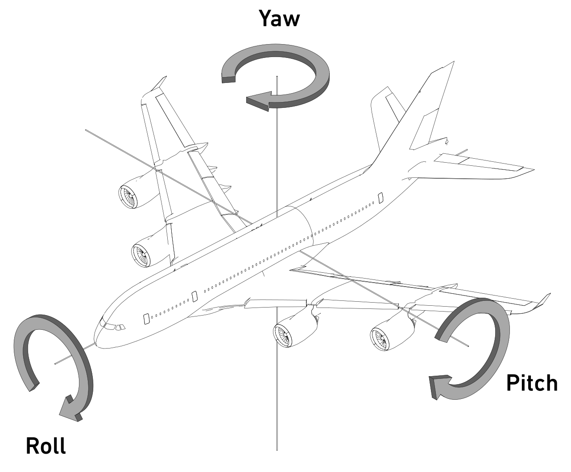
height on the circle will show up on the roll axis. The roll compensation should be smaller than the pitch compensation. The yaw axis is not used.

So the control rules are simple :
- Positive pitch angle increases power and power.
- Negative pitch angle decreases power.
- Any roll angle increase power
- Positive and Negative prich gains are independant

For a simple lightweight indoor airplane we can simply add some predetermined power at these times. This is like pressing down the accelerator in your auto when reaching a hill. This is known as feed forward control and for a simple system it should be sufficient for small indoor craft.

Other effects to consider are the rapid deceleration when turning. While this can be compensated for it has not been implemented at this time. This pitch boost function may be needed for larger aircraft. Also larger outdoor aircraft may need additional control to maintain a more constant speed in the larger maneuvers done in an outdoor setting.

Part 3 will cover build up, installation and testing

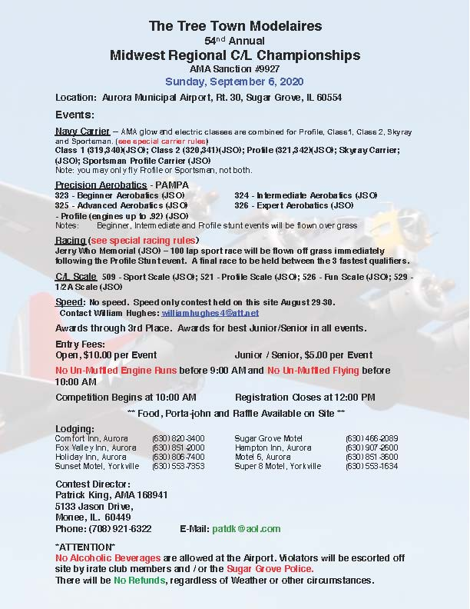

July 2020
SUNDAY | MONDAY | TUESDAY | WEDNESDAY | THURSDAY | FRIDAY | SATURDAY
28 | 29 | 30 | 1 | 2 | 3 | 4
 |  |  |  |  | independence Day
5 | 6 | 7 | 8 | 9 | 10 | 11
 |  |  |  |  |  | Club Meeting at the field
12 | 13 | 14 | 15 | 16 | 17 | 18
Control Line nats | Control Line nats  Scale Flying Electrons | Control Line nats | Control Line nats | Control Line nats | Control Line nats | Control Line nats
19 | 20 | 21 | 22 | 23 | 24 | 25
26 | 27 | 28 | 29 | 30 | 31 | 1
2 | 3 | 4 | 5 | 6 | 7 | 8

