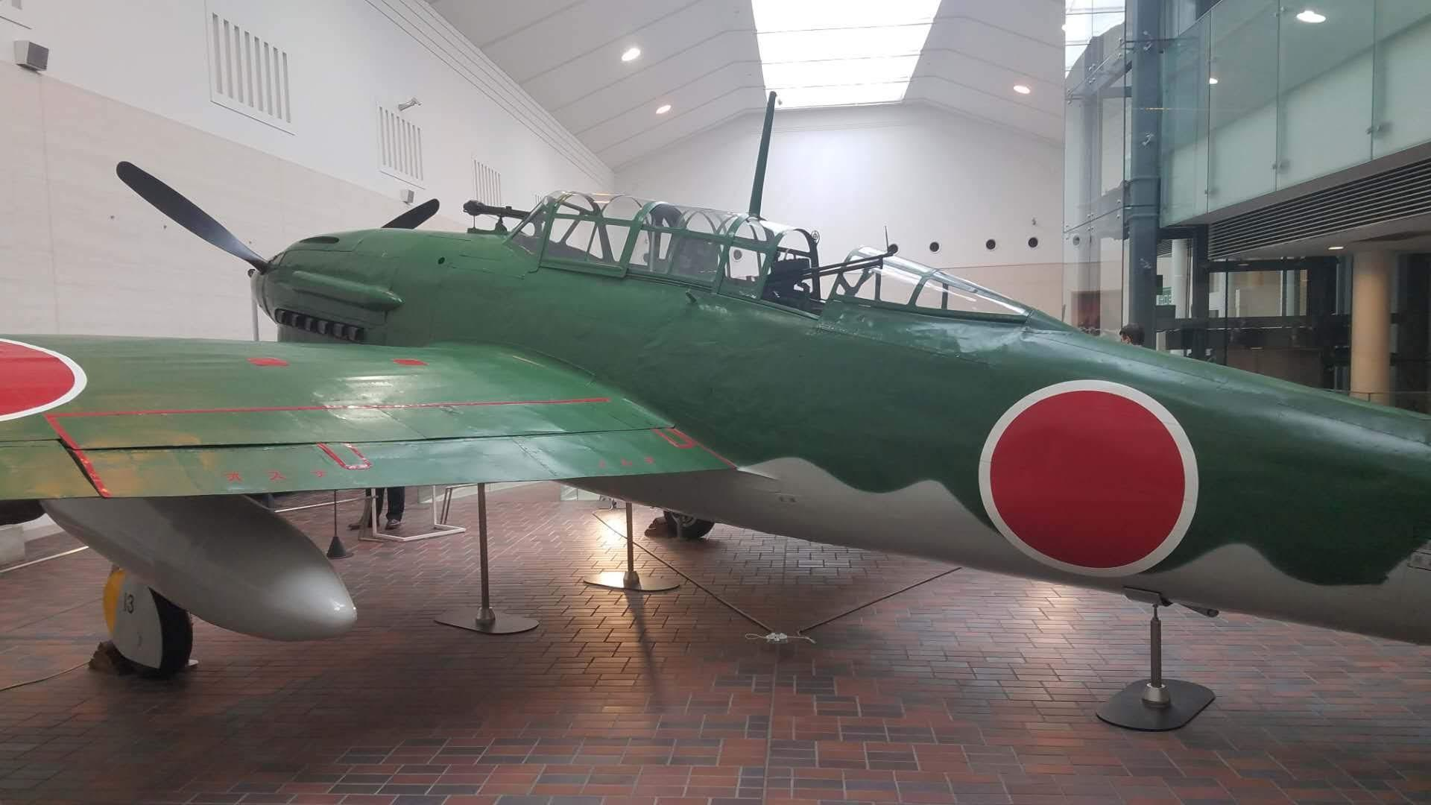

Volume 1 issue 7
Circle Masters Flying Club  Wisconsin’s control line club June 2020 |  | Lifetime Member Bob Gidildi
Announcements  The lead picture was taken by my son in Tokyo. It is a Yokosuka D4Y Judy dive bomber. Displayed in Yūshūkan shrine Tokyo  Still on lockdown. The Tuesday night shop time continues consider joining  At this time the Nats are still on. A decision will be made June 10. Most other events are canceled.  Hopefully you have your fleet ready for an accelerated summer of dizzy smiles and crashes. |  | Inside This Issue  PG. 2 Contact information  PG. 3 Plan of the months  PG. 4 Meeting Minutes  PG. 5 Flying and building reports  PG.6 Events

Editors Notes  I have included the solution for the puzzle last month. How many mistakes did you find?  A drawing of how stars and bars have changed over war years is included for you scale guys.  A section on tips stolen from the internet is included. This is a great source of material. Send your favorite one and I’ll include it. Part 1 of the speed controller is included.  A book review on Racine Wisconsin’s Mustang Ace Bob Gobel. A great read with local context. The book reads like someone from Racine Wisconsin wrote it. Highly recommended. |  | Club Information  Web site www.circlemasters.com  Dues $20.00  Flying Location  Sussex Village Park, Sussex. Wisconsin  Meeting First Saturday of the month 1pm  Location Summer (May- Oct) at the field  Location Winter Sussex Library  Comments to circlemastersflyclub@gmail.com
Online meetings will continue. Join the Tuesday hangout 8- 10pm |  | Video meetings tips  - Mute yourself when not speaking. (barking dogs are not club members)  - Be on time.  - Ensure your technology works correctly. (spells and incantations OK)  - Wear appropriate clothing. (wear pants)  - Frame the camera correctly. (no one wants to see that)  - Have the right light. (no disco balls, or lava lamps)  - Have fun (this is a hobby)

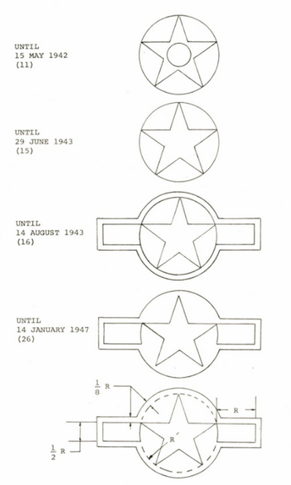  Army Air Corp stars  How insignias changed over the years is interesting. This shows how it evolved between prewar up to 1947 |  | “Mustang Ace “  When Bob Goebel left home to join the Army Air Corps in 1942, he was 19 years old and a high school graduate. Cadet Goebel worked his way steadily through Basic, Primary, and Advanced phases of military flight training, and found in himself an aptitude for flight. After graduation from flight school, with his new wings and new commission as a 2d Lieutenant, he and his classmates were posted to a fighter squadron defending the Panama Canal. By the spring of 1944 he was on his way to Italy and the 31st Fighter Group, one of the top fighter outfits of the war. He was also headed for a new aircraft, the legendary P-51 Mustang. After 61 combat missions now Captain Goebel was officially credited with 11 victories in his Mustang. Returning home in September 1944, he was not yet 21 years old.  Goebel's memoir is a classic of combat aviation, giving the listener a true sense of what it was like to fly and fight as a World War II fighter pilot. It covers stories about the often overlooked 12th AF in Italy, and tales of flying the classic P-51D, America's ultimate piston-engined fighter. ©1991 Gary M. Goebel (P)2016 Gary M. Goebel

Club Events
Club Contest-- August
EAA Kidventure Late July
Sussex Antique Tractor and Steam Engine show August
Club Fun Fly and Picnic June
Christmas Party December

Plan of the month
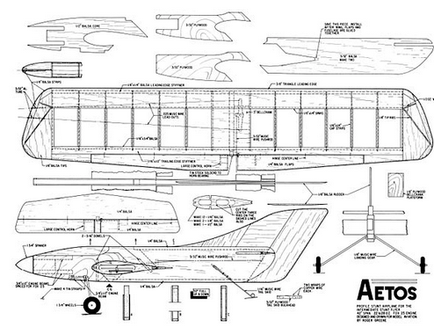

CIRCLE MASTERS FLYING CLUB
MEETING MINUTES for May 2020
The May meeting of the Circle Masters Flying Club was held at Home. Thanks to the Coronavirus this meeting was held with computers. The meeting was hammered to a start at 1:08 PM by Pres. Chris. He began by asking if the members (6) had received The Circle Flier newsletter and had read the minutes from the April meeting. The members present had all read & approved the minutes. So, the minutes stood as published.
The Treasurers Report for April was presented by Wayne. There was no receipts or payments made since the previous months report. The report was approved as presented.
REPORTS & ANNOUNCEMENTS: A brief discussion regarding the passing of member Wayne Stevenson. Also discussed was the passing of John Brodak, Owner of Brodak Mfg. and the passing of Art Johnson. Jason reported that the Park Dept. is not accepting any reservations for use of the park. So, Aug. 15th Flying for Nat. Model Aviation Day or even meeting and flying Saturdays included.
OLD BUSINESS: Chris asked about the resumption of “Tuesday Night Flights” and was reminded by Jason that the Park Dept has not issued any permits due to Coronavirus. He will follow up on this also. (Jason will be busier)
NEW BUSINESS: The location of a removeable steel pole in the center of the pilot’s area at the flying field was outlined by Chris. This will allow those pilots who might be less physically stable to successfully fly. The club approved this however Jason will check with his Park contact to be sure that this can be done.
WEB SITE BUSINESS: Dave reported an increase of hits on the web site as well as Facebook, probably due to the “Stay at Home “order.
OTHER BUSINESS: None.
There being no further business Chris asked for a motion to adjourn the meeting. It was quickly moved and seconded. Meeting adjourned at 1:35 PM.
SHOW & TELL: Although not officially part of the meeting, Chris reported that both Mike and he logged a few real flights at the flying field. Chris managed a short maiden flight on his new T-38. This aircraft had a nose heavy issue and is back at the engineering department for rebalance.
Submitted by Wayne M. Schmidt Secretary/Treasurer 05/18/2020

Results from Last month's challenge
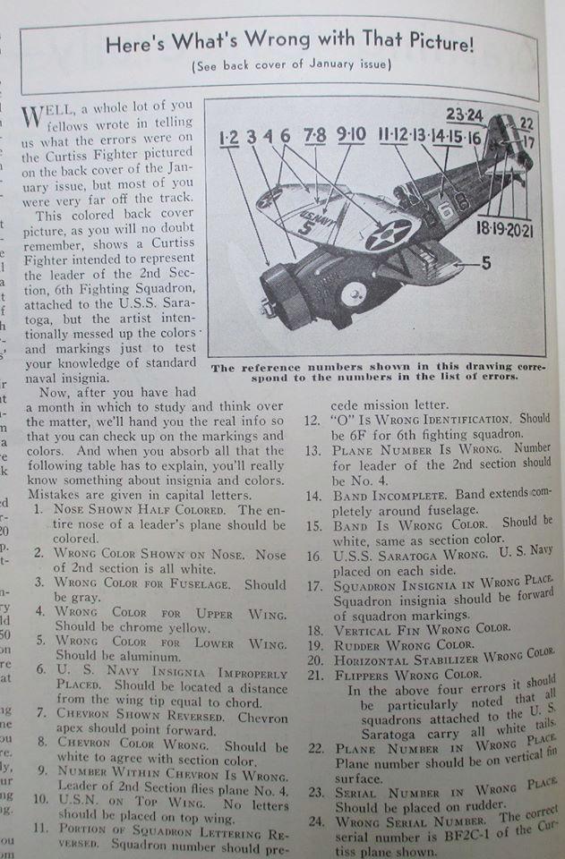

Stolen from the internet part 1: Quick change Cox test stand
Paul Smith: Detroit

Check this out. It's a tight-fitting collar designed to fit a reed valve .049 or .020 and be secured with only two c-clamps.
It's laminated from two layers of 1/8" plywood with a 1/16" plywood on the back with a cutout for the ears.

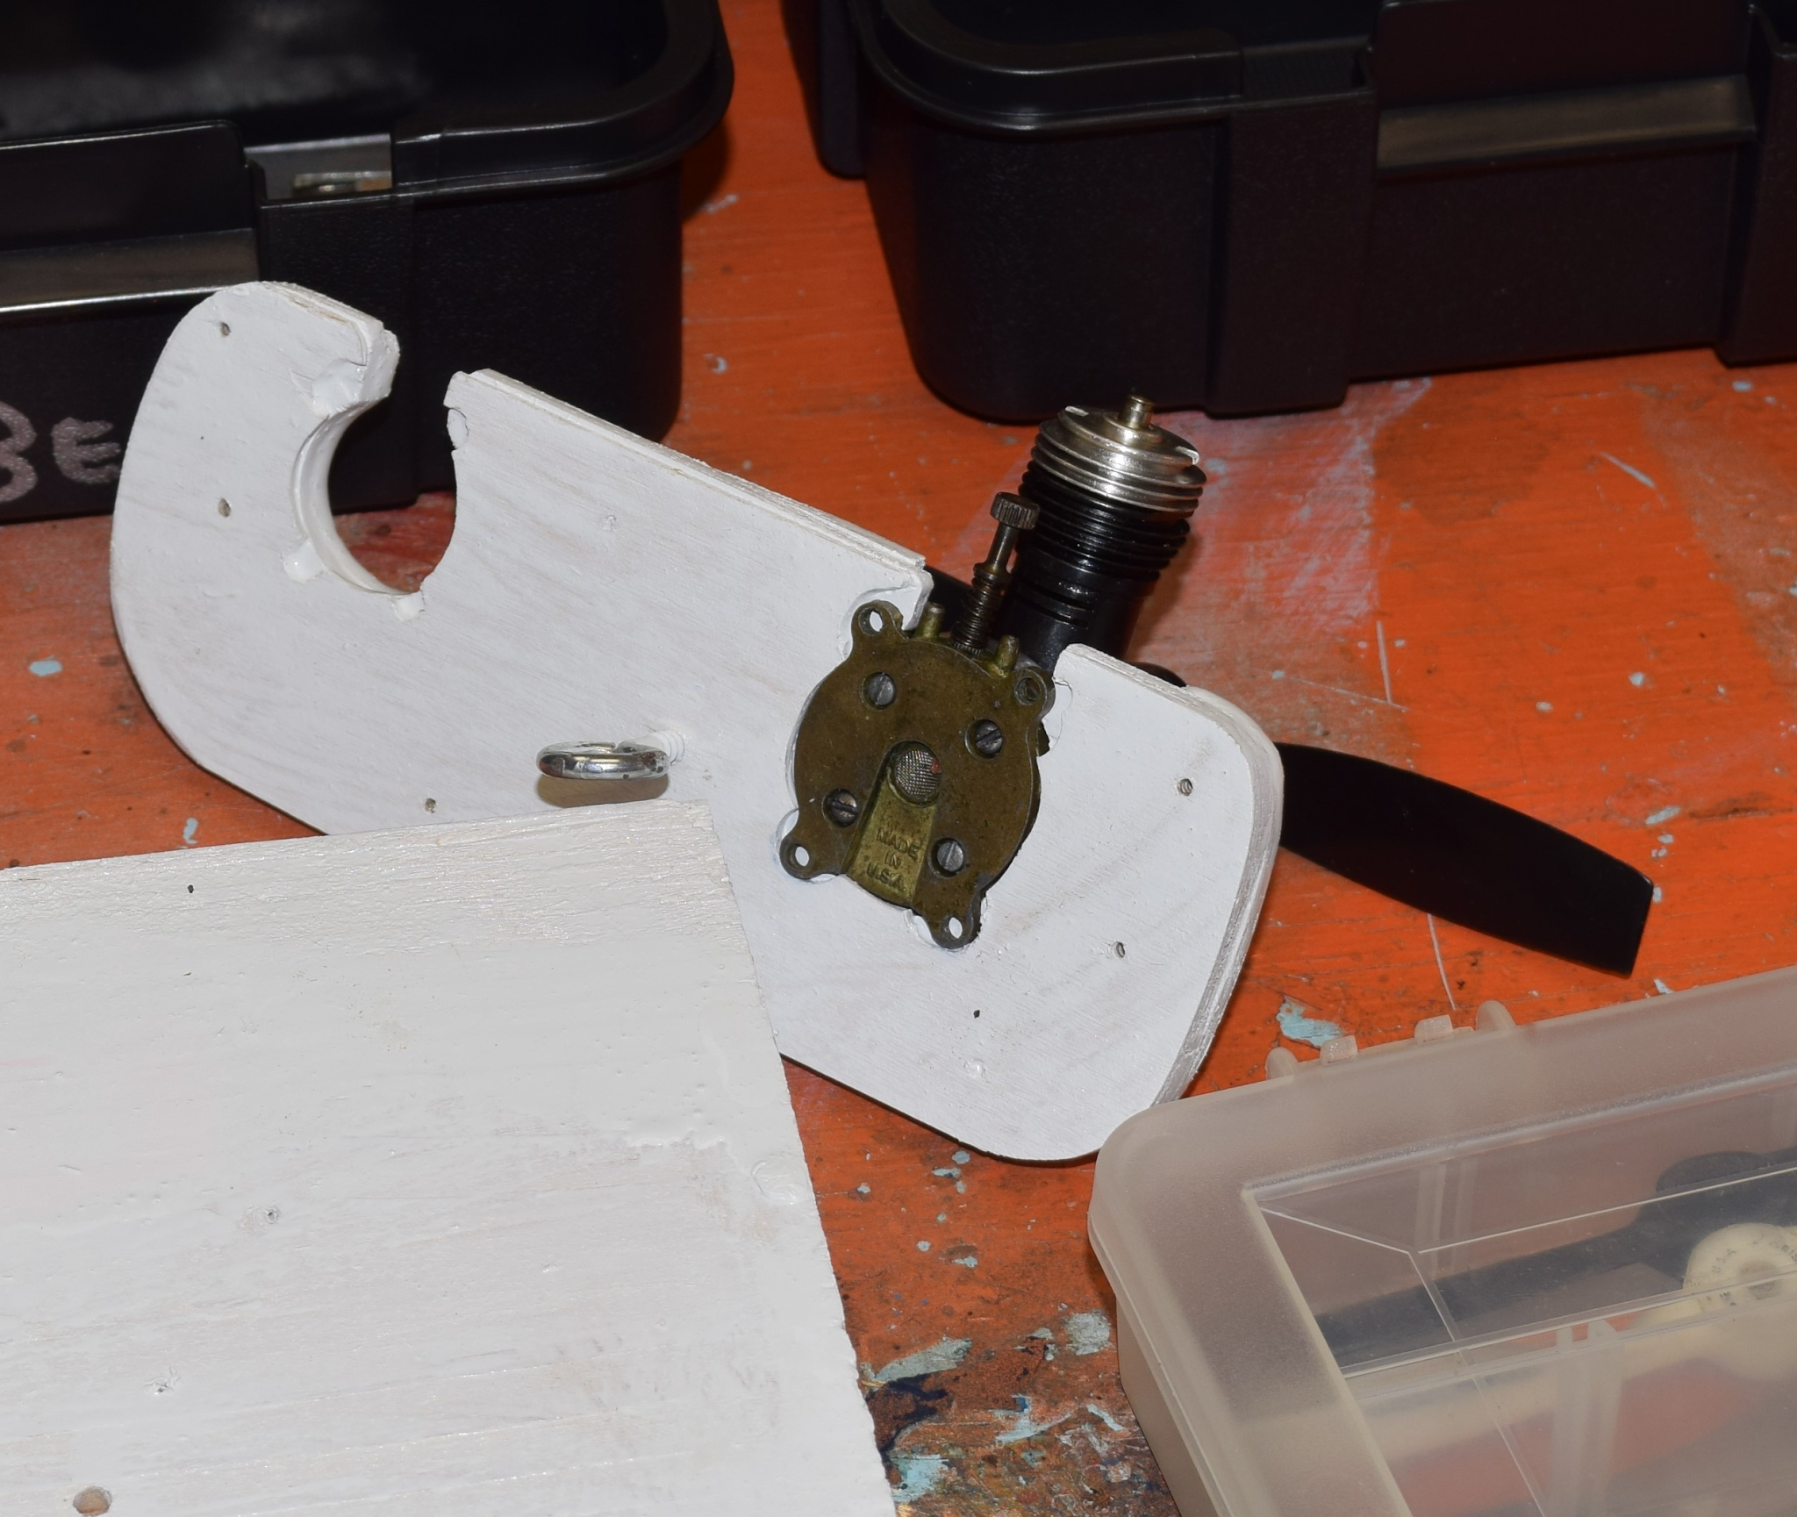
So I can cycle five Babe Bees and five PeeWees through the fixture without messing with tiny screws every time.
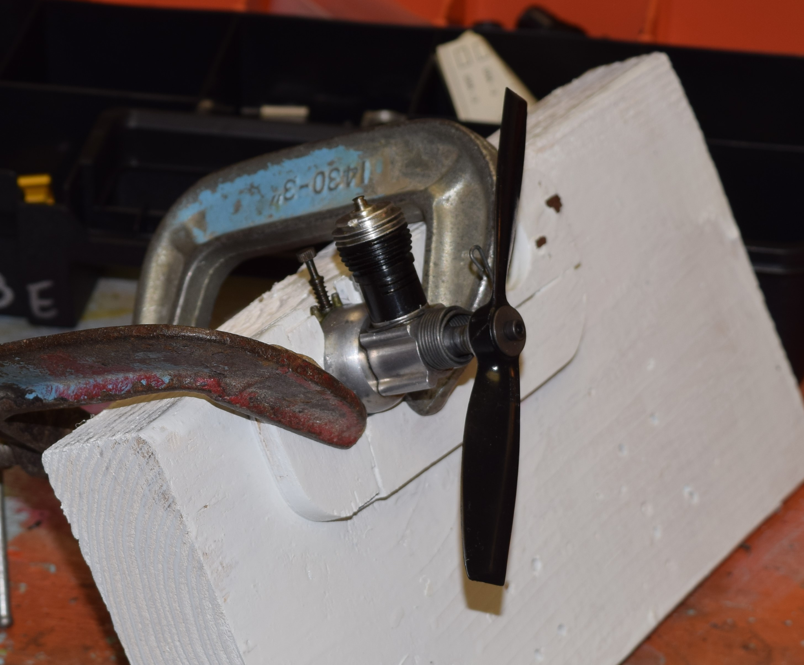

Stolen From The Internet part 2: Glow batteries
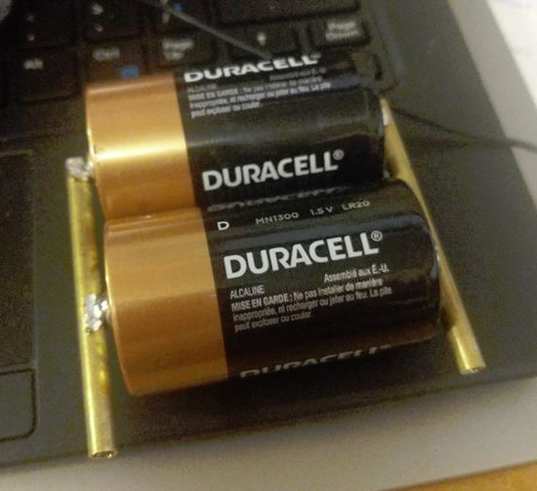
A simple cheap glow battery. Get 2 or more (3 or 4 is better) good D cell batteries and solder them in parallel to some brass tubing. A search through my tubing rack and some banana plugs saw that 3/16 OD was a real tight fit 7/32 OD would be better. Banana plugs are 3/16 OD, and plug right in the ends.

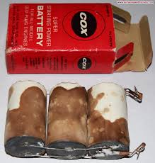
Many of you run banana jacks on your flight boxes and this is a great way to keep one set of glow leads for the pack and panel.

The pack should last for 1 or more flying seasons of normal use. COX used 3 D cells in their flat battery packs. Wrap the whole mess in some cardboard and duct tape for protection and you have a pack that is always ready to use. Graphics of old batteries can be found on line for the vintage look. Write a date on it so you know when to replace it. When the voltage drops below about 1.1V replace the Cells.

 | June 2020
 | SUNDAY | MONDAY | TUESDAY | WEDNESDAY | THURSDAY | FRIDAY | SATURDAY
 | 31 | 1 | 2 | 3 | 4 | 5 | 6
 |  |  |  |  |  |  | Club Meeting at the field
 | 7 | 8 | 9 | 10 | 11 | 12 | 13
 | 14 | 15 | 16 | 17 | 18 | 19 | 20
 |  |  |  |  |  |  | June Solstice
 | 21 | 22 | 23 | 24 | 25 | 26 | 27
 | Father's Day
 | 28 | 29 | 30 | 1 | 2 | 3 | 4
 | 5 | 6 | 7 | 8 | 9 | 10 | 11
 | NOTES

AutoThrottle-- Electronic Speed controller / Timer. P1
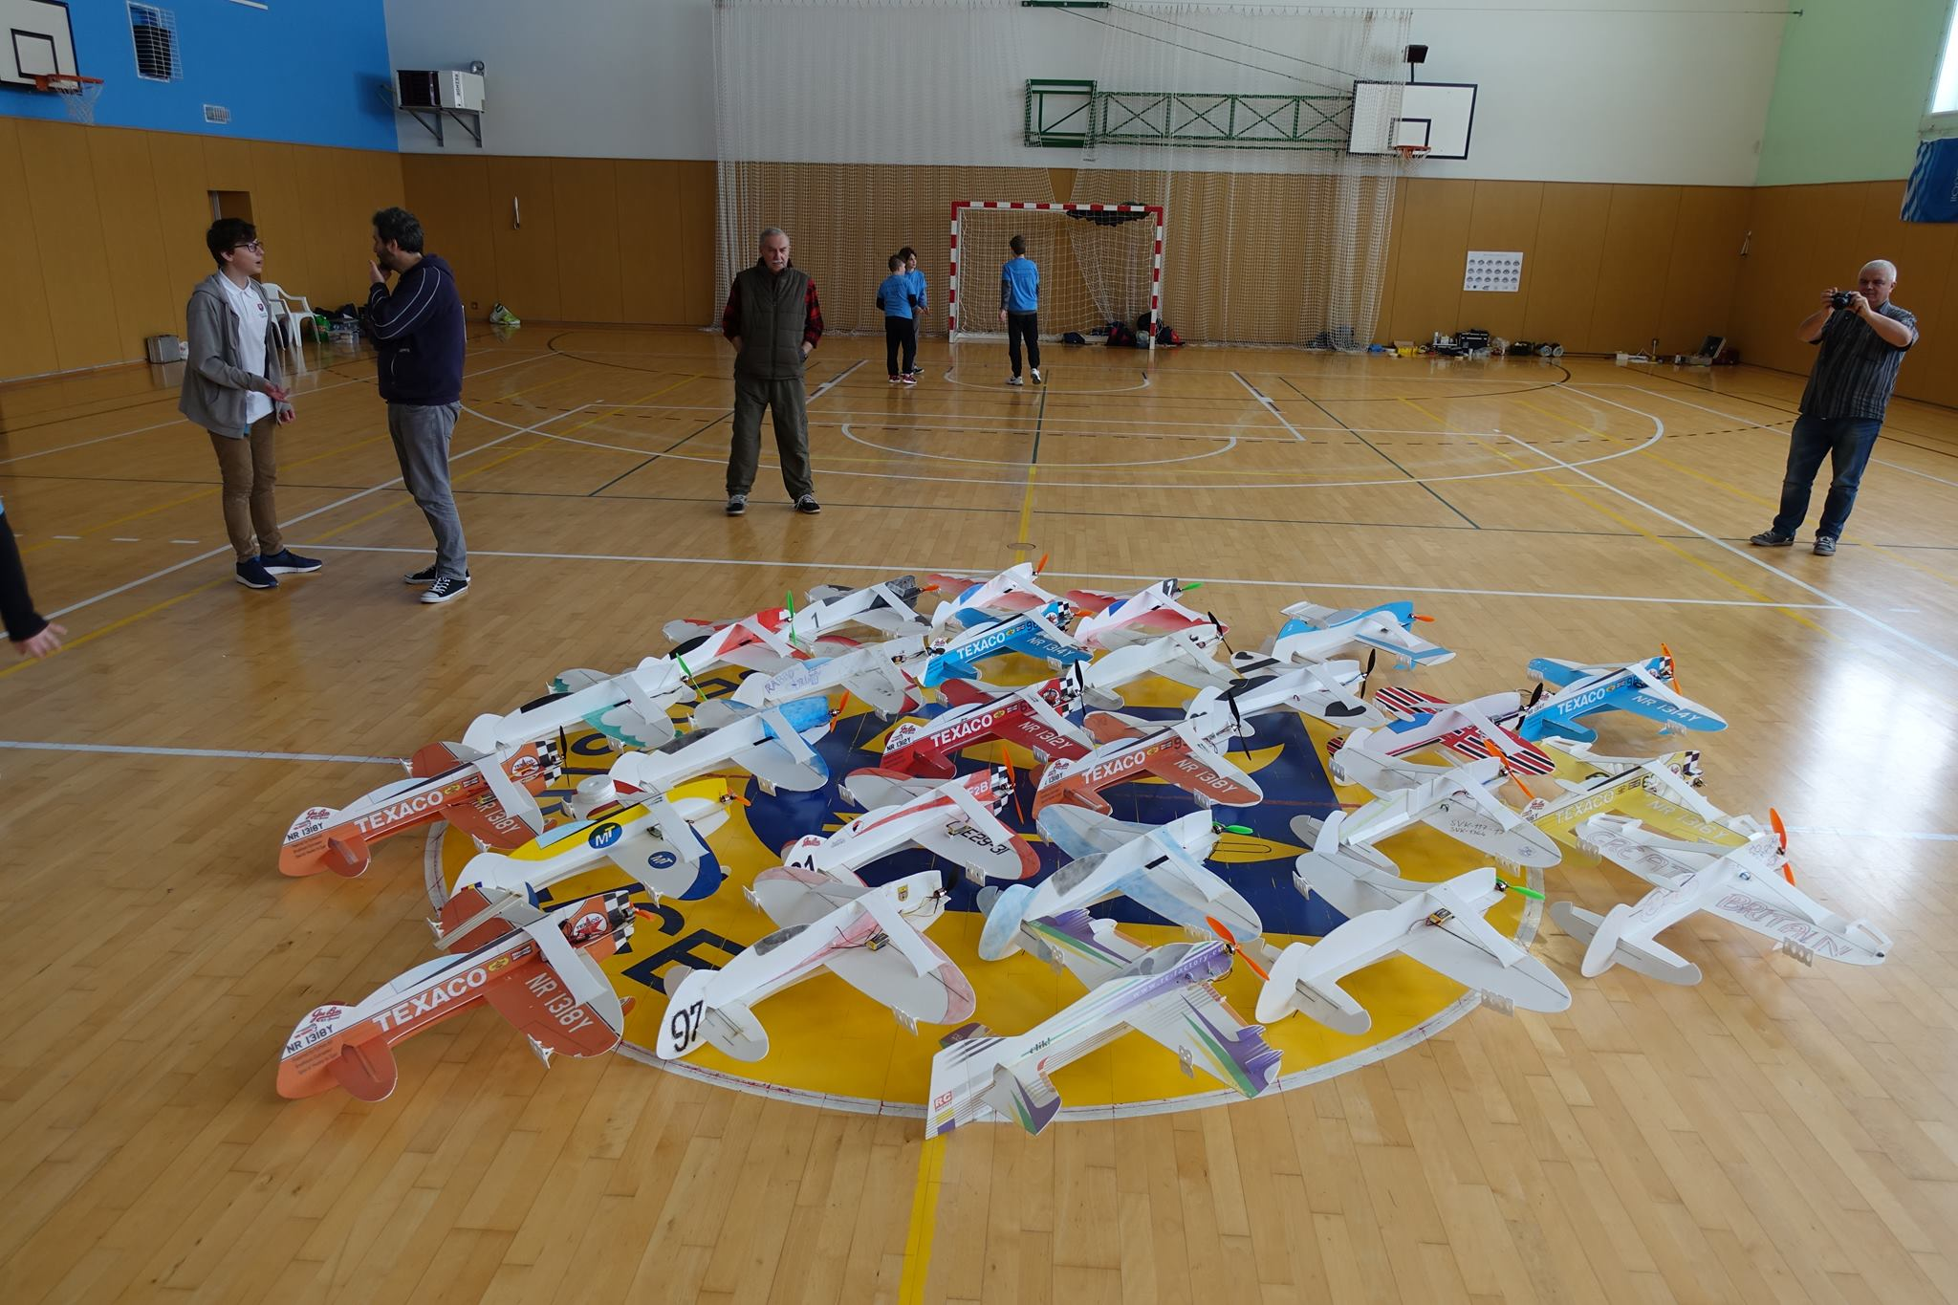
An arduino based timer for electric control line flying . Dave Siegler Ama 720731

This is multi part article
Two years ago I had the pleasure of attending an indoor control line stunt contest in Bruno, Czech Republic, called the GeeBee cup. Former world champion Igor Burger and all around nice guy made it possible. It was a great trip. There is a series of events in Europe for indoor winter flying and engaging young modelers. They have great prizes and food.

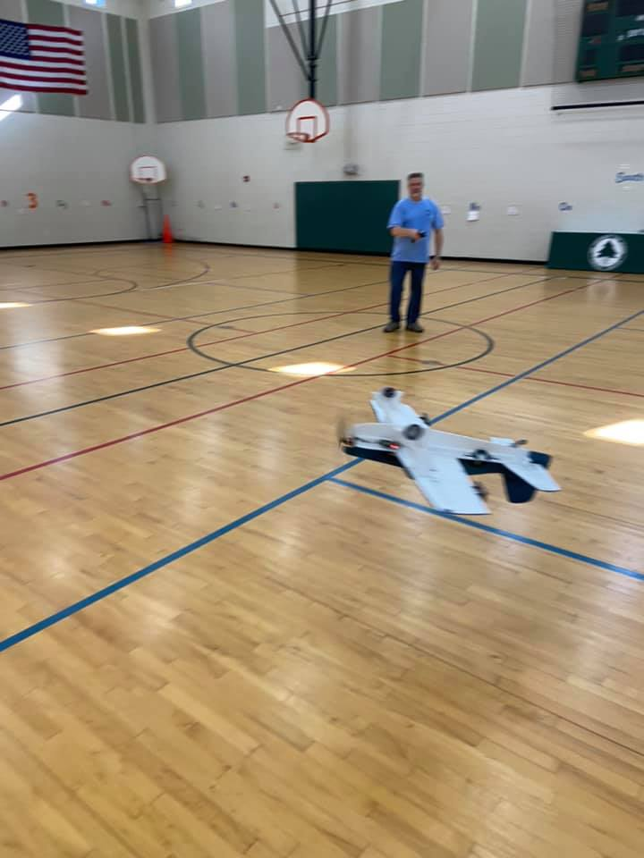
Several problems must be solved to allow the plane to complete an entire aerobatic schedule on 15 foot lines. A big problem is that to have enough centrifugal force for loops and wingoves, the speed has to be fairly high. On 15 foot lines the rotation speed is uncomfortable and the even smaller hemisphere really compressed, so it is difficult to fly stunt.

The airplanes were all large, light, flat airfoiled foam planes. Plans for this model are listed on the club web page. http://www.circlemasters.com/plans-page.html
There are many resources for building foam airplanes and it may be a newsletter article in the future.

Chris stretched and tweaked the basic design into a Hellcat design. Foam is very forgiving and there are many opportunities to customize the design look how you want. Weight control is important.

I knew from previous RC experience that airplanes of that configuration don’t like to fly fast. The airplanes are ok in slow flight but as the speed climbs the pitch control gets challenging. Some tend to “tuck under” at higher speeds and the elevator is very sensitive and non linear. This isn’t desired behavior for a control line aerobatic airplane. Speed control ends up being critical.

The power system consists of low cost 20A esc units and 3 cell packs(850- 1100ms). Motors like the Emax 2822 work well. You can get them from many sources. You want a KV of about 1300 and a current rating of about 15 amps. A 10 inch slow flier prop works well. Timer controls needed to start and stop the flight but an RC TX and RX can be used. An RC car transmitter and receiver can be used to control the throttle and is fun to fly. Chris built his transmitter into the handle with the throttle on the trigger finger and it works great!

Igor Burger has a sensor based timer and speed regulator.

Igor’s Gee Bee’s just crawled along in flight and the motors growled and add power when the nose comes up or the plane cornered.. As an electrical controls engineer, I was fascinated. How does this all work? Closed loop control? Some kind of gyroscope and supercomputer? It did not add up. The plane was fun to fly, could do all the tricks in the pattern but had unnervingly low line tension and flew slowly. With the slow speeds, the controls were set up to be very sensitive, but still easy to fly. Igor Burger sells the controller that most people use, but I had to try to figure it out and make my own design. Part 2 will cover hardware design.

