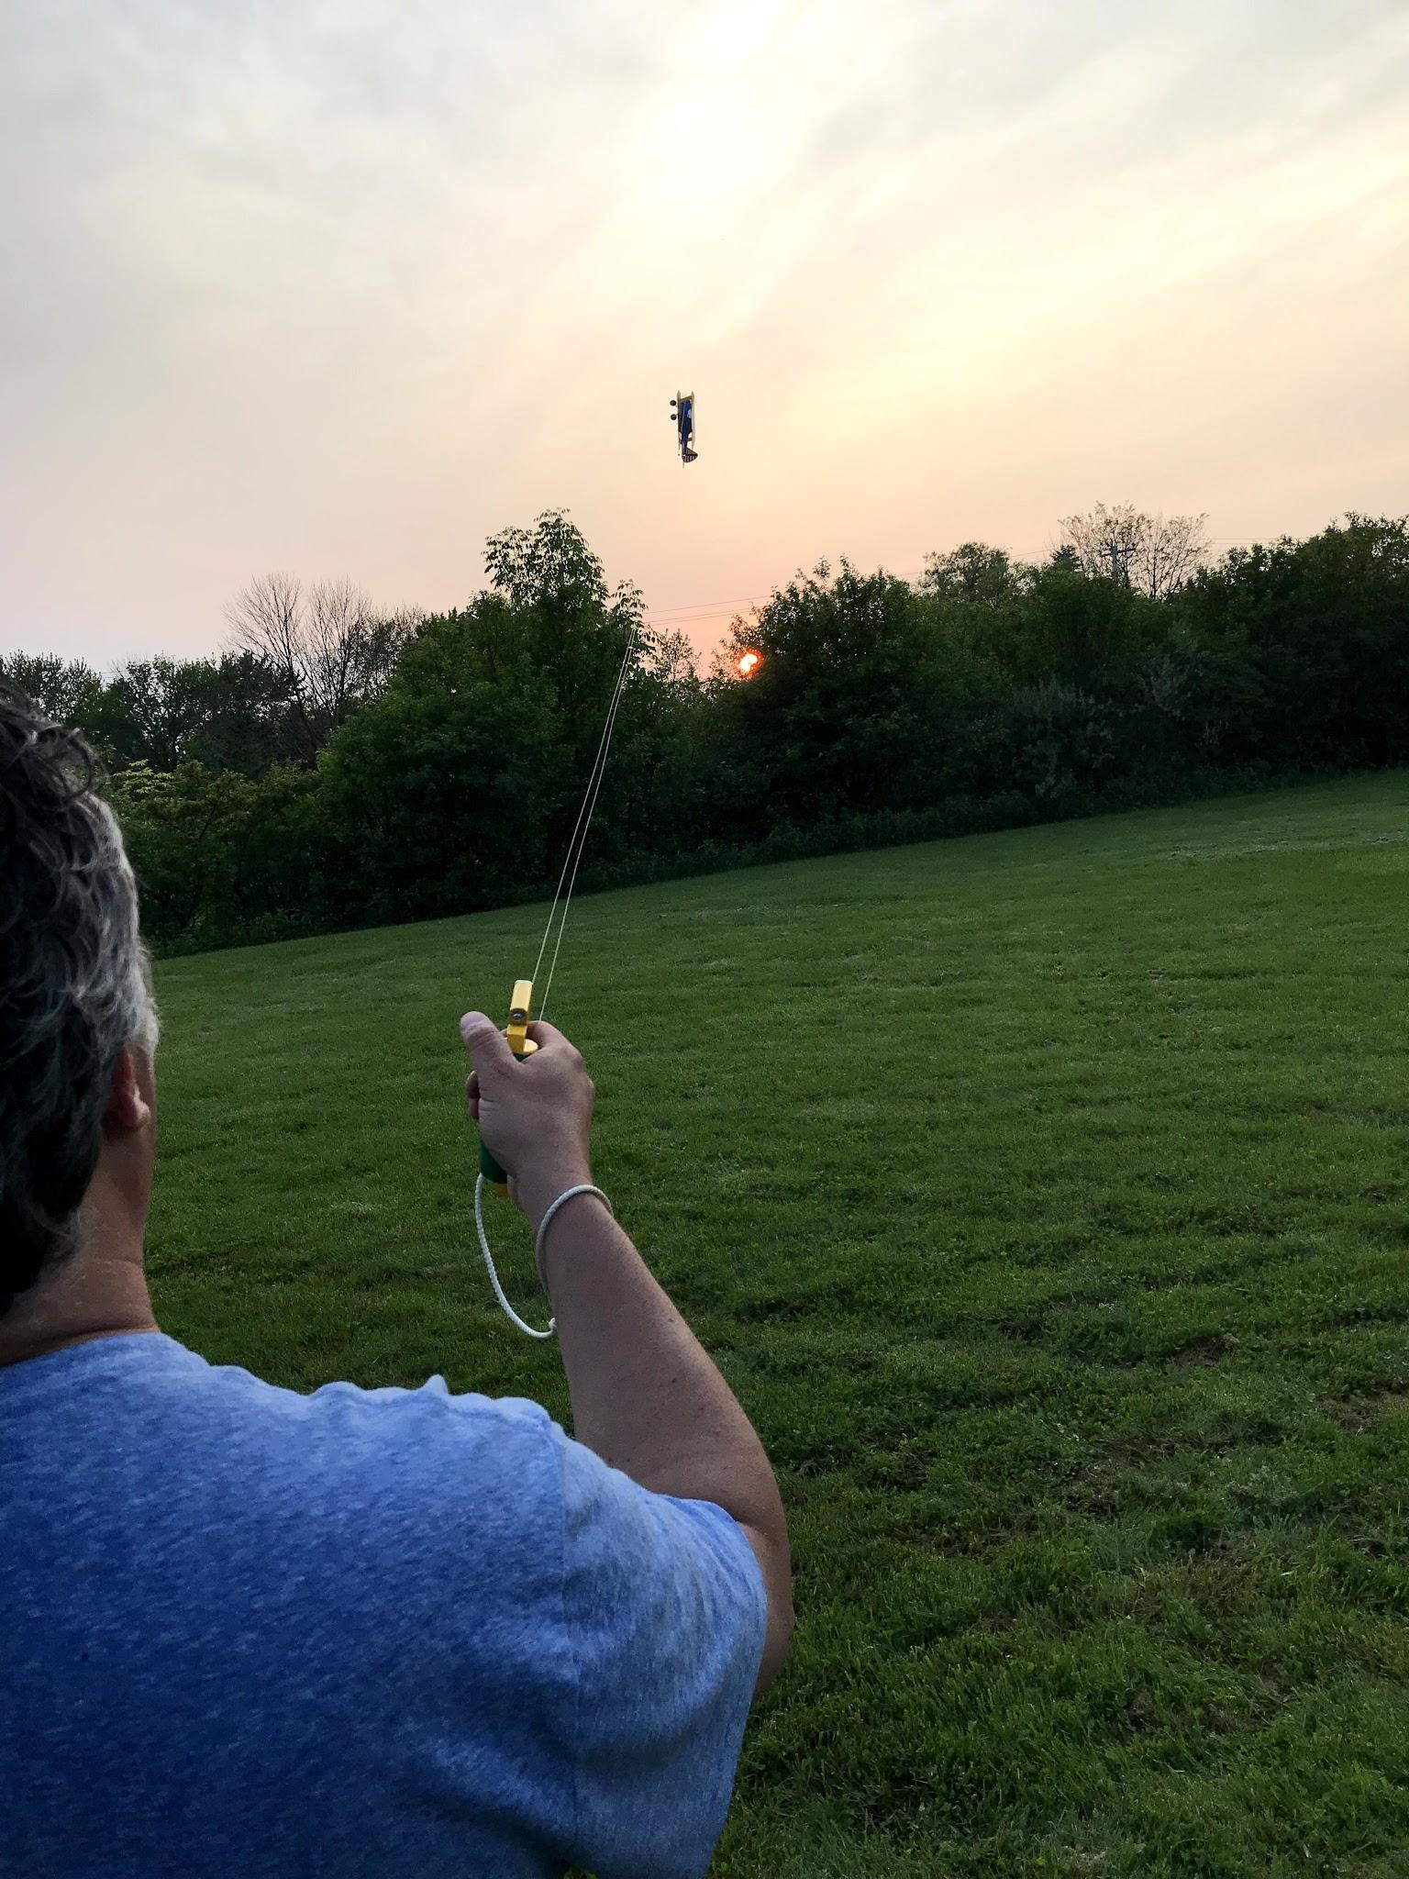
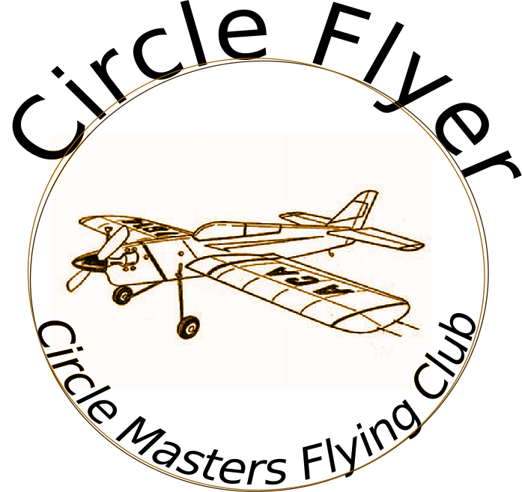

Circle Masters Flying Club  Wisconsin’s control line club March 2020 volume 1 issue 3 |  | Lifetime Member Bob Gidildi
Announcements  Hope your projects are going well. March comes in like a lion and we should be flying soon.  Next Month’s issue (April) is time sensitive will hit the air on April 1. It wouldn't be any fun to publish it before April fools day? I hope you will like it.  Don D found an old club poster. That I included |  | Inside This Issue  PG. 2 Contact information  PG. 3 Plan of the months  PG. 4 Meeting Minutes  PG. 5 Cub Calendar  PG.6 Using Lamination film and exam paper

Editors Notes  This month I will start a series on technical articles that I would like to write on technical stuff on model airplanes, building materials and the like. This month we will cover (ha) the use of mylar lamination film, and exam table paper as a covering option.  The plan today is a tank drawing for pesky profile uniflow tanks. Uniflow tanks give constant head pressure from full to empty and usually get more consistent runs. Their construction is poorly understood, but are simple devices.  I ma including event fliers when I get them. |  | Club Information  Web site www.circlemasters.com  Dues $20.00  Flying Location  Sussex Village Park, Sussex. Wisconsin  Meeting First Saturday of the month 1pm  Location Summer (May- Oct) at the field  Location Winter Sussex Library  Comments to circlemastersflyclub@gmail.com
“.. I even learned farming, who hasn’t planted a few deep in this hobby?” |  | The hobby of all hobbies  Building airplanes is a hobby of many hobbies. Woodworking, fiberglass, metal work electronics are often needed. Hell I even learned farming, who hasn’t planted a few deep in this hobby?  I learned to make blueprints from models. Building model rockets made me study calculus. Modeling taught me how to solve problems and taught me rudimentary engineering skills.  I have traveled and met people from all over the world because of his hobby. I flew control line in Singapore and the Czech Republic. The Hobby has been good to me. Hope I can be good to it.

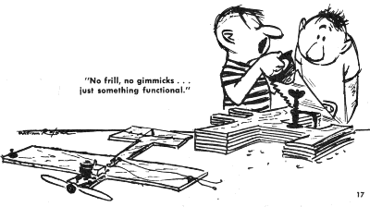Cartoon |  | Book Review  Harnessing the Sky --Frederick "Trap" Trapnell, the U.S. Navy's Aviation Pioneer, 1923-1952  Great book, part of history I did not know.  A pilot of calculated courage, "Trap" entered the Navy when test pilots were more like stuntmen than engineers. Airplanes had not yet come into their own as weapons of war, and they had an undeveloped role in the fleet. His vision and leadership shaped the evolution of naval aviation through its formative years and beyond.  When the threat of war in 1940 raised an alarm over the Navy's deficiency in aircraft - especially fighters - Trap was appointed to lead the Flight Test Section to direct the development of all-new Navy airplanes. He played a key role in expediting the evolution of the two superb fighters that came to dominate the air war against Japan - the Corsair and Hellcat. After World War II, Trap returned as commander of the Naval Air Test Center to lead the Navy through the challenges of transitioning to jets. Trap was not only the first US Navy pilot to fly a jet, but is also recognized for defining the operating requirements for carrier-based jet propelled aircraft.
We all build cool airplanes. But sometimes we just need something to fly. Something we are not too attached to. This looks like a Tough Baby ala cardboard.

Club Events
Club Contest-- August
EAA Kidventure Late July
Sussex Antique Tractor and Steam Engine show August
Club Fun Fly and Picnic June
Christmas Party December

Plan of the month
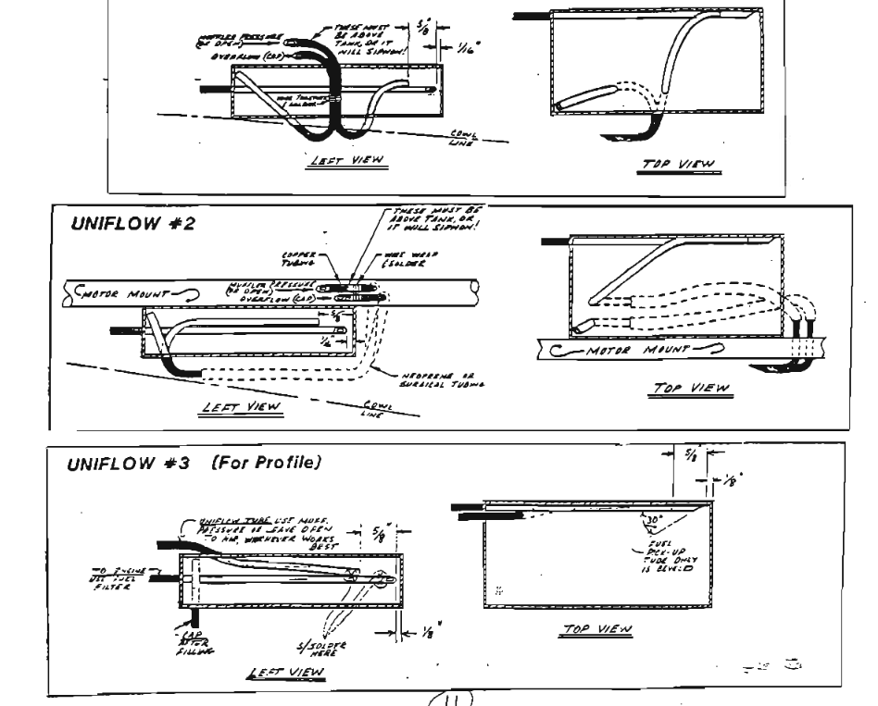
From Stunt News Uniflow tanks

CIRCLE MASTERS FLYING CLUB
MEETING MINUTES for FEBRUARY 2020
The February meeting of the Circle Masters Flying Club was held at the Pauline Haas Public Library. The meeting was hammered to a start at 1:05 PM by Pres. Chris. He began by asking if the members (8) had received The Circle Flier newsletter and had read the minutes from the January meeting. The members present had all read the minutes. So, the minutes stood as published.
The Treasurer's Report for February was presented by Wayne. His report was approved as presented. Also: CLUB DUES ARE OVERDUE!
REPORTS & ANNOUNCEMENTS: Chris reported that the “Electric Slow Flyers” division of the Circle Masters Flying Club has secured a location for their indoor C/L flying. All of those who are interested are invited to join them following the meeting. If you are reading this info for the first time, then contact Chris for details. Wayne reported that the club has received the Leader Club plaque for 25 years of participation with this AMA program. Also, the application for the club charter and insurance has been filed. John Schram reported that he acquired a box of older models & accessories which he sold at the recent R/C Auction for $65.00 then donated that amount to the club. Thanks John. Don reported on the results of the recent R/C Auction. He passed out some CMFC tri-fold literature to some interested attendees and discussed the club’s activities with them. Actual results of the auction will be available at the next meeting.
OLD BUSINESS: (from new business last month) The resurrection of Tuesday Night Flights was brought up but not fully discussed due to not knowing when there will be disc golfing in the area. More info from the Village is needed.
NEW BUSINESS: John Schram reported that on the weekend of Feb. ^{21st,} 22nd & 23rd. up at EAA, will holding Family Flight Fest. There will be many events including indoor free flight by the Bong Eagles. Don A. read a letter from the Town of Lisbon inquiring if the club would be interested in participating in the annual Easter Egg hunt. Volunteers are needed for this April 4th event, see Don.
WEB SITE BUSINESS:
OTHER BUSINESS: None.
There being no further business Chris asked for a motion to adjourn the meeting. It was quickly moved and seconded. Meeting adjourned at 2:25 PM.
SHOW & TELL: Chris’s T-38 and his F6F Hellcat slow flyer.
Submitted by Wayne M. Schmidt Secretary/Treasurer 02/11/2020

 | March 2020
 | SUNDAY | MONDAY | TUESDAY | WEDNESDAY | THURSDAY | FRIDAY | SATURDAY
 | 23 | 24 | 25 | 26 | 27 | 28 | 29
 | 1 | 2 | 3 | 4 | 5 | 6 | 7
 | Swap Meet Kaukauna |  |  |  |  |  | Club Meeting
 | 8 | 9 | 10 | 11 | 12 | 13 | 14
 | Daylight Saving Time starts |  | VINTAGE STUNT CHAMPIONSHIPS XXXII | VINTAGE STUNT CHAMPIONSHIPS XXXII | VINTAGE STUNT CHAMPIONSHIPS XXXII | VINTAGE STUNT CHAMPIONSHIPS XXXII | VINTAGE STUNT CHAMPIONSHIPS XXXII
 | 15 | 16 | 17 | 18 | 19 | 20 | 21
 |  |  | St. Patrick's Day |  | EAA Kim Campbell A-10 Pilot | F2D Top Gun Phoenix | F2D Top Gun Phoenix
 | 22 | 23 | 24 | 25 | 26 | 27 | 28
 | F2D Top Gun Phoenix
 | 29 | 30 | 31 | 1 | 2 | 3 | 4
 | NOTES

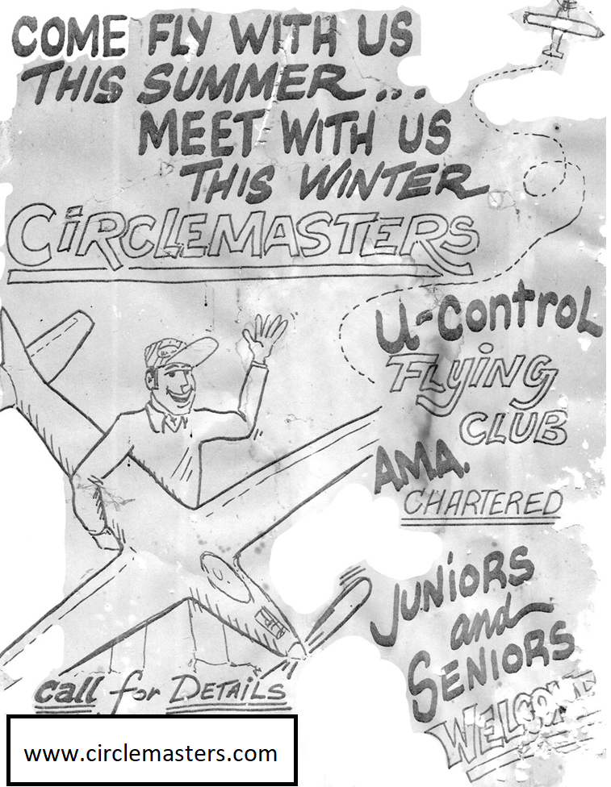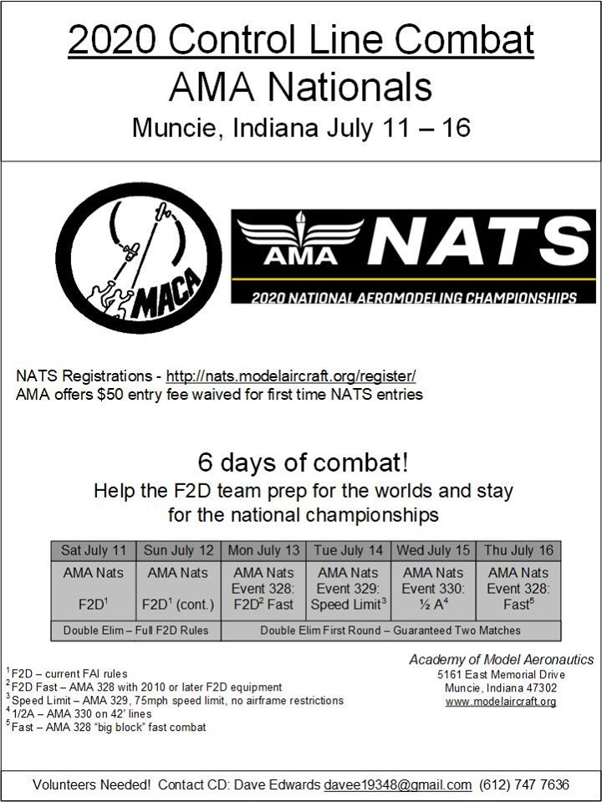
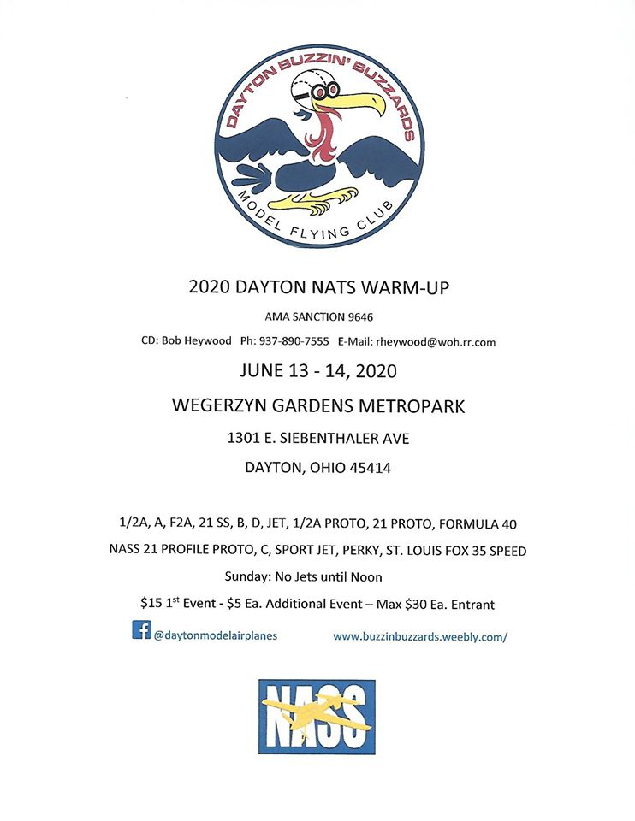

Lamination film for model airplanes
Dave Siegler AMA 720731
Modelers have long searched for alternate material for model construction. This is especially true for covering materials. At some point, advanced mylar and polyester materials were adopted and adapted specifically for modeling use. The material came from many industries like sign making, document lamination and industrial covering. Model airplanes were big business, but tiny compared to the other use of this material. Combat builders used a lot of FasCal to cover and repair airplanes. Polyspan has been adopted from the fabric industry. Heavier coverings like Koverall and Oracover came from full scale applications.

Monokote, Solar Film and many others really made life better for many modelers. In this house, brushing or spraying dope is an outdoor activity, and that limits its use in the winter months. Dope is also really expensive now.

Monokote and all their clones are wonderful, but pose some problems.
- Hobby films are expensive.
- Pigments and glues used in Hobby Films are heavy and not suitable for ultra light structures
- Sometimes glueless and paintless options are needed
- Hobby films need high heat and won't work on foam structures
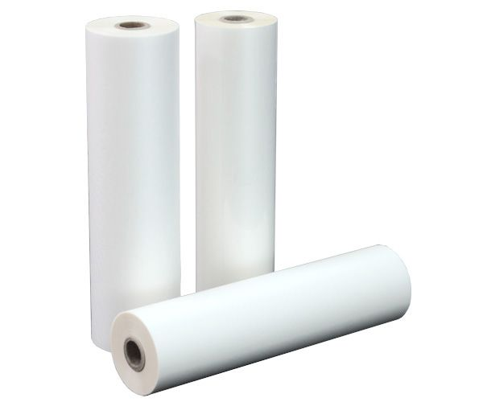
- Hobby films have become less available recently as the industry continues to shrink and hobby shops disappear. New Monokote isn't a nice as the older stuff and Solarfilm (my favorite) is no longer in business

Roll laminators are in wide use and use low cost rolled heat activated adhesives, heat shrinkable polyester covering. Hey that sounds like just what we need!

You can get it from many places like office supply stores, amazon or ebay, and in many thicknesses. Look for material that is .7 to 1.5 mills and is clear. They come in long rolls 500 feet typically. And widths from 8 inches to 36. They often come in pairs. Look for the 22” to 24” wide stuff
Phil Cartier ( google core house foam wings) sells his awesome SLC film cheap. He will sell it by the foot and is 1mill. Phil is a polymer chemist and claims this stuff is the toughest stuff he could find. SLC is a populate substrate for tissue and polyspan.

In the lamination business, they often throw the last 100 feet or so to prevent changing rolls mid job. You may be able to score some cheap or free. I got some from the old milwaukee map store.
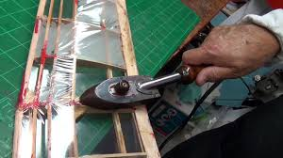
You apply this stuff just like normal low heat iron on film. It is thinner, so you have to be careful with too much heat. Heat is a little lower than monokote. It does not have a backing. Keeping the surface dust free is important as the glue is minimal. The film is frosted in color till you heat is and changes to crystal clear.

It works well around wing tips, but doesnt stretch like hobby film. I do keep some balsa rite handy to put around the nose and other high stress points as the glue is thinner.
It can be painted after scuffing it up with a scotch bright pad. Some combat guys lightly mist the glue side with paint before applying it. It is often used under polyspan, silk or silk span as a way to quickly fill the weave. I use it over foam and on open bays on smaller airplanes. It works well.
Dave

Exam Table Paper cover as a silkspan replacement.
This is taken from Stunt Hangar Frank from the Northern Virginia Control Line Club found this out. I bought a box and it works like the old medium weight stuff.
Dave
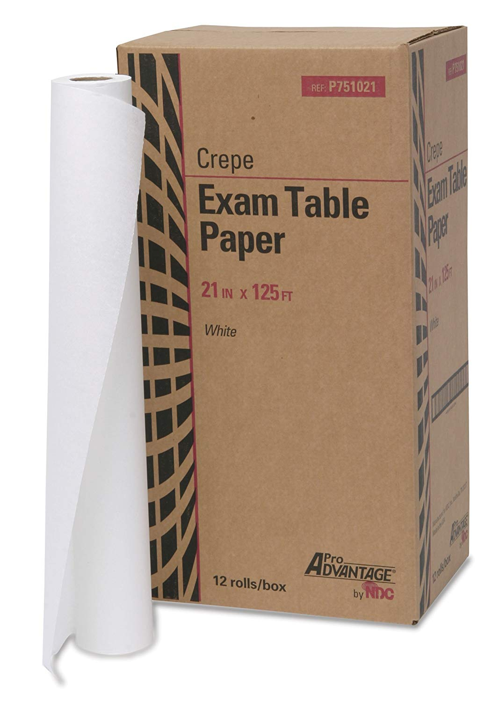
From Stunthanger.com:

NVCL members,

Ever since hobby websites have run out of silkspan, I have been on a quest to find a substitute for it since I am a paper and dope kind of guy.

During a check-up at the local military hospital a few months ago I noticed that the exam table paper sure looked a lot like the silkspan I’d been using on all my model aircraft. The doctor thought I was nuts when I asked him if I could take home the 6 foot section I was sitting on. After all, it looked and felt just like silkspan……….the question was, would it act like silkspan? The short answer is, YES IT DOES!!!! I tried out my test piece on a built up stabilizer for my next stunt beast and it went right on damp, took the nitrate dope and shrunk right up when I hit it with a blow dryer. I tried it on bare wood to cover the grain and it works great and leaves a smooth surface.

Now I was ready to find out from the hospital what it was called and where to get more. One of the medics offered to give me a roll but I told him “Son, if I take that we’re both gonna be in a lot of trouble”. I asked him to tell me what it says on the box it comes in and he said, “they only give us the roles”.

I went to the hospital supply office and they tried to help, but all they could tell me was the brand, Medline, and I could get it at Staples. To make a long story short I had to order various types and send them back before I finally found the match. It comes from the Tidi company and it is their top of the line crepe exam table paper, 21 inches wide on a roll 125 feet long…..enough paper to cover the Spruce Goose, and it comes in a carton of 12 rolls.

The paper looks just like the silkspan we get from K&B. It is strong when wet (it’s wet tensile strength is not quite as good as silkspan) but it has good strength none the less (hell, we sit on it on the exam table) and is strong and pliable when laying it on the aircraft. It sticks down with nitrate dope on a doped wood structure no problem. It is thin enough to be worked on compound curves too. When it dries, it comes out tight and smooth, ready for more coats of dope. It has a rough and a smooth side, and has a grain. To give you an example of how it works, a 6 inch strip expands to 6 ½ inches when wetted. Lay that down and it tries to shrink back to size and that makes it tighten up.

I’ll bring some rolls over to Scott’s tomorrow so you can see for yourselves. The rolls are either 60 ft or 125 ft long (I haven’t rolled one out) and are $4 to cover the cost. What a deal. You’ll never have to buy paper for the rest of your life.

Fly Stunt, Frank

