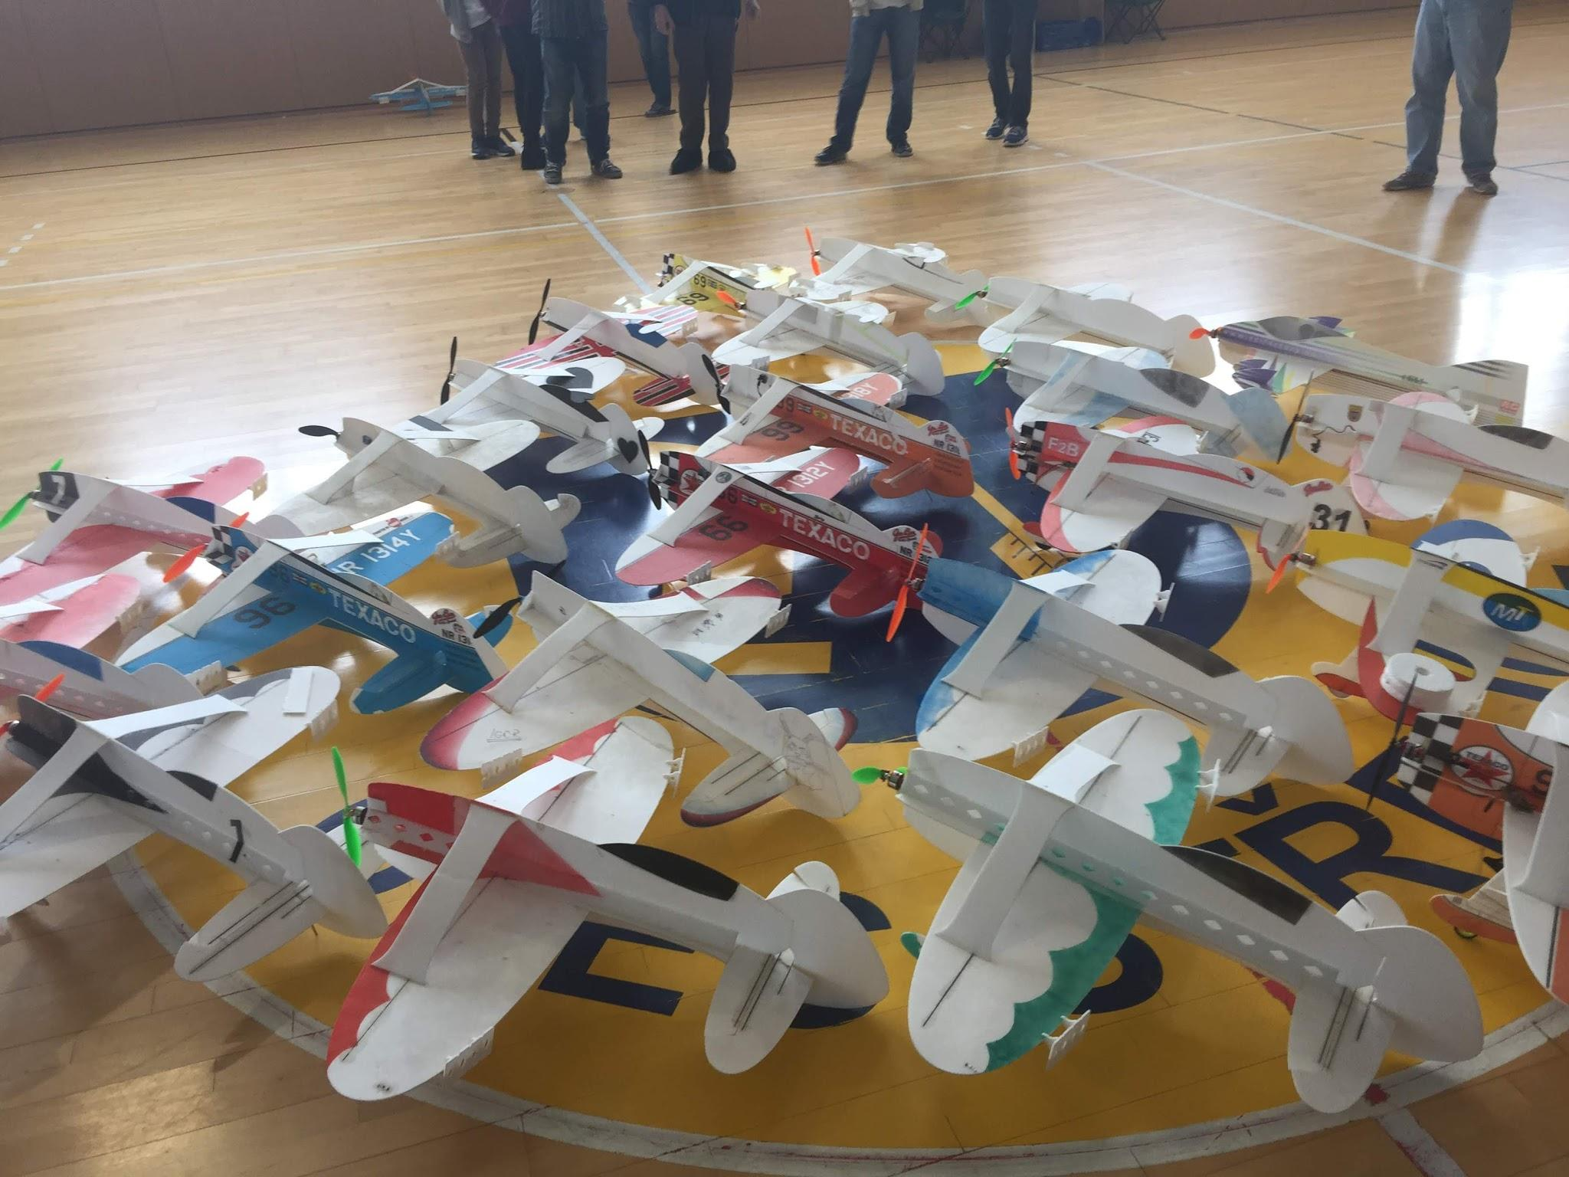


Volume 1 Issue 5 May 2020
Circle Masters Flying Club  Wisconsin’s control line club |  | Lifetime Member Bob Gidildi
Announcements  At the time of this writing we can't fly and can't meet as a group. Online meetings will continue through Zoom.  I will be having tuesday night build sessions on google hangouts.  At this time of writing EAA Airventure is still on announcing early May. Joe Nall canceled..  The Nats, indoor is canceled but all other are still in plan |  | Inside This Issue  PG. 2 Contact information  PG. 3 Plan of the months  PG. 4 Meeting Minutes  PG. 5 Venturi's on a lathe

Editors Notes  This issue will have a few deeper topics. The development of the speed controller. It will cover the reasons for doing it and some of the Hardware and software. Sill a little more work on it and test.  I added a photo essay on how you can make venturis on my sherline lathe. I drew the part on solidworks, my first 3-D models and turned it on the lathe.  Current progress on my speed controller is here as well.  Quarentten is time for puzzles and problems, there is a Where-Is-Waldo problem. Solution will be published next month. There are 24 problems with this picture.  I will be adding an old advertisement of hobby items each month. |  | Club Information  Web site www.circlemasters.com  Dues $20.00  Flying Location  Sussex Village Park, Sussex. Wisconsin  Meeting First Saturday of the month 1pm  Location Summer (May- Oct) at the field  Location Winter Sussex Library  Comments to circlemastersflyclub@gmail.com
“Stay Safe and keep engaged Build build build” |  | 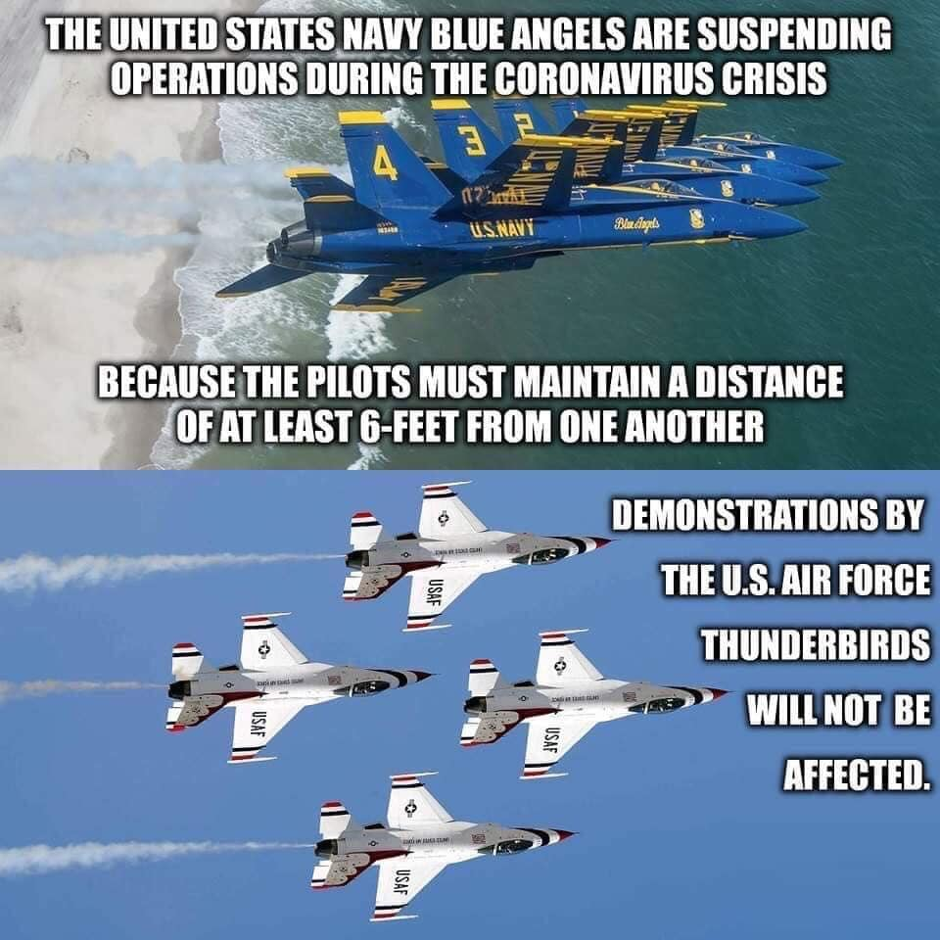

Cartoon  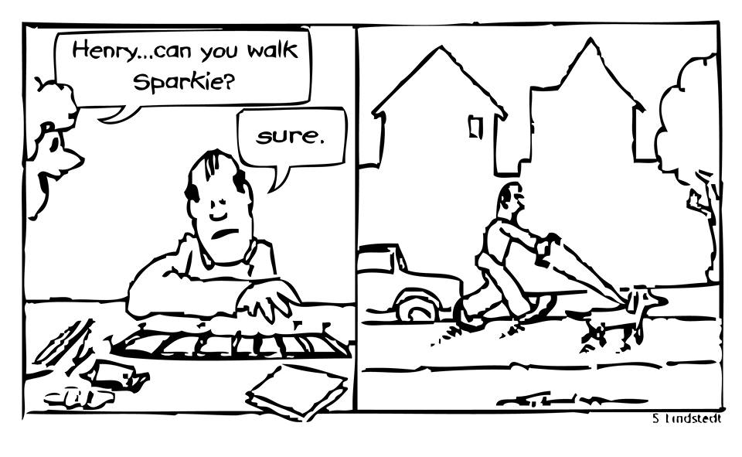 |  | 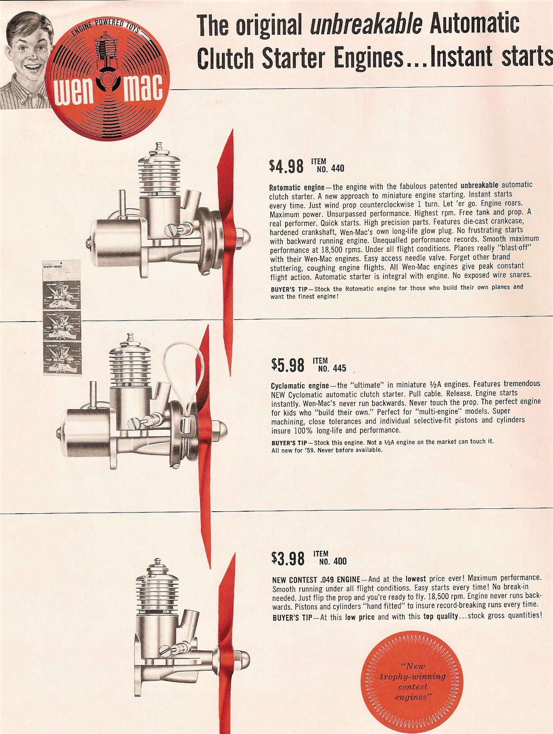  Old Ad
Walking a dog with a handle is a fun way to get old sparky out there. If you can't fly, do some laps with your dog.

Club Events
Club Contest-- August
EAA Kidventure Late July
Sussex Antique Tractor and Steam Engine show August
Club Fun Fly and Picnic June
Christmas Party December

Plan of the month
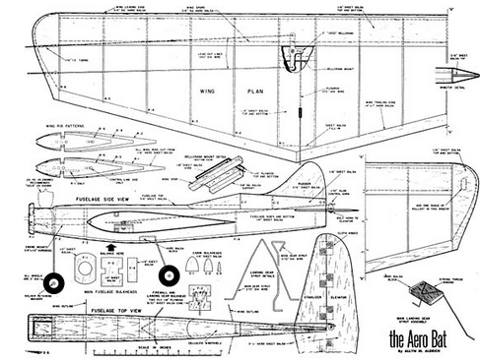

CIRCLE MASTERS FLYING CLUB
MEETING MINUTES for April 2020
The March meeting of the Circle Masters Flying Club was held at Home. Thanks to the Coronavirus this meeting was held with computers. The meeting was hammered to a start at 1:10 PM by Pres. Chris. He began by asking if the members (?) had received The Circle Flier newsletter and had read the minutes from the March meeting. The members present had all read the minutes. So, the minutes stood as published.
The Treasurers Report for was presented by Wayne but read to the members by Chris. The report was approved as presented.
REPORTS & ANNOUNCEMENTS: There might have been some reports but were unheard by the secretary. Dave if you have any record please add it here.
OLD BUSINESS: Chris asked about the “Wednesday Night Flights” and Jason reported that no activities have been signed up due to the virus situation. Therefore, this we must do the same and put this subject on hold. The Lisbon Easter egg hunt has been cancelled for this year for the same reason. The piles of soil will be removed and smoothed over. Probably done by now.
NEW BUSINESS: Since August 15th will be National Model Aviation Day it was proposed that perhaps we could fly on that Saturday and practice for the upcoming Antique Tractor and Steam Show. Jason will check to find out if we can use the field.
WEB SITE BUSINESS: Dave reported a lot of hits on the web site as well as Facebook.
OTHER BUSINESS: None.
There being no further business Chris asked for a motion to adjourn the meeting. It was quickly moved and seconded. Meeting adjourned at 2:01 PM.
SHOW & TELL: A lot of discussion and visual regarding Indoor Electrics.
Submitted by Wayne M. Schmidt Secretary/Treasurer 04/20/2020

Answers next month


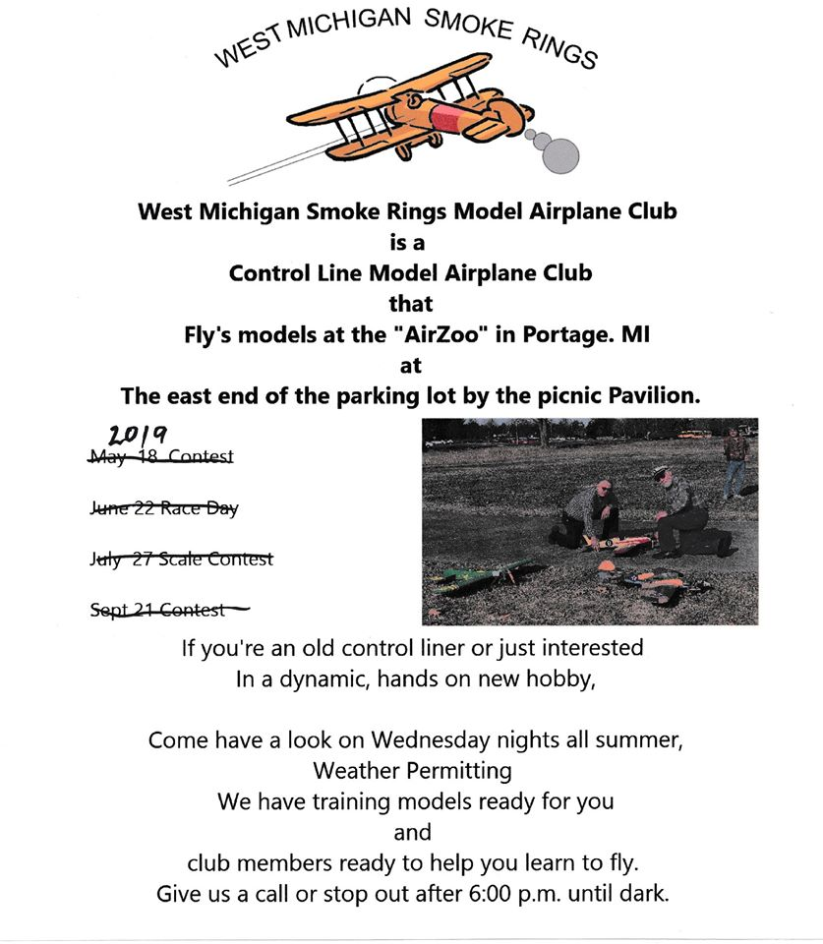
 | May 2020
 | SUNDAY | MONDAY | TUESDAY | WEDNESDAY | THURSDAY | FRIDAY | SATURDAY
 | 26 | 27 | 28 | 29 | 30 | 1 | 2
club meeting
Eldorado, Arkansas
 | 3 | 4 | 5 | 6 | 7 | 8 | 9
 | Eldorado, Arkansas |  |  |  |  | Joe Nall Victory in Europe Day | Joe Nall
 | 10 | 11 | 12 | 13 | 14 | 15 | 16
 | Joe Nall | Joe Nall | Joe Nall | Joe Nall | Joe Nall | Joe Nall | Joe Nall  Speed St Louis
 | 17 | 18 | 19 | 20 | 21 | 22 | 23
 |  |  |  |  | EAA goodyear Blimp | Northwest Control-Line  Regionals | Northwest Control-Line Regionals
 | 24 | 25 | 26 | 27 | 28 | 29 | 30
 | Northwest Control-Line Regionals | Memorial Day fay
 | 31 | 1 | 2 | 3 | 4 | 5 | 6
 | NOTES

Photo Essay Making venturi
making veturies for OS 25 for speed limit Combat engines. Dave Siegler AMA 720731

This was a project I gave myself to force me to learn SolidWorks. I had to draw up a venturi and carve it out on my Sherline lathe. I started with s real OS venturi to be used as a gude . Using a caliper, I made measurements and modeled it in SolidWorks. This took a little time, as I was new to 3D CAD. All I can say is it is worth learning. I used the solid works student edition that is part of the EAA membership.

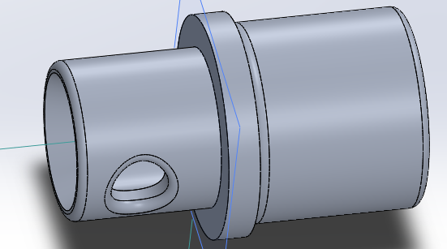

Cross section and parts were modeled by using a caliper on an existing venturi. Part was dropped into a print and solid works generated a 4 view drawing. I added a cross section and definitions.
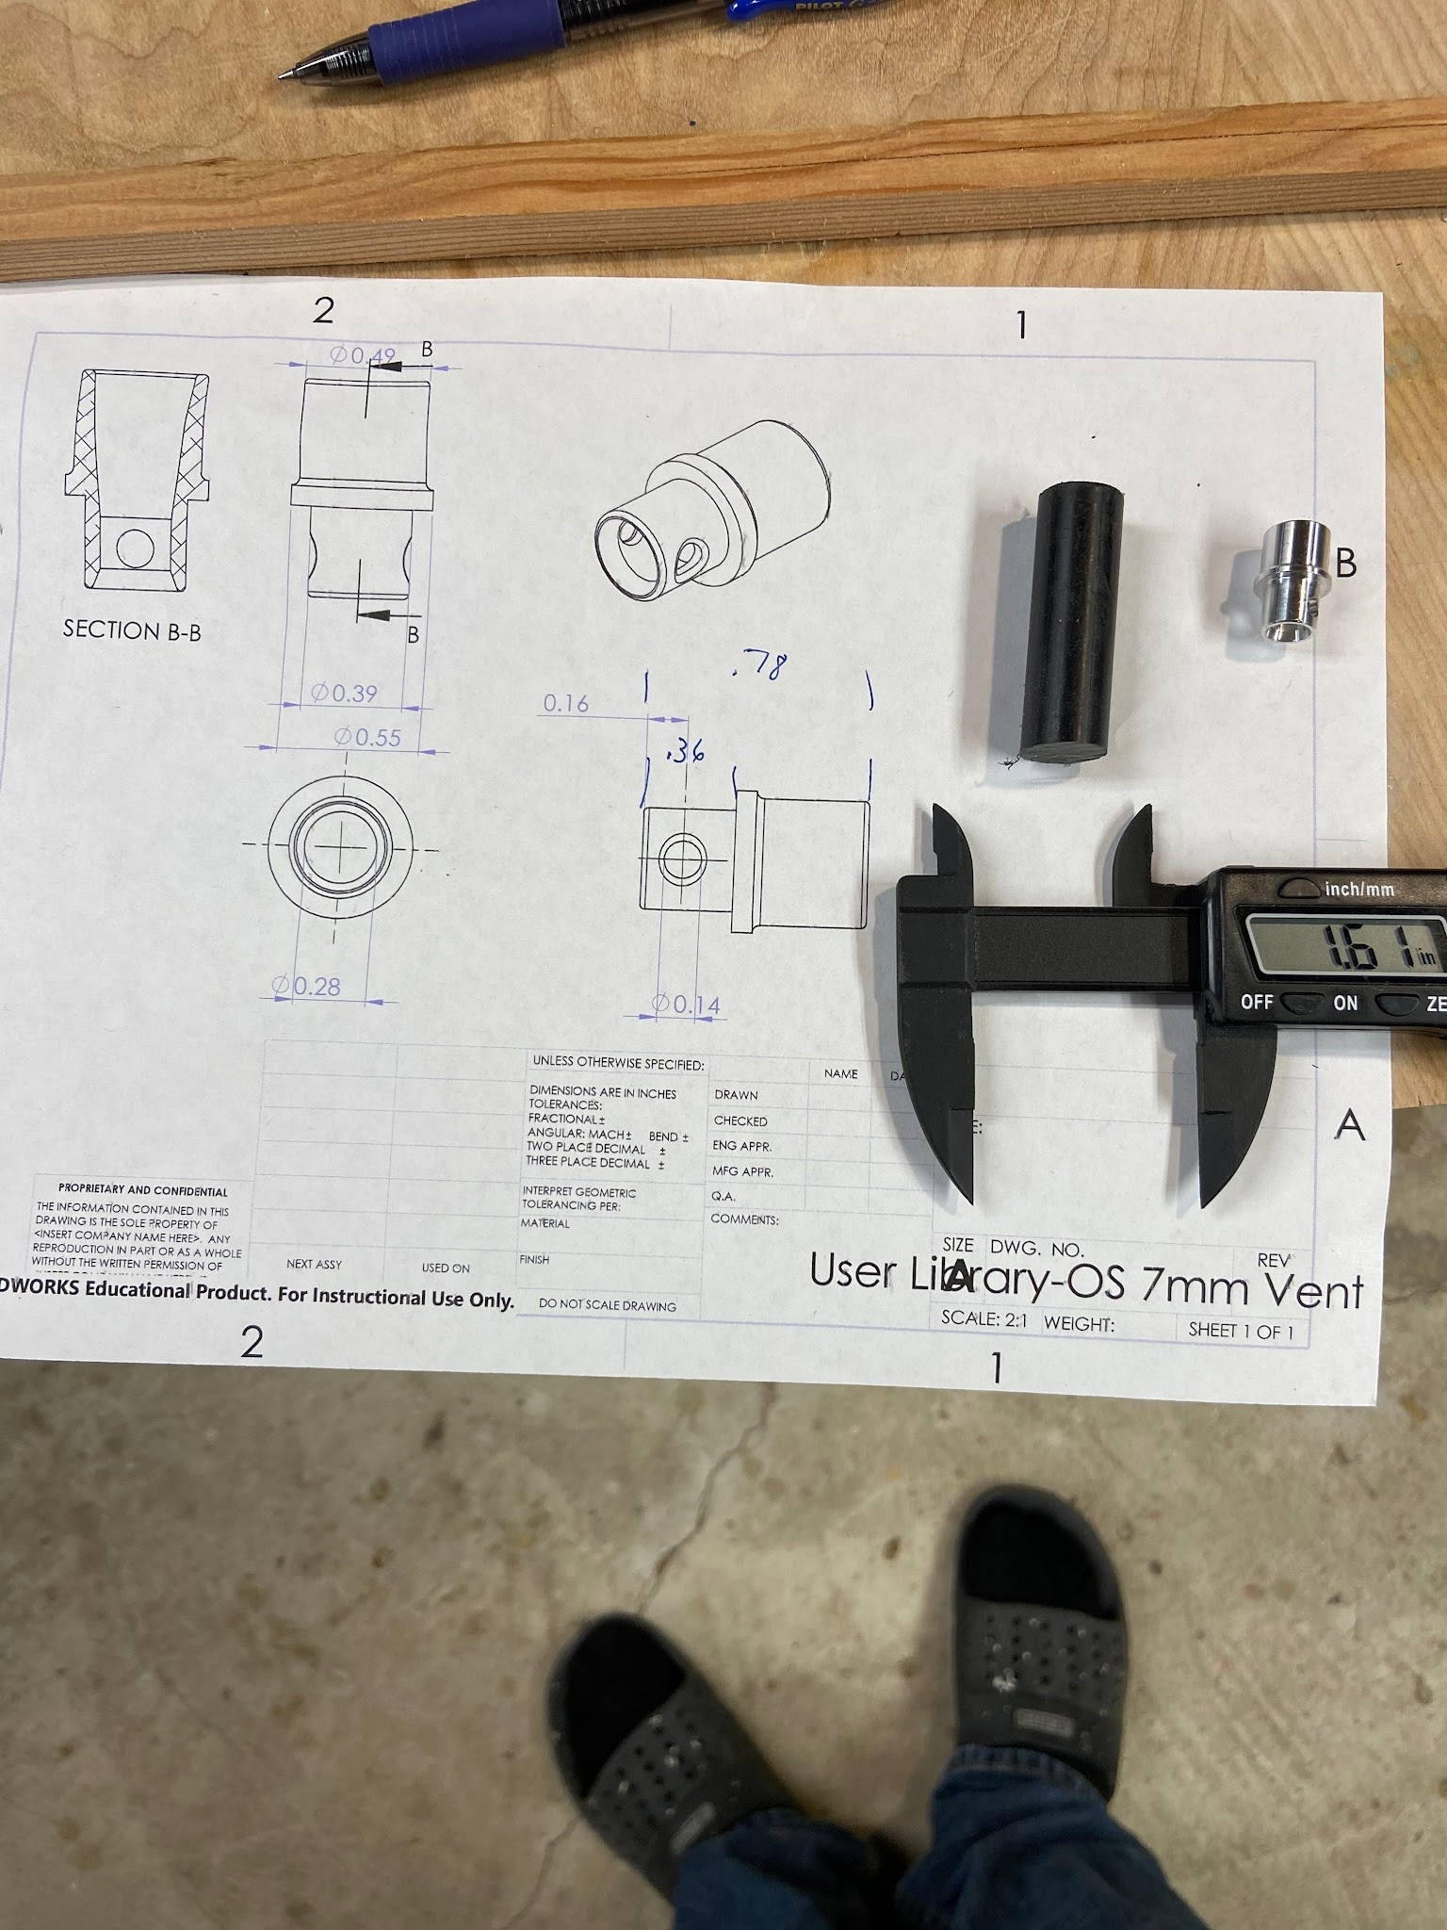
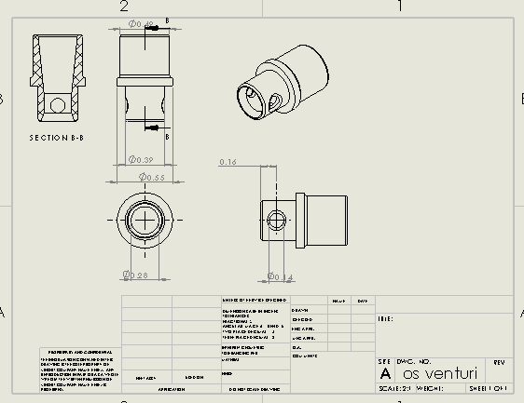
I used black Delrin rod and did the work on the sherline. Since it was a pressure system the taper of the venturi was not as important. I used a countersink on both ends. I’ll cross drill it to fit the engine.

