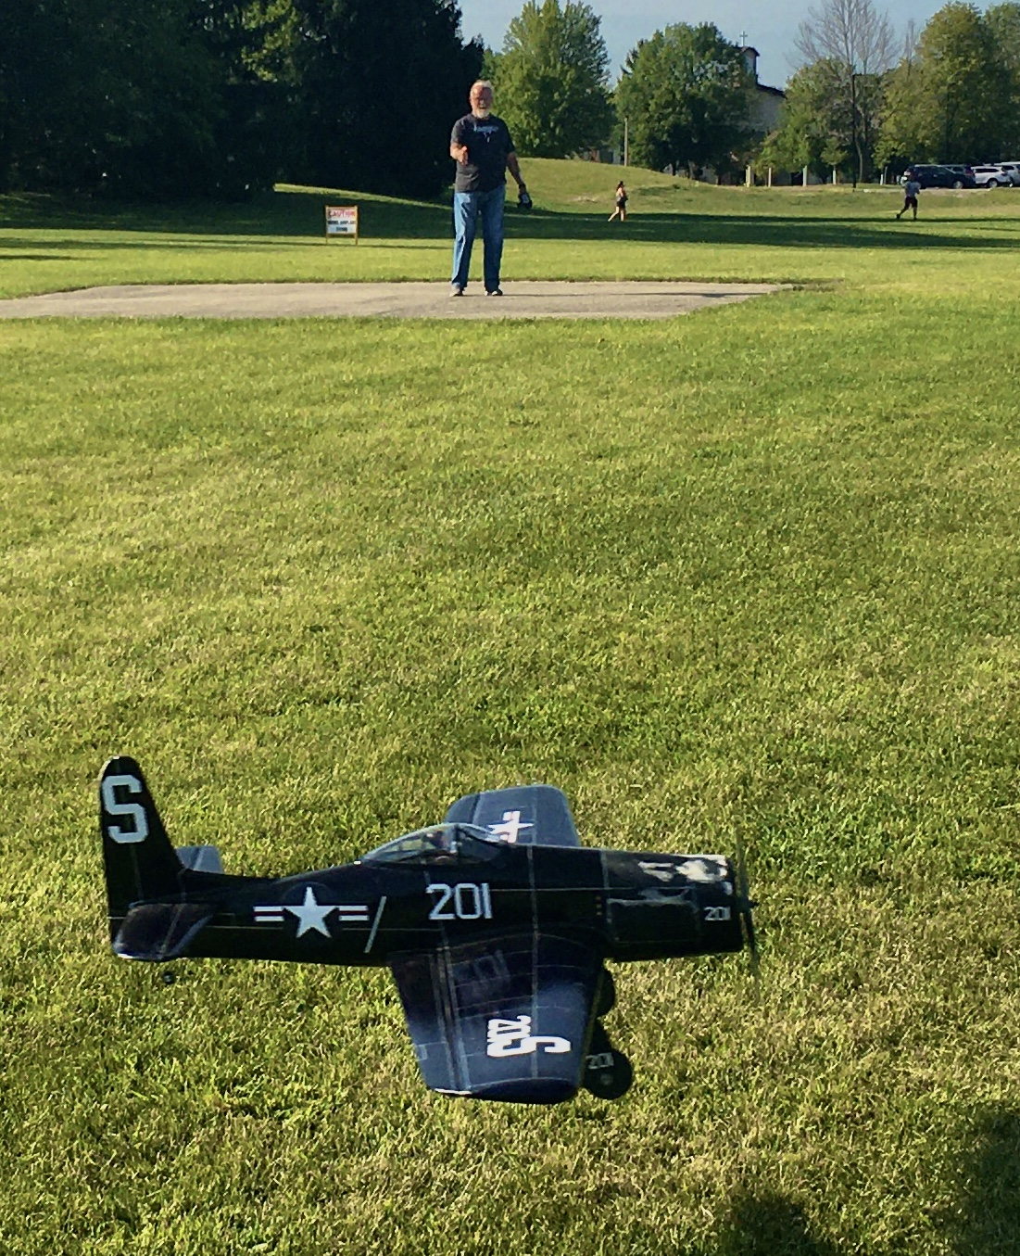

Volume 1 issue 11

Circle Masters Flying Club

Wisconsin’s control line club September 2020

Announcements  Welcome new members John Strobel and Fred Kauer  Howard Olsen will be our new Contest director. Thanks Peter for all the years in that role.  The SIG fly-in (both RC and CL) is Canceled due to Covid 19 for 2020  Last minute opportunity to fly at the Sussex Big engine Car Show Aug 29. contact Chris. |  | Inside This Issue  Contact information  Plan of the month  Meeting Minutes  Flying and building reports  Events

Editor’s Notes  Dave Siegler AMA 720731 circlemastersflyclub@gmail.com  The cover photo is a good one of Mike flying his electric Rabe Bearcat with an RC throttle. A very pretty airplane that met its end a few weeks later.  This month’s plan of the month is a control line car. A humorous item from the past. They put a mast on it to be a target for combat planes  This month we have a movie review, a classic aviation movie, Waldo Pepper.  Lots of photos this month from our funfly and the Wednesday night flights. For this author it is more like crappy-engine-run nights. |  | Club Information  Web site www.circlemasters.com  Dues $20.00  Flying Location Sussex Village Park, Sussex. Wisconsin  Meeting First Saturday of the month 1pm  Location Summer (May- Oct) at the field  Location Winter Sussex Library  Comments to circlemastersflyclub@gmail.com
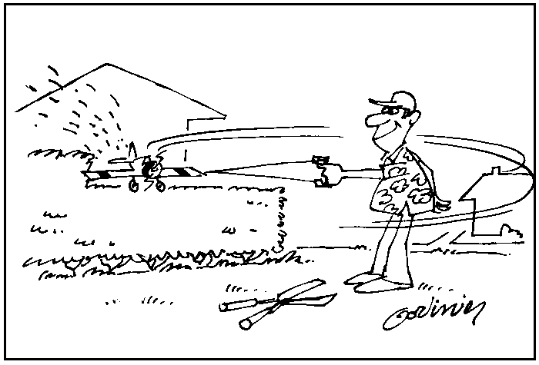  Dual use for that heavy stunter and super sharp APC props |  | Making Friends is good  Wednesday night flying has been a lot of fun. The weather has been awesome, and the bugs not too bad. It has some real benefits. Not only is it a weekly escape from the Covid-19 confinement, it is good for the club. There is a fairly good sized stream of people coming out to fly. Mike, Pete, Gene Chris, and Jason are often out. Parking sometimes is an issue due to the number of fliers.  The normal users of the park are seeing us flying at that location on a regular basis. Prez Chris (Mr. Popular) has reached out to the frisbee guys and they LOVE us operating there.  Also we added 2 new members this summer.  All of this helps our position in the park. Kudos to Chris, he is working to improve our image and get more people involved.  Get out and FLY. We are the Circle Masters Flying club.

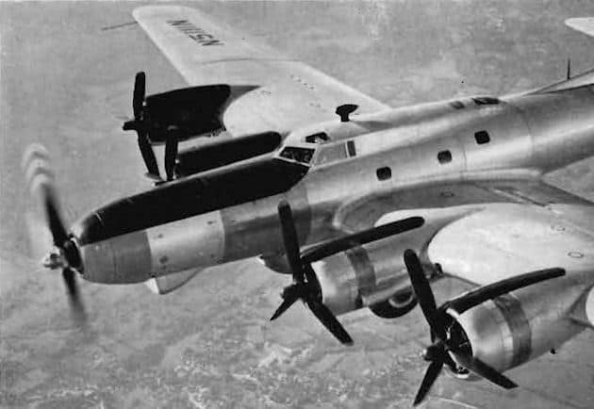  Strange Bird  This is not a photoshop picture, it is a real airplane. Hint: an engine test bed. |  | Movie Review  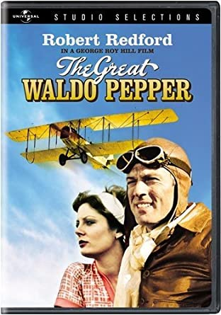  This is a classic story of barnstormers and people not dealing with change. Frustrated WWI pilot Waldo Pepper (Robert Redford) flying around Nebraska in a Standard J 1 biplane scratching out a living, hopping ride for $3. Susan Sarandon plays an unsuccessful wing walker. The competition for the first outside loop was a plot line. In the last scene, Folkers and Camels fought a final dogfight.  This is pre CGI and the airwork was done by mostly period airplanes flown by Frank Talman, Frank Price and Art Scholl. The great Johny Kazan did the wing walking. Waldo’s Standard J1 was recently restored by the EAA and is hangared at Oshkosh pioneer airport.
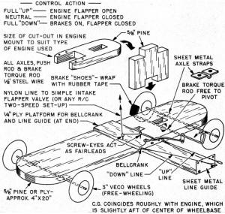  Control line car with throttle and brakes |  | Club Events  Car show demo flights on the ball field August 29  Wednesday Night Flights- 3- dusk  Christmas Party December  Stay tuned for 2021 events.
CIRCLE MASTERS FLYING CLUB
MEETING MINUTES for July 2020
The July meeting of the Circle Masters Flying Club was held at the Dan Tetzlaff Flying Field on Saturday July 11th. The meeting was hammered to a start by Pres. Chris at 1:04 PM. Approval of the June minutes was given by the members. This was followed by the Treasurers report by Wayne. He reported only one transaction for weed control. The report was approved as presented.
Chris then introduced new member John Strobel, a resident of West Allis and former control line flyer.
REPORTS & ANNOUNCEMENTS: Wayne reminded the members to be sure to check their email as a new Roster was sent out on June 16th. (Secretary Note: a revised roster will be sent out by the end of July which will include the new members.) Dave reported that for the first time the Toledo model show has been cancelled for good. This show has run continuously for 65 years.
OLD BUSINESS: Pete, the Contest CD, began a discussion on the club contest. He said that so far, based upon the responses received, participation will be lower than anticipated which will barely offset the cost to put on the contest. The virus crisis could lower it even more. Pete asked for and received a vote to cancel the contest. Since the site remains reserved it was proposed to use the date for a club “Fun Fly” and meeting. (Sec. note; Due to the High School moving its graduation ceremonies to Aug. 2nd the Fun Fly was moved to Saturday Aug. 1st.) Start time for the meeting will be 10:00 AM.
NEW BUSINESS: There was no New Business.
WEB SITE/FACEBOOK BUSINESS: Dave reported that there was a lot of hits from Russia. Dave is also looking for any newsletter info.
OTHER BUSINESS: Chris briefly discussed the Trifold that Don Doss has been revising and updating. He passed around sample copies for all to check out. Don did an awesome job on these.
Meeting adjourned at 1:34 PM
SHOW AND TELL: There was no show and tell for this month.

Submitted by Wayne M. Schmidt Secretary/Treasurer 07/27/2020

Control Cline Capers -- At the field August 2020
Picture below is from the funfly at Mukwonago High school. Saturday August 2, 2020. Fun Fly HQ. Good seeing Don, Melissa, Sonya and John. The whole Olson family trekked in from Central Wisconsin for a visit. Don and John came out for the day. Who is that masked man? 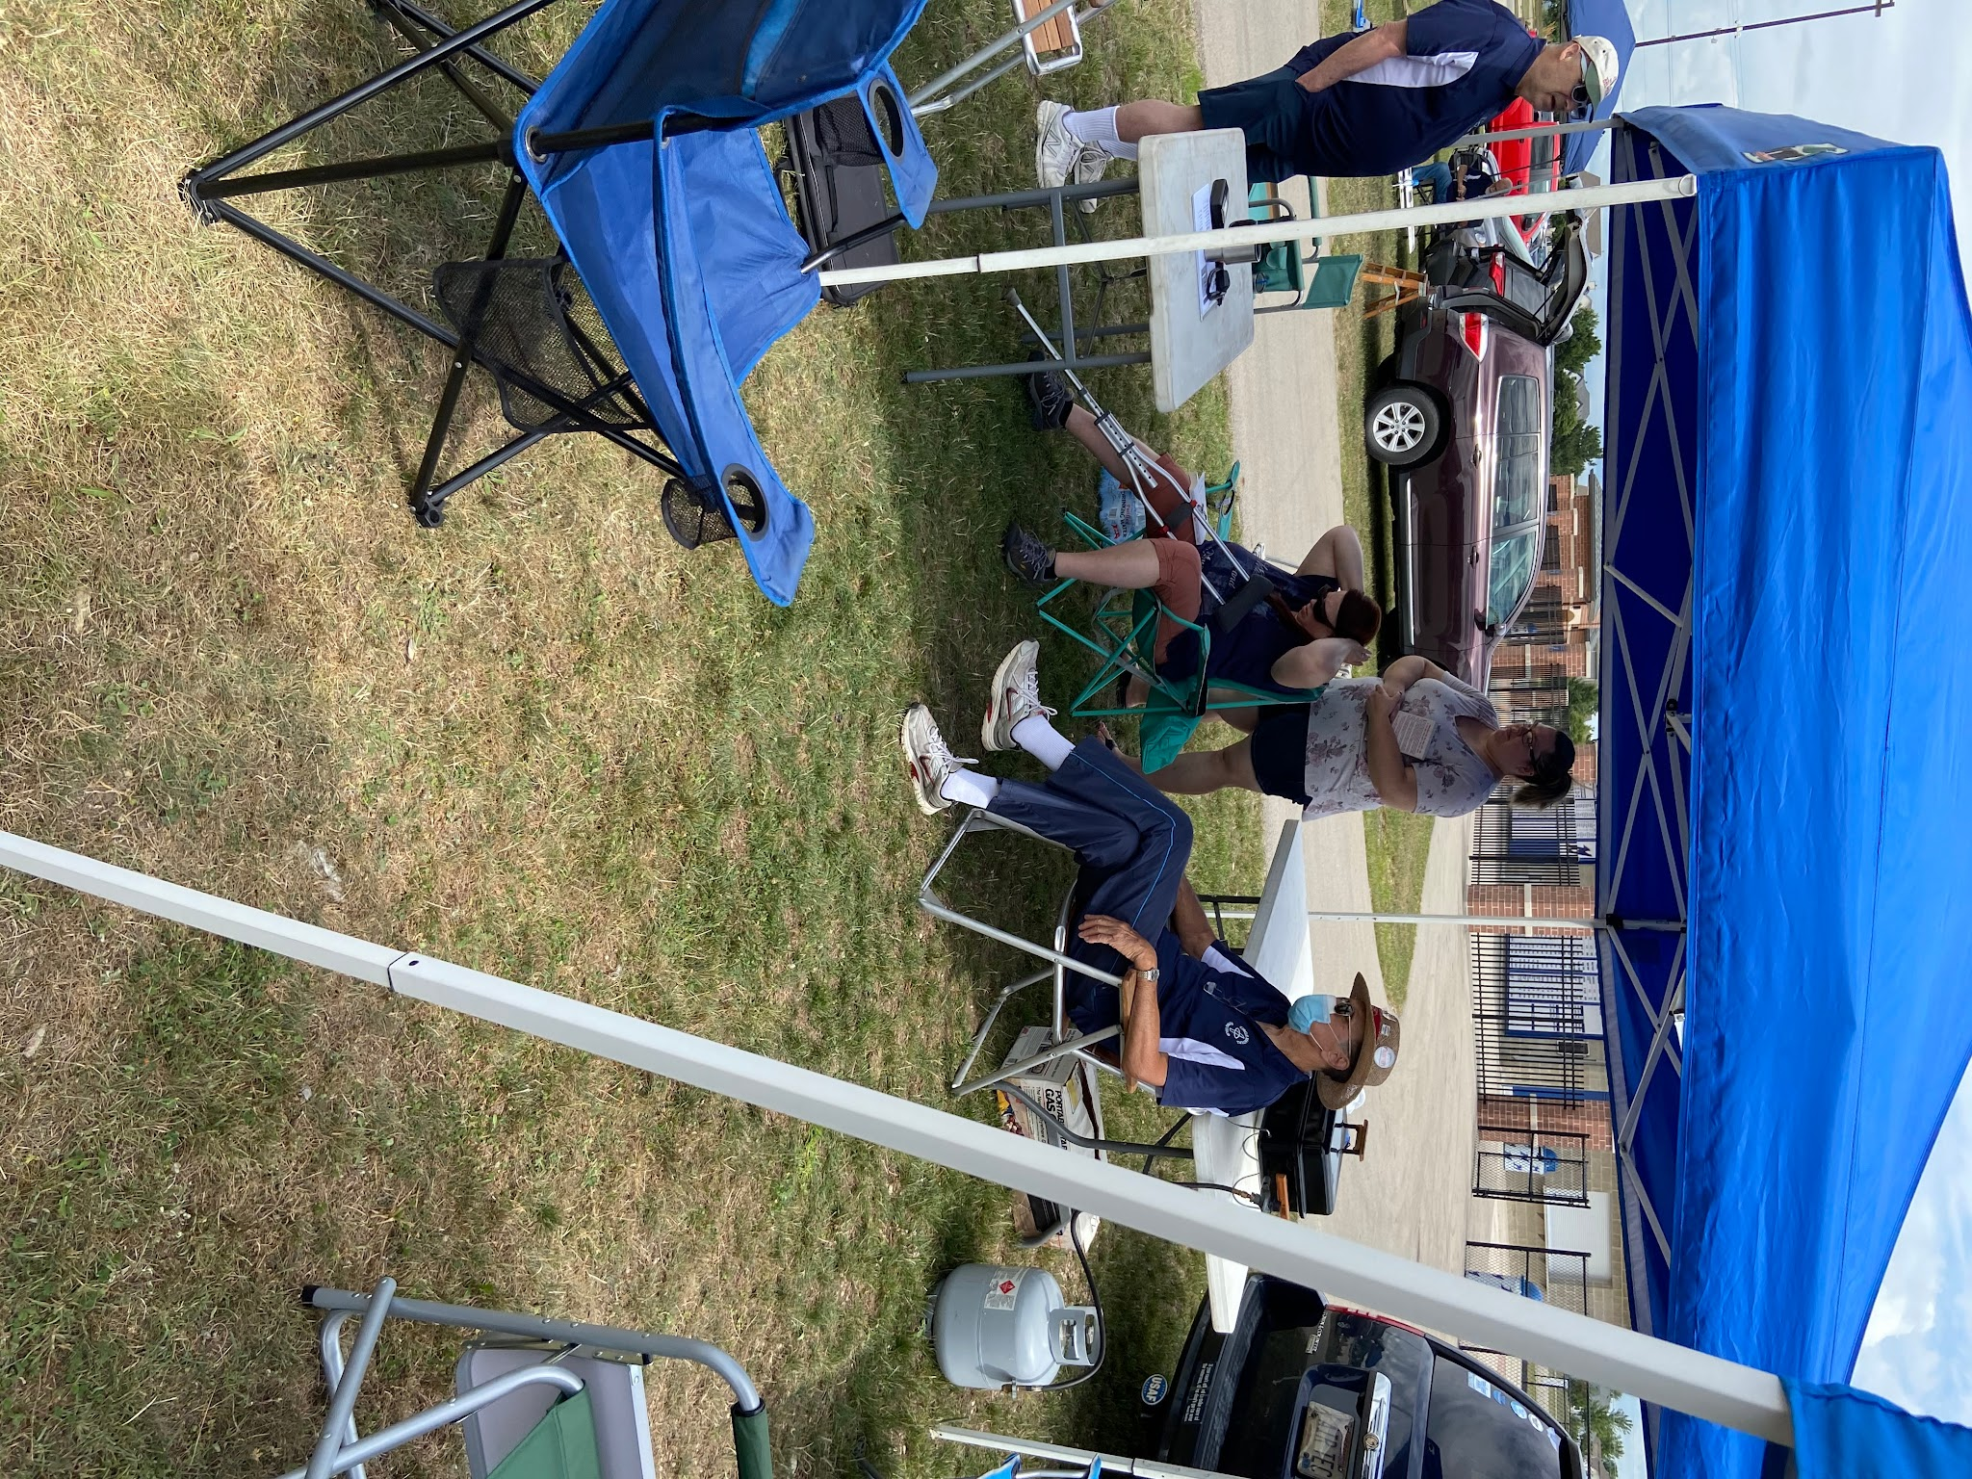
Several of the members flew over the pavement. Len, Jason, Chris, Dave, Pete all flew. Some had a severe case of pavement pucker. Dave won the bounce contest. His Streak had a 40 point landing score consisting of 8 5-point landings all in one flight! Site was wonderful, I could get used to pavement.

We had a visit from the Waukesha County Sheriff’s plain clothes detectives, a car was parked in the lot and they came, and they had it towed. The detectives were poking around my truck, I went over to see what was going on and I saw the guns and badges. After freaking out a little, they asked a few questions about the airplanes and the club, Very nice people. Support your police, they have a tough job.

Fun Fly pictures
Top Left Chris flying his Cox Hyper Viper. He will soon have a full set of the stuntable Cox plastics airplanes.

Top Right Chris flying the $20 plane Howard bought. The consensus is it is a Scientific ‘Big Otto”. The Black Widow had not run in a number of years and ran pretty good once flushed out.

Lower Left Sig Mustang built by Art Webber, retrieved from Art Johnsons’s estate. It has engine fuel flow issues.

Lower Right Chris and Wayne plan the day in the pitts.
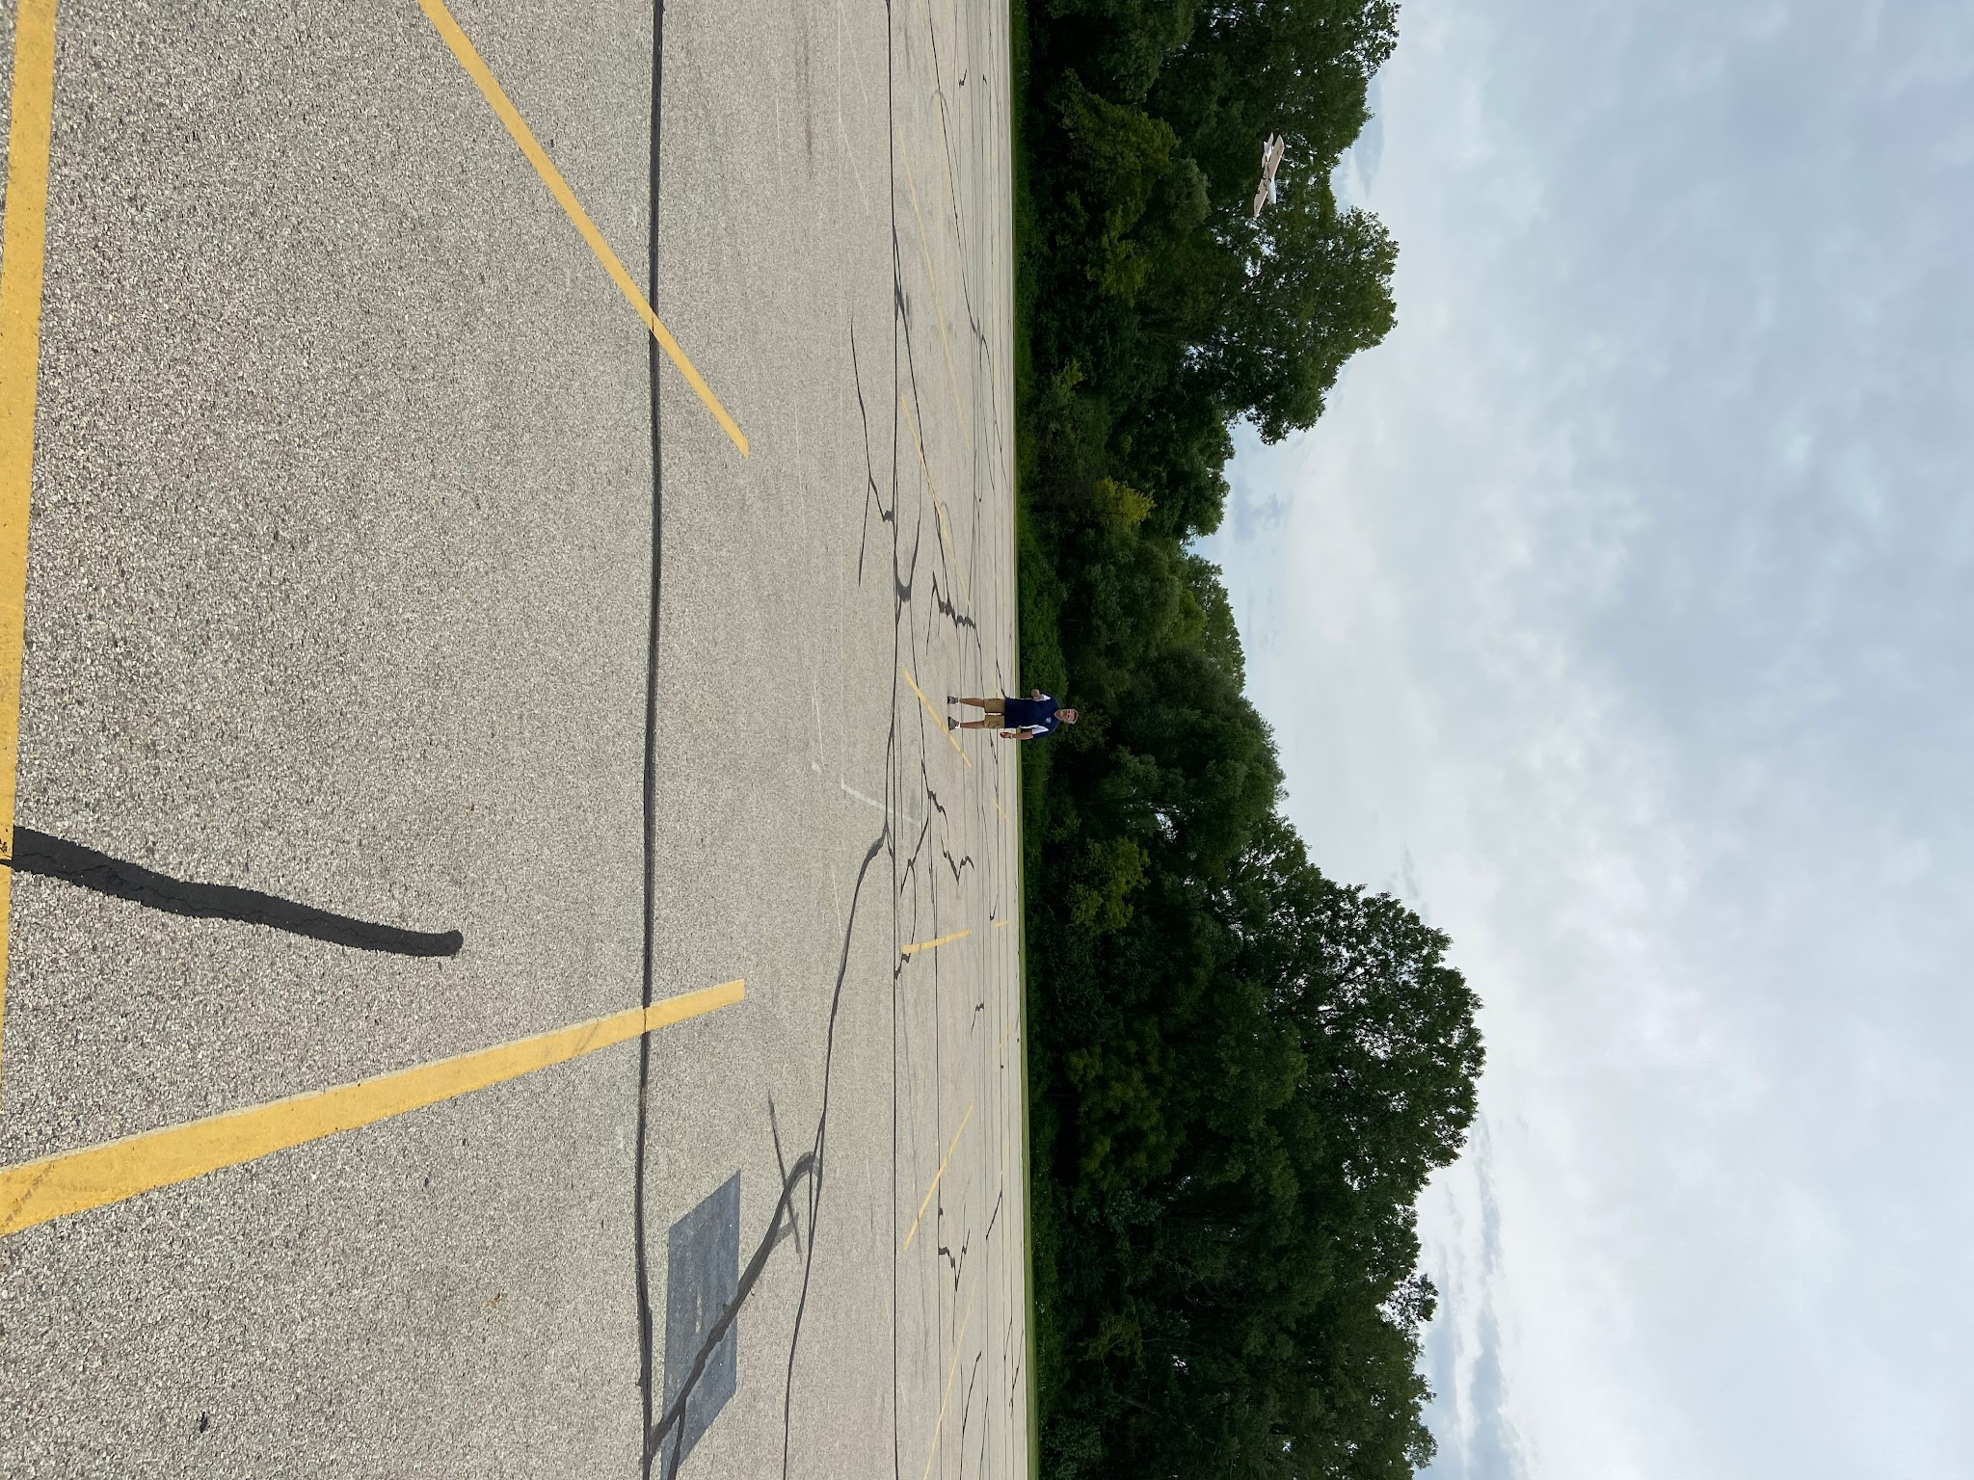
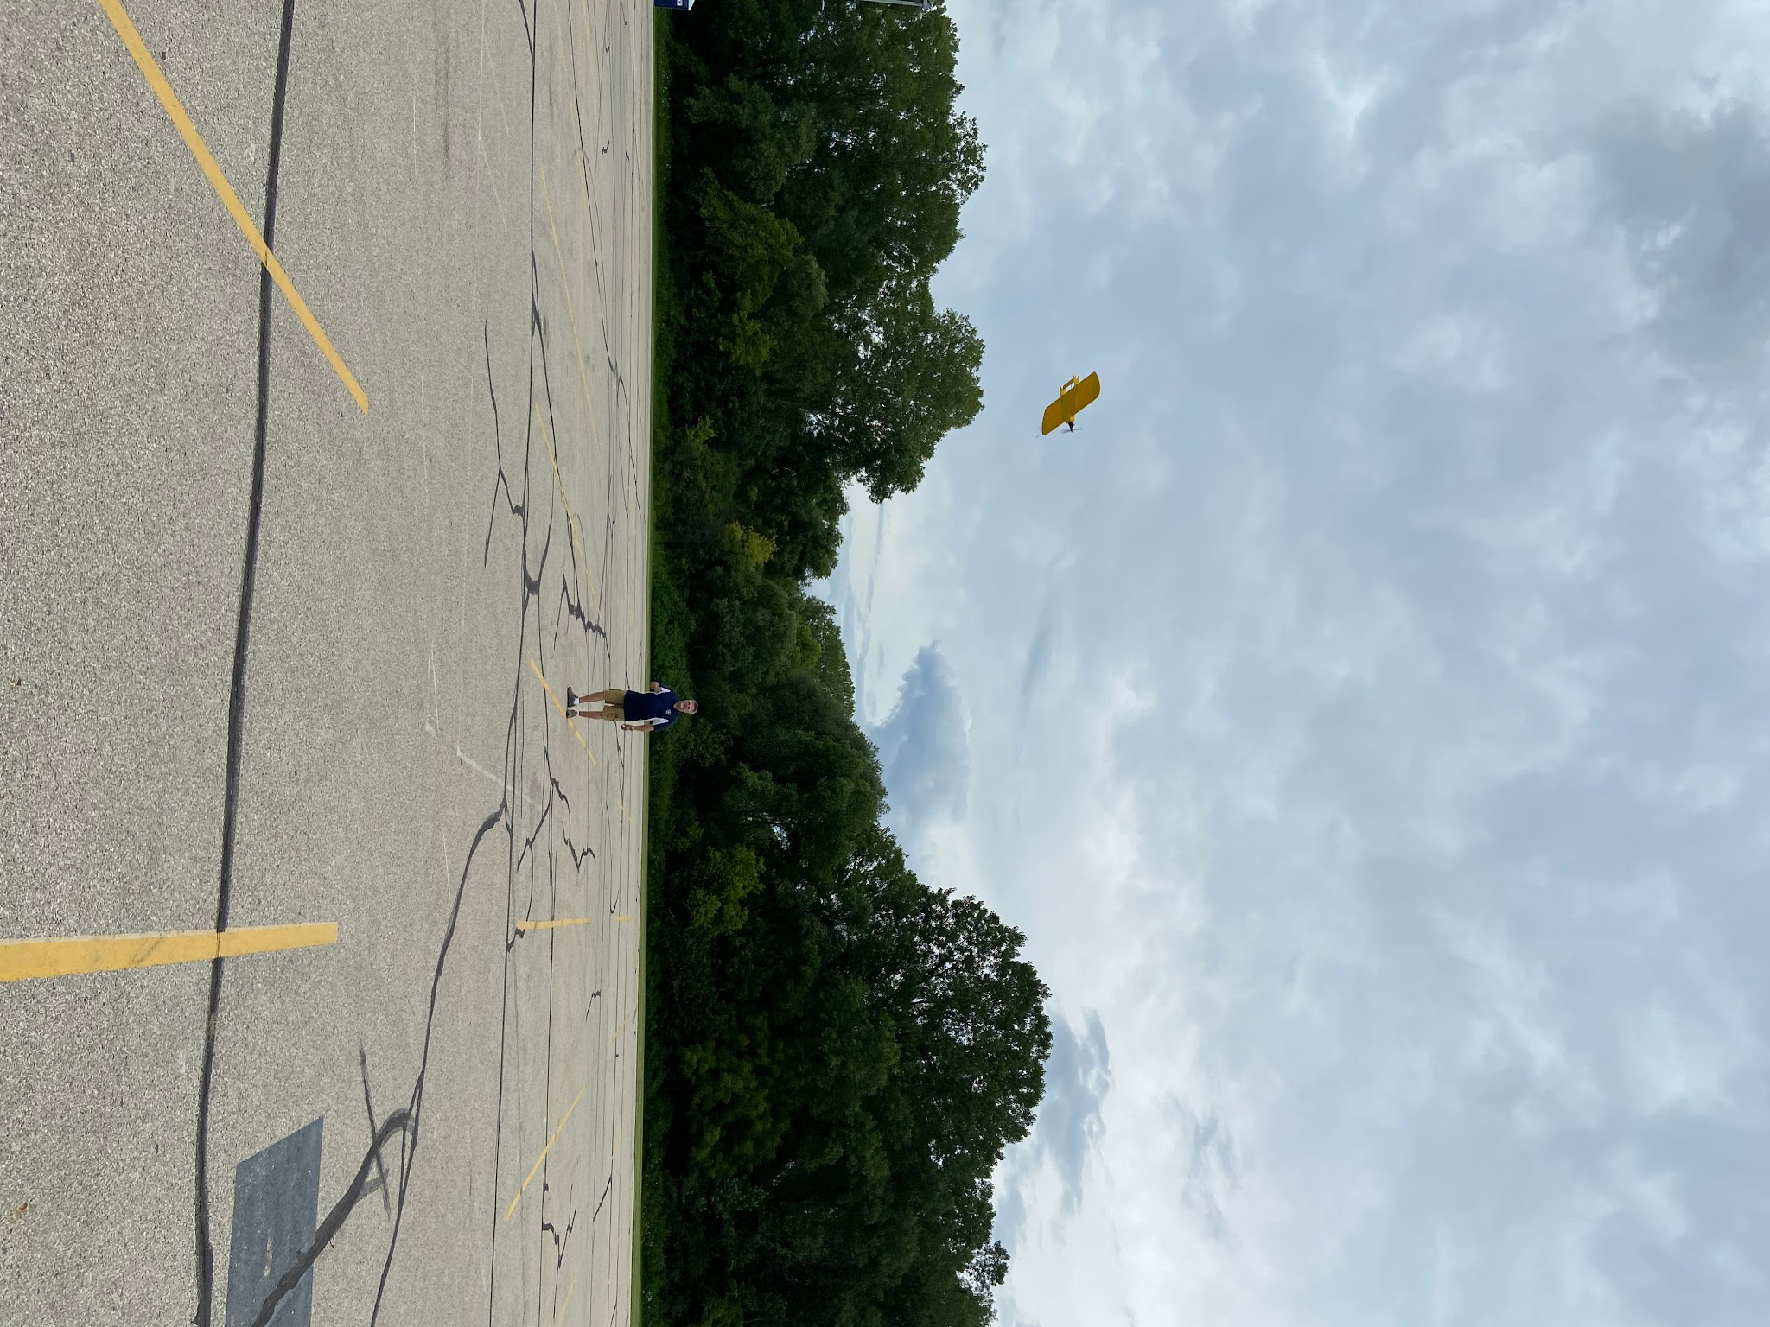

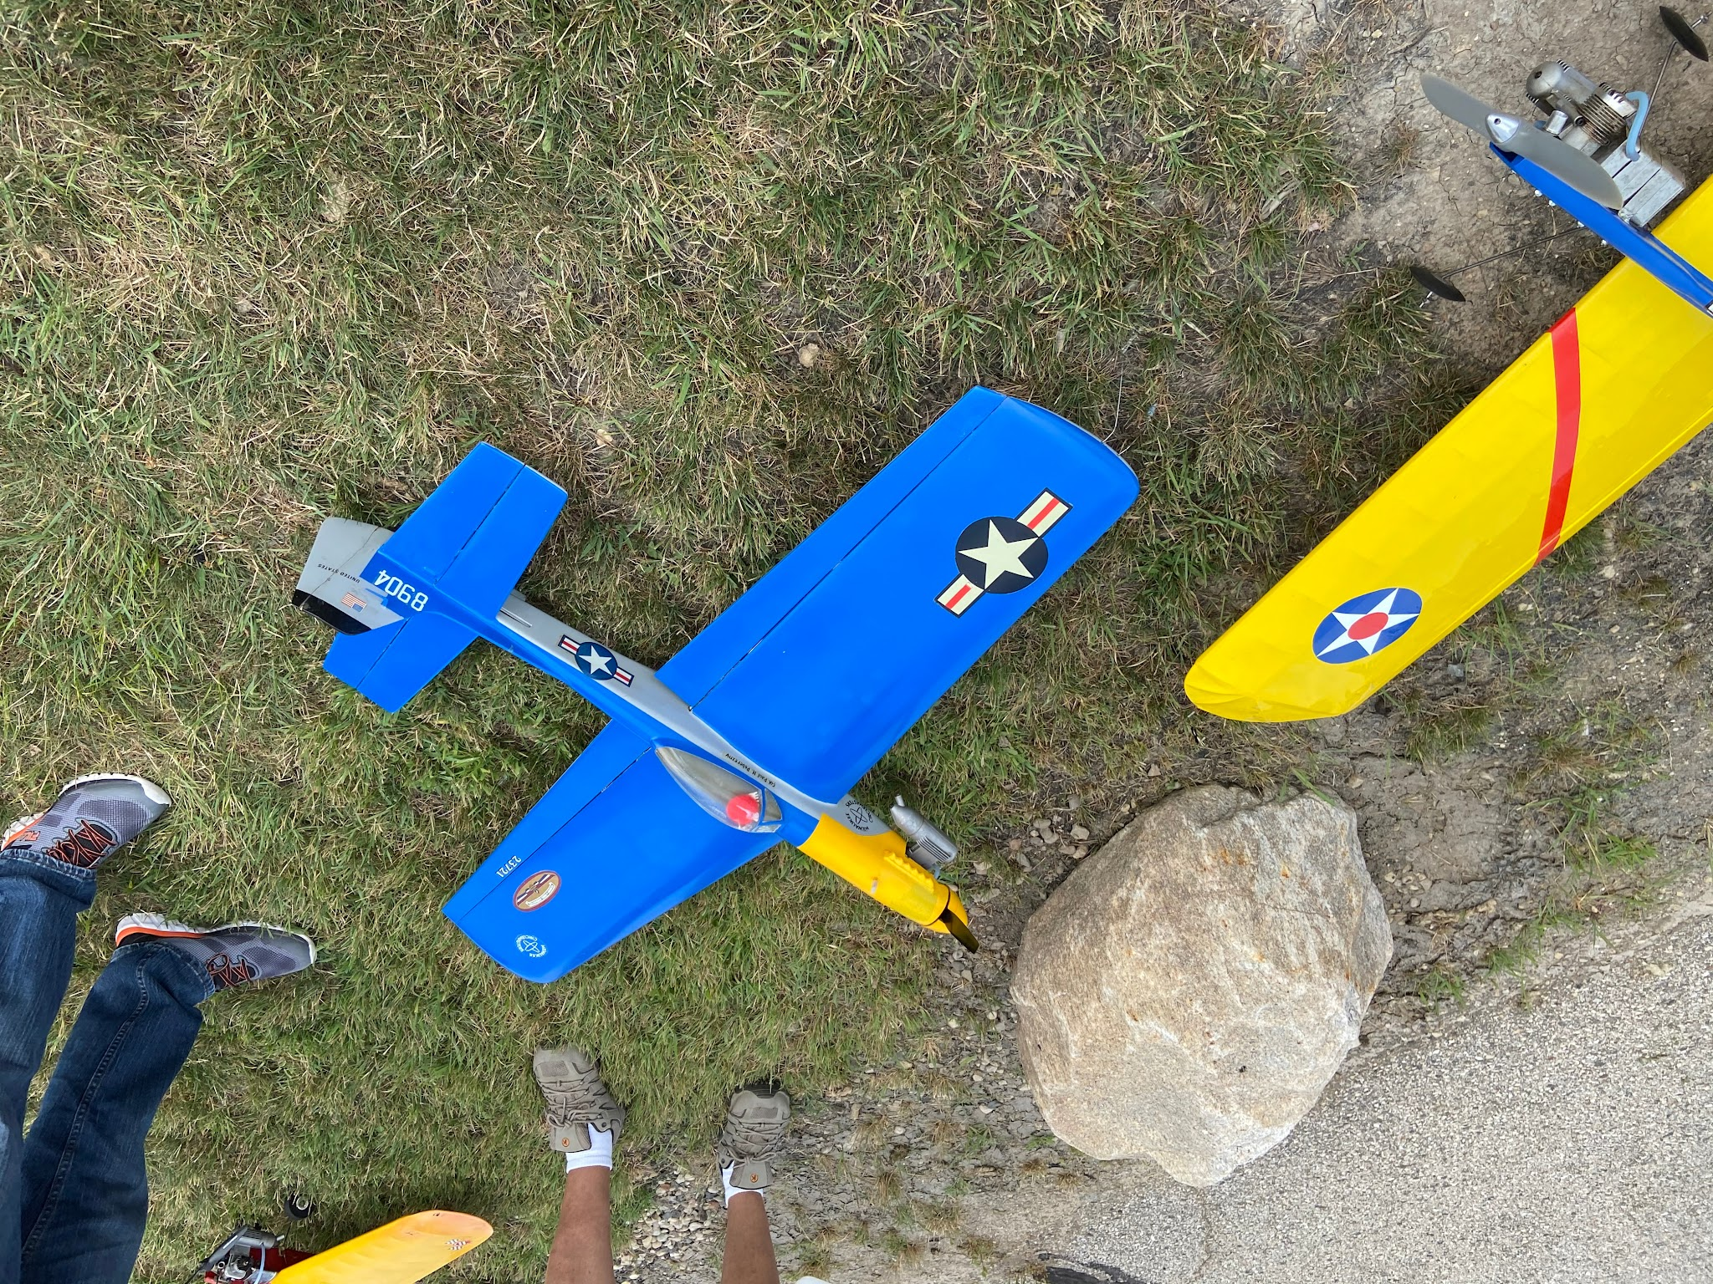
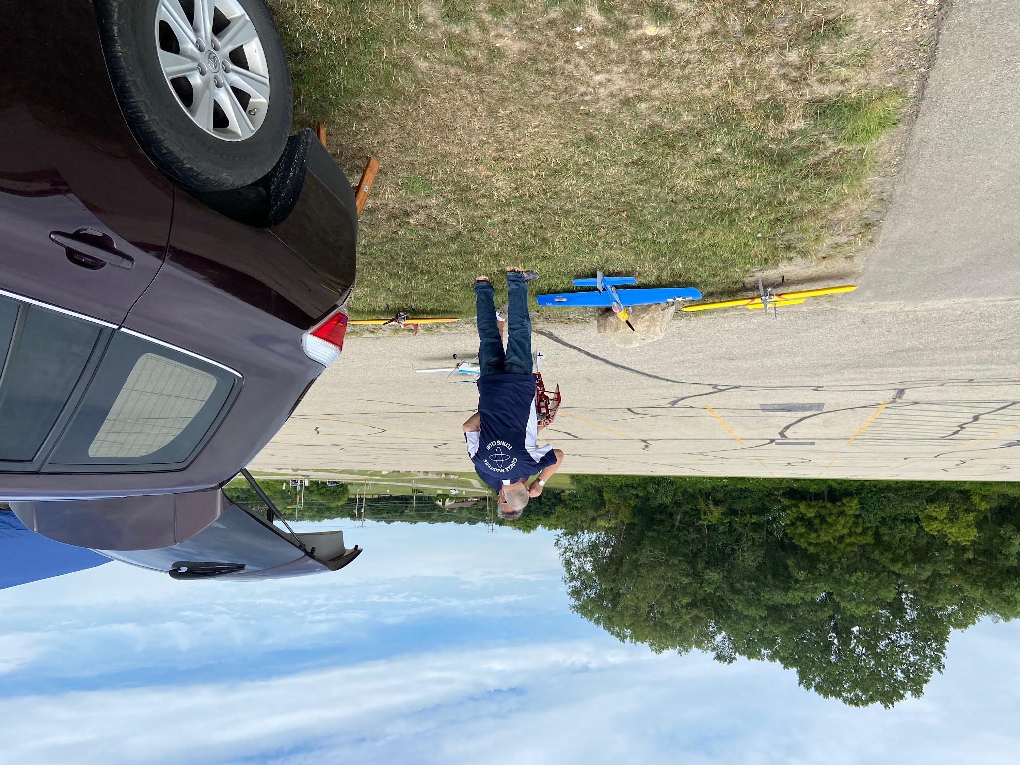

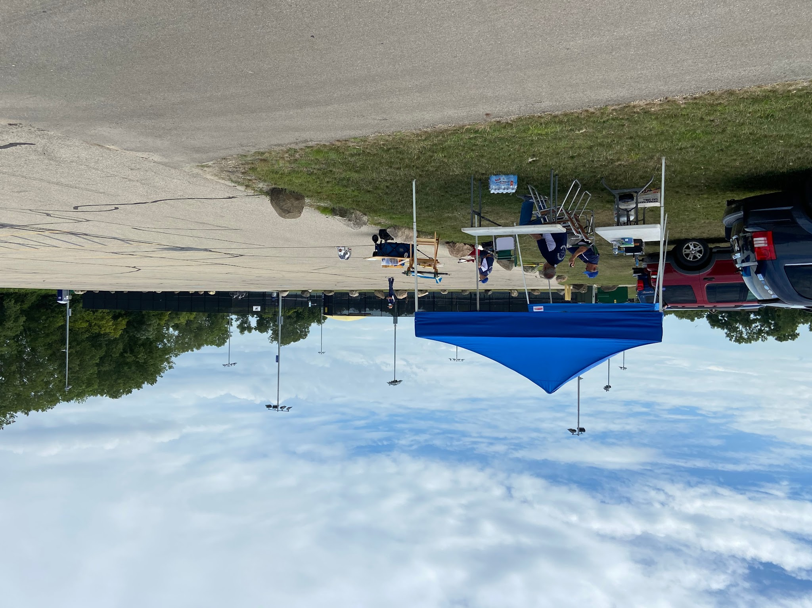
Left Howard patrols the Pit area. Good to see the Olson clan again. Really missed not having the opportunity to attend Airventure this year. Howard made the best of it by getting another rating during that time. Congratulations to Howard on getting his Inspector ticket.
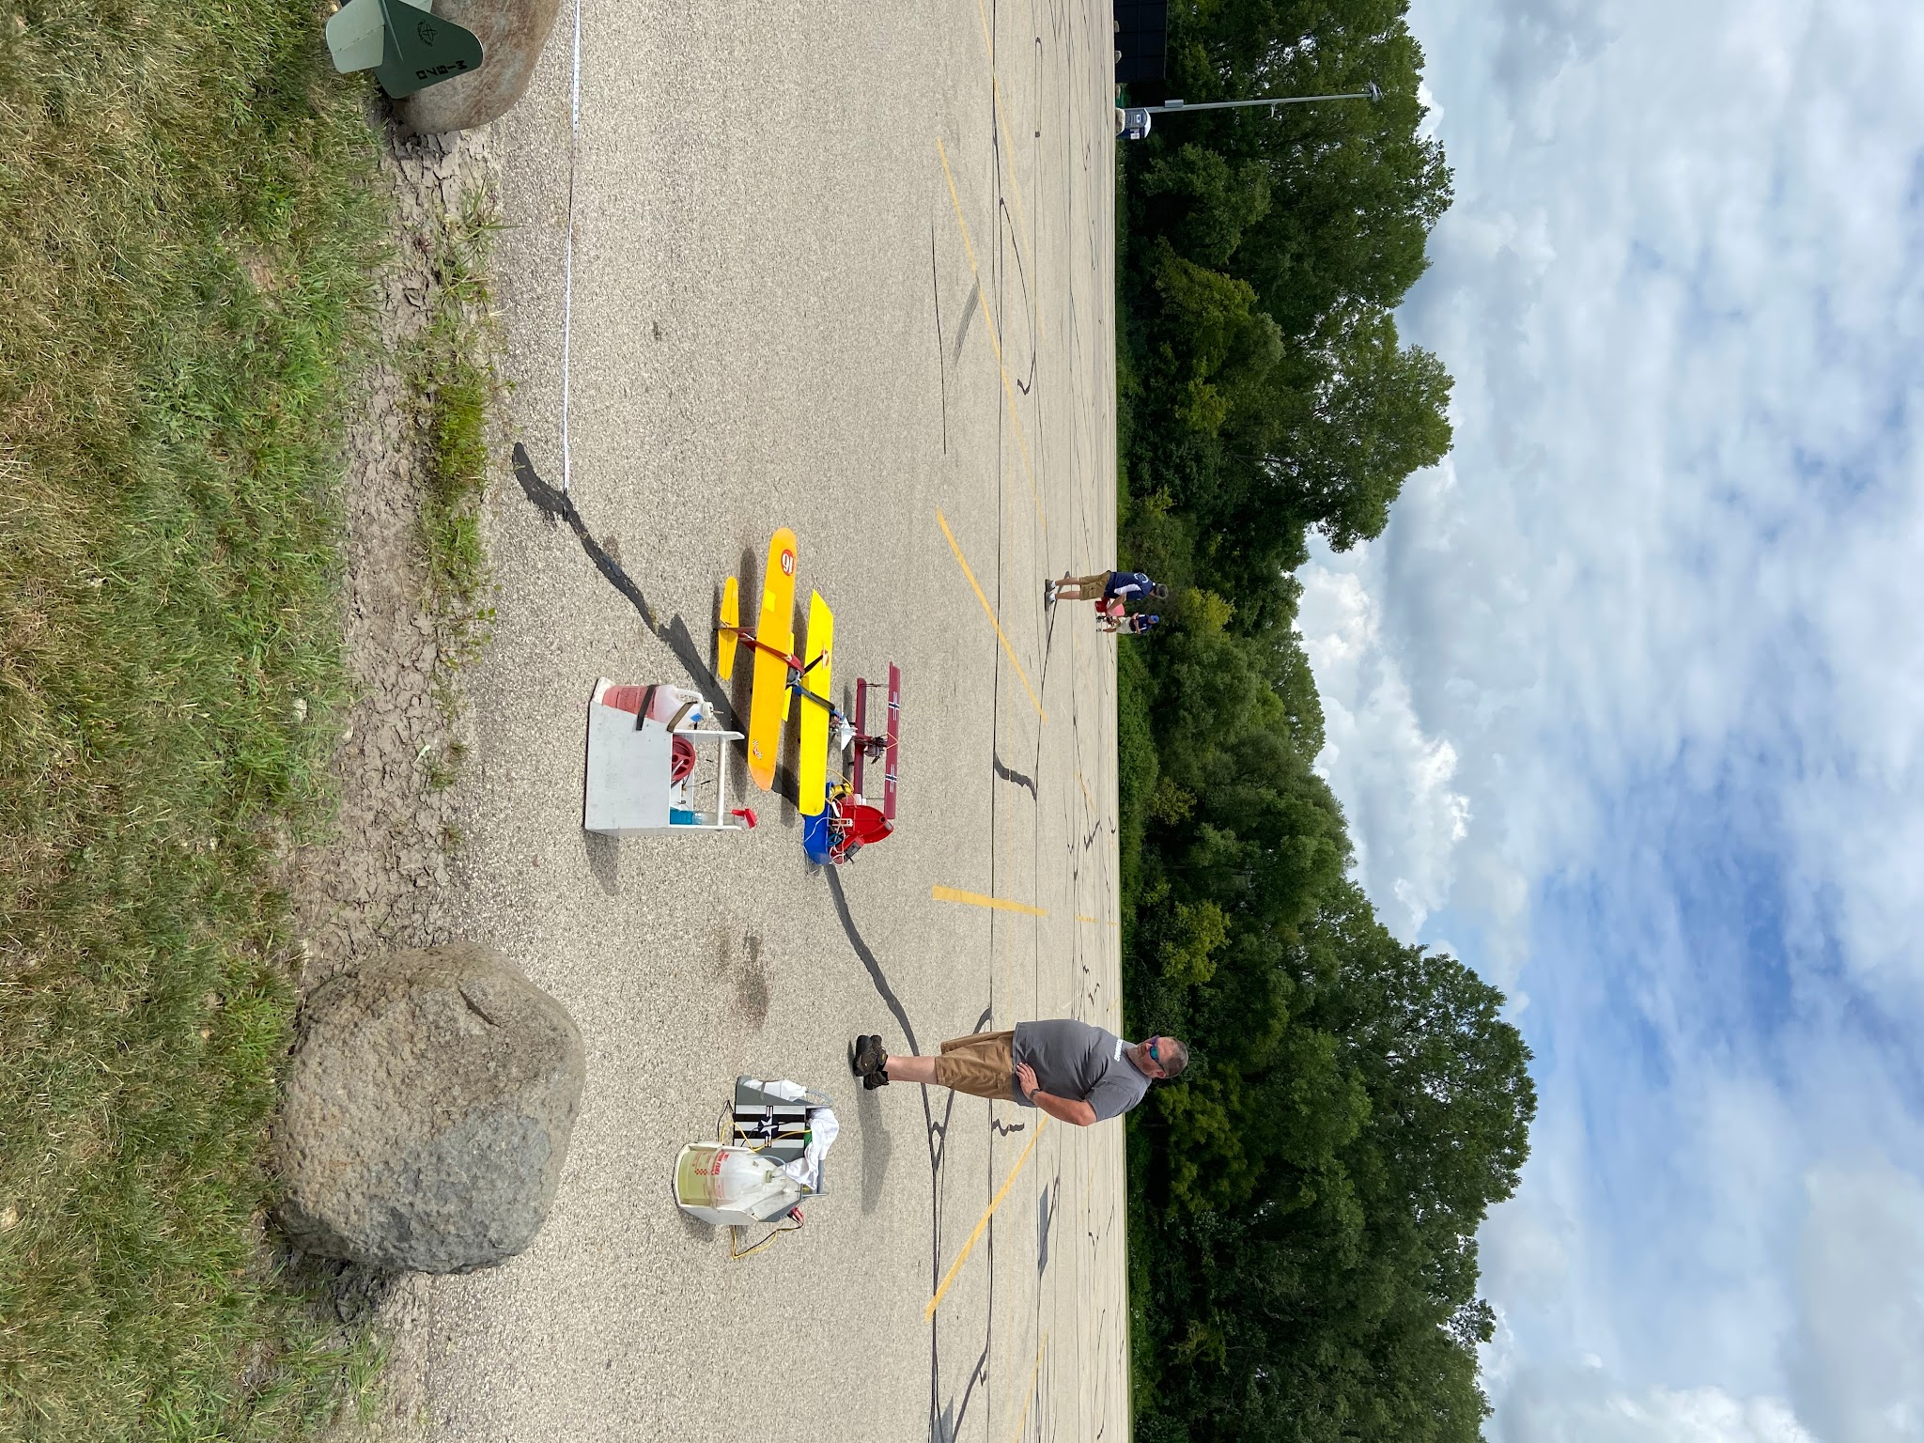

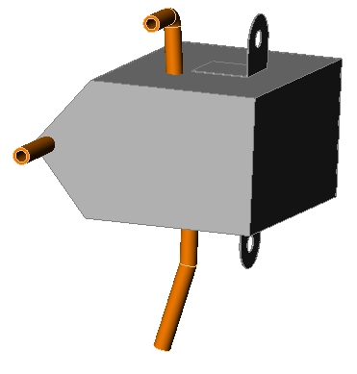

Right More views of the Pit and HQ area. area. Temperature was very comfortable, low wind and the tents were barely needed. Peter is on his phone again. Len waits his turn to fly

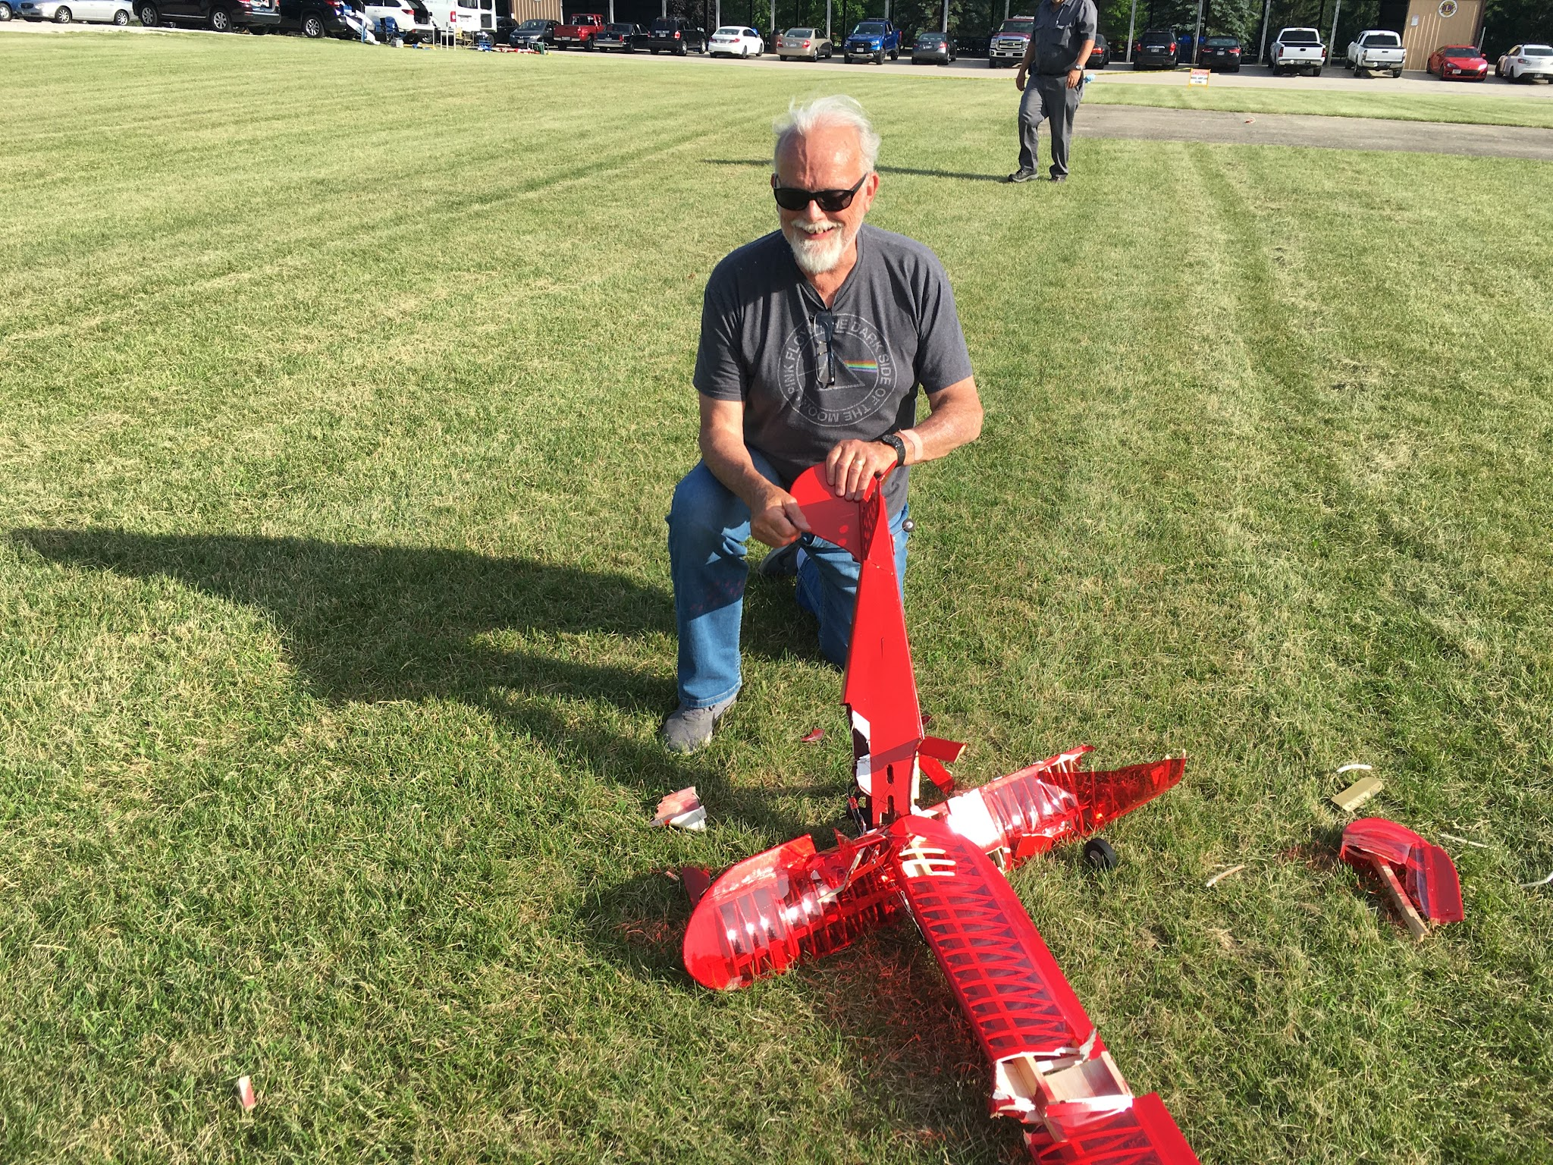
Some pictures from Wednesday night flying . Mike was just getting the Staggerwing dialed in. It staggered in hard. Too bad it was a beautiful airplane. Electrics can crash pretty hard.
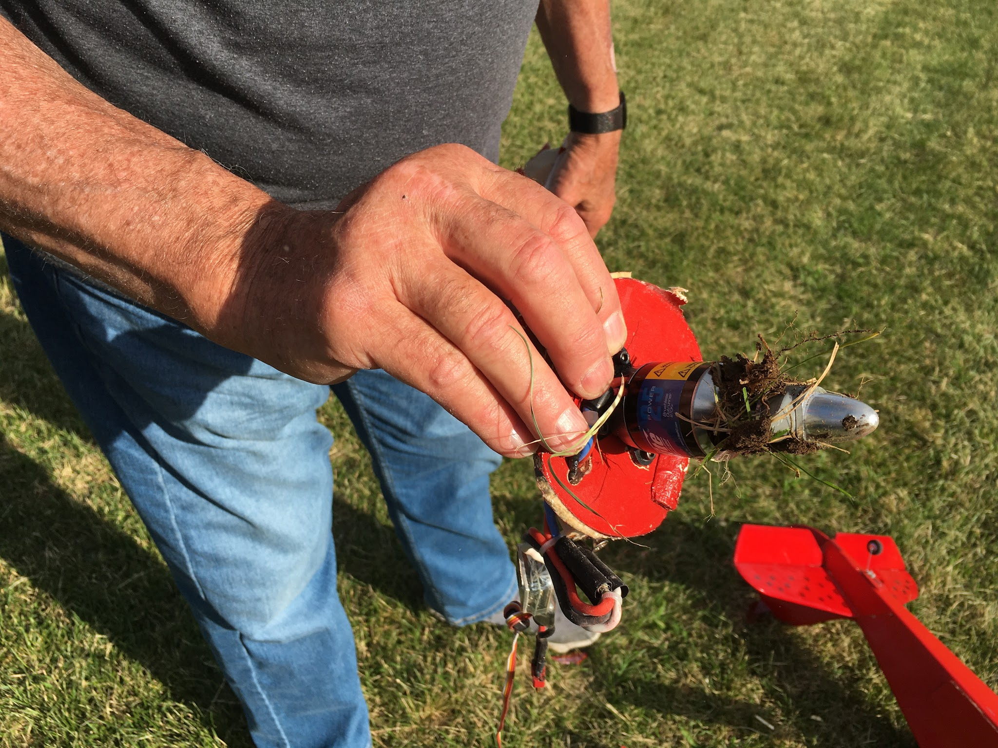
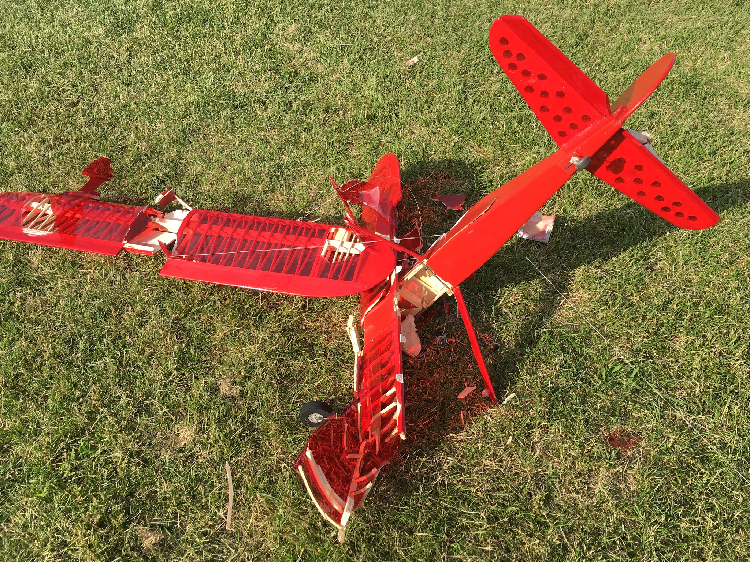


Left Yes we fly till dark,

Right Ouch! Sad about this, it was a beautiful Rabe Bearcat. The same airplane in the lead picture. Mike builds class airplanes and has had a little hard luck this summer.

Bottom Sig cancelation Hope the event returns in 2021

