


Circle Masters Flying Club  Wisconsin’s control line club April 2020  Volume 1 issue 4 |  | Lifetime Member Bob Gidildi
Welcome to the April issue. The corona virus is on us, stay safe. This month our local FAA presented a new ruling. This ruling has been found in a gin soaked cocktail napkin at an airport bar. It was leaked to circle masters HQ, Our roving reporters uncovered the big story for model aviation. Crack reporter Walter Thomas Fox (W.T.F.) brings the details. Also Circle Masters Exclusive, Airbus’s new electric airliner and a Boeing VTOL photo leaked. EXACTO has released the product we always needed this month see below. In a secret Skunk works file photos of a prototype WWII bomber were found. |  | Inside This Issue  PG. 2 Contact information  PG. 3 Plan of the months  PG. 4 Meeting Minutes  PG. 5 Flying and building reports  PG.6 Events

FAA reduces max altitude to 40ft by W.T.F.  Dateline East Belch Montana, April 1 2020. In a surprise move the FAA reduces maximum altitude for all model airplanes from 400feet to 40 feet. This is regardless of airspace classification. RC groups outraged. Cox international has immediately begun production of PT19 trainers. Brodak is purchasing all assets of tower hobbies, now that RC is flying is illegal. PAMPA is rushing emergency rules proposals to eliminate the wingover and overhead 8 from the stunt pattern.  CD’s and Judges will assign shot guns with goose loads to ensure compliance. |  | Club Information  Web site www.circlemasters.com  Dues $20.00  Flying Location  Sussex Village Park, Sussex. Wisconsin  Meeting First Saturday of the month 1pm  Location Summer (May- Oct) at the field  Location Winter Sussex Library  Comments to circlemastersflyclub@gmail.com
“With All this shortages of toilet paper, my stash of silkspan is OFF LIMITS” |  |   PB-388 (Navy version PBJ 38) a prototype short range bomber version of the P38  Drawings found in the skunk works trash can. Developed as a complete waste of fuel and a recruiting tool to get fighter jocks to think it was cool to fly bombers

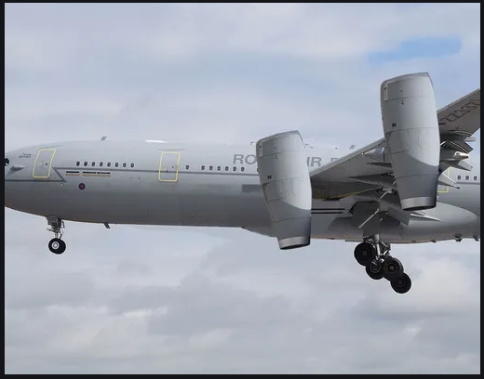Boeing VTOL Airliner?  Now that the 737 max has won world acalim for its software development process, the structures guys want in on the act. The prototype will either fly “any day now” or “when hell freezes over” whatever comes first.  The design team is said to have “grown up flying wimpy quadcopters and not FliteStreaks as children”. |  |   New X-Acto based safety equipment

Club Events
Club Contest
EAA Kidventure
Steam Show
Club Fun Fly and Picnic
Christmas Party

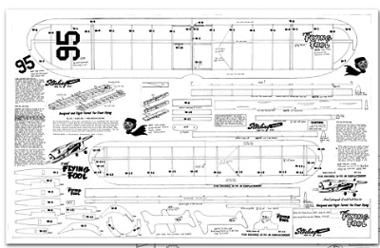
For April we present the Flying Fool. Everyone wanted one they all flew like crap but looked good.

CIRCLE MASTERS FLYING CLUB
MEETING MINUTES for March 2020
The March meeting of the Circle Masters Flying Club was held at the Pauline Haas Public Library on Saturday March 7th. The meeting was hammered to a start at 1:10 PM by Pres. Chris. He began by asking if the members (9) had received The Circle Flier newsletter and had read the minutes from the February meeting. The members present had all read the minutes. So, the minutes stood as published. Chris then introduced a new member, Mike Crotteau of Slinger, a retread model builder.
The Treasurers Report for was presented by Wayne. His report was approved as presented.
REPORTS & ANNOUNCEMENTS: Dave reported on the recent FAA Rules for Models. His interpretation is that control line models will fall under this rule which restricts flight. As of right now C/L is not affected. Dave also reported that there are piles of soil dumped on the flying field, possibly from the waterpark construction. Chris sent an email to Jason requesting him contact the Village Park Dept. to ask if the soil will be removed by May.
OLD BUSINESS: Chris asked about the “Wednesday Night Flights” but since there was no info from Jason regarding the disc golf dates this subject was relegated to another meeting. Chris checked with Don regarding the Easter Egg Hunt at Lisbon and he said that he will check on his helpers, but the April 4th date is still on.
NEW BUSINESS: There was no new business.
WEB SITE BUSINESS: Dave reported that he sent a survey to all club members but only received THREE responses. (Sec. note: There is no reason for this. Dave is asking for help to improve the newsletter and he is asking YOU. If you turn your back on this request, you turn your back on the club. You are telling all members that you do not give a s++t about the club. This is disgusting and angers me.) Back to Dave. A lot more hits on Facebook, even from Russia.
OTHER BUSINESS: No meeting at the Library until October. A discussion ensued as to weather the club should remain members of the R/C association. No decision was reached.
There being no further business Chris asked for a motion to adjourn the meeting. It was quickly moved and seconded. Meeting adjourned at 2:10 PM.
SHOW & TELL: Dave’s new timer for indoor electric.
Submitted by Wayne M. Schmidt Secretary/Treasurer 03/12/2020

 | April 2020
 | SUNDAY | MONDAY | TUESDAY | WEDNESDAY | THURSDAY | FRIDAY | SATURDAY
 | 29 | 30 | 31 | 1 | 2 | 3 | 4
 |  |  |  |  |  | Toledo RC show | Club Meeting  Toledo RC  Gold Country Combat Ca.  Allan Perret Memorial LA
 | 5 | 6 | 7 | 8 | 9 | 10 | 11
Toledo RC
Gold Country Combat Ca.
Allan Perret Memorial LA
 | 12 | 13 | 14 | 15 | 16 | 17 | 18
 | Easter Sunday |  |  |  | EAA Larry Mauro Solar Riser
 | 19 | 20 | 21 | 22 | 23 | 24 | 25
 | 26 | 27 | 28 | 29 | 30 | 1 | 2
 | 3 | 4 | 5 | 6 | 7 | 8 | 9
 | NOTES
 | Toledo RC show
 | Club Meeting


Reposted from the Onion, where we get all our news

NASA Frantically Announces Mission To Earth’s Core After Accidentally Launching Rocket Upside Down

HOUSTON—Rushing into a press conference mere minutes after lift-off, NASA officials frantically announced a mission to the Earth’s core Friday after accidentally launching a Atlas V rocket upside down. “Today, I’m excited to announce that we’ve successfully launched—let’s see. Well, I guess we’ll just call this the first-ever manned mission to explore this planet’s core,” said sweat-covered and visibly panicked NASA administrator Jim Bridenstine, who paused momentarily to put up a crudely drawn diagram labeled “Core Shot 2020” depicting the rocket burrowing through the planet’s crust towards its 10,000-degree-Fahrenheit inner core. “Thanks to the ship’s powerful boosters and its pointed tip, we anticipate the rocket might conceivably break through the Earth’s mantle and reach its destination within the year. I also cannot stress enough the bravery of the two astronauts inside the rocket, who are presumably okay with all of this. You know, some might even say a NASA expedition to the Earth’s core was long overdue.” At press time, NASA officials expressed hope that the rocket would exit the other side of the Earth and proceed on its previously planned mission to restock the International Space Station by 2021.

Model Airplane news Cover
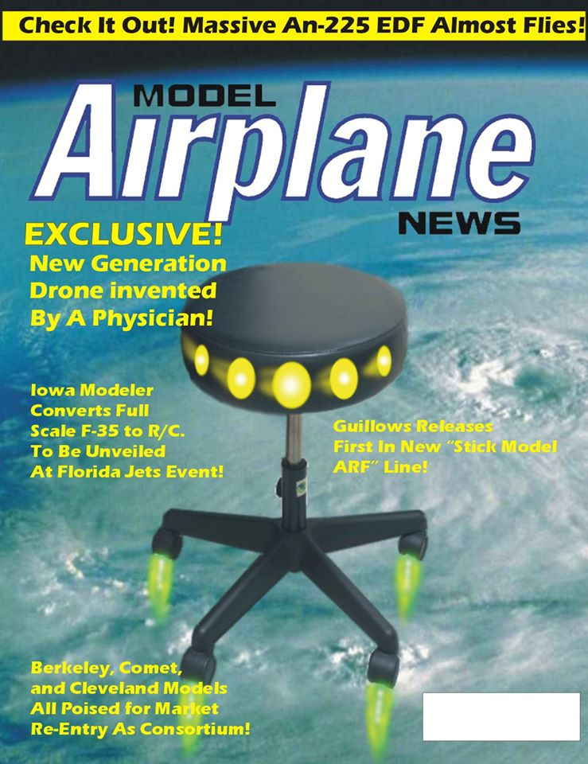

WTF Model Aviation press release
By Dave

The recent FAA rules request for a proposal for remote identification system (RID) has created a problem for RC modelers. Did you know a small RC model of an ultralight would require a RID system to be legal, but the larger man carrying version does not. That simple statement was pondered over several pitchers of cheap beer “How can I fly RC without a RID system?.


Then it hit them like a hangover or the bar bill at the end of a long night. Why not combine the two? “An RC controlled ultra light with a human passenger?” Brillant!
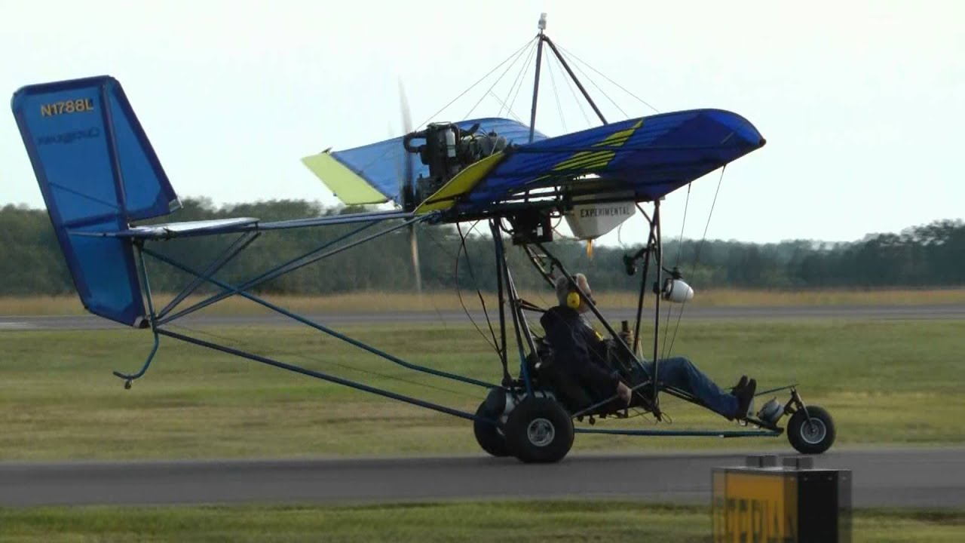

INTRODUCING THE BUDY FLIGHT™ SYSTEM.
Imagine flying yor giant sized model aircraft, out of any field at any time. You, the Pilot, assemble and start the engine and fly safely from the ground while your flying buddy is strapped in an ultralight cockpit non working controls.


Your terrified flying buddy will age quickly, while you, safe on the ground, execute hair raising maneuvers for your friend to experience. Loops rolls, low inverted flight, no problem! Things you would never do while risking your own ass, you can do with Buddy Flight™. While you friend craps his pants, you will feel safe that the FAA does not need to know about it as there is a pilot in command, and RID system is not needed.

Imagine their excitement as you attempt to hover and fly knife edge and low altitudes while your passenger is fighting the non working controls.
Give him a video camera for realistic FPV action including the screams of excitement. Your YouTube channel will go viral!
Imagine your relief as you narrowly miss the ground and do all manner of risky maneuvers all from the safety of the ground. If you crash, no worries, it’s only an airplane and a friend.

A great gift for Ex wives, cheating spouses, Horrible bosses, unappreciative children and worthless brothers in law.
BUDDY FLIGHT™ system by WTF aeronautics motto: “rules loop holes lead to loops and rolls”.

