FESI design document
Design of the Free ECMAscript Interpreter

Copyright © 1998-2003, Jean-Marc Lugrin
Provided under the same condition as the FESI sources, (LPGL) without any warranty.

Table of content

Table of content 2
Goals 4
Interpreter design 4
Possible use 4
Some logical structures used 4
Values in FESI 4
Execution context 5
Attributes 6
Grammar 6
AST 7
EcmaScript Object structure 9
FESI objects implementation structure 10
Evaluation 11
Type of environment information 11
Scope chain 11
References (8.7) 11
Objects (8.6) 11
This 12
Variable environment 12
Evaluator environment 13
Program text 13
Values 13
Evaluator interface 13
Evaluator design 13
Visitors 13
Environment information 13
Builtin functions 14
Well known objects 14
Thread handling 14
Error handling 14
Java interface 15
Event handling 15
Creating new object types 15
Creating built-in extensions 16
JSxxx compatible objects 16
Code management 17
Building the official kit 17
Interpreter usage 19
Calling the interpreter 19
Interactive mode 19
BasicIO Extensions 19
JavaAccess Extensions 20

Goals

Interpreter design
An extensible interpreter (a programmer can design extensions).
Incremental interactive evaluation to help in the creation of new scripts.
General access to java from the EcmaScript scripts.
Java beans integration (take advantage of the bean information), including applets.
Useful with AWT and Swing (support for event handling)

Possible use
servlet (server side Ecmascript).
Macro language for any program (see FesiFTP example).
Macro language for an XML based gui builder (see FesiForm example).
Prototype of database access applications.
Driver for test cases of beans or data bases.

Some logical structures used
See the EcmaScript standard !
NOTE: Fesi currently implements EcmaScript first/second edition (which are defining the same language, corresponding more or less to Javascript 1.1 and first version of Rhino). Supprot for 3rd edition is being added.
The implementation is patterned after the language definition as much as possible, except when this caused severe implementation issue. In that way conformance with the standard is easier to achieve.

Values in FESI
This section helps getting an overview of the hierarchy of values in EcmaScript – it must be read with the standard.
Value (type)
implements
GetBase
GetPropertyName
GetValue
PutValue
isA
Primitive isA
Undefined
Null
Boolean
Number
String
Reference
Object isA
HostObject
has
Properties has
Attributes isOneOf
ReadOnly For prototype, length, arguments and constants
DontEnum For prototype, length, arguments and constants
DontDelete For prototype, length, arguments and constants
Internal
isOneOf (* is mandatory for all, + is mandatory for native objects)
<identifier> (including Prototype)
[[Prototype]]* or null
[[Class]]*
[[Value]]
[[Get]]*
[[Put]]*
[[CanPut]]+
[[HasProperty]]*
[[Delete]]*
[[DefaultValue]]*
[[Construct]]
[[Call]]
isOneOf
Object
Global
Function isA
Constructor has
Prototype
Array
String
Boolean
Number
Math
Date
Added built-in Objects
Host Objects

Operator isOneOf
mult, div, ..

ListType implementedAs array of Value
completion type

Conversions:
All ESValues:
toPrimitiveXxx When type must be checked at run time for overloaded operations
toNumber For Number objects, arithmetic, date calculation
toBoolean For boolean objects, conditions, iterations
toInteger Index value, parameter to time and date routines
toInt32 For bitwise not, some shift, radix
toUint32 For some shift operators and array length
toUint16 For conversion of integer to characters to build strings
toString When string arguments are needed, for string conversions

Execution context
Execution context (a stack), for with
Context hasA
Variable object isOneOf
global Object
variable Object hasA
length property
callee property
<identifer> properties
Previous Scope

Activation hasA
Context object

Attributes
Attributes include:
length of array special, dontdelelet, dontenum
length of functions (arity): readonly, dontdelete, dontenum
builtin objects functions: dontenumn
builtin object constants (math, number): readonly, dontdelete, dontenum
constructors: dontenumn
prototype of constructed functions: dontenum
prototype of builtin functions: readonly, dontdelete, dontenum
arguments: readonly, dontdelete, dontenum
Attribute implementation:
length of array
get: special
canput: true
put: special
hasproperty: true
enum: ignore
delete: ignore
length of function
get: special
canput: false
put: ignore
hasproperty: true
enum: ignore
delete: ignore

Grammar
The parsers is implemented using the JavaCC system (recursive descent, LL1).
True, false, null used as keyword in the grammar.
The original grammar is LR, and has been manually transformed to LL (with the obvious risks of errors this include, however this does not seem too severe for common scripts)
To add a new statement (this requires understanding JavaCC).
Edit the keyword and grammar as needed.
Generate grammar once with the BUILD_NODE_FILES set to true (this will generate the new AST and EcmaScriptVisitor interface. See comments in the source jjt package.
The various visitors of the interpreter package and the EcmaScriptDumpVisitor of the AST package must be enhanced to support the new syntax.
Adequate tests must be added to the validation suite.
The source kit contains the grammar already generated, so it is not required to regenerate it if you do not modify it.

AST
This section shows the logical structure of the generated Abstract Syntax Tree
A program could be a statementlist OR a functiondeclaration
PROGRAM ::= TopElement …

TopElement ::= STATEMENT
FUNCTIONDECLARATION

FUNCTIONDECLARATION ::= <ID> FORMALPARAMETERLIST STATEMENTLIST (???)
contains the source of the function

STATEMENTLIST ::= STATEMENT …

FORMALPARAMETERLIST ::= <ID>…

STATEMENT ::= STATEMENTLIST
| VARIABLEDECLARATION
| IFSTATEMENT
| WHILESTATEMENT
| FORSTATEMENT
| FORINSTATEMENT
| FORVARSTATEMENT
| FORVARINSTATEMENT
| CONTINUESTATEMENT
| BREAKSTATEMENT
| RETURNSTATEMENT
| WITHSTATEMENT
| expression

VARIABLEDECLARATION ::= <IDENTIFIER> [ expr ] (stay optional as meaning different)

IFSTATEMENT ::= expression STATEMENT [ STATEMENT ]

WHILESTATEMENT ::= expression STATEMENT

FORSTATEMENT ::= optionalexpression
optionalexpression
optionalexpression STATEMENT

FORVARSTATEMENT ::= variabledeclarationSTATEMENTLIST
optional_expression
optional_expression STATEMENT

FORINSTATEMENT ::= expression expression STATEMENT

FORVARINSTATEMENT ::= <ID> optional_expression expression STATEMENT

CONTINUESTATEMENT ::= void

BREAKSTATEMENT ::= void

RETURNSTATEMENT ::= OOPTIONALEXPRESSION

WITHSTATEMENT ::= <ID> STATEMENT

A composite reference could start by a literal ?
COMPOSITEREFERENCE ::= <ID> Compositor

Compositor ::= PROPERTYVALUEREFERENCE
| PROPERTYIDENTIFIERREFERENCE
| FUNCTIONCALLPARAMETERS)

Distinguish between a[b] and a.b, as <ID> is an expression too
PROPERTYVALUEREFERENCE ::= expression
PROPERTYIDENTIFIERREFERENCE ::= <ID>

ALLOCATIONEXPRESSION ::= expression FUNCTIONCALLPARAMETERS

FUNCTIONCALLPARAMETERS ::= expression …

POSTFIXEXPRESSION ::= expression <OPERATOR>

UNARYEXPRESSION ::= <OPERATOR> expression

BINARYEXPRESSIONSEQUENCE ::= expression (<OPERATOR> expression)…

ANDEXPRESSIONSEQUENCE ::= expression (<OPERATOR> expression)…

OREXPRESSIONSEQUENCE ::= expression (<OPERATOR> expression)…

CONDITIONALEXPRESSION ::= expression expression expression

ASSIGNMENTEXPRESSION := {Assignable}expression <OPERATOR> expression

EXPRESSIONLIST := expression …

EMPTYEXPRESSION ::= void

optional_expression ::= expression
| EMPTYEXPRESSION

expression ::= <ID>
| <LITERAL>
| <THISREFERENCE>
| COMPOSITEREFERENCE
| POSTFIXEXPRESSION
| UNARYEXPRESSION
| BINARYEXPRESSIONSEQUENCE
| ANDEXPRESSIONSEQUENCE
| OREXPRESSIONSEQUENCE
| ASSIGEMENTEXPRESSION
| EXPRESSIONLIST

EcmaScript Object structure
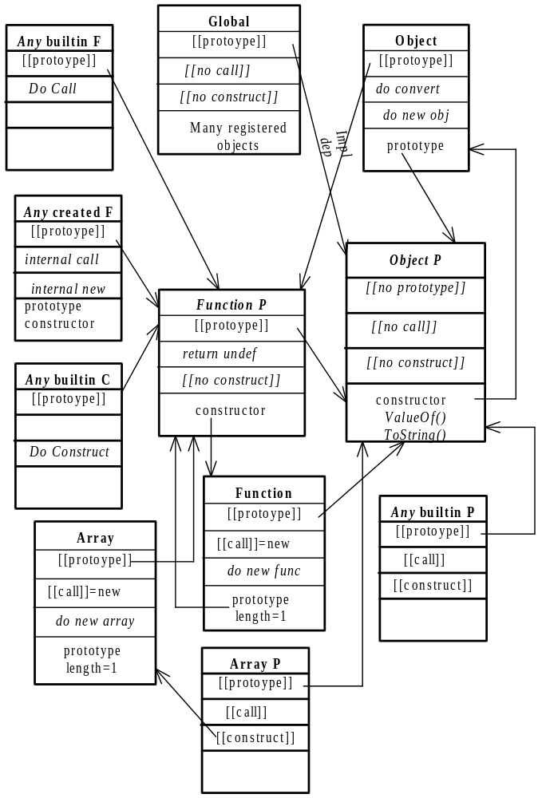

FESI objects implementation structure
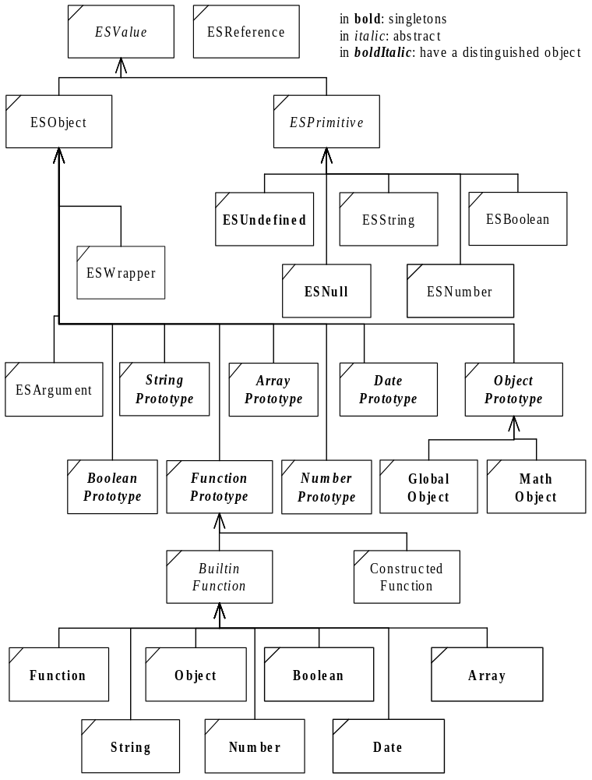

The following changes could be done:
- Have a general ESData above ESReference and ESValue
- Split ESReference is a general-purpose reference (possibly returned by a java object) and an ESPropertyReference/ ESIndexReference.
- ESIndexReference uses the index integer value instead of the string (for array access).
- Have built-in ‘delete’ capability in ESReference (do not need base name and property).
- Ask object to build their references

Evaluation
The evaluation environment must maintain access to various information, which may be different for different evaluators (allowing multiple evaluator to work in one program).

Type of environment information
See 10.1 in EcmaScript standard

Scope chain
Represents the lexical scope chain. It is:
- The GlobalObject for top level code
- The variable object (arguments and local variables) of the function, followed by the global object during function evaluation (that is all functions are lexically scoped in the global scope).
- The lexical scope of the caller for eval code.
- The object specified in with, followed by the previous scope, for with blocks.

References (8.7)
See ESReference
References are used only when assignment will be done (the left-hand side must be evaluated before the right hand side). This lowers the garbage generated.
The sequence “evaluate a reference - get its value” is replaced by a direct “evaluate to value” when interpreting identifiers for the right-hand side of an expression.
The getBase and get PropertyName are only used by the delete operator - a delete operation could be built in ESReference instead.

Objects (8.6)
See ESObject
[[prototype]] is implemented by getPrototype (do not confuse with the prototype property of function objects).
[[class]]
[[value]]
[[get]] Is implemented by the getProperty routines. There is one for string and one for integer values, to allow optimization for arrays. The could be one for ESValue which convert to string by default (but would test for integer in case of array). There could be one for interned strings as well if this is a useful optimization.
The special routine getPropertyInScope argument is used to lookup values directly in a scope with chaining, avoiding a separate hasProperty test. It combines the operations of 10.1.4, but may return directly a value.
However a few object cannot meaningfully be member of a with statement, as for example an ESPackage (as it is the mere fact of accessing one of its property which creates it - therefore all accesses would be trapped by such an object). In that case accessing it via a with statement will not create the package, this must be done in a root environment, or using another interface.
[[put]] Is implemented by the putProperty routines, similar to the getProperty routines. They implement the [[canPut]] function as well (by ignoring errors or put on read-only properties). There is a variant called putHiddenProperty which create “hidden” properties during the initialization. Read-only properties are hard-coded.
The current implementation generate an errors if a non-existent property is set in a host object - this is not standard (it should be ignored) but quite helpful.
[[canPut]] As it is used by [[put]] only (8.6.2.3), it is integrated with the implementation of [[put]].
[[hasProperty]] Implemented by the hasProperty function. In the standard, it is used by search in the scope chain (to skip an object in the chain if it does not have the property, see getReference in ScopeChain) and in the delete operator only. It is used by the createVariable routine of the evaluator to avoid overwriting existing variables or hiding hidden properties (this could be replaced by an special variant of putValue).
The hasProperty routine must be implemented in subclass (with a call to super class) for each class implementing getProperty.
[[delete]] Implemented by deleteProperty. ESWrapper is not perfect, as a hack is used for hasProperty…. For value lookup another trick is used to bypass a separate hasProperty and getProperty call. A getProperty function with a scope parameter is used.
[[defaultvalue]]
[[construct]]
[[call]]

This
Represents the specific this reference. It is:
- The GlobalObject for top level code
- An object determined at call time during function evaluation.
- The thisObject of the caller for eval code.
- The thisObject of the surrounding code for with blocks.

Variable environment
Represents the activation record for calls to constructed function. It contains the named arguments and the variables created locally. It is:
- The GlobalObject for top level code
- An pseudo-object initialized at call time during function evaluation.
- The GlobalObject for eval code.
- The current variable object for with blocks.
The arguments and special activation record is not represented in the current implementation.

Evaluator environment
Represents the general common evaluation environment, for example allowing access to the well known objects as the GlobalObject or the FunctionPrototype.

Program text
The program text must be transmitted to the environment (especially for functions!). It is represented by the top node of the function to evaluate.

Values
Currently all EcmaScript values and objects are ESValues (but not references!)

Evaluator interface
A public interface to be used is in FESI.java and uses the class JSObject and JSException in a way somewhat compatible with Netscape.

Evaluator design
The Evaluator object contains the current state of an evaluation environment. When inactive, all the state is reachable via the Global object and well known objects reachable from the evaluator.
Many interpretation tasks are delegated to visitors, which walks through the AST. The visitors keep minimal state information (only a reference to the evaluator and the current location in the AST).

Visitors
The evaluator is built using the visitor pattern. A function declaration visitor is used to prepare the functions. A variable declaration visitor is used to process the var declarations. Then an evaluation visitor is used to evaluate the AST. The evaluation visitor returns the value (or null if no value is returned by this statement). In some case the value must be a reference - this is indicated by the parameter. Only a few constructions can return a reference - if other constructions return a reference, an error will be generated when the reference is used. If a reference is needed but a non-reference is returned, then an error is signaled to the user. There is no special check during parsing or preliminary visit for malformed left values, so that expressions returning left values can be implemented in the future.

Environment information
The evaluator keeps the evaluation environment.
The evaluator has special entries for constructed function calls, the eval function, and for the evaluation of with scope. These entries are used only for recursive calls to the interpreter, to set and restore the currentVariableObject , the scope chain and the thisObject according to the semantic of the various recursive calls.
When active (that is when an evaluation is in progress), the following additional variables are initialized:
- The evaluation stack (all statements pushes a result there, possibly undefined).
- The AST being interpreted is passed as parameter to the visitors (it is on the java stack during recursive call to the visitors).
- The variables not explicitly created in the global environment are created in the currentVariableObject, which is either the global environment or a variable environment. The variable environment is changed when a function is evaluated.
- The scopeChain is used to find references to variables. It is initialized and restored depending on the type of evaluation (global, eval or function).
- The thisObject is used for the value of the this keyword. It is set a function call and restored and function exit.
The evaluation starts with an empty stack and returns an empty stack (the last value on the stack being returned as the result of the evaluation).

Builtin functions
Builtin functions are called with parameters in an array, including the thisObject and the evaluator. Unlike constructed functions they normally do not have to ask the evaluator local environment variables (no variable object is created, and the evaluator’s thisObject is not updated during the evaluation of the builtin functions).
So builtin functions should use the received thisObject, and not use the one provided by the evaluator (which is the one of their caller).

Well known objects
The evaluator provides the well-known objects as the global object and the prototypes for the built-in types. Other standard objects, which are not needed for the interpreter code (as Math and the constructors), are only reachable by name from the global object.
The thisObject may be considered a specially known special object (the interpreter retrieve it via the evaluator but built-in functions are provided with its value as one of their arguments).

Thread handling
Every entry in the interpreter is protected by synchronization on the Evaluator object. Therefore the evaluator itself is always serialized. This may create deadlock for some cases of the AWT, but ismore like the Swing implementation.

Error handling

In interpreting AST
The various visitors are responsible to trap interpretation errors and report them as an EcmaScriptException (or subclass of it), with proper reference to the immediate (static) source location. For this purpose an evaluation source object is given to the visitors. In case of error, the visitor creates a detailed source description, which contains the local description (line and col numbers, possibly details on the location as the type of statement or function name), and a reference to the static source.

Netscape extension (not implemented in FESI)
Netscape define an onError event handler, which receive the message text, URL and line number of the error. If onError is null, or if it is a function returning true or undefined, then no message is displayed. If onError is not defined or if it is a function returning false, an error message is displayed. Apparently interpretation is interrupted up to the level of the last call from the surrounding exiting of all current internal eval code. If onError is defined on a window rather than globally, then only errors for that window are trapped.
Currently the try/catch/throw system is not used.

FESI extension
First a convention + facility to get error message, line number and source name.
Similar to Netscape, when onError being attached to the global object.
Ideas: tryEval, raise (functional throw), displayError(exception)

Java interface
Java objects are either converted to an EcmaScript equivalent or encapsulated in a ESWrapper object. If an object is created directly by a call to a basic class constructor as String, Double, etc… it is not converted to an EcmaScript equivalent, to help casting objects to resolve overloading conflicts.
Java classes can be created by calling a constructor as in new Package.java.lang.String(“abc”), returned by a call to an existing java object.
The Enumeration object can be used in the “for in” clause (however it does not enumerates properties of arbitrary object, as the wrapper object has no enumerable property).

Event handling
JDK 1.1 event handlers are supported. Adaptor classes are created dynamically as needed, therefore any event can be processed. The event handling capability is built into the ESWrapper object, which package all accesses to an object (not that there can be more than one ESWrapper for one java object - this may be a cause of error for event processing!).
An event adaptor is a subclass of EventAdaptor, and is generated by EventAdaptorGenerator (and EventAdaptorClassFile). This was largely copied from an example of the BDK. When an event is fired, the EventAdaptor class fire routine is called (with a reference to the method that fired the event and to the parameters). The event adaptor as a reference to the ESWrapper object too, it can therefore forward the event to the ESWrapper for dispatching. For this purpose the event keyis rebuild and the event handler looked up in the list of event handlers for this object - there may be no event handler, in which case the event is ignored.
Only one adaptor can be registered for each listener type and wrapper pair - so a table of current adaptor is kept with the wrapper object. A single handler can exists for a specific event in a wrapper object, so a table of handlers is found as well.
Event are identified by the “onEvent” property name, which accept either the event name (if there is a single routine for that event) or the routine name. From this an event key is built, which consists of the fully qualified listener class name and method name, independently of the way the event was specified.
A null event handler specifies that the event should be ignored if it is currently handled. Otherwise a routine is built to handle the event, and saved in the event key.
Currently the adaptor is not removed, even if there is no handler for it to process.

Issue of multiple wrappers
This could be solved in jdk 1.2 using weak references. For specific operations (event handling) a list of all objects with an active handler could be kept.

Creating new object types
An object type is usually created in an extension. A new object type consists at least of a prototype object, which is a subclass of ESObject and contains the implementation code specific to the type, and a creation function object (a subclass of built-in function object) , which creates new objects of the type.
The prototype object may have 3 type of constructors:
- The constructor used to create the prototype object, which may not have some arguments.
- The constructor used by the constructing function, which has the arguments matching the function.
- The constructor used internally by the code, often with internal argument types.
Often the 3 types are partially of fully collapsed.
The prototype and function objects of a type are specific to an evaluator, and may therefore not be stored in a static variable. If common prototypes are well known object, extension related prototypes must be passed around to be available to the function creation routine.
The function-creating object must have the prototype and length attribute. The prototype attribute of the Function creating value points to the prototype of the target object (not to be confused with the prototype of the Function object itself, which is a built-in function object).
The object prototype, which is usually an object of the target type with some kind of default value (a empty string for String, a 0 for Number) must have the constructor attribute. In general the prototype cannot be used as a full-blown object, but could have some default values.

Creating built-in extensions
A built-in extension is an extension of the Extension class (got that?). Very often at least one data type must be created as part of the extension, the function creating the new object representing the extension in some way. To keep the prototype of the new objects reachable, the structure can be:
public class Xxx extends Extension {
private Evaluator evaluator = null;
private ESObject xxxPrototype = null;

class GlobalObjectXxx extends BuiltinFunctionObject {
}
public void initializeExtension(Evaluator evaluator)
throws EcmaScriptException {
this.evaluator = evaluator;
GlobalObject go = evaluator.getGlobalObject();
ObjectPrototype op =
(ObjectPrototype) evaluator.getObjectPrototype();
xxxPrototype = new ObjectPrototype(op, evaluator);
. . .
}
}

JSxxx compatible objects
To support simple user extension to FESI, a Netscape like interface is provided, named FESI.jslib. See the API description.
The class/interface hierarchy is as follow:
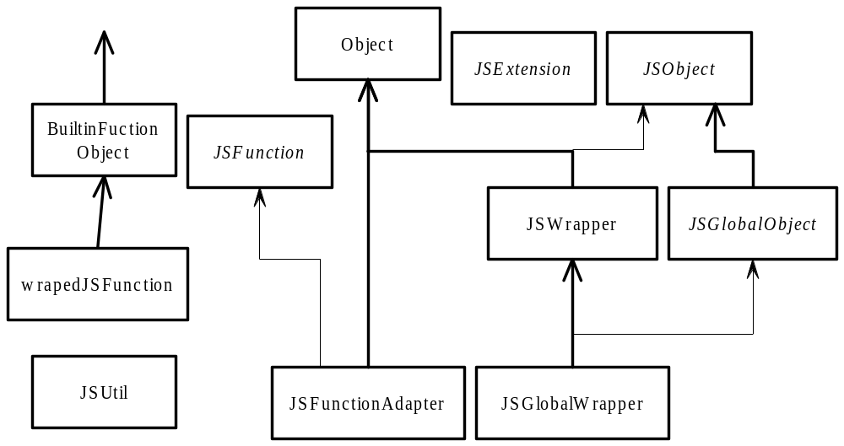
In general the objects returned by the evaluator using the JSxxx calls are unwrapped (the most internal java object is returned). It is possible to unwrap them explicitely using facilities of JSGlobalObject.

Code management

Building the official kit
The process is currently done under windows
The following directories contains only transient data, and are deleted in the clean process – do not change them:
…/classes (contains compiled classes files, generated by compilation)
…/lib (contains the jar file)
…/doc/html/api (contains the html files generated by JavaDoc)
…/site (contains an iamge of the site generated by the build process)
In addition some java files are generated by JavaCC. EcmaScript.java is kept, other files are discarded.
To prepare to build the kit (local preparation of all pages, including HTML that will be included in the kit):
- Ensure that you have a backup of the previous version and current state.
- The version number and version date must be updated in the Build.xml.
- The information on the doc/html (BEWARE, do not update the site directory directly) subdirectory must be udated.
NOTE: The version and date are updated autmoatically in most files. The following files must still be modified:
- The enhancements must be described in index.html and readme.txt
- the new examples described in FesiExamples\readme.txt
- Any other relevant documentation update must be applied.
- The the batch files in bin/src must updated if required (change of parameters for execution). as well as the kit building procedure (MakeFesiInstall.xml) if required.
- The same in FesiFTP.
- A clean rebuilt (debug options can be left) is required. Done with ANT by executing (in order):
- clean
- configure
- grammar
- compile
- jars
- doc
- test
- Build for jdk118 (use target forJdk118, depends on external batch file!)
- A clean rebuild is needed for FesiFTP (clean, compile, jars) (Not currently in kit).
- Backup the version

Building the kit (using IzPack)
Update the installer definition file (MakeFesiInstall.xml) if needed.
The kit is built by ANT using the target “kit”.
A single kit is created, that contains sources, examples and compiled versions. It will be created in
fesi/install-fesi.jar
The kit has the following directory structure:
fesi-xxx Root directory for specified version
bin – contains launcher command files
lib – Contains fesi.jar
doc/html – Contains doc in html format
doc/api – Contais javadoc of the Jslib (only)
(examples)
examples – contains example code
(source kit):
src – contains the sources
doc/design – Contains design doc (this document)
ant – contains the ant buildfile
test – test files
(forJdk118):
lib – the jar file for JDK 1.1.8 to 1.3.x
bin – Command files to execute the jar file
classes – work directory used when rebuilding the file

In addition to root directory contains the readme, copyright, and kit building…

Building the site:
The site is built using the site target of the ant file. FESI, FesiFtp and the kit must have been previously built. The site is built I nthe subdirectory site.
Then upgrade the site (currently manual copy from the local site directory to the public location).

Sitepage structure

The html pages have the following structure:
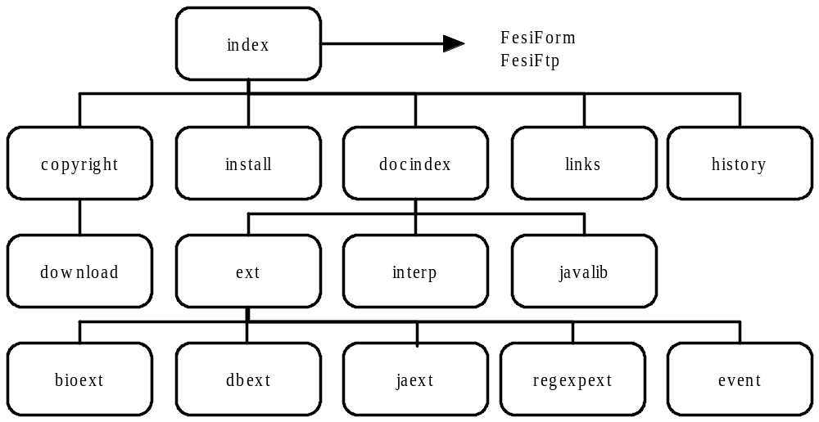

Interpreter usage
A stand-alone interpreter is provided, allowing testing program interactively and running programs which use only dynamically loadable extensions.
See the user guide for details.

Calling the interpreter
The interpreter can run in batch mode and in interactive mode.
In batch mode (the default) it reads and interprets the files specified in the command line and output the result to the standard output stream (with error to the standard error stream). If no file is specified on the command line, the standard input is read. The standard input can be specified by the “—“ option too. In both cases the standard input is read in batch mode (that is until an EOF is encountered, then interpreted). Any error will terminate the evaluation.
If the option -o filename is specified, the output is redirected to the specified file.

Interactive mode
In interactive mode (option -i) the files specified in the command line are loaded (the standard input file cannot be specified), then the system enter an interactive read eval loop. Each statement is evaluated immediately when entered, and errors are not fatal. In addition the user can type various commands (see the user guide). Additional commands are easy to add.

BasicIO Extensions
The following global objects and routines are defined:
write Write the parameters to the current output stream
write Write the parameters to the current output stream, followed by a new line
exit Exit with the specified status
alert Write an [[alert]] message on the error stream (in window mode, use a dialog box).
confirm Ask a confirmation from the user (in window mode, use a dialog box).
prompt Ask a one line response (with default) to the user (in window mode, use a dialog box).
document An object for compatibility when expanding html files
document.write As write
document.writeln As writeln
document.open Dummy routine for compatibility when expanding html files
document.close Dummy routine for compatibility when expanding html files
document.URL Current file if defined by the interpreter
window An object for compatibility when expanding html files
window.alert Write an [[alert]] message on the error stream (in window mode, use a dialog box).
window.confirm Ask a confirmation from the user (in window mode, use a dialog box).
window.prompt Ask a one line response (with default) to the user (in window mode, use a dialog box).

JavaAccess Extensions
The following global objects and routines are defined in the global object:
Package Root of all packages reachable via the classpath.
java Root of the java classes
javaTypeOf Return the name of the Java class which would be used for this object.
The operation new javaClasscalls the java constructor and return the Java object (even if it is an object which is usually converted to a native object, as String, Date, Number, Character or Boolean. A Java object is in a wrapper object in EcmaScript. The use of this wrapper object is transparent to the user. The constructor is selected in the same way as a function (see below).
The call of a Java function (either a static one or an instance one, if provided with a Java object) result in the call of the static or dynamic public function of the same name, with compatible parameters. Parameters are transformed to the corresponding java type (unwrapping wrapped objects) and narrowed to the smallest compatible value (byte, short, int). The type of the parameters are checked, applying the Java conversion rules if needed, and the routine is called if found.
The value returned from a function call is transformed to a native type if possible, that is if it is null, a member of String, Date, Number, Character or Boolean, or a corresponding primitive type. Otherwise it is returned as a wrapped object (this is unlike the use of new, which leave object wrapped).
If an object is called as a function, its corresponding constructor is called (like in EcmaScript, where function and constructor are essentially identical). However in this case the object is always normalized to a native EcmaScript value if possible (Date, String, Number, Boolean).
Rational The construct Package.class.routine(new Long(2)) can be used to for the selection of the routine taking a Long as a parameter, otherwise a routine taking a byte would be selected, if it existed. However in general objects are converted to their native EcmaScript equivallent because there is little loss of functionality but a great gain of performance.
Note that all calls from EcmaScript is done synchronized on the evaluator, and all call to the interpreter synchronize on it as well (which may cause some deadlock depending on the threading model used for callbacks).

[ e n d ]

