CHAPTER I

THE PROBLEM AND ITS SCOPE

Introduction
Digital technology and its continuous innovation have reshaped the academic information and research resources management process in the context of a university. Most universities are implementing digital management systems to streamline academic and administrative processes. As stated by Phuong and Hai (2026), digital transformation has boosted the performance of higher education institutions by integrating digital technology into their operations, making institutional work procedures more effective. Within this transition, institutional repositories contribute remarkably to effectively collecting and preserving academic works and providing access to the general community. Further, incorporating advanced technologies such as semantic search within academic repositories supports users accessing information by understanding the context and actual intent of queries, rather than finding results based on keyword matches, leading to the search being more precise and fast in academic repositories (Lubis et al., 2026).
Capstone projects in higher educational institutions constitute a significant academic document representing the cumulative learning, capstone competence, and creative thinking skills of the student. As the volume of produced documents grows year by year, the problems related to storing, accessing and searching those works are escalating within institutional repositories. However, the keyword search method relies on exact matches, which limits its efficiency in finding related studies; therefore, searching titles and comparing documents is done manually. Furthermore, semantic search-based methods have seen significant advancement with proven effectiveness in retrieving conceptually associated papers and have proved their importance in digital repositories for higher education (Musa et al. 2026).
Although digital repositories have provided a useful tool, many universities still face challenges in measuring the similarity of capstone titles and research objectives, as well as identifying research trends from previously completed studies. As the number of capstone reports continues to grow, manually reviewing and comparing research proposals becomes increasingly time-consuming and inefficient. Without an automated similarity detection tool, evaluating the relatedness of proposed studies becomes more difficult, increasing the possibility of overlooking highly similar research topics. Moreover, without trend analytics, the university cannot effectively identify frequently explored topics, monitor research patterns, or recognize potential research opportunities for future capstone studies.
In line with the concerns stated above, the proponents introduce a web-based repository system, CapstoneHub: A Research Repository System for Capstone Projects at J.H. Cerilles State College (JHCSC). The proposed system will facilitate the accessibility of all institutional capstone projects and offer additional capabilities like semantic search of capstone, analyze the similarities of titles and objectives, and analyze capstone trends.

Project Context
Capstone projects are major intellectual outputs of J.H. Cerilles State College that demonstrate the students’ academic understanding, technical competencies, and research capabilities. These studies are also important sources of reference for students and future researchers. As the number of completed capstone projects continues to grow, the institution needs a more efficient way to organize, manage, and preserve these research documents so that they will remain accessible and useful over time
The currently approved capstone projects are stored in hard bound copies and soft copies. As the repository grows, the retrieval and management of research documents gets more and more difficult. The lack of a centralized repository also makes it difficult to easily access the past studies, compare the similarity of the research titles and objectives, and track research trends. Today’s repository systems are mainly applied as storage locations and usually do not provide intelligent features to support better research management.
In response to these challenges, this study designed CapstoneHub, a web-based research intelligence platform for J.H. Cerilles State College. The system combines approved capstone projects and adds semantic search, similarity detection, and research trend analytics to improve the accessibility, retrieval, organization, and management of institutional research. The proposed system provides these capabilities, thus supporting more efficient research management and improving access to the institution’s growing collection of capstone projects.

Purpose and Description
This study aims to provide a centralized platform that will store all capstone projects completed at J.H. Cerilles State College (JHCSC). The project aimed to enhance the organization, accessibility, and management of capstone institutional research and make it accessible where the system would store and access approved capstone research by providing an interface that would organize research studies. By integrated search functionalities and analyses, it helps the college institute to avoid research duplication, ensures the originality of research, and gives a trend of study.
CapstoneHub is a web-based research intelligence platform for students or researchers who are involved in capstone research. With the system, users can access past capstone studies through semantic search capability, analyze the resemblance of the current proposed study with the existing study, and analyze trends. The said system is to facilitate the accessibility of previous capstone study, help students in identifying relevant research opportunities and more effectively manage capstone projects in J.H. Cerilles State College.
Objectives of the Study
General Objective
The purpose of this study is mainly to design and develop a web-based repository system named CapstoneHub to improve the accessibility, organization, and management of capstone projects at J.H. Cerilles State College.
Specific Objectives
Specifically, this project aims:
1. To design a user-friendly web-based repository for the centralized storage, organization, and retrieval of capstone projects of J.H. Cerilles State College.
2. To develop a secure and functional repository system including semantic search, comprehensive similarity detection and research trend analytics to assist in the management of capstone projects.
3. To test the effectiveness of CapstoneHub in supporting the efficient access to capstone projects and helping to detect related and similar studies.
4. To evaluate the system functionality on managing, retrieving, and analyzing capstone projects at J.H. Cerilles State College.
Scope and Limitation
This study focuses on developing a web-based repository system for the capstone projects of J.H. Cerilles State College (JHCSC). The system will centralize and provide efficient storing, retrieving, and managing of approved capstone projects and provide specific functions of CapstoneHub, such as semantic searching, analyzing comprehensive similarities, and providing trend analytics. This study intends to allow authorized users to efficiently upload, manage, search, and recover capstone projects by using a centralized repository.
This study is only limited to the capstone projects of J.H. Cerilles State College and is for academic purposes in the institution only. The similarity of capstone titles and objectives is compared with the existing repository of capstone projects and not with the external research databases or publications. Moreover, the research trend analytics are derived only from the capstone projects that are available in the system. CapstoneHub does not evaluate the quality of research papers as a whole, does not detect plagiarism in the entire manuscript.
Definition of Terms
The following terms are operationally defined for the purpose of this study:
Administrator (Admin). An authorized individual responsible for managing the CapstoneHub system, such as user accounts, capstone project information, and other data relevant to system's operation so as the system to function accordingly in accessing of repository.
CapstoneHub. Web-based repository system for the storing, organizing and managing the capstone projects in J.H. Cerilles State College (JHCSC). The system involves the semantic search, detection of similarity of the title and the research objectives and analytics of capstone trends.
Comprehensive Similarity. This is the comparison of the title and objectives of the proposed capstone study with the title and objectives of the existing capstone projects to determine the degree of similarity.
Guest. A user who accesses the CapstoneHub system without registering or have an account. Guests can search capstone projects, check similarity, view study abstracts, and register for a student account.
Capstone Trend Analytics. A feature that analyzes repository data to display yearly capstone project uploads, identify frequently searched topics, and highlight the most common research categories within the repository.
Student. An authorized student who can search, accesses, and retrieves previous capstone projects, check similarity of the proposed research titles and objectives.

CHAPTER II

REVIEW OF RELATED STUDIES AND SYSTEM
This chapter presents the technical background, including the hardware and software specifications, and relevant local and foreign studies.

Technical Background
CapstoneHub is a web-based repository system designed to enhance the management, organization, storage, retrieval and access of approved capstone projects in J.H. Cerilles State College. The system is developed on the Laravel framework, which implements the Model–View–Controller (MVC) architectural pattern, and is based on the client–server architecture. According to Rangkuti et al. (2026), MVC architecture classifies business logic, the user interface and data accessibility of the application in distinct parts so the code is simpler to review, reusable, accessible and reliable. The study also pointed out the in-built features of Laravel like Eloquent ORM, Blade Templating Engine and Routing which help in implementing MVC architecture effectively and help to develop modern web applications. Laravel is a good framework for CapstoneHub development with such capabilities.
The main application is developed with PHP 8.3 and Laravel 13.8. It works with Eloquent ORM for database access and relationships, routing and middleware for request & controls on access, Blade Templates for creating a dynamic web page. The front-end of the system is built utilizing HTML, CSS, JavaScript, Tailwind CSS, Alpine.js and Chart.js to build a responsive and interactive user interface. Furthermore, Vite acts as the development server and asset bundler, allowing for efficient compilation and management of the system’s CSS and JavaScript assets.
The default database of the system is MySQL, which is used to store user accounts, metadata of capstone projects, categories of projects, types of projects, search logs, one-time password (OTP) codes, and numerical embeddings. The record of the capstone project includes the title, abstract, objectives, keywords, authors, year of publication, file path, publication status, and rejection reason. Also, the database supports many to many relationships, for example, one capstone project can belong to many project categories and project types. Approved capstone manuscripts in PDF or DOCX format, with a maximum file size of 10 MB, are stored in the public local storage and can be opened directly in the browser.
The system has a dedicated AI service build in Python using Flask to facilitate semantic search and similarity check. The AI service uses the pretrained Sentence Transformers model all-MiniLM-L6-v2 to convert the titles, abstracts, objectives of the capstone projects and search queries into numerical vector representation, known as embeddings. Yin and Zhang (2024), argue that the all-MiniLM-L6-v2 model can produce accurate sentence embeddings for tasks that depend on similarity, allowing to recognize texts with identical meanings, despite differences in the sentences. We then compare the resulting embeddings using cosine similarity to quantify the semantic distance between the vector representations. According to Sunandar and Muiz the integration of cosine similarity in an automated capstone title similarity detection system improves detection of conceptually similar titles, reduces the time required for title verification, and reduces the approval of duplicate titles. These results motivate the addition of similarity detection in CapstoneHub. The similarity calculation is performed using Scikit-learn and the communication between the Laravel application and the AI service is implemented through HTTP requests to the local endpoint http://127.0.0.1:8000.
The core functionalities of CapstoneHub are based on a semantic processing mechanism. Semantic Search understands the intent of a user query, compares it with the embeddings we have on file, and returns the most relevant approved capstone projects. If the AI service is not available, or no semantic matches are found, the system automatically performs keyword-based searching over the title, keywords, authors and objectives. Title and Objectives Similarity Checker analyzes similarity of the proposed title and objectives with approved capstone projects and displays most similar results to assist users to identify existing or closely related studies. Moreover, the AI Classification module proposes suitable project categories and project types on the basis of the combined title, abstract and objectives. CapstoneHub computes similarity by analyzing meaning and context of textual information.
CapstoneHub has three authorized user roles: Administrator, Student and Guest. Guest can browse repository, semantic search, comprehensive similarity checker, and allow to view capstone abstract. Students can manage their capstone project records. They can perform a semantic search, browse repository, check for comprehensive similarity, download manuscript, upload capstone project and monitor the status of their projects. Administrators manage users, project categories, project types, approved capstone projects, upload capstone projects, and repository records. The administrator also reviews capstone projects for publication. Once the capstone project is published, embeddings are created and stored to allow for semantic search, similarity checking and to find related projects. This also allows for research trend analytics.
To improve system security, CapstoneHub has authentication middleware, Role-Based Access Control (RBAC), server-side validation of user inputs, password hashing, six-digit One-Time Password (OTP) verification via email, and administrator approval of student registrations. Students also have to upload images of the front and back of their school identification card for identity verification. CapstoneHub integrates a centralized repository with semantic search, similarity checking and trend analytics to improve the organization, accessibility, retrieval and management of approved capstone projects at J.H. Cerilles State College.
Hardware Specification
Hardware | Description
Processor | Intel Core i5
RAM | 8 GB
Storage | 20 GB free space
Network | Broadband internet connection
Software Specification
Software | Description
Server Environment
Operation System | Windows 10
Browser | Chrome or Firefox
Database Management System | MySQL
Text Editor/ IDE | VsCode
Backend Language | Php 8.3(laravel 13.8)
Frontend Technologies | HTML, Css, JavaScript, Laravel blade
Client Server
Device | Desktop Computer, Laptop or Smart Phone
Browser | Chrome or Microsoft Edge
Internet | Reliable internet connection for web access

Programming Environment
The CapstoneHub system was designed utilizing various kinds of web development tools and technologies, with a purpose of producing a digital capstone repository that is secure, efficient and user-friendly. It is selected to improve the core function of the system such as storage handling, semantic search, similarity detection and study trend analytics. The application, through the integration of frontend and backend technologies and a strong database management system, provides a responsive interface and ensures smooth operation, storage, and discovery of study information.
For the frontend development of the system HTML, CSS, JavaScript, and Laravel Blade are utilized to construct the user interface. HTML is used for making the fundamental structure of web pages while CSS is used to enhance the appearance by including layouts, colors and styles. JavaScript is used to add interactivity like form verification, interactive page modifications, and more to enhance the experience of users. The user interface is developed using Laravel Blade to develop reusable and page designs and display dynamic content in order to make the user interface structured, consistent and convenient to maintain through the system.
The backend development was developed in PHP 8.3 with Laravel 13.8 Framework, which is used to respond to user queries, apply a business reasoning, control authentication and handle interactions between an application and database. Laravel is based on the Model-View-Controller (MVC) architectural pattern that makes the validation, session handling, and easier routing. The MySQL database management system is used to maintain and handle research data, information about users, uploaded documents, and metadata that is needed for semantic searches, similarity-based detection, and capstone trend analysis. By integrating these technologies, CapstoneHub offers a consistent data management, accurate data retrieval, and efficient performance in handling the capstone projects at J.H. Cerilles State College.
Related studies

Foreign Studies
The increasing use of modern technology in higher education has changed the way capstone outputs are handled, maintained and accessed. Lazarenko et al. (2022) state that digitized academic archives are essential facilities for universities considering that they archive research papers, offer free access to studies, and improve published study availability. The study results led the researchers to establish CapstoneHub as a centralized digital repository to enhance the availability, management, and archiving of the capstone projects at J.H. Cerilles State College.
In addition to the demand for available research repositories, effective data retrieval is also a significant factor. Hussan (2020) claimed that traditional keyword-driven searching engines tend to provide insufficient or unrelated outcomes, as they largely depend on matching with the exact keywords. But semantic search technologies use the significance and context of user searches to present more precise as well as relevant retrieved data. The results of the study urged the proponents to include a semantic search function in CapstoneHub that enables the users to look for related capstone projects no matter how different terms or phrases are applied to refer to similar study topics.
The need to support original research has also led to the development of automatic similarity detection technologies. In consideration of problems that arise with manual review of capstone titles being prolonged and prone to mistakes, Sunandar and Muiz (2025) created a digitally accessible scholarly title similarity detection technique. By using the algorithms Levenshtein Distance and Cosine Similarity, the researchers were able to find out the similarity of characters and similarity of semantics, thus faster verification. Further, Xu et al. (2021) highlighted the importance of research trend analysis to the development of emerging and expanding research areas. In their research, they raised a framework to analyze the existing research by the criteria of whether the topic is new, receiving more attention, always studied, or will be significant in the future. The researchers say the analysis of existing studies will help institutions determine potential areas of research and make better decisions when planning future research. These findings motivated the proponents to incorporate research trend analytics in CapstoneHub so that users can easily identify popular research topics in the repository.
Finally, Ferrao and Soares (2026) acknowledge that capstone projects are a common final academic requirement in higher education, but are generally challenging to manage because of the numerous tasks of recording, organizing and monitoring project information. To solve this problem, the researchers developed a web-based capstone management system to aid in the facilitation of capstone projects through digital technology. The study showed that the web-based solutions can improve the efficiency of capstone project management and help institutions to manage student research better. These findings strengthened the proponents' motivation to design CapstoneHub as a web-based platform that not only acts as a repository of capstone projects but also facilitates semantic search, detection of title duplications, similarity checking, and analysis of research trends.
Local Studies
In the context of the Philippines, the use of digital repositories has become an important approach to improving the accessibility, organization, and management of institutional research outputs. Arruejo (2020) developed eBirok: An Online Repository for Theses and Dissertations as an alternative to the manual retrieval of printed research manuscripts. The study demonstrated that implementing a centralized digital repository improves the search, accessibility, retrieval, preservation, and dissemination of academic research. Similarly, Tindoc et al. (2023) designed and developed the Automated Storage and Systematic Exploration Tool (ASSET), a web-based research archiving system that addressed the challenges of disorganized paper records, limited storage space, and inefficient retrieval of capstone projects. Their findings showed that a centralized repository enables users to efficiently store, upload, and retrieve undergraduate research while providing easier access to related studies for future researchers.
Likewise, Caseres et al. (2025) developed a Digital Research Portal for Bukidnon State University's Scholarly Work to centralize and manage institutional research outputs. The portal improves the storage, organization, accessibility, and dissemination of scholarly works through a web-based platform, demonstrating the value of centralized digital repositories in enhancing research management. In addition, Javier et al. (2022) developed the Institutionally Farmed Research Online Repository and Management System (InFORMs) to promote knowledge sharing and improve the utilization of institutional research. Their study found that a web-based repository effectively supports the organization, preservation, and accessibility of research documents while enhancing research management within higher education institutions. These studies inspired the proponents to develop a centralized web-based repository that not only improves the storage, accessibility, and management of approved capstone projects but also incorporates intelligent features such as semantic search and similarity detection.
Local studies also highlight the importance of analyzing existing research to support better planning and institutional decision-making. Picardal Jr. (2026) demonstrated that research trend analysis enables universities to monitor research productivity, identify frequently studied research areas, and evaluate research performance over time. Such analyses provide valuable information for institutional research planning and strategic decision-making. The findings of this study motivated the proponents to incorporate research trend analytics into CapstoneHub to present yearly uploaded capstone projects, frequently searched topics, and popular research categories, thereby supporting more informed research management within the institution.
Synthesis
The reviewed foreign and local studies showed that web-based repositories and digital research management systems are important to improve the storage, accessibility and organization of academic research outputs. Research has shown that institutional repositories offer a central location for storing scholarly outputs, and semantic search improves the discovery of relevant research by understanding the intent and context behind user queries, rather than just matching specific keywords. The use of similarity detection tools also helps to reduce the number of duplicate or closely related research titles, and the analysis of research trends helps institutions to identify topics that are frequently investigated and areas that could potentially be relevant to future research. Similarly, the reviewed studies indicated that in the local setting, the use of web-based research repositories and archiving systems facilitates institutions to store, manage and retrieve research outputs, and at the same time, enhances access to relevant studies for students and researchers. Local studies also emphasized the usefulness of research trend analysis in assisting institutions to monitor research productivity and determine opportunities for future studies. In general, these researches served as a motivation for the proponents to design and develop CapstoneHub as a web-based repository system for capstone projects in J.H. Cerilles State College that offers a centralized storage and retrieval system of research outputs, as well as semantic search, similarity checking, and research trend analytics to improve research availability, uniqueness, and management in the institution.

CHAPTER III
DESIGN AND METHODOLOGY
This chapter includes the requirements analysis, methodology used, and the system design diagrams, including 4D methodology, current technical situation, context diagram, conceptual framework, activity diagram, use case diagram, entity relationship diagram, structured diagram, and system architecture of the study.
Requirement Analysis
In the development of CapstoneHub, a web-based repository system designed to enhance the storage, accessibility, and management of capstone projects at J.H. Cerilles State College, the proponents of this study employed the 4D Model as the research methodology.

Figure 1. 4D Methodology
The researchers of this study used the 4D Model as the research methodology in the development of the CapstoneHub, a web-based repository system designed to improve the storage, accessibility, and management of capstone projects in J.H. Cerilles State College. The model assisted the proponents in the identification of the system needs, creating the required functionality, developing the system and preparing it for testing. The proponents used this methodology to develop a system that caters the need of the institution for a central repository, with semantic search, checking for similarity and research trend analytics.
Define Phase
The first step of the study was the conduction of interviews by the proponents, as shown in Image 1. These interviews were a starting point in collecting the data needed to understand the current procedures of managing and retrieving approved capstone projects in the department.

Image 1A. Interview

The proponents interviewed the capstone subject adviser, as shown in image 1A. The researchers will then submit the entire manuscript of the study on a flash drive after a capstone study. The interview revealed that the researchers will submit the entire manuscript of the study on a flash drive after receiving approval for the capstone study. These flash drives are stored in one storage area for future reference. Furthermore, a printed copy of the accepted manuscript is placed on the shelves in the department hub for future researchers to access previous studies. But when a digital copy of a study needs to be retrieved, they still manually search for the specific flash drive containing the completed manuscript. This makes storage and retrieval of approved studies time-consuming and highly dependent on manual handling.

Image 1B. Interview
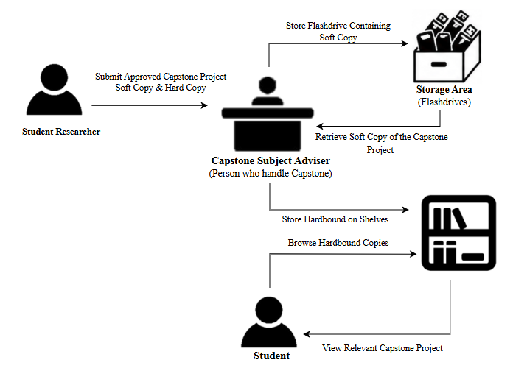
As shown in Image 1B, the proponents also interviewed a student to understand how previously approved capstone projects are accessed. The respondent explained that when they need a related capstone study, they visit the department hub where hardbound copies of approved capstone manuscripts are stored on shelves. They manually search the existing manuscripts studies relevant to their study. That is a time-consuming procedure, especially since the number of approved capstone projects keeps growing. This means that the manual retrieval process creates the difficulty for researchers to quickly find relevant studies based on a specific topic, title or research area.

Figure 2. Current Technical Situation
Figure 2, illustrate the current capstone management method within J.H. Cerilles State College. After approval of a capstone project, the researcher provides the full manuscript on a flash drive and a hardbound copy to the Capstone Subject Adviser. The flash drive is kept in a storage area, and the hardbound copy is on the department bookshelves for future use. Student can locate existing studies by manually looking at the hardbound copies on the shelves of the department. If a soft copy of a study needs to be retrieved, the capstone adviser will manually look through the stored flash drives and get the required manuscript. However, this manual process has made the preservation and retrieval process of capstone studies time-consuming and highly reliant on physical records.
Design Phase
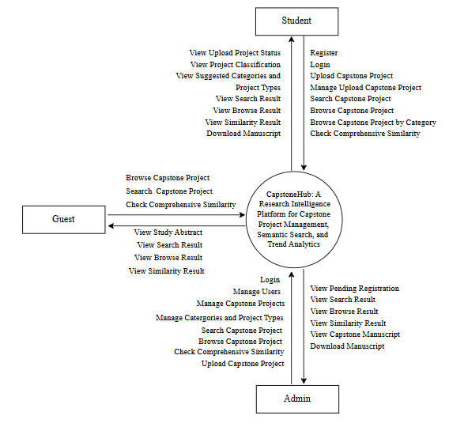
This is the second phase of the 4D Model. In this phase the structure and general concept of the proposed CapstoneHub system is presented. It is composed of diagrams and descriptions of the whole features and functions of the system.

Figure 3. Context Diagram
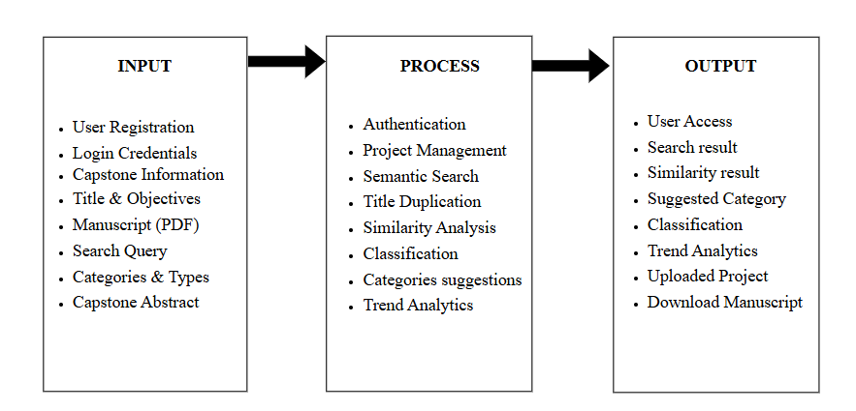
The context diagram shown in Figure 3 illustrates the interactions between the Guest, Student, Administrator, and the CapstoneHub system. The Guest interacts with the system by searching capstone projects and checking comprehensive similarity. The system allows the Guest to view search results and similarity results. The student can register, log in, upload capstone projects, and search capstone projects and check comprehensive similarity. The system allows the student to view upload project status, project classification, suggested categories and project types. The Administrator can log in, upload capstone projects, manage users, manage capstone projects, and manage categories and project types. The system allows the Administrator to review and approve or reject capstone projects, search capstone projects, and view capstone manuscripts.

Figure 4. Conceptual Framework- IPO Diagram
Figure 4 presents the conceptual framework of the proposed CapstoneHub with the Input-Process-Output (IPO) model. The system receives the user and capstone project information as input. These inputs are analyzed using authentication, project management, semantic search, similarity detection, and classification. The system then produces outputs like search results, similarity results, project classification, suggested categories, trend analytics and downloadable capstone manuscripts.
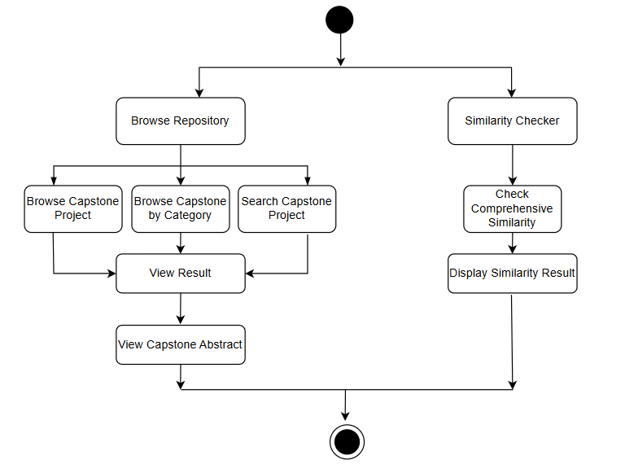
Figure 5. Activity Diagram (Guest)
Figure 5 shows the activity diagram for the Guest user. This process begins when the guest reaches the system and chooses either to browse the repository or to use the similarity checker. The guest can browse approved capstone projects, browse by category, or search for a specific capstone project in the repository module. The selected option shows the respective results, and the guest can see the abstract of a related capstone project. Otherwise, the guest can use the similarity checker by checking comprehensive similarity. The system then processes the input and presents the similarity results. The process ends once any of these activities are finished.

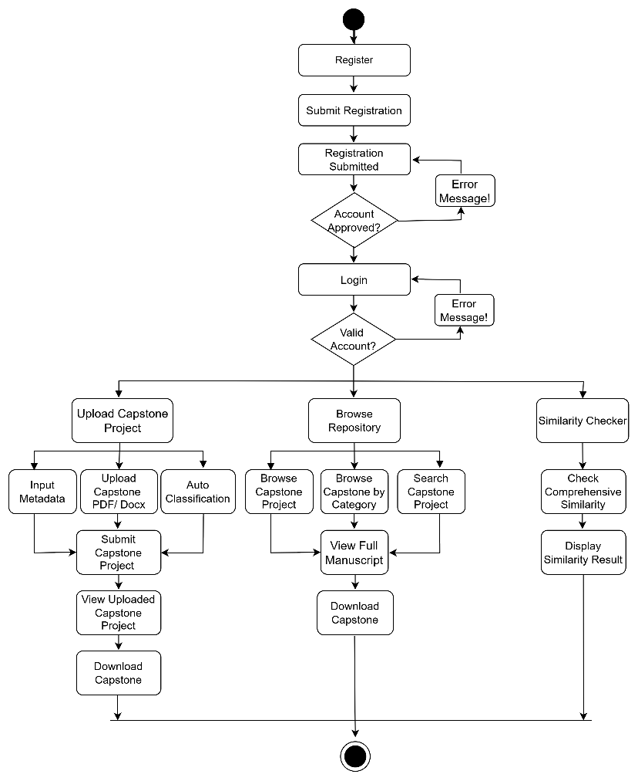
Figure 6. Activity Diagram (Student)
Figure 6 shows a student user in the CapstoneHub system. The process begins with the account registration and approval from the administrator before the student can log in. The student, after authenticating himself, is allowed to upload a capstone project by providing the required metadata, upload the manuscript, and submit to the system. The student can also browse the repository by browsing all capstone projects, browsing by category, or searching for a specific project and then view and download the selected manuscript. In addition, the student can also check the comprehensive similarity of a proposed capstone project through the Similarity Checker. The similarity results will then be displayed by the system.

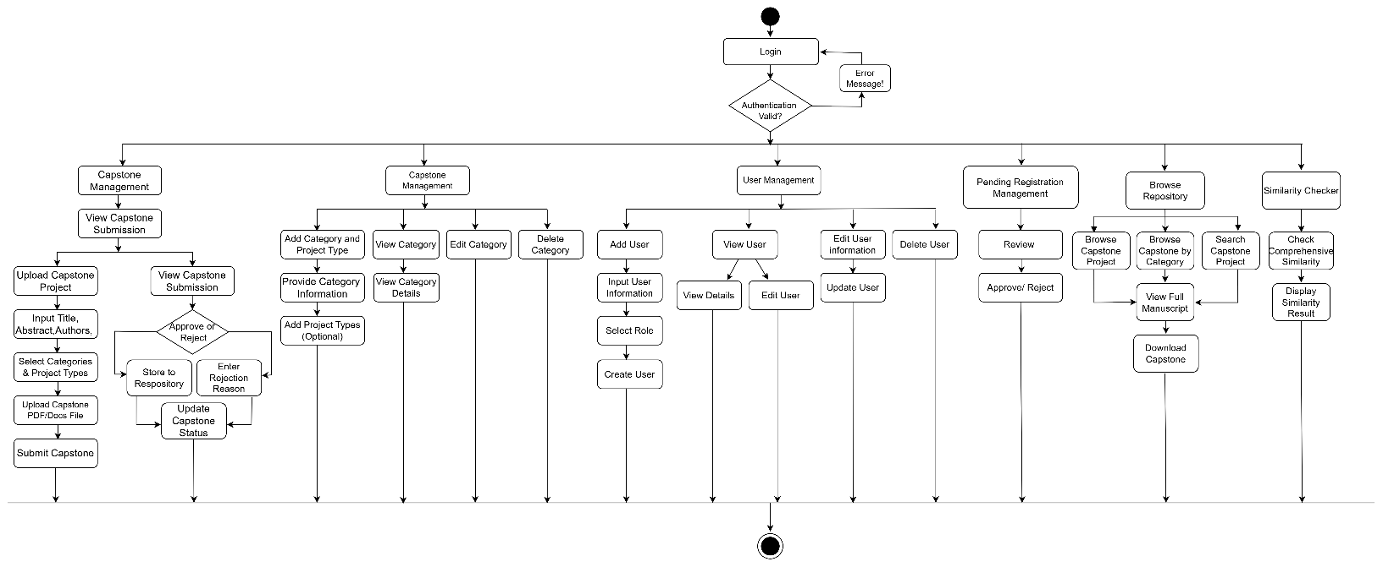
Figure 7. Activity Diagram (Admin)
The Activity Diagram for the Administrator illustrates the flow of activities that the administrator carries out to manage the CapstoneHub system. The process starts with Login, where the system checks the credentials of the administrator and provides access to the available modules. After login, the administrator is capable of performing the Capstone Management that contains uploading of capstone projects, editing project information, assigning category and project type, uploading manuscript files, review submitted projects, approve or reject the submission, update its status in the repository. The administrator has the ability to add, view, edit, and delete categories and to add project types and to manage Categories and Project Types. Administrator can create, view, edit, update and delete user accounts in the User Management. The administrator uses the Pending Registration Management module to check the student registration requests and approve/reject application after verification. Furthermore, the administrator is able to browse the repository to look for capstone projects by title or category, to view and download approved manuscripts, and to utilize the Similarity Checker to check comprehensive similarity and show the corresponding results. These activities allow the administrator to administer the users, capstone projects, contents of repositories and similarity checking in the CapstoneHub system.

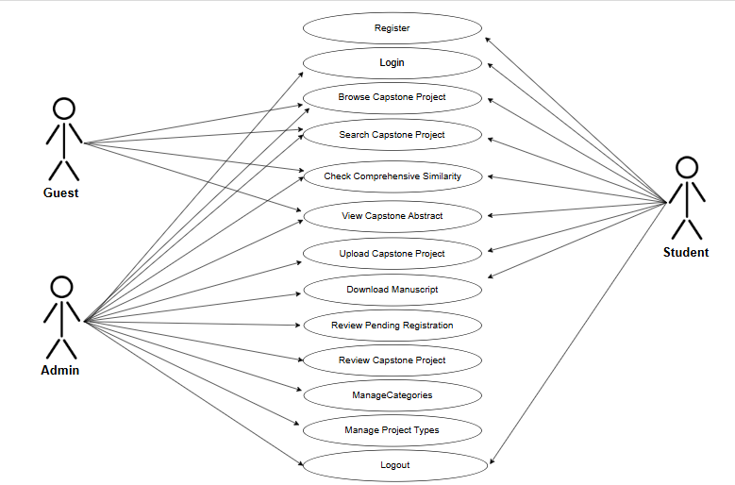
Figure 8. Use Case Diagram
The Use Case Diagram shows the main interactions between the three user roles (Guest, Student, and Admin) and the CapstoneHub system. Guests can browse and search capstone projects, view titles, objectives, and comprehensive similarity, and see capstone abstracts without an account. A Guest has all the capabilities of a User and can additionally register, login, upload capstone projects, download manuscripts, and logout. Admin has the responsibility to manage the system by reviewing the pending student registrations, reviewing the uploaded capstone projects, managing the categories and project types, and access to the repository functions such as browsing, searching, similarity checking, viewing the abstracts and downloading the manuscripts. The diagram depicts the functional requirements of CapstoneHub by showing how each user role can interact with the system based on their permissions and responsibilities.
Name | Register Student Account
Description | The student registers for a CapstoneHub account.
Actor
  Student
Preconditions | Registration page is available.
Postconditions | Registration request is submitted for admin approval.
Main Course | 1. Open Registration Page.  2. Enter personal information.  3. Upload Front and Back Student ID.  4. Click Register.  5. System saves the registration as Pending.
Alternate Course | Invalid or incomplete information.  1. Display error message.  2. Return to registration form.

Table 1. Use Case Description- Register Student Account
Name | Approve Student Registration
Description | The admin reviews and approves or rejects a student's registration request.
Actor
  Admin
Preconditions
  Student registration request exists.
Postconditions | Student account is approved or rejected.
Main Course | 1. Open Pending Registrations.  2. Review student information and uploaded ID.  3. Approve registration.
Alternate Course | Registration information is invalid.  1. Reject registration.  2. Record rejection reason.
Table 2. Use Case Description- Approve Student Registration
Name | Check Similarity
Description | The user checks the similarity of a proposed capstone project title and objectives against existing capstone projects in the repository.
Actor | Guest, Student, and Administrator
Preconditions
  The user is on the Similarity Checker page and has entered the proposed title and objectives.
Postconditions | The system displays the similarity result and the list of related capstone projects, if any.
Main Course | 1. Open the Similarity Checker page.  2. Enter the proposed capstone project title.  3. Enter the project objectives.  4. Click the Check Similarity button.  5. The system compares the entered title and objectives with the repository.  6. The system displays the similarity percentage and matching capstone projects.
Alternate Course | No similar capstone projects are found.  1. The system displays a message indicating that no similar capstone projects were found.

Table 3. Use Case Description- Check Similarity

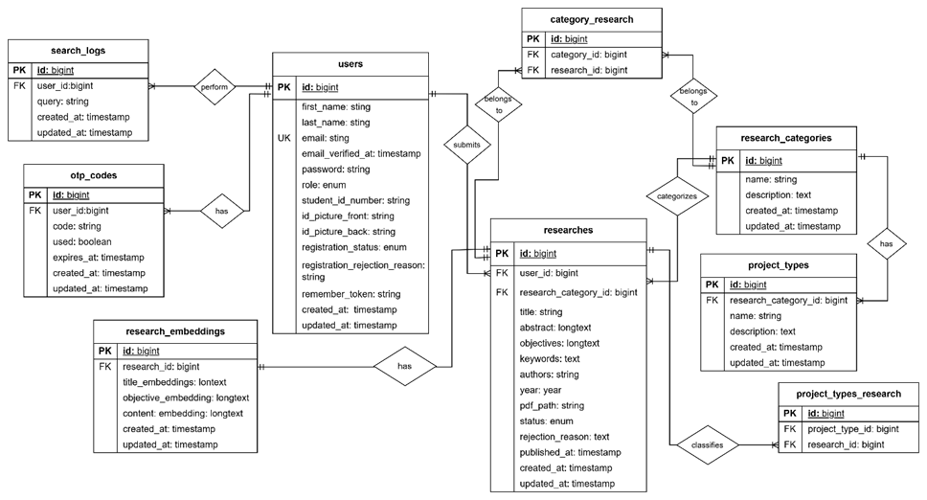
Figure 9. Entity Relationship Diagram
The relationships between the main entities of the CapstoneHub system are shown in Figure 9. The users entity is associated with the researches, search_logs and otp_codes entities. This allows users to submit capstone projects, perform search activities and get OTP records to verify their account. The research_embeddings entity is associated with the researches entity to give an embedding record for each capstone project used for semantic search and similarity detection. It is also related to the entities research_categories and project_types through the tables category_research and project_types_research, allowing capstone projects to be classified into multiple categories and project types. Also, the entity research_categories is connected to the entity project_types so that each category can have different project types. These relationships allow the CapstoneHub repository to efficiently organize, classify, retrieve and manage approved capstone projects.
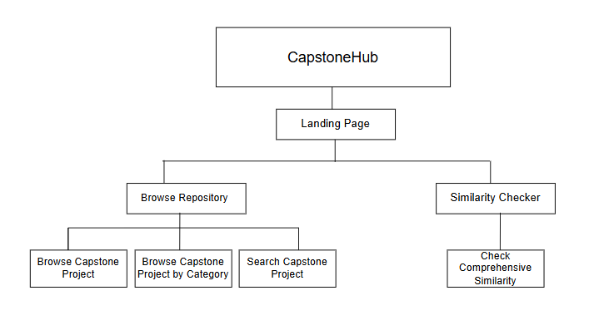
Figure 10. Structural Diagram (Guest)
The structural hierarchy of the CapstoneHub system is shown in Figure 10, which represent the major modules and their sub-functions. The system starts with the Landing Page which is the entry point for the users. The landing page provides access to two main modules, Browse Repository and Similarity Checker. Browse Repository module allows users to browse capstone projects, browse projects by category and find specific capstone projects. Meanwhile, the Similarity Checker module allows users to check comprehensive similarity to find related or potentially duplicated capstone projects. The overall structural diagram gives a good overview on how main functionalities of CapstoneHub are organized and related to each other in the system.
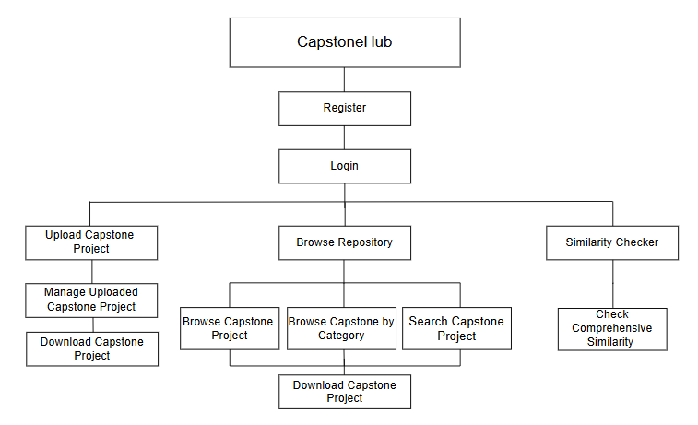
Figure 11. Structural Diagram (Student)
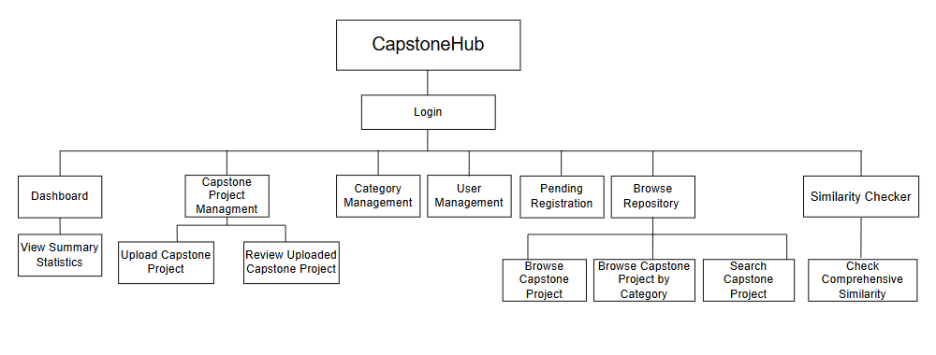
The Structural Diagram for the Student User is shown in Figure 9 which describes the modules available to the registered students in the CapstoneHub system. The student begins by registering and logging into the system. After successful login student will get access to Dashboard which displays system statistics. The student can also submit a capstone project and view the status of its upload using the Upload Capstone Project module. In the Search Capstone Project module, students can browse search results, view the full manuscript of approved capstone projects, and download manuscripts for reference purposes. In addition, the Check Similarity module allows the student to check the comprehensive similarity and view the similarity results accordingly. These modules provide students with the functions needed to submit, search, retrieve, and evaluate capstone projects within the CapstoneHub system.

Figure 12. Structural Diagram (Admin)
Figure 12 shows the structural diagram of the Admin module in the CapstoneHub System. Upon login, the administrator can access the major functional modules of the system. The modules include Dashboard, Capstone Project Management, Category Management, User Management, Pending Registration, Browse Repository, and Similarity Checker. The Dashboard provides aggregate statistics of the repository, and the Capstone Project Management module allows the administrator to upload and review capstone projects. The administrator can also manage categories and user accounts, review pending student registrations, browse and search capstone projects, and perform similarity checking for title, objective, and comprehensive similarity. The diagram in general demonstrates the hierarchy of the administrator’s functions, which makes it possible to distinguish the capabilities of the system regarding the management of the repository, users, and similarity detection.
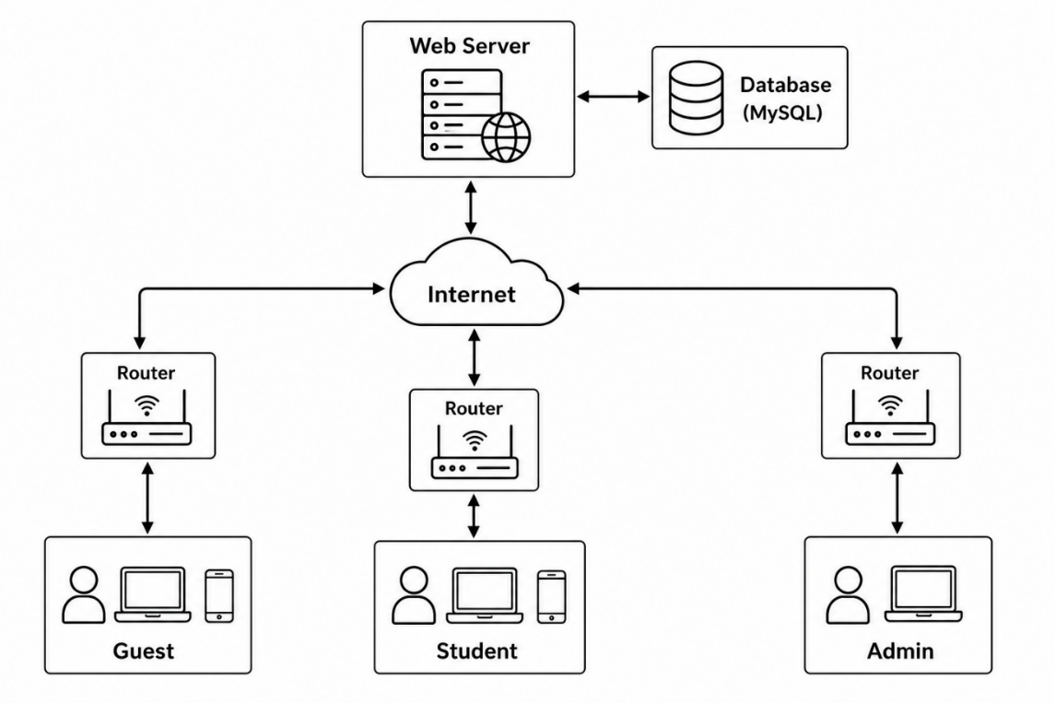
Figure 13. System Architecture
Figure 11 shows the system architecture of the CapstoneHub platform. The system architecture is based on the Internet, where the Guest, Student, and Admin users interact with the platform. Each user connects to the system through a computer, a laptop or a mobile device connected to a router which forwards requests to the Web Server via the Internet. The Web Server provides the platform for the CapstoneHub application, and connects to the MySQL Database, which is used to store, retrieve, and manage user accounts, records of capstone projects, categories, search logs, and data related to similarity. The Guest can browse the repository and perform similarity checking without login while the Student can register, upload approved capstone projects, browse and download manuscripts and use the similarity checker. The Admin is responsible for managing users, reviewing uploaded capstone projects and student registrations, organizing data repositories and maintaining the overall system. This client-server

REFERENCES
Arruejo, R. C. (2020). eBirok: An Online Repository for Theses and Dissertations. International Journal of Emerging Trends in Engineering Research, 8(10), 7093–7098. https://doi.org/10.30534/ijeter/2020/738102020
Caseres, K. J. R., P. Cruz, R., T. Gonzales, L. A., Mary L. Tapayan, P. G., & Aribe Jr., S. (2025). Developing Digital Research Portal for Bukidnon State University’s Scholarly Work. SSRN Electronic Journal. https://doi.org/10.2139/ssrn.5389800
Dede Sunandar, & Adam Muiz. (2025). Thesis Title Similarity Detection System Using Levenshtein Distance and Cosine Similarity. Bit-Tech, 8(1), 1131–1139. https://doi.org/10.32877/bt.v8i1.2864
Ferrao, R. C., & Soares, L. P. (2026). Enhancing Capstone Program Workflow: A Case Study on a Platform for Managing Academic-Industry Projects (Version 1). arXiv. https://doi.org/10.48550/ARXIV.2602.20120
Hussan, B. K. (2020). Comparative Study of Semantic and Keyword Based Search Engines. Advances in Science, Technology and Engineering Systems Journal, 5(1), 106–111. https://doi.org/10.25046/aj050114
Javier, B. S., Paliuanan, L. P., Talamayan, C. T., Agpalza, J. K. A., & Agoto, J. S. (2022). Development and Evaluation of the Institutionally Farmed Research On-line Repository and Management System (InFORMs) towards Knowledge-Sharing and Utilization. arXiv. https://doi.org/10.48550/ARXIV.2211.05827
Lazarenko, N. I., Kolomiiets, A. M., Bilous, V. S., Zahorodnii, S. P., Gromov, I., Zhovnych, O. V., & Ivanichkina, N. P. (2022). Institutional Repositories as a Global Dissemination Tool of Educational And Scientific Information. Encounters in Theory and History of Education, 23, 241–258. https://doi.org/10.24908/encounters.v23i0.15230
Lubis, I., Lubis, H., & Nur Wahidah, I. (2026). Implementation of Semantic Search in an Academic Repository Using Sentence-BERT and FAISS. Sinkron, 10(2), 1060–1069. https://doi.org/10.33395/sinkron.v10i2.15940
Musa, M. H., Salam, S., Norasikin, M. A., Hall, W., & Rusdi, J. F. (2026). Advancing semantic search in higher education through the Heterogeneous Student Performance data retrieval model. Discover Education, 5(1). https://doi.org/10.1007/s44217-026-01580-0
Phuong, D. C. V., & Hai, P. V. (2026). Digital Transformation and Sustainability in Higher Education Management: A Bibliometric Study. International Journal of Scientific Research and Management (IJSRM), 14(03), 10616–10622. https://doi.org/10.18535/ijsrm/v14i03.em14
Picardal Jr, E. B. (2026). Research Productivity trends in Philippine Higher Education Institutions: a Bibliometric and Institutional Analysis [Dataset]. Mendeley Data. https://doi.org/10.17632/9CGBFGM6PX.1
Rangkuti, M. Y., Ilhamsyah, H. R., Mutaqin, R. Z., & Khoirullah, M. L. (2026). Analisis penerapan arsitektur model–view–controller (MVC) pada pengembangan aplikasi web berbasis Laravel. Kohesi: Jurnal Sains dan Teknologi, 10(8), 261–270. https://cibinstitute.id/index.php/kohesi/article/view/5546
Tindoc Jr., F., Torres, R., Corpuz, K. A., Salem, J., & Paliuanan, L. (2023). Design and Development of the ASSET: A Web-Based Research Archiving System. Cagayan State University. https://doi.org/10.5281/ZENODO.20724570
Xu, H., Winnink, J., Yue, Z., Zhang, H., & Pang, H. (2021). Multidimensional Scientometric indicators for the detection of emerging research topics. Technological Forecasting and Social Change, 163, 120490. https://doi.org/10.1016/j.techfore.2020.120490
Yin, C., & Zhang, Z. (2024). A Study of Sentence Similarity Based on the All-minilm-l6-v2 Model With “Same Semantics, Different Structure” After Fine Tuning. In Advances in Computer Science Research (pp. 677–684). Atlantis Press International BV. https://doi.org/10.2991/978-94-6463-540-9_69

