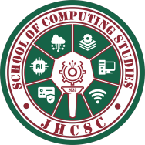

J.H. CERILLES STATE COLLEGE
School of Computing Studies
Bachelor of Science in Information Technology
Main Campus, Mati, San Miguel, Zamboanga del Sur

JHCSC Library Borrowing System ________________________________________________________

Final Requirements
in
IT-311

System Integration and Architecture 2

Submitted by:
Pahayahay, Juvelyn G. – 3A
Student

Submitted to:
Rea Jane Prumon
Instructor

2026
Chapter I
THE PROBLEM AND ITS SCOPE
  - Introduction
Information systems are now important resources in increasing accuracy and efficiency in workplaces, businesses and institutions. They enable process automation, reduce human error, and improve resource management. Libraries are crucial for education because they are the primary source of information for teachers and pupils alike. A properly managed library system provides accessible, well-organized and appropriately monitored academic resources, which contribute greatly to the educational process and promote institutional development.
The agency selected for this project is JHCSC Main Campus Library, Mati, San Miguel, Zamboanga del Sur. The library still uses traditional ways in monitoring book borrowing and returning through printed utilization logbook. The borrower’s details such as name, major and year, time, purpose, book title, accession number, contact number and signature are to be filled manually in this logbook. This process has been in practice for years and has its own set of common problems such as wrong entries, delay in recording, and a chance of records getting lost. With the increasing number of students and faculty visiting the library on a daily basis, these problems have negative impact on the efficiency, accuracy and quality of library services.
To address these problems, I intend to develop the JHCSC Library Borrowing System as a separate project. Before setting up this system I requested permission to do a preliminary assessment of how the library is working and spoke with staff members about the difficulties that they face today. The information needed for the system is the student ID number, course, book title, call number and transaction date and time from the first interview that was held with the library staff. The needs are integrated in the system in order to have a more complete and organized view on the usage of books. It will also improve accuracy in record keeping, speed up transactions and improve the efficiency of library services for the benefit of both faculty and students.

  - Purpose and Description
The purpose of this study is to make the borrowing and returning of books in the JHCSC Main Campus Library more convenient through the development of the Library Borrowing System, where instead of writing in a logbook, the student will provide their details such as Course, Title of the Book, Date and Time of transaction, Call No. or Serial Number of the book, and Student Identification Number directly into the system to confirm and record their borrowing or returning activity. The system will record all transactions done by the users and will update the status of the books, track the overdue borrowings and will give an option to generate and print organized reports. This will make the whole process more systematic, efficient on the side of the administrator where only the library staff are allowed to access.
Objectives
This proposed system aims to:
- Develop a web-based borrowing system that would improve the accuracy and efficiency of book borrowing and returning transactions..
- To develop a computer based system for secure storage of borrower and book information with easy to use and user friendly interface for students and librarians.
- Implement a reporting feature to track book status and build accurate reports to test the implemented system.
  - Scope and Limitations
The system is used for the management and monitoring of the borrowing and returning of books and resources in the school library. It makes it simple for students to borrow and return items, and it gives librarians efficient tools to record transactions, keep track of due dates and generate reports. It guarantees accuracy, minimizes manual effort and also maintains records in a centralized database for easy access and retrieval.

However, this system can only be used by the students registered in JHCSC Main Campus. The system does not cover inter-campus loans or any transactions outside the campus. Moreover, the system is only meant for loaning and returning library books and not for anything else found within the school’s premises.

  - Definition of Terms
In order to provide clarity and understanding of these terms in the context of this research, their definitions are provided below:
JHCSC Library Borrowing System - The main (official) system of Josefina H. Cerilles
State College library that has been designed in order to automate book borrowing and returning process in order to substitute the old manual logbook system. The librarian can use the system to document borrowing and returning of books, check due dates, notify borrowers via SMS and make reports.
Librarian – The person in charge of maintenance of the system and registration of
borrowing transactions. The librarian enters information about the borrower, manages issued books, lends and returns books.
Module – It is one particular component or unit of the system that includes Book
Management, User Management, Borrowing/Returning of Books, and Reporting among others. The task performed by each of the modules has been specifically assigned.
Reporting feature – It is the feature in the system which makes possible the ability to
create summaries and report generation (list of borrowed books, overdue list and
activities of users) by the librarian for decision making and records.
SMS Notification – It is the notification in the form of text message sent by the system
to the contact number of the borrower, informing about his/her due date and reminder of the same along with information regarding overdue books.
Student/Faculty - It is any student or faculty who has access to the library resources.
The student/faculty first accesses the OPAC (Online Public Access Catalog) for
availability of book and then searches for the same from the shelves and takes it
to the librarian counter for borrowing. The due dates and overdue information
is communicated to them through SMS.
System Testing – It is the procedure by which the entire system is evaluated to confirm
whether it meets the desired criteria or not.

Chapter II
REVIEW OF RELATED STUDIES AND SYSTEM
This chapter presents the theoretical background of this study. The researcher believed that the works of the authors have direct bearing to this investigation.
2.1 Foreign
Mining and Analyzing Patron's Book-Loan Data and University Data to Understand Library Use Patterns
The research by Silwattananusarn and Kulkanjanapiban (2020) involves the application of data mining and clustering methods in analyzing book loan information from universities. Through the investigation of borrowing trends, the researchers uncover library usage trends among students and offer solutions to improve services offered in libraries. The results highlight the importance of electronic borrowing for maintaining accurate records that can later be used to improve services.
The research is closely related to the proposed system, demonstrating how electronic borrowing records can not only contribute to more efficient transactions but also help in improving library operations in the future.
Strategies and Practices to Enhance the Efficiency of Borrowing and Returning Books in College Libraries
According to Mengping (2023), there are ways to overcome the inefficiency in the traditional lending and returning processes by making improvements to these processes and using the technology of information. In this study, different strategies including the use of digital records and automation are discussed to help overcome delays and make the operations in the college library more efficient.
The research contributes to the proposed system since it highlights how technology can be used to overcome the inconvenience of manual processes and makes the lending process more organized.

California Institute of Technology (Caltech) – Digital Borrowing System (DIBS)
The Digital Borrowing System (DIBS) is described in the introduction provided by the California Institute of Technology (2021). This system is developed in order to allow users of the library to make reservations, borrow materials, and manage them via the Internet. It is another example showing the transition of university libraries from traditional systems to digital ones.
The relationship between this case study and the suggested system is that it shows how a digital borrowing system can be used in reality.
2.2 Local
Padilla (2022). Assessment of Library Users' Problems on Transactional Procedures: Basis for Library Management System Development
According to Padilla (2022), there have been various challenges that have been associated with users of the libraries ranging from students, teachers, and other workers in connection with manual borrowing and lending and searching process. The study revealed inefficiencies in manual processes that are related to longer waiting time, inaccuracies in record-keeping as well as the challenge in monitoring the borrowed items. Not only did it reduce the productivity of the students, but it also increased the burden on librarians. As a result, the study called for the creation of a library management system that will automate some of the processes involved.
The above research is very close to the proposed system since it shows the weaknesses in manual processes and the need for automation.
Asid (2020). Library Automation System of Academic Libraries: A Multicultural Paradigm
In Asid’s research (2020), the researcher examined the level of automation in academic libraries of Zamboanga City and further assessed whether such libraries can function in a multicultural environment. Based on the results of the study, one can say that while there were some automation aspects concerning administration, staffing, facilities, and services in libraries, the level of automation was not high enough to completely meet the needs of users. Moreover, Asid highlighted some obstacles to full automation: poor funding, lack of professional development of librarians, and technological problems. Thus, the adoption of more efficient automation systems is required.
The research contributes to the proposed automation system as it provides the evidence that libraries in the Philippines need more efficient automation systems, which will allow creating an innovative lending system.
Wei et al. (2022). Analysis of Students' Borrowing Behavior in Local University Library Using Data Mining Technique.
Wei et al. (2022) have studied borrowing behaviors using K-Means clustering by collecting borrowing information from students at the university level in the Philippines. Some of the identified behaviors include increased borrowing tendency around exam periods, specific subject interest, and borrowing tendencies based on various fields of study. This study was used to evaluate the ways in which students utilize library facilities in order to make future improvements in the library services to be more aligned to the users' needs. It was concluded that data analytics techniques like data mining can help libraries improve the process of book acquisition and services design.
This study is relevant to the proposed system as it shows how borrowing behavior can be analyzed for decision making.

Chapter III
DESIGN AND METHODOLOGY
This chapter describes the procedure followed in order to come up with the JHCSC Library Borrowing System, aimed at automating the library processes for borrowing, return, and monitoring the borrowed books from the J.H. library. Cerilles State College Library (JHCSC) is the study subject in this project. The 4D Model is the project management approach used to develop the library system. The 4D Model gives a methodical and iterative approach to ensure that all phases of the project’s development are based on user requirements, objectives, and quality assurance testing.

  - 4D Model
The 4D Model is the framework in which this study will be undertaken (Maylor, 2010). The four iterative phases of the 4D Model include: Define, Design, Develop, and Deploy. These phases ensure that the system is developed in an organized manner, taking into account the technical feasibility and the user needs. These phases have been illustrated in Figure 1.0 below.
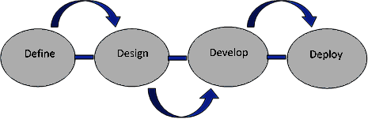

Figure 1.0 4D Model

Define Phase
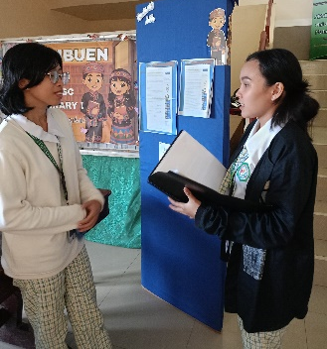
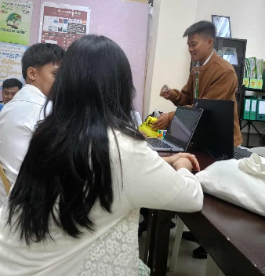
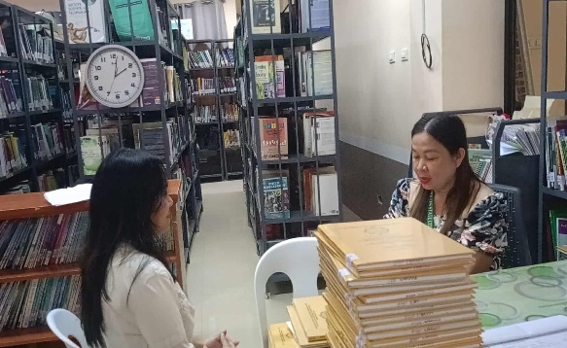

This phase is all about understanding the current problems, key users, and system requirements of the JHCSC Library. It was observed through initial interviews and observation that the manual process of borrowing and lending the books leads to misplaced records, lengthy searches, and inaccurate monitoring of overdue books. In order to tackle these issues, various data gathering techniques such as interviews, questionnaire and observation were used with the help of administrators, librarians, and users of the library. As a result of which, the main requirements of the system have been identified which include digital record management, tracking of borrowed books automatically, and reporting. SRS (Software Requirements Specification) document is the output of this phase, where all the functional and non-functional requirements of the system are defined. This phase helps us understand the problem and gives us a foundation for next phases.
This phase is important for the proposed system since it will give us an insight of actual library processes and actual requirements of administrators as well as users.
Design Phase
The design phase entails developing a design of the system and its diagrams. During the design phase, the researchers develop the architecture, database and user interface. The system will utilize a web-based system with an admin panel and a client panel where the administrator manages the database of books, the transaction process and generating reports while the client searches for books, borrows and returns books. The database will include the users, books, transactions and overdue reports for effective data management and retrieval. Data flow diagram (DFD) and entity relation diagram (ERD) are generated in order to show the flow of data in the system. Web interface prototypes are also developed during this phase.
The design phase is relevant to the system since the identified requirements in the define phase are turned into design during this phase.
Develop Phase
In the Develop stage, it involves the actual construction of the system based on the designs developed in the previous stage. The researchers used HTML, CSS, JavaScript, PHP, and MySQL languages to program each module, which includes user management, books, borrowing and returning process, and reporting modules through an incremental development approach. Each part is designed, tested, and debugged to ensure that the design is accurate and efficient. Development software like XAMPP was used in simulating the server and connecting it with the database while debugging was done to reduce the number of errors. Each module was tested individually and together for proper functioning.
It is compatible with the proposed system since it involves constructing the system using the designs planned by the researchers.
Deploy Phase
Deploy Phase mainly focuses on the implementation, testing, and evaluation of the system in the real-world setting of the library. After the development of the whole prototype of the system, the integration testing and user acceptance testing (UAT) was done to make sure that all the modules work together efficiently and to receive feedback from the librarians and the students respectively. After this phase, the system was installed on the local area network (LAN) of the college allowing the system to be operated in real-time by the administrator. Trainings were conducted for the library personnel to familiarize them with the system operations which include record management and report generation. Feedback received from the pilots allowed identifying the areas that need improvement before implementation.
This phase is relevant to the proposed system since it guarantees that the product will be functional and efficient.
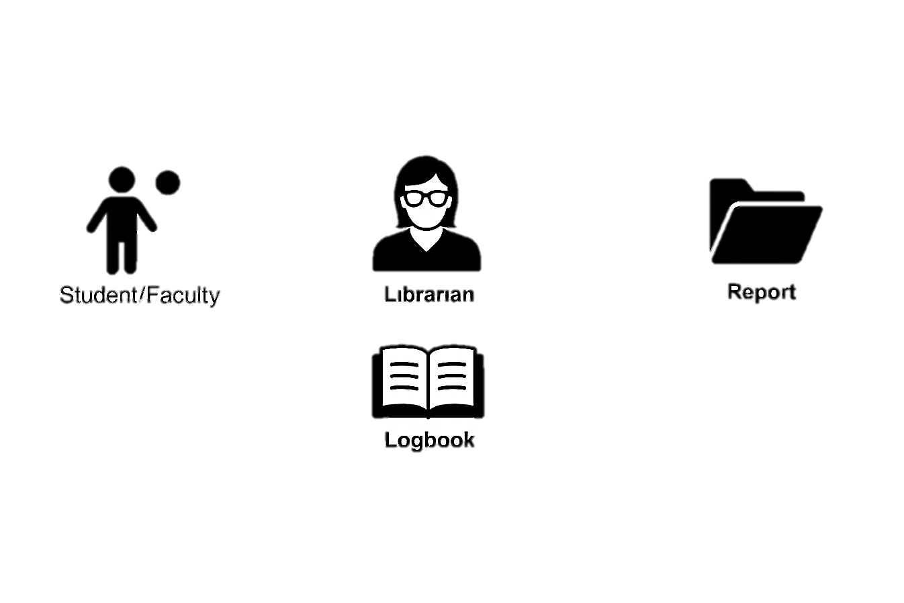
  - Current System Flow
Request to borrow book and returning book
The Librarian uses the recorded logbook data to prepare the Report.
Fill out the Logbook with their name, date, purpose, and book details.

Figure 2.0 Current System Flow
The flow chart above shows the current library book borrowing system at JHCSC that still operates in a totally manual way. In the event where a student or a teacher wants to borrow a book from the library, they have to go straight to the librarian and write down all their information in the logbook that includes their name, course and reason for borrowing and the title of the book. After doing this, the librarian will check and ensure the information given is correct, will check whether the book is available and keep the record of all the transaction in the logbook. The transactions are recorded in one logbook which is the main book used for recording. Reports will be produced manually by the librarian using the entries made in the log book. This process is very time consuming and difficult because of human errors. It makes it difficult to monitor overdue book records and to retrieve them. Hence, this shows why there is need for computerization of the library book borrowing system.

Context Diagram
JHCSC Library Borrowing System
Librarian
Has the access to all levels in the system. Enters data, processes transactions
Faculty/Student
Provides personal information, request to borrow books
Displays informations and generate reports
Assists with borrowing/returning
SMS GATEWAY
(SMS API)
Sends SMS reminders to the borrower (Due Date)

Figure 3.0 Context Diagram
Context Diagram for JHCSC Library Borrowing System Figure 3.0 shows the context diagram of the JHCSC Library Borrowing System and represents the broad outline of the system boundaries and interactions in an attempt to show the system in its entirety as one main process without detailing any internal processes. Central to the diagram is the central circle that bears the name "JHCSC Library Borrowing System" representing the automated web based solution to managing the borrowing and returning of books. Surrounding the central circle are two main external processes presented using rectangles on the left and right sides respectively. On the left side is the Librarian who enjoys complete access to the system and interacts with the system via the bidirectional arrows to exchange full data flow such as inventory updating, transaction processing, overdue checking, and reporting to make the administration easy without using logbooks. On the other hand, the Faculty/Student interacts via the bidirectional arrows for user-oriented processes, such as logging into the system by choosing his/her role, searching for and viewing the available books, making borrowing request with details of course, student ID, book title, call number and time stamp, and confirming return of or due date of the book. The diagram uses monochrome colors and basic shapes with arrows to show data flows, considers the web interface for all processes and confines itself to intra campus borrowings among registered JHCSC users.

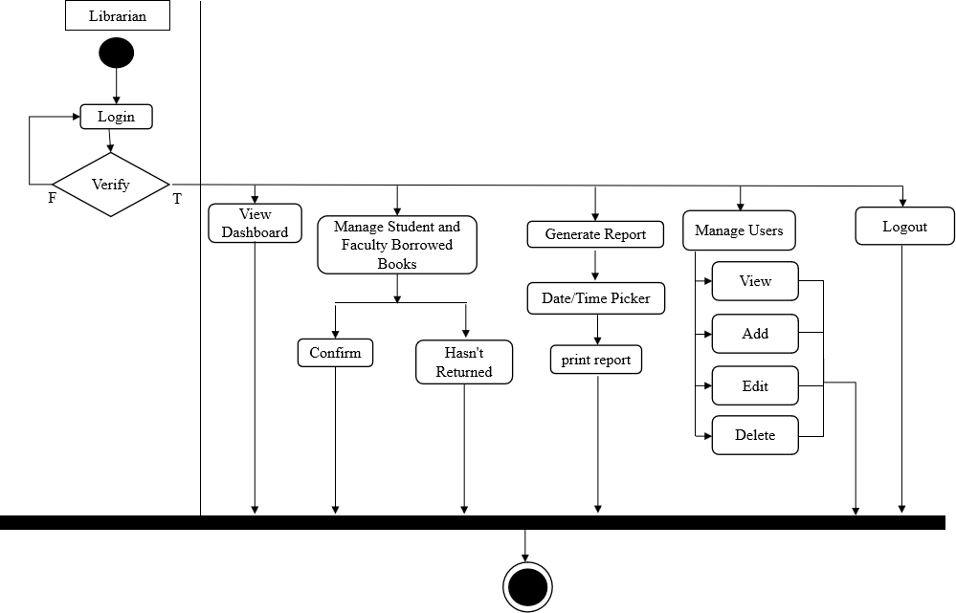
Activity Diagram

Figure 4.0 Activity Diagram (Librarian)
Activity diagram of the Librarian, shown in figure 4.0, shows how the workflow is administered using UML components like rounded rectangles to show the activities, diamond-shaped structures to depict the decision making points, and arrows to show the sequence of events. The process begins with logging into the administrative interface and progresses through various tasks that include inventory checking of books through adding, editing and marking books as available. Decision making points involve handling of incoming borrowing requests whereby the Librarian checks user eligibility, approves or denies transactions and makes the database update. Parallel points of the workflow involve handling of overdue books through automation alerts, user notifications through system emails and imposition of fines. The process ends with reporting on usage trends before the log out is done. The workflow above highlights how the Librarian ensures the integrity of data and engages in pro-active management utilizing MySQL to retrieve data quickly and error checking of inputs that helps in developing phases of the 4D model.

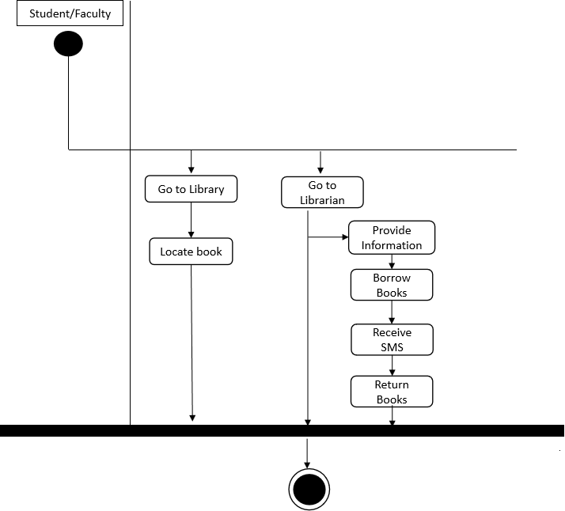

Figure 4.1 Activity Diagram (Student/Faculty)
The activity diagram of the Student/Faculty role highlights the simplicity of the process where the user moves to the library, discusses with the librarian and gives personal details. Afterward, the student/faculty then asks for borrowing or returning books and the librarian carries out the process through the system. Upon borrowing, an SMS message is sent to the borrower from the system with the date that the borrowed item should be returned. The process ends after returning the book with an optional SMS reminder and late notice where necessary. This will ensure that there will be no need for login accounts of students/faculties.

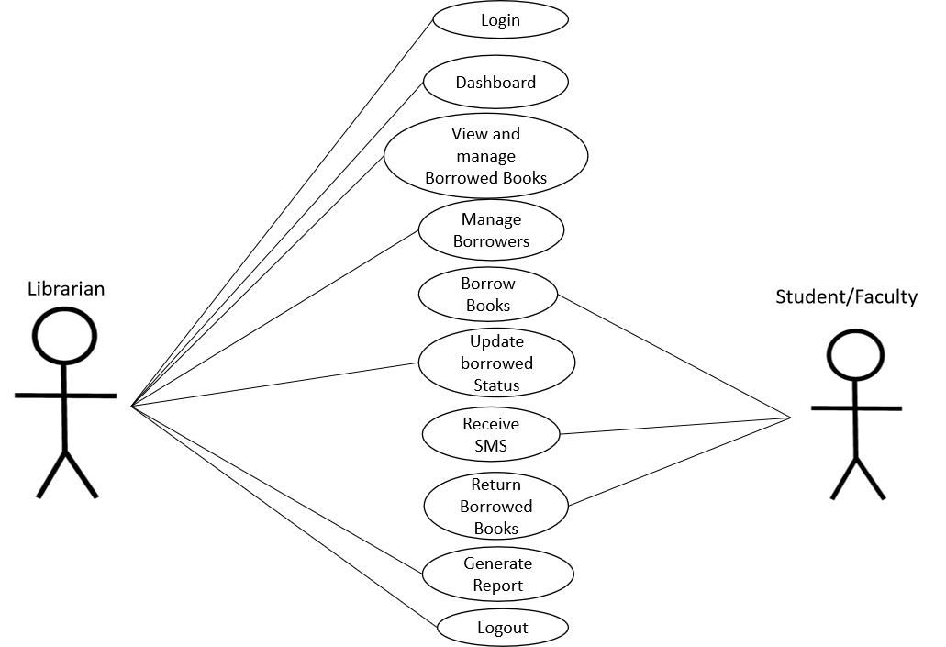
  - Use Case Diagram

Figure 5.0 Use Case Diagram
The use case diagram illustrated above follows UML standards and consists of two stick-figure actors represented by Librarian on the left side of the diagram and Student/Faculty on the right side. The use case diagram clearly illustrates the boundary of the JHCSC Library Borrowing System where it is evident that the Librarian is the only person who interacts with the system. The actor (Librarian) is connected to the oval-shaped use cases inside the system boundary in lines which represent the functional requirements including: Login, Dashboard, View and Manage Borrowed Books, Manage Borrowers, Borrow Books, Update Borrowed Status, Return Borrowed Books, Generate Report and Logout. Student/Faculty is positioned outside the system boundary where he/she is connected to a single use case Receive SMS which indicates that the students/faculty members neither log into the system nor generate any other use case except receiving an SMS message when needed. The system automatically generates an SMS when a book is borrowed in order to notify the borrower of the due date of the book. The system also generates a reminder SMS one day before the due date of the borrowed book to remind the borrower of returning the book on the next day during library hours. In case if the due date has passed but the book has not been returned, the system generates an overdue SMS for the borrower. Once the Librarian updates the status of the borrowed book to returned, the process is completed and SMS is not generated further for the transaction. The use cases of Librarian actor consist of Login and Logout securely, View statistics of system on Dashboard, Monitor all ongoing borrowings, Add, Edit, View and Delete Borrower information, Process Borrowing and Returning of book, Update the status of books and Generate printed reports of borrowed books, Overdue items and Transaction history. Relationships of the diagram show the dependency of certain use cases like Update Borrowed Status is contained by Borrow Books and Return Borrowed Books while Receive SMS is an external output of Borrowing transaction, Due Date Reminder and Overdue transactions. This model provides no login account for students and faculty members, makes librarian-assisted services effective through Automated SMS communications, saves time from queuing, makes sure about the accuracy of record keeping and ensures privacy controls.

REFERENCES
Asid, B. A. (2020). Library Automation System of Academic Libraries: A Multicultural
Paradigm. Fihris: Jurnal Ilmu Perpustakaan Dan Informasi, 15(2), 236. https://doi.org/10.14421/fhrs.2020.152.236-262
California Institute of Technology Library. (2021). Digital Borrowing System (DIBS).
https://caltechlibrary.github.io/dibs/
Maylor, H. (2010). Project management (4th ed.). Financial Times Prentice Hall.
Mengping, C. (2023). Strategies and practices to enhance the efficiency of borrowing
and returning books in college libraries. Academic Journal of Humanities & Social Sciences, 6(22), 53–58. https://doi.org/10.25236/AJHSS.2023.062209
Padilla, R. C. (2022). Assessment of library users’ problems on transactional
procedures: Basis for library management system development. International Journal of Scientific and Management Research, 5(6), 10–17. https://doi.org/10.37502/IJSMR.2022.5602.
Silwattananusarn, T., & Kulkanjanapiban, P. (2020). Mining and analyzing patron's
book-loan data and university data to understand library use patterns. arXiv.
https://arxiv.org/abs/2008.03545
Wei, Y., Machica, I. K. D., Arroyo, J. C. T., Sabayle, M. L. P., & Delima, A. J. P.
(2022). Analysis of students’ borrowing behavior in local university library using data mining technique. International Journal of Emerging Technology and Advanced Engineering, 12(7), 68–77.
Zhang, W. (2021). Research on the service mode of the university library: Using data
mining on borrowing records. International Journal of Academic Library and
Information Science, 9(1), 11–20.

