

JH CERILLES STATE COLLEGE
SCHOOL OF ENGINEERING AND TECHNOLOGY
Bachelor of Science in Information Technology
Main Campus

iBOOK: GUIPOS VEHICLE BOOKING
_____________________________________________________________

Final Project in SIA 2

Estaño, Jerald A.
_______________________________________________

Chapter 1

THE PROBLEM AND ITS SCOPE

  - Introduction

Technology streamlines organization in daily life. Advanced information systems build on that by further developing the role of technology in transportation. The systems of the popular smartphone-based transportation services, Uber and Grab, offer excellent and reliable examples of how unorganized transportation services can sell a flexible solution to structuring and managing transportation services. Because of the services that these companies offer, local governments and transport groups have modern technology integrated into systems that make services more efficient and increase satisfaction. The services benefit the transportation system and stakeholders, drivers, and passengers immensely (Cramer & Krueger, 2016).

Payong-Payong and Bao-Bao, the small public vehicles of choice, dominate the transportation system in Poblacion Guipos, Zamboanga del Sur. These serve as the primary mode of transportation that connects the center of the barangays to the town proper. Currently there is a lack of centralized control in this transportation system. The lack of centralized control creates quality and other systemic problems. Examples are long waiting times to board a vehicle, very uneven distribution of available vehicles, and surprise fares; all while some areas remain underserviced. Due to the absence of a standardized fare, passengers are frequently overcharged, which further extends their dissatisfaction with the transportation system all while leaving the transportation system unreliable (Litman, 2020).

To address the issues outlined, this study focuses on creating iBook: Guipos Vehicle Booking. This mobile booking system intends to facilitate the booking system and improve the transport system for the community. This application provides a digital centralized system for users to book their rides. Users also have the option to book rides ahead of time and are offered the service to do so based on their current location. With a clear and consistent fare system, this application provides a service to achieve fair rates and decrease disputes. This system also encourages better distribution of service outside of the town center by assisting drivers understand passenger needs in different locations. With the outlined system features, the service strives to improve community transport service by making it better, more efficient, and dependable (Shaheen et al., 2018).

  - Purpose and Description

The purpose of the iBook: Guipos Vehicle Booking is to modernize the transport service in the community by establishing a system that ensures balance between the needs of passengers, Payong-Payong and Bao-Bao drivers. The system is intended to be a digital connection for individuals needing a ride to be matched with available drivers. iBook aims to solve the pain of waiting for rides and fare disputes, and aims to achieve coverage of the transport service for all locations, especially those that are farther away. The goal of this project is to improve the quality of life for everyone that lives in Poblacion Guipos Zamboanga del Sur, using simple technology, to facilitate this improvement.

This system will be a smartphone application that includes several important features. One core feature will be the Booking Function. This feature allows the user to set a ride request by entering a pick-up and drop-off location. This feature is important as it allows the user to request a vehicle rather than having to stand and wait uncertainly on the street. The second feature is GPS Tracking. This feature enables users to track a vehicle once a driver accepts the book request by showing an image of the vehicle that is in motion and is getting closer to the Booker's location in real time. This feature helps users with the uncertainty of not knowing when the driver will arrive or their current location.

Another feature of the application is Transparent and Fixed Fares. The application will compute and display the fare fix in advance of the booking request. Thus, the fare is set and will not be able to be changed by the driver. This helps to eliminate the confusion of what the fare will be and helps to eliminate arguments over what the fare should be. The final feature will be Driver Mode, which is a list of booking requests. This feature will show drivers all the booking requests and where users are located, allowing the driver to make the best decision for serving the request. The feature is important as it allows the application to be reliable and efficient.

  - Objectives

The goal of this research is to create, implement, and assess the iBook: Guipos Vehicle Booking System, a mobile application targeting passengers and drivers of Payong-Payong and Bao-Bao vehicles in Poblacion Guipos, Zamboanga del Sur, to provide an equitable and reliable transportation service.

This research specifically aims to:
- Design User Interfaces and System architecture of the iBook application, including, but not limited to, the Booking interface, Administrative interface, Driver interface and Passenger interface, along with the features of real time GPS Tracking and Fair Fare Calculation.
- Develop an Android app that has user sign in, has functionality to book a ride, has GPS, send push notifications to users, and has a separate Admin Dashboard.
- Conduct a Controlled User Testing to find and fix bugs for the purpose of stabilizing the application for the target users. Evaluate if the app is functional and easy to use.
- Analyze the application to determine if the described features meet the need of the end user to provide a reliable service, reduce the waiting time for passengers, provide a fair fare, and help allocate drivers in a more effective way.

Scope and Limitation

This research focuses on the design and development of the mobile application iBook: Guipos Vehicle Booking System, which aims to provide an organized booking service for Payong-Payong and Bao-Bao Vehicles in Poblacion Guipos, Zamboanga del Sur. The system facilitates ride booking, real time GPS tracking, and automatic fare calculation with a driver interface. The driver interface allows booking management along with basic user account operations and notifications. Admin Panel allows admin to monitor drivers and transactions.

Although booking applications have gained great prominence, they still lack many necessary features, and many of their components are still in their infancy. An example of this is the Pasay City booking application. Currently, it relies only on cash payments, has an unsecure authentication system, and has no features that enable automated dispatching. Drivers are left to accept bookings manually. The application is also limited to Android platforms, and the web and Apple versions of the application are non-existent. On top of that, the application is missing a host of important features like safety functions, a vehicle management system, among others.

Moreover, this research is also limited to dealing with the booking and fare transparency of the Payong-Payong and Bao-Bao transportation systems within the Poblacion Guipos area. For this particular study, no advanced features of booking applications or transportation systems will be assessed.
  - Definition of Terms
To provide clarity and to prevent any misinterpretations, below are the definitions of some terms as they relate to this study.:
iBook: Guipos Vehicle Booking – Refers to a mobile application designed to enable booking of the Payong-Payong and Bao-Bao vehicles in Poblacion Guipos, Zamboanga del Sur. This application is the main deliverable of this study, and provides users the capability to book a ride, track the ride, view an estimated fare, enter driver mode, and receive/send notifications.
Passenger User – Refers to a person that uses the application to book rides to a particular destination. As a passenger user, one can book rides, view fares, track the driver, and receive notifications pertaining to a booking request.
Driver User – Refers to registered Payong-Payong and Bao-Bao drivers. Driver mode enables viewing of booking requests, as well as the ability to accept passengers and access navigation to the various picker and drop-off locations.
Admin User – The person in charge of administering the system. The admin user is the one who signs up drivers, approves them, and monitors the bookings. The admin user also supervises the system’s functionality. The admin user can also deal with issues, change the pricing, and manage the users’ records.

Booking Function – This is the feature in the system that provides the ability to schedule a ride in advance. This function eliminates the need to wait on the roadside for traffic.
GPS Tracking – This refers to the use of GPS technology embedded in the application, which provides the ability for the passengers to see the location of the vehicle that has been booked.
Transparent Fare System – A system feature that calculates and displays the transportation charge for a trip automatically, eliminating the need for negotiation on the price for transport between the passengers and the drivers.
Driver Mode – Refers to the driver-side application interface. It shows available passengers and their booking requests and enables a selection of a booking request in order to increase the coverage of service delivery to both the central and remote locations.
Notification System – A system feature that notifies passengers on the status of their booking requests and predicts the time of arrival of their driver.

Chapter 2

REVIEW OF RELATED STUDIES AND SYSTEM

In this chapter a literature review will be conducted on transportation booking apps where literature and studies will be reviewed both internationally and locally. The rationale of the review is to provide a theoretical and practical basis for the development of the iBook: Guipos Vehicle Booking system. It will analyze the primary works and technologies related to transportation booking apps and their socio-economic implications, and will identify what this study hopes to accomplish.

2.1 Foreign Studies

Book-ahead ride-hailing trip and its determinants
Li et al. (2023) published "Book-ahead ride hailing trip and its determinants" in Transportation Research: Part A: Policy and Practice. This study analyzes the elements that affect a rider's decision to utilize the book-ahead option on a ride-hailing app. This includes the weather, trip factors, and transportation hub proximity. This study will help improve the understanding of users’ behavior to design booking systems that will allow advance booking, which is its core offering. It further justifies the need for a proper booking feature to serve passengers with varying needs and requests.

Does Online Ride-Hailing Service Improve the Efficiency of Taxi Drivers?
The title of the study is "Does Online Ride-Hailing Service Improve the Efficiency of Taxi Drivers?" (Ma et al., 2022) Sustainability (MDPI). This study was conducted at the Shanghai University (China). This study presents a comparison of taxi services in Shanghai by analyzing the trip-level data for taxi services. The purpose of this research is to study the impact of digital matching on the reduction of the idle time of taxi drivers and the optimization of trips. This study is related to iBook because it demonstrates factually that digital matching improves drivers' productivity and optimizes the operational efficiency of the digital platform, which is a significant factor in improving service for Payong-Payong and Bao-Bao drivers in Guipos.

Analyzing User Behavior in Choosing Ride-Hailing Services

A study by Raj et al. (2022) published in the journal Travel Behaviour and Society, sheds some light on how ride-hailing services work in Delhi. Basically, what they wanted to understand was how people decide between using ride-hailing apps versus other ways of getting around. It focused on cost, convenience and travel time. Since iBook targets a group of users this study can help that group in Poblacion Guipos and improve the app and services offered.

2.2 Local Studies

Impact of Digital Platform Economy and Ride-Hailing Services on Urban Mobility in Pampanga
An article by Galang et al (2025) in the Journal of Technology and Systems talked about the impact of ride-hailing services in Pampanga.What they were really interested in were the basics that matter most to commuters stuff like how easy it is to get a ride, how convenient the whole experience feels, and just how smooth the daily commute ends up being. They pulled together survey data and ran some fairly complex statistical analyses to tease out how this whole digital platform economy is shifting the local transportation landscape in one Philippine province. For iBook, that's exactly what makes it useful it kind of gives us a preview of how ride-hailing could take shape somewhere like Guipos, Zamboanga del Sur.

Impact of E-Hailing Motorcycle Services Adoption on Motorcycle Ownership Trends
Biason, Reyes and Cabauatan (2025) examined the effects of motorcycle e-hailing services on motorcycle ownership in the Philippines in the TWIST Journal. It examined how the use of these services relates to vehicle purchases, and the potential long-term impacts on transportation. The study is useful to the iBook project in that it predicts the effects that may be observed in terms of vehicle and driver economics in the community.
The Assessment of the Usage, Attitude, and Image of Filipino Students Utilizing Motorcycle Taxi Hailing Services as Alternative Transportation in the NCR
In the Journal of Business and Management Studies, Manaois et al. (2024) examined the use and attitude of Filipino students in the National Capital Region on motorcycle taxi-hailing services. The emphasis was on user adoption and satisfaction. This study is useful for iBook because it can measure the service acceptance of the users of Guipos. It can help you to make a service that users will like and use often.
These studies helped us develop our idea. IBook: Guipos Vehicle Booking aims to modernize booking services for Payong-Payong and Bao-Bao vehicles, in Guipos. It seeks to improve the transportation system reduce wait times and resolve fare disputes.
Chapter 3
DESIGN AND METHODOLOGIES

This section describes the procedure used for the creation of the iBook: Guipos Vehicle Booking application. The 4D Project Management Model (Define, Design, Develop, Deploy) will be used for the construction of the project. This model is iterative, and it brings the advantage of providing structure and breakpoints. This way, from the identification of the issue to the provision of the working and deployed software solution, the structure will help to determine and meet the aims and goals for every breakpoint.

3.1 4D Model
The 4D Model is the main structure for this project. It has four iterative phases: Define, Design, Develop, and Deploy. Phases contain the activities and deliverables. These are systematically developed for the application. This is in Figure 1.0. The use of this model helps to keep the project developed in a methodical way and helps sustain focus and the state of the project in a disciplined way and oriented toward the goals, while allowing flexibility in the development process.
DEPLOY
DEVELOP
DESIGN
DEFINE

Figure 1.0 4D Model

Define Phase

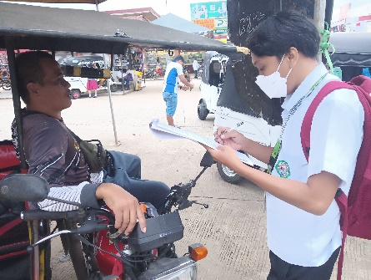
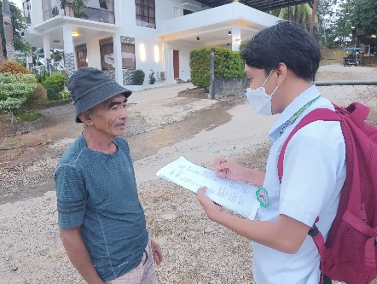
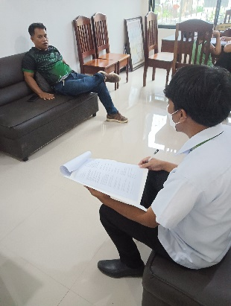
The Define phase focuses on the identification of the problem, the system stakeholders, and the system requirements. Through informal observation and some initial data collection, the issues of uneven distribution of vehicles, excessive and unpredictable wait times, and fare disputes have been identified. To better specify and validate these issues, some surveys and interviews will be conducted. These will be conducted to the passengers, Payong-Payong and Bao-Bao drivers, and local administrators. The purpose will be to understand the issues and constraints from a user perspective. The outcomes from this phase will be the Software Requirements Specification (SRS) document, which will specify in detail the requirements, both functional and non-functional of the system and serve as the guide for the following phases.

Design Phase
During the Design phase, the requirements align with system specifications and architecture during the Design phase. At its core, the system follows a client-server model. Picture this: passengers and drivers using Android apps, admins managing things through a web dashboard, and all of it running on a cloud backend. The building blocks? React Native, Firebase Firestore, Google Maps API, and Node.js. For passengers, it's all about ease just one tap and they're booked, watching their driver approach in real time, with the fare displayed clearly before they even get in. Drivers aren't left out either; they get notified the moment someone books, guided through the route, and can track how much they've earned. Over on the admin side, there's a dashboard that lets them monitor everything going on, go through driver verifications, and pull up reports when they need to dig into the data. The design includes user and booking data, driver locations, and fare matrices in the database.
Develop Phase
The Develop phase employs an agile approach to design realization. The incremental features and constant testing are part of the agile model. After the Define phase wrapped up, three core things stood out booking functionality, fare calculation, and live tracking. That set our direction. We began with the user account stuff (registration and login) since that's the entry point for everything else. Once that was solid, we shifted to building out the booking system, then notifications, then GPS integration. Git handled all the version management different branches per feature, proper version tracking, and we made a point to keep CI flowing and documentation updated the whole time. Each module went through unit and integration testing before we called it done, and we made it a habit to follow coding standards and do regular peer reviews just to keep things from getting messy. Every module got put through unit and integration testing by the team. And to keep the framework from getting sloppy, we leaned on coding standards and regular peer reviews to maintain quality. Every module got put through unit and integration testing by the team, and we made sure the overall quality stayed solid by sticking to coding standards and doing regular code reviews. The phase ends after a prototype is developed that includes all necessary features.
Deploy Phase
The Deploy phase is characterized by more intensive integration and user acceptance testing of the refined prototype. Testing is conducted with users who participated in earlier surveys. Improvements or modifications are then made to the system. Once this iteration is deemed successful, the application is published to the Google Play Store, and the Admin dashboard is deployed to a cloud environment. Special training is provided to less tech-savvy corporate users, in this case the Drivers. In addition, System performance is monitored, and user feedback is actively collected. This is done to understand if the solution achieves its intended objectives of minimizing the average wait time, eliminating fare disputes, and optimizing the distribution of vehicles. The last phase of the post-deployment brings an evaluation of the system to the objectives and offers feedback with prioritized recommendations on what could be done to improve the system.
3.2 Current System Flow
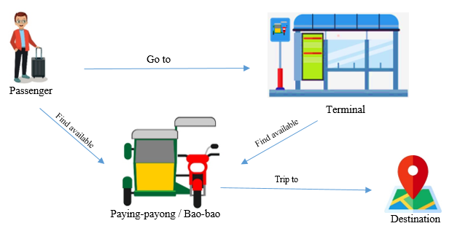
Figure 2.0 Current System Flow

The above diagram depicts the informal, ad-hoc methods used to obtain a ride in the Poblacion Guipos transportation system. Passengers have to physically go to either the terminal or the common waiting area to access a Payong-Payong or Bao-Bao. There is no option to book a vehicle ahead of time. Likewise, the fares are not standardized. Instead, they are negotiated verbally after the completion of the trip, and often result in unfair fare disputes. There is no central control or management of the system to optimize vehicle distribution. This results in long and unpredictable wait times for passengers located in the outlying areas, as drivers all choose to concentrate their vehicles in the Town Center. With the current informal, manual and completely decentralized system, there is a great need for an organized booking system to allow customers to reserve a ride in advance, have a transparent pricing system with standardized fares, and real-time location of drivers to make the system more efficient.
3.3 Context Diagram
Administrator
Manage drivers,
Monitor bookings,
View system reports
View & accept
Booking request,
Update trip status
Driver
Send ride request
Receive confirmation, fare
quote, and driver location
Passenger
iBook: Guipos Vehicle Booking System

Figure 3.0 Context Diagram

Figure 3.0 above depicts the context diagram, which supplies a summary of the relationships between the system's external entities and the proposed iBook: Guipos Vehicle Booking System. This diagram describes the information flow, interactions and processes framing the system's operational boundaries. It portrays three system actors: the Passenger, the Driver and the Administrator. The Passenger starts the process by sending a ride request to the system, including a pickup and drop-off location. The request is processed, and the system responds with an instant and clear fare, a booking notification, and an ETD / ETA driver assignment and a series of notifications. The Driver views the system for Passenger requests and conveys acceptance of the request. The Driver also provides trip status updates. The Administrator manages the system by approving Driver registrations, overseeing booking requests, and creating reports for system activity and health. This context diagram captures the boundaries of the system and the critical data transactions with system users.
3.4 Activity Diagram

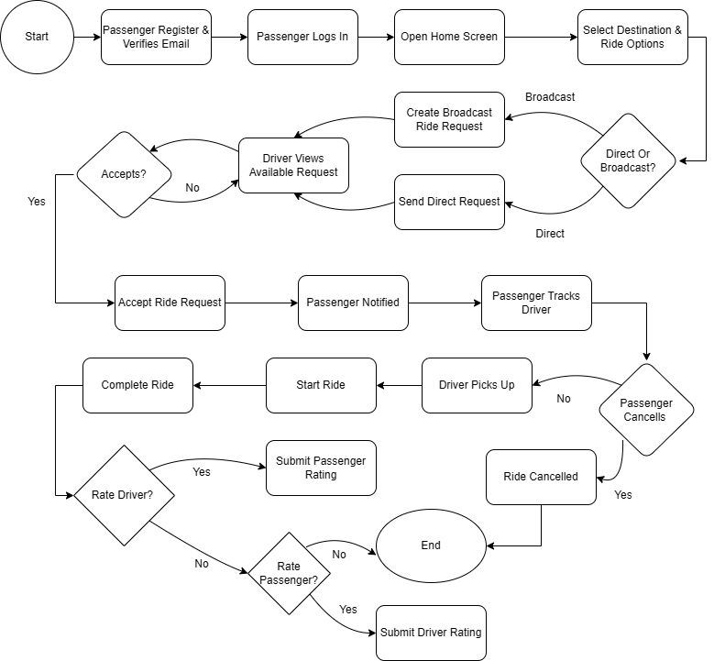

Figure 4.0 Activity Diagram
Activity diagrams represent workflows and use different symbols to depict how tasks are carried out in a given system by actors. Figure 4.0 shows the activity diagram for the iBook: Guipos Vehicle Booking system. It analyzes the interactions between the three main actors: The Passenger, The System, The Driver. The Passenger is the first to initiate the process by logging into the mobile application, entering a pickup location, entering a drop-off location, and sending a booking request. The system processes the request, automatically calculates the fare based on the route, and displays it for the Passenger to confirm. After confirmation, the booking request is sent to all Drivers available in the System. A Driver that is logged in, and available, is able to view the request and has the option to accept it. Once a Driver accepts the request, the System assigns the trip and sends a notification to the Passenger with the Driver's details and the Driver's location is available via real-time GPS. The Driver travels to the pickup location, marks the Passenger as picked up, and travels to the drop-off location. After the trip is complete, the Driver marks the trip as complete, and the fare is automatically deducted from the Passenger's account, and both the Driver and Passenger have the option to provide feedback via a star rating. The system diagram transforms the current informal process of hailing a vehicle into an advanced system, that provides the features of pre-booking a vehicle, fare confirmation, with transparency, and real-time status updates to all actors participating in the process.
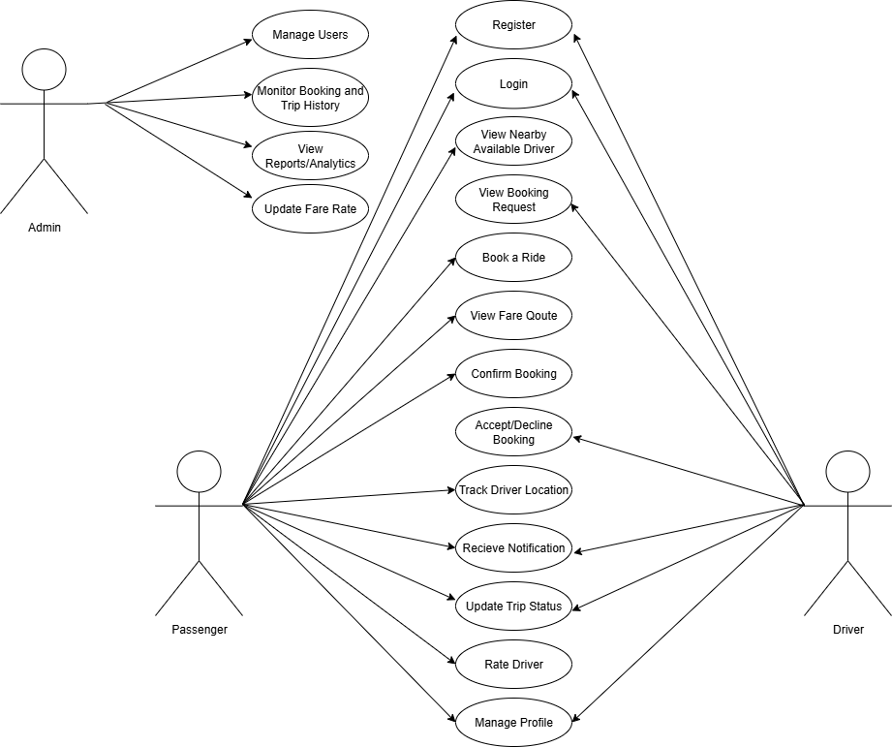
3.5 Use Case Diagram
Figure 5.0 Use Case Diagram
The finalized Use Case Diagram of the iBook: Guipos Vehicle Booking system is illustrated in Figure 5.0. It captures details for the three main actors of the system, Passenger, Driver, and Admin. Passengers have the most processes. First, they must register and log into the system. Users can view Drivers, confirm the fare quote, and book a ride. Users can also view the Driver in real-time and are notified of the reservation. Users can also rate the Driver after the ride. Drivers log into the system to view booking requests. They can also Accept/Decline requests. They can also update their trip status and manage their profile. Admins also manage the system's users, view reports and analytics in the system, and manage the base fare with booking requests. Admins also view past bookings and trips. Overall, this Use Case Diagram details the system's processes in booking a ride and the ride itself and the system's processes for the Admin. It also integrates all the main users of the system.

Reference

Biason, R. P., Reyes, J. M., & Cabauatan, R. R. (2025). Impact of E-Hailing Motorcycle Services Adoption on Motorcycle Ownership Trends. TWIST Journal, 18(2). https://twistjournal.net/twist/article/view/582
Galang, N. A. A., Villeno, A. M. M., Camaro, P. J., & Cabauatan, R. R. (2025). Impact of Digital Platform Economy and Ride-Hailing Services on Urban Mobility in Pampanga. Journal of Technology and Systems, 5(1). https://carijournals.org/journals/JTS/article/view/2506
Li, W., Wang, J., & Zhang, W. (2023). Book-ahead ride-hailing trip and its determinants. Transportation Research Part A: Policy and Practice, 177, 102835. https://www.sciencedirect.com/science/article/abs/pii/S0965856423002951
Ma, Y., Zhu, X., & Liu, Z. (2022). Does Online Ride-Hailing Service Improve the Efficiency of Taxi Drivers? Sustainability, 14(15), 9456. https://www.researchgate.net/publication/362166002
Manaois, I. K. N., Dela Cruz, A. R., & Reyes, S. M. (2024). The Assessment of the Usage, Attitude, and Image of Filipino Students Utilizing Motorcycle Taxi Hailing Services as Alternative Transportation in the NCR. Journal of Business and Management Studies, 6(2). https://al-kindipublisher.com/index.php/jbms/article/view/8039

Raj, P., Verma, A., & Singh, R. (2022). Analyzing User Behavior in Selection of Ride-Hailing Services. Travel Behaviour and Society, 29, 1-12. https://link.springer.com/article/10.1007/s40890-022-00172-5

Reference

Biason, R. P., Reyes, J. M., & Cabauatan, R. R. (2025). Impact of E-Hailing Motorcycle Services Adoption on Motorcycle Ownership Trends. TWIST Journal, 18(2). https://twistjournal.net/twist/article/view/582

Galang, N. A. A., Villeno, A. M. M., Camaro, P. J., & Cabauatan, R. R. (2025). Impact of Digital Platform Economy and Ride-Hailing Services on Urban Mobility in Pampanga. Journal of Technology and Systems, 5(1). https://carijournals.org/journals/JTS/article/view/2506

Li, W., Wang, J., & Zhang, W. (2023). Book-ahead ride-hailing trip and its determinants. Transportation Research Part A: Policy and Practice, 177, 102835. https://www.sciencedirect.com/science/article/abs/pii/S0965856423002951

Ma, Y., Zhu, X., & Liu, Z. (2022). Does Online Ride-Hailing Service Improve the Efficiency of Taxi Drivers? Sustainability, 14(15), 9456. https://www.researchgate.net/publication/362166002

Manaois, I. K. N., Dela Cruz, A. R., & Reyes, S. M. (2024). The Assessment of the Usage, Attitude, and Image of Filipino Students Utilizing Motorcycle Taxi Hailing Services as Alternative Transportation in the NCR. Journal of Business and Management Studies, 6(2). https://al-kindipublisher.com/index.php/jbms/article/view/8039

Raj, P., Verma, A., & Singh, R. (2022). Analyzing User Behavior in Selection of Ride-Hailing Services. Travel Behaviour and Society, 29, 1-12. https://link.springer.com/article/10.1007/s40890-022-00172-5

