

J.H. CERILLES STATE COLLEGE
School of Computing Studies
Mati, San Miguel, Zamboanga del Sur

iSECTION: A DECISION SUPPORT SYSTEM FOR BSIT FRESHMEN SECTIONING

A CAPSTONE PROJECT
Presented to the Faculty of
SCHOOL OF COMPUTING STUDIES

In Partial Fulfillment
Of the Requirements for the degree of
BACHELOR OF SCIENCE IN INFORMATION TECHNOLOGY

By:
Caong, Lovelyn
Parame, Romelyn
Hadjula, Kimberly
Lao, Mary Jane

2026
CHAPTER I
THE PROBLEM AND ITS SCOPE
Introduction
In higher education, the strategic sectioning of first-year students is pivotal in shaping their academic trajectory (Swiecki et al., 2022). This process typically commences with a sectioning exam a diagnostic tool designed to assess baseline competencies and categorize students into learning groups commensurate with their skill levels. In many academic institutions, this process is supported by a Decision Support System (DSS), which is a computer-based system that assists administrators in making accurate, consistent, and data-driven decisions by processing and analyzing large volumes of assessment data. Effective sectioning enables instructors to tailor pedagogical approaches, ensuring students are placed in environments optimized for learning.
Currently, the J.H. Cerilles State College (JHCSC) – BSIT Main Campus employs a generic web-based platform to administer sectioning exams for incoming freshmen; however, this general-purpose system fails to address the specific prerequisites and nuances of the BSIT curriculum. Faculty members have identified a critical need for a dedicated system capable of streamlining the entire workflow—from automating scoring and managing high-volume enrollment to ensuring rapid, data-driven section assignments. These operational challenges mirror broader trends in educational technology research. For instance, Ilić et al. (2023) note that adaptive assessments within intelligent learning systems can significantly enhance testing precision and user experience. Furthermore, a systematic review by Muzaffar et al. (2021) highlights persistent gaps in current online exam solutions, particularly regarding automation and intelligent feedback. To bridge these gaps, this study proposes the development of iSection: A Decision Support System for BSIT Freshmen Sectioning. iSection is designed to modernize the current placement process by automating ranking and assignment while providing transparent, performance-based results, ultimately aiming to improve institutional decision-making and enrollment efficiency at JHCSC.
Project Context
Sectioning exams play a vital role in higher education, as they ensure that students are grouped according to their academic readiness. In the BSIT program at J.H. Cerilles State College (JHCSC) – Main Campus, these exams help place first-year students in sections that match their performance levels. However, the current platform used by the department is not fully aligned with the specific procedures required for administering sectioning exams. This situation emphasizes the need for a dedicated system tailored to the BSIT program’s requirements.
The proposed system, iSection, functions as a Decision Support System (DSS) designed to assist faculty members in managing the sectioning process more effectively. It automates exam scoring, student ranking, and section assignment within a single integrated platform. By doing so, it reduces administrative workload, enhances accuracy, and ensures that sectioning decisions are made fairly and efficiently.
iSection supports both students and faculty by providing data-driven insights that guide academic management decisions. Specifically, it aids BSIT faculty during enrollment periods by offering reliable, automated processes for grouping students. As a web-based DSS, the system applies IT knowledge in a practical and innovative way, contributing to digital transformation in the college. Developed and tested at JHCSC with school of computing studies active faculty input, iSection demonstrates how a decision support system can optimize educational workflows and improve outcomes for incoming BSIT freshmen.
Purpose and Description
This system will automatically check the students’ scores and assign them to their appropriate sections. It aims to help students know their sections quickly and to make the workload easier and more efficient for staff. The system is designed to be simple, accessible, and user-friendly for all.
Objectives of the Study
General Objective
The main goal of this project is to develop a web-based sectioning system that will categorize incoming first-year IT students at JHCSC Main Campus quickly and accurately based on their exam results.
Specific Objectives
- To design a system that will check students’ scores automatically.
- To develop a system that will assign students to their appropriate sections based on their scores.
- To provide a user-friendly platform that allows students to conveniently view their section assignments.
- To enable staff to record sectioning results more efficiently and accurately.
Scope and Limitation
iSection is designed for first-year IT student at JHCSC Main Campus. The system will check students’ sectioning exam scores automatically, rank them, and assign them to the right sections. It will also allow students to see their assigned section online and help faculty manage sectioning results in an organized way.
The system is only for incoming BSIT first-year students and does not include other courses or departments. It focuses only on sectioning exams and assignments, not on other enrollment processes. Also, students will need an internet connection to view their results, and manual section changes by students is not allowed.

Definition of Terms
The following are the terminologies used in this study and are defined to provide clearer understanding of the concepts and system involved:
iSection. iSection is the proposed web-based system designed to improve the process of sectioning first-year students based on their exam results. In this study, it refers to the system being developed to automatically check sectioning exam scores and assign BSIT first-year students at JHCSC Main Campus to their appropriate sections.
Sectioning Exam. The sectioning exam is an assessment given to students to determine their knowledge level for proper class grouping. In this study, it refers to the exam taken by incoming first-year IT students at JHCSC Main Campus, with results processed by iSection to assign them to sections.
Web-Based System. A web-based system is an application that runs on a web server and can be accessed through internet browsers. In this study, it refers to iSection, which results.
Section Assignment. Section assignment is the process of placing students into classes or groups based on certain criteria such as exam scores. In iSection, this refers to the automatic placing of students into their respective sections based on their sectioning exam results.
Incoming IT Students. First-year IT students are those in their first year of the Bachelor of Science in Information Technology program. In this study, it refers specifically to incoming BSIT freshmen at JHCSC Main Campus who will use iSection for their sectioning process.
CHAPTER II
REVIEW OF RELATED STUDIES & SYSTEMS
Technical Background
This section explains the concepts and tools used to build iSection: A Decision Support System for BSIT Freshmen Sectioning. Research shows that web-based systems make school processes faster and more organized for both students and staff (Paul et al., 2022). iSection applies these benefits to simplify the current workflow. Instead of manual work, the system will automatically check exam scores and place students into the correct sections. This approach improves accuracy, reduces processing time, and helps administrators manage student sectioning more efficiently.
This section also details the hardware and software needed to run the system, focusing on a design that is secure and easy to use. Studies confirm that using automated tools helps schools handle exams and enrollment much more efficiently (Swiecki et al., 2022; Ilić et al., 2023). Based on these findings, iSection will use standard web technologies—specifically PHP and MySQL—to manage data and scoring in real-time (Chaudhary & Kumar, 2024). Ultimately, the goal is to provide JHCSC Main Campus with a reliable system that makes the sectioning process smoother for everyone.
Hardware | Description
Processor | Intel corei5
Memory | 8gb of RAM
Storage | minimum 8GB storage space
Hardware Specifications and Software Specifications
Software | Description
Server Environment
Operating System | Windows 10
Programming Tool | Php, Js, Html
Database Server | MySql
Web Server | Localhost
Client Environment
Internet Connection | Mobile data or WIFI with at least 1mbps
Programming Environment
The proponents will use PHP as the main programming language for backend development to handle server-side processing and logic. JavaScript will be used to make the system interactive and dynamic, while HTML will be used to design the structure and layout of the web pages.
For data storage and management, MySQL will be used as the database server to efficiently handle and store students’ exam scores and sectioning data. The system will run on a Windows 10 operating system and use Localhost as the web server for development and testing before deployment. efficient in automating the sectioning process for first-year IT students at JHCSC Main Campus.
Related Studies
Foreign
Online Exam Proctoring System Using Machine Learning
A study by Akber et al. (2025) describes an online system that acts like a digital exam proctor to keep tests fair and secure. This system uses smart technology to check a student’s face, ensuring the right person is taking the exam, and counts the number of people in the room to prevent outside help. It also monitors where a student is looking to verify, they are focused on their screen and can detect if someone tries to use a photo or video to fake their identity. Additionally, the system spots banned items, such as cell phones or notes, and alerts the teacher immediately. This study use technology to improve exam security, our proposed project, iSection, uses similar tools to simplify school administration. While their system focuses on monitoring exams, iSection focuses on automatically checking scores and placing students into the correct sections. Both systems demonstrate how online tools can help schools work faster, reduce mistakes, and create a better experience for students and staff.
NEET Exam Guidance
According to the National Testing Agency (2025), NEET is an offline entrance exam in India for students aiming to study medicine. The exam consists of 180 multiple-choice questions covering Physics, Chemistry, and Biology. In this system, students earn 4 marks for every correct answer but lose 1 mark for each mistake. To be eligible, students must be at least 17 years old and have studied the required subjects in high school.
Like the study of NEET uses scores to select students for medical programs while iSection, uses exam results to organize students. While NEET filters candidates for college admission, iSection automatically places first-year IT students into the correct sections based on their performance. Both systems share the same goal: grouping students effectively to match their academic level.
Change in Entrance Exam Requirements for Medical School
A study by Hallia et al. (2025) looked at how changing entrance exam rules affected medical students in Finland. The researchers compared two groups: one that studied a special textbook for the exam, and another that was tested on standard high school subjects like biology and chemistry. They found that changing the test material did not really change who got accepted or how well they did in their studies. In the end, the students who passed were those with strong learning skills, regardless of what the exam covered.
Also, the iSection, uses exam results to guide students to the right place. While the Finish study focused on selecting students for medical school, iSection focuses on placing IT students into the correct sections based on their scores. Both approaches rely on using accurate exam data to ensure students are grouped in a way that best matches their skills and knowledge.
Local
Extent of Utilization of Paperless Technology
A study by Fredeluces et al. (2023) examined the extent of paperless technology utilization among teachers in Bula District. The results showed that paperless tools were highly effective in managing grades and test banks, while user management was found to be moderately effective. The study recommended the use of paperless technology because it helps save time, reduce workload, and promote environmental sustainability. In the same way, the proposed iSection system applies technology to improve school administrative processes, while Extent of utilization of paperless technology focused on paperless tools for classroom management, iSection is designed to automate the student sectioning process without the use of paper. Both systems demonstrate how digital solutions can streamline school operations, minimize manual tasks, and improve overall efficiency.
Online Examination System with Cheating Prevention
A study from IEEE Xplore (2019) discussed an online examination system that uses question randomization and tab locking to reduce cheating during exams. The system allows schools to conduct examinations more efficiently and generate results quickly, although the study noted that internet connectivity issues may affect system performance. Similar to the study from IEEE Xplore (2019), the proposed iSection system utilizes online technology to enhance school processes, while the IEEE Xplore study focused on secure online exam delivery and cheating prevention, iSection is designed to evaluate sectioning exam results and automatically assign students to appropriate sections. Both systems highlight how online tools can improve efficiency, organization, and accuracy in academic operations.
A study by Abass et al. (2017) developed a Web-Based Examination System (WES) to address issues in traditional paper-based examinations, such as exam leakages, marking errors, and delays in releasing results. The system was built using open-source technologies including HTML, CSS, PHP, SQL, MySQL, and Dreamweaver, allowing automated exam checking and result recording. This approach reduced teachers’ workload and enabled faster and more accurate release of examination results. In addition, WES supports real-time data management and analysis, making it suitable for large-scale educational evaluation and distance learning. Similar to the study by Abass et al. (2017), the proposed iSection system applies web-based technology to improve academic processes. While WES focuses on automating examination checking and result management, iSection is designed to automate the evaluation of sectioning exam scores and assign students to appropriate sections. Both systems demonstrate how web-based platforms and open-source tools can minimize human error, reduce manual workload, and improve efficiency in educational institutions.
Both foreign and local studies show that technology helps schools work better. The foreign studies created systems that use AI and online tools to check students’ identities, prevent cheating, and group students based on exam scores. The local studies made systems that reduce teachers’ workload, stop cheating, and release exam results faster by using paperless and online platforms. Overall, these studies prove that using technology in schools makes work easier, faster, and more accurate.

CHAPTER III
DESIGN AND METHODOLOGY
This chapter discusses the requirement analysis using the 4D model phases: Discover, Design, Develop, and Deliver, a structured development framework that outlines distinct stages for planning and building a system. The 4D model is recognized in research and development methodologies as a four-stage approach to organizing development activities and ensuring products meet user needs and functional requirements (Thiagarajan et al., 1974). It outlines the current technical situation, presents the context and activity diagrams, explains the conceptual framework, and provides use case descriptions, giving a clear summary of the system’s development process.
Requirements Analysis








The project’s development is guided by the System Development Life Cycle (SDLC), which efficiently directs the whole process. These stages assist the proponents in developing the iSection system.
Figure 1. 4D Model

Deploy
Design
Discover
Develop

Figure 1 shows the 4D Methodology, this is the method used in this study. The 4D Methodology includes four phases, these are the define, design, develop and deploy. Every phase has its own corresponding actions in order for the proponents to be guided on the study proceedings.
Define Phase
The first phase of the 4D model is called the Define Phase. This phase is very
important because it helps the proponents understand the problem they are trying to
solve. The first phase of the 4D model is called the Define Phase. This phase is very important because it helps the proponents understand the problem they are trying to solve. In this step, they gather data and information by talking to people, observing processes, and asking questions. After collecting the data, they carefully analyze it to find the root of the problem and think of possible solutions.
The goal of this interview was to clearly understand the steps involved and to identify the parts of the process that need improvement. By gathering first-hand information, the proponents will be able to design a better system that makes student sectioning faster, more accurate, and less stressful for everyone involved.
Mr. Mejorada explained that the sectioning exam is conducted to properly place students into sections according to their IT knowledge. Previously, students were grouped without assessing their skills, which made it difficult to adjust lessons to their varying needs. With the exam in place, teachers can now identify which students require more support and which are ready for advanced lessons, allowing for better lesson planning. This process helps create more balanced classes and improves the overall learning experience of students. It also enables instructors to deliver lessons at an appropriate pace for each group.
The exam is administered through Quizizz and is very quick—each student spends only about two minutes completing it. However, the overall sectioning process depends on the number of students who take the test and the timing of their enrollment. Sectioning is not done immediately; results are reviewed first before assigning students to a section. While Quizizz enables students to view their scores, it does not automatically assign them to sections. Mr. Mejorada also encourages others to explore Quizizz further to better understand its features and consider possible improvements.
Image 1.2 Interview
Image 1.1 Interview
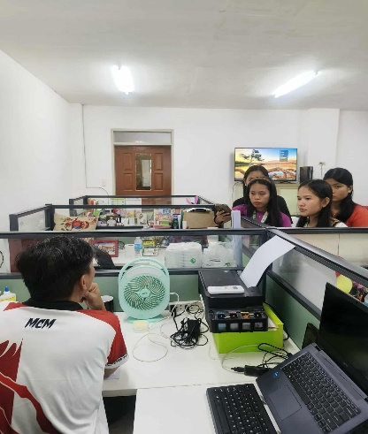
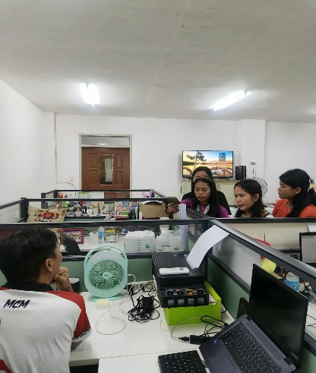

Image 1.2 Interview
Image 1.1 Interview
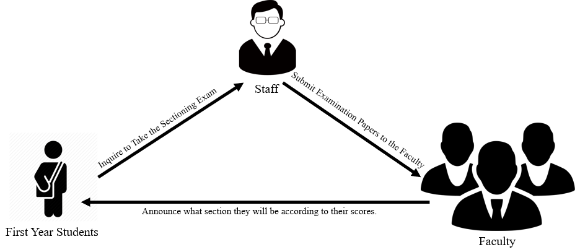

Figure 2. Current Technical Situation

Figure 2 shows how the current technical situation works. First, the students will inquire to take the sectioning exam. After they finish, the staff collects and submits their exam papers to the faculty for checking. Once the faculty has checked all the exams, they announce each student’s score along with their assigned section based on their exam results.
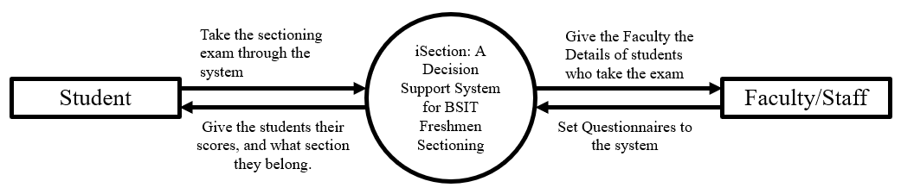
Design Phase

Figure 3. Context Diagram
Figure 3 shows how the students interact with the faculty and staff. First, the students take the sectioning exam through the system. After they finish, the system provides the faculty with the details of the students who took the exam. Then, the faculty sets the questionnaires in the system.
INPUT
iSection: A Decision Support System for BSIT Freshmen Sectioning

- Planning the system design based on the solution created from the analyze data collected.
- Drafting of the system’s user interface.
- Coding/Programming to develop the system.
- Testing and feedbacking to finalize the system features.

- Collecting of Data or Information
- Determining data to be Collected
- Analyzation of collected data or information
- Planning the system design based on the solution developed from the data analysis result
- Determining software and hardware requirements.
PROCESS
OUTPUT

Figure 4. Conceptual Framework (IPO Diagram)

Figure 4 shows the conceptual framework used in this study which has input, process, and output. In the input stage, the proponents collected data or information regarding the current situation. First, they determined what data needed to be collected. After that, they analyzed the collected data or information. Based on the results of their data analysis, they planned the system design as a solution to the identified problems. Lastly, in the input stage, they determined the software and hardware requirements needed for the development of the system. In the process stage, the proponents started by planning the system design based on the solution created from the analyzed data collected. Then, they drafted the system’s user interface to ensure that it would be easy for the users to navigate. After drafting the design, they proceeded with the coding and programming to develop the system. Lastly, in the process stage, they conducted testing and feedbacking to finalize the system features and improve its operations based on user needs. Finally, the output of this study is the developed iSection: A Decision Support System for BSIT Freshmen Sectioning.
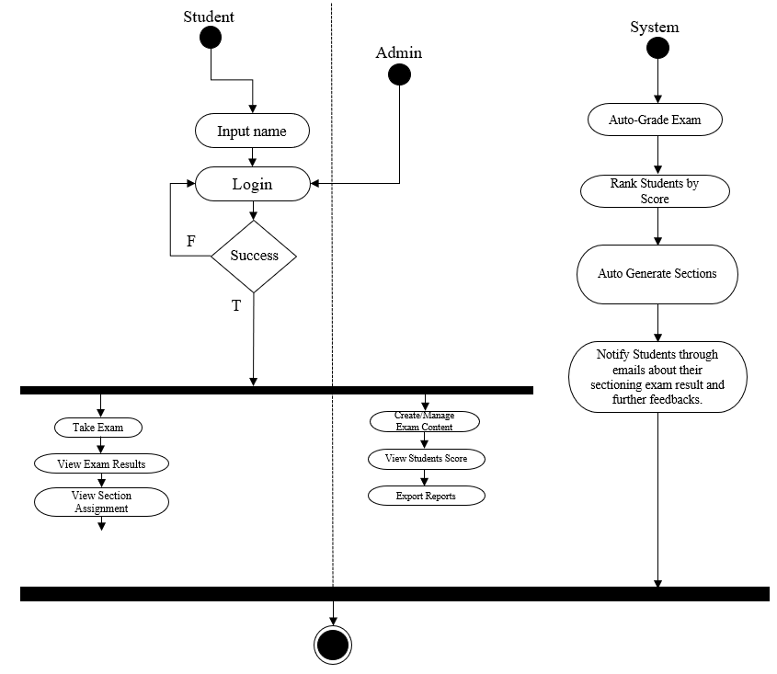

Figure 5. Activity Diagram
Figure 5 shows the Activity Diagram for the students, admin, and the system. In the student side, first, the students will register and log in to their accounts. If they input the wrong email or password, an error message will appear. However, if they log in correctly, it will be successful, and they can proceed to the take exam, and view exam results and assigned section. For the Admin side, they don’t need to register just log in directly. Once logged in, their tasks include manage exam content, view students score, trigger sectioning and export reports. Lastly, for the system side, its functions are to auto grade exam, rank students by scores, generate sections, and notify students through text/email about their sectioning exam result and further feedbacks.
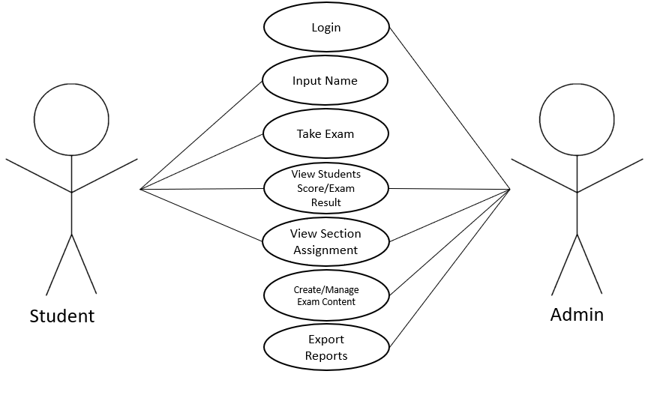

Figure 6. Use Case Diagram
Figure 6 illustrates the Use Case Diagram involving the students and Admin. Students are able to register an account, log in, input name, take exams, view their exam scores and results, and view their section assignments. The admin, who has a built-in account and can log in directly, view section assignment, can create manage exam content, and export reports.
Table 1. Use Case Description (Student)

Name | Take Exam
Description | Student logs in and takes the entrance exam online.
Actors | Student
Pre-conditions | Student must be registered and logged in.
Post-condition | Answers are submitted and graded
Main Course | - Students Take Exam  - Submit Examination
Alternate Course | - If unable to Submit, Check the Internet and try again step 1 of main course.
Name | Registration
Description | Student Registers for an account to access the exam system.
Actors | Student
Pre-conditions | None
Post-condition | Account is saved in the system
Main Course | - Students Registration  - Access the system
Alternate Course | - If unable to Register, Check the Internet and try again step 1 of main course.
Table 3. Use Case Description (System)

Table 2. Use Case Description (Student)

Name | Auto-Grade Exam
Description | Automatically checks answers and stores the score.
Actors | System

Name | Rank Students
Description | After all exams are completed, system ranks students by score
Actors | System
Table 4. Use Case Description (System)

Table 5. Use Case Description (System)

Name | Generate Section Assignments
Description | Assign students to sections based on their score and section size limit.
Actors | System  Table 6. Use Case Description (Admin)
Name | Manage Exam Content
Description | Admin Creates or Updates exam questions and correct answers.
Actors | Admin

Name | View Results
Description | Students can log in and view their exam score and assigned section.
Actors | Student
Table 7. Use Case Description (Student)

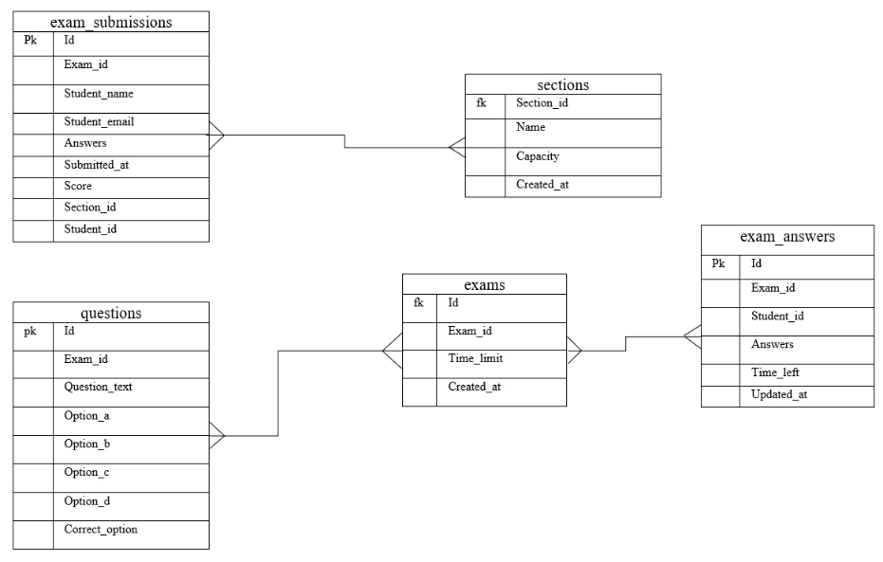

Figure 7. Entity Relationship Diagram
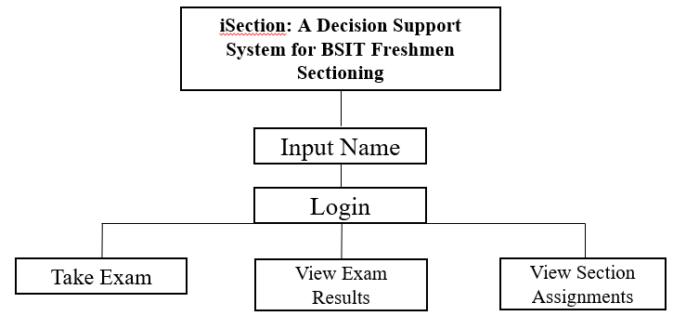
Figure 7 shows the Entity Relationship Diagram (ERD) of the system iSection: A Decision Support System for BSIT Freshmen Sectioning. The system contains five main tables: exam_submission_tb, sections_tb, questions_tb, exams_tb, and exam_answers_tb. The questions_tb is connected to the exams_tb table through a many-to-many relationship, meaning that multiple question_id values can be linked to multiple exam_id values, and each exam can be taken by different students. The exam_submissions_tb is also connected to the sections_tb in a many-to-many relationship, since a students_name can belong to one or more sections, and each section can contain multiple students. Lastly, the exam_answers_tb has a many-to-many relationship with the exams_tb, because multiple exam_id values can be associated with different exam submissions, and these answers are displayed after exams are submitted.
iSection: A Decision Support System for BSIT Freshmen Sectioning

Figure 8. System Structure Diagram for Student
Figure 8 presents the structure diagram for the student. It shows the sequence of activities starting from registering an account, logging in, taking the exam, viewing exam results, and checking section assignments.
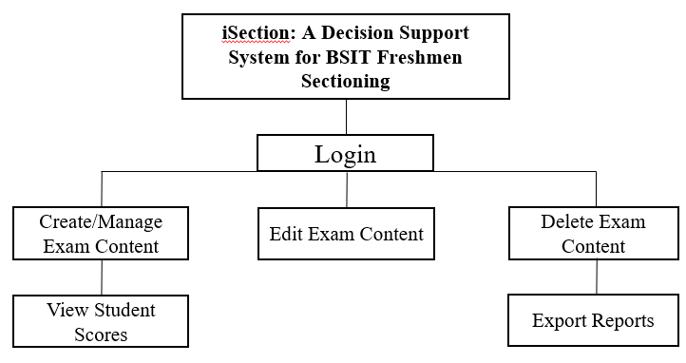
iSection: A Decision Support System for BSIT Freshmen Sectioning

Figure 9. System Structure Diagram for Admin
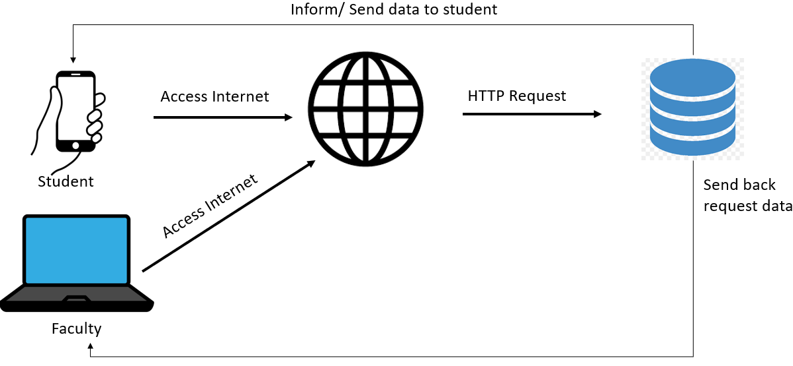
Figure 9 illustrate the structure diagram for the admin. It outlines the sequence of activities, which include logging in, managing exam content, viewing student scores, editing exam content, deleting exam content, and exporting reports.

Figure 10. System Architecture
Students use their phones and faculty use their laptops to access the internet. The internet sends a request to the database, and the database sends the data back to the students and faculty.
CHAPTER IV
DEVELOPMENT, TESTING, AND IMPLEMENTATION
This chapter presents the steps carried out by the proponents in relation to the development, testing, and implementation of the project. It provides details and insights on the major activities accomplished throughout the project’s process.
Description and Prototype
The iSECTION: A Decision Support System for BSIT Freshmen Sectioning is a web-based platform developed for incoming first-year IT students at JHCSC Main Campus. The system automates the sectioning process by checking exam scores, ranking students, and assigning them to appropriate sections. It also allows students to view their results and assigned section online.
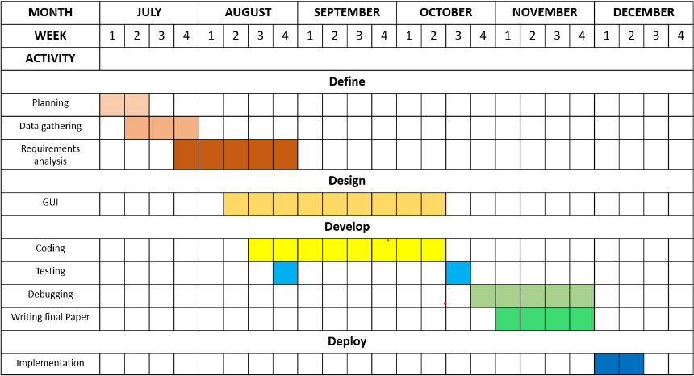
The prototype features a simple and user-friendly interface, accessible through web browsers on both mobile devices and computers. By automating exam checking and section assignment, iSECTION reduces manual workload, minimizes errors, and provides a faster and more organized way of handling the sectioning process.

Table 3. Gantt Chart

Table 3 presents the Gantt chart of the study, illustrating the activities undertaken by the proponents in line with the phases of the 4D methodology. From the first week of July to the first week of August, the proponents carried out the planning stage under the Discover phase, identifying the key tasks required for the study. Continuing in the Discover phase, from the first week to the third week of August, the proponents collected data through surveys and interviews with faculty and students to understand the current challenges in the student sectioning process. From the third week of August to the first week of September, the proponents conducted a requirements analysis, identifying the tools, information, and components necessary for developing the iSECTION: A Decision Support System for BSIT Freshmen Sectioning.
Development
In the 4D methodology, the Development phase is the third stage. During this phase, the system was created using PHP as the main programming language for backend development, which handled tasks such as checking exams, auto-grading, and assigning students to sections. JavaScript was used to make the system more interactive, while HTML was used to build the structure and layout of the web pages. For storing and managing data, MySQL served as the database to keep records of exam scores, results, and sectioning information.
Admin Dashboard Module
The Admin Dashboard gives administrators a quick view of important information in the system. At the top, the Header and Sidebar are included to make it easy for the admin to move between different pages. In the main area, the dashboard shows three key details: Total Students (number of students in the system), Exams Created (how many exams were made), and Active Sessions (current activities happening in the system). Each detail is shown in a simple box with clear labels and large numbers for easy reading.
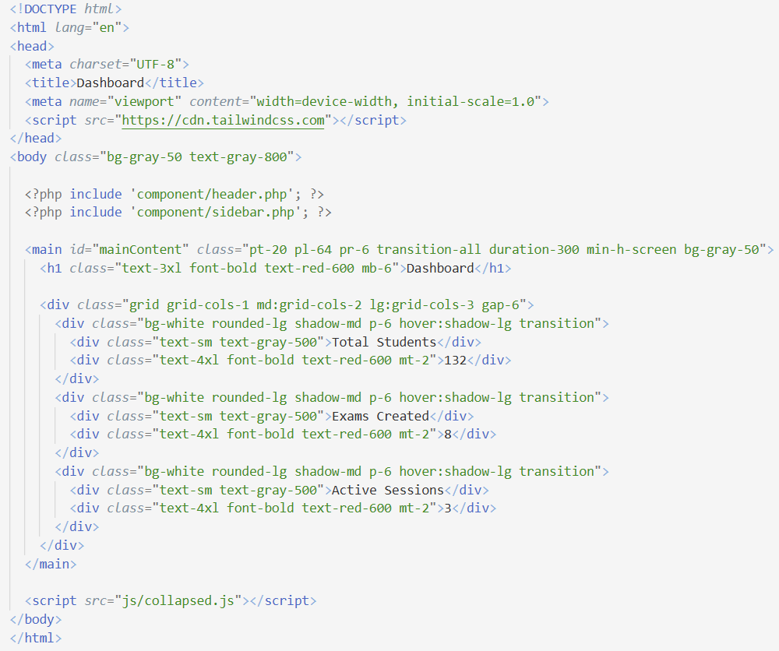
This module helps administrators monitor the system at a glance. With its clean and simple design, admins can quickly check student data, exam records, and sessions without confusion.

Create Section Module
The Create Section Module lets the administrator manage class sections for BSIT freshmen. On this page, the admin can view all sections, see how many students are enrolled, and check the total number of students across all sections.
A button labeled “Create Section” opens a modal form where the admin can enter the section name and capacity. Once submitted, the system saves the new section through the backend (createSection.php) and updates the section list automatically.
Each section displayed on the dashboard shows its name, the number of enrolled students compared to the maximum capacity, and options to edit or delete the section. The system also calculates and shows the total number of students across all sections.
This module provides an easy way for staff to create, update, and manage sections. It ensures that student distribution is organized and gives the admin full control over sectioning results.
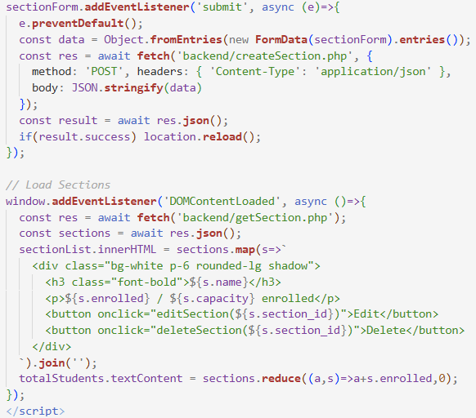

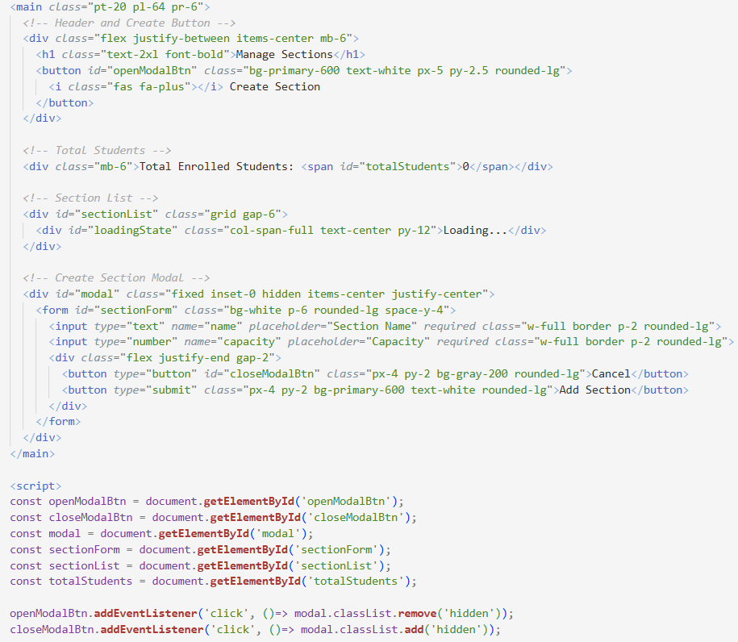
Retrieve Exam Module

The Exam Management Module helps administrators efficiently manage exams for BSIT freshmen through a centralized, card-based interface. Each exam card displays key details such as the Exam ID, time limit, and number of questions, and includes options to view, edit, delete, or export results, with a confirmation prompt to prevent accidental deletions.
The module also features a Create New Exam button that simplifies the process of making new assessments. By clicking this button, administrators are redirected to a form where they can input all necessary exam information. A search bar is also included, enabling administrators to quickly locate exams by typing the exam ID or title. This is especially useful when handling a large number of exams, as it improves efficiency and saves time.
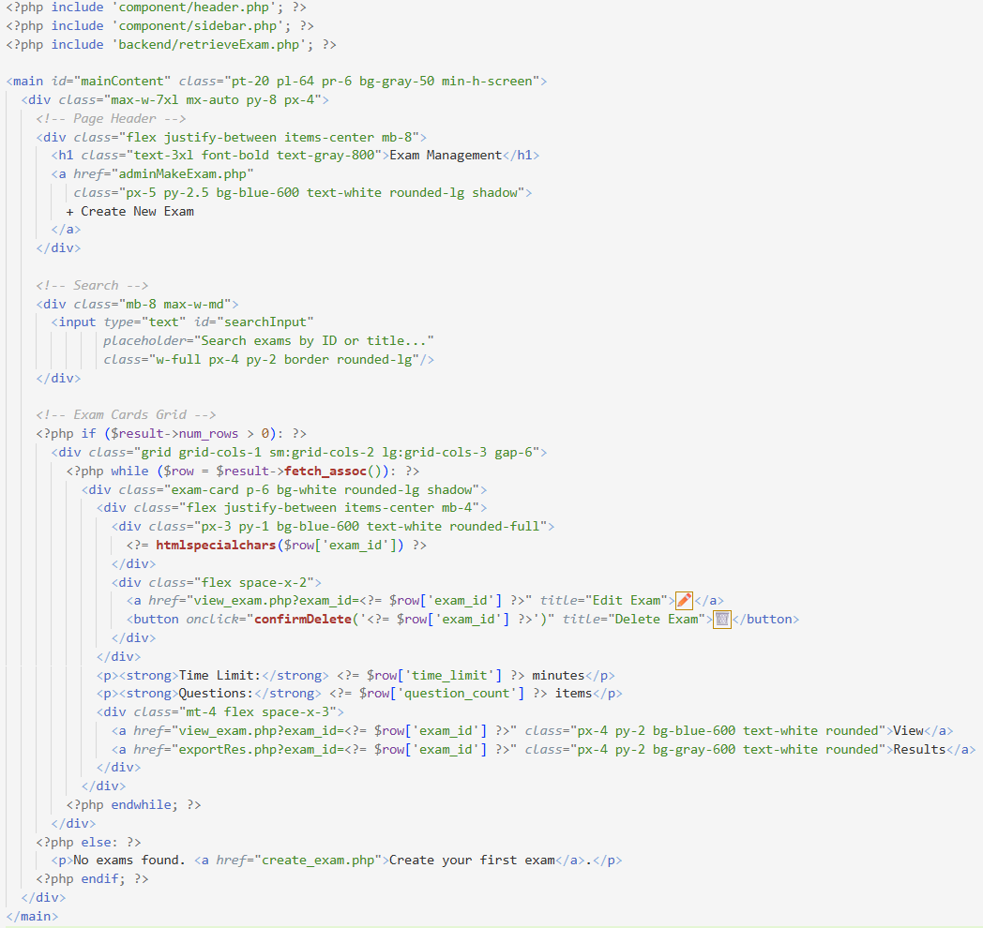
Student Dashboard Module

The Student Dashboard is designed to help BSIT freshmen easily register and take exams. Each student receives a unique Student ID that is automatically created by the system for identification. Through the registration form, students enter their name, Gmail, and the exam ID provided by the administrator.
The system then validates the exam ID and checks if the student has already taken the exam to avoid duplication. If everything is correct, the exam instructions are displayed, giving students clear guidance before starting. Once ready, students can begin their exam directly from the dashboard.
This module ensures a smooth and secure exam process by making registration automatic, preventing errors, and guiding students step by step until they take their test.
Start Exam Module

The Exam Taking Module allows students to take their sectioning exams online in an organized way. The system loads the exam details, student information, and questions from the database, then displays them step by step. A timer keeps track of the exam duration, while navigation buttons let students move between questions easily.
The module also includes an instructions screen before starting, multiple-choice options for each question, and an auto-save feature that stores answers every 30 seconds. When finished, the student’s answers are submitted to the server. This makes the exam process smooth, secure, and reliable.
In addition, the module is designed to reduce errors and prevent cheating by restricting multiple logins and requiring valid student credentials. It ensures fairness in the exam process while giving both students and faculty confidence in the results.
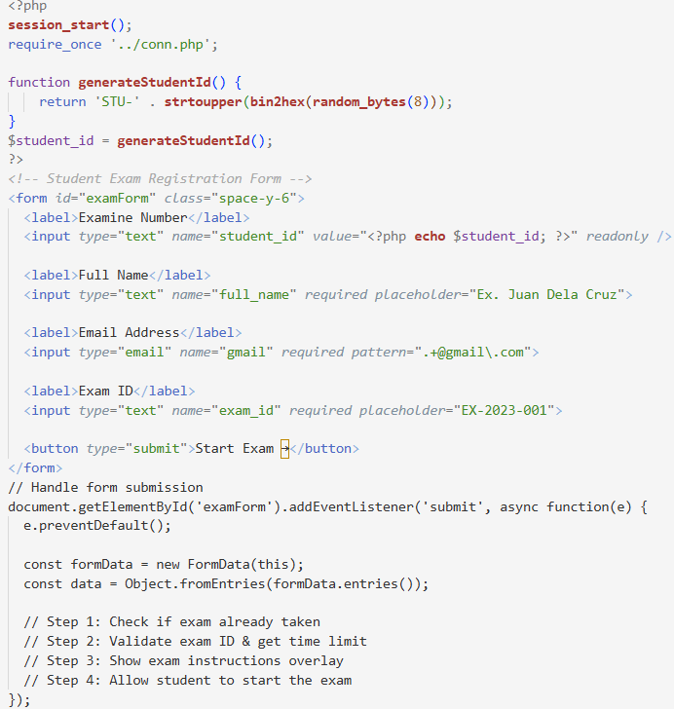
Exam Success Module

The Exam Success Module presents a detailed summary of a student’s performance after completing the sectioning exam. It retrieves exam results from the database, calculates the percentage score, and displays both the raw score and overall percentage. The module also provides a question-by-question breakdown, showing whether the student answered correctly or left items blank.
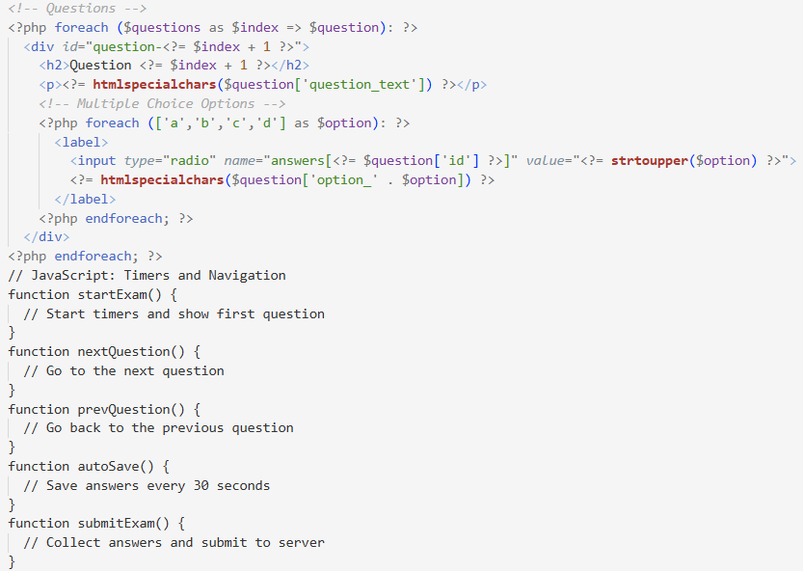
Additionally, the system automatically displays the student’s assigned section and its capacity, helping students understand their placement. This module ensures transparency, fairness, and clarity by giving students full access to their results while giving staff an organized way to review exam performance.

Testing Summary
The table below summarizes the software testing methods used during development, outlining their purpose, how they are performed, and the expected results. This ensures the system works correctly, is easy to use, and performs well before deployment.
Testing Method | Purpose | Criteria / How to Test | Expected Outcome | Actual Output | Status
Alpha  Testing | Examine internal system processes and operational reliability. | Developers test: login process, staff in-charge and students’ workflows, exam creation/editing/deletion, logic, and validation/error handling. | Major bugs identified and resolved; core modules functioning properly; no critical issues detected. | No major errors; login, examination management, and sectioning features functioned correctly. | PASSED
Beta  Testing | Assess system performance and usability by real users in an actual operational environment. | Release to limited users; observe login, take examination, collect feedback on UI/usability. | Users were able to complete exam tasks; interface was clear and intuitive; only minor issues observed. | Users logged in, accessed sections, and took exams; reported that the interface was clear and easy to use. | PASSED
Load  Testing | Assess how the system performs under expected traffic conditions. | Simulate multiple students accessing the system simultaneously, perform numerous concurrent reservations, and monitor response times and database performance. | System stays responsive, maintaining acceptable exam and sectioning speeds under the anticipated load. | Load times remained fast, and examinations were processed accurately even with concurrent users. | PASSED
Stress  Testing | Assess system stability under conditions exceeding normal load. | Stress the system beyond expected limits with numerous simultaneous exams attempts and rapid administrative updates. | System degrades gracefully without data loss and recovers smoothly after peak load. | System remained stable under heavy load, experienced no data loss, and recovered successfully after peak usage. | PASSED
Compatibility Testing | Verify compatibility across different devices and web browsers. | Tested on laptops and mobile devices using Chrome and Edge across various screen sizes. | Pages display properly, and functionality remains consistent across all platforms. | Login, section display, and exam features functioned correctly across tested browsers, with no significant layout issues. | PASSED
Usability Testing | Evaluate user-friendliness and overall user experience (UX). | Monitor users as they complete tasks, assess the clarity of buttons and labels, and gather feedback on user satisfaction. | Users were able to navigate and complete exams with little guidance, and the interface proved to be intuitive. | Participants completed the tasks with minimal assistance and reported that the system was intuitive. | PASSED
Functionality Testing | Confirm that all essential functions meet the defined system requirements. | Applicant: login, view schedules, reserve, prevent double reservations. Admin: add/edit/delete slots, view reservations. | Student: log in, view sections, take exams, and view results. Staff/In-charge: add, edit, delete exams, and view sections. | All modules functioned as expected; over-reservation was prevented; administrative features operated properly. | PASSED
Table 4. Testing
Stress Testing
To conduct stress testing for the iSection system, the proponents used tools such as Apache JMeter to measure how the system performs under heavy user loads. The testing environment included a PHP backend, MySQL database, and a Windows 10 localhost server. The test started with 10 concurrent users and gradually increased the load to 30, 40, and 50 users. The focus was on critical functions, such as logging in, viewing exam results, and accessing section assignments.
During testing, the proponents monitored important metrics like response time, error rate, and server resource usage (CPU and memory) to determine the system’s performance limit. After the tests, results were analyzed to identify bottlenecks or failures. Recommendations such as optimizing database queries, adjusting server configurations, or upgrading server capacity were proposed to improve performance.
This process ensures that the iSection system remains stable, reliable, and responsive even during peak usage when many students access their sectioning results at the same time.
Beta Testing

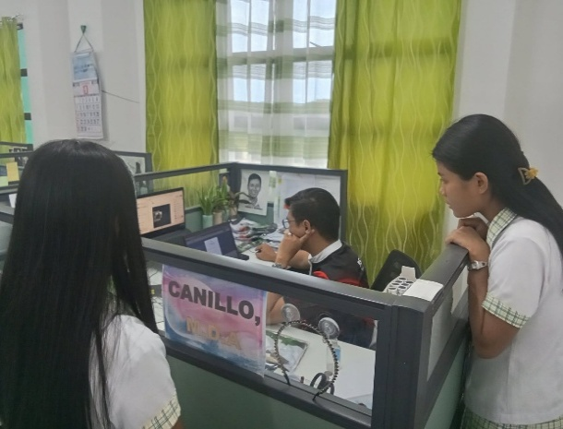
During the testing phase, the instructor and first-year students were allowed to try out and use the system. The documentation of this activity is shown in Image 2.

Image 2. Beta Testing

This version has been revised according to Mr. Mejorada’s recommendations.
Based on the results of the beta testing and his observations, Mr. Mejorada suggested that students should be properly grouped based on their IT knowledge rather than being assigned randomly. He emphasized that instructors should carefully review the exam results to identify which students need more support and which are ready for advanced lessons before assigning them to sections. He also agreed that the system is helpful in managing the iSection based on user feedback. Furthermore, he provided suggestions to further improve the system, make it more user-friendly, and encouraged exploring the features of Quizizz to better understand its functions and possible enhancements.
Table 4.1 Implementation Plan

Strategy | Activities | Persons Involve | Duration
Approval of the System | Acceptance of the project during final defends | Proponents, Panelist | 1 Week
Installation | System Hosting | Proponents | 1 Day
Training | Train the user of the system | Proponents, Panelist | 2 Weeks

As shown in Table 4, the implementation plan for the iSection system is presented. The approval phase lasted for one week, during which the proponents and panelists worked together to approve the project. The installation was completed in one day and was included in the training week. The training, which lasted for two weeks, was conducted by the proponents and involved both the instructor and the first-year students to ensure that all users were comfortable using the iSection system.

CHAPTER V
IMPLEMENTATION RESULTS, DISCUSSION, CONCLUSION, AND RECOMMENDATIONS

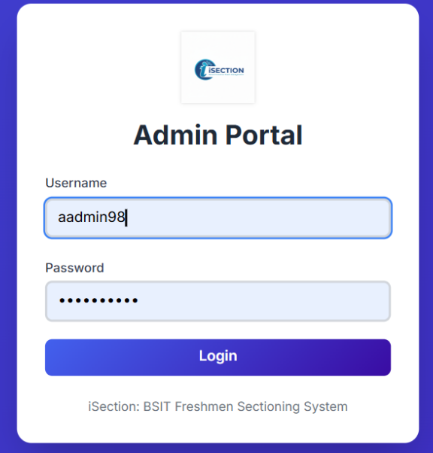
This chapter presents the results of developing and using the iSection: Automated Student Sectioning System, highlighting its main features, interface, and sample outputs. It evaluates how effectively the system achieved the study’s goals of speeding up the sectioning process, reducing manual work, and grouping students based on exam results and skill levels, followed by a brief discussion of findings, the overall conclusion, and recommendations for future improvement and adoption.

Image 3. Admin Login
Image 3 shows the Admin Login Page. Before accessing the system’s features, the admin must log in with their credentials to ensure secure and authorized access to manage sections, exams, and other system operations.
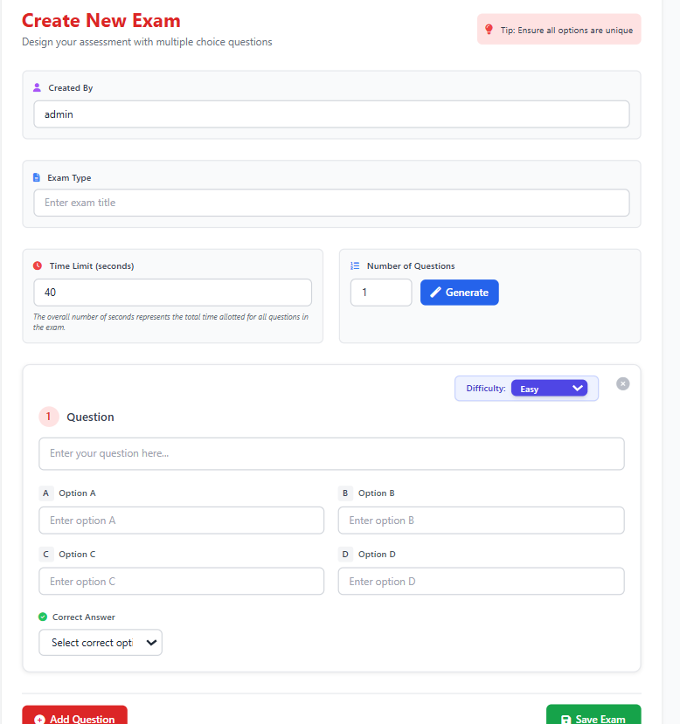

Image 4. Create New Exam
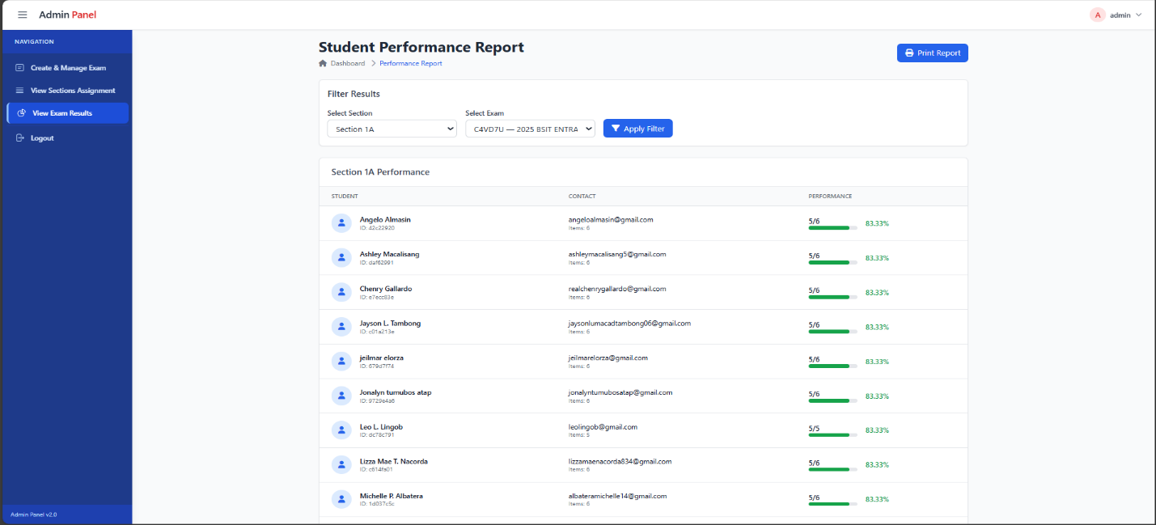
Image 4 shows the Create Exam Page for the admin in the iSection system. This page allows the administrator to create new exams by entering details such as exam title, subject, and number of questions, ensuring that all exams are properly organized and ready for students to access.
Image 5. Student Performance Report

Image 5 shows the Student Performance Report in the iSection system. This report displays each student’s name, contact information, and exam performance. The admin can also use this page to generate and print reports for record-keeping or evaluation purposes, making it easier to monitor and manage student performance efficiently.
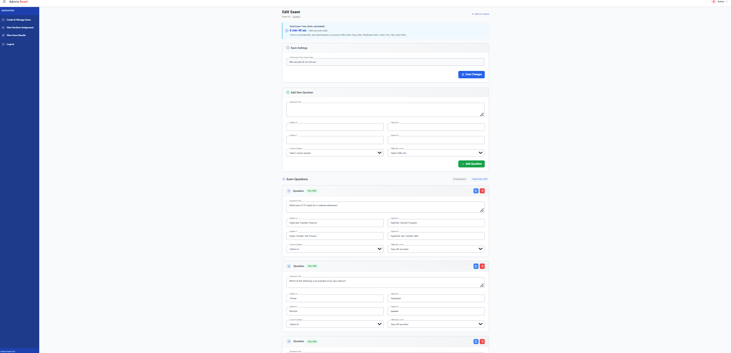
The report also shows the total score obtained by each student during the sectioning exam. It allows administrators to quickly identify students who performed well and those who may need additional support. The organized format of the report helps in reviewing large numbers of student records with ease. It also supports transparency in the sectioning process by clearly presenting the results. Through this feature, faculty members can make more informed decisions when evaluating student placement.

Image 6. Edit Exam

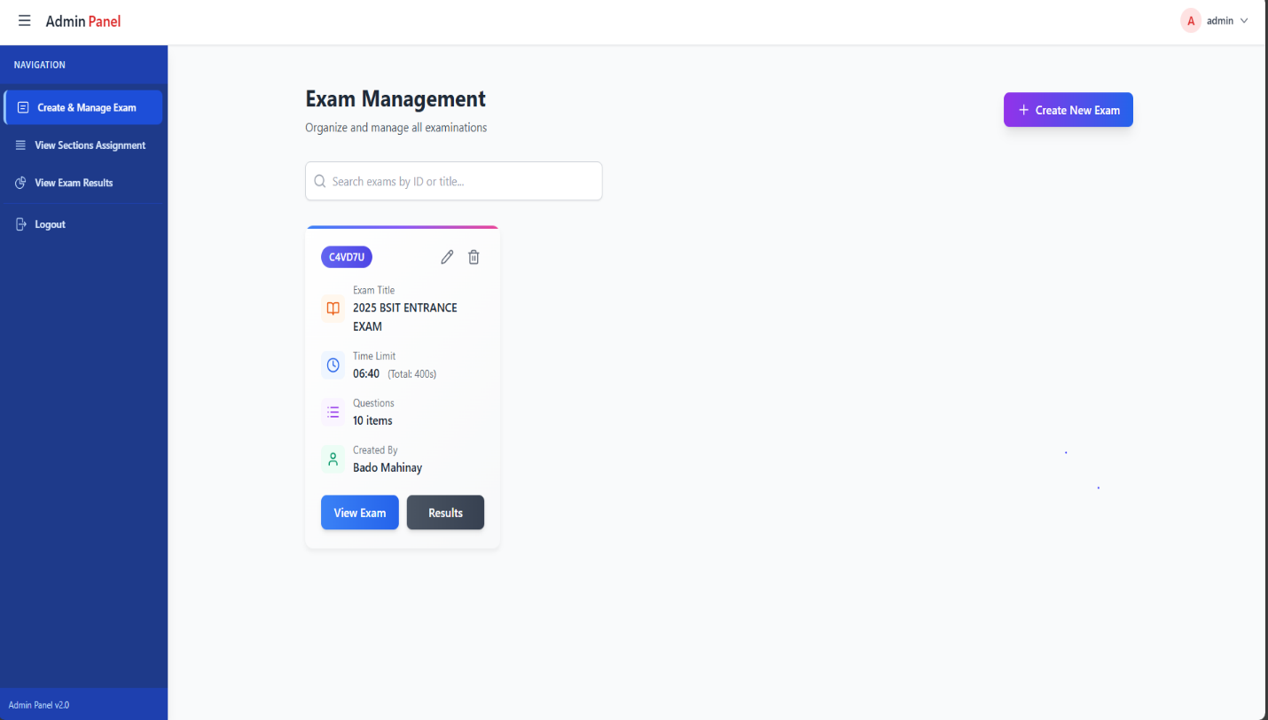
Image 6 shows the Edit Exam Page on the admin side of the iSection system. On this page, the administrator can add new questions, delete existing ones, or modify questions as needed, allowing full control over the content and structure of each exam to ensure accuracy and completeness.

Image 7. Exam Management

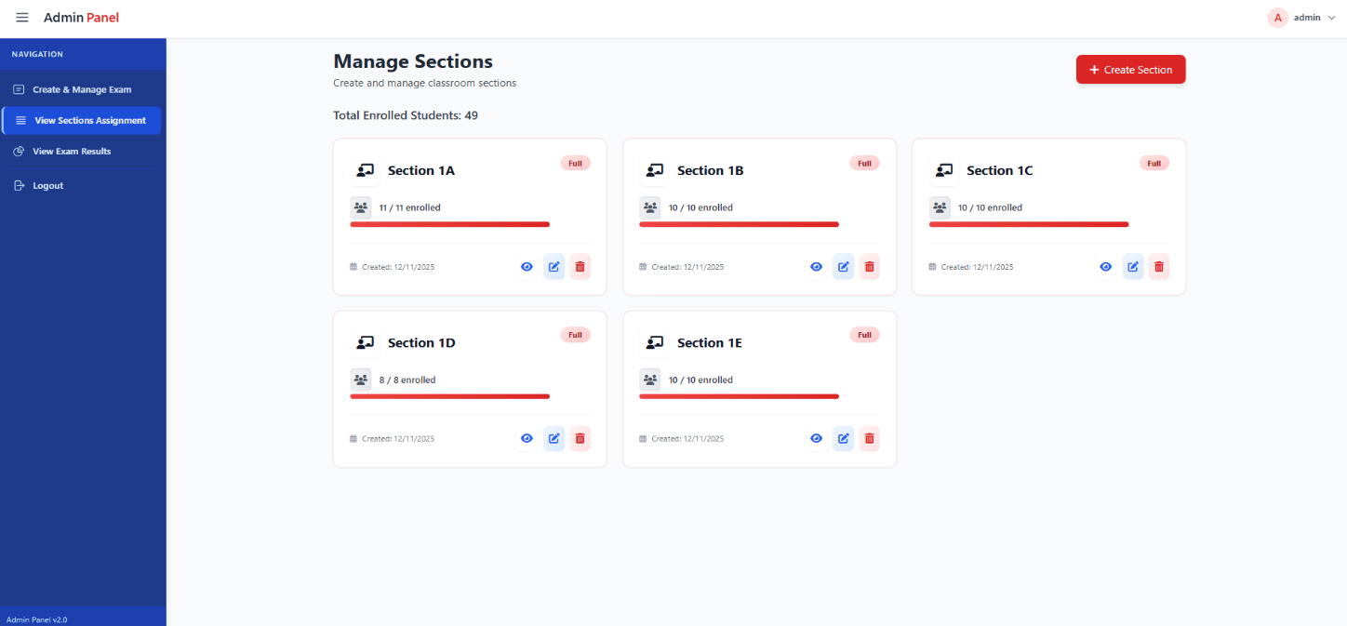

Image 8. Manage Sections

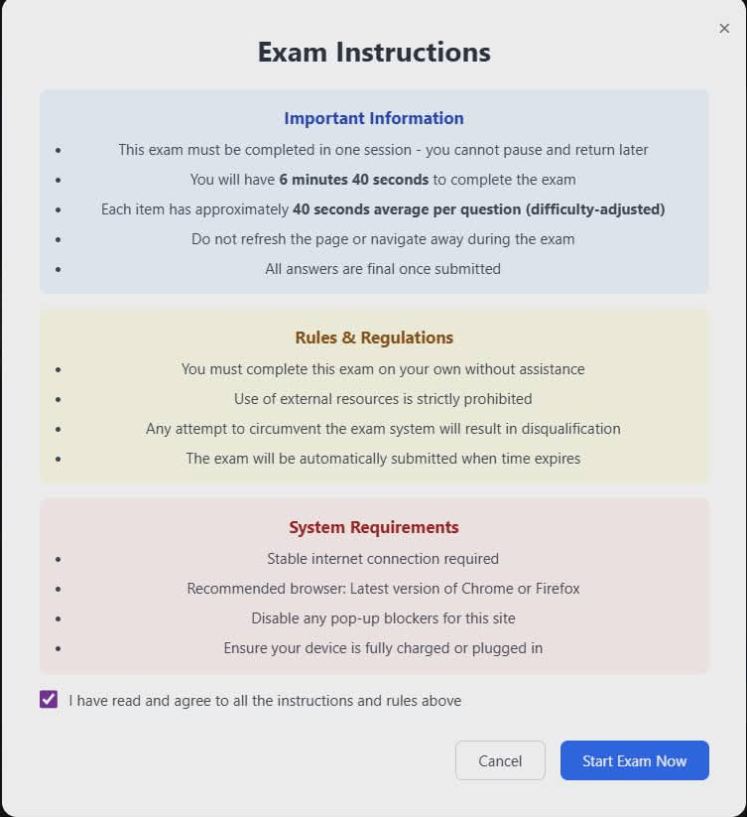
Image 8 shows the Manage Sections Page in the iSection system. On this page, the admin can oversee all sections, check whether a section is full or still has available slots, and view the students assigned to each section. This feature allows the admin to efficiently monitor and organize student groupings, ensuring balanced sections and proper allocation of students.

Image 9. Exam Instructions
Image 9 shows the exam instructions page for students in the iSection system. Before starting the examination, students can read important guidelines and rules to ensure they understand how to take the exam properly. This helps prevent mistakes and ensures a smooth and organized testing process.
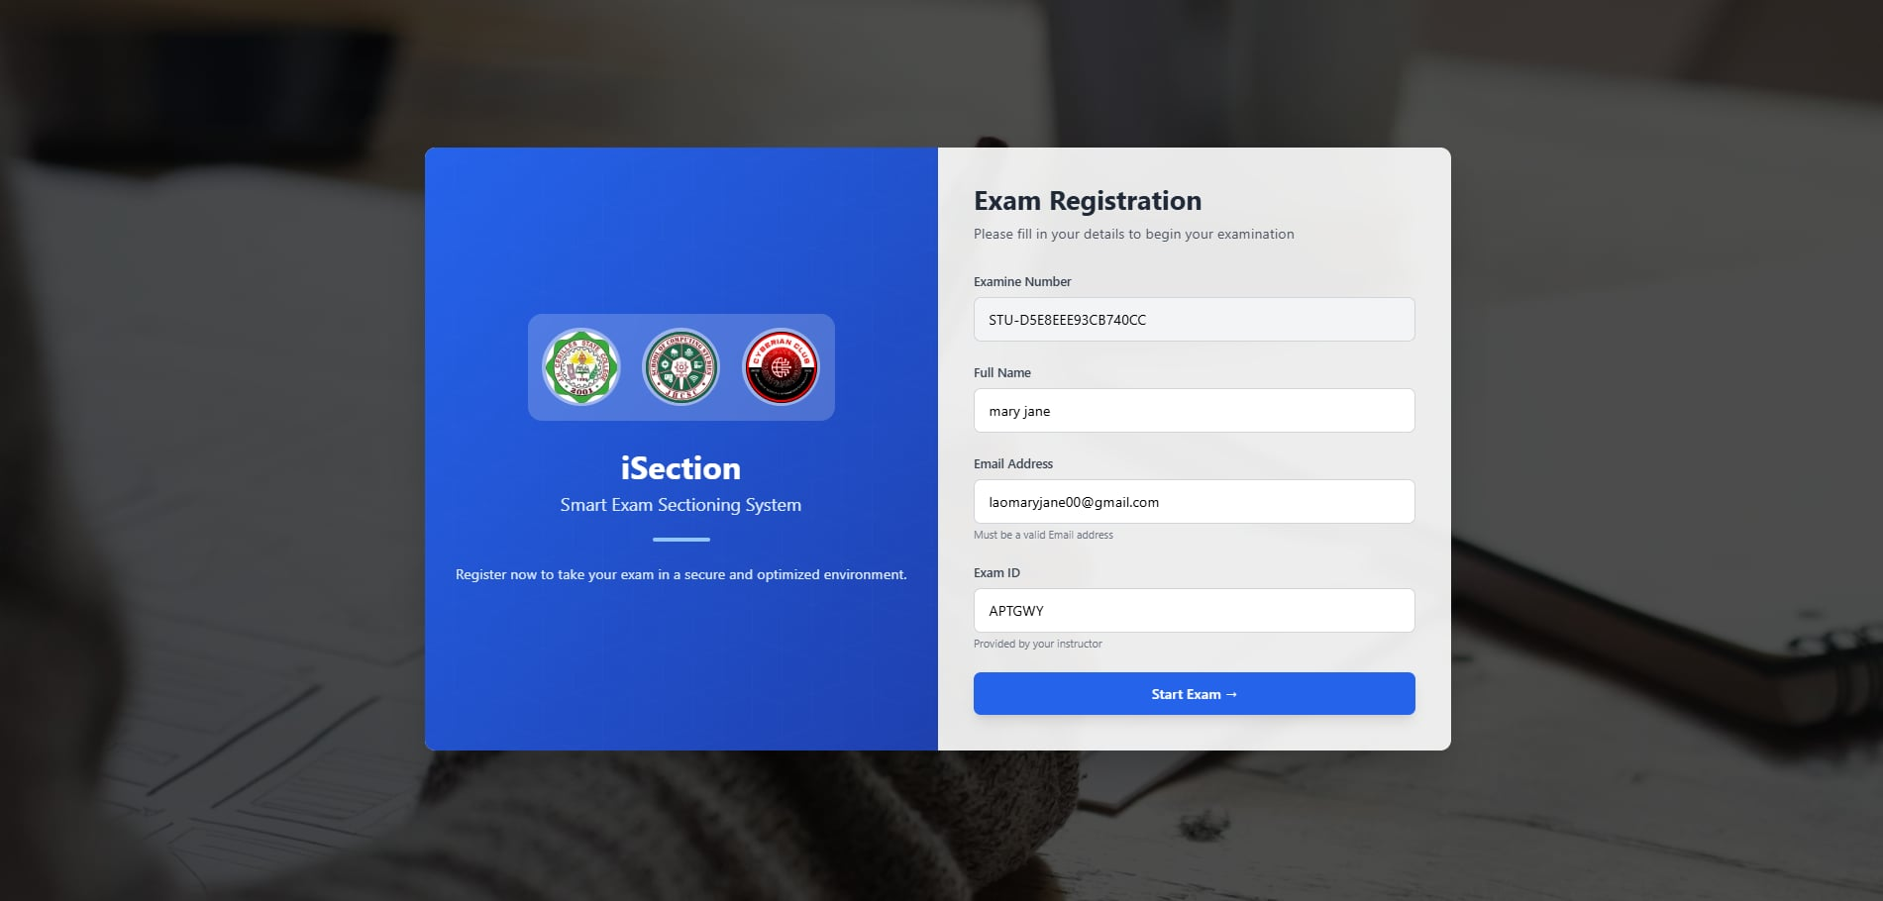

Image 10. Exam Registration

In image 10, the exam registration page is shown. On this page, students are required to register by providing their personal information, including their name and email and properly linked to their exam activities.
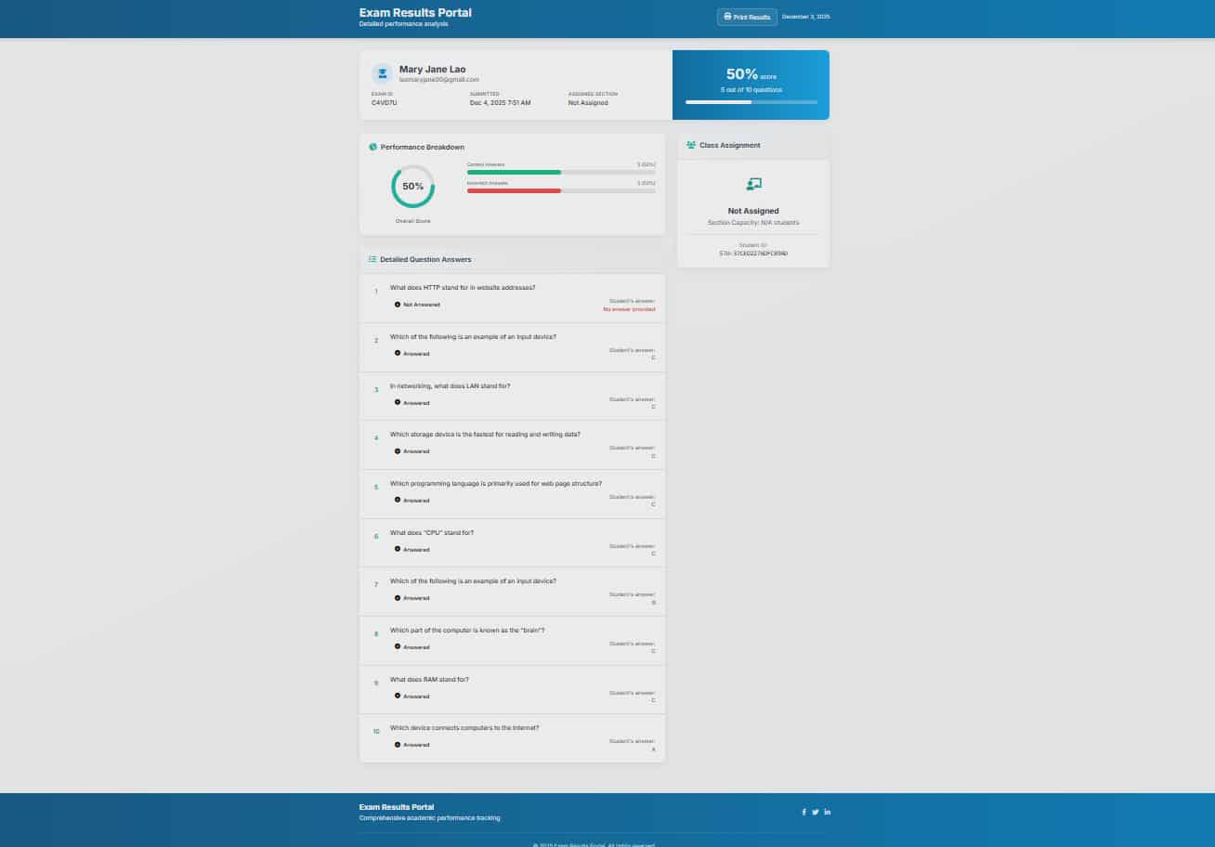
Image 11. Exam Results

In image 11, the Exam Results page is shown. After completing the exam, students can view the scores they received along with the section they have been assigned to. This page allows students to immediately see their performance and understand their placement within the system.
System Output and Functional Results
System Output and Functional Results A survey was conducted involving 50 respondents, comprising both students and staff members of the JHCSC School of Computing Studies. The primary objective was to evaluate the user experience and operational efficacy of the iSection: Automated Student Sectioning System. Utilizing a seven-point Likert scale ranging from "Extremely Likely" to "Extremely Unlikely," the study sought to measure key performance indicators including learnability, navigational clarity, functional efficiency, and overall user satisfaction.
The cumulative data reveals a decisive preference for the new system, with the vast majority of responses concentrating on the positive end of the evaluation spectrum. 1. Learnability and Skill Acquisition.
One of the most critical success metrics for any new software is how easily users can adopt it. The survey results indicate that the iSection system has a very low barrier to entry.
Ease of Learning: When asked if "Learning how to use the system is easy for me," the response was overwhelmingly positive. A significant 44% (22 respondents) rated this as "Extremely Likely," followed by 30% (15 respondents) as "Quite Likely."
This suggests that 74% of the user base grasped the system's mechanics with minimal effort. Skill Development: Furthermore, users expressed high confidence in their ability to master the system over time.
Regarding the potential to become skillful with the system, 42% (21 respondents) chose "Extremely Likely," while 28% (14 respondents) selected "Quite Likely." This data implies that the system is not only easy to start using but also supports long-term proficiency.
2.Functionality and Task Performance.
The core purpose of the iSection system is to facilitate specific academic tasks. The feedback confirms that users felt empowered and capable when interacting with the software.
Task Completion: In response to the statement, "I can easily make the system
Perform Task Completion: In response to the statement, "I can easily make the system perform the functions I need," 28% (14 respondents) were "Extremely Likely" to agree, and 40% (20 respondents) were "Quite Likely."
This combined positive response rate demonstrates that the system’s logic aligns well with user intent, allowing students and staff to achieve their goals without frustration. •Interaction Quality: Regarding the clarity of interaction, 32% (16 respondents) rated it "Quite Likely" and 28% (14 respondents) "Slightly Likely."
While a small minority (6%) remained neutral ("Neither"), the absence of significant negative feedback reinforces that the interaction flow is generally logical and predictable.
3. Interface Design and Navigation.
The visual and navigational aspects of the iSection system were also subjected to scrutiny. •User-Friendliness: The prompt "The system’s interface is easy to navigate and user-friendly" yielded a balanced distribution of positive sentiment. 26.5% (13 respondents) found it "Extremely Likely" to be user-friendly, with 30.6% (15 respondents) rating it "Quite Likely.
" Implication: These figures suggest that the UI design successfully guides users through the sectioning process, minimizing the cognitive load required to find features or complete steps.
4. Overall Usability and Conclusion.
The results here were particularly strong, with an equal split of 36% (18 respondents) for both "Extremely Likely" and "Quite Likely," followed by 26% (13 respondents) for "Slightly Likely."
Dissatisfaction Levels: Notably, only a negligible portion of the population expressed any form of dissatisfaction (Unlikely ratings), indicating that the system is robust and relatively bug-free from the user's perspective.
Thus, the survey distribution provides empirical evidence that the iSection system has successfully met the operational needs of the JHCSC School of Computing Studies. By scoring consistently high across learnability, functionality, and interface design, the system has proven itself to be a convenient, clear, and efficient tool.
The data validates the development efforts and suggests that the iSection system is ready for wider implementation and continued usage by both students and staff.
Conclusion
The development of the system successfully addressed the recurring problems found in manual student sectioning, such as inconsistent grouping, time-consuming processing, and difficulty in organizing freshmen based on their performance.
By automating both the examination and section assignment process, the system provided a reliable and structured way to group students according to their scores. Higher performing students were automatically placed into the top sections, while those with lower scores were assigned to the appropriate lower sections.
Throughout testing, all core features exam creation, exam taking, result generation, and automated sectioning functioned effectively and met the expected requirements.
Overall, the system improves accuracy, reduces the workload of administrators, and offers a clear and user-friendly solution for managing freshmen placement at the JHCSC School of Computing Studies. It also ensures that students are assigned to sections that match their level of knowledge and skills. In addition, the system helps streamline the entire sectioning process, making it faster and more organized for both students and faculty members.
Recommendation
Based on the overall performance of the system and the areas identified for future improvement, the following additional recommendations are proposed:
• Future developers may add a feature that allows instructors to manually adjust section placements in special cases where student performance needs further review.
• Adding a secure archive module for storing past exam results and previous sectioning records can help maintain organized historical data.
• Notify Students of their section.

REFERENCES
A Systematic Review of Online Exams Solutions in E-Learning: Techniques, Tools, and Global Adoption. (n.d.). IEEE Journals & Magazine | IEEE Xplore. https://ieeexplore.ieee.org/document/9357335
Akber, N., Neha, N., Rithinraj, P. K., Shinas, S., & Swathy, C. S. (2025). Online exam proctoring system using machine learning. International Journal of Scientific Research in Engineering and Management, 9(3), 1–9. https://doi.org/10.55041/ijsrem43097
Chaudhary, S., & Kumar, S. (2024). A web-based proctoring system using PHP-MySQL and logistic regression for student classification. In 2024 IEEE North Karnataka Subsection Flagship International Conference (NKCon) (pp. 1–5). https://doi.org/10.1109/NKCon61726.2024.10810933
Fredeluces, S. M. A., Garcia, N. P., & Quines, L. A. (2023). Extent of utilization of paperless technology: Basis for a proposed intervention program. European Journal of Education Studies, 10(7). https://doi.org/10.46827/ejes.v10i7.4903
Hallia, M., Kulmala, P., Pursiainen, J., & Nieminen, P. (2025). The change in entrance exam requirements for medical school: Impact on prior performance, entrance exam success, and study achievement. Education Sciences, 15(6), 683. https://doi.org/10.3390/educsci15060683
Ilić, J., Ivanović, M., & Klašnja-Milićević, A. (2023). Examining the applications of intelligent tutoring systems in real educational contexts: A systematic literature review from the social experiment perspective. Education and Information Technologies, 28(7), 9113–9148. https://doi.org/10.1007/s10639-022-11555-x
Muzaffar, A. W., Tahir, M., Anwar, M. W., Chaudry, Q., Mir, S. R., & Rasheed, Y. (2021). A systematic review of online exams solutions in e-learning: Techniques, tools, and global adoption. IEEE Access, 9, 32685–32712. https://doi.org/10.1109/ACCESS.2021.3060195
National Testing Agency. (2025). Information bulletin: National Eligibility cum Entrance Test (UG) 2025. Department of Higher Education, Ministry of Education. https://neet.nta.nic.in
Online Examination System with Cheating Prevention Using Question Bank Randomization and Tab Locking. (n.d.). IEEE Conference Publication | IEEE Xplore. https://ieeexplore.ieee.org/abstract/document/8912065
Paul, R. U., Ekanem, E. O., & Ekanem, S. (2022). A web-based information management system for educational institutions in riverine areas. Acta Scientific Computer Sciences, 4(4), 31–40.
Swiecki, Z., Khosravi, H., Chen, G., Martinez-Maldonado, R., Lodge, J. M., Milligan, S., Selwyn, N., & Gašević, D. (2022). Assessment in the age of artificial intelligence. Computers and Education: Artificial Intelligence, 3, 100075. https://doi.org/10.1016/j.caeai.2022.100075

APPENDICES
- Storyboard
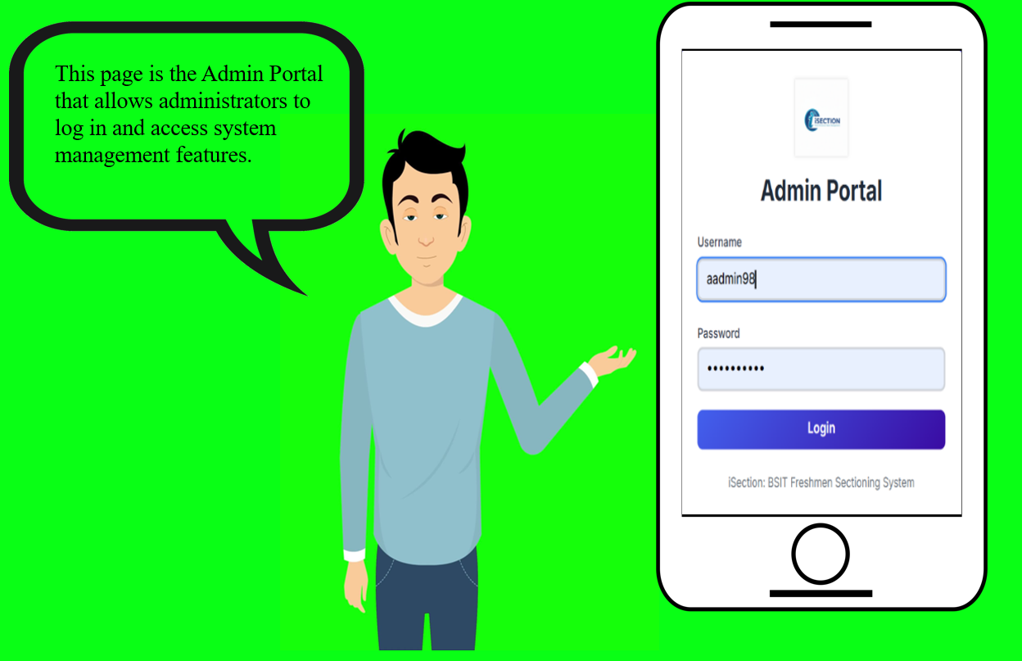

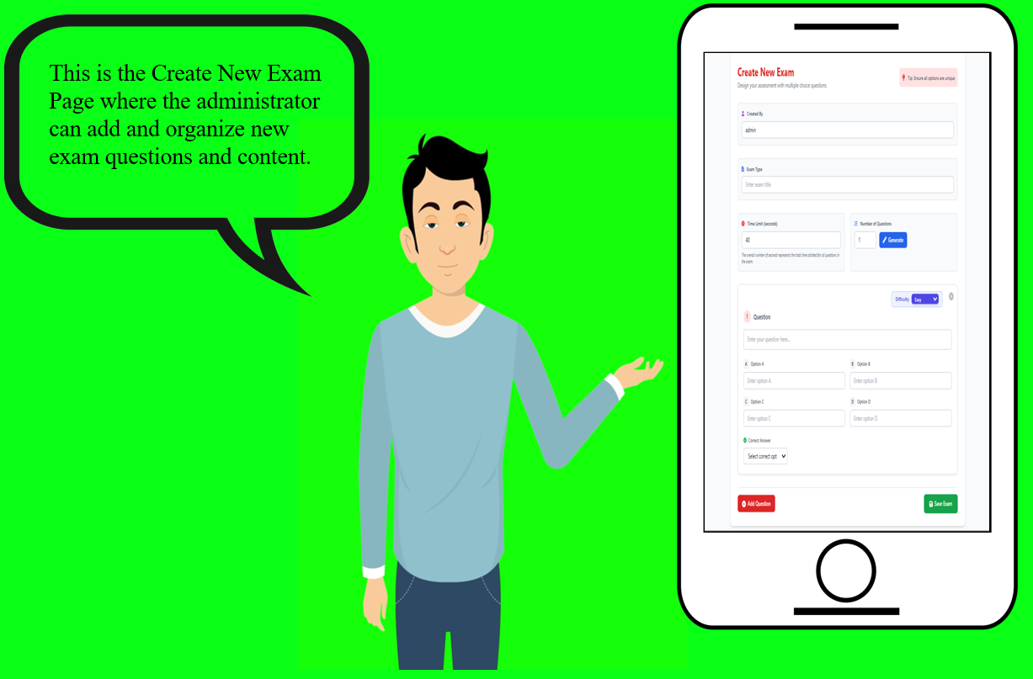

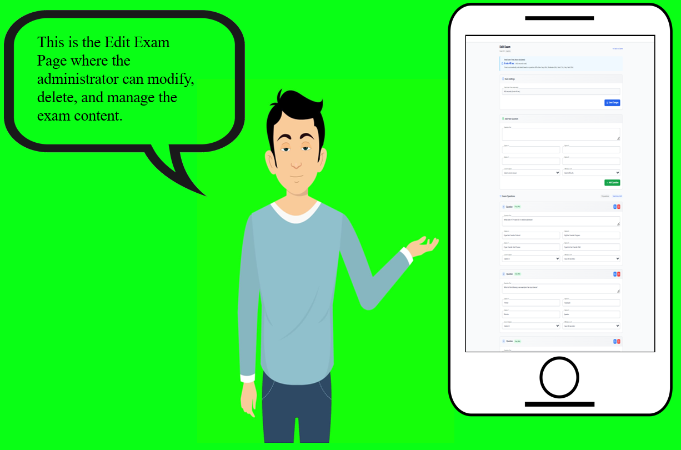

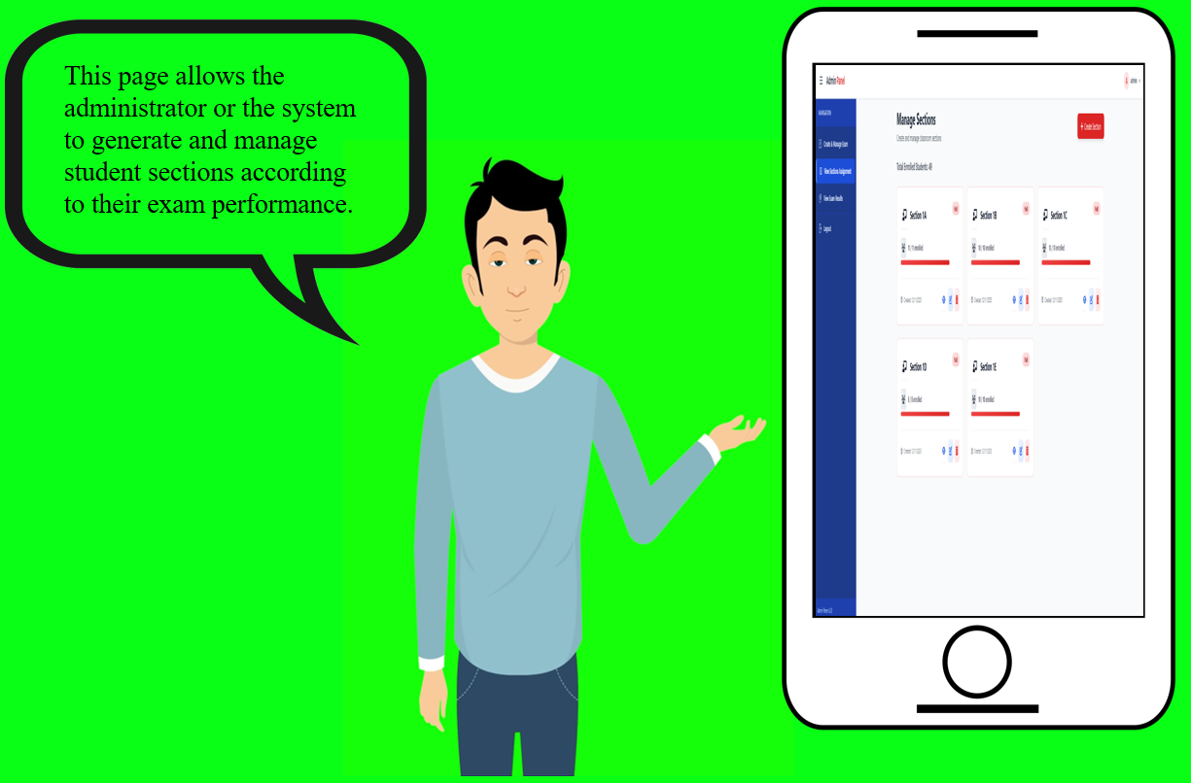
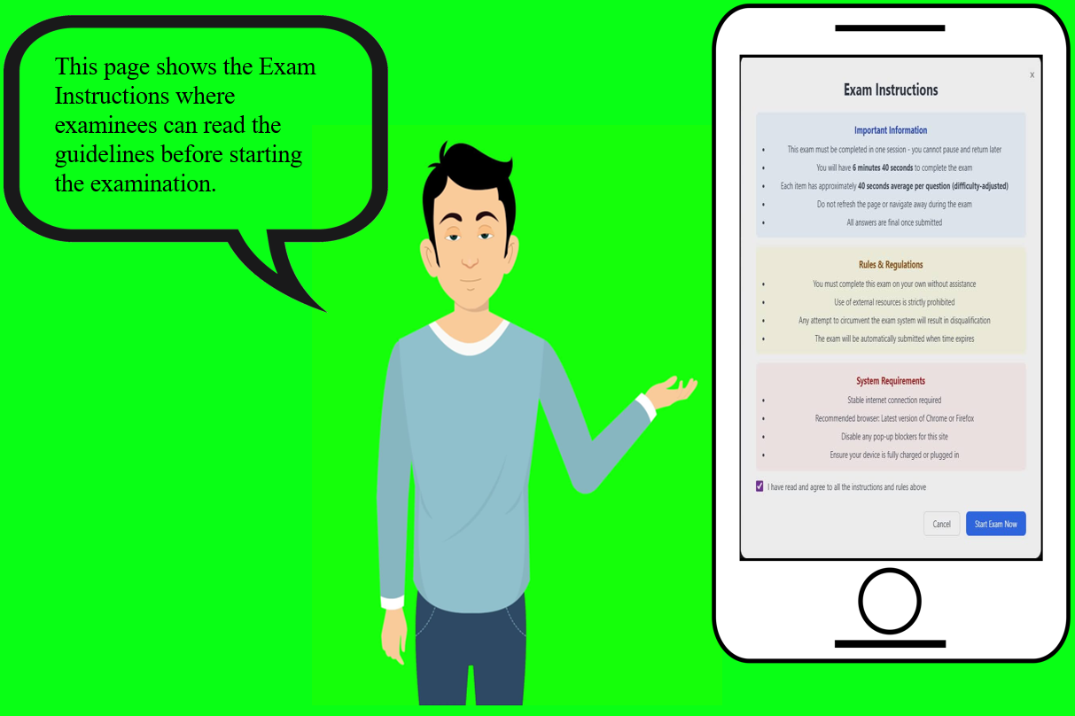

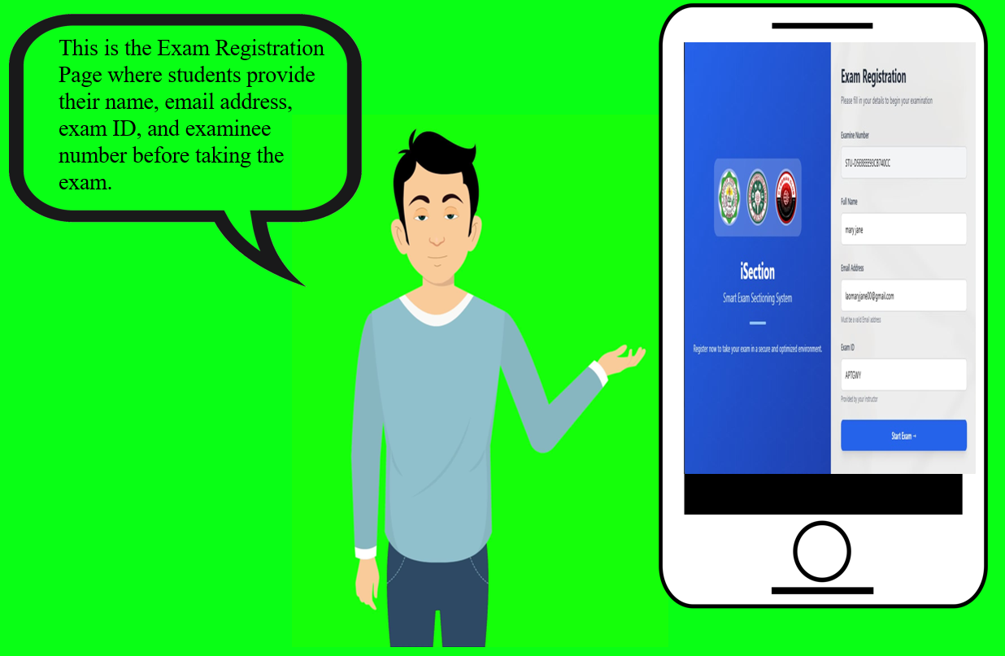

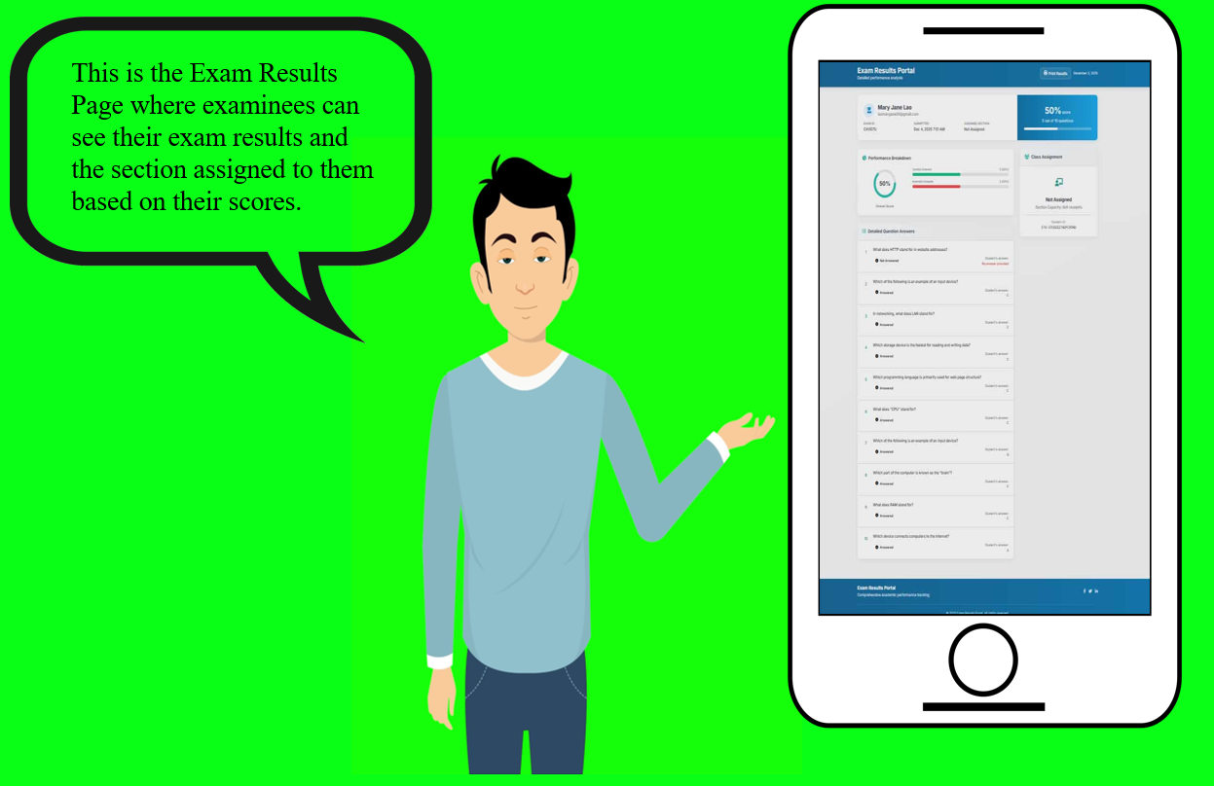

Sample Input/Output

The picture above shows an example of the completed input provided by the user. The Student Performance Page was selected since it displays the students’ performance and their corresponding exam scores.

The picture above displays the final result or output produced by the system after processing the input data. This output allows administrators and students to easily review performance and section assignments.



Photo Documentation

The images above show the journey of this study, highlighting the key steps and activities completed during the development of the system. They provide a visual overview of the process, from planning and design to testing and final implementation, demonstrating how the iSection system was created and made functional.


Curriculum Vitae

Personal Data

Full Name : Mary Jane D. Lao
Gender : Female
Date of Birth : August 06, 2002
Place of Birth : Dao-an San Miguel, Zamboanga Del Sur
Civil Status : Single
Citizenship : Filipino
Religion : Roman Catholic
Address : Dao-an San Miguel, Zamboanga del Sur
Father's Name : Leonardo D. Lao
Occupation : Farmer
Present Address : Dao-an San Miguel, Zamboanga del Sur
Mother's Name : Marissa D. Lao
Occupation : Housewife
Present Address : Dao-an San Miguel, Zamboanga del Sur

Educational Background
Education  Primary  Secondary  Tertiary  Degree | School Year Graduated  : Dao-an Elementary School 2015-2016  : Betinan, National High School 2021-2022  : J.H. Cerilles State College 2025-2026  : Bachelor of Science in Information Technology (BSIT)


Curriculum Vitae

Personal Data

Full Name : Lovelyn B. Caong
Gender : Female
Date of Birth : November 12, 2002
Place of Birth : Limbatong, Margosatubig, Zamboanga Del Sur
Civil Status : Single
Citizenship : Filipino
Religion : Roman Catolic
Address : Limbatong, Margosatubig, Zamboanga del Sur
Father's Name : Marcelo M. Caong Jr
Occupation : Construction
Present Address : Limbatong, Margosatubig, Zamboanga del Sur
Mother's Name : Irene B. Caong
Occupation : Housewife
Present Address : Limbatong, Margosatubig, Zamboanga del Sur

Educational Background
Education  Primary  Secondary  Tertiary  Degree | School Year Graduated  : Limbatong Elementary School 2014-2015  : Kalian National High School 2020-2021  : J.H. Cerilles State College 2025-2026  : Bachelor of Science in Information Technology (BSIT)


Curriculum Vitae

Personal Data

Full Name : Kimberly T. Hadjula
Gender : Female
Date of Birth : October 21, 2002
Place of Birth : Martirez Jolo, Sulu
Civil Status : Single
Citizenship : Filipino
Religion : Islam
Address : Guling, Guipos, Zamboanga del Sur
Father's Name : Martelino A. Hadjula
Occupation : Law Enforcer
Present Address : Guling, Guipos, Zamboanga del Sur
Mother's Name : Norma T. Hadjula
Occupation : Deceased
Present Address : Guling, Guipos, Zamboanga del Sur

Educational Background
Education  Primary  Secondary  Tertiary  Degree | School Year Graduated  : Guling Elementary School 2014-2015  : Guling National High School 2020-2021  : J.H. Cerilles State College 2025-2026  : Bachelor of Science in Information Technology (BSIT)


Curriculum Vitae

Personal Data

Full Name : Romelyn U. Parame
Gender : Female
Date of Birth : November 25, 2003
Place of Birth : Guling, Guipos Zamboanga del Sur
Civil Status : Single
Citizenship : Filipino
Religion : Roman Catholic
Address : Guling, Guipos, Zamboanga del Sur
Father's Name : Romeo C. Parame
Occupation : Carpenter
Present Address : Guling, Guipos Zamboanga del Sur
Mother's Name : Arlyn U. Parame
Occupation : House Wife
Present Address : Guling, Guipos, Zamboanga del Sur

Educational Background
Education  Primary  Secondary  Tertiary  Degree | School Year Graduated  : Guling Elementary School 2015-2016  : Guling National High School 2021-2022  : J.H. Cerilles State College 2025-2026  : Bachelor of Science in Information Technology (BSIT)

