

J.H. CERILLES STATE COLLEGE
School of Computing Studies
Bachelor of Science in Information Technology
Main Campus, Mati, San Miguel, Zamboanga del Sur

Food Allergy iGuide

Final Project
In
IT-311
System Integration and Architecture 2

Submitted by:
Mary Claire R. Sumonod
Student
Submitted to:
Rhea Jane M. Prumon
Instructor
2026

Chapter 1
THE PROBLEM AND ITS SCOPE

1.1 Introduction
Food allergy is a frequent health concern these days that affects people of all ages. Some food allergies can cause symptoms such as itching, swelling, breathing problems or, in extreme cases, life-threatening infections, even after a brief exposure. People generally don’t have easy access to reliable information regarding what to do in the event of an allergic reaction. Such misinformation can be harmful to health and cause a delay in necessary treatment, especially in emergencies.
In Barangay Regla, people with food allergies usually rely on their own knowledge, on advice from others, or on delayed doctor’s appointments. This issue underscores the need for a system that can give fast, reliable and easily accessible information about allergy therapies. A computerized platform enabling people to look for the proper medications for their sensitivity can substantially improve the response time and safety.
To fulfill this demand, the proposed system Food Allergy iGuide is designed. The system is intended to be a user-friendly platform for users to search for specific food sensitivities and receive prescription or treatment recommendations. At the same time, the administrator updates drug and allergy data and checks its accuracy. The system is designed to be a reliable tool for community health and safety improvements, quick action and raising awareness.
1.2 Purpose and Description
The Food Allergy iGuide is intended to give consumers a reliable, easy approach to identify appropriate treatments for food allergies. Because food allergies require immediate attention, getting the proper medication quickly can prevent complications and improve health outcomes. This approach assists consumers in retrieving critical medical information, particularly in the absence of professional assistance. Its easy-to-use format allows users to search for specific food allergies and discover recommended remedies, safety warnings and explanations. This enables customers to respond swiftly and make prudent decisions in case of an allergic response.
Another responsibility of the administrative module of the system is to keep current information on allergies including prescription drugs and treatment specifics. The Food Allergy iGuide also guarantees that all information will be current by providing a single resource consumers can always refer to for up-to-date, easy-to-understand and well-organized information. The community benefits from this strategy through the increase of information, the acceleration of treatment of allergy problems and the improvement of health management practices.
1.3 Objectives
This study aims to:
1. Design a Food Allergy iGuide system that allows users to search for allergy-related medicines.
2. Develop a user-friendly platform that provides accurate and accessible information about food allergies and treatments.
3. Test the system to ensure its accuracy, usability, and reliability for both users and administrators.

1.4 Scope and Limitation
The Food Allergy iGuide is a web-based system intended to allow users to search for food allergies and find prescribed treatments. The system has capabilities including allergy search, display of medicine information and basic safety precautions. It also provides an admin module for the administrator to add, delete and update allergy information, medicine details and other system data.
However, the system can only provide information concerning food allergies and the drugs associated to food allergies. This is not a substitute for professional medical consultation or diagnosis. The accuracy of the system is dependent on the data entered and maintained by the administrator. Moreover, the system requires internet access, thus anyone without access to digital devices or Internet may not be able to access it.
1.5 Definition of Terms
Food Allergy iGuide – A suggested system to allow users to search for food allergies and view recommended drugs and treatments.
User – An individual who utilizes the system to look for information and medications about allergies.
Administrator – The person who is responsible for updating and managing the system’s data, including allergy and drug information.
Food Allergy A medical condition in which the body reacts adversely to specific foods.
Medicine – A drug to treat or manage symptoms of food allergies.

Chapter 2
REVIEW OF RELATED STUDIES AND SYSTEM
2.1 Foreign Studies
Development and Evaluation of a Mobile Web-based Food Allergy and Anaphylaxis Management Educational Program for Parents of School-aged Children with Food Allergy: A Randomized Controlled Trial
Kwen and Oh (2022) designed and tested a mobile web-based education program to enhance the understanding and management abilities of parents responsible for their children’s anaphylaxis and food allergies. The initiative offered users teaching materials, allergy control techniques, and emergency response protocols through a user-friendly online platform. The researchers observed that users of the system had a better awareness of food allergies, symptom detection and appropriate treatment options. The study also proved the effectiveness of web-based technology in health education and self management. The research suggests that online platforms can be valuable tools for promoting awareness and reducing the chances of food allergy occurrences.
The results of this study are pertinent to the Food Allergy iGuide since both systems use digital technology to offer clients with crucial information about food allergies.These findings suggest the use of web-based platforms as helpful tools to improve knowledge and comprehension of allergy management. It also supports the goal of the proposed system which is to provide reliable and readily available information that can help users to respond correctly to allergic reactions.
Food Allergy Symptom Self-Management With Technology (FASST) mHealth Intervention to Address Psychosocial Outcomes in Caregivers of Children With Newly Diagnosed Food Allergy: Protocol for a Pilot Randomized Controlled Trial
Broome et al. (2021) created a mobile health intervention called Food Allergy Symptom Self-Management With Technology (FASST) program to assist caregivers in managing food allergy symptoms. The system was developed to give users tools for documenting symptoms, educational materials, and help on managing allergic responses. The study showed the importance of technology in fostering self-management practices and improving the access to health care information. The results indicated that customers valued being able to acquire reliable information quickly, which in turn enhanced their confidence in their choice of allergies. “Technology-based therapies can significantly improve allergy management and health outcomes,” the researchers say.
The study provides evidence for the construction of Food Allergy iGuide by demonstrating how technology can support patients in better managing food allergies. Both programs are designed to provide users with rapid access to accurate information on allergy symptoms and treatments. Those findings underscore the benefits of digital health tools in helping to make timely informed decisions during allergic reactions.

Assessment of the quality of mobile apps for food allergy
The quality, reliability and utility of mobile apps for food allergy management have been investigated by Wu et al. (2022). The study examined a wide variety of applications, according to things such as accuracy of information, usability, user interaction and overall effectiveness. The findings showed that many people use digital tools to learn about food allergies and their prevention and treatment. Researchers say it’s important to share accurate and up-to-date information to help maintain user trust and promote safe ways to treat allergies. The study showed that smartly designed health applications can be quite helpful for users wanting advice on allergy related issues.
This study is directly relevant to Food Allergy iGuide as it highlights the necessity of accurate and reliable allergy information on digital platforms. The results support the addition of an administrator module to manage and update drug and allergy records on a regular basis. It emphasizes the need for a simple-to-use system that individuals can trust when searching for information on food allergies and their management.
2.2 Local Studies
Understanding Adoption of Electronic Medical Records (EMRs) During a Health Emergency: An Analysis of EMR Usage Logs from Rural Health Facilities in the Philippines
Acacio-Claro and colleagues (2024) examined the usage of electronic medical records in health facilities in rural areas of the Philippines. Digital health systems increase clinical management, effectiveness of healthcare and access to patient information, the report said. It pointed out that when digital records are neatly organised it is easier for medical workers to handle and retrieve data. The study also found that health information systems enable better health service delivery and decision making. Their findings underscore the rising relevance of digital solutions in the Philippine healthcare market.
This study is related to Food Allergy iGuide since both use digital technology to store and access health related information. This supports the concept of a centralized database for efficient administration of allergy and pharmacological data. The findings further underscore the need of organized health information systems in enhancing health care services.
Quality of Care of Adult Patients With Allergic Diseases in Urban, Rural, and Remote Primary Care Sites in the Philippines
A study by Tan-Lim et al. (2025) examined the level of care provided to individuals with allergic conditions in certain healthcare settings in the Philippines. The study found that the provision of healthcare services and information on allergies was affected by geographical and resource disparities, highlighting the necessity to enhance the care provided to individuals with allergies. The researchers also underscored the significance of improved management systems and accessible health information for optimal patient care. They concluded that technology could play a vital role in improving health care related to allergies.
The focus of this study on allergy-related healthcare management has direct relevance to Food Allergy iGuide. The results support the need for easily available information systems which could assist people understand and manage allergy diseases. It also stresses the necessity for reliable allergy and treatment information on digital platforms.

Formative Evaluation of the Implementation of eHealth in the Philippines: A Qualitative Study
Evio & Bonito (2024) in their qualitative study on the installation of eHealth systems in the Philippines. The research claims information and communication technology is crucial to enhancing health care delivery, access and information management. The results showed that digital health platforms provide communities with more access to healthcare services and information, especially in locations with scarce healthcare resources. The researchers also underscored the need for reliable and timely health data for efficient healthcare services. The study also emphasized the importance of eHealth systems in improving decision making and enhancing public knowledge on health concerns.
This study is pertinent to Food Allergy iGuide since both are concerned with the dissemination of health information using digital technology. The results support the adoption of web-based technologies to improve access to healthcare information and services. The need of precise and updated information in the proposed allergy management platform is also validated.

Chapter 3
DESIGN AND METHODOLOGY
3.1 Methodology
The proponent used 4D model to represent the developmental process of the study. This model includes define, design, develop, and deploy phases.
Develop

Design

Deploy

Define

Define Phase
The Define Phase aimed to understand the difficulties and needs in the area of food allergy information management. Information was acquired from observations and literature analysis on food allergies, allergic reactions, and treatment approaches. The researchers found that many people had trouble accessing immediate and credible information on relevant treatments for food allergies. Hence, the requirement for a centralised and easily accessible information system was formed. This phase was the basis for defining the objectives, scope and requirements for the Food Allergy iGuide.
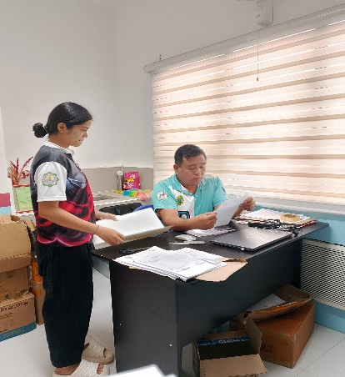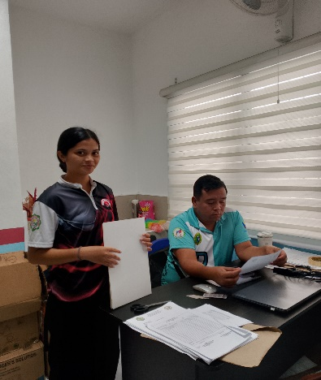
Design Phase
The Design Phase was concerned with planning the general structure and functionality of the system. In this step, the researchers designed the system navigation flow, database structure, and user interface. The system was designed to provide a simple and easy-to-use environment where the users can easily search for food allergies and get relevant information about the medications. In addition, a database structure was designed to properly arrange information on medicine, safety instructions and allergy records.

Develop Phase
The Develop Phase was all about actually creating the Food Allergy iGuide. The system was built with the relevant web development tools and technology. Researchers created the system’s main functions, including looking for allergies, displaying drug information, describing treatments, and giving safety information. An administrative module was also developed to enable the administrator to monitor and update allergy and prescription data. The system was tested after its establishment to verify that all its features functioned as expected and the data it contained was trustworthy and correct.

Deploy Phase
The Deploy Phase was the implementation and evaluation of the final system. The Food Allergy iGuide was released for testing and assessment by the target users. Feedback and observations were gathered to help pinpoint possible improvements and ensure the system was achieving its objectives. This stage was important to ensure the system operated, was easy to use and could provide reliable information about food allergies.

3.2 Current System Flow

Treat Case
Manage Case
Health Center


Record Case
Health Worker
Patients
Figure 3.2 Current System Flow

The graphic depicts how Barangay Regla now handles food allergies. When someone has an allergic response, they are brought to the health center to receive medical care, evaluated by health professionals, prescribed medication, and have data on their allergy recorded. The health clinic is the main place to get advice and treatment for food allergies. However, the approach is mostly dependent on human consultation and documentation, which may delay the access to precise information about suitable drugs and therapies. There is no one digital platform for allergy information, which limits its availability and accessibility, especially in an emergency. These shortcomings underline the significance of the Food Allergy iGuide, an online tool created to offer customers fast, reliable, and user-friendly access to information on specified food allergies and treatments.
3.3 Context Diagram
Add allergy records, Update medicine information, Manage system data

Search food allergy, Request allergy information
FOOD
ALLERGY
iGUIDE
User
Administrator

Allergy records, Medicine information,System data reports
Recommended medicines, Treatment information, Safety guidelines

Figure 3.3 Context Diagram

The graphic shows a high-level view of the system's interactions with its external entities, the User and the Administrator. The User can search for information on food allergies and ask for specifics on allergens, and the system recommends medicines, treatment information and safety instructions. On the other side, the Administrator is responsible for adding allergy records, updating drug information and monitoring system data. In return the system provides access to allergy records, medicine information, system statistics and reports. This graphic serves to explain the scope of the system and the flow of information between the users and the Food Allergy iGuide System.

3.4 Activity Diagram

Login Account

Yes
No
Valid Account

Print Result
View Recommended Medicines
Search Allergy
View Allergy Details
Read Safety Guidelines

Figure 3.4 Activity Diagram (User)

The figure shows the order of activities that the user executes in the Food Allergy iGuide System. The user logs into the system to start the process. To confirm the authenticity of the account, the system checks the user’s login info. If the account is invalid it returns the user to the login screen. Once the user has authenticated properly, the user can search for a particular food allergy, check up allergy information, study various remedies, read safety instructions and store or print the results for later use. These activities offer people dependable and readily available information on food allergy and its treatment. Once the user has carried out the
desired operations on the system , the procedure terminates .
Login Account

No
Yes
Valid Account

Manage Allergy
Update Safety Guidelines
Manage Medicine Information
Generate Reports

Figure 3.5 Activity Diagram (Administrator)

The figure shows the sequence of activities conducted by the administrator in the Food Allergy iGuide System. It starts when the administrator logs into the system. If the system finds the administrator’s account credentials invalid, the administrator is sent to the login screen. After a successful authentication the administrator can warn users, enforce safety rules, update prescription information, manage allergy data and generate reports. These administrative tasks guarantee that the data recorded in the system is timely, correct and reliable. When the administrator has finished all required system management activities, the process stops.

3.6 Use Case Diagram
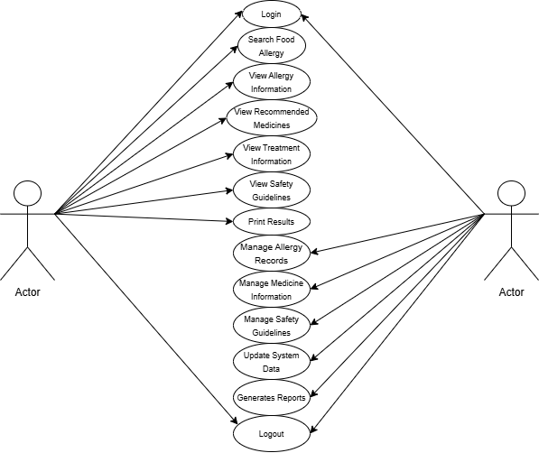
Figure 3.6 Use Case Diagram

The image depicts the Use Case Diagram of the Food Allergy iGuide System which shows the interaction of the system with the two primary users the Administrator and the User. The user receives information about the food allergies, recommendations on medicine, information about the treatment, safety measures and the ability to print the results for their records. These features enable customers to access accurate and readily available information on the management of food allergies. The Administrator, on the other hand, maintains the system by generating reports, monitoring allergy records, managing access to the system, updating prescription information, and ensuring that safety regulations are being followed. These administrative responsibilities ensure that the system's data is timely, accurate and reliable. The use case diagram of the Food Allergy iGuide shows how technique helps for data management for administrators and information retrieval for users.

REFERENCES
Acacio-Claro, P. J., Estuar, M. R. J. E., Villamor, D. A. R., Bautista, M. C. G., Pulmano, C. E., & Sugon Jr, Q. M. (2024). Understanding adoption of Electronic Medical Records (EMRs) during a health emergency: an analysis of EMR usage logs from rural health facilities in the Philippines. Acta Medica Philippina, 58(22), 7.

Broome, B., Madisetti, M., Prentice, M., Williams, K. W., & Kelechi, T. (2021). Food allergy symptom self-management with technology (FASST) mHealth intervention to address psychosocial outcomes in caregivers of children with newly diagnosed food allergy: protocol for a pilot randomized controlled trial. JMIR Research Protocols, 10(3), e25805.

Evio, B. D., & Bonito, S. R. (2024). Formative evaluation of the implementation of eHealth in the Philippines: a qualitative study. Acta Medica Philippina, 58(12), 35.

Kwen, H., & Oh, P. J. (2022). Development and evaluation of a mobile web-based food allergy and anaphylaxis management educational program for parents of school-aged children with food allergy: a randomized controlled trial. Asian nursing research, 16(5), 265-274.

Tan-Lim, C. S. C., Falcon, R. M. G., Feliciano, J. F., Fong, M. B., Javelosa, M. A. U., Dans, L. F., ... & Dans, A. M. L. (2025). Quality of Care of Adult Patients With Allergic Diseases in Urban, Rural, and Remote Primary Care Sites in the Philippines. Journal of Primary Care & Community Health, 16, 21501319251353599.
Wu, A. C., Walsh, R., & Wang, A. L. (2022). Assessment of the quality of mobile apps for food allergy. The Journal of Allergy and Clinical Immunology: In Practice, 10(6), 1658-1659.

