client_account_id = disrupt_burrup_hub
client_account_link = https://www.instagram.com/disrupt_burrup_hub/
client_post_id = https://www.instagram.com/p/C9TEKADTcgY/?img_index=1
client_post_summary = BREAKING: WOODSIDE’S BURRUP HUB DISRUPTED
A 17-year-old school student and a school teacher have blocked the only road in to Australia’s largest fossil fuel project by chaining themselves to concrete barrels inside an SUV and boat at approximately 4am this morning.
The protest by Emma, a 17-year-old high school student, and Petrina, a schoolteacher, is the culmination of an escalating campaign to block Woodside’s Burrup Hub from destroying sacred Murujuga rock art and emitting 6 billion tonnes of CO2 into the atmosphere until 2070.
The Browse gas field threatens to collapse the fragile Scott Reef, the only nesting habitat for endangered sea turtles, and to interrupt whale migration routes.
Meanwhile, emissions from Woodside’s Burrup Hub will destroy not just Australia’s global carbon commitments but also recklessly endanger sacred Murujuga rock art - Woodside has already destroyed thousands of sites.
It comes as research shows that Woodside’s Burrup Hub threatens to diminish WA’s domestic gas supply by exporting nearly all of the gas Woodside produces offshore to foreign companies that pay almost no Australian royalties.
Petrina, a school teacher, said:
“I’m here at Woodside’s Burrup Hub to stop the largest fossil fuel project in Australia. This is a safe, sensible, proportionate response to an emergency unfolding at Woodside’s Burrup Hub.”
“Woodside is spewing toxic emissions all over this sacred rock art all around me, and Woodside is pumping 6 billion tonnes of CO2 into our atmosphere. The gas plants behind me are the most polluting in the Southern Hemisphere and Woodside is asking the government to extend them.”
A Disrupt Burrup Hub spokesperson said this morning:
“There is one road in and out of Woodside’s Burrup Hub - this isn’t hard, anyone can do it.”


pri35278

Thank you 👏👏👏

belindaprentice

Amazing!!! Thank you thank you thank you!!!!
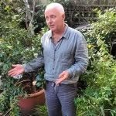
michaelmobbs

Thank you. You are all so very wonderful. Heroic and full of integrity.

jasm1ne._.williams

✊✊✊
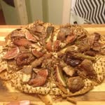
dumpsterdivechef

Good stuff
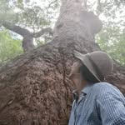
amy.warne.50

Legends!
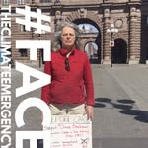
climatestrikefridays

Thanks
climatestrikefridays

Tack

ara.kaitness

This is real climate action. Great work folks. Much respect and gratitude 💚
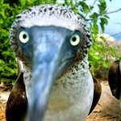
rhirhi.privsssss

Amazing action ❤️

leepatrick9

Thank you Emma, for your courage, wisdom and awareness. May Australia support and protect you for this courageous stand. ❤️❤️.

manee.jane

Go Emma! 👏👏👏
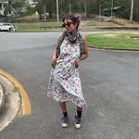
chaiskid

solidarity sis ❤️❤️
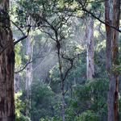
wildlife_forever_m_r

🙌 Legend Emma, your an inspiration 🙌
Thank you 🙏
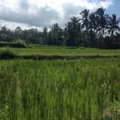
grasshutliving

👏 thank you for blocking Woodside, brave people!

annalouiserichardson

Legends. 🙌

indigoo_andersonn

your amazing emma ❤️

smallstream.82

Go team 💪❤️
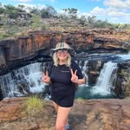
envirobren

Thank you so much Emma and Petrina for standing up

tommy_tiplady

🔥🔥🔥
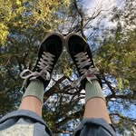
ocean_noonan

👏👏👏

schoolstrikeforclimate

✊✊

rileyy_katrin

GO EMMA

cmchatbox

Aww this brings tears to my eyes! Well done ❤️🙌

n.nirvanaa

SENDING LOVE AND POWER TO THE BOTH OF YOU 💗💗
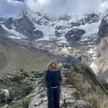
desert.gemillea

Ahhhhh go Emma! Go Petrina! Absolutely amazing, thank you thank you ❤️

lauraablogg_______

✊🏾✊🏾✊🏾✊🏾✊🏾

seedmob

🔥🔥🔥Deadly! Thanks for standing up for Country, communities and climate ✊🏾

ariana._.harris

👏👏

omegamunga

⭐⭐⭐🔥❤️🔥⭐⭐⭐ You rock. Sucks this is necessary, thank you for doing it.

katentwist

you go emma ❤️

arlo.h_97

Omg Emma I love you so much! So incredible

mermaids.mads

Incredible stuff ❤️❤️❤️

pattiburton

so staunch ❤️ @emma1h_
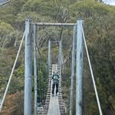
ca.rina3

HIT AFTER HIT. absolute legends
decloid757

Legends

beatsandpiecesstudio

With you, thank you ✊🏼💜🌿
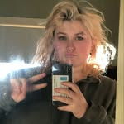
_ayla_ermm_

Sick one 💖💖

mooreandmoore_cafe

👏👏

alexgoodsir

go emma !!!

jessenaylorz

So awesome Emma, good work!

karaakingup

So grateful to everyone that made this happen. And to Emma and Petrina for your courage, heart and rage.

tilda.lr

many many thanks to emma and petrina for their courage & tenacity ❤️❤️❤️❤️❤️

sazzlebedazzle

@hayleyskirk more wonderful humans ❤️
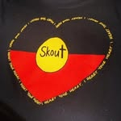
hayleyskirk

@sazzlebedazzle 🙌🏾 YESSSSSSSS 🌏🔆🙏🏽🌊 thank you Emma and Petrina for your courage in being fiercely determined to protect our oceans and our planet!

mrs.burnsey

Emma you bloody ICON I LOVE YOU LEGEND🔥🙌

shellilabelle

Thank you.

ruby.pickers

amazing

tommallum

Legends

isabellaanne07

amazing!!!! 👏
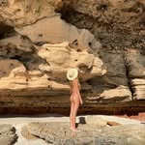
yazmin.byrne

amazinggg
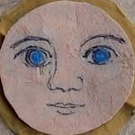
anmrie_l

Brilliant! 👏👏👏👊🔥❤️

brontessimpson

Legends!!! 👏

trice0208

👏👏👏

lastquokka

Fck yes 🔥

madeleineantoine

Great action! Thank you to everyone involved 🤍

sampsonmccrackan

🔥

alex_westover

Legends. Good work!!
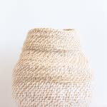
sianboucherd

Legends 🙌
lucasblackman_

legends!!!!!!
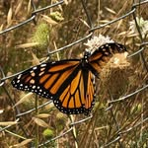
mena_tabeshfar

so so so awesome 💖

ka_zzaaaa

Absolute legends 🔥🔥Thank you both so much! Massive respect ❤️🙌
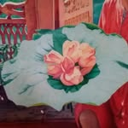
devaaviram

Thank you Emma and Petrina for keeping faith and animating this for us all
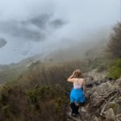
dallymore4

Amazing 👏👏

liamcrossactivism

🔥🔥🔥🔥🔥🔥🔥

d4ndoush

MY LOVE
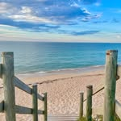
therealkerryb

Love your work you absolute legends

sweetsage_tattoo

Amazing work 👏

tea_freak_

🙌🙌

ratajabdullahh

🩵🩵 too good, so staunch both of u
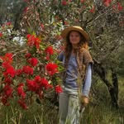
urallauralla

🔥🔥🔥
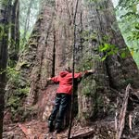
_chelsea.sea_

Legends 🔥🔥🔥

jodarbs

Amazing effort. Good work you legends

natttreeves

EMMA YOU’RE SO COOL <33

violet_coco_canary

Awesome action. Just one road in and Out hey? 🤔😎
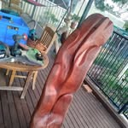
theos_timber_creations

@violet_coco_canary hello 👋

xrwagrandparents

@violet_coco_canary yep

petrinaharley6

@violet_coco_canary - eastern states comrades want to come over and camp? The stars are incredible over the Burrup!!
violet_coco_canary

@petrinaharley6 absolutely I do

theveganmindsetcoach

Wow, so incredibly courageous the both of them!
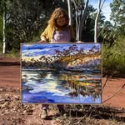
tazwitkamp.artist

👏

margs_edwards

Emma and Petrina … the planet thanks you 🙏🏼 and so do all who wish the government had the courage and passion to protect it that you have 🌿🤎
Having heard you speak several times now Emma, I know how strongly you and your generation feel about having no choices but to act for the planet. Long live #climatechampions the generations to follow will thank you too #facethefuture #disruptburruphub
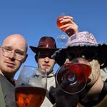
lewispke

👏👏👏

misskyleemae

Legends! ❤️
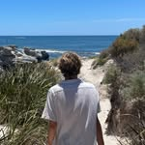
willdalliimore

absolute legendsss 🔥💗
willdalliimore

UR MY IDOL EMMAURRR

maranoa.mosaic

🔥👏🔥👏well done 🔥👏🔥👏

__jesstigram__

👏👏👏👏 courageous

bek.spear

Thank you both ❤️

devonmaide

Absolute legends

schmangelinee

Power to you both!!!!
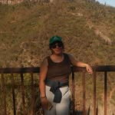
anjali_jb

LOVE YOU EMMA, SO STAUNCH ❤️❤️
mjmisi

Shut it down! You bloody legends!
Скрыто алгоритмами Instagram

ca.rina3

GO EMMAAAAA FUCK YEAH
theos_timber_creations

❤️ very proud 👏 thankyou 👋 call out to anyone who's inspired 🔥
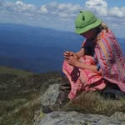
joey_thompsn

EMMA YOU FUCKING LEGEND
ratajabdullahh

EMMA YOU FUCKING LEGEND
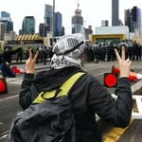
cutmesomeslacktivism

@ratajabdullahh in such an iconic position too
cutmesomeslacktivism

Absolutr fucking icons

