# New Dependencies

New Dependencies 1

Abstract 2

1. Who Would Win? 4
2. Cloud Gazing 5
3. Surfing the Web 7
4. Back to the Sea 9
5. Back to the Land 11
6. Occupying the Land 14
7. Hotel Mokum 17

7: Trespassing, an afterword 21

Appendix: Incomplete and Unordered List of Reasons to Refuse the Cloud 24

## Abstract

*Dear Reader,*

*This text is a nomadic journey from the (or: this) abstract to the material. I am trying to establish a lineage between a spatial practice like squatting and a (for lack of a better term) digital practice like self-hosting. First, I examine the spatial and geographical metaphors we (have) use(d) to describe the internet, and argue that any understanding of it as a separate, autonomous space is insufficient. I then argue that tactics and sentiments from the squatting movement could be applied to their digital counterparts. As an example, I examine how squats don't function as autonomous spaces per se, but rather as nodes situated in larger contexts and (support) networks, reliant on a new set of dependencies that they define for themselves. I conclude with examples in which the two domains merge, specific to the city of Amsterdam. I do take for granted a certain understanding of what is wrong with the internet today. You can find a summary of this, a starting point of sorts, in the appendix.*



fig A.1: A Thundercloud, a mix of a cloud icon and the international squatting sign that resembles lightning strike.

## Who Would Win?

| **self-hosting** | **squatting** |
| --- | --- |
| refusing (privacy) policies | refusing (housing) policies |
| hosting and serving (files) | hosting and serving (people) |
| programming (computers) | programming (events) |
| don't pay rent (software as service) | don't pay rent (actual rent) |
| community building (who is invited?) | community building (who is invited?) |
| security (encryption) | security (barricades) |
| constant maintenance | constant maintenance |
| resist cloud control | resist crowd control |
| using existing infrastructures | using existing infrastructures |
| recycling (old hardware) | recycling (old houses and building materials) |
| open source principles | open source principles |
| following manuals and protocols | following manuals and protocols |
| improvised structures & unconventional design strategies | improvised structures & unconventional design strategies |
| disaster always imminent: data loss | disaster always imminent: eviction |
| Everything went downhill from ~2010 | Everything went downhill from ~2010 |
| nostalgia | nostalgia |
| nomadic in nature: changing ip addresses | nomadic in nature: changing addresses |
| situating yourself in a network | situating yourself in a network |
| de-appropriating someone else's space | de-appropriating someone else's space |

fig 0.1: A lot of words in tech are similar to words used IRL

## Cloud Gazing

On September 12, 2010 the Youtube Channel revelation13net uploaded a video titled *By Psychokinesis a Psychic* *Turns a Cloud into a Square Cloud* in Sept. 2010. In this 02:18 video, a man is filming the sky with a handheld camera. Visible is a single cloud on an otherwise entirely blue sky, lined by some trees on the edge of the frame. We never see the person holding the camera but can hear them speak throughout the video. They introduce themselves as T. Chase and explain that they will now attempt to change the shape of the cloud into a square through psychic powers. They keep repeating this statement like a mantra of sorts, altering and distorting their voice as the video progresses. The cloud slowly changes shape, and by the end of the video it does look more like a square than in the beginning of the video, even though it's hard to say whether this might have just been the way it naturally changed shape.

In September 2008, the free software advocate Richard Stallman expressed his concerns regarding cloud computing to the Guardian, claiming that it was stupid1and just a way to lock users into proprietary ecosystems. Stallman is a prominent advocate for privacy and the open source movement, and (among a lot of other things) founder of the Free Software Foundation. He is well-respected in the tech community, but his statements about cloud computing received mixed responses. He was accused of populism2, supposedly ignoring the lived realities of actual users who are often already trapped in their operating systems and office suites anyway and don't necessarily have the capacities to practice the cloud refusal he was preaching. Others accused Stallman of simply stating the obvious. Reuven Cohan3illustrated this criticism with a still from an episode of the animated TV show *The Simpsons*, which ended up becoming something of a meme later. The image shows a newspaper clipping in which Abe Simpson, the elderly father of one of the protagonists, Homer Simpson, angrily shakes his fist at the sky under the headline Old Man Yells at Cloud. Since my 30th birthday last month I sometimes think this image is actually about me.

The Cloud is a mystical space, its name is already opaque, veiling what it actually describes, which you could call network infrastructure, or maybe just: someone else's



1[https://www](http://www.theguardian.com/technology/2008/sep/29/cloud.computing.richard.stallman).theguar[dian.com/technology/2008/sep/29/cloud.computing.richard.stallman](http://www.theguardian.com/technology/2008/sep/29/cloud.computing.richard.stallman)

2https://web.archive.or[g/web/20081122005447/http://www.mathewingram.com/work/](http://www.mathewingram.com/work/) 2008/09/29/hey-hey-you-you-get-off-of-my-cloud/

3https://web.archive.or[g/web/20081205032726/http://www](http://www.elasticvapor.com/2008/09/stupid-).elasticvapor[.com/2008/09/stupid-](http://www.elasticvapor.com/2008/09/stupid-) redux-old-man-gnu-yells-at-cloud.html

computer4. Interestingly, the term originates from exactly this position of not knowing, of occlusion. In network diagrams the cloud is traditionally used to denote parts of the network that we have no control over or no concrete knowledge about. It's the part beyond the blinking lights of our router, the abstraction of the internet. Its shape alludes to the uncertainty of what is out there, something that constantly changes shapes, is hard to grasp.

This inherent uncertainty is maybe why attempts to refuse the cloud can often feel futile. Even defining what it exactly is that we are refusing is already a tiring exercise. As it often is with computers, the conversation is one-sided, with us yelling at the cloud, trying to shape it, but not getting a response, because the cloud doesn't generally care. Still, a vague feeling of urgency remains.

In 2019, web designer Becca Abbe sensed the dawn of what she called the internet's back-to-the-land movement5, a new movement of users away from the cloud, in reference to the 1960s counter cultural movements away from the cities in the US (which, in turn, directly informed the early beginnings of Silicon Valley's tech world). It seems tempting to leave the celestial cloud behind, with all its fake news and inequalities, to get back down to the ground truth so to say. But what exactly is this land, we would return to, and who exactly is it that is going there?



4[https://www.amazon.com/Humor](http://www.amazon.com/Humor-There-cloud-someone-computer/dp/B07KW5MPH2)-Ther[e-cloud-someone-computer/dp/B07KW5MPH2](http://www.amazon.com/Humor-There-cloud-someone-computer/dp/B07KW5MPH2)

5[https://www](http://www.are.na/blog/the-internet%27s-back-to-the-land-movement).ar[e.na/blog/the-internet%27s-back-to-the-land-movement](http://www.are.na/blog/the-internet%27s-back-to-the-land-movement)

## Surfing the Web

Before the cloud was a cloud it was an ocean, and oceans can be surfed. In 1986, when the internet wasn't commercially available yet, it was mostly being used by scientists and governments. That year, in the Netherlands, Hans Rosenberg from Utrecht University founded the non-profit organization SURF6, which ran SURFnet, a computer network linking different academic institutions7. A few years later, in 1989, and in direct proximity to the ocean, Susan Estrada of the San Diego Supercomputer Center founded one of the first internet service providers (ISP) in the world, and, since SURFnet was taken, settled on the name CERFnet8.

In 1991, CERFnet released a promotional comic book, *The Adventures of Captain Interne*t *and CERF Boy*. Filled to the brim with rad crossword puzzles and bad puns, it recounts the story of Diana Domain, her surfboard slinging alter ego Captain Internet and her side kick CERFboy, fighting against their nemesis Count Crackula9. Unaware of all of this, just a year later, librarian Jean "netmom" Armour Polly published an article called Surfing the Internet10on the University of Minnesota Wilson Library Bulletin and shortly after that, Tom Mandel of Stanford Research Institute (SRI) wrote another one called Surfing the Wild Internet11.

What all these examples have in common is that they evoke the fun, but also the skill required to, well, surf the web, and the randomness, chaos, and even danger that the web itself presented12. Using the internet was a sport, something you did for fun, and



6Samenwerkende Universitaire Reken Faciliteiten, *Co-operative University Computing Facilities*

7*SURFnet* still exists today, and, among other things, founded and operates *eduroam*, an authentication infrastructure letting users in higher education facilities use wifi, which many readers might be familiar with.

8San Diego being a surfer's paradise, Estrada originally wanted to call it SURFnet, but since the name wasn't available, she settled for CERFnet, an abbreviation for *California Education and Research Federation Network*, and a reference to Vint Cerf, one of the inventors of the TCP/IP protocol, so-called fathers of the internet and today Chief Internet Evangelist at Google.

9https://archive.org/details/CaptainInternetAndCERFBoyNumber1October1991/mode/2up

10[https://www.netmom.com/images/pdf/Sur](http://www.netmom.com/images/pdf/Surfing_the_Internet_2_02.pdf)fi[ng_the_Internet_2_02.pdf](http://www.netmom.com/images/pdf/Surfing_the_Internet_2_02.pdf)

11https://preterhuman.net/docs/SURFING_THE_WILD_INTERNET

12In a beautiful rounding off of events, the surfing magazine *Surfer Today* published an article about the history of the term surfing the web in which they quote Polly on her intentions when using the term for the first time: [https://www.surfertoday](http://www.surfertoday.com/surfing/the-woman-who-coined-).com/sur[fing/the-woman-who-coined-](http://www.surfertoday.com/surfing/the-woman-who-coined-) the-expression-surfing-the-internet/amp

temporarily, before hanging up your wetsuit and returning to real life. Especially back then, when interfaces were less smooth, people less sad13and personal computers were just beginning to become a thing, it perfectly captured this new, mysterious and seemingly bottomless place that was the internet14(other exhausted geographic metaphors include cyberspace, the electronic frontier and the information superhighway).

Today nobody surfs anymore (the ocean has evaporated into the cloud, you could say). But, despite the immiscibility of water and technology, the image of the internet as a vast ocean, free from the constraints of the aground, physical world, an ocean that just has to navigated by a skilled steersman15with an appropriate vessel16, lingers as residue if you know where to look; In the ports and berths that we use to connect our computers to the internet, torrent sites17, app icons of browsers18or the names of NFT marketplaces.19The Network is eternal20, and so is the ocean.



13Anastasia Kubrak, User-Agent: If everything is so smooth, why am I so sad?, 2018 Needs full sourcing.

14Arguably it helped that the terms was so visual, which gave way to an endless sea of illustrations of people literally surfing on their peripherals, see: [https://www.thehairpin.com/](http://www.thehairpin.com/) 2011/02/people-literally-surfing-the-web/

15The word *cybernetics* originally developed from the word *steersman*, see: https:// [www.etymonline.com/word/cybernetics](http://www.etymonline.com/word/cybernetics)

16See: Netscape Navigator

17See: Pirate Bay

18See: Safari

19See: Opensea.io

20See: Transmediale, https://archive.transmediale.de/content/the-eternal-network-1

## Back to the Sea

While some are trying their best to get back to the land, others want to get back to the sea. Where *homesteading* describes self-sufficient life on land, *seasteading* takes this idea several steps further and out into the open sea (hypothetically, at least).

Seasteading is an idea from San Francisco, and advocated for by the Seasteading Institute, which in turn was funded by venture capitalist and strangely *obsessive Lord of the Rings* fan Peter Thiel21, with the goal of making governments *smart*. Claiming that most of the land in the world is already taken, the seasteaders propose building floating cities in international waters, free from convention, regulation, and taxes.

Up until 2020, most attempts to make these dreams a reality had been of moderate success, with crypto millionaire, anti-taxer22and anti-vaxxer23Chad Elwartowski coming closest when he and his girlfriend lived 12 nautical miles off the coast of Thailand in a small, elevated, floating platform for a total of two months before being discovered by the Thai government and having to flee the country in fear of prosecution for violating the country's independence24. Elwartowski is one of the founders of *Ocean Builders*, a company dedicated to the promotion of seasteading, that has been developing so called *SeaPods*, floating luxury homes that look remarkably similar to Apple AirPods in the concept renders25. The platform in Thailand (which looked nothing like those renders) had been the first prototype.

But in 2020, Ocean Builders decided to give it one more try. Due to the COVID-19 pandemic, the cruise ship industry had almost gone under and they managed to buy an old, 245m cruise ship for a bit less that $10m, around 1/10th of its pre-pandemic price. They named it the MS Satoshi, after the (presumed) author of the original Bitcoin white paper. The plan was to lay anchor off the coast of Panama, where it would be



21At the time of writing, Thiel has founded a total of 6 (in words: six) companies that are named after places and objects in J. R. R. Tolkien's *Lord of the Rings*, see: [https://www.bbc.com/](http://www.bbc.com/) news/technology-38315682

22[https://www](http://www.reddit.com/r/AskReddit/comments/o5jepd/what_do_you_wish_was_illegal/).r[eddit.com/r/AskReddit/comments/o5jepd/what_do_you_wish_was_illegal/](http://www.reddit.com/r/AskReddit/comments/o5jepd/what_do_you_wish_was_illegal/) h2pagzw/

23[https://www](http://www.reddit.com/r/AskReddit/comments/oanhr8/).r[eddit.com/r/AskReddit/comments/oanhr8/](http://www.reddit.com/r/AskReddit/comments/oanhr8/) what_invention_has_done_more_harm_than_good/h3kfxdh/

24https://youtu.be/OovkeOuZsqU?t=340

25https://oceanbuilders.com/

incorporated into an artificial, floating island in the shape of the Bitcoin B26. Until then they would auction off the 777 cabins27to a clientele of digital nomads, startup founders and crypto enthusiasts, and finally establish the first truly free, crypto-only (and mostly male), seasteading society (or *seavilization*).

Journalist Sophie Elmhirst recounts the following unfolding of unfortunate events in great detail for the Guardian28. The day the ocean builders officially gained ownership of the ship, its certificates of seaworthiness had expired. They had to sail it from Greece to Gibraltar to have it dry-docked and inspected, before finally starting the voyage across the Atlantic to Panama. There they had hoped to be able to de-register the ship, for it to legally become a floating residency in order escape strict maritime law, but the government of Panama insisted that, while they were allowed to anchor, the MS Satoshi had to officially remain a ship. This came with a lot of issues regarding the disposal of waste water and especially insurance: The team was unable to find anybody that would agree to insure their stationary crypto-ship, and facing the enormous costs of running it, including having a crew on board at all times, and the fact that they were not able to sell enough cabins, they had to cancel their plans and sell the ship, before ever making it to Panama, but not before calling the corona pandemic a conspiracy by the global elites and somehow blaming everything on them29. Elmhirst fittingly sums up the MS Satoshi's ultimate dilemma. "The high seas", she writes, "while appearing borderless and free, are, in fact, some of the most tightly regulated places on Earth".



26https://2oxut21weba5oivlniw6igeb-wpengine.netdna-ssl.com/wp-content/uploads/ 2020/12/2020-12-22-Convert-Cruise-Ships-Into-Sustainable-Seasteads.pdf

27[https://www](http://www.reddit.com/r/Bitcoin/comments/jefmth/).r[eddit.com/r/Bitcoin/comments/jefmth/](http://www.reddit.com/r/Bitcoin/comments/jefmth/) so_i_am_buying_a_cruise_ship_and_naming_it_ms/

28[https://www](http://www.theguardian.com/news/2021/sep/07/disastrous-voyage-satoshi-).theguar[dian.com/news/2021/sep/07/disastrous-voyage-satoshi-](http://www.theguardian.com/news/2021/sep/07/disastrous-voyage-satoshi-) cryptocurrency-cruise-ship-seassteading

29https://vivavivas.com/2020/12/19/ms-satoshis-journey-coming-to-an-end/

## Back to the Land

Like the high seas, another place that many people thought was the epitome of freedom, but which turned out to be tightly regulated, is the internet. *A Declaration of the Independence of Cyberspace**30*, which John Perry Barlow, founding member of the Electronic Frontier Foundation, published in 1996, is often used as an example for this false optimism. As their name suggests, in the 90s, the EFF perceived the internet as a new frontier, a wild and unexplored space for settlers to claim, where they could build new lives, new utopias, new modes of (smart?) governance. Barlow's text reads as a challenge to the governments of what he calls the *Industrial World*, or the world outside of the computers, who, according to him, had no legitimate claim to govern cyberspace.

Of course, this document has to be seen in the context of its time, and it has been critiqued to exhaustion. Even preceding it, many31people32have33pointed34out, and Barlow himself has admitted since, that this clear division between digital and physical space is not a very good model to describe the world—after all, the internet runs on real computers, which stand in real rooms that are connected to the rest of the world with real cables, all of which is powered by real electricity35. The internet obviously runs on physical infrastructure36, which follows the rules of the physical world.

In 2021 probably not a lot of people would make this mistake anymore. In his essay *Imagining the Internet: Explaining our Digital Transition*, Brewster Kahle, founder of the Internet Archive, explores the different metaphors that we have collectively used to try to understand the internet throughout the years37. According to him, around 2010 the internet became more and more mobile, and more and more tied to our real identities. Around that time, cartoons depicting the internet shifted in tone: the surfers of the 90s



30[https://www](http://www.eff.org/cyberspace-independence).eff.or[g/cyberspace-independence](http://www.eff.org/cyberspace-independence)

31Tubes book

32The Wikipedia reference (Graham, Mark (2013-03-01). "Geography/internet: ethereal alternate dimensions of cyberspace or grounded augmented realities?)

33the transmediale woman lol

34evan roth

35energy usage of the internet

36[https://www](http://www.theguardian.com/world/2011/apr/06/georgian-woman-cuts-web-access).theguar[dian.com/world/2011/apr/06/georgian-woman-cuts-web-access](http://www.theguardian.com/world/2011/apr/06/georgian-woman-cuts-web-access)

37[https://www](http://www.are.na/blog/reimagining-the-internet).ar[e.na/blog/reimagining-the-inter](http://www.are.na/blog/reimagining-the-internet)net

were now prisoners, bound to their oversized phones with heavy chains. With anonymity, the optimism of the 90s had disappeared.

Today the virtual is not separate but augmented38, which is maybe why the image of the cloud, hovering above us, overlaid like another layer in Photoshop (or Gimp), continues to stick around (that and marketing). But the collapse of the gap between the two also means that the inequalities inherent in one apply to the other, cannot be approached separately from one another. Inequalities in the virtual (where we are limited to the possibilities of the interface39) cannot be solved from within it, like code running in a sandbox that can't affect the system outside of it.

If Cyberspace was the indefinite space between the nodes, that magical place that exists between your computer and mine, then a digital *back to the land*-movement focuses precisely on these nodes and their physical connections, the underlying infrastructure, which is overwhelmingly aground, even if sometimes submerged in water. Luckily for us, we have much more experience in negotiating physical space than virtual space.



38The artist and design theorist Silvio Lorusso argues something similar in his text *The User Condition: Computer Agency and Behavior*, where he quotes technology essayist Joanne McNeil: "As smartphones blurred organizational boundaries of online and oﬄine worlds, spatial metaphors lost favor.

How could we talk about the internet as a place when we’re checking it on the go, with mobile hardware offering turn-by-turn directions from a car cup holder or stuffed in a jacket pocket?", see: https://theusercondition.computer/

39User—Agent thesis



fig 4.1: A group of people negotiating physical space, 2021 (Photo by Sammy Iason)

## Occupying the Land

Squatting is the act of occupying an unoccupied space without owning it or having permission to use it. It occurs around the world and is mostly connected to poverty and homelessness, where people without alternatives build settlements on unoccupied land, which over time often develop into shanty towns and slums. In 2003, the United Nations estimated that globally more than 1 billion people were living in squats and slums, projecting this number to increase up to 1.5 billion by 202040. For most of these people, squatting is a tactic to survive.

In the Global North, squatting is mostly residential, meaning that it involves the occupation of vacant buildings in the city. While it's a response to the various inequalities in housing here, and as a tactic still presents the only alternative to homelessness for many (for example: undocumented) people, it also often has an activist dimension. In their eponymous 2019 book41, the collective *Architectures of Appropriation* conceptualizes squatting here (and in the Netherlands specifically) not only as a social movement and historical phenomenon but as a kind of *spatial activism*.

In the Netherlands, squatting developed into a politically motivated movement after World War 2 but it wasn't until 1971 that squatters acquired legal protection. That year a court ruled that if squatters could prove that they had established so-called *house peace (huisvrede)* they would enjoy the same legal protection in their homes as everyone else, meaning they could not just be evicted by the police without the ruling of a judge. Squatting then became institutionalized: by 1980 there were weekly squatting information hours (*Kraakspreekuuren*) in every Dutch city, where squatters would give free advice to whoever was interested, and the action itself was protocolized in the form of freely available manuals down to the last detail, including the interaction with the authorities and police. In the book, *Architectures of Appropriation* argue or posit? that already back then, the squatting movement had a decidedly *open source* character.

Around the time that people grew disillusioned with the internet, in 2010, squatting became a criminal offense in the Netherlands, despite the raging housing crisis, which



40https://unhabitat.org/sites/default/files/download-manager-files/ The%20Challenge%20of%20Slums%20-

%20Global%20Report%20on%20Human%20Settlements%202003.pdf

41https://architecture-appropriation.hetnieuweinstituut.nl/en/publication

has only worsened since then42. Until 2012 more than 330 squats were evicted in Amsterdam alone43. In its prime, this network of squatted places had amounted to a parallel society of sorts44. This aspect of embedding yourself in a *network* is a central aspect of political squatting—whether it's the internal network of the occupants, a local network with the neighbors, a regional network with the local scene, or an international network of political squatters around the world.

One way this *networked-ness* might be epitomized is in the convention to name a newly- squatted building after the address where it is located. By doing this, the squatters embed themselves into the broader (social) context of the city, as well as into the network of other squats there, while being simultaneously site specific and location independent: if they get evicted, the collective can squat another place next week, and the place will have a different address and a different name. Its identity will simultaneously be the same and completely different, similar to the way a computer gets assigned a new IP address in a network.

The connections between these nodes in a network are not simply abstract but can and have been diagrammatically mapped out as with an emergency list of the former Amsterdam squat Plantage Dok45. This network diagram does not include a cloud, an unknown factor beyond its control. If a cloud were to be included in this schematic, it would present exactly the raid by the police or the violent group of attackers sent by the landlord that it was created to protect its members from in the first place. Instead of a network that is concerned with things like scalability, it operates on different principles. It is in its essence a network of solidarity. nice!



42Between 2010 and 2020, the average rent price per square meter in Amsterdam increased by around 50%: [https://www.statista.com/statistics/612227/average-rent-in-four](http://www.statista.com/statistics/612227/average-rent-in-four-largest-cities-)-lar[gest-cities-](http://www.statista.com/statistics/612227/average-rent-in-four-largest-cities-) in-the-netherlands-by-city/

43https://web.archive.or[g/web/20190830180133/https://www](http://www.rd.nl/amsterdam-ontruimt-330-).rd.nl/amster[dam-ontruimt-330-](http://www.rd.nl/amsterdam-ontruimt-330-) panden-sinds-kraakwet-1.259316

44Architectures of Appropriation list alternative housing projects, (sub)cultural venues, food distribution centers, peoples' kitchens, legal support, media outlets and medical services as nodes in this network.

45In a time before cell phones, this flowchart, composed on a typewriter and distributed through copying machines, mapped out how, in case of an emergency such as violent groups attacking one of the squats, the different nodes in the immediate network of Plantage Dok should be contacted for support, in which order, by who, and by what means (by *fiets*, meaning by bike, or by *bellen*, meaning by phone). Sourced from the book Architectures of Appropriation.

graph TD;

A[Alarmlijst Artis]-->B[INGANGSNUMMERS];

B-->|CHECK| 2[2. KleinePrins];

2-->|fietst| 3[3. Amstelhof];

3-->|fietst| 4[4. nwe kg 50];

4-->13[13. Keizersgr 721];

3-->|fietst|5[5. nwe pg 6]; 5-->6[6. nwe pg 10];

6-->7[7. nwe pg 22];

2-->|belt|8[8. sarp.str 39];

8-->10[10. CHAOS];

10-->9[sarp.str 62-64];

9-->|loopt|12[sarp. str 74];

B-->|CHECK| 1[1. Avondrood];

1-->|belt|14[14. TEMPO DOELOE];

14-->22[22 OCHTENDGLOREN];

1-->LUKRAAK;

LUKRAAK-->|fietst|16[16 plantage muidergracht 20]; 16-->17[17 alexanderkade 7, 8, 9-boven];

1-->|belt|18[18 h. kadijke... 16]; 18-->19[19 h. kadijke... 18];

19-->21[21. kad plein 9 IV];

19-->20[20. h. kad. 97-99];

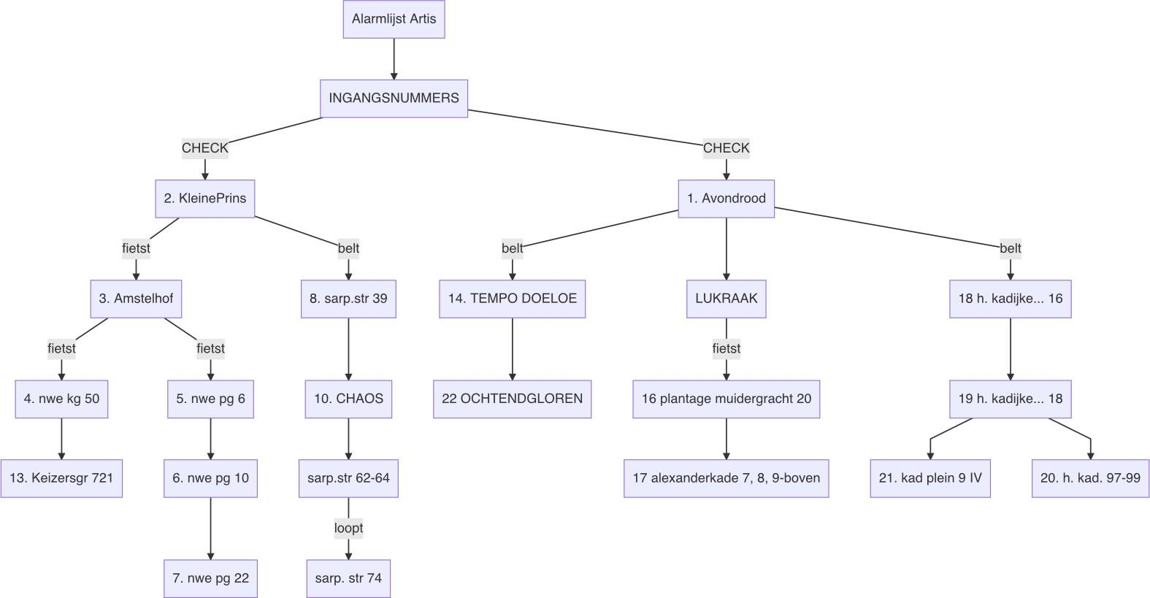

fig. 5.1 Alarmlijst Artis expressed in a mermaid.js script

## Hotel Mokum

Many of us struggled with the pressure, the excitement, the exhaustion, the uncertainty, the lack of structure, impostor syndrome. The let-down effect was real, immediately after the action a number of people got sick. Most of us had stopped exercising, ate unhealthy, and couldn't keep up with simple household tasks. Someone said their home had started to look like a squat while our squat had slowly started to look like a home. At the same time, most of us experienced difficulties to leave, to go home, and felt guilty when we missed just a day or two.

We squatted Hotel Mokum on October 16th, 2021. None of us had really expected to succeed—in the secretive meetings with the *real* squatters in which we planned the action (out of a general distrust in technology we always had to leave our phones in another room) the best-case scenario was nothing more than a rhetorical bridge into the infinitely more likely crisis scenarios of varying gravitas: *of course, at that moment the police can just decide to leave, but more likely they will [insert various degrees of state violence here].* But then it all turned out differently, and they did leave, and there we were, 20-odd 20-somethings (and me), and all 6 floors of the former Hotel right in the center of Amsterdam were *ours*, and every news outlet in town wanted to talk to us.

The day of the action we got drunk, the day after we started programming. Our first event was a series of screenings, selected by Jeffrey Babcock from *Jeﬀrey's Underground Cinema(s)*. After that the program never stopped. In the first month, we organized a neighborhood lunch, political cafés, screenings, a screen printing workshop, a chess tournament, an exhibition with more than 70 participants, a demonstration and seemingly infinite amounts of bar nights. Fueled by a mix of enthusiasm, disbelief and constant fear of eviction, we went on and on, and every time it got better and bigger, and every time it was packed.

When we didn't have a public program, we worked on the building: It had been gutted to the core and in the two years that it had been abandoned, it had decayed dramatically. After changing the locks, we cleared out the carcasses of the pigeons that had been trapped inside, cleaned the floors of their excrements, built a toilet for ours, pumped out the water from the crawlspace beneath, built a bar, set up internet throughout the building (stolen from the hotel across the street), built living rooms and bed rooms, furnished it all, and cleaned—everything, endless amounts of times. Hardly any of us had ever squatted before, let alone on this scale and without the

unconditional and selfless support and expertise from helpers, friends and members of the squatting scene, we could have never pulled any of it off. LR;

1[(Joes Garage)];

2[(Bowling)]; 3[(Kinderen van Mokum)]; 4[(Villa Ivivke)]; 5[(Hotel Mokum)];

A[angry individuals]; B([meetings]); C[action group];

subgraph planning;

A-->B-->C;

end;

1-- facilitated -->planning;

2-- facilitated -->planning;

D[action group]; E([squats]); F[Hotel Marnix];

subgraph action;

D-->E-->F;

end;

action --> 5;

1-- advised -->action;

2-- supplied materials -->action;

G[abandoned building]; H([renovation]); I[public events];

subgraph occupation;

G-->H-->I;

end;

3-- plumbing, floors -->occupation; 4-- electricity -->occupation;

J[municipality] K([evicts])

L[angry individuals]

subgraph eviction

J-->K-->L

end

1 & 2 & 3 --> eviction

planning-->action; action-->occupation; occupation—>eviction;

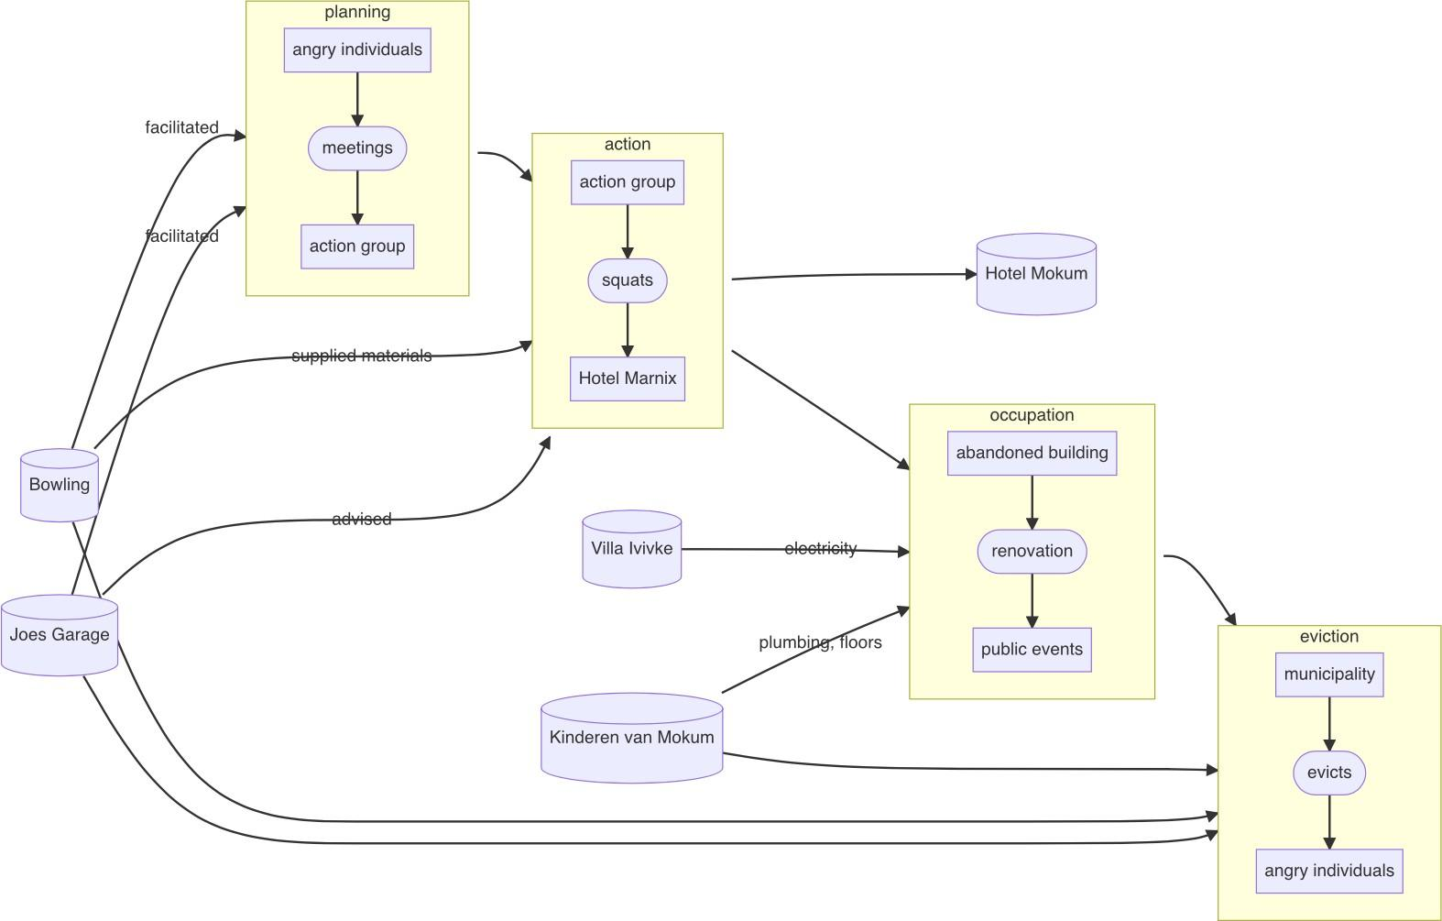

fig. 6.1: Angry individuals becoming angry individuals. The story of Hotel Mokum, in mermaid.js

Whatever time was left, we spent in meetings. We had to organize and decide on events, fill the sleeping schedule, plan the renovations, find legal representation, write public statements, apply for funding, talk to an endless stream of journalists, talk to the neighbors, invite activists and politicians, deny entry to other activists and politicians, form connections to other squats, talk to the owner and formulate a corona policy. We organized on the fly—we set up Signal groups and a Matrix server, learned hand signs, kept times, moderated meetings, argued and solved conflicts, did check-ins and kept notes of everything. We decided collectively—not simply by majority, but looking for consensus even in disagreement.

We needed this place, and it needed us. We were starting to neglect the lives we had outside of Hotel Mokum—it was consuming us. After a month, we came together in an *emo meeting* to discuss the emotional aspects of our involvements. It was important to create this space for us to listen to each other, let each other air grievances and send each other messages of support. Unanimously, we agreed that this month had been one of the most fulfilling months of our lives, but we had all known that before. That had been the collective experience. At the emo meeting we acknowledged what

happened outside of it. For a few hours, the collective collapsed into a collection of individuals, each with their own, unique experience, with complaints, insecurities and dirty apartments.

One by one we assured each other, complimented each other on *good shares*. It was emotional and supportive. A lot of us hadn't known each other before the action, but in this moment of allowing ourselves to be vulnerable in front of each other, it felt like we had been doing this for years. We had become nodes in a (support) network, but far from autonomous, our network, in turn, was just a node in an even larger network. As someone put it, outside the doors was a now city, not just a collection of houses.

Utterly dependent on each other's solidarity, we knew that we *could* depend on each other, and that these new dependencies were dependencies we had chosen ourselves.

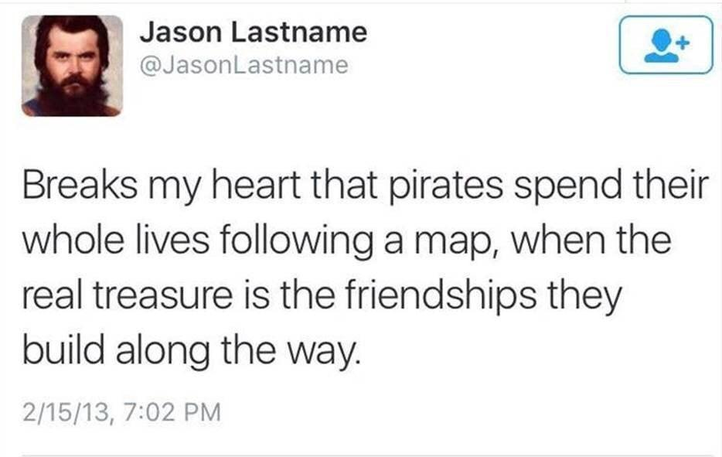

fig 6.2: A former meme

## 7: Trespassing, an afterword

There are few contact points where the augmented nature of the virtual becomes as explicit as in the city, and Amsterdam serves as a good example. By 1993, internet access here was still limited to a small number of households, but in 1994 Marleen Stikker, founder of Waag Society, started De Digitaale Stad (The Digital City)46, a freenet47. For many Amsterdammers, this was the first opportunity to access the internet. Aptly named, the digital city still used the *metaphor* of the city as a mode of navigation. To send emails you would have to go to the post office, for public discussions you would visit the cafe. While the interface was text-based initially, many parts were later illustrated.

Today, in Europe's largest data center hub48, the relationship between the digital and the spatial (the *augmenter* and the *augmentee*, if you will) has fundamentally shifted. Their conflation is maybe most apparent in the example of Airbnb. Arguably, Amsterdam is one of the cities in Europe that has suffered the most from Airbnb's business model49. In his 2016 essay Everything *Techno-Feudalism and The Tragedy of The Commons*, William Kherbek explains this process50:

* 1. People rent out surplus rooms and apartments on Airbnb.
  2. As there is usually more money to be made on Airbnb than with traditional rental agreements, more and more places are offered on the platform, leading to a decrease in available traditional housing and an increase in rent as supply shortens.
  3. The extra income from Airbnb lets the hosts keep up with rising costs of living (for example: rent) as wages continue to stagnate, which ultimately creates a dependency.



46Interestingly, DDS preceded even Geocities by a few months.

47What is a freenet, you ask? I still need to write this footnote. Danke ;)

48Already back in 2019, the (potentially biased) Dutch Data Center Association called the Netherlands the leader in data centers in Europe, see: [https://www.dutchdatacenters.nl/en/](http://www.dutchdatacenters.nl/en/) nieuws/dutchdatacenters2019-2/

49It's hard to find exact numbers on this. However, there are some things I can say about this, but I have to still write this footnote.

50<http://staging.berlinartprize.com/essay-william-kherbek/>

* 1. This leads to pressure on people to participate in the secondary housing market (Airbnb) in order to keep up and survive.

Kherbek argues that, while this process is usually called platform capitalism, the situation is actually closer to feudalism than to capitalism (even if capitalism is the result): Big tech companies (the lords) generate wealth from their users (the serfs) as they exploit their labor and data. The users find themselves in a state of inverted totalitarianism51, where the democratic structures supposed to give them *agency* have been reduced to formalities. The few own the property the many have to live on and the data enclosed in the walled garden of the cloud is the pasture from the tragedy of the commons52.

In a similar vein, Silvio Lorusso argues that the logic of labor also applies to the digital53and that there are no class-less computers: there are coders54and there are users55(augmenters and augmentees). In the resulting discussion about (computer) literacy, Lorusso quotes Paul Graham, who states that ordinary users shouldn't even [have to] know what drivers or patches are. In *The New Dark Age*, the artist and writer James Bridle claims we shouldn't need to know how to code in order to use a computer, after all we don't need to understand plumbing to use the toilet56.

When we squatted Hotel Mokum, we didn't know anything57about plumbing, which was a problem because the building didn't have a toilet (or running water). A lot of the more experienced squatters, it turns out, do know about plumbing however, as it's a frequently occurring issue, and within a few days they had helped us build one.

*Architectures of Appropriation* argue that these unscripted and collective ad-hoc spatial tactics used by squatters to transform the spaces they inhabit have significantly



51Sheldon Wolin, need proper quote 52Explain the tragedy of the commons 53Silvio Lorusso, the User Condition

54The only one more powerful than the coder might be *non-user*, the one who doesn't use computers to begin with (Lorusso evokes the images of big-tech-CEOs that don't let their kids use social media), but as demonstrated in Kherbek's example of Airbnb, refusal takes privilege, in this case the financial capability to waive the extra income.

55One can't help but think of the quote attributed to Edward Tufte, that the only industries that call their customers *users* are software companies and drug dealers, which is another way to think of dependencies. Wow.

56Or, he adds, without our toilet trying to kill us. James Bridle, New Dark Age, 2018

57shit

shaped Dutch cities and have left behind a spatial heritage that still speaks of the desire to put the right to *live* above the right to own (private) property58.

Lorusso argues that maybe these positions are not even so at odds with each other— it's fine if some people don't know about plumbing, as long as they are not constantly forced to change their behavior by system and driver updates (the toilet metaphor is stretched to a limit at this point). Maybe the question is just whether we are tourists59or residents. In the end, locals, immigrants and expats, even nomads can (temporarily) become residents, and residents have neighbors. Neighbors that can hopefully help them fix their toilets.

graph TD;

A[/no place to be\]; B[(squat)];

C[\no longer a squat/];

A-- squatting -->B; B-- eviction -->A;

B-- legalization —>C;

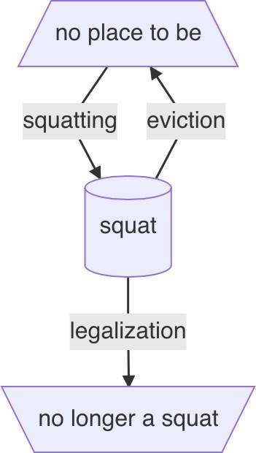

fig. 7.1 In the words of singer Nelly Furtado, All good things come to an end.

Thank you to Ada Reinthal for the initial diagram.



58This principle of reusing what is there might be something to keep an eye on when talking about electronics. Will you add more to this? Architectures of Appropriation book

59God forbid!

## Appendix: Incomplete and Unordered List of Reasons to Refuse the Cloud

* Workers in the Global South are being exploited and our devices are assembled by modern day slaves. Probably the only ethical hardware is second hand.60
* Rare earths such as Lithium are extracted from indigenous lands without their consent and with no accountability for the environment.61
* E-Waste is polluting the planet and is being dumped in landfills without regulations in the global south, poisoning both the lands and the people.62
* Tech companies and governments by extension are constantly spying on us. The right to privacy is being eroded and the surveillance state is being facilitated.63
* For almost a decade we have had reliable evidence that tech companies are forwarding information gathered about their users to governments, yet nothing has changed.64
* Social media companies profit from a divided political landscape, disconnected filter bubbles are not a by-product but part of the product.65
* The massive proliferation of fake news actively costs lives (see: anti-vaxxers) and is being facilitated by the big platforms.66
* Users(which users?) are routinely being radicalized to the point of committing physical violence and domestic terrorism.67



60(need to still back this up with a footnote) 61(need to still back this up with a footnote) 62(need to still back this up with a footnote) 63(need to still back this up with a footnote) 64(need to still back this up with a footnote) 65(need to still back this up with a footnote) 66(need to still back this up with a footnote) 67(need to still back this up with a footnote)

* The internet, and most devices we carry in our pockets like smart phones, are developed from US military technology. Possibilities for surveillance for example are no accident.68
* *Tech* is a race to the brain stem. Some of the most-educated people in the world spend all their energy in selling us ads. Thinking we could resist the machinery is like thinking we could win against a super computer in chess.69
* It's addictive on purpose. At places like the Stanford Persuasive Technology Lab people have been trained to specifically find ways of persuading users to keep using their products, and metrics like engagement are still the main factors their design.70
* Big companies that have (unreadable!?)terms and conditions instead of constitutions which can censor users without any form of accountability or oversight.71
* Even though participation is always voluntary, social (and financial!) pressure to participate often outweighs any serious form of alternative.72

fig. AP.1: The terms cloud is a bit of a stand-in for everything wrong with the internet, in this case



68(need to still back this up with a footnote) 69(need to still back this up with a footnote) 70(need to still back this up with a footnote) 71(need to still back this up with a footnote) 72(need to still back this up with a footnote)