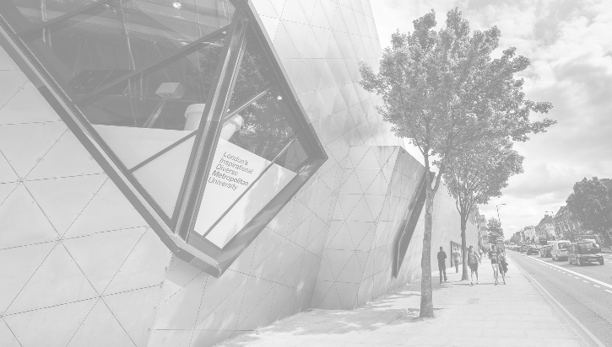

SD Map General Report

SW20 8ED

Merton

London

|  |
| --- |
| Location |
|  |
| The post code SW20 8ED belongs to the ward Dundonald and borough Merton within the city of London. There is 1 other post code which the following data is part of. This being SW20 8EB. There are 20 other wards in the borough which are Longthornton, Cricket Green, Pollards Hill, Figge's Marsh, Graveney, Lavender Fields, Colliers Wood, Ravensbury, West Barnes, Raynes Park, Lower Morden, Cannon Hill, St Helier, Merton Park, Wimbledon Park, Trinity, Abbey, Hillside, Dundonald and Village |

Population

The population density of Merton is ranked 23 of 33 at 60493.30 Which is below the average borough population density of 93208.00 Westminster has the highest population density at 182455.00 City of London has the lowest population density at 6450.00 Females account for 51% of the borough population, which is the same as the average of 51% at borough level. Males account for 49% which is the same as the average of 49% at borough level.

Household

In that area are the following residential houses in descending total order are;

1. Semi Detached - OAcode:31 - ward:700 - borough:14732 - borough avg:19079
2. Terraced - OAcode:21 - ward:1863 - borough:31138 - borough avg:23538
3. Flat - OAcode:13 - ward:574 - borough:21540 - borough avg:38546
4. Detached - OAcode:6 - ward:115 - borough:4701 - borough avg:6401

Education

In that area are education levels in descending total order are;

1. Level 4 - OAcode:102 - ward:4701 - borough:66091 - borough avg:74790
2. Level 2 - OAcode:24 - ward:643 - borough:18875 - borough avg:23501
3. Level 3 - OAcode:17 - ward:667 - borough:15928 - borough avg:20760
4. No qualifications - OAcode:13 - ward:603 - borough:24378 - borough avg:34909
5. Other qualifications - OAcode:12 - ward:642 - borough:16979 - borough avg:19825
6. Level 1 - OAcode:9 - ward:382 - borough:15900 - borough avg:21281