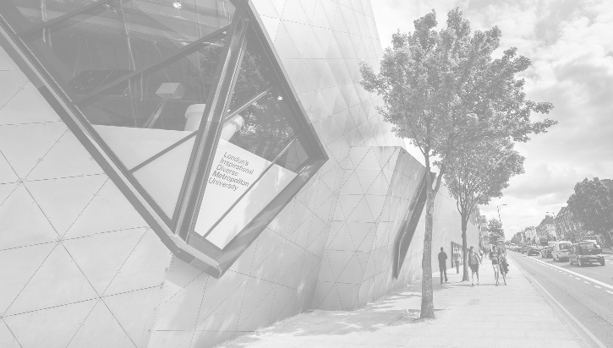

|  |  |
| --- | --- |
|  | SD Map General Report  «POST_CODE_OR_WARD_NAME»  «Borough»  «City» |



# Introduction

Lorem ipsum dolor sit amet, consectetur adipiscing elit. Fusce sed risus aliquam, aliquet sem nec, facilisis sapien. In elit neque, efficitur eu leo sed, consequat vulputate nunc. Nulla est ante, pulvinar ac elit venenatis, finibus malesuada tellus. Suspendisse dapibus augue nulla, sed faucibus orci iaculis ac. Phasellus sed sem at massa mollis mollis ut sed risus. Sed id est nunc. Aenean eget lacus at ante accumsan laoreet.

Nunc vulputate metus at lorem placerat consequat. Donec scelerisque malesuada nibh quis ultrices. Mauris tincidunt magna a aliquet sagittis. Proin nisl velit, elementum vitae justo ac, congue euismod ante. Fusce semper non augue vitae semper. Nulla id dapibus enim. Cras faucibus mattis risus sed rhoncus. Donec ac volutpat risus. Aliquam cursus, tellus vel pulvinar rutrum, dui ex aliquam odio, eu mattis tellus lorem vel urna. Nam et diam quis turpis pretium egestas. Maecenas quam velit, accumsan in maximus id, posuere sed ex. Etiam tristique scelerisque risus, non sagittis lorem ultrices at. Duis hendrerit risus ut justo sagittis blandit.

Maecenas euismod quam eget purus sodales consequat. Nam porta diam quis eros elementum, sed feugiat lorem congue. Phasellus sodales, dolor sed faucibus dictum, tellus arcu ultricies sem, ut ornare ligula mauris eu sem. Vivamus sit amet mauris non sapien malesuada molestie. Cras nec eros interdum ex tempus hendrerit quis eget enim. Donec a mauris orci. Integer luctus, nibh ut posuere posuere, eros sem commodo felis, et facilisis ex magna vel quam. Donec quis volutpat elit. Nulla at fermentum felis. Donec eget efficitur nisi, sed ornare nibh. Vivamus eget lectus quis erat faucibus efficitur. Ut ornare odio ac elit finibus tincidunt. Donec porta vulputate ex at posuere. Nunc vulputate neque sit amet condimentum ultricies. Donec id lectus auctor magna commodo iaculis sed ac mauris.

# Location

|  |
| --- |
| {{  include_image(‘location_png_file’,’center’,5)  }} |

«population_field_01»

|  |
| --- |
| {{  include_image(‘population_mekko_plot_gender’,’center’,3)  }} |

# Ethnicity

|  |
| --- |
| {{  include_image(‘ethnicity_horizontal_stacked_report_plot’,’center’,6.5)  }} |

# General Health

|  |
| --- |
| {{  include_image(‘general_health_horizontal_stacked_report_plot’,’center’,6.5)  }} |

# Education Data

|  |
| --- |
| {{  include_image(‘education_horizontal_stacked_report_plot’,’left’,6.5)  }} |

# Earnings

|  |
| --- |
| {{  include_image(‘earnings_rankings_by_borough_plot_report’,’left’,6.5)  }} |

|  |
| --- |
| {{  if earnings_flat:  include_text('earnings_trend_text', ‘center’)  else:  delete_row()  }} |
| {{  if earnings_up:  include_text('earnings_trend_text', ‘center’)  else:  delete_row()  }} |
| {{  if earnings_down:  include_text('earnings_trend_text', ‘center’)  else:  delete_row()  }} |

# Crime

|  |
| --- |
| {{  include_image(‘crime_per_capita_ranking_by_borough_plot_report’,’left’,6.5)  }} |

|  |
| --- |
| {{  if crime_flat:  include_text('crime_trend_text', ‘center’)  else:  delete_row()  }} |
| {{  if crime_up:  include_text('crime_trend_text', ‘center’)  else:  delete_row()  }} |
| {{  if crime_down:  include_text('crime_trend_text', ‘center’)  else:  delete_row()  }} |