NASCOM Keyboard
Here are some waveforms grabbed from my NASCOM 2. They aim to show (some of) the inner workings of the keyboard. They should be read in conjuction with a NASCOM 2 keyboard schematic (The NASCOM 1 keyboard schematic is nearly identical but has different component references).
Errors, omissions and comments to the author, please: foofoobedoo@gmail.com
The keyboard is scanned under software control. These examples were taken using NAS-SYS 3 running on a NASCOM 2 running at 4MHz with no wait-states. Code examination showed that the keyboard scanning code in NAS-SYS 1 is identical.
The NASCOM controls the keyboard with 2 output signals: RESET and CLOCK, also called “keyboard counter reset” and “keyboard counter clock”. These should not be confused with the RESET CPU signal which is generated on the keyboard. The NASCOM reads the keyboard status with 7 input signals, /S0.. /S6.
Illustration 1 is an overview of the periodic scan. Each scan consists of a high-going pulse on RESET (yellow) followed by 8 high-going pulses on CLOCK (pale blue). When no key is pressed, the pulses are evenly spaced. When one or more keys are pressed, the gap between pulses increases because NAS-SYS is performing additional processing to decode the key(s). The period shown between scans is approximately 740us. In this example, the code is simply in an idle loop waiting for key-presses and echoing them to the screen.
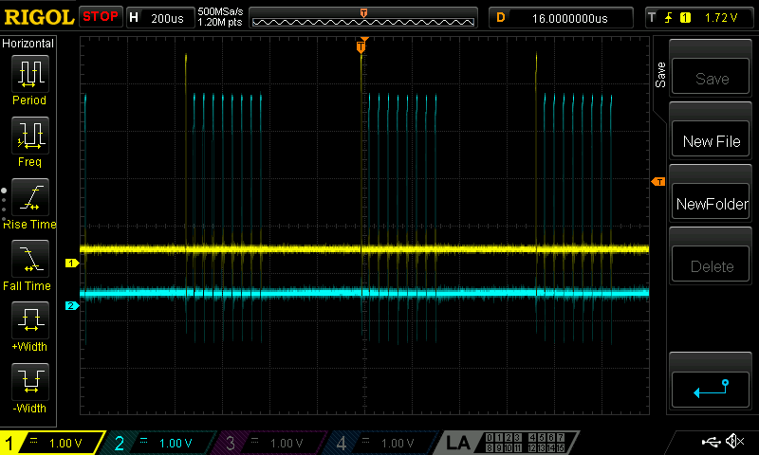Illustration 1: Overview of periodic keyboard scan

Illustration 2 zooms in on a RESET (yellow, partially hidden by the cursor timings box) and two CLOCK pulses (blue). The pulse width of the RESET and CLOCK pulses are equal, and these widths do not vary (they are both imposed by the same subroutine, fflip). Each of these signals is loaded with 100pF capacitor to 0V, explaining the slugged rising edge.
The basic operation of the keyboard is thus: RESET resets state. CLOCK selects each drive line in turn. When a drive line is selected, the SR (the cross-coupled NAND gates on the right-hand side of the schematic) are cleared and then the drive line is pulsed. Any sense lines for which a key is pressed generates a low-going pulse on one of the /A.. /G signals, which sets one of the SR latches. NAS-SYS reads the state of the latches.
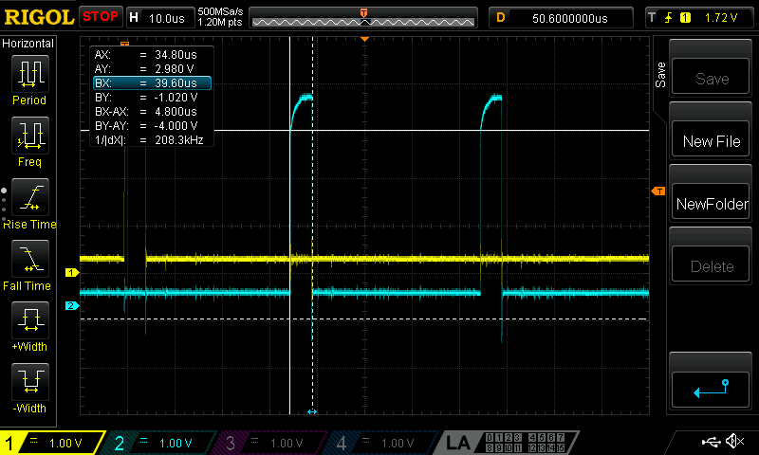Illustration 2: CLOCK pulse

Both the RESET pulse and the CLOCK pulse trigger a chain of pulses, via the 74123 monstable, as shown in Illustration 3. RESET (yellow) and /CLOCK (IC4/3, pale blue) both have the effect of triggering monostable 1, generating the output 1Q (pink). This in turn triggers monostable 2, generating the output /2Q (dark blue).
The pink trace is inverted to generate /CLEAR, which resets the SR latches. The dark blue trace acts as a “strobe” into the 74145 decoder. The transformer effect in a depressed LICON switch casues the high-low transition of the dark blue trace to generate (via the CA3086 transistor array) an active-low SET pulse on one of the SR latches (signals /A.. /G).
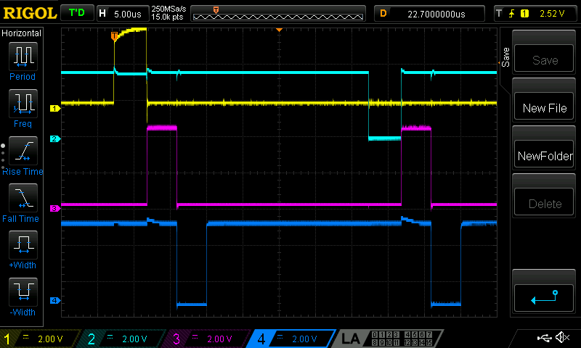Illustration 3: Pulses from the monostable, triggered by RESET and CLOCK

Zooming out again (Illustration 4) shows RESET (yellow) followed by 8 /CLOCKs (pale blue). As before, dark blue is the output /2Q which acts as a “strobe” into the 74145 decoder.
Because both RESET and CLOCK trigger the monostable, it looks as though 9 drive lines are being sequenced, which is confusing because the schematic shows 8. This can be explained by looking at the pink trace. This is the /A signal, the set pulse for the SR latch associated with sense line 0, and it shows the effect of pressing the ‘-’ key, which is on drive 0, sense 0. There are 2 low-going pulses on /A. The RESET selects drive 0, the 8 CLOCK pulses select drive 1..8. However, the decoder works modulo 8 and so “drive 8” is aliases to drive 0. Examination of the NAS-SYS code shows that it only reads the SR latches after a CLOCK. Therefore, NAS-SYS reads the drive lines in the sequence: 1, 2, 3, 4, 5, 6, 7, 0.
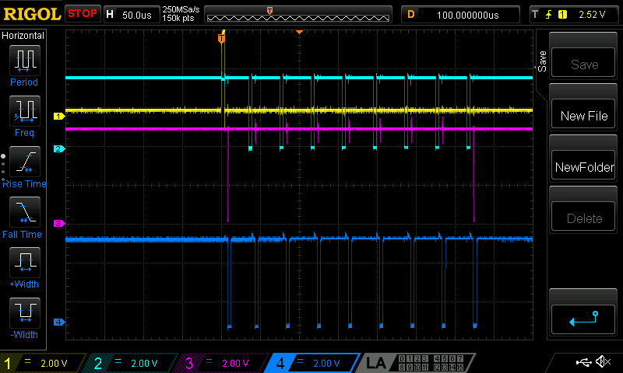Illustration 4: Pressing the ‘-’ key pulses /A (pink) to set one of the SR latches

Whereas Illustration 4 showed the ‘-’ key pressed, and a pulse on /A when drive 0 is selected, Illustration 5 shows the same signals but with the ‘5’ key pressed: this time, the pulse on /A occurs when drive 1 is selected (drive 1 is selected by the first pulse on CLOCK).
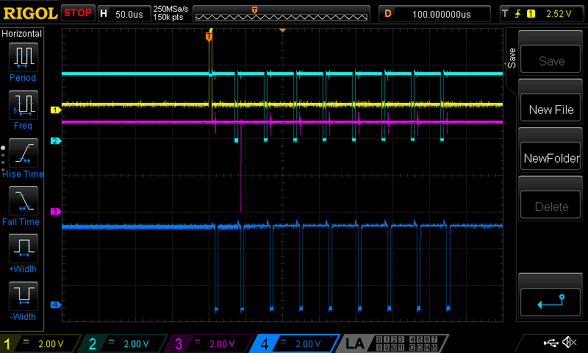Illustration 5: Pressing the '5' key pulses /A (pink) to set one of the SR latches

Illustration 6 zooms in on the pulse on /A (pink) which sets one of the SR latches. As before, it also shows RESET (yellow), the active edge of the first /CLOCK (pale blue) and the monostable /2Q output (dark blue). The pulse on /A is about 270ns wide.
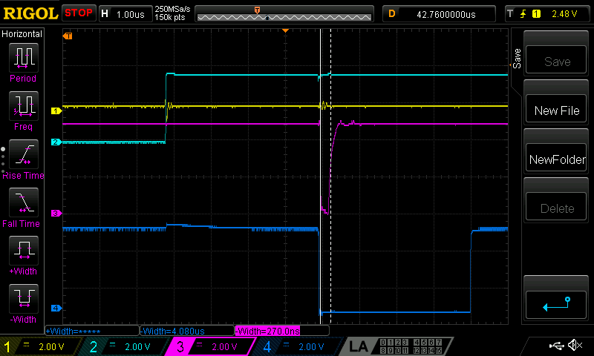Illustration 6: Zoom in on /A (pink) which sets one of the SR latches
In Illustration 7 the pink trace is the output of the SR latch set by /A. The pink signal goes 0→1 as a result of the low-going edge of /A (see Illustration 6) and goes 1→0 as a result of the low-going edge of /CLEAR (which corresponds to the high-going edge of the pink signal in Illustration 3).
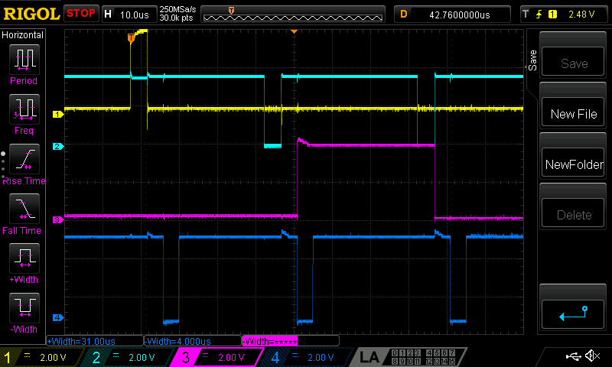Illustration 7: Output (pink) of SR latch set by /A
Finally, we can put it off no longer; we have to look at the analogue stuff going on around the keys and the CA3086 transistor arrays. First thing to say is that it is super-confusing to look at the outputs of the 74145 decoder; I expected only one output at a time to be asserted, low. Actually it seemed that all of them are asserted for each clock. A second look at the schematic explains it: the 74145 has open-collector outputs and all of the outputs are connected together at the “top” of the columns (after each column has passed through the primary coil of the LICON switches in the column). This also explains why the low-going transitions on the drive lines are fast (active) while the high-going transitions are slow, RC curves. It is the fast low-going transition that is responsible for inducing a pulse in the secondary that is large enough to switch one of the transistors in the CA3086 array to generate a set pulse to one of the SR latches.
Illustration 8 and Illustration 9 show the behaviour of the sense 0 line when a key is pressed. As before, the pale blue trace is the active edge of the first /CLOCK. The dark blue trace is the LICON end of R27, and the pink trace is the CA3086 end. The change in voltage level when the key is pressed is enough to switch the transisor.

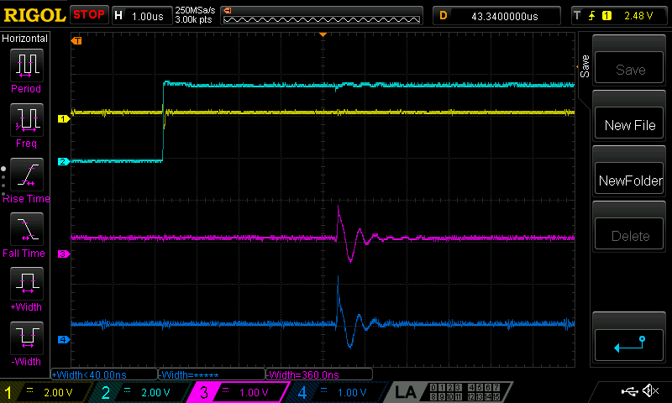Illustration 8: Sense line 0 (pink, dark blue) with no key pressed
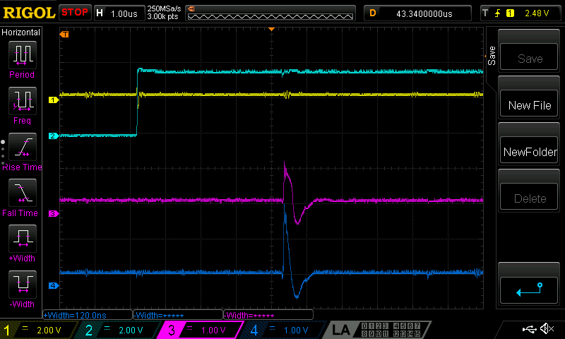Illustration 9: Sense line 0 (pink, dark blue) when '5' key pressed
Finally, Illustration 10 is like Illustration 9 but now the pale blue trace is showing the pulse on /A caused by the changed voltage levels in the sense line.
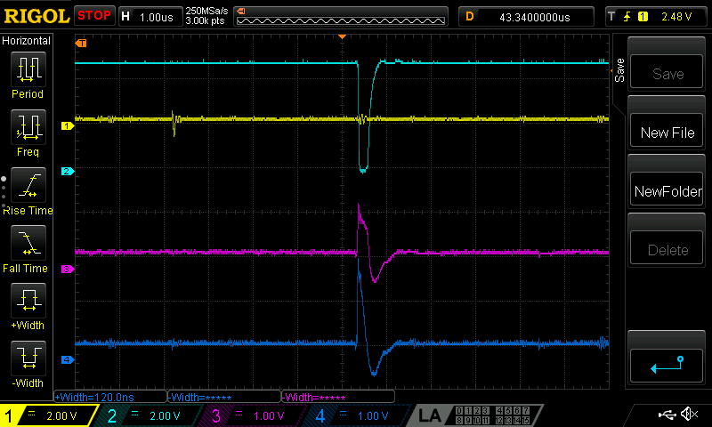Illustration 10: Sense line 0 (pink, dark blue) when '5' key pressed and resultant pulse on /A

