# Results

## The systematic mapping process

Details of the number of records retained through each stage of the review process are provided in Figure . A total of 38,825 potentially relevant records were identified across all resources searched. A total of 25,683 unique records was screened for eligibility, with 347 eligible records following full text screening. The final systematic map database contains 538 studies from 357 articles.

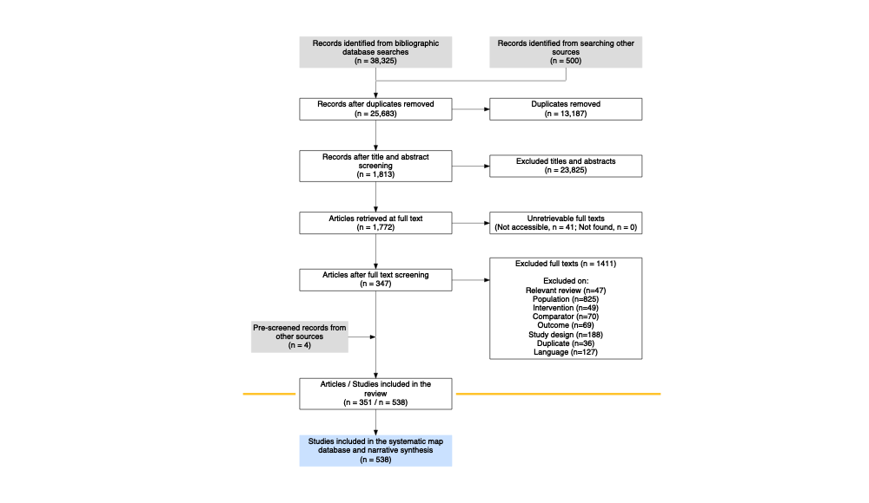

Figure 1: ROSES flow chart for the systematic map, showing the number of records retained at each stage of the review process. Produced using the R package ‘ROSES_flowchart’ (Haddaway 2020).

## The systematic map database and visualisations

### Descriptive information

**Publication year:** As expected, there has been a significant increase in the number of published articles on the topic over the last 20 years (Figure ). Interestingly, there may be evidence of a reduction in publication rate over the most recent 5 years from 2014 to 2018. The earliest record in our database is from 1981. Since searches were performed in 2019, representation from this year is incomplete.

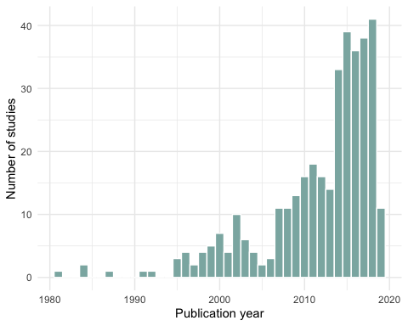

Figure 2: Plot showing the final number of articles included in the systematic map by publication year.

**Publication type:** Some 96% of articles in the map database are traditional research papers, with only 8 theses, 7 conference papers, and 1 report. This may in some degree reflect the ease with which traditional research articles can be discovered, but may also be the result of the complex and expensive GHG measurement equipment needed for this type of research: it may be unlikely that unpublished reports would be conducted on a local or organisation scale. **Country:** The choropleth in Figure displays the number of studies per country in the map. Some 3 countries each represented more than 10% of the total studies in the evidence base: United Kingdom (90), Australia (73), and USA (73). Much of the evidence came from Europe (a total of 227 studies).

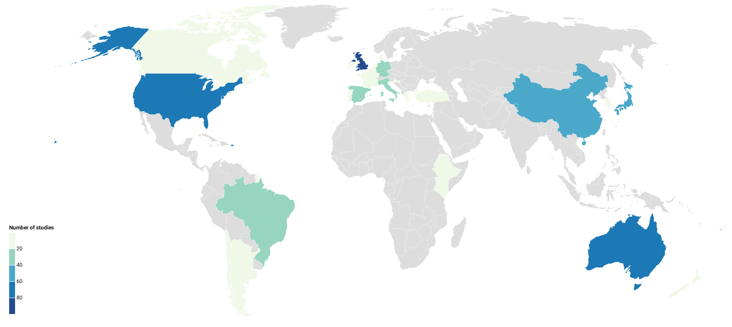

Figure 3: Choropleth showing the number of studies per country in the systematic map database.

**Climate zone:** Table displays the distribution of studies across climate zones. The most frequently studied climate zone was Cfb with 236 studies. Cfa was the second most studied zone with 226 studies. Some 2 studies could not be located to a climate zone.

Table 1: Number of studies conducted in each eligible Köppen-Geiger climate zone. ‘n’ indicates the number of studies.

|  |  |
| --- | --- |
| Köppen-Geiger climate zone | n |
| Cfb | 236 |
| Cfa | 226 |
| Csa | 54 |
| Csb | 20 |
| Not reported | 2 |

**Soil texture:** The most frequently reported soil texture information was from the [USDA Natural resources conservation service soil texture classification system](https://www.nrcs.usda.gov/wps/portal/nrcs/main/soils/survey/class/). Figure shows the distribution of soil texture classifications across the evidence base. A large number of studies (133 of 538) did not report the soil texture classification. Table displays the soil texture data reported for studies not reporting soil texture classification, showing that 78 studies provided no data from any of the three soil classification systems, hampering synthesis of these data.

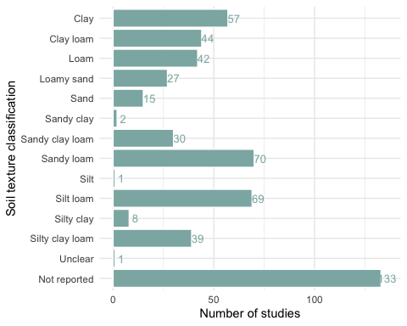

Figure 4: Soil texture classifications of studies in the systematic map.

Table 2: Soil classifications of studies not using the USDA Natural Resources Conservation Service soil texture classification system. Blank cells indicate no data. ‘n’ indicates the number of studies.

|  |  |  |
| --- | --- | --- |
| USDA soil classification | FAO soil classification | n |
|  |  | 78 |
| Andisol |  | 14 |
|  | Andosols | 13 |
|  | Cambisols | 6 |
|  | Luvisols | 5 |
|  | Acrisols | 3 |
| Vertisol |  | 3 |
|  | Ferralsols | 2 |
| Oxisol |  | 2 |
| Alfisol |  | 1 |
|  | Arenosols | 1 |
|  | Hapli-Cutanic Luvisols (IUSS-WRB, 2007) | 1 |
|  | Nitisols | 1 |
|  | Podzols | 1 |
|  | Vertisols | 1 |
| Ultisol |  | 1 |

**Field history description:** Just over half of the studies in the systematic map (310 of 538) provided a description of the previous management practices used within the experimental fields. **Study length:** The duration of investigation was reported in 511 of 538 studies. Figure shows the range of study durations used across the included studies. Median study length was 12 months.

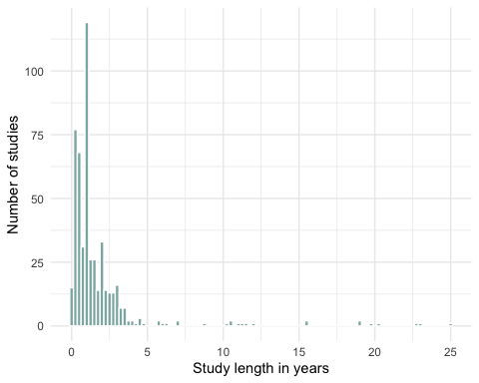

Figure 5: Study durations employed across the evidence base, collated into 6 month bins.

For studies lasting less than 1 year (n = 203), the median study length was 5 months (see Figure ).

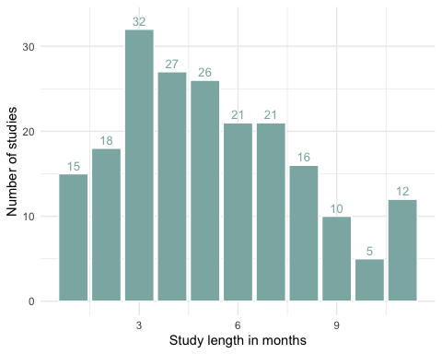

Figure 6: Study durations for investigations less than 1 year in length.

**Study design:** The most frequently employed study design across the evidence base was control-impacts (n = 534 studies). Before-after was much less common (n = 3). Study design was not reported in 1 study. **Experimental design:** The most commonly used experimental design in the included studies was ‘randomised complete block’, with 314 studies, with ‘split/strip plot’ the next most frequent (n = 132). Figure displays the frequency of all experimental designs. The experimental design was not reported or unclear in 3 and 11 studies, respectively.

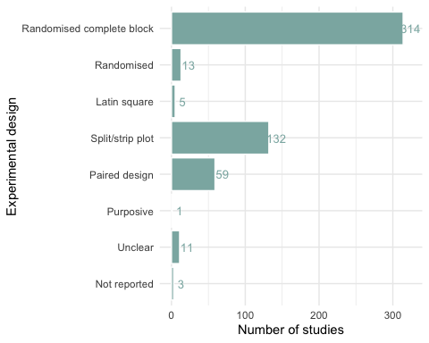

Figure 7: Experimental designs employed across studies in the systematic map.

**Spatial replication:** Figure shows the range of spatial replication across all studies. This demonstrates an overall very low level of true replication (no study used greater than 8 spatial replicates): this is likely hindered by challenges in replicating field- or farm- scale experiments. The median level of true spatial replication was 3 replicates.

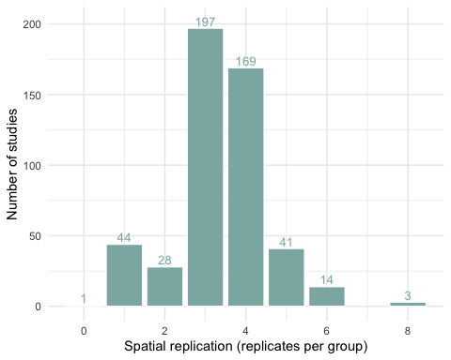

Figure 8: Study spatial replication (replicates per treatment group) across included studies in the map.

**Temporal replication:** Most studies in the map did not take measurements at more than one time point (n = 510): 28 studies did employ temporal replication, and no studies did not report this information. **Interventions:** Figure shows the types of interventions investigated in the evidence base. Here, we define intervention types as the broad category of management practice used, as opposed to treatments (see below), which are the individual management practices investigated within each study. A total of 296 out of 538 studies examined multiple interventions together. The top three most frequently studied single intervention types were chemical fertiliser (n = 100), tillage (n = 70), and organic fertiliser (n = 30). Across all intervention types, the top three most frequently studied were: 1) chemical fertiliser (n = 312); 2) organic fertiliser (n = 176); 3) tillage (n = 158); 4) nitrification inhibitor (n = 72); and, 5) cover crops (n = 62).

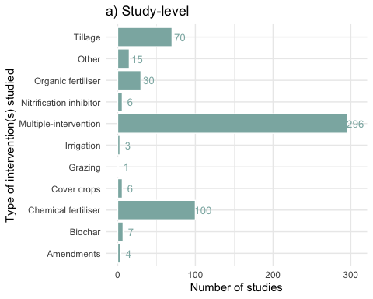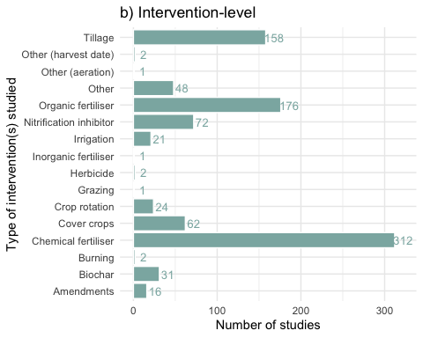

**Treatments:** Within intervention types, studies often investigated multiple treatment levels/types (see Figure ). The median number of treatments was 4.

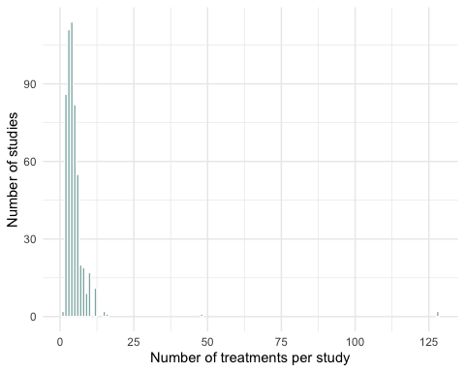

Figure 11: Number of treatments investigated in studies included in the systematic map.

**Outcomes:** Tables and show the measured outcomes across all studies in the map, across outcomes and where outcomes were measured together, respectively. All three outcomes were reported in 57 studies. The next most commonly co-measured outcomes were CH4 and CO2 and N2O (n = 57) and CH4 and N2O (n = 43).

Table 3: Outcomes measured across studies in the systematic map. ‘n’ indicates the number of studies.

|  |  |
| --- | --- |
| Outcome | n |
| Nitrous oxide | 441 |
| Carbon dioxide | 208 |
| Methane | 106 |
| Not reported | 1 |

Table 4: Outcomes measured together in studies measuring multiple outcomes in the systematic map. ‘n’ indicates the number of studies.

|  |  |
| --- | --- |
| Outcomes | n |
| Carbon dioxide, Nitrous oxide | 58 |
| Methane, Carbon dioxide, Nitrous oxide | 57 |
| Methane, Nitrous oxide | 43 |
| Methane, Carbon dioxide | 2 |
| Nitrous oxide, Methane | 1 |

Figure shows the distribution of measured outcomes across time (the final study measurement year), showing the consistent interest in nitrous oxide. These patterns give no indication of a change in attention to specific GHGs over time.

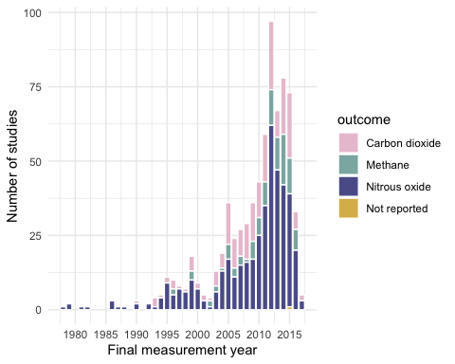

Figure 12: Measured outcomes across all studies by the final study measurement year.

In Figure , the total number of measured outcomes across all investigated interventions shows the prominance of nitrous oxide in research on fertilisers and nitrification inhibition.

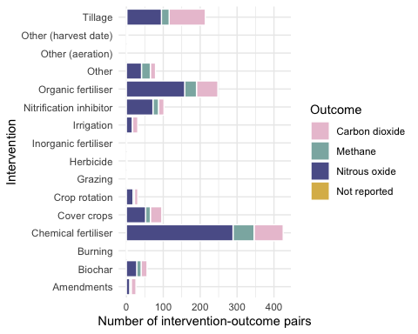

Figure 13: Measured outcomes across all interventions investigated.

Figure shows the number of measured outcomes across all study climates. There is a somewhat smaller proportion of studies of nitrous oxide relative to other GHGs in Csa zones than Cfa and Cfb, but the total studies in this climate zone is also much smaller.

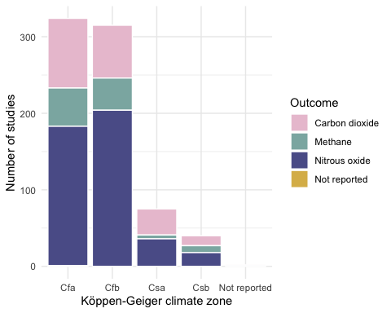

Figure 14: Measured outcomes across all studies by the climate zone.

**Outcome measurement methods:** The most commonly reported measurement method was ‘static chamber’ (n = 243) (see Figure ). A substantial proportion of studies (n = 269) did not report the outcome sampling methods used.

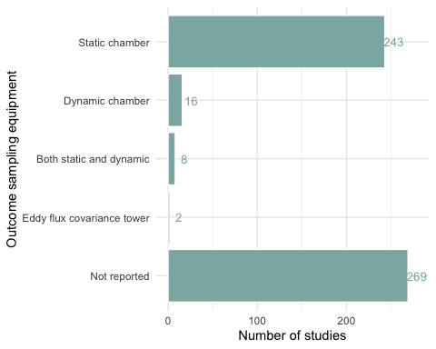

Figure 15: Experimental designs employed across studies in the systematic map.

Open chambers were used in 17 studies, whilst closed were used in 231 (it was not possible to ascertain this information for the remaining studies). Opaque chambers were used in 141 studies, whilst transparent were used in 11 (it was not possible to ascertain this information for the remaining studies).

### Heat maps

In Figure , interventions have been plotted against countries for the three measured outcomes.

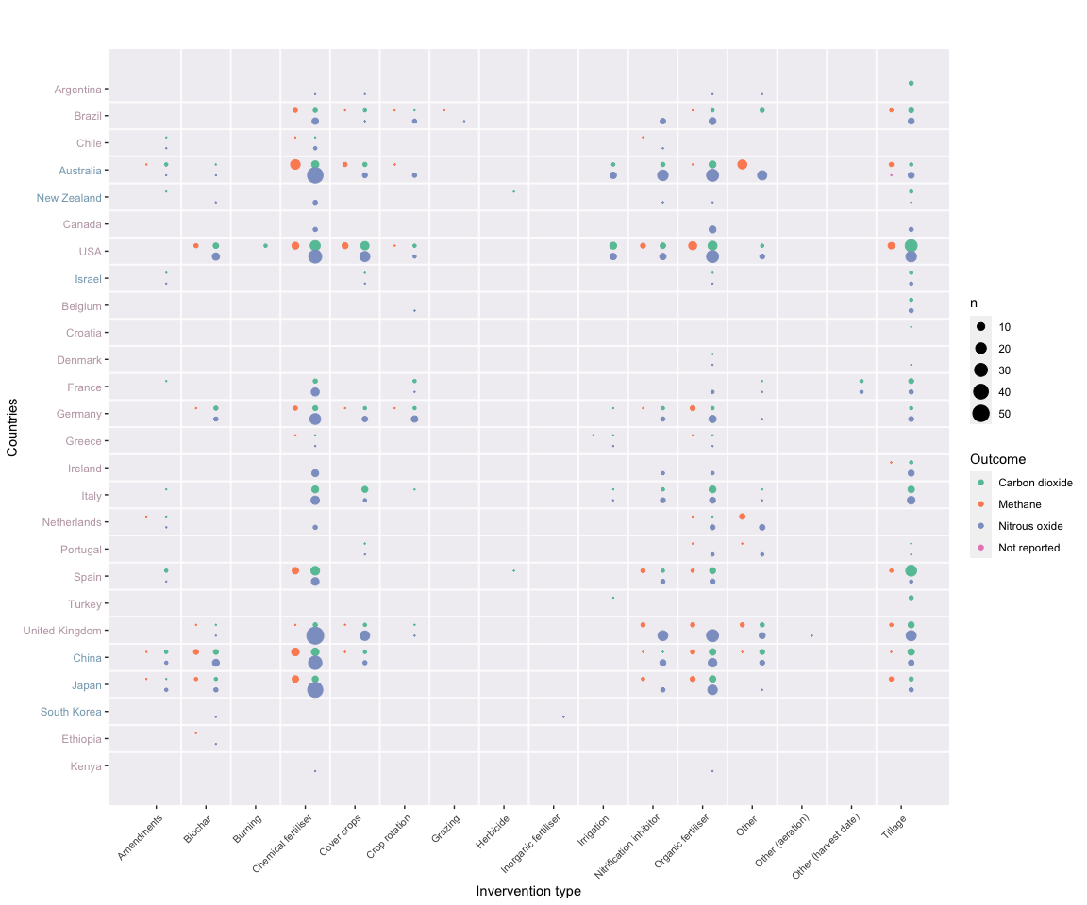

Figure 16: Bubble plot of intervention type against study country and measured outcome for studies in the systematic map. ‘n’ indicates the number of studies. Countries coloured by continent.

In Figure , interventions have been plotted against Köppen-Geiger climate zones in a heat map that shows the spread of evidence.

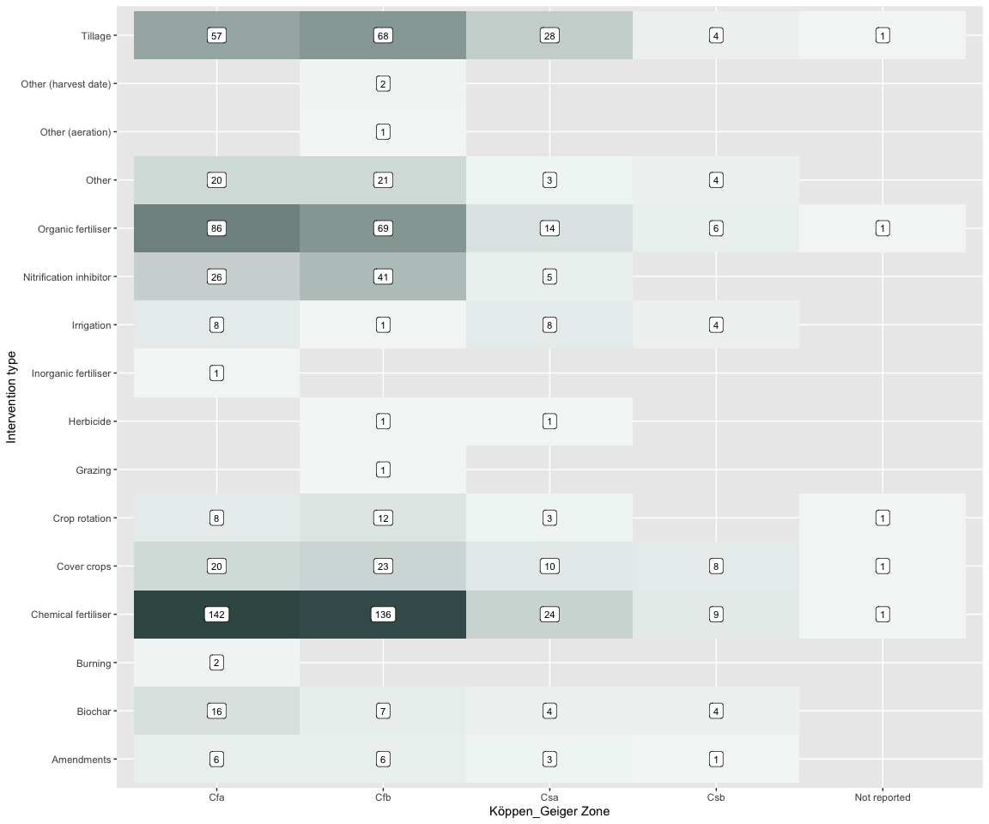

Figure 17: Bubble plot of intervention type against climate zone for studies in the systematic map. ‘n’ indicates the number of studies.

In Figure , interventions have been plotted against soil type in a heat map that shows the spread of evidence.

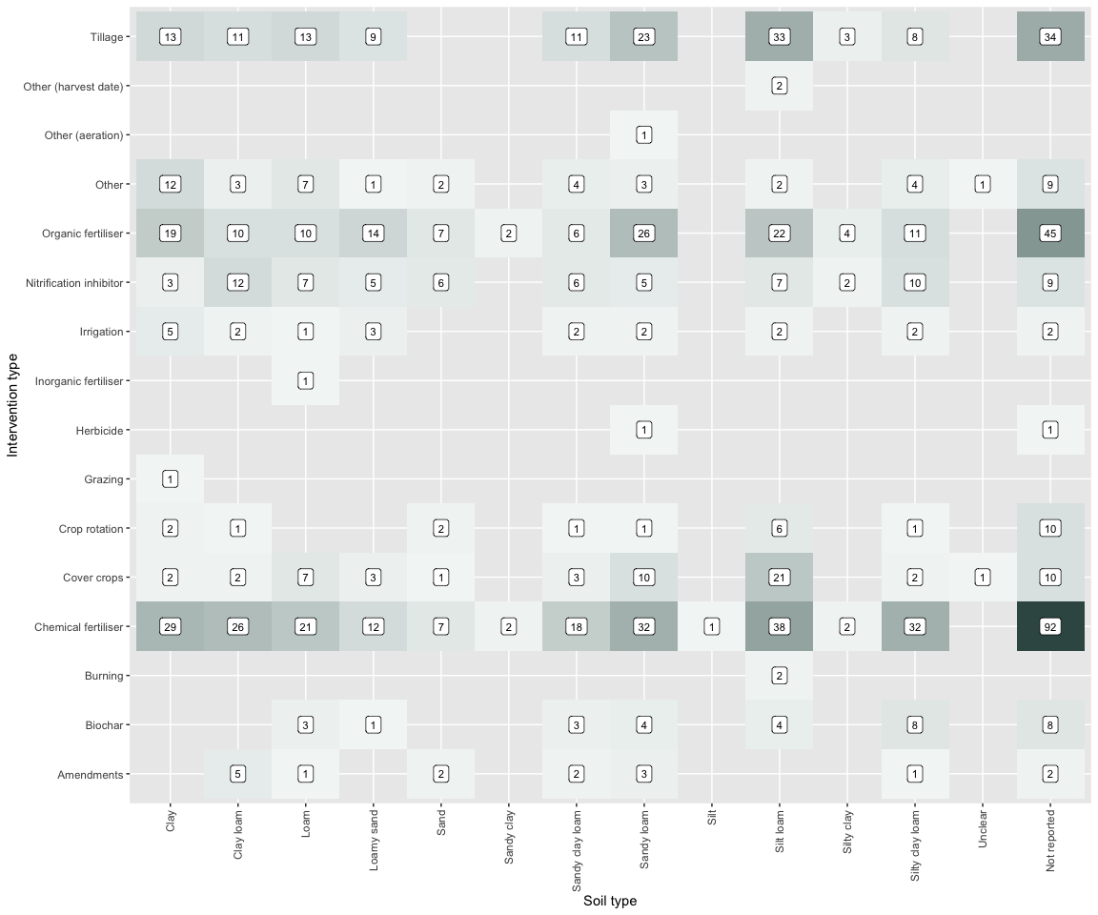

Figure 18: Bubble plot of intervention type against soil type for studies in the systematic map. ‘n’ indicates the number of studies.