1) What is Big "O" of this expression?
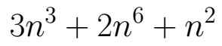

2) What is Big "O" of this expression?
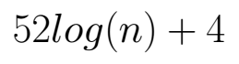

Assume this swap function is available to any code on this quiz.

def swap( list, i1, i2 ):
temp = list[i1]
list[i1] = list[i2]
list[i2] = temp

3) What does this code print?

numbers = [0, 3, 2, 5, 4]
for i in range( len( numbers ) - 1):
if numbers[i+1] < numbers[i]:
swap(numbers, i, i+1)
print(numbers)

4) What does this code print?

numbers = [2, 8, 15, 40, 10]
i = 4
current = numbers[i]
j = i - 1
while j >= 0 and current < numbers[j]:
swap(numbers, j, j+1)
j = j - 1
print(numbers)

5) What's the ideal pivot to use to split this list?
[45, 20, 97]

6) What's the ideal pivot to use to split this list?
[22, 65, 100, 62, 88]

7) What does this code print?

list1 = []
list2 = []
numbers = [2, 4, 5, 1, 6, 3]
pivot = numbers.pop(4)
for n in numbers:
if n < pivot:
list1.append(n)
else:
list2.append(n)
print(list1 + [pivot] + list2)

8) Was a good pivot used in the previous question, why or why not?

9) When quick-sorting, the ideal pivot does what?

10) In your own words, what is an in-place sorting algorithm?

