CIA-3 PROJECT SUBMISSION REPORT
P01 — ENTERPRISE E-COMMERCE CATALOG & ORDER MANAGEMENT SYSTEM
Domain: Retail / Multi-Vendor E-Commerce Platform
Team Details & Module Ownership Matrix
# | Student Name | Roll Number | Dept & Section | Assigned Modules
1 | Neal Sebastian | 2462520 | CSE/5BTCSIOT | Sprint 1: Auth & JWT, RBAC, Product Catalog, Categories
2 | Nithin Krishna | 2462521 | CSE/5BTCSIOT | Sprint 2: Product Search & Filter, Cart, Checkout, Order Status Machine
3 | N Muthukrishnan | 2462519 | CSE/5BTCSIOT | Sprint 3: Inventory Alerts, Coupons, Mock Payments, Reviews & Ratings
4 | Noel K Roy | 2462522 | CSE/5BTCSIOT | Sprint 4: Seller Dashboard, Admin Sales Analytics, Postman & QA
1. Problem Statement & Business Overview
Enterprise multi-vendor retail platforms face significant operational complexities when managing disparate product catalogs across third-party sellers while preserving transactional integrity during customer checkouts. Key engineering challenges addressed in this platform include real-time stock decrements to prevent overselling, enforcing strict role-based access control (RBAC) across Customers, Sellers, and Admins, orchestrating non-reversible order fulfillment workflows, and synthesizing actionable business intelligence without treating document-oriented MongoDB like a legacy relational database.
2. System Architecture & Tech Stack
The solution adheres strictly to a clean Model-View-Controller (MVC) architectural pattern implemented with Node.js and Express.js, backed by MongoDB through Mongoose ODM. Security is enforced through stateless JSON Web Tokens (JWT) and salted bcrypt password hashing. All API routes feature server-side validation and funnel through a centralized global error handler preventing unhandled exceptions from terminating the process.
Layer / Component | Technology / Module Used | Role in Project
Runtime & Framework | Node.js (v24) + Express.js (v4) | REST API router, middleware pipeline, MVC controllers
Database & ODM | MongoDB + Mongoose (v8) | Document persistence, schema validation, indexing, hooks
Authentication & RBAC | jsonwebtoken + bcryptjs | Stateless token sessions, 10 salt rounds password hashing
Input Validation | express-validator | Server-side request sanitization & 400 error formatting
Interactive Demo UI | HTML5, Tailwind CSS, Vanilla JS | Live demonstration dashboard with 1-click role switcher

3. Database Design: Referencing vs. Embedding Strategy
A critical criterion in the evaluation rubric (6 marks) is making deliberate, justified decisions between referencing and embedding in MongoDB:
Entity / Field | Design Pattern | Architectural & Business Rationale
orders.items | Embedded Array | Financial immutability: Captures snapshot of product name and price at moment of sale; unaffected if seller modifies product later.
orders.statusHistory | Embedded Subdocuments | Strictly bounded (3-4 transitions per order) and always read with order. Eliminates redundant $lookup queries.
carts.items | Embedded Array | High frequency read/write tied to a single user session. Bound to user cart lifecycle.
products.sellerId | Referenced (ObjectId) | Sellers and products have independent lifecycles. Avoids exceeding 16MB document limit on high-volume seller stores.
products.categoryId | Referenced (ObjectId) | Enables hierarchical category taxonomies (parent-child trees) and prevents massive data duplication across catalog.
reviews (collection) | Referenced Collection | Unbounded growth: Popular products can accumulate tens of thousands of reviews; referencing keeps product documents lean.
4. Summary of Implemented Modules (14/14 Baseline)
# | Module Name | Implemented Logic & Business Rules
1 | User Registration & Auth | JWT auth, bcrypt salted hashing, profile endpoint
2 | Role-Based Access Control (RBAC) | Segregated routes for Customer, Seller, and Admin with 401/403 guards
3 | Product Catalog Management | CRUD operations with seller ownership validation
4 | Category & Sub-Category Tree | Hierarchical parent-child tree, slug generation, orphan deletion blocks
5 | Product Search & Filtering | Regex keyword search, price range, rating min, stock availability & sort
6 | Shopping Cart Management | Live stock checks; rejects cart addition if quantity > available stock
7 | Order Placement & Checkout | Cart to order conversion, coupon discounts, shipping capture
8 | Order Status Workflow | State machine: Placed -> Confirmed -> Shipped -> Delivered. Rejects illegal skips with 409
9 | Inventory & Stock Management | Auto-decrement on checkout, auto-restore on cancel, low-stock alerts (<=5)
10 | Discount & Coupon Engine | Percentage/flat discount validation, expiry check, min order thresholds
11 | Payment Status Tracking | Mock payment gateway, status updates (Pending -> Completed), transaction IDs
12 | Reviews & Ratings | Verified buyer check (must have Delivered order) & auto rating re-aggregation
13 | Seller Dashboard APIs | Revenue analytics, units sold, product performance, pending orders
14 | Admin Reporting & Analytics | Sales summary pipeline, Gross/Net sales, AOV, user growth trends

5. Screenshots & Visual Proof (Paste Screens Here)
Module 1 & 2: User Login & Role Switching
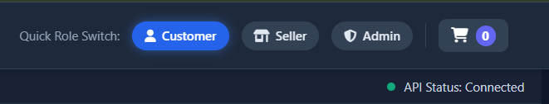
Module 3 & 5: Product Catalog with Live Search & Filter
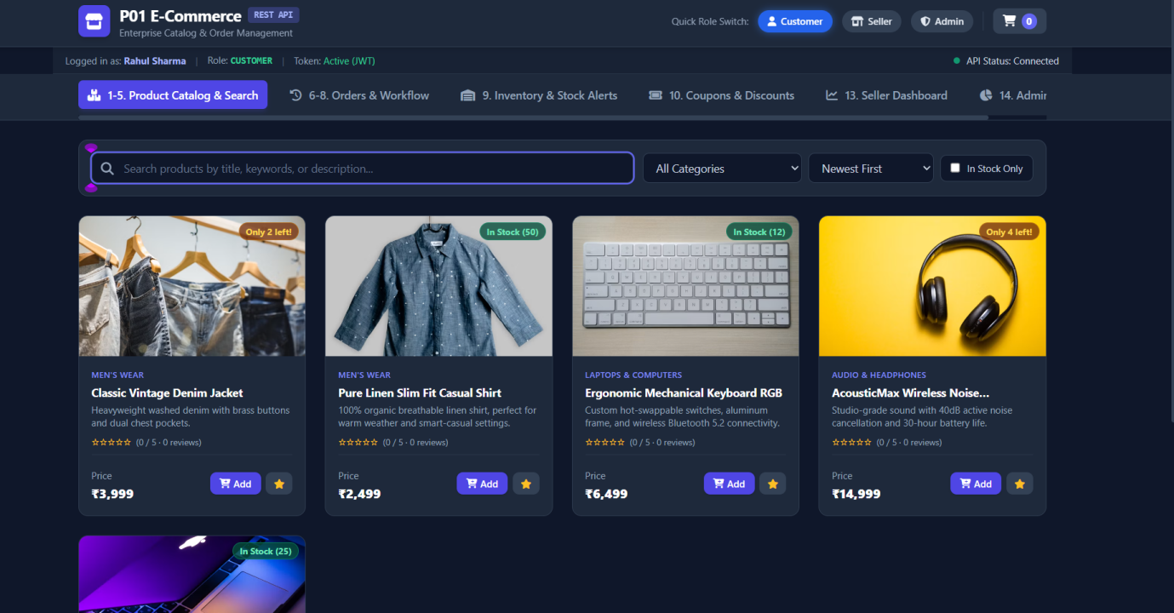
Module 6, 7 & 10: Shopping Cart, Coupon & Checkout
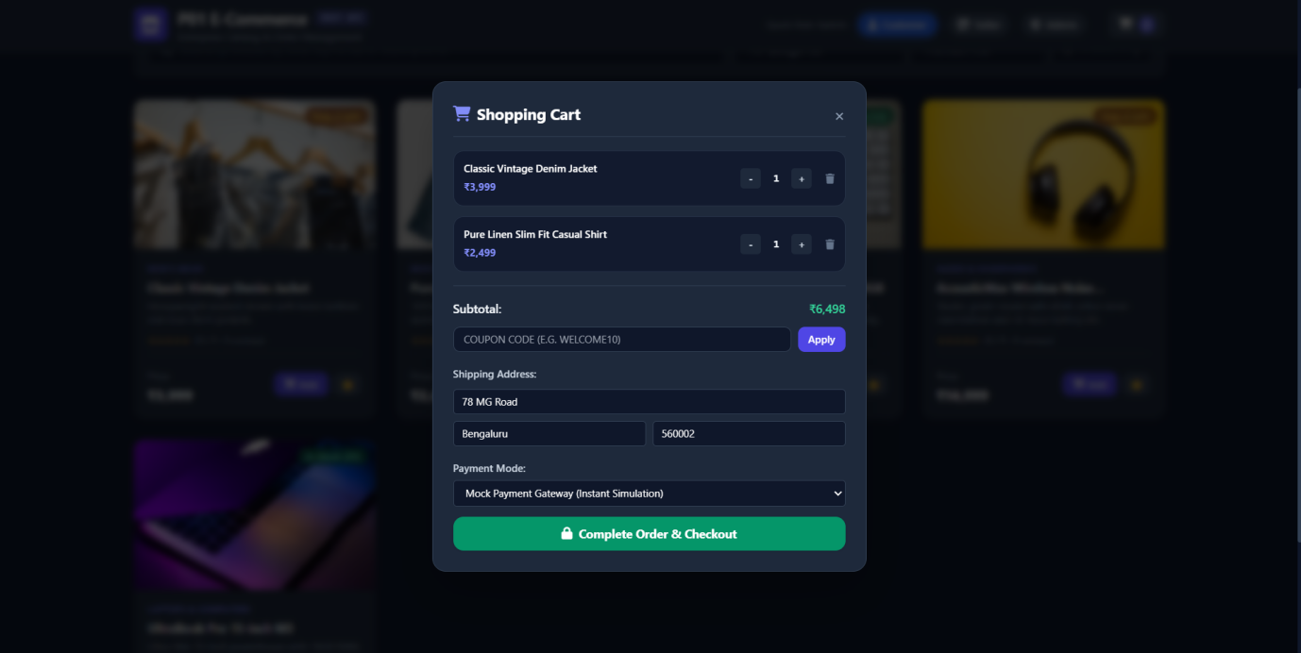

Module 8: Order Status Workflow Progression
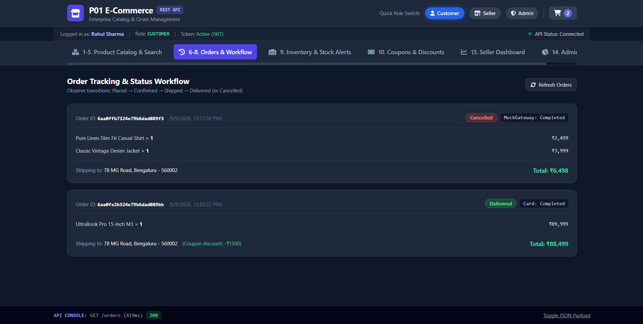
Module 9: Low-Stock Inventory Alerts
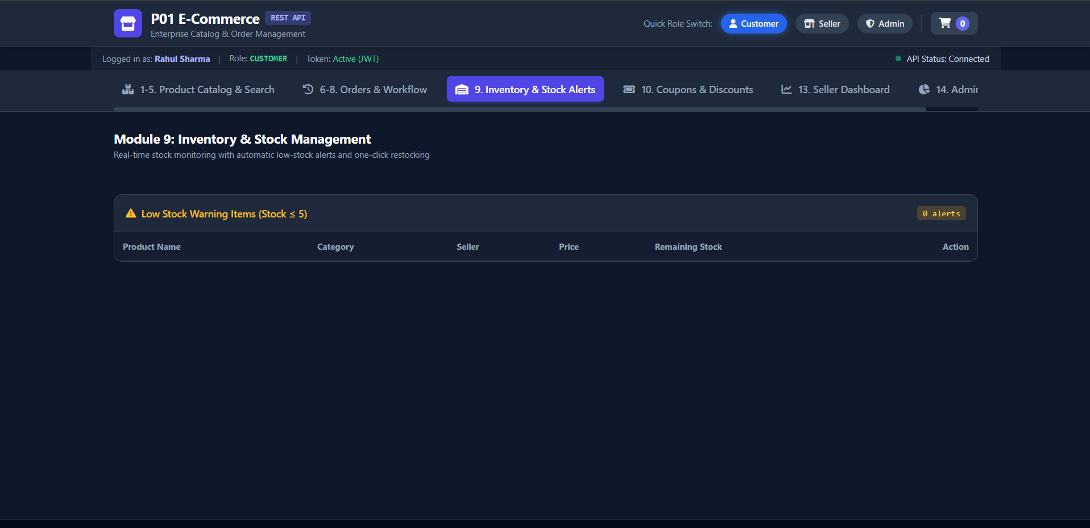

Module 13 & 14: Seller Dashboard & Admin Analytics
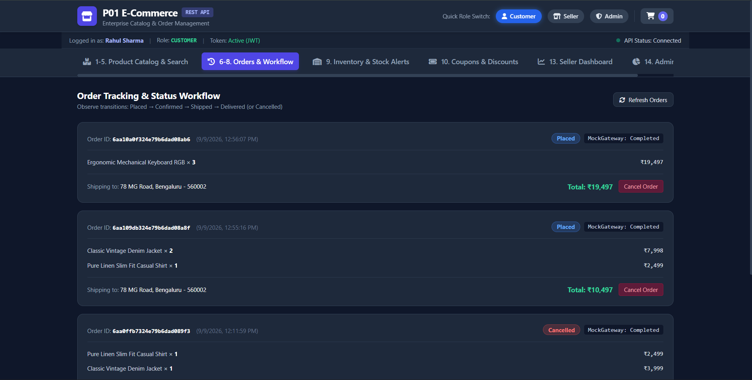
6. Automated Test Suite Results (30/30 Passed)
All 14 modules were verified using scripts/test-api.js. Total Assertions: 30 Passed, 0 Failed (100% success rate). All business constraints (400 validation, 401 unauthenticated, 403 forbidden, 404 not found, and 409 conflict) operate exactly as specified.

