Use Case: The user opens the app and can create new notes to display in the notes section.

Step 1: The user opens the app

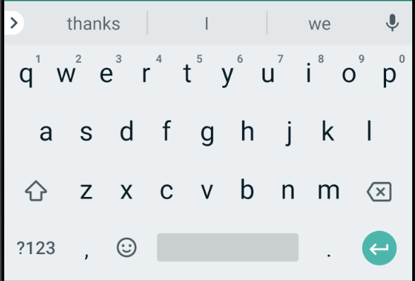

New Note:

Save

Step 2: The user types up the note they want to add in the ‘New Note’ section.



New Note: I like coding!

Save

Step 3: The user presses the save button and the newly created note will populate in the notes field.



New Note: I like coding!

Save

Step 4: The user can edit any notes they have created.



New Note: I like coding!

Save

1.) I do not like coding!

2.) Pick up eggs from the store.

3.) Destroy my enemies.