Use Case 1: The user adds money to their account balance.

Step 1: The user opens the app

Current Balance: $0

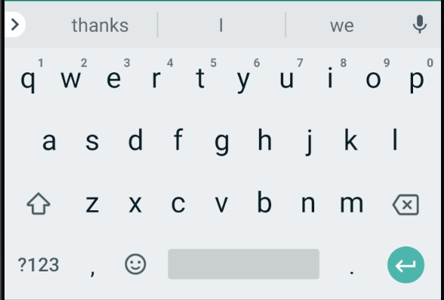

-

+

History

Date | Amount | Category

Step 2: The user types in the date of the transfer, the amount of the transfer, and the source of the transfer into the appropriate slots.

Date | Amount | Category

2/2/12

+

Current Balance: $0

4.30

-

History

Paycheck

Step 3: The user presses the add button and the newly created transfer is put into the history.

Date | Amount | Category

Current Balance: $4.30

+

2/2/12 $4.30 Paycheck

-

History

Use Case 2: The user spends money from their account balance.

Step 1: The user opens the app.

Current Balance: $4.30

+

Added $4.30 on 2/12/12 from Paycheck

-

History

2/2/12 $4.30 Paycheck

Date | Amount | Category

Step 1: The user opens the app.

Step 2: The user fills in the slots for date, amount, and source of the payment.

Date | Amount | Category

Current Balance: $4.30

4/4/12

+

Added $4.30 on 2/12/12 from Paycheck

4.30

Movie

-

History

2/2/12 $4.30 Paycheck

Step 3: The user presses the minus button to enter an expense into the app.

2/2/12 $4.30 Paycheck

4/4/12 -$4.30 Movie

Date | Amount | Category

+

Added $4.30 on 2/12/12 from Paycheck

Spent $4.30 on 4/4/12 on Movie

Current Balance: $0

-

History