Use Case 1: The user filters for all transactions since Jan 1, 2020.

Step 1: The user opens the app

Current Balance: $88,431.50

-

+

Filters

Category

Amount

Date

History

1/2/98 $88,432 Adding

2/3/20 -$4.00 Spending

4/10/20 $3.50 Adding

Date | Amount | Category

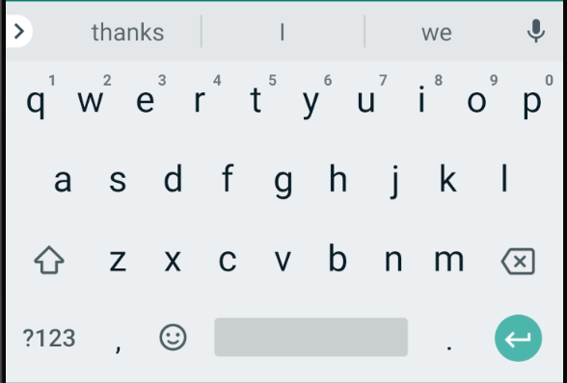

Step 2: The user types in the search parameter of the number of transactions since Jan 1st, 2020.

Current Balance: $88,431.50

+

-

1/2/98 $88,432 Adding

2/3/20 -$4.00 Spending

4/10/20 $3.50 Adding

Date | Amount | Category

Filters

Date

Amount

Category

>Jan 1, 2020

History

Date | Amount | Category

Step 3: The user presses the filter button and the entries are sorted.

Current Balance: $88,431.50

+

-

Category

Amount

Date

Filters

Date | Amount | Category

2/3/20 -$4.00 Spending

4/10/20 $3.50 Adding

History

Date | Amount | Category

2/2/12 $4.30 Paycheck

