- As a user, I want to add a new product or update a current product in the system.

New Product Success Use Case:

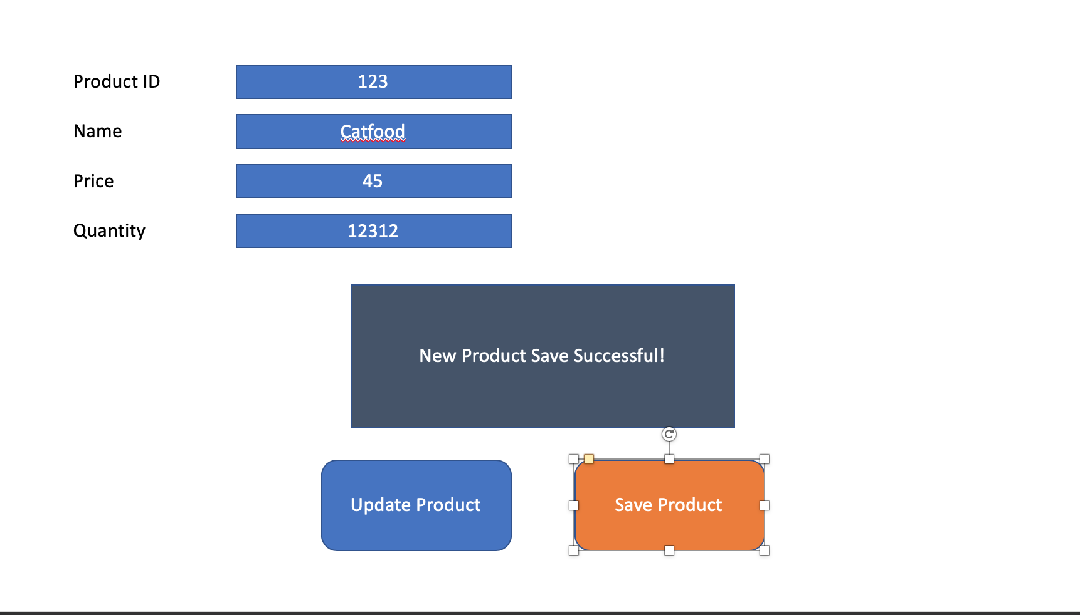

Update Product Successful Use Case:

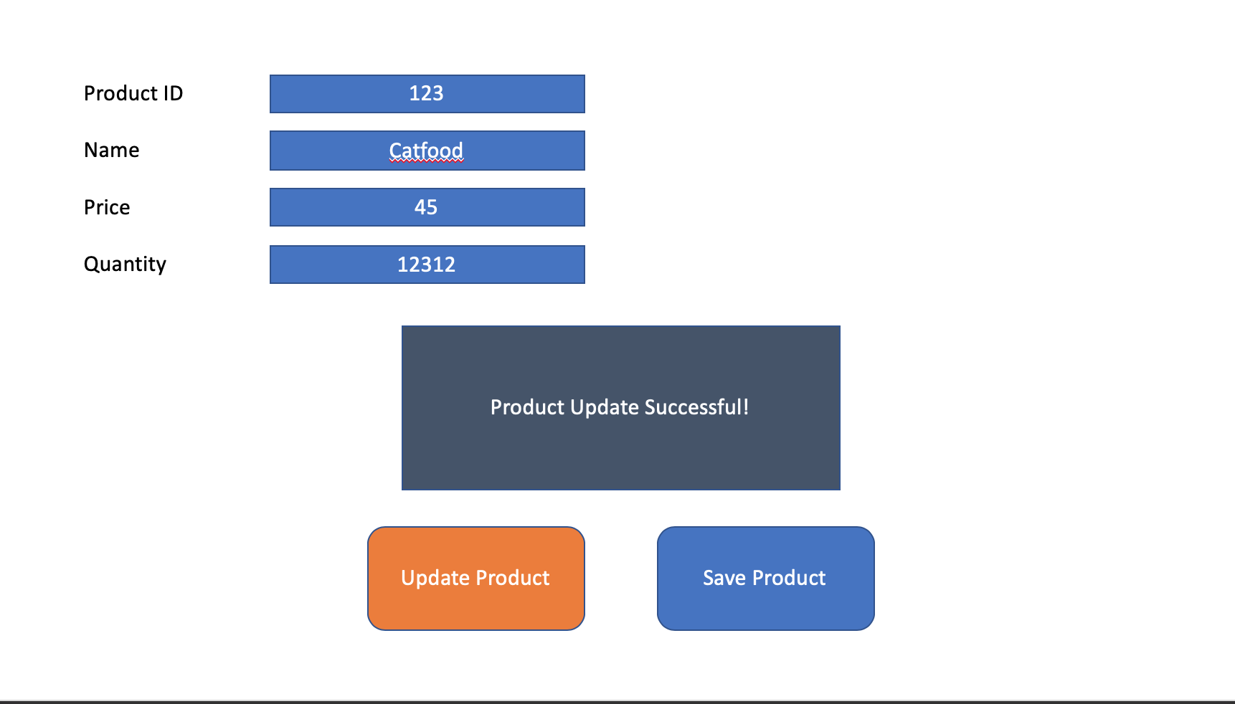

- As a user, I want to add a new customer or update a current customer in the system.

New Customer Success Use Case:

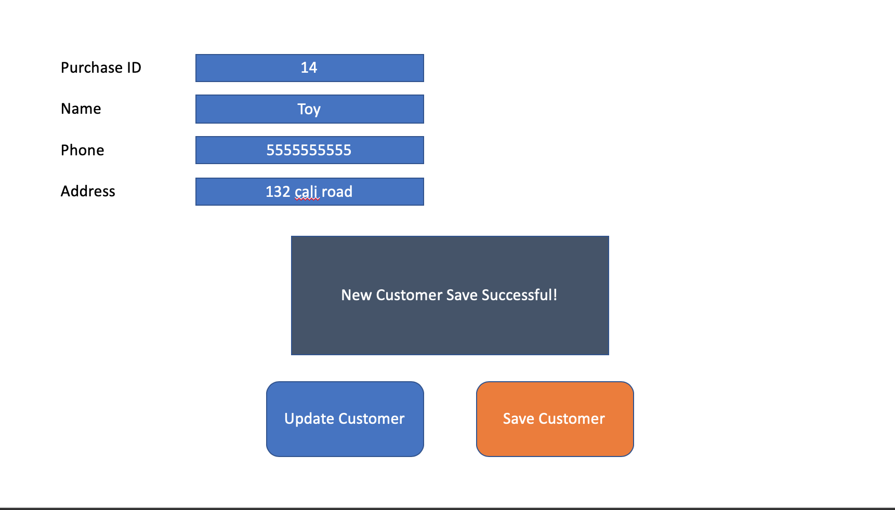

Update Customer Success Use Case:

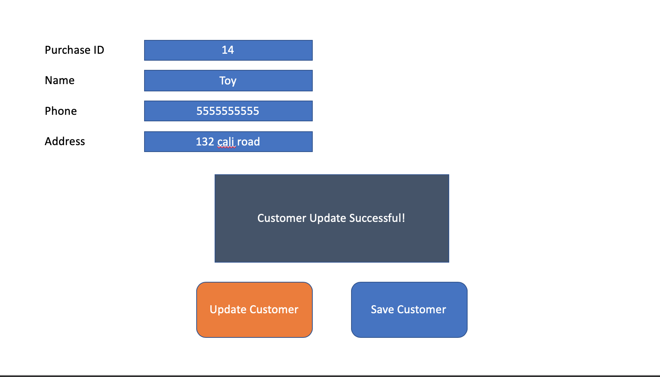

- As a user, I want to add a new purchase or update a current purchase in the system.

New Purchase Success Use Case:

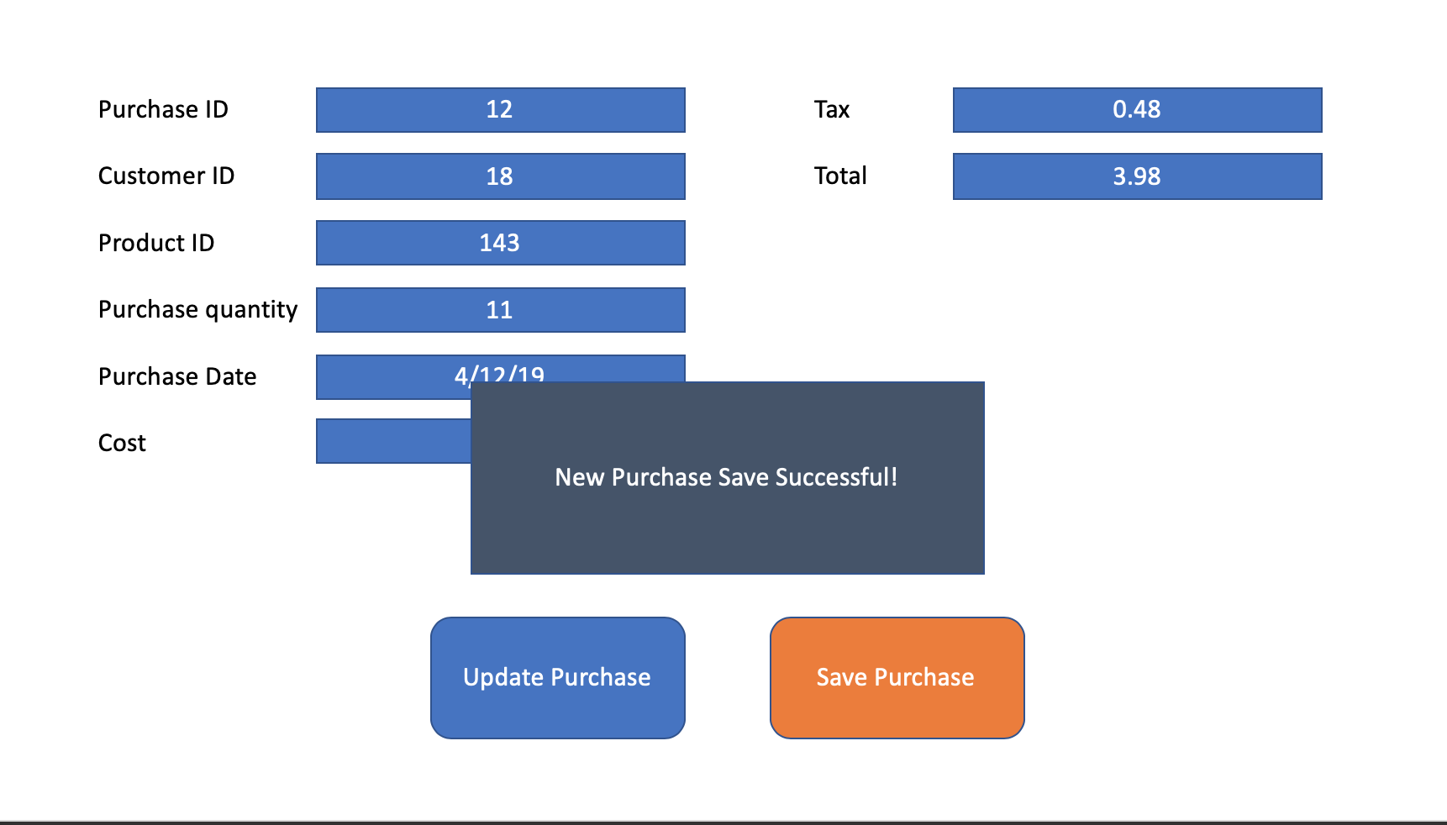

Update Purchase Success Use Case:

