3-tier:

User Interface

* MainView class,
* 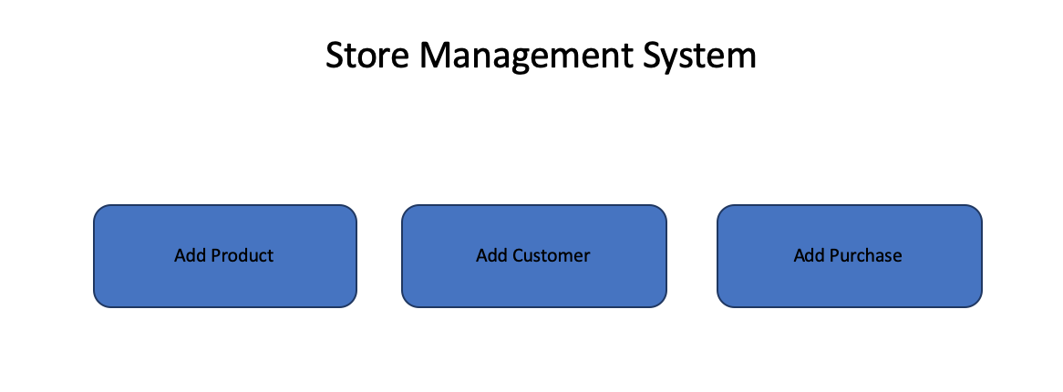
* AddProductView class
* 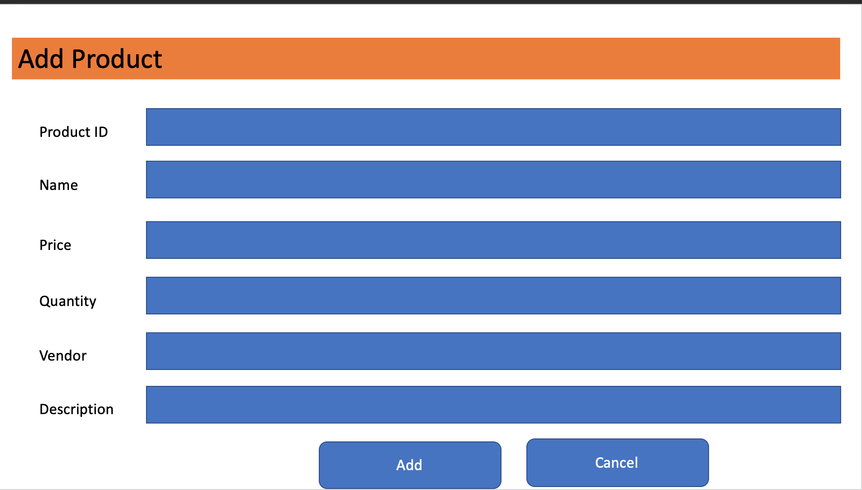
* AddCustomerView
* AddPurchaseView

Business Logic

* ProductModel class: store information of a product
* AddProductController: process events of AddProductView (AddButtonListener, CancelButtonListener)
* CustomerModel class: store information of a customer
* AddCustomerController: process events of AddCustomerView (AddButtonListener, CancelButtonListener)
* PurchaseModel class: store information of a purchase
* AddPurchaseController: process events of AddProductView (AddButtonListener, CancelButtonListener)
* StoreManager: main application object
* MainController: controller of MainView

Data Access

* SQLiteDataAdapter class: read/write data
  + loadProduct, saveProduct
  + loadPurchase, savePurchase
  + loadCustomer, saveCustomer