Marine Geology Brochure

The last major area of the world that has not been capitalized upon is the ocean. In recent years developers have started marketing underwater areas as vacation destinations. Scuba diving trips to see the natural formations of the underwater seafloor have recently become popular.
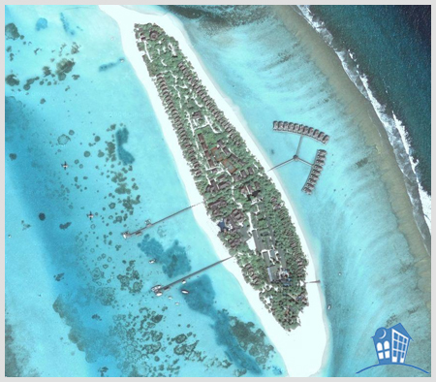
In Thailand, a resort owner has made huts that have a glass bottom that is suspended over the shallow seas. The huts rent for approx. $800 a night.

In the project you will be developing an underwater vacation destination. You do not need to take into account the feasibility of creating and manufacturing your destination. This destination can be of anything you can think of, but the location of it does need to be underwater.

You will create a brochure advertising your destination. This brochure must include 8 marine geographical features that can be found on the seafloor. Examples are (but are not limited to):

Black or White Smokers Ridges Caves
Rift Valleys Trenches Deep Sea Vents
Rifts Continental Slope Seamounts
Volcanoes Islands Canyons
Abyssal Plains Deep Sea Floor Coral Reef
Basin Shelf Abyssal Hills

Also, in this brochure you must define what these geographical features are. Defining the formations can easily be done by placing the definition in brackets after mentioning it.

Example: If I was making an underwater spa resort a line in the brochure could be “Visit our deep sea vents (a hot spring on the ocean floor, where heated fluids exit from cracks in the earth's crust) which supply great facials for the discerning customer. Only $150 a visit!”

Marine Geology Vacation Destination

Student Name: ________________________________________

CATEGORY | 12 | 8 | 4 | 1
Spelling, Proofreading, and Grammar | No spelling errors remain after one person other than the typist reads and corrects the brochure. There are no grammatical mistakes in the brochure. | No more than 1 spelling error remains after one person other than the typist reads and corrects the brochure. There are no grammatical mistakes in the brochure after feedback from an adult. | No more than 3 spelling errors remain after one person other than the typist reads and corrects the brochure. There are 1-2 grammatical mistakes in the brochure even after feedback from an adult. | Several spelling errors in the brochure. There are several grammatical mistakes in the brochure even after feedback from an adult.
Attractiveness & Organization | The brochure has exceptionally attractive formatting and well-organized information. | The brochure has attractive formatting and well-organized information. | The brochure has well-organized information. | The brochure's formatting and organization of material are confusing to the reader.
Content - Accuracy | All facts in the brochure are accurate. Eight marine geological landmarks are mentioned and are incorporated into the brochure. | 99-90% of the facts in the brochure are accurate. 6-7 marine geological landmarks are mentioned and are incorporated into the brochure. | 89-80% of the facts in the brochure are accurate. 3-5 marine geological landmarks are mentioned and are incorporated into the brochure. . | Fewer than 80% of the facts in the brochure are accurate. Less than three marine geological landmarks are mentioned and are incorporated into the brochure. .
Definitions of landmarks | Correct definitions are given for all 8 geological landmarks. | Correct definitions are given for 6-7 geological landmarks. | Correct definitions are given for 3-5 geological landmarks. | Correct definitions are given for less than 3 geological landmarks.
Graphics/Pictures | Graphics go well with the text and there is a good mix of text and graphics. | Graphics go well with the text, but there are so many that they distract from the text. | Graphics go well with the text, but there are too few and the brochure seems "text-heavy". | Graphics do not go with the accompanying text or appear to be randomly chosen.
Creativity | Shows a great amount of creativity with ideas in the brochure. | Shows a good amount of creativity with ideas in the brochure. | Shows creativity with ideas in the brochure. | Shows little to none of creativity with ideas in the brochure.

_________________/ 72 points

