Marine Biology (Ecology)

- Work in pairs of two.
- You will create a poster detailing one selected organism and it’s environment.
- Draw the organism in its usual habitat on the poster.
- Be sure to label at least 12 abiotic and biotic factors in this habitat.
- Find out what that organisms’ niche in its community is, and depict (draw) this on the poster. Describe (written) this niche on the poster at the bottom.

Example:
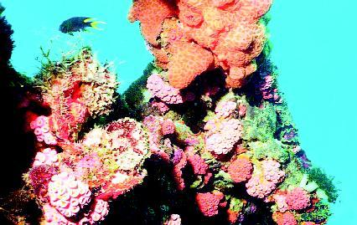
Fish (my organism)

Water;
I would continue to list more abiotic and biotic factors

Niche: Suckerfish cleans other organisms

Grading:

______/ 15 Accurate depiction of the habitat.

______/ 12 Abiotic and Biotic factors are listed and they are correct.
______/ 10 Explanation and drawing of the niche

______ / 8 Neatness/ visual qualities/ Presentation

_________/ 40 Total Points

