Starfish Dissection Lab Data Sheet

Cycle: ___ Date: _______________ (___/50) Name: __________________________________

Your lab partner(s) name: _______________________________________________________

Background Questions (6 pts)
1. In what phylum are starfish found? ______________________________________________
2. What is the habitat for starfish? _________________________________________________
3. On what do starfish feed? ______________________________________________________
4. What system in their body helps them catch & hold their food? ________________________ _____________________________________________________________________________
5. State 2 classes of echinoderms and name a member of each class.
(A) ________________________________________________________________________ (B) ________________________________________________________________________

Label the structures on the figures as indicated in the lab procedures. Answer the questions once you are finished your dissection and have cleaned everything up!

Figure 1 - Aboral Surface: Label (and draw in if necessary) the madreporite, dorsal spine, ray, central disc, and eyespots (5 pts)
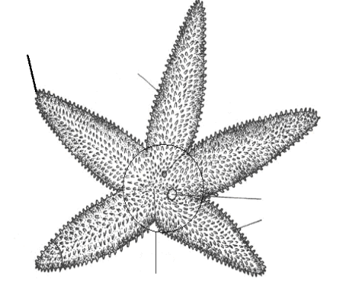

Figure 2 - Oral Surface: Label the mouth, oral spines, ambulacral groove, and tube feet. (4 pts)

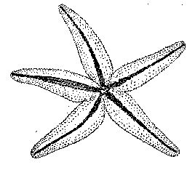

Figure 3 Figure 4
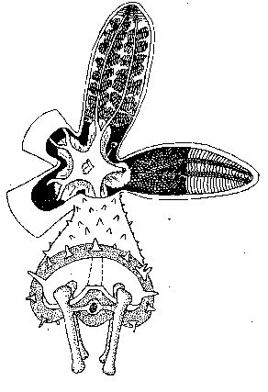 | 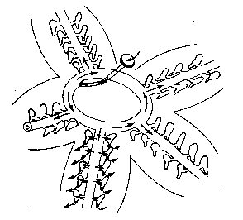
Digestive & Reproductive Systems | Water Vascular System
Label the pyloric caeca, stomach, gonads, ampulla, tube foot, and ossicles (6 pts) | Label the lateral canal, tube feet, ring canal, stone canal, and madreporite (5)

Label these parts: (7 pts)  A - ______________________  B - ______________________  C - ______________________  D - ______________________  E - ______________________  F - ______________________  G - ______________________ | 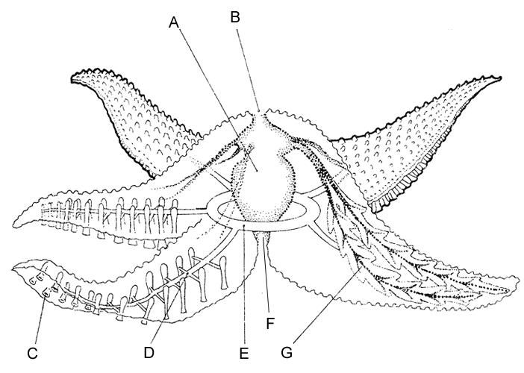

Starfish Dissection Analysis Questions

1. What type of symmetry did your starfish have? (1) __________________________________

2. What is the upper surface of the starfish called? (1) __________________________________

3. What is the lower surface of the starfish called? (1) __________________________________

4. On which surface are these parts of a starfish visible? (use proper terminology!) (3 pts)
a. Mouth - ______________________
b. Madreporite - ______________________
c. Suckers - ______________________
d. Oral spines - ______________________
e. Eyespots - ______________________
d. Ambulacral groove - ______________________

5. What part of the tube foot creates suction to open clams whenever the starfish feeds? (1) ____________________________________________________________________________ ____________________________________________________________________________

6. What type of skeleton, endoskeleton or exoskeleton, does the starfish have? (Circle) (1)

7. What bony plates make up its skeleton? (1) ________________________________________

8. What is the function of the pyloric caeca? (1) _______________________________________

9. Where is the stomach of a starfish located? What can the starfish do with its stomach when feeding on clams & oysters? (2) ___________________________________________________ _____________________________________________________________________________
_____________________________________________________________________________
_____________________________________________________________________________

Do NOT forget to pass in your coloured coded diagram sheet of the starfish! (5 pts)


