Sponge Creation Lab
Sponge Anatomy
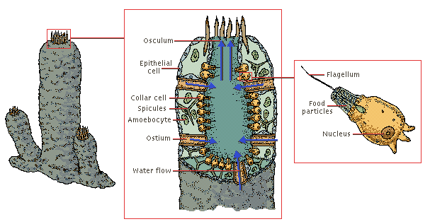
The structural components of a sponge include the outer, protective layer of cells and the spiny spicules, which form the skeleton. Sponges feed off microorganisms in the water that flow in through small openings known as ostia. The flagella on the inner layer of cells move the water through the sponge, absorbing food particles as the water flows past. Eventually the water exits through the osculum, the cavity at the top of the sponge.

External Sponge Anatomy:
epidermis - the layer of cells that covers the outer surface of the sponge. The thin, flattened cells of the epidermis are called pinacocytes.
holdfast - root-like tendrils that attach the sponge to rocks.
osculum - the large openings in a sponge through which water flows out of the sponge. Sponges may have more than one oscula.
water flows in - water flows into a sponge through pores (holes) located all over its body. The sponge obtains its nutrients and oxygen by processing this flowing water.
water flows out - water flows out of a sponge through large openings called oscula.
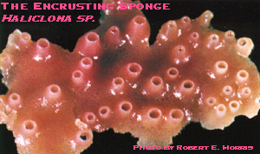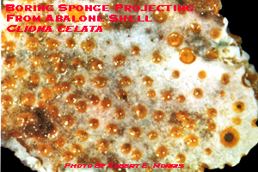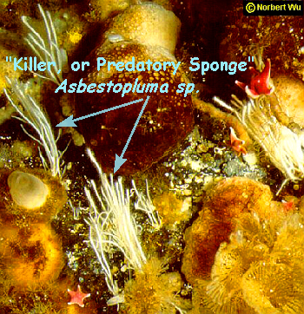
There are many different types of sponges in the oceans. I have compiled three interesting specimens you might want to use. These are three different examples of sponges. Top left is a pink sponge known as the encrusting sponge, while the top right is white with tons of brown spots and known as a boring sponge. The largest picture is that of a rare killer, or predatory sponge, which actually is carnivorous.

In this lab, you will be doing the opposite of dissection, which would be creation! There will be two parts to the lab. Research and development which will happen in the library/computer lab and the implementation, in which you will create a model of your sponge, will happen in the lab room.

- Research two different types of sponges you would like to make a hybrid of. There are many types of sponges tubular and globular being two of the main shapes of sponges.
- Find and pick the unique characteristics about the two sponges that you have chosen.
- Fill out the following information form about your sponge.
- Create a clay model of your sponge.
- Label all 6 of the anatomical structures that were underlined in the introduction to this lab. Use a toothpick with a piece of paper taped on it to label the anatomical structure.

Sponge Hybrid Information Sheet

- What are the two types of sponges you are melding together in order to create your new hybrid sponge? Be specific on the type of the sponge- not just green sponge. ______________________________________________________________________________________________________________________________________________________________________________________________________
__________________________________________________________________
- Describe both of the sponges habitat and niche. ______________________________________________________________________________________________________________________________________________________________________________________________________
- What characteristics are you drawing from each type of sponge? Ex. Color, reproduction methods, motility vs. sessile, etc…
____________________________________________________________________________________________________________________________________________________________________________________________________________________________________________________________________________________________________________________________________________________________________________________________________________
- Hypothetically, in nature, could these two sponges you have chosen ever create a hybrid sponge?
______________________________________________________________________________________________________________________________________________________________________________________________________
- Print out one picture of each sponge you have chosen and attach it to the lab. This will help you when you are creating your clay model out of your sponge.
- On a separate piece of paper, draw a sketch of what your hybrid sponge will look like. Be sure to point out the characteristics you are drawing from each sponge, along with placing the anatomy of the sponge in your sketch also.

Lab Grading:

Hybrid Information Sheet:
Questions 1-5 3 pts each _____________/ 15 possible pts
Question 6 10 pts each _____________/ 10 possible pts
Clay Model:
Likeness to drawing 5 pts _____________/ 5 possible pts
Craftsmanship 10 pts _____________/ 10 possible pts
Creating and labeling anatomical structures _____________/ 24 possible pts
4 pts each
_____________/ 64 possible pts

