Shark vs. Bony Fish
Comparative Anatomy

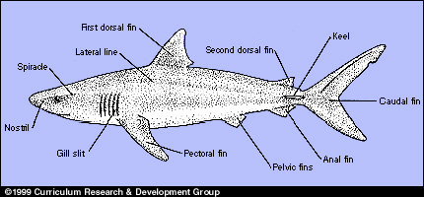
Fig. 1–3. Anatomy of a shark
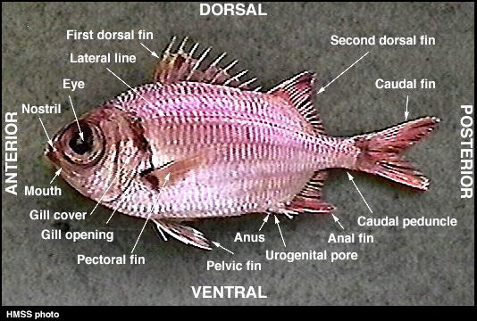
Figure 1-1
PROCEDURE
- Sharks are fish, but because their anatomical and functional features differ from those of the bony fish, they belong to a different class. Fig. 1–3 shows the external anatomy of a shark. Compare it with the external anatomy of a bony fish in Fig. 1–1.
- Complete the table below, a comparison of bony fish and sharks.
  - Study the information in the table on the structures and characteristics of sharks.
  - Supply the information describing the structures and characteristics of bony fish. Refer as needed to the figures above.

Table 1–1. Comparison of sharks with bony fish

1. How do sharks compare with bony fish? What are the differences? What are the similarities?
2. In general, what advantages, if any, do bony fish have over sharks?
3. What advantages, if any, do sharks have over bony fish?

