Shark Attack!
Name:
As you work with the data this activity, keep in mind that the information is inconsistent because it comes from several sources. In this activity we are looking for trends, not exact values.
Determine the latitude, season, and time of day of most shark attacks worldwide.
Determine the activity, depth and environment of the victim at the time of attack.
PROCEDURE
1. Study the data in the following tables showing:
- the world distribution of shark attacks by month and the latitude of each attack.

- the relative numbers of shark attacks in a 24-hr day.

- on times of shark attacks

- the activity and depth of the victims at the time of the attack.

- the environment of the attack

- the deaths and injury related to shark attacks

SHARK ATTACK DATA TABLES:
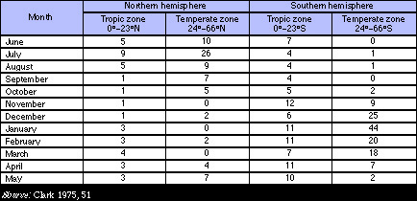 Incidences of Shark attacks by hemisphere and month from 1941-1968
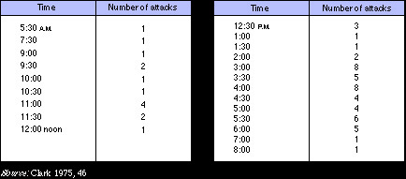 Shark attacks in 1971by time of day
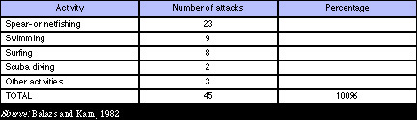 Shark attack activity in Hawaii from 1886-1980
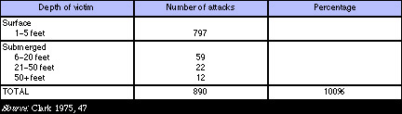 Shark attacks by depth worldwide from 1941-1968
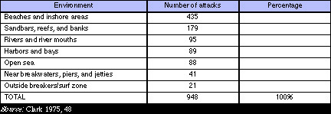 Worldwide shark attacks by water environments from 1941-1968
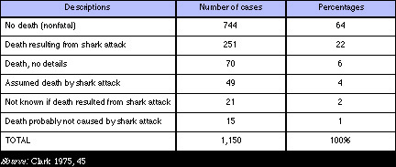 Worldwide deaths from shark attacks from 1941-1968

- Did most of the shark attacks occur in tropic zones (from 0 degrees to 23 degrees N or S) or in temperate zones (from 24 degrees to 66 degrees N or S)?, in the northern hemisphere or in the southern hemisphere?, in summer, fall, winter, or spring?
- Which zone do you live in—a tropic zone, a temperate zone, or a polar zone?
- At what time(s) of day did most shark attacks occur?
- What does this information suggest about shark behavior?, about human behavior?
- Under what conditions do most shark attacks occur by type of activity?, submerged depth of the victim?, type of environment?
10. Using the data in the table, estimate what percentage of shark attack victims live to tell their experience.

