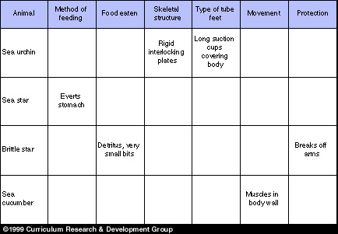
Table 8–1. Comparison of structure, function, and behavior of major groups of echinoderms

