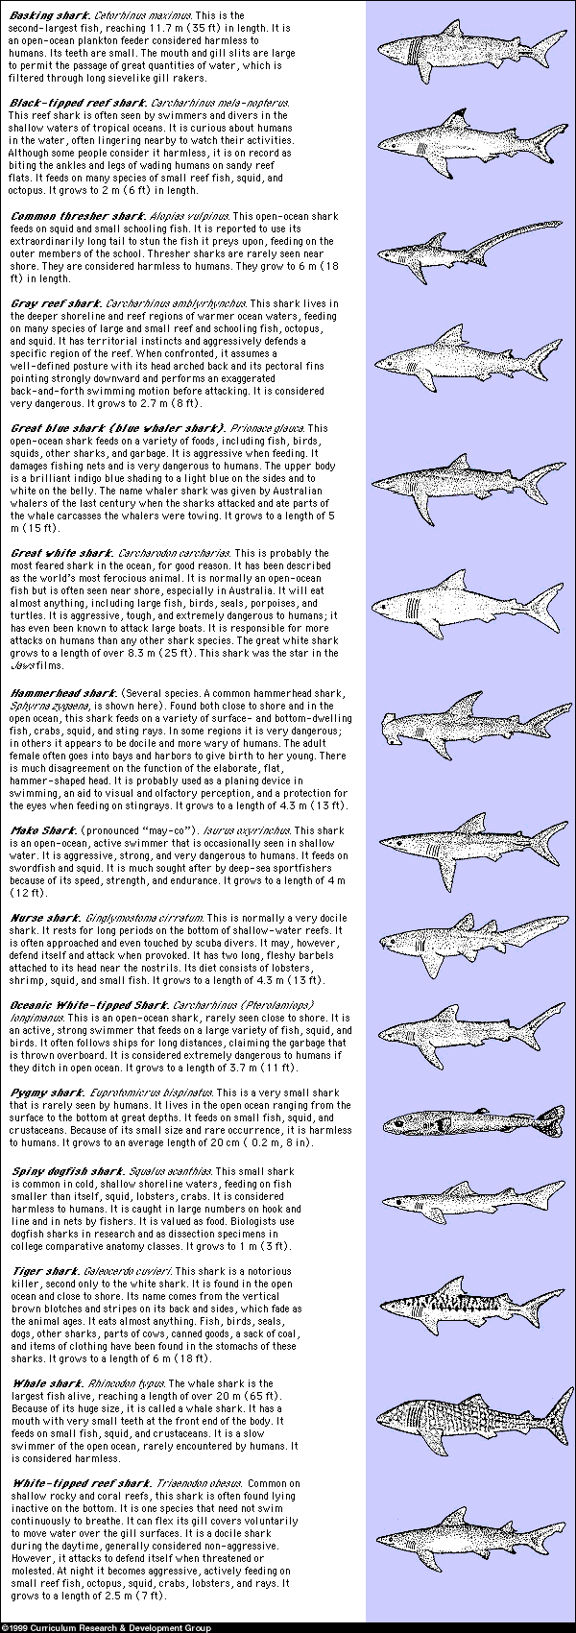

Make a poster showing the habitats of sharks. Indicate which sharks are dangerous to humans.
MATERIALS
Scissors
Glue
Colored pencils or crayons
PROCEDURE
1. Make a poster showing the habitats of sharks by ocean zones, keep this for yourself but take a picture of it, or fax it to me, or do it in paint, mail it to me, whatever works for you. A habitat is the place where an organism lives, eats, and grows. Cut out the sharks in Figure 1-5 and glue them on to a paper using the following criteria.
2. Devise a color code for showing how dangerous each shark species is. Then color the sharks on your poster. See Fig. 1-4 for descriptions of shark behaviors. Categorize the sharks as follows:
Extremely dangerous: unusually aggressive behavior; considered a killer
Very dangerous: aggressive, unpredictable behavior; known human fatalities
Dangerous: known to bite people rarely or occasionally; attacks not fatal
Harmless: not considered dangerous to humans
Show your color code in the lower right-hand corner of your poster.
3. Using information from Fig. 1-4, decide which zone the sharks are found, in near-shore waters, in open-ocean waters, or in both near-shore and open-ocean waters. Place the label on the shark drawing.
c. Using information from Table 1-4 again, arrange the sharks by what they eat. If the shark eats only surface-dwelling organisms, put it near the surface. If the shark eats bottom-dwelling organisms, put it near the seafloor.
d. Glue each shark drawing and its name to the poster.
4. Add information to the poster telling what the sharks eat.
