Status of Fisheries in Jordan

# Summary

The majority of the commercial fish catch in Jordanian fisheries is made up of tuna, swordfish and sardines. These migratory, pelagic species are unlikely to have built a separate population in Jordan or in the Gulf of Aqaba, and are most likely part of the broader Indian Ocean stocks. While the swordfish population in the Indian Ocean is not currently over-fished, no stock assessments exist for the other major species.

In contrast, the reef fish species, which make up only a small part of the catch, have likely formed a separate local population. Although more comprehensive and detailed data is necessary to estimate stock size and definite stock status for these species, first investigations from surveys show that important indicator species are heavily over-fished and that the stocks are nearly depleted. This is supported by the finding that more than ¼ of the fishing trips are ended without any catch.

##### Page Break

# Acknowledgment

##### Page Break

# Introduction

## Literature Review 250 words

### The Fishery Status in Jordan’s Gulf of Aqaba — Mohammad Al-Zibdah, Maroof Khalaf, and Nidal Odat

This study collected data from July 1999 to June 2000 on fish size and composition as well as the gear used and effort expended. Data was collected through government resources along with interviews and direct measurements with fishers. This data was then supplemented by Ministry of Agriculture documents from previous years on catch sizes. While 153 tonnes of fish were recorded for the period in question, the researchers found that the catch size would fluctuate by as much as 100 tonnes per year historically. Much of this fluctuation can be explained by non-environmental factors like stricter border control and the banning of dynamite for fishing, but heavy overexploitation was observed for most species outside of tuna. Fishing trips would begin in the early morning around sunrise and end when either the fishers were satisfied with the catch or at sunset. Boats mostly remained along the north coastline and in Al-Mamlah Bay, where the Gulf has a biotic soft floor or seagrass beds. Deep sea fishing in the summer. The number of trips would increase in the winter when tuna populations were at their peak; in the summer catches mostly consisted of deep sea fishing for commercial species. Fishers do not utilize shellfish and other invertebrate species in the area. The Researchers found that only 60% fishers licensed in the area actually fished, possibly because the shallow water and complex topography of the ocean floor make fishing difficult in the area. The researchers also calculated CPUE, or catch per unit effort, a measure of how much fish is caught per trip.

$CPUE=\frac{CA_{m}}{T_{m}*B_{y}}$ Where $CA_{m}$ is the catch in Kg per month, $T_{m}$ is the average number of trips per boat per month, and $B_{y}$ is the average number of active boats per month.

(Bartkowiak, 1955; Braid and Khalidi, 1962; Dabaj, 1981; Eriksen, 1957).

### Fishery Status, Growth, Reproduction Biology and Feeding Habit of Two Scombrid Fish from the Gulf of Aqaba, Red Sea (2007) — Mohammad Al-Zibdah and Nidal Odat

Zibdah and Odat used surveys and physical analysis to determine the characteristics of two important fish species in the Gulf of Aqaba: *Katsuwonus pelamis* (Skipjack Tuna, *Arabic Name*) and *Euthnnys affinis* (mackerel tuna, *Arabic Name*.) They found that these two species together make up about 60% of the total catch from Aqaba and that the Scombridae family in general made up 91% of the catch from about 50 trips each day. Catch totals were estimated from monthly records kept by authorities. Some of the catch of each species was also analyzed by the researchers to determine physical and behavioral characteristics. Physical characteristics of the fish indicated that only mature fish migrated into the area and that the quality and abundance of food were inadequate. The bulk of each species’ consumption comes from other small fish, often *Atherinomorus lacunosus*. The rates of mortality revealed that both species are being heavily exploited by fishers, at roughly equal rates. Movement patterns also indicated that the population crosses international boundaries, making proper management between countries vital to ensure the sustainability of the fishery.

### Fish Fauna of the Jordanian Coast, Gulf of Aqaba, Red Sea (2004) — Maroof Khalaf

Khalaf aimed to take an inventory of the fish present in the Gulf of Aqaba and display the diversity found in the region. This study found a total of 507 fish species belonging to 109 families, 65 of which (12.8%) were endemic to the Gulf. Inventories were obtained from 4 sources: species collected or deposited at the Marine Science Station in Aqaba, the collection of the Sencknberg Museum Frankfurt, the catch of fishers between 1995 and 2002, and previous species reported in literature about the Gulf. Fish were photographed and measured by marine station staff, both after being caught and in their habitats during a visual census. The Gulf showed a high level of diversity despite its small size, potentially due to the presence of various environments like sandy flats, coral reefs, and seagrass meadows. 51% of the species lived in coral and boulders while 8.3% lived in the sea grass. Two species had also migrated into the Gulf from the Mediterranean Sea, and three invasive species were observed from inland aquaculture projects. In total, 76 species were identified as present in the Gulf for the first time.

### Fish Assemblages in seagrass habitat along the Jordanian coast of the Gulf of Aqaba (2012) — Maroof A. Khalaf, Saber Al-Rousan, Fuad A. Al-Horani

This study surveyed three seagrass meadows in the Gulf of Aqaba, identified as the ‘Hotels Area,’ ‘Phosphate Loading Berth,’ and ‘Tala Bay.’ Of 507 total species known in the Gulf of Aqaba, 132 species (26%) were identified in these seagrass areas. 19.7% of these species were from the family Labridae, and 8.33% were Pomacentridae, with the top 8 families making up 56.82% of species. In total, 37,034 fish were counted, with Lethrinidae making up 30.5%, Pomacentridae 28.7%, Serranidae 15.4%, and the top 7 families total making up 90.0%. The study also found that seagrass acts as a nursery for the fish and that when there is more coral cover, more species inhabit the seagrass.

### FAO Jordan Fishery Report (2003)

The UN Food and Agriculture Organization prepared a report in 2003 on the structure and prospects of the fishing industry in Jordan. The FAO found 85 fishermen employed on 40 boats, with a total catch from 2001 of 170t. Of the 2001 catch, 65% were tuna. The organization also found that the number of fishermen had been static in over a period of years, and that developmental prospects were very limited. In 2003 domestic fishing made up a small portion of Jordanian fish consumption, at around 2%, with the vast majority coming from imports. The FAO also found limited management measures for fisheries in Jordan despite certain restrictions on fishing methods. Because the important commercial species in Jordan extend beyond Jordanian borders, the FAO recommends regional co-operation for marine environmental management.

### Authors (Tawaha and Eid, 2011 studied fisheries at the Gulf of Aqaba name of publication. Methodology and then main results and main conclusion

### Literature review the red sea and the Gulf of Aqaba on fisheries

## The Gulf of Aqaba; an Overview- Ehab Eid

### Location

The Gulf of Aqaba is a semi-enclosed water basin in the Middle East, extending from the northern tip of the Red Sea. It connects to the Red Sea through the Straits of Tiran, between Sinai and Tiran Island. It is opposite the Gulf of Suez, across the Sinai Peninsula. The Gulf borders 4 countries: Saudi Arabia, Jordan, Israel, and Egypt through the Sinai Peninsula. The Gulf of Aqaba is Jordan’s only access to the ocean, as well as Israel’s only access to the Red Sea. As such, the cities of Aqaba and Eilat (in Jordan and Israel respectively) occupy roles as important port cities. Other minor port cities also exist, like Taba in Egypt and Haql in Saudi Arabia.

The Gulf of Aqaba has a length of 170km, with an average width of 15km and average depth of 800m (maximum depth 1800m.) The Jordanian coastline extends for about 27km along the Gulf. It consists of a series of embayments with a wide range of communities present in each, including rocky shore, reef flat, reef face, fore reef, sandy shore, sandy bottom and sea grass ecosystems. The Gulf’s ecological importance stems from its location as a bridge between Africa and Eurasia.

### Climate

### Sea Characteristics

The Gulf of Aqaba is marked by a relative lack of stormy weather, which along with mild water currents and relatively high salinity levels, provides a suitable environment for the growth of corals and countless varieties of marine-life forms. The water of the Jordanian coastline is exceptionally clear, with high transparency and little wave action throughout the year. The poor freshwater influx has led to poor supply of minerals salts and nutrients such as nitrogen or phosphorus compounds which left planktonic primary production very low. This characteristic is supported by a water temperature ranging between 21°C in winter and 27°C in summer; shallow coastal areas may reach as high as 29 °C during the warm months.

### Species Diversity

Between 161 (Tellawi 2001) and 507 different species of fish have been documented (Khalaf 2004) in the Jordanian part of the Gulf of Aqaba. These include species with possible local populations (e.g. groupers and lionfish) as well as migratory species such as tuna and swordfish. Most of the fish species present in Jordan (82.8%) are associated with benthic habitats such as corals and rocks (Khalaf 2004).

Sound data on the status of the fish stocks in Jordan has been mostly unavailable. While some investigations have been made (e.g. Zibdah et al 2006), no comprehensive stock estimates have been provided.

## Current status of fishing at Aqaba

1. ASEZA establishment- Ehab
2. Fishermen association
3. Aqaba marine park

## Efforts performed for fishing in the red sea

## Strategic direction of Aqaba

##### Page Break

# Methods

Mapping — identification of fishing areas  
Semi-structured Questionnaire

1. Fishermen
2. Local and touristic Restaurants

Socio-economic survey  
Database establishment

The data gathered by JREDS between November 2014 and November 2015 is the first continuous data collection effort to cover nearly the entire commercial fishing operation in Aqaba. Data on landings, species, gear and fishing area are collected by questionnaires directly from the fishermen in the harbor. The questionnaires have been developed with reference to those used by the FAO for the project “Scientific and Institutional Cooperation to Support Responsible Fisheries in the Eastern Mediterranean – EastMed” in Egypt and Lebanon. The collected data include the date, duration, location, the fishing method used and the estimated weight and number of the catch by species. The data is stored in a specially developed database hosted by JREDS and is regularly analyzed for misreporting and false entries. All catch is documented by pictures, so misidentification of species can be easily recognized.

##### Page Break

# Results

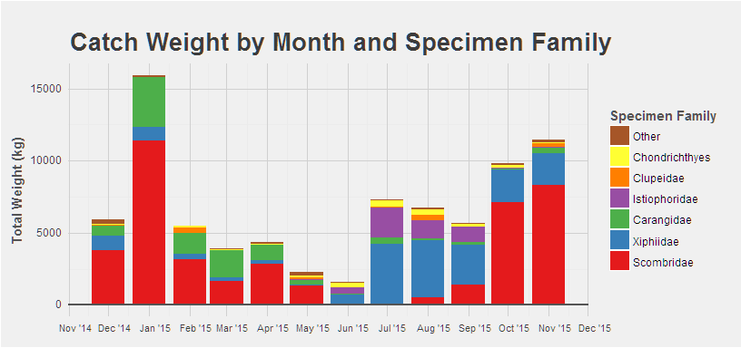

In total, information from 3530 fishing trips was collected and analyzed. The grand total catch from November 2014 to November 2015 was 80522 kg. Of all the fishing trips, 32% caught no fish. A total of 11432 kg of Sardines and Sardine-like species were caught in 250 trips. Of these, 7757 kg (68%) were caught opposite to the container port.

A total of 41618 kg of tuna species were caught, in 881 trips. The total catch for swordfish was 18955kg, 5005kg for sailfish, and 1966kg for sharks.

5919kg fish were caught in December, of which 3761kg (64%) are Tuna species.

15934 kg fish have been caught in January, of which 11390kg (71%) are Tuna species.

5518kg fish was the total catch of February, of which 3162kg (57%) are Tuna species.

3935kg fish was the total catch of March, of which 1684kg (43%) are Tuna species and 1905 (48%) Sardine.

4352kg fish was the total catch of April, of which 2854kg (66%) are Tuna species and 1052 (24%) Sardine.

Total catch in Mai was 1133kg, of which 445kg were sardine and 200kg “Sanbouk”.

Total catch in June was 1577kg, of which 710kg (45%) Swordfish and 411kg (26%) Sailfish. Total catch in July was 7318kg, of which 4209kg (58%) are swordfish and 2113kg (29%) are sailfish. Total catch in August was 6673kg, of which 3928kg (59%) Swordfish and 1208kg (18%) are Sailfish.

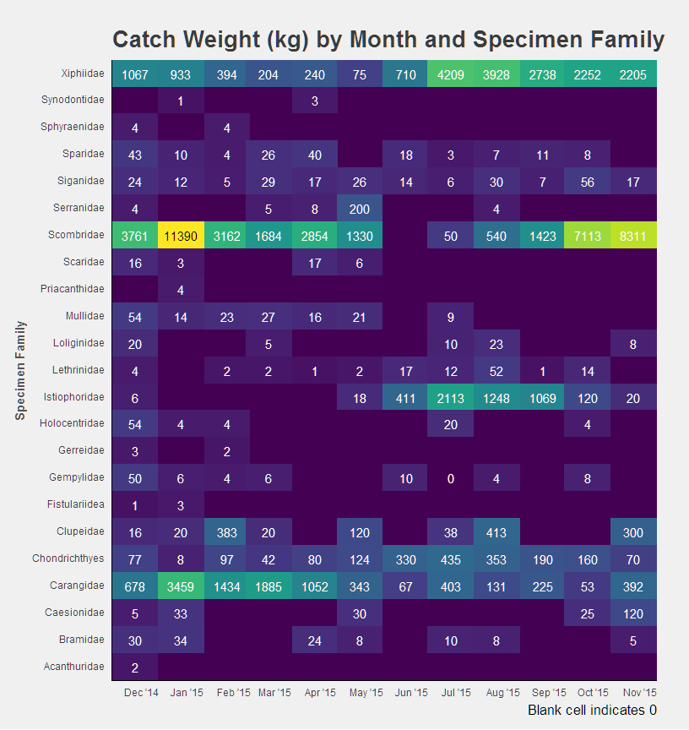

$\frac{1}{4}$ of the fishing trips were carried out opposite of the Container Port, $\frac{1}{4}$ at the old power station, $\frac{1}{5}$ opposite of the main port and some opposite of the Phosphate port. These areas are all close to the city, only few go more south. From 104 trips, which did come back without fish we did not get information about fishing area or gear.

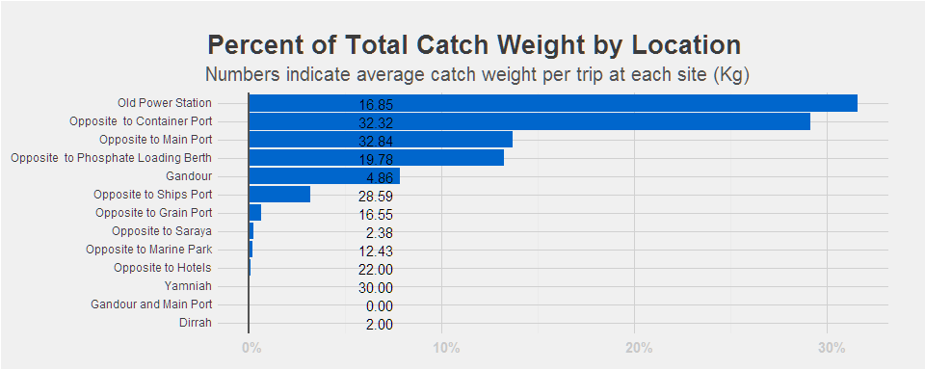 Overall, 84% of fishing trips used lines as part of their gear, compared to 21% for nets and 6% for cages. Of the major fishing areas (>50 trips during the time period) only Gandour was had significantly less line usage (at 15%) along with the Container Port (at 82%.) 32% of all fishing trips returned with no catch. That number is 32% for trips using lines, but jumps to 61% for nets and 45% for cages.

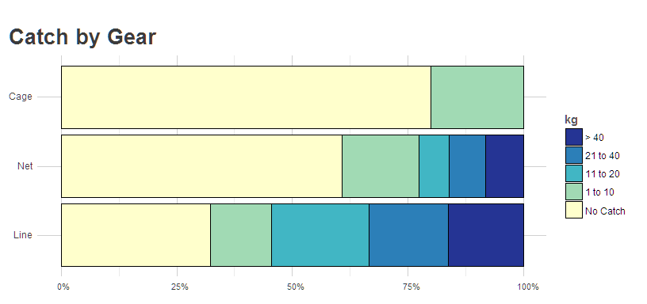

Controlling for fishing location and boat properties, both cages and nets are correlated with less catch weight, with cages seeing a change of -15.69kg [(-22.68, -8.41), p = 0.00002] and nets seeing a change of -7.29kg [(-10.35, -3.09), p = 0.00029] respectively. This suggests that lines are more effective than other gear, providing a possible reason for their overwhelming usage over nets and cages.

JREDS data collection reveals that 52% of the catch consists of tuna, followed by small pelagic schooling fish like swordfish (24%) and sardine and mackerel species (14%). In contrast, the local populations of reef fish species are making up only a very small part of the catch (under 1% each), less than 1600 Kg per year. In general, the fishermen have no access to fishing waters outside Jordan. Even inside Jordan’s boundaries, large areas are closed to fishing. For example, fishing is prohibited within 350 meters of the shore along the 4 km coast containing the Aqaba Marine Park area; fishing is also banned within 500 m of the port areas as well as south of the Tala Bay resort. Consequently, more than 65% of all fishing operations concentrate on three fishing areas off the coast.

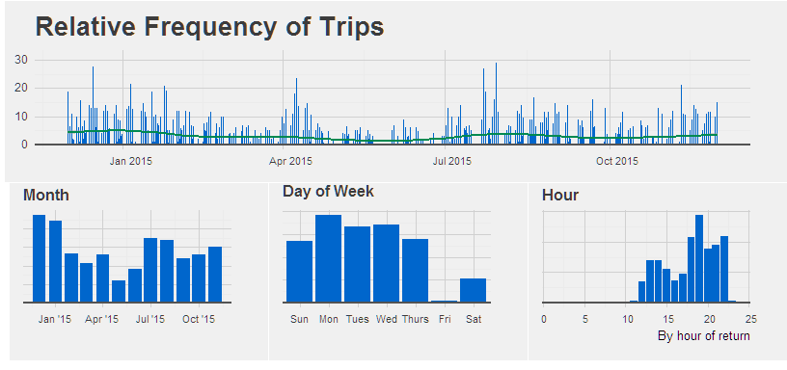

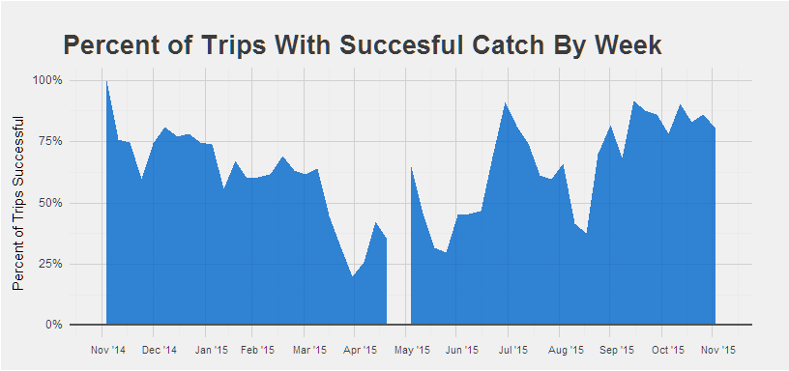 Above we can see a temporal breakdown of successful fishing trips. The filled area indicates what percent of trips for any given week returned with any fish. As a broad overview, the percentage of successful trips drops during the winter and spring months before rising through the summer and fall.

##### Page Break

# Discussion

## Fisheries and stock status

As the data from the fisheries itself does not yet allow for a comprehensive estimation of stock size and fishing status, these properties must be estimated from other sources. For the pelagic species which make up the majority of the catch, it can be assumed that no separate Jordanian population exists and that they are part of the broader Red Sea stock. Additionally, the swordfish caught in Jordan are most likely part of the Indian Ocean stock. The Indian Ocean swordfish is currently not over-fished, and the biomass is close to the maximum sustainable yield threshold (BMSY).

According to earlier investigations, the tuna catch mostly consists of three species. The most common are the Skipjack (*Katsuwonis pelamis*) and the Kawakawa (*Euthynnus affinis*). Minor catches consist of Yellowfin tuna (*Thunnus albacares*), Dogtooth tuna (*Gymnosarda unicolor*) and Longtail tuna (*Thunnus tonggol*) (Al-Zibdeh 2007). All of the tuna are taken from a larger migrating population, of which only a small part migrates to Jordan. The sardines and mackerels, which form another important part of the catch, are also most likely part of a bigger population in the Red Sea and not a local fish stock. Separate stock assessments for these species in the Red Sea do not yet exist.

In contrast to the most important commercially fished species, which are migratory and pelagic, the reef fish species which make only a small part of the landings are local populations. Although the gathered data does not yet allow for an estimation of stock size and fishing status, first conclusions can be drawn from ReefCheck Surveys, carried out by the Aqaba Marine Park during the PERSGA project in 2008 and by JREDS in 2015. These surveys focus on indicator species to give a rough estimation of important reef fish populations.

The snapper was selected as an indicator species because of its importance as a culinary fish that is caught by nets near reefs. Average snapper abundance for the whole region was 22.4±19.34 fish per 100 m2 reef, but no snappers were found in Jordan in 2006, 2008 (PERSGA 2010) and 2015 (JREDS 2015).

Parrotfish were selected as an indicator of over-fishing of various kinds. Between 1.25 fish per 100m2 reef (PERSGA 2010) and 1.8 fish per 100m2 reef (JREDS 2015) were found in surveys of the area. This is lower than in Egypt (2.13 fish per 100m2 reef) and Saudi Arabia (2.24 fish per 100m2 reef) (PERSGA 2010).

Butterflyfish of the family Chaetodontidae are taken as indicators for over-fishing (they are often bycatch in reef fisheries), ornamental fish trade and reef health. In Jordan, around 6.88±1.24 fish per 100m2 were counted in 2006 and 2008 (PERSGA 2010) and 8.9±1.33 fish per 100m2 (JREDS 2015), lower than in the Indo-Pacific region (10 fish per 100m2 reef) and Indonesia (18 fish per 100m2 reef). The abundances in Egypt were lower (6.23±0.69 fish per 100m2) and in Saudi Arabia were higher (8.22±0.36 fish per 100m2) (PERSGA 2010). The abundance of Chaetodontid was reported as 11.75 fish per 100m2 reef in 5m depth and 10.40 fish per 100m2 reef in 1981 (Bouchon-Navaro 1981).

Sweetlips (*Haemulidae*) were taken as indicator for overfishing, as they are one of the most popular fish species. In the Indo-Pacific, <1 fish per 100m2 were found, in Indonesia around 4 fish per 100m2. No sweetlips were found during any surveys in Jordan. 0.64±0.07 fish per 100m2 were found in Egypt and 1.09±0.03 fish per 100m2 in Saudi Arabia (PERSGA 2010).

Grouper above 30cm length of any species serve as an indicator for overfishing of all types. Jordan has very low values at 0.25±0.12 fish per 100m2(PERSGA 2010) in 2006 and 2008; no grouper were found in the 2015 survey (JREDS 2015). This is in contrast to Egypt with 0.75±0.35 fish per 100m2 and Saudi Arabia with 1.03±0.20 fish per 100m2. The recorded abundance from Red Sea reefs during 1997-2001 (average: 1.15±1.3 fish per 100m2) and from the Indo-Pacific region was much higher (0.45±0.98 fish per 100m2) (PERSGA 2010).

The results of the surveys suggest that the local reef fish populations are heavily overfished. This is supported by the findings of the current fisheries data collection, which shows that for the first time about 33% of the fishermen come back from the sea without any catch.

# Recommendations

## Recommendations for Management

## Recommendations for Public Awareness and Education

## Recommendations for Research

##### Page Break

# References

Tellawi 2001. Conservation and sustainable use of biological diversity in Jordan, First National Report of The Hashemite Kingdom of Jordan on the Implementation of Article 6 of the Convention on Biological Diversity. Compiled and Edited by Dr. Abdel-Muti M. Tellawi, December 2001. Table 2: Commercial Fishes from the Gulf of Aqaba

Khalaf, Maroof 2004. Fish Fauna of the Jordanian Coast, Gulf of Aqaba, Red Sea. JKAU: Mar. Sci, vol. 15, pp.23-50

Al-Zibdah 2006. Mohammad Al-Zibdah, Maroof, Khalaf, and NidalOdat. The Fishery Status in Jordan’s Gulf of Aqaba, Red Sea. Dirasat, Pure Sciences, Volume 33, No. 1, 2006

Al-Zibdah 2007. Mohammad Al-Zibdah and NidalOdat. Fishery status, growth, reproduction, biology and feeding habit of two Scombrid fish from the Gulf of Aqaba, Red Sea. Lebanese Science Journal, Vol. 8, No. 2, 2007

PERSGA. 2010. The Status of Coral Reefs in the Red Sea and Gulf of Aden: 2009. PERSGA Technical Series Number 16, PERSGA, Jeddah.

Bouchon-Navarro 1981. Y. Bouchon-Navaro and M. L. Harmelin-Vivien. Quantitative Distribution of Herbivorous Reef Fishes in the Gulf of Aqaba (Red Sea). Marine Biology 63, 79-86 (1981)

##### Page Break

# Appendix I - Table of Species

|  |  |  |  |  |  |  |
| --- | --- | --- | --- | --- | --- | --- |
| Common Name | Scientific Name  (If Available) | Arabic Name | Weight (kg) | % of Total | Number Caught | % of Total |
| Amberjack | Seriola spp. | قحم | 70 | 0.09 | 7 | 0.01 |
| Barracuda | Sphyraena spp. | بركودا | 8 | 0.01 | 2 | 0.00 |
| Blacktip Grouper | Epinephelus fasciatus | دغم | 8 | 0.01 | 27 | 0.03 |
| Blue Skinned Seabream | Polysteganus coeruleopunctatus | فريدي | 170 | 0.21 | 617 | 0.69 |
| Bluespotted Cornetfish | Fistularia commersonii | قصبه | 4 | 0.00 | 7 | 0.01 |
| Calmar Squid | Sepioteuthis lessoniana | حبار | 66 | 0.08 | 15 | 0.02 |
| Common Dolphinfish | Coryphaena hippurus | سيف ريم | 447 | 0.56 | 99 | 0.11 |
| Common Silver Body | Gerres oyena | رياشان | 5 | 0.01 | 35 | 0.04 |
| Dogtooth Tuna | Gymnosarda unicolor | شك ابو عين | 75 | 0.09 | 10 | 0.01 |
| Goatfish | Parupeneus spp. | سلطان ابراهيم | 164 | 0.20 | 1795 | 2.00 |
| Goggle Eye | Priacanthus hamrur | فنص أبو عين | 4 | 0.00 | 35 | 0.04 |
| Grouper | Variola louti | بوصية | 213 | 0.26 | 616 | 0.69 |
| Indian Scad | Decapterus russelli | سردين عريضة | 5 | 0.01 | 50 | 0.06 |
| Lizardfish | NA | ضب | 4 | 0.00 | 2 | 0.00 |
| Longtail Tuna | Thunnus tonggol | شك ابوذيل | 150 | 0.19 | 16 | 0.02 |
| Mackerel Scad | Decapterus macarellus | عميه | 9569 | 11.88 | 37487 | 41.76 |
| Marbled Spinefoot | Siganus rivulatus | سيجان | 243 | 0.30 | 2644 | 2.95 |
| Narrowbarred Spanish Mackarel | Scomberomorus commerson | شك ابو سنان | 40 | 0.05 | 4 | 0.00 |
| Orange-spotted Jack | Carangoides bajad | ريم قرابي | 29 | 0.04 | 5 | 0.01 |
| Parrotfish | Scarus spp. | غبان | 42 | 0.05 | 308 | 0.34 |
| Pomfrette | Taractichthys steindachneri | سلوم | 119 | 0.15 | 40 | 0.04 |
| Round Herring | Etrumeus teres | سردين مصرية | 808 | 1.00 | 14860 | 16.55 |
| Sailfish | Istiophorus spp. | فرس طافح | 5005 | 6.22 | 1452 | 1.62 |
| Sardine | Herklotsichthys quadrimaculatus | سردينا | 502 | 0.62 | 6860 | 7.64 |
| Shark | NA | قرش | 1966 | 2.44 | 783 | 0.87 |
| Snake Mackerel | Thyrsitoides spp. | سيف ليل | 88 | 0.11 | 51 | 0.06 |
| Soldierfish | NA | فنص احمر | 86 | 0.11 | 843 | 0.94 |
| Spangled Emperor | Lethrinus nebulosus | شعور | 52 | 0.06 | 89 | 0.10 |
| Swordfish | Xiphias gladius | فرس غزير | 18955 | 23.54 | 4888 | 5.44 |
| Tuna | NA | تونا | 40212 | 49.94 | 9133 | 10.17 |
| Unicorn Fish | Naso spp. | ابو قرن | 2 | 0.00 | 1 | 0.00 |
| Variegated Emperor | Lethrinus variegatus | بنقز | 55 | 0.07 | 246 | 0.27 |
| Yellowfin Tuna | Thunnus albacares | شك زور | 1141 | 1.42 | 63 | 0.07 |
| Yellowspotted Jack | Carangoides fulvoguttatus | ريم عادي | 2 | 0.00 | 1 | 0.00 |
| Yellowtail Fusilier | Caesio spp. | باغا | 213 | 0.26 | 6685 | 7.45 |

Total Number of Unique Species Identified: 33