**EL_Book Simple User Manual**

**Gallen Zhou 2013 Nov. 28**

# Installation

## Pre-installation

AppPath: **C:\AVIAGE_SYSTEMS\1000404-X02**

## Installing

1. Find the following files in the release package and copy them into **AppPath\bin**.

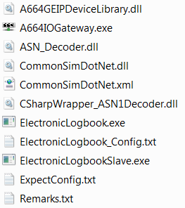

1. Copy the following files in the release package into the directory **AppPath**.

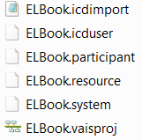

1. This EL_Book subscribes to the same messages as OMS_ACR. So this EL_Book reuses the OMS_ACR configuration, and EL_Book and OMS_ACR must be used together. If you want to use EL_Book without OMS_ACR, you need to modify the EL_Book VAIS configuration (you can refer to OMS_ACR VAIS config):
   1. Create a Utility Participant for IOGateway:

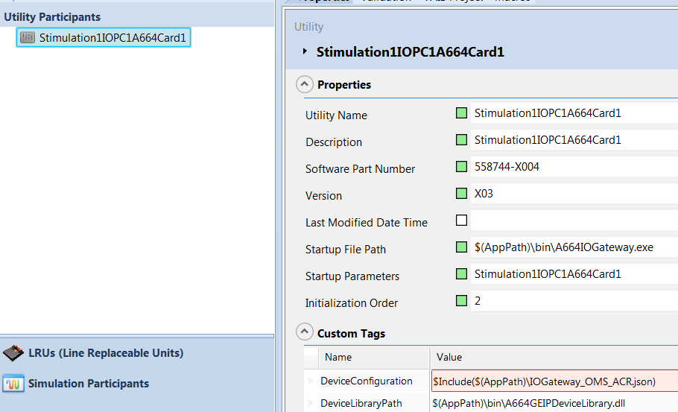

* 1. Put the Utility Participant on a Computing Resource with A644 card.

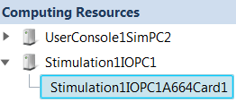

* 1. Copy the Json file from OMS_ACR. You can refer to OMS_ACR user manual to update this file.

1. The VAIS configuration in “Internal Release Folder” is for SSDL. If you want to use this model in other place, please update the VAIS configuration. 2 places need to be updated:
   1. AppPath:

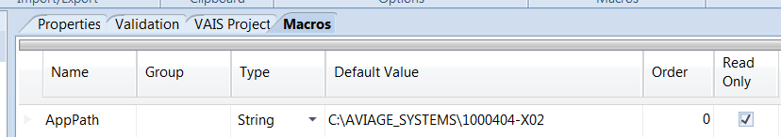

* 1. The Computing Resources definition

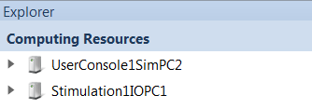

# Usage

## Launch EL_Book.

1. Use “VAIS Control Panel” to load ELBook.vaisproj from **AppPath**.
2. After loading, it would be shown as below:

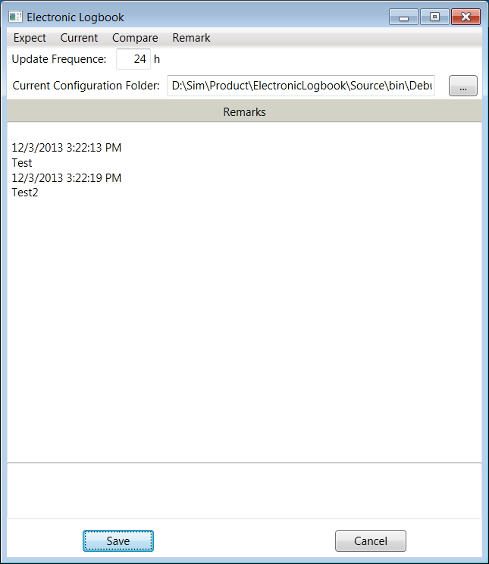

## Use EL_Book

1. There are 2 executable files, “ElectronicLogbook.exe” and “ElectronicLogbookSlave.exe”, which need to be installed on every computer. But only on “ElectronicLogbook.exe”, which has the GUI, can run at the same time.
2. This tool is to receive the Configuration Report message from each LRU, and Configuration Report message from each VAIS runtime and Simulation models. Then this tool compares the reported configurations with the expected configuration and reports the differences.
3. There is a configuration file “ElectronicLogbook_Config.txt”. It contains 4 sections:
   1. <LastSetting> section: User doesn’t need to change it, it is for GUI to use;
   2. <3rdPartySWCheckList> section: User needs to change it. Remove or add some SW names which should be reported by EL_Book.
   3. <EquipmentDefine> section: This section is for configurate the messages from IMA. So please use the same LRU name and message name as the OMS_ACR simulation configuration.
   4. <BeyondComparePath> section: this tool needs to invoke “Beyond Compare” to compare the reported configuration with the expected configuration. So please configurate the install path of the “Beyond Compare”.

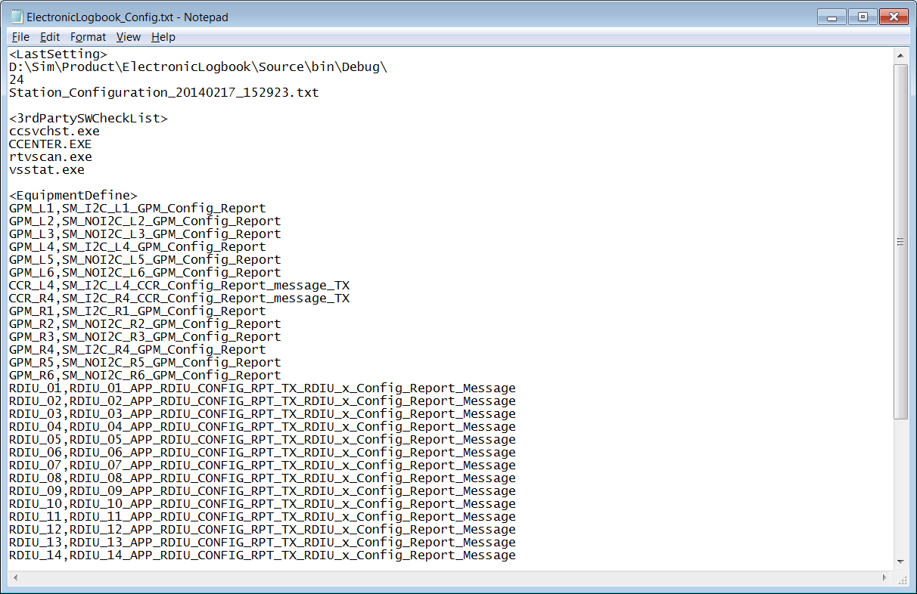

1. When user clicks the “Expect” menu item, the content of configuration file “ExpectConfig.txt” will be shown on GUI. User then can modify it. The result will be saved to “ExpectConfig.txt”. The format ***does*** matter, because “Beyond Compare” just does text compare.

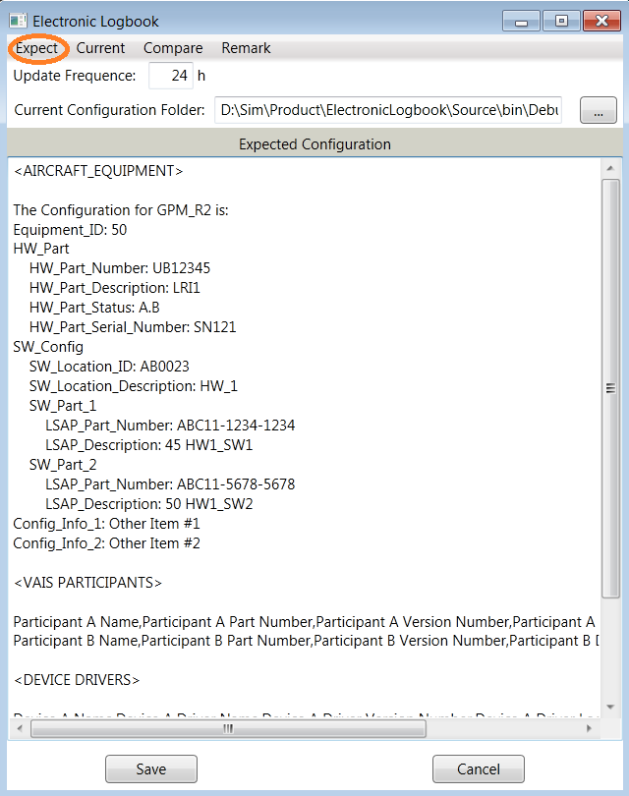

1. If user clicks the “Get Configuration”, EL_Book will get the configurations from IMA and all VAIS runtime again. It will take some time. If user clicks the “Show Configuration”, EL_Book just shows the configuration gotten from last “Get Configuration”.

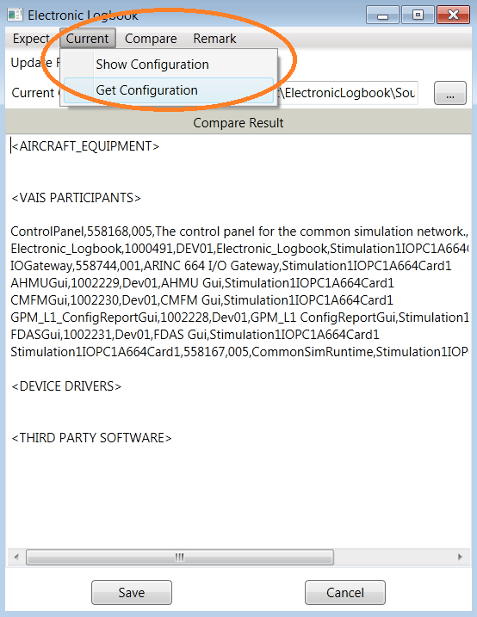

1. If user clicks the “Compare” menu item, the “Beyond Compare” is invoked to compare the “Expected Configuration” and the “Reported Configuration”.
2. If user clicks the “Remark” menu item, the content of configuration file “Remarks.txt” will be shown. When user inputs comments on the GUI, GUI will save the comments into this file.

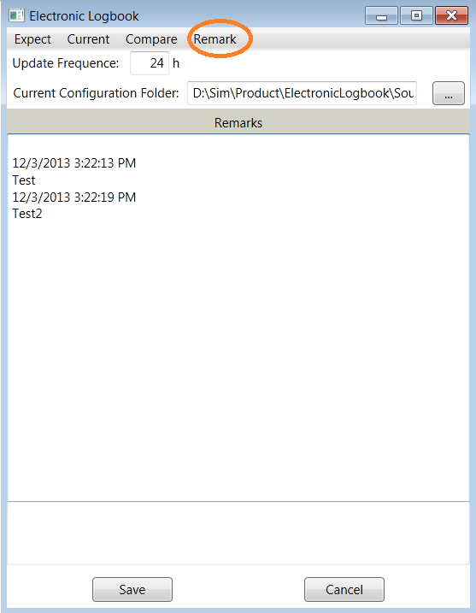

## Json file

EL_Book needs the configuration messages from IMA platform, which have been configured in simulation OMS_ACR model Json file. So EL_Book doesn’t need Json file.