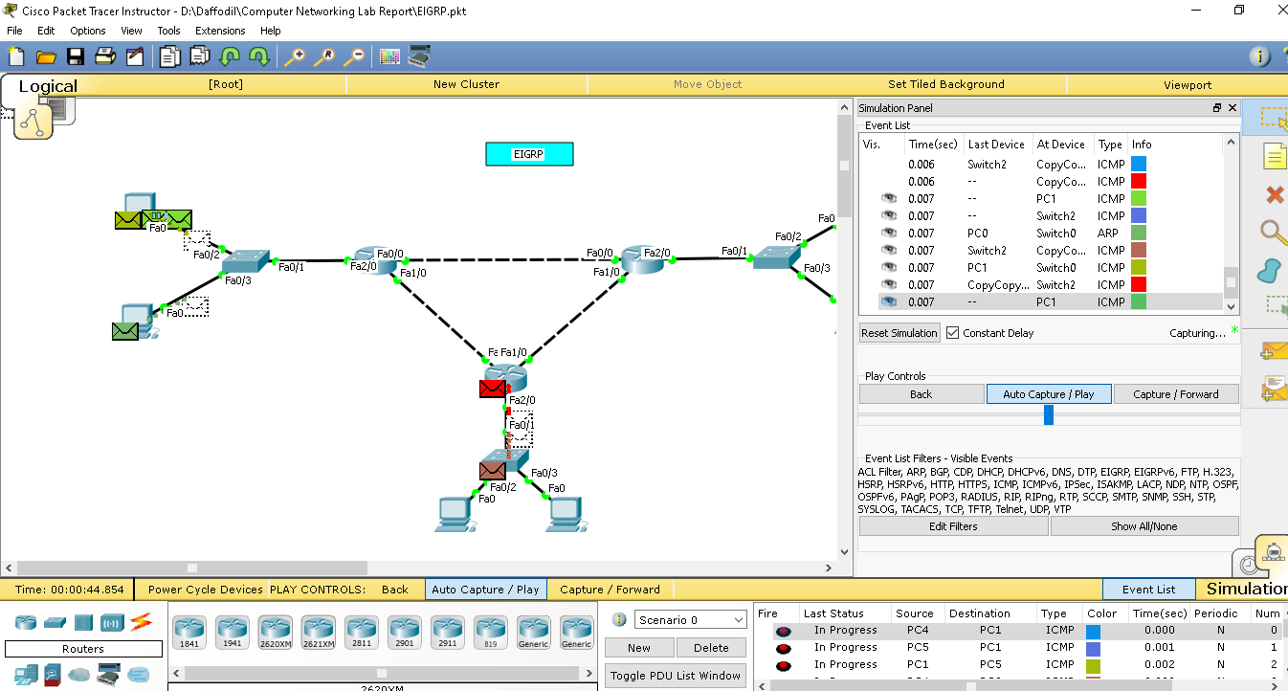

Here,

Router networks are,

10.10.10.0/30

10.10.20.0/30

10.10.30.0/30

And end device networks are,

192.168.10.0/32

192.168.20.0/32

192.168.30.0/32

**Router Configuration**

**router 1>>**

**----------**

**en**

**conf t**

**int fa0/0**

**ip address 10.10.20.2 255.255.255.252**

**no shut**

**exit**

**int fa1/0**

**ip address 10.10.10.1 255.255.255.252**

**no shut**

**exit**

**int fa2/0**

**ip address 192.168.10.1 255.255.255.0**

**no shut**

**exit**

**router ospf 1**

**network 192.168.10.0 0.0.0.255 area 1**

**network 10.10.10.0 0.0.0.3 area 1**

**network 10.10.20.0 0.0.0.3 area 1**

**exit**

**router 2>>**

**----------**

**en**

**conf t**

**int fa0/0**

**ip address 10.10.30.1 255.255.255.252**

**no shut**

**exit**

**int fa1/0**

**ip address 10.10.20.1 255.255.255.252**

**no shut**

**exit**

**int fa2/0**

**ip address 192.168.20.1 255.255.255.0**

**no shut**

**exit**

**router ospf 2**

**network 192.168.20.0 0.0.0.255 area 1**

**network 10.10.30.0 0.0.0.3 area 1**

**network 10.10.20.0 0.0.0.3 area 1**

**exit**

**Router 3>>**

**----------**

**en**

**conf t**

**int fa0/0**

**ip address 10.10.30.2 255.255.255.252**

**no shut**

**exit**

**int fa1/0**

**ip address 10.10.10.2 255.255.255.252**

**no shut**

**exit**

**int fa2/0**

**ip address 192.168.30.1 255.255.255.0**

**no shut**

**exit**

**router ospf 3**

**network 192.168.30.0 0.0.0.255 area 1**

**network 10.10.30.0 0.0.0.3 area 1**

**network 10.10.10.0 0.0.0.3 area 1**

**exit**